Fire Management Plan for
Cowbridge Compost
Co-mingled Waste Transfer Site

Llwynhelig
Cowbridge
Vale of Glamorgan
CF71 7FF

Contents
Introduction 3
Site Details 4
Fire Risk Assessment 6
Fire Risk Rating 13
Review of the Fire Prevention & Management Plan 14
Emergency action procedure 15
Contingency plan 16
Appendix 1 - Site Plan 17
Appendix 2 - Building Plan – Waste Transfer Station 18
Appendix 3 - Building Drainage Plan 19
Appendix 4 - Building Internal Plan 20
Appendix 5 - Sensitive Receptors within 1 Kilometre. 21
Appendix 7 - References 23

Introduction

Fire is an ever-present possibility at most waste management sites, if only because many wastes are readily combustible. Cowbridge Compost will ensure adequate controls are in place to prevent fires and, should a fire occur, that the risks to human health and the environment are minimised.
We recognise that fires involving wastes can cause significant harm to people and the environment:
- There is a risk of death and/or serious injury and ill-health from high thermal energy and smoke inhalation
- Combustion products, even those from non-toxic materials, release airborne pollutants which can cause short and long term effects on human health and the environment
- Firewater run-off can transport pollutants into drainage systems, rivers and lakes, groundwater and soil, threatening water supplies, public health, wildlife and recreational use
- Explosions and projectiles can harm people and spread any fire
- There may be destruction of our and third party property and subsequent financial losses
We also recognise that there are also less direct sources of harm, such as:
- The burden for the Fire and Rescue Services (FRS), Natural Resources Wales and other public agencies when responding to a fire may be both immediate and/or long lasting
- Time spent dealing with civil claims from third parties relating to nuisance or potential health effects and fines and/or costs levied by environmental, fire and health and safety regulators. There may also be an increase in insurance premiums following an incident.
- We also recognise that we may be responsible for the costs of clean-up, both on and off-site under the ‘principle of the polluter pays’.
- Our business may also suffer loss of reputation with subsequent loss of contracts leading to job losses, etc.

The plan was drawn up with reference to the following guidance - ‘Fire Prevention & Mitigation Plan Guidance – Waste Management Guidance Note 16’ and ‘Reducing Fire Risk at Waste Management Sites’ (see Appendix 7 References).

Site Details

Operation Details: | Cowbridge Compost will operate as a co-mingled waste transfer station (WTS), handling 40 – 50 tonnes of unprocessed recyclable loose waste per day. This may include plastic, paper, cardboard, tin and glass. No processing will be undertaken, loads will be unloaded by mechanical handler from the waste vehicle parked within the building and stored in a concrete bunker.  Maximum storage at any one time will not exceed 290 tonnes and will be internally; waste will be stored on site mainly overnight with worst case scenario being 3 days. Within the building there will be no other waste storage or activity.
Building Details: | The building designated as the WTS is a free standing single storey 75m x 30m steel framed building with concrete panel lower walls and metal cladding under a metal sheeted roof.  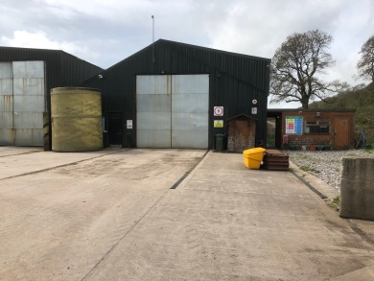  Internally there are 17 concrete bays, however waste will be tipped in the reception area and then moved to the storage area. This is a two bay 15m x 10m concrete bunker with concrete floor to the front section of the building.  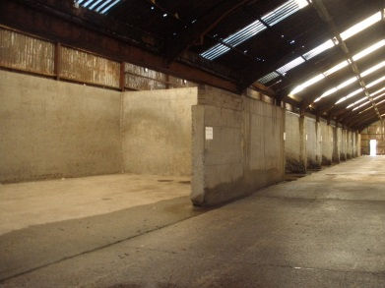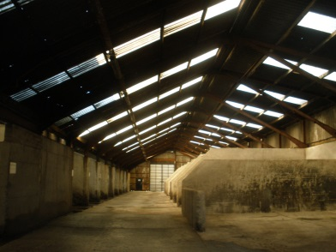  Adjacent to the building is a timber site office and welfare facility containing a WC and hand wash basin, washing machine and tumble dryer. There is also a bio-filtration system comprising a 5m x 10m filter bed of 1m woodchip over a layer of pea gravel with concrete walling.  A clear area of concrete and hard-core yards is maintained around the building.  See Site Plan in Appendix 1 and Building Drainage Plan Appendix 3 for details.
Occupancy: | 1 operative will man the site. Occupants are able to safely use the escape routes in the event of fire.
Site opening times: | Monday to Friday 07:30 – 16:00h
Post code / Grid reference | SS98408 75382  Aerial view of Waste Transfer Station (WTS) and Llwynhelig Farm  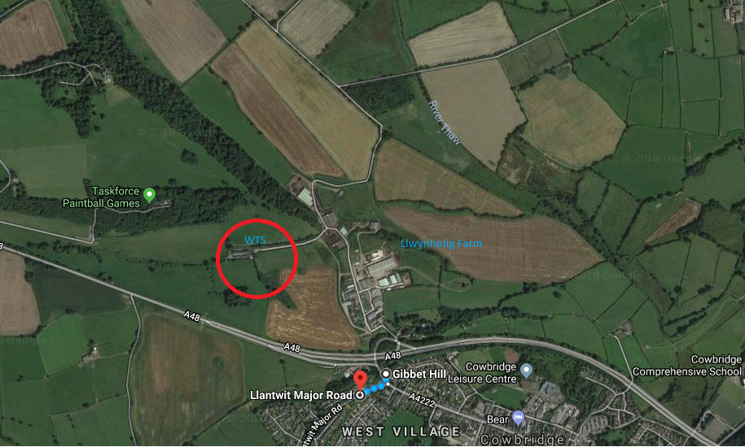
Plan compiled by: | Michael Hallett, Site Manager – Cowbridge Compost  Paul Roberts, Environmental Consultant to Cowbridge Compost  Suzanne Summers-Coles, Health & Safety Consultant NFU Mutual Risk Management Services
Date: | 23rd April 2018

Fire Risk Assessment
Significant Fire Hazards
Sources of Heat and Ignition:
Fixed electrics – Electrical wiring in the premises is of a modern standard and has been inspected (March 2018) by a competent electrician. The fuse board is located to the front of the WTS building.
Portable electrics – All portable electrical equipment is PAT tested on a regular basis. Portable electrical appliances are mostly in use within the adjacent site office. Records are kept of the PAT testing carried out.
Work processes (i.e. machinery, grinding, welding, etc.) – No hot work will be undertaken by Cowbridge Compost staff but a ‘hot work’ permit system will be applied for any welding, grinding or other hot work required. Mechanical handler buckets of Hardox steel have been specified. It is not anticipated that these will cause sparking if floor contact is made when scooping waste material. The hydraulic system of the JCB loader has fire protection.
Portable heaters – Nil. There is a wall-mounted electric panel heater in the site office. This is switched off when not in use. There is no heating within the building.
Engines/Boilers – Mechanical handlers will have hot exhausts. Machinery parking will be on a non-combustible surface and away from waste storage building. Machinery carries portable fire extinguishers and will be serviced and maintained.
Arson – No significant risk of arson. No waste materials / fuels stored externally. The building is locked as is the site office. There is CCTV coverage of the yards and the site entrance is secured by remote controlled gate.
Lightning – Building located in a valley, not considered to be at risk of strike.
Naked flames (e.g. smoking, matches, bonfires, etc.) – Nil; no smoking in buildings or plant. Smoking allowed outside only, metal waste bin provided.
Cooking – Microwave oven in site office only, interior maintained in clean condition. Appropriate fire extinguisher provided.

Spontaneous / self-combustion – waste received and stored is assessed to be low risk.
Other – due to the environmental conditions in the storage building, risk of static discharge is considered to be low. The tumble drier lint filter is regularly cleaned.

Sources of Fuel:
Co-mingled Recycling - The Waste Transfer Station handles a range of co-mingled recycling streams i.e. paper, cardboard, plastic and tin, occasionally there may be a small aerosol container within the waste.
Adjacent bio-filtration system comprised of wood chip.
No motor oils, lubricants, hydraulic oils, paints, thinners, solvents and degreasing agents, petrol, fuels, etc. are stored at the site.
The site does not accept gas cylinders of any type, Li-ion batteries, etc. These would be rejected on reception and disposed of into separate waste bins for disposal.
Modern office furniture is in good condition. No battery charging is carried out.
Waste produced by the business is deposited in a skip for disposal. No skips are sited around the building.
The quarantine area is located at Area 3 marked on the Site Plan (Appendix 1).

Sources of Oxygen:
No oxidising agents or oxygen cylinders are accepted. Any items of this nature will be segregated (removed to the green waste site) and disposed of.

Items that may promote the spread of fire:
Open plan nature of the premises – there is no effective internal compartmentation within the building; bunker walls do not reach ceiling level but are constructed of concrete. However waste will be stored at the front of the building, utilising less than 30% of the available floor space and the interior is mainly concrete.
No combustible materials are stored in close proximity to the exterior walls. The building is constructed of incombustible steel and concrete. No other combustible materials or plant / equipment are stored within the building. The loading shovel is parked in a designated area at 20m from the front of the building. There are no other buildings within 250m. See Site Plan Appendix 1 and Building Plan Appendix 2.
Housekeeping standard is good.
People at Risk
Employees – One operative on site, in communication with staff elsewhere on the premises. No persons on site requiring assistance to evacuate. Alternative escape routes to rear of building. Open plan interior would assist in early detection of a fire.
Contractors – Occasional; low numbers; signed in at Main Site Office and under supervision. Workspace checked by operative after work is complete / area left unattended for any reason. Hot work permit in place.
Visitors – By appointment only, low numbers. Accompanied by site management at all times.
Neighbouring premises - Penllyn Estate Llwynhelig Farm (includes commercial occupancy – numbers unknown); however unlikely to be affected directly by fire situation due to farm and tenanted buildings being sited on higher ground and separated by rough ground and yards. See Site Plan Appendix 1.

Sensitive Receptors in 1km radius
West Cowbridge residential dwellings, number unknown.
The Newton Moors is a groundwater source and designated a drinking water protection zone – the pumping station at Trebettyn is currently redundant. See Appendix 5 Sensitive Receptors within 1 Kilometre.
Evaluation of Existing Fire Precautions
Storage within the Building & Waste Pile Layout
The waste will exclusively comprise of co-mingled waste as collected by Vale of Glamorgan Council as part of their contract with Cowbridge Compost. The permitted amount of waste is 13000 tonnes and will be composed of co-mingled dry recycling that includes:
- Mixed paper
- Cardboard
- Cans
- Glass
- Mixed plastics
- Clean foil
- Aerosols
All waste is inspected at Reception following our waste acceptance procedures to prevent receipt of unauthorised waste. Any gas cylinders, Li-ion batteries, etc. would be rejected. These types of waste would be deposited in a receptacle at the green waste site for disposal as hazardous waste.
There will be only one waste pile within the building composed of two adjacent bays. The pile will be maintained at a maximum height of no more than 2m, length of 15m and width of 10m. Should the waste pile reach this size a smaller pile could be accommodated elsewhere within the building. See Building Internal Plan Appendix 4. Waste will be stored against mass concrete ‘push’ walls and no waste will be stored externally.
The pile size will be monitored daily using weighbridge records to ensure inputs and outputs do not exceed 40 – 50 tonnes. If this limit is reached then input will be prevented.
The adjacent bio-filtration system is located in an area exposed to rain and moisture and not considered to be a high fire risk.
The site does not accept gas cylinders of any type, Li-ion batteries, etc. These would be rejected on Reception and disposed of appropriately. No flammable and/or hazardous substances are stored on the site. The quarantine area is located at Area 3 on the Site Plan Appendix 1.
No ignition sources are permitted within close proximity of the waste pile. The WTS building is away from other occupied buildings see Site Plan Appendix 1. No high value equipment is parked or stored around or within the building. The loading shovel has a designated parking space at the site entrance and the bowser is parked at Area 4 on the Site Plan Appendix 1. No fuel is stored at the WTS.
There are no major services (overhead power lines, major roads or rail lines) adjacent that would be affected by a fire.

The waste storage building can be opened at both ends with doors large enough to accommodate heavy plant and large vehicles plus there are pedestrian exits. Waste piles will be kept well clear of fire-fighting equipment such as fire extinguishers. See Building Internal Plan Appendix 4.

Waste will not be sorted or processed but will be deposited directly from the street collection vehicle.

The waste pile will be cleared on a rotational basis over a 2 day period. The maximum pile size will be 290t tonnes. Pile core temperature monitoring will be implemented using a 2m temperature probe. Temperature recordings taken morning and evening and records kept. Findings of a temperature in excess of 70°C will necessitate removal of the waste to the quarantine area and cooling. Prior to return to the store or loading the temperature will be checked again. Operators will also visually inspect the pile for signs of heating i.e. production of steam.

The waste storage building has openable roller shutter doors both to aid fire-fighting access and smoke clearance. Further smoke management will be as advised by the fire and rescue service.

Seasonality & Waste Stack Management:

The customer is exclusively the Vale of Glamorgan Council. The contract with the Council is for bulking up of co-mingled waste only. The council is responsible for all deliveries and daily removal of waste from the site; this will continue independently of foreseeable market conditions. The supply chain and end user outlets are guaranteed via the contract with the Vale of Glamorgan Council. No other waste will be accepted at the WTS from third parties.
Fire Detection and Warning System:

The building is single storey and open plan, with one operative working in the area thus a manual operated call point is deemed to be adequate for the risk. The call point is located at the front of the building. The building interior and exterior is monitored by CCTV that is relayed to the main site office for monitoring. Cameras are located at the exit doors at either end of the building.

Pile core temperature monitoring will be implemented using a 2m temperature probe. Temperature recordings taken morning and evening and records kept. Findings of a temperature in excess of 70°C will necessitate removal of the waste and cooling.

Due to the occupancy of the building, presence of CCTV monitoring, pile management (rotation and nature / type of waste), pile temperature recordings and fire suppression systems (see next section) the risk of fire is assessed to be low thus fire detection and warning systems such as smoke and heat detection, visual flame / infra-red and ultraviolet detection are not required.

Fire Suppression and Fire-Fighting:
The use of fire suppression systems such as sprinklers, manual open deluge systems, deluges and water spray systems and water cannons / curtains have been considered. However in consultation with the Fire & Rescue Service the most appropriate method of firefighting will include applying water to cool unburned material and other hazards and separating unburned material from the fire using appropriate heavy plant.
Firefighting equipment - Serviced portable fire extinguishers are installed at the main and rear exits in marked wall-mounted fire points. See Building Internal Plan Appendix 4 for locations. The mechanical handler (loading shovel) is fitted with a portable fire extinguisher.
Firefighting water supplies are provided in a 25000 litre tank with high pressure hose at the yard at the front of the building. An additional 1 million litres of clean water is stored in the Storth aboveground circular storage tank (see Appendix 1 Site Plan for location). There is a fire hydrant at Gibbet’s Hill (near main entrance to Llwynhelig Farm) at Westgate – Grid reference SS988749.
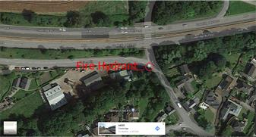
Firefighting water would be pumped from the Storff tank into 15000 and 12000 litre vacuum tankers towed by tractors from the green waste site working on rotation.
Assuming the entire pile of 300m³ is on fire and this will require 2000 litres a minute for a 3 hour minimum period. The above facilities should be adequate.
To store contaminated water run-off the lined lagoon has a capacity of 500000 litres. The water draining from the building floor can be contained behind a soil bund. This can then be pumped to the lagoon. The lagoon has an automatic pumping system that activates once the water level rises.
Drains around the yards are colour coded – ‘blue’ for clean water (rain) and ‘red’ for foul contaminated water.
Subsoil supplies (100 tonnes) for fire suppression / damping as a soil ‘blanket’ are stored on a level area at the entrance to the site. See Appendix 1 Site Plan for location. This will be used to suppress a fire / form a bund.
Alternative site access is available from a hard-core track that is suitable for large vehicle access. This runs parallel to the building. See Appendix 1 Site Plan for location.
Disposal of wastes – Fire water will be sampled and sent for analysis and then disposed of appropriately. Fire residues will be sent to landfill.
Emissions to air (smoke) – it is recognised that products of combustion are toxic thus a procedure is in place to warn local residents and all businesses on site. Cowbridge Compost will attempt to control the fire prior to arrival of the Fire & Rescue Service.
Means of Escape:
There are two pedestrian exits – one at either end of the building, these are unlocked when the building is in use. The exits are in clear line of sight through the building. Distances to exits are suitable for the building use. Travel distances are no more than 45 metres from any point in the building. There are no inner rooms.
The means of escape throughout the building is kept clear of combustibles and unobstructed.
Wall and ceiling linings are generally incombustible.
Exit widths are sufficient for the anticipated occupancy figures.
Lighting:
General lighting levels are satisfactory due to the number of roof lights within the building. Artificial lighting is also provided.
Emergency escape lighting comprising 2 twin spot lighting units with 3 hour battery back-up are installed at either end of the building and externally. The mechanical handler is fitted with head lamps.
Emergency lighting will be tested and maintained in line with the relevant British Standard and records of this will be retained.
Signs and Notices:
No smoking signs are displayed at the building entrance. Fire exit signs are displayed within the building. The fire assembly point is located at the site entrance, internally exit signs are fitted.
Fire action notices are displayed.

Testing and Maintenance:
The fire alarm sounder will be tested on a weekly basis by operating the call point which is a manual fire bell located at the front of the building.
The means of escape are checked daily.
Monthly tests will be carried out in-house on the emergency lighting system within the building.
The above tests will be recorded in the fire log book.
The emergency lighting will be maintained on an annual basis by a competent electrician.
The firefighting equipment is serviced annually.

Information, Instruction & Training:
Site operatives (including green waste site staff) attended fire extinguisher and fire awareness training in February 2017.
The fire assembly point is located at the yard away from the building and site entrance. See Appendix 4 – Building Internal Plan.

The local fire service was invited to site (23/03/18) for further advice and familiarisation.

The Fire Prevention & Management Plan is held at the main site office with a further copy retained at the transfer station office. See Location of Fire Prevention & Management Plan (FPMP) Appendix 6.

Co-operation and Communication:

There are no other businesses who share the site. However staff at the neighbouring green waste suite would be informed of the situation as they will be drafted in to assist. The farm and tenanted units will also be informed as necessary by PA system as would occupants of potentially affected areas of Cowbridge.

Fire & Rescue Service Details:

The local fire & rescue service is at:
Druids Green
Cowbridge
CF71 7EL

The station is approximately 5 minutes away.

Station type: Retained
Appliances: 1 x Water Ladder
1 x Light Pump Unit 4x4

Nearest hydrant located at Gibbet’s Hill grid reference SS988749

Fire Risk Rating
Taking into consideration the fire hazards observed as well as the fire prevention measures in place at the time of the assessment, the fire risk on these premises is considered: delete as appropriate
LOW NORMAL HIGH
A definition of the above terms is as follows:
Low: A low chance of fire occurring as there are few potential sources of ignition, small quantities of flammable materials or other sources of fuel. In addition there is a low occupancy level and all occupants are able bodied and capable of using the means of escape without assistance. There are a number of fire precautions installed and maintained to a high standard including Fire detection. A fire will be detected quickly so people are warned and can make their escape.
Normal: In most cases the fire risk will be considered as normal fire hazard (e.g. sources of ignition and fuel present are typical of this type of occupancy and they are subject to adequate controls e.g. fire detection system, emergency lighting, fire resisting construction, some compartmentation and fire safety management systems etc.
High: Lack of adequate controls applied to significant fire hazards, resulting in an increase in the likelihood of fire. The likelihood of a fire starting and spreading quickly, or a fire could start and grow without being detected quickly and a warning given. The premises may have large quantities of flammable materials used or stored and numerous sources of ignition present. There may be less able bodied people present who may move slowly or are unable to move or escape without assistance. The premises may be constructed so that a fire spreads quickly or there is a lack of fire resting construction and compartmentation.

Review of the Fire Prevention & Management Plan
This document will be reviewed annually or sooner if there is reason to believe that there is a change to the Risk Profile of the business. Issues that may change the Risk Profile include:
- Development of site including additional buildings or making changes to the structure of the building
- Changes to the occupancy of a building
- Significant change in work practices or equipment
- If the fire growth characteristics change (e.g. we begin to store flammable substances or where significant changes in waste received and stored are planned)
- Changes in specific guidance or legislation
- Occurrence of a fire
- Acceptance of additional combustible waste streams
- Increase in volume of waste handled
It is essential that a copy of this document be kept somewhere accessible and is made available for inspection by the South Wales Fire & Rescue Service and Natural Resources Wales.

Date of review | Name (and signature) of person reviewing

Emergency action procedure

General
DO:
- Make it Safe, Stop, Contain, Notify!
- Identify the cause of the emergency or incident and act immediately to prevent it from getting worse.
- Make sure that appropriate PPE is available to use where necessary.
- Report any emergency or incident to the Site Manager on 07973 894773 immediately, detailing the nature, cause and location so that appropriate action can be taken.
- Contact the Fire & Rescue Service, Local Authority and Natural Resources Wales (NRW) as necessary.
DO NOT:
- Ignore an incident as this will lead to disciplinary consequences and/or legal action – always take action and respond to the incident.

AFTER AN INCIDENT:
- Ensure that any lessons from the incident are communicated to all relevant staff and appropriate action taken elsewhere on site if necessary.
- Update all relevant Method Statements and Toolbox Talks, and ensure new information is communicated to site staff.

FIRE
DO:
- Use a fire extinguisher as per your training. Additional sources of water are available (tank outside the building) and Storff circular store.
- Call fire brigade (the fire may only appear to be out).
- Report emergency to the Site Manager on 07973 894773 immediately.
- Inform neighbouring premises that may be affected. This will depend on the direction of smoke plume as there is a SW prevailing wind the residential area of Cowbridge may be affected. Residents can be made aware by using a PA system from a site van. Other businesses on the Penllyn Estate may not be affected.
DO NOT:
- Place yourself at any risk.

EMERGENCY SPILLS AND POLLUTION INCIDENTS
DO:
- Make sure you have the appropriate PPE before taking action.
- Contain a pollution incident immediately using absorbent materials and booms, or by digging containment facilities or bunds. A larger spill or release can be contained using the soil from the store at the site entrance.
- Report incident to site manager and contact NRW.
- Contact the designated spill clean-up company for appropriate assistance.
- Check all nearby water bodies and watercourses to ensure if any spills or pollution has spread beyond the immediate area and take action as required in liaison with NRW.
DO NOT:
- Dig ditches to drain polluted matter to watercourses.
- Remove bunds, booms and bales used to hold polluting materials.
- Ignore an incident.

AFTER AN INCIDENT:
- All waste generated by clean-up activities should be disposed of in accordance with current legislative requirements and the site waste management plan and copies of all transfer notes retained.

Contingency plan

If a fire occurs and decreases the ability to safely store waste, then all waste will be diverted to:
Bryn Recycling
Bryn Group
Gelliargwellt Farm
Gelligaer
Hengoed
CF82 8FY

Telephone number: 01443 838 121

Call our insurer on telephone number: 01656 350253

Appendix 1 - Site Plan

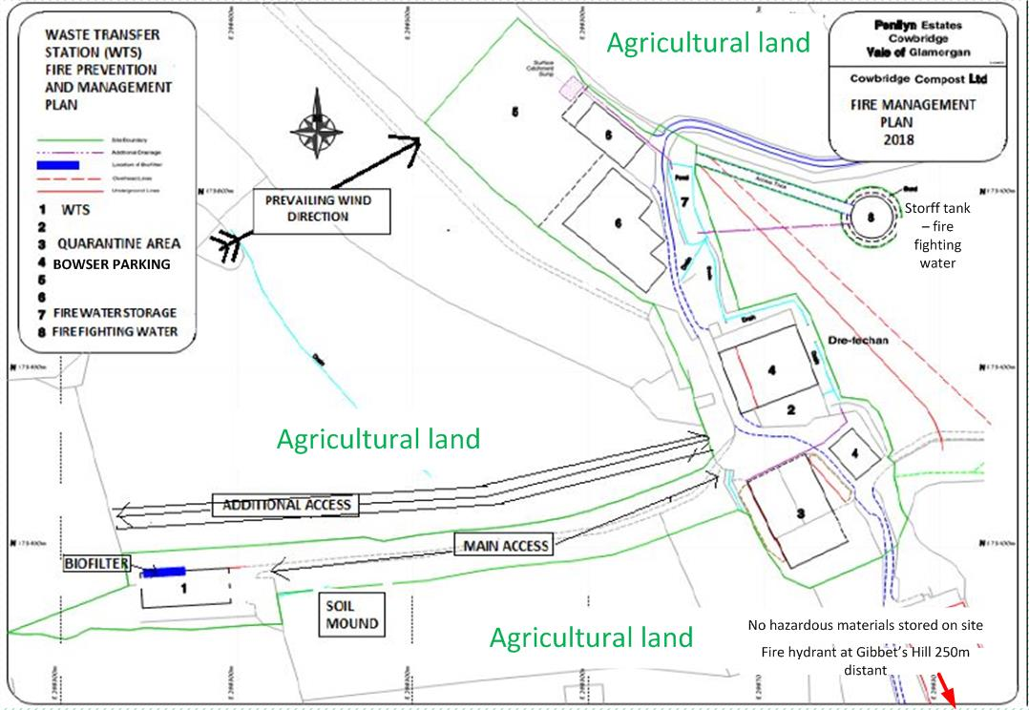

Appendix 2 - Building Plan – Waste Transfer Station
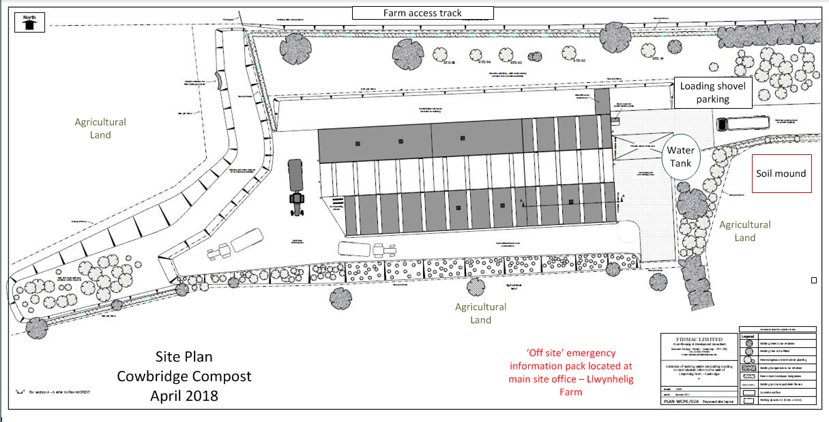

Appendix 3 - Building Drainage Plan

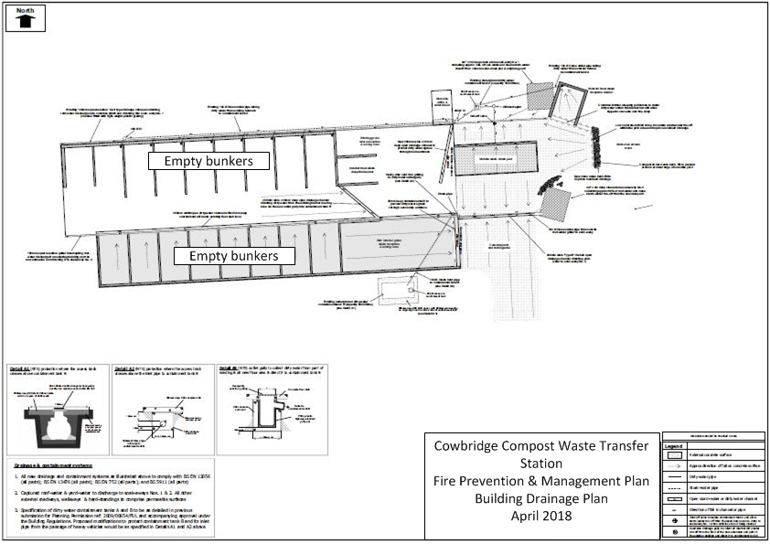

Appendix 4 - Building Internal Plan
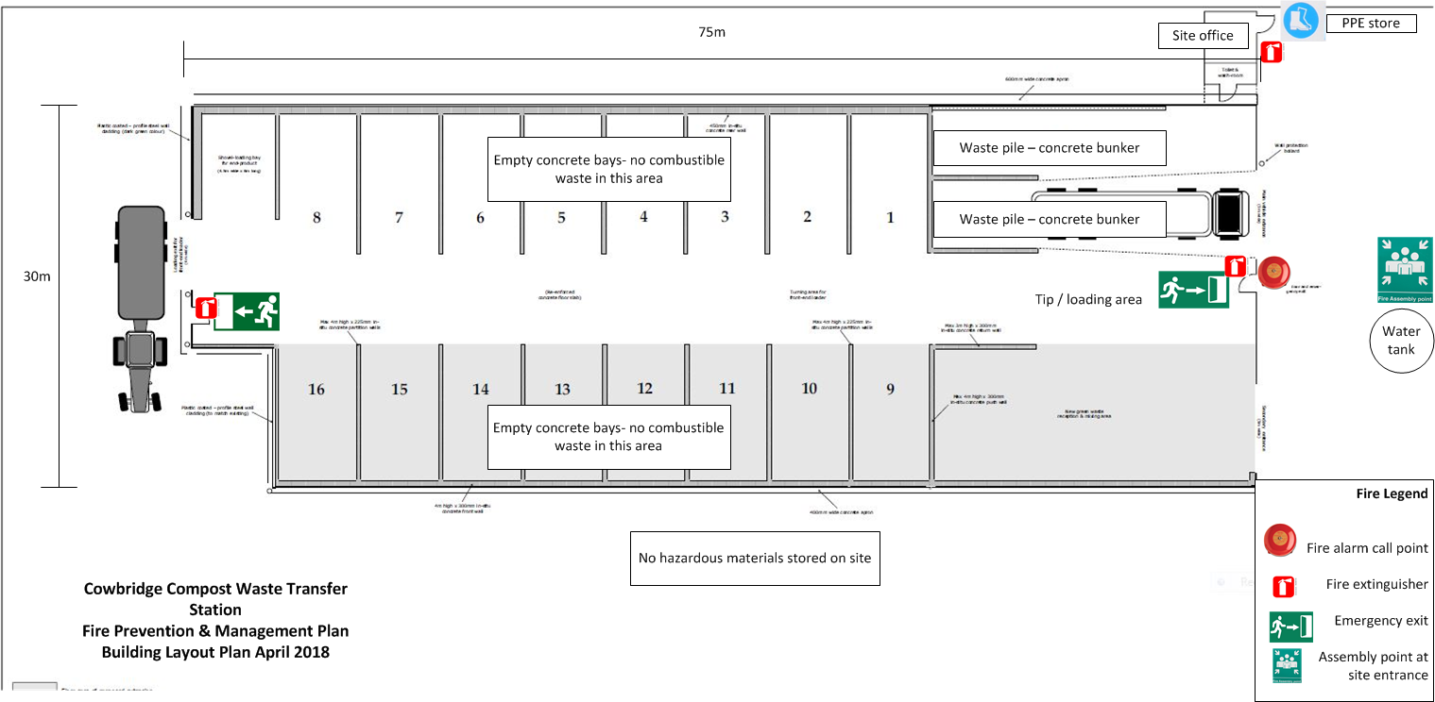

Appendix 5 - Sensitive Receptors within 1 Kilometre.

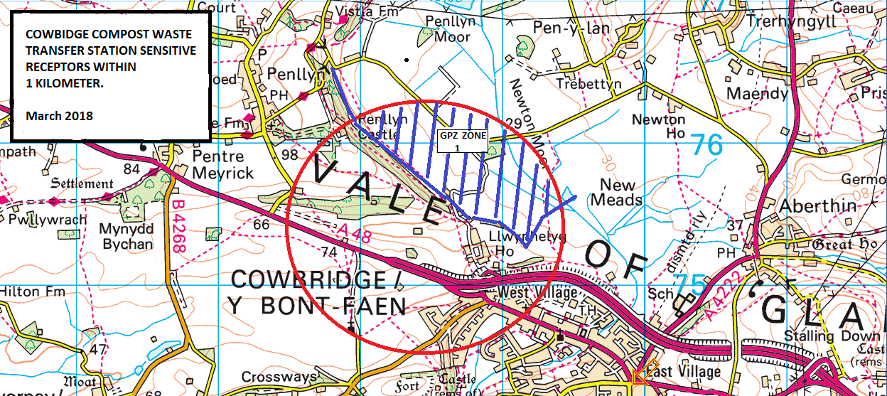
Appendix 6 Location of Fire Prevention & Mitigation Plan (FPMP)
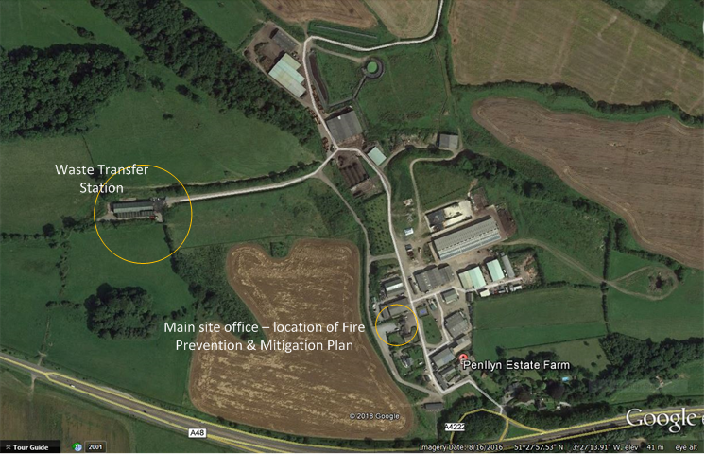

Appendix 7 - References
‘Fire Prevention & Mitigation Plan Guidance’ – Waste Management Guidance Note 16 https://naturalresources.wales/media/682159/eng-guidance-note-16-fire-prevention-mitigation-plan.pdf
‘Reducing Fire Risk at Waste Management Sites’ - Waste Industry Safety and Health Forum (WISH)

