Ein cyf/Our ref: FP3836MU

Eich cyf/Your ref:

Dyddiad/Date: 22 October 2018

For the attention of Mr Morgan

D Morgan and Company
Trostrey Court Poultry Farm
Trostrey Court
Usk
Monmouthshire NP15 1HT

Dear Mr Morgan

Pig and Poultry Assurance Scheme: Compliant Inspection
Farm Name: Trostrey Court
Permit Number: FP3836MU

Thank you for taking part in the inspection by your Farm Certification Body on 19 September 2018.

We are pleased to confirm that you are now compliant with your permit. Your farm will continue to remain in the scheme for the current year.
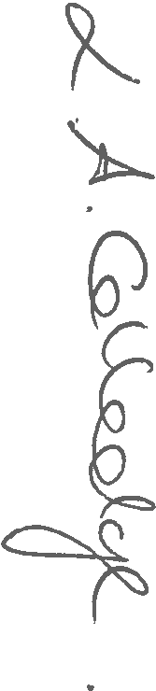
Please contact us should you have any questions about this letter.

Yours sincerely

LESLEY COLLEDGE
Swyddog Cymorth Technegol / Technical Support Officer
Cyfoeth Naturiol Cymru / Natural Resources Wales
Ffôn/Tel: 0300 065 3492
E-bost uniongyrchol/Direct e-mail: lesley.colledge@cyfoethnaturiolcymru.gov.uk
Croesewir gohebiaeth yn y Gymraeg a'r Saesneg
Correspondence welcomed in Welsh and English

