

Cardiff Coastal Defence Scheme

Water Framework Directive (WFD) Assessment

November 2021

www.jbaconsulting.com

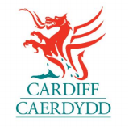

JBA Project Manager
Anne-Marie Moon
JBA Consulting
Kings Chambers
8 High Street
Newport
NP20 1FQ

Revision History
Revision Ref/Date | Amendments | Issued to
July 2021 | Draft Report
August 2021 | Draft Report | Cardiff County Council
November 2021 | Final Report | Cardiff County Council

Contract
This report describes work commissioned by Cardiff Council. Hannah Hepworth and Anissia Halwyn of JBA Consulting carried out this work.
Prepared by Hannah Hepworth BSc MSc GradIEMA
Environmental Consultant
Anissia Halwyn BSc PhD
Eco-geomorphologist
Reviewed by Natasha Todd-Burley BSc PhD
Senior Geomorphologist

Purpose
This document has been prepared as a Final Report for Cardiff Council. JBA Consulting accepts no responsibility or liability for any use that is made of this document other than by the Client for the purposes for which it was originally commissioned and prepared.
JBA Consulting has no liability regarding the use of this report except to Cardiff Council.

Copyright
© Jeremy Benn Associates Limited 2021.

Carbon Footprint
JBA is aiming to reduce its per capita carbon emissions.

Contents

1 Introduction - 1 -

1.1 WFD Overview - 1 -

1.1.1 Scope of the WFD Assessment - 1 -

1.1.2 Preventing Deterioration in Status - 1 -

1.1.3 Artificial or Heavily Modified Water Bodies - 2 -

1.2 Purpose of this WFD Assessment - 3 -

2 Assessment Methodology - 4 -

2.1 Overview - 4 -

2.2 Screening Assessment - 4 -

2.3 Scoping Assessment - 5 -

2.4 Impact Assessment - 5 -

3 Project Description - 7 -

3.1 Project Overview - 7 -

3.2 Proposed Works - 7 -

3.2.1 General construction points - 11 -

4 WFD Screening Assessment - 12 -

4.1 Overview - 12 -

4.2 WFD water bodies - 12 -

4.3 Screening Outcome: water bodies - 13 -

4.4 Baseline Status of screened-in water bodies - 13 -

4.4.1 Severn Lower Transitional Waterbody - 13 -

4.4.2 Roath Brook - 14 -

4.4.3 Rhymney River - conf Nant Cylla to Chapel Wood - 14 -

4.4.4 Nant Glandulas - source to conf Rhymney River - 14 -

4.4.5 SE Valleys Southern Devonian Old Red Sandstone & Triassic Mercia Mudstone Groundwater body - 14 -

4.5 Protected Areas - 15 -

4.5.1 Nitrate Vulnerable Zones (NVZ) - 15 -

4.5.2 Drinking Water Groundwater Safeguard Zones (SgZ) - 15 -

4.5.3 Bathing Water Zones - 15 -

4.5.4 Urban Waste Water Treatment Zones - 15 -

4.5.5 Shellfish Water Protected Areas - 16 -

4.6 Invasive Non-Native Species - 16 -

4.7 Summary - 16 -

5 WFD Scoping Assessment - 17 -

5.1 Overview - 17 -

5.2 Severn Lower Water Body - 17 -

5.2.1 Biological Quality Assessment - 17 -

5.2.2 Hydromorphological Quality Elements - 18 -

5.2.3 Physico-Chemical Quality Assessment - 19 -

5.2.1 Chemical Quality Assessment - 20 -

5.3 SE Valleys Southern Devonian Old Red Sandstone & Triassic Mercia Mudstone Groundwater Body (GB40902G201500) - 21 -

5.4 Impacts of works on protected sites - 22 -

5.5 Impacts of works on INNS - 22 -

6 WFD Impact Assessment - 23 -

6.1 Overview - 23 -

6.2 Impact Assessment - 23 -

6.1 Protected areas - 29 -

6.2 INNS - 29 -

6.3 Water body Mitigation Measures - 29 -

6.4 WFD Assessment Objectives - 31 -

7 Discussion and Conclusions - 33 -

7.1 Assessment Summary - 33 -

7.1.1 Biological Assessment - 33 -

7.1.2 Hydromorphological Assessment - 33 -

7.1.3 Physico-chemical Assessment - 34 -

7.1.4 Chemical Assessment - 34 -

7.1.5 Protected sites - 34 -

7.2 Scheme Recommendations/Key Considerations - 34 -

7.3 Conclusions - 34 -

List of Figures
Figure 2-1: WFD assessment process flow chart - 4 -
Figure 3-1: Site Location - 7 -
Figure 3-2: Overview of the proposed development sections - 8 -

List of Tables
Table 4-1: Current WFD status - 12 -
Table 5-1: Assessment of works against the biological elements - 17 -
Table 5-2: Assessment of works against the hydromorphological quality elements - 18 -
Table 5-3: Assessment of works against the physico-chemical quality elements - 19 -
Table 5-4: Assessment of the proposed works against the Environmental Quality Standards (EQS) of the priority substances and other polluting chemicals of the Severn Lower water body. - 20 -
Table 5-5: Quantitative and chemical quality elements - 21 -
Table 5-6: Assessment of works on protected sites - 22 -
Table 6-1: Impacts and mitigation measures - 23 -
Table 6-2: Assessment of proposed works against the water body’s mitigation measures - 29 -
Table 6-3: Assessment of proposed works against WFD objectives - 31 -

Abbreviations
NGR National Grid Reference
NVZ Nitrate Vulnerable Zones
PEA Preliminary Ecological Appraisal
RBD River Basin District
RBMP River Basin Management Plan
SAC Special Area of Conservation
SPA Special Protection Area
WFD Water Framework Directive

Introduction
JBA Consulting (JBA) has been commissioned to develop the Full Business Case (FBC) for the coastal and fluvial flood defence scheme in the Severn Estuary and Rhymney River near Cardiff on behalf of Cardiff City Council.
As the proposed work site is located in close proximity to water bodies listed on the Water Framework Directive (WFD), a WFD screening assessment is required to be completed.

WFD Overview
The Water Framework Directive (WFD) came into force in 2000 and is the most substantial piece of EU water legislation to date. The Directive imposes legal requirements to protect and improve the water environment. All activities in the water environment need to take the Directive into account. The EU Water Framework Directive was transposed into law in England and Wales by the Water Environment (Water Framework Directive) (England and Wales) Regulations 2003. The 2003 regulations were consolidated and replaced with the Water Environment (Water Framework Directive) (England and Wales) Regulations 2017. The Floods and Water (Amendment etc.) (EU Exit) Regulations 2019 ensure that floods and water legislation continues to be operable in the United Kingdom following withdrawal from the EU in January 2021. The instrument addresses deficiencies in retained EU law arising from the UK’s withdrawal from the EU. The purpose of the instrument is to preserve and protect the existing policy regime rather than to introduce new policy. The Water Environment (Water Framework Directive) (England and Wales) Regulations 2017, as amended by the Floods and Water (Amendment etc.) (EU exit) Regulations 2019, are hereafter referred to as the WFD Regulations in this report.

Scope of the WFD Assessment
The WFD Regulations require that Environmental Objectives be set for all surface and ground waters in England and Wales to enable them to achieve Good Status (or Good Ecological Potential for Heavily Modified and Artificial Water Bodies) by a defined date. These Environmental Objectives are listed below:
- Prevent deterioration in the status of aquatic ecosystems, protect them and improve the ecological condition of waters.
- Aim to achieve at least good status/potential for all water bodies by 2021. Where this is not possible and subject to the criteria set out in the Directive, aim to achieve good status/potential by 2027.
- Meet the requirements of Water Framework Directive Protected Areas.
- Promote sustainable use of water as a natural resource.
- Conserve habitats and species that depend directly on water.
- Progressively reduce or phase out the release of individual pollutants or groups of pollutants that present a significant threat to the aquatic environment.
- Progressively reduce the pollution of groundwater and prevent or limit the entry of pollutants.
- Contribute to mitigating the effects of floods and droughts.

Preventing Deterioration in Status
Any activity which has the potential to have an impact on the ecology of a water body will need consideration in terms of whether it could cause deterioration in its Ecological Status or Potential.
For each water body, three different status objectives are identified within the River Basin Management Plan (RBMP). These are the overall status objective, the ecological status or potential objective and the chemical status objective. A default objective for all water bodies is to prevent the deterioration in the Ecological Status (or Ecological Potential for Heavily Modified and Artificial Water Bodies) of the water body. Note, the Ecological Status applies only to surface water bodies, and not ground water bodies. A separate assessment may be required to assess the impacts on the chemical and quantitative status of a ground water body, if the proposed activity is likely to cause impact.
The Ecological Status of a water body is determined through analysis of its constituent Biological Quality Elements. These elements are in turn supported by a series of Physico-Chemical and Hydromorphological Quality Elements. These Quality Elements are taken from Annex V of the WFD Regulations and are listed below. The overall Ecological Status is determined by the lowest element status.
The Biological Quality Elements assessed in the WFD for a transitional water body include:
- Composition, abundance and biomass of phytoplankton
- Composition and abundance of other aquatic flora
- Composition and abundance of benthic invertebrate fauna
- Composition and abundance of fish fauna
The WFD defines the flow, shape and physical characteristics of a water body as its ‘hydromorphology’. Any in-channel works can impact upon the morphology of a transitional water body and the natural processes that occur within it, including:
- Morphological conditions:
- Depth variation
- Quantity, structure and substrate of the bed
- Structure of the intertidal zone
- Tidal regime:
- Freshwater flow
- Wave exposure
The WFD considers the chemistry of a water body through general water quality (physico-chemical measurements) and chemical pollutants. The chemical status of a water body is assessed in relation to Environmental Quality Standards (EQS) for a specified list of ‘priority’ and ‘priority hazardous’ substances first established by the Priority Substances Directive (PSD) (2008/105/EC). Chemical status is recorded as good or fail. All three environmental components; morphology, hydrology and chemistry, support the biology of a water body. For a surface water body to be in overall “good” status or potential, both its ecological and chemical status must be at least “good”.
Any activity that has the potential to have an impact upon any of the Quality Elements will need consideration in terms of whether it could cause a deterioration in the status of a water body. The activity will also need to be considered in terms of whether it will compromise the ability of the water body to reach Good Ecological Status or Good Ecological Potential by the date specified in the river basin management plan (RBMP).
Any adverse impacts can cause a water body's ecology to deteriorate and prevent environmental improvements from being undertaken. Nevertheless, in-channel works can also be beneficial if they can be designed to help achieve environmental improvements included in the RBMP, thus enhancing the water environment for plants and animals.

Artificial or Heavily Modified Water Bodies
Whilst good ecological status is defined as a slight variation from undisturbed natural conditions in natural water bodies, artificial and heavily modified water bodies are unable to achieve natural conditions. Instead, artificial and heavily modified water bodies have a target to achieve Good Ecological Potential, which recognises their important uses, whilst making sure ecology is protected as far as possible. Ecological potential is also measured on the scale high, good, moderate, poor and bad. The chemical status of these water bodies is measured in the same way as for natural water bodies.
Specific mitigation measures have been identified for each Artificial and Heavily Modified Water body and are listed in the RBMP. These mitigation measures are necessary to reduce the existing hydromorphological impacts on the water body and all measures need to be in place in order for the water body to achieve Good Ecological Status or Potential.

Purpose of this WFD Assessment
This WFD assessment aims to determine the effects of the proposed development on ecological, hydromorphological and chemical quality and identify any potential impacts that could cause deterioration in the current status of the water body or could hinder the water body from meeting its WFD objectives in the future.
The site of works is located within the Severn Lower water body (Water body ID: GB530905415401) and falls within the Severn River Basin District (RBD). The Environmental Objectives, together with any specific actions (mitigation measures) necessary to enable the water body to meet these objectives, are set out in the Severn RBD River Basin Management Plan (RBMP), the Environment Agency’s Catchment Data Explorer, and Natural Resources Wales’ Water Watch Wales website.

Assessment Methodology

Overview
The following flow chart summarises the WFD Assessment process.
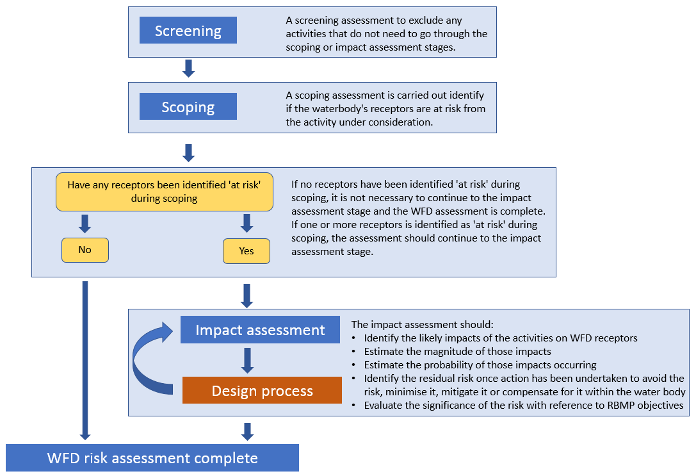
Figure 2-1: WFD assessment process flow chart
This report follows guidance on how to carry out a WFD assessment for estuarine and coastal waters from the GOV.UK website.

Screening Assessment
The Screening Assessment aims to exclude any activities that do not need to go through the scoping or impact assessment stages.
The Severn RBMP, the Environment Agency’s Catchment Data Explorer and the Natural Resources Wales’ Water Watch Wales website were used to determine which water bodies could be potentially affected by the proposed works. The names, ID numbers, designation, status classification and objectives for all relevant water bodies were obtained and downloaded from the Natural Resources Wales’ Water Watch Wales and the Environment Agency’s Catchment Data Explorer website.
The initial stage of the assessment screens the proposed works against the Ecological and Chemical Status objectives for the water bodies potentially affected by the works, together with their Quality Elements. The aim of this process is to determine whether the works could have an impact upon any of these criteria. Those criteria for which no potential adverse effects are identified are not considered further in the assessment. Any potential adverse effects are screened into the assessment and are carried forward to a detailed assessment.

Scoping Assessment
A detailed assessment is then undertaken to determine the effects that the proposed works could have upon those Quality Elements screened into the assessment. Any impacts identified are then considered in relation to the Ecological Status of the water body, which comprises biology, hydrology, hydromorphology and water chemistry, and the water body objectives.
The following assessment objectives are then used to determine whether the proposed works comply with the overarching objectives of the WFD. These objectives were therefore derived from the Environmental Objectives of the Directive (as listed in section 1.2).
- Objective 1: The proposed scheme does not cause deterioration in the Status of the Ecological Elements of the water body.
- Objective 2: The proposed scheme does not compromise the ability of the water body to achieve its WFD status objectives.
- Objective 3: The proposed scheme does not cause a permanent exclusion or compromised achievement of the WFD objectives in other bodies of water within the same RBD.
- Objective 4: The proposed scheme contributes to the delivery of the WFD objectives.
In order to establish whether the strategy complies with the WFD it is necessary to ascertain whether the preferred options have the potential to result in:
- Failure of a water body to achieve Good Ecological Status or Potential; or
- Failure to prevent a deterioration in the Ecological Status or Potential of a water body
If the answer to these questions is ‘no’ the strategy can be considered WFD compliant. If either of these failures is identified and if any receptors are identified as ‘at risk’, further assessment may be required to identify if the strategy meets all of the conditions set out by the WFD Legislation.

Impact Assessment
The third stage of the WFD Assessment, if determined as necessary from the Screening and Scoping Assessments, is to undertake an Impact Assessment to consider the impacts of the proposed scheme in more detail and recommend necessary mitigation measures. An impact assessment must be carried out for each receptor identified during scoping as being at risk from your activity.
The Impact Assessment describes how any identified impacts from the proposed scheme will be mitigated, to either avoid or minimise the impacts. The assessment shows how any impact on WFD receptor caused by the proposed activity fits with the objectives of any affected WFD water bodies. After the works have been amended to try and avoid, minimise, mitigate or compensate for the risks to WFD receptors the following questions will need to be answered:
- Could the activity still cause a water body to deteriorate from one WFD status class to another or cause significant localised impacts that could contribute to this happening?
- Could the activity prevent or undermine action to get water bodies to good status?
When these questions are answered, the following should be borne in mind:
- A water body deteriorates in status when one WFD receptor (an "element") is affected such that it drops from one WFD status class to another.
- A significant localised impact on an element is one that is either long-lasting; causes severe harm; or affects a wide area within a water body. These are likely to contribute to a water body dropping from one status to another and highly likely to prevent action to get water bodies to good status.
- The compliance assessment should consider the potential for deterioration in status of parameters at all classifications.
- If it cannot be demonstrated with a high level of confidence that the activity supports RBMP objectives, then in order for the Environment Agency to permit the activity it must be shown that the activity meets the criteria set out in Article 4(7) of the WFD. Article 4(7) sets out stringent environmental and socio-economic tests to assess if a scheme meets struct environmental and sustainability criteria.

Project Description

Project Overview
Cardiff Coastal Defence scheme is located on the eastern side of Cardiff City around the confluence of the River Rhymney with the Severn Estuary. The project area extends from Lamby Way bridge to the confluence, and then east and west along the coast from Dwr Cymru Welsh Water to the eastern extend of the Lamby Way landfill, see Figure 3-1.
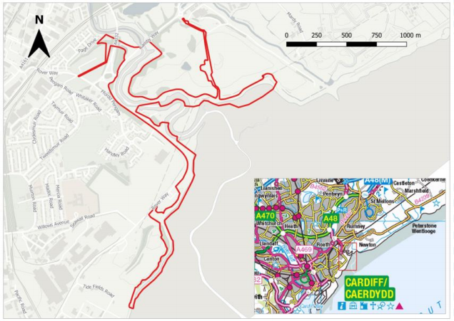
Figure 3-1: Site Location

Proposed Works
A detailed description of the design proposals for each section is provided below. Due to its large size, the scheme has been divided into sections (Figure 3-2). A high-level overview of the construction methodologies is included in Appendix A.1. For more detail, please refer to Section 2.5 of the Environmental Statement (JBA Consulting 2021).

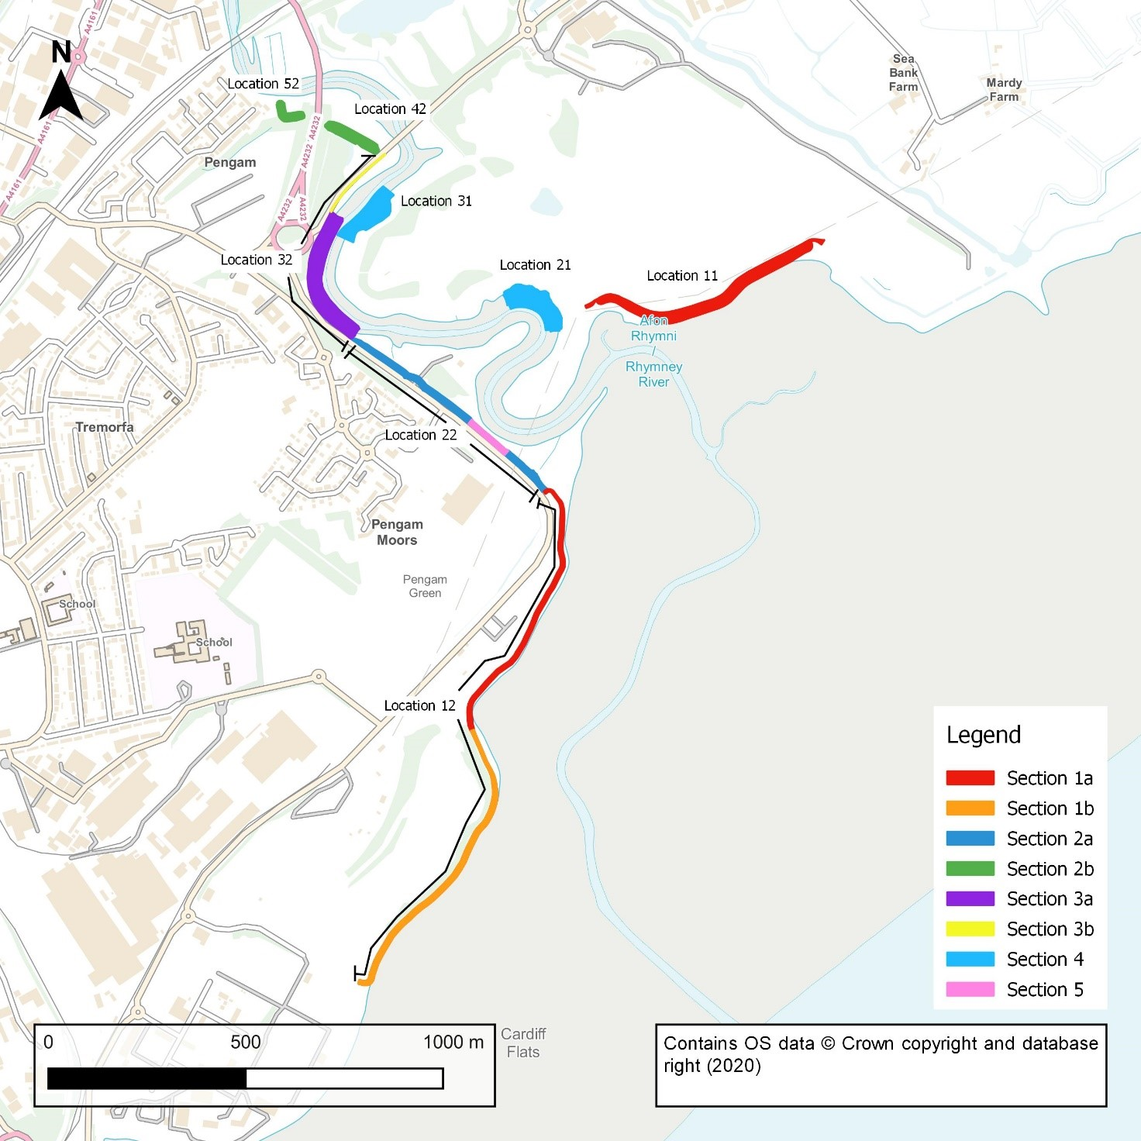
Figure 3-2: Overview of the proposed development sections

Description of the proposed development

A detailed description of the design proposals for each section is provided below. This is based upon the description provided in the environmental statement and further details can be found there.

Section 1a/Locations 11 & 12: Severn Estuary coastline east and west of the confluence with the Rhymney River
This section extends along much of the coastal reach of the Severn Estuary within the scheme area. The frontage includes the entire eastern coastal reach and approximately half the western reach. These areas are generally natural coastline, although there is a short length of existing defence. It includes the coastal frontage of the Lamby Way Landfill, which is at risk of erosion in the near future. Along both sections of estuary frontage are the remnants of historic flood defence structures, including sections of severely damaged gabion baskets adjacent to the Frag Tip and the remains of a rock armour revetment along much of the frontage next to the Lamby Way Landfill. The Wales Coast Path extends along this coastal section and is immediately adjacent to the foreshore for much of the extent. Land use in this area includes a Traveller’s static residential site.
The design cross-section includes a rock armour revetment on the foreshore area with an (imported) clay bund behind. To the east of the Rhymney, the bund is at approximately the same level of the existing ground, with rising levels behind. To the west of the Rhymney, the bund is at a higher level than existing, approximately 500mm above the rock crest. The bund will be covered in seeded topsoil and will double as pedestrian access.
To construct the rock revetment, earthworks will be required to shape formation level. As part of this, some granular fill material import will be required. Additionally, various geotextiles and a turf reinforcement mat are included in the structure build-up.
Section 1b/Location 12: Severn Estuary coastline west of the confluence with the Rhymney River
This section extends along the coastal reach of the Severn Estuary within the scheme area. The frontage is in front of the old frag tip on the western coastal reach. This area is generally a natural coastline, although there is exposed manmade materials on the shallow cliff behind the beach. This ground is being steadily eroded into the Severn estuary. Land use in this area includes a derelict area used as a dirt bike track but with planning approval for a biomass energy plant, and a main electricity sub-station. The DCWW Cardiff East Waste Water Treatment Works and Tremorfa Industrial Estate are located immediately west of this section.
The design cross-section includes a rock armour revetment set forward on the foreshore area with an (imported) fill material slope behind. The slope behind the new rock revetment slackens the existing slope and ties into existing ground levels with a termination detail. Earthworks will be required to construct both the rock armour and slope behind, requiring granular fill material import. Additionally, various geotextiles and a turf reinforcement mat are included in the structure build-up.
Section 2a/Location 22: Segment of the west bank of the Rhymney River from its confluence with the Severn Estuary northwards to the southern approach to the Rover Way/A4232/Lamby Way roundabout
This section generally comprises an existing earth bund that is located between Rover Way and the Rhymney River channel and extends northward to the Rover Way/A4232/Lamby Way roundabout. It includes a length of existing steel sheet piles and erosion protection measures in the riverbank on the riverside of the earth embankment, adjacent to the large meander. The embankment and sheet piles provide flood and erosion protection for Rover Way, which is immediately landward, as well as utilities (electricity and water) services, and serves as the primary flood defence for nearby residential areas in Pengam Green and Tremorfa. The Wales Coast Path is located on the crest of the existing embankment. The river channel in this area contains extensive areas of inter-tidal mudflat and saltmarsh habitat, which provide very important feeding and high-tide roosting habitat for SPA/Ramsar bird species. The large areas of saltmarsh adjacent to the large river meander in this area are particularly important as high-tide roosts for significant numbers of birds.
The proposed defence raises the existing bund (where present) to the required level, continuing the existing bund slope face adjacent to Rover Way up to the new crest level. The flood defence will be achieved using imported clay fill with a seeded topsoil finish. The crest of the embankment will provide pedestrian access alongside the Rhymney.
The frontage includes a double flood gate installed within a concrete housing structure to provide access to the Rhymney River Motor Boat Sail & Angling Club.
Section 2b/Locations 42 & 52: West bank of the Rhymney River from the Lamby Way road bridge, northwards to Page Drive
Section 2b extends along the west bank of the Rhymney River between Lamby Way road bridge and the southern boundary of Page Drive. The defence currently consists of two sections of earth embankment set back from the river bank, and in places, the embankment is lower than the 2117 200-year still water level.
The proposed defence raises the existing bund (where present) to the required level, generally following the centreline of the existing defence. The flood defence will be achieved using imported clay fill with a seeded topsoil finish.
Section 3a/Location 32: West bank of the Rhymney River, from the southern approach of Rover Way up to Rover Way/A4232/Lamby Way roundabout.
This section is generally a natural riverbank alongside the Rover Way and Lamby Way although there are some old sheet piles present. There are signs of active erosion, and the sheet piles are at the end of their service life. This erosion is threatening roundabout and adjacent sections of Rover Way and Lamby Way, which are critical transport routes connecting Cardiff city centre and eastern areas of the city.
The design proposes that concrete erosion protection mats are installed on the riverbank. The toe of these mats will be buried into the riverbed below the low water line and secured by backfilling with rock armour units. On the lower portion of the bank, the mats will be exposed on the surface of the bank as required to manage scour action. The design proposes that at a suitable level, the erosion mats cut back into the bank and continue up under a depth of natural mud material. The risk of erosion of this mud layer is reduced, but over the service life there is the possibility that the erosion protection beneath may become exposed. At the transition point between buried and exposed erosion mats, wooden stakes and brushwood is proposed to help retain mud and facilitate establishment of the mud layer.
At the top of the bank, a sheet piled flood defence is proposed completed with concrete capping beam. This will be provided to the flood defence level.
Section 3b/Location 32: West bank of the Rhymney River, from the Rover Way/A4232/Lamby Way roundabout, northwards to the Lamby Way road bridge
This section is generally a natural riverbank alongside Lamby Way and the Lamby Way road bridge. There are signs that this area is currently accreting and so no erosion protection is proposed. At the top of the bank, a sheet piled flood defence is proposed completed with concrete capping beam.
Section 4/Locations 21 & 31: Segments of the East bank of the River Rhymney at the Lamby Way road bridge and the large meander opposite the Rhymney River boat club
This section is generally a natural riverbank adjacent to the historic Lamby Way landfill. There are signs of active erosion, with a significant bank slip occurring directly opposite the roundabout. This slip was repaired by Cardiff Council in 2018 but was subject to further failure in February 2020.
The design proposes that concrete erosion protection mats are installed on the riverbank. The toe of these mats will be buried into the riverbed below the low water line and secured by backfilling with rock armour units. On the lower portion of the bank, the mats will be exposed on the surface of the bank as required to manage scour action. The design proposes that at a suitable level, the erosion mats cut back into the bank and continue up under a depth of natural mud material. The risk of erosion of this mud layer is reduced, but over the service life there is the possibility that the erosion protection beneath may become exposed. At the transition point between buried and exposed erosion mats, wooden stakes and brushwood is proposed to facilitate establishment of the mud layer.
Section 5/Location 22: Segment of the west bank of the Rhymney River at the meander adjacent to Rover Way.
This section comprises an existing earth bund that is located between Rover Way and the Rhymney River channel. The proposed defence is a steel sheet pile wall complete with concrete capping beam. The sheet pile provides more resilience to erosion than a flood embankment in this location due to the restricted space between the highway and river channel.

General construction points
- During construction, the materials will be delivered to the intertidal area via an access route on the embankment. No materials, including excavated sediment, will be stored on the foreshore.
- The rock revetment in Sections 1 and scour protection in sections 3 and 4 will be constructed from toe to crest in sections that can be completed during a single tidal period. Sediment within these short sub-sections is to be excavated, tested for contaminants and temporarily stored outside of the intertidal area before being reinstated on the defence.
- A geotextile membrane will underlie the rock armour and Dycel Blocks, which will reduce erosion at the toe and base of the revetment and prevent leaching of underlying substrate.
- All of the works will be conducted under dry conditions (i.e. when tide levels expose the work areas).

WFD Screening Assessment

Overview
This screening assessment aims to screen in any works that require WFD Assessment and to identify which WFD water bodies are within and near to the proposed works.
The results of the screening assessment are presented below. The baseline status of the Quality Elements within the water bodies screened into the assessment are discussed in this chapter. As discussed in the Introduction and Methodology, if this section finds there is potential for the proposed works to cause deterioration in the status of a water body, or prevent it from achieving its status objectives, the relevant water body and its Quality Elements should be taken forward and consider further in the Scoping Assessment chapter.

WFD water bodies
The following water bodies have been assessed against the proposed works to identify potential conflicts with the WFD, and to identify whether they should be screened in or out of this WFD compliance assessment.
The proposed works are along the shoreline of the Severn Estuary at the River Rhymney confluence and along the banks of the River Rhymney. Both of these are part of the Severn Lower transitional water body.
The proposed works location lies directly above the SE Valleys Southern Devonian Old Red Sandstone & Triassic Mercia Mudstone ground water body.
The proposed works location lies 0.5km downstream of the confluence with Roath Brook and 2.5km downstream of Rhymney R - conf Nant Cylla to Chapel Wood and 3.5km downstream of Nant Glandulas - source to conf Rhymney River.
Details of the classification, status and objectives for the water bodies identified above (as described by Water Watch Wales and the Environment Agency’s Catchment Data Explorer), are summarised in Table 4-1 below.
Table 4-1: Current WFD status
Water body ID | Name of water body | Hydromorphological designation | Current Overall Status/ Potential | Current Ecological Status/ Potential | Current Chemical Status | Overall Status Objective
GB530905415401 | Severn Lower | Heavily Modified Water Body | Moderate | Moderate | Fail | Good by 2021
GB40902G201500 | SE Valleys Southern Devonian Old Red Sandstone & Triassic Mercia Mudstone | N/A | Good | N/A | Good | Good by 2015
GB109057027150 | Roath Brook | Heavily Modified Water Body | Moderate | Moderate | Good | Good by 2027
GB109057027280 | Rhymney River - conf Nant Cylla to Chapel Wood | Not designated a Heavily Modified Water Body | Good | Good | Good | Good by 2015
GB109057027160 | Nant Glandulas - source to conf Rhymney River | Not designated a Heavily Modified Water Body | Moderate | Moderate | Good | Good by 2027

Screening Outcome: water bodies
The following table indicates which water bodies have been screened in or out of the assessment and the reasons for this decision.
Water body/ies | Reason | Screening outcome
Severn Lower | Works will be occurring immediately adjacent and within this water body. There is the possibility that the status of the Severn Estuary could be affected by the works or that the works could prevent it from achieving its status objectives. | Screened In
SE Valleys Southern Devonian Old Red Sandstone & Triassic Mercia Mudstone | Works are above this groundwater body and works involve penetrating the ground and inserting a less permeable layer between the groundwater body and transitional water body. | Screened In
Roath Brook | Works will be occurring 0.5km downstream of this water body. There is the possibility that migratory fish could be affected by the works. | Screened In
Rhymney River - conf Nant Cylla to Chapel Wood | Works will be occurring 2.5km downstream of this water body. There is the possibility that migratory fish could be affected by the works. | Screened In
Nant Glandulas - source to conf Rhymney River | Works will be occurring 3.5km downstream of this water body. There is the possibility that migratory fish could be affected by the works. | Screened In

Baseline Status of screened-in water bodies
For each water body screened into the assessment, details on the status of each element, as described by the Environment Agency’s Catchment Data Explorer and NRW’s Water Watch Wales, are given below.

Severn Lower Transitional Waterbody
The three tables below describe the current status of the Ecological and Chemical Elements according to the most recent WFD cycle.
Biological Quality Element | Current Status (2018) | Objective
Angiosperm | Moderate | Good
Seagrass | Good | Good
Saltmarsh | Moderate | Good
Phytoplankton | High | Good
Invertebrates | Good | Good
Fish | Good | Good
Imposex | High | Good

Hydromorphological Quality Element | Current Status | Objective
Flow | Pass | Good

Physico-Chemical Quality Element | Current Status | Objective
Dissolved Oxygen (DO) | High | Unknown
Dissolved Inorganic Nitrogen (DIN) | Good | Unknown

Chemical Quality Element | Current Status | Objective
Arsenic | High | Unknown
Copper | High | Unknown
Iron | High | Unknown
Zinc | High | Unknown
Chem PHZ | Moderate | Unknown
BDPECalc | Moderate | Unknown
Mercury and its compounds | Moderate | Unknown
Nonylphenol | High | Unknown
Benzo(a)pyrene | High | Unknown
Cadmium | High | Unknown
Hexachlorobutadiene | High | Unknown
Hexachlorobenzene | High | Unknown
Fluoranthene | High | Unknown
Lead | High | Unknown
Nickel | High | Unknown
Trichloromethane | High | Unknown

Roath Brook
The only data that is obtainable regarding the WFD elements of the Roath Brook was the Overall WFD Status which is has been classified as Moderate, the Chemical Status classified as Good and the Ecological Status classified as Moderate. However, given that impacts to the Roath Brook are limited to impacts on fish passage through the scheme area, it is considered that these impacts are assessed satisfactorily under the main water body in Section 6.

Rhymney River - conf Nant Cylla to Chapel Wood
The only data we were able to obtain regarding the WFD elements of the Rhymney River conf. Nant Cylla to Chapel Wood was the Overall WFD Status which is has been classified as Moderate, the Chemical Status classified as Fail and the Ecological Status classified as Good. However, given that impacts are limited to impacts on fish passage through the scheme area, it is considered that these impacts are assessed satisfactorily under the main water body in Section 6.

Nant Glandulas - source to conf Rhymney River
The only data we were able to obtain regarding the WFD elements of the Nant Glandulas was the Overall WFD Status which is has been classified as Moderate, the Chemical Status classified as Good and the Ecological Status classified as Moderate. However, given that impacts are limited to impacts on fish passage through the scheme area, it is considered that these impacts are assessed satisfactorily under the main water body in Section 6.

SE Valleys Southern Devonian Old Red Sandstone & Triassic Mercia Mudstone Groundwater body
The two tables below describe the current status of the Quantitative and Chemical Elements according to the most recent WFD cycle.
Quantitative Quality Element | Current Status (2015) | Objective
Overall | Good | Unknown
Quantitative status element | Good | Unknown
Quantitative surface water body status | Good | Unknown
GWDTEs test | Good | Unknown
Quantitative saline intrusion | Good | Unknown
Quantitative water balance | Good | Unknown

Chemical Quality Element | Current Status (2015) | Objective
Overall | Good | Unknown
Chemical status element | Good | Unknown
Chemical dependent surface water body status | Good | Unknown
Chemical drinking water protected area | Good | Unknown
GWDTEs test | Good | Unknown
Chemical saline intrusion | Good | Unknown
General chemical test | Good | Unknown

Protected Areas
The WFD specifies that areas requiring special protection under other retained EC Directive and waters used for the abstraction of drinking water are identified as protected areas. These areas have their own objectives and standards. Article 4 of the WFD requires Member States to achieve compliance with the standards and objectives set for each protected area by 22nd December 2015, unless otherwise specified in the legislation under which the protected area was established.
The water body is linked to the Severn Estuary SAC and SPA within the site boundary; therefore these protected sites will be screened into the scoping assessment.

Nitrate Vulnerable Zones (NVZ)
The retained European Commission Nitrates Directive requires areas of land that drain into waters polluted by nitrates to be designated as Nitrate Vulnerable Zones (NVZs). There are no NVZs within 2km of the proposed works location.

Drinking Water Groundwater Safeguard Zones (SgZ)
Drinking Water Protected Areas (DrWPA) are designated under the Water Framework Directive, with the aim of avoiding deterioration in their quality in order to reduce the level of purification treatment required in the production of drinking water. SgZs are areas where actions will be targeted to address the causes of DrWPA objective failure/risk of failure.
There are no SgZs within the vicinity of the proposed site.

Bathing Water Zones
There are no Bathing Water Zones within the vicinity of the proposed site.

Urban Waste Water Treatment Zones
Urban Waste Water Treatment Zones are bodies of water identified as sensitive areas under the urban waste water treatment regulations. There are no Urban Waste Water Treatment Zones in the vicinity of the proposed site.

Shellfish Water Protected Areas
Shellfish Water Protected Areas are areas designated for the protection of economically significant species. The protected areas were formerly designated under the repealed Shellfish Waters Directive which are now specified under the Water Framework Directive. There are no Shellfish Water Protected Areas within the vicinity of the proposed site.

Invasive Non-Native Species
There is a necessity to screen Invasive Non-Native Species (INNS) into the scoping stage if the activity could introduce or spread INNS to a water body. Therefore, INNS will be screened into the scoping assessment for this project.

Summary
To conclude the Screening Assessment, the following quality elements need to be considered further within the Scoping Assessment:
- Severn Lower Transitional Waterbody
  - Biological Elements
  - Hydromorphological Elements
  - Physico-chemical Elements
  - Chemical Elements
- Roath Brook
  - Biological Elements
- Rhymney River - conf Nant Cylla to Chapel Wood
  - Biological Elements
- Nant Glandulas - source to conf Rhymney River
  - Biological Elements
- SE Valleys Southern Devonian Old Red Sandstone & Triassic Mercia Mudstone Groundwater body
  - Quantitative Elements
  - Chemical Elements
- Protected areas: Severn Estuary SAC and SPA
- INNS.

WFD Scoping Assessment

Overview
This scoping assessment identifies whether the water body’s receptors, identified during the screening assessment, are at risk from the proposed works discussed in Chapter 3. This assessment is supported by the evidence in the Appendix. The proposed development works are being appraised in terms of their impact on WFD status and objectives. If any Quality Elements are found to be at risk of detrimental impact, further assessment and/ or mitigation may be required in the next chapter (as demonstrated by the final column).
Some WFD Quality Elements have not been formally assessed as part of the classification for this water body. However, due to the scale and nature of the proposed works, all WFD Quality Elements have been included in the previous screening and any identified impacts have been considered in relation to the ecological status of the water body and the status objectives.
Article 4.7 of the Directive defends deterioration in status or failure to meet WFD objectives resulting from new modifications or sustainable human development activities (if all conditions set out under this Article are met). If the assessment procedure predicts that an activity will cause deterioration in water body status or prevent a water body from meeting its ecological objectives, then an assessment is also required against the conditions listed in Article 4.7 of the WFD. If all the assessment conditions are met, there will not be a breach of the WFD and compliance will be attained.

Severn Lower Water Body

Biological Quality Assessment
Table 5-1 resents an assessment of the proposed works against the biological quality elements of the Severn Lower water body.
Table 5-1: Assessment of works against the biological elements
WFD Quality Element | Current Status | Potential Impact | Further assessment and/or mitigation required?
Angiosperm | Moderate | There is potential for impacts on angiosperms through physical removal and disturbance of existing intertidal habitat. | Yes
Seagrass | Good | N/A | N/A
Saltmarsh | Moderate | The scheme will directly impact 0.45 ha of saltmarsh and has the potential to further impact saltmarsh and intertidal mudflats in the Rhymney and the Severn through the provision of access tracks. | Yes
Phytoplankton | High | There is potential for impacts on phytoplankton through increased levels of suspended sediment during the works. | Yes
Invertebrates | Good | The intertidal mudflats in this area support a range of macroinvertebrate assemblages which provide a food source for a range of bird and fish species. Damage and disturbance to these habitats through the movement of vehicles and construction plant will result in the killing of any macroinvertebrates present. | Yes
Fish | Good | Works to sub-tidal areas have the potential for impact to fish species. There is also the potential risk of disturbance to migratory fish from working practices that will cause vibrations within the water column. | Yes
Imposex | High | The works will not result in the input of TBT into the waterbody. Therefore, no impacts on this WFD receptor are predicted resulting from the works. | No
Macrophytes and Phytobenthos Combined | Not Available | The works have the potential to directly impact macrophytes and phytobenthos, through physical removal and disturbance. | Yes

Hydromorphological Quality Elements
Table 5-2 presents an assessment of the proposed works against the hydromorphological quality elements of the Severn Lower water body.
Table 5-2: Assessment of works against the hydromorphological quality elements
WFD Quality Element | Current Status | Potential Impact | Further assessment and/or mitigation required?
Morphological conditions: Depth variation | Not assessed | Water depths will be reduced above the footprint of the proposed works below MHWS (i.e. rock armour in Section 1; Dycel Block scour protection in Sections 3 and 4). | Yes
Morphological conditions: Quantity, structure and substrate of the bed | Not assessed | The works on the Severn foreshore in Section 1 will change the structure and substrate of the bed, as will the works at the toe of the Dycel Block scour protection in Sections 3 and 4. | Yes
Morphological conditions: Structure of the intertidal zone | Not assessed | The works on the Severn foreshore in Section 1 will alter the structure of the intertidal zone, as will the Dycel Block scour protection on the river banks in Sections 3 and 4. | Yes
Tidal regime: Freshwater flow | Not assessed | The Dycel Block scour protection on the river banks in Sections 3 and 4 have the potential to impact on the dynamics of freshwater flow during higher flow events. | Yes
Tidal regime: Wave exposure | Not assessed | The works on the Severn foreshore in Section 1 have the potential to increase wave reflection in the intertidal zone. | Yes

Physico-Chemical Quality Assessment
Table 5-3 presents an assessment of the proposed works against the physico-chemical quality elements of the Severn Lower water body.
Table 5-3: Assessment of works against the physico-chemical quality elements
WFD Quality Element | Current Status | Potential Impact | Further assessment and/or mitigation required?
Transparency | Not assessed | During the works there is the potential for transparency levels to be affected locally in the short-term through sediment mobilisation. | Yes
Thermal conditions | Not assessed | No changes to thermal conditions are expected as a result of the works. Therefore, no impacts on this WFD receptor are predicted. | No
Salinity | Not assessed | No changes to salinity are expected as a result of the works. Therefore, no impacts on this WFD receptor are predicted. | No
Oxygenation conditions | Not assessed | During construction, dissolved oxygen levels could be affected locally in the short term through increased sedimentation. | Yes
Nutrient conditions | Not assessed | No inputs of nutrients are expected as a result of the works. Therefore, no impacts on this WFD receptor are predicted. | No

Chemical Quality Assessment
Table 5-3 presents an assessment of the proposed works against the Environmental Quality Standards (EQS) of the priority substances and other polluting chemicals of the Severn Lower water body.
Table 5-4: Assessment of the proposed works against the Environmental Quality Standards (EQS) of the priority substances and other polluting chemicals of the Severn Lower water body.
WFD Quality Element | Current Status | Potential Impact | Further assessment and/or mitigation required?
Pollution by all priority substances identified as being discharged into the body of water | Not assessed | During temporary works there is the potential for the release of contaminated sediments, if present, into suspension. | Yes
Pollution of other substances identified as being discharged in significant quantities into the body of water | Not assessed |  | Yes

SE Valleys Southern Devonian Old Red Sandstone & Triassic Mercia Mudstone Groundwater Body (GB40902G201500)

This section presents an assessment of the proposed works against the quality elements of the SE Valleys Southern Devonian Old Red Sandstone & Triassic Mercia Mudstone Groundwater Body.
Table 5-5: Quantitative and chemical quality elements
WFD Quality Element | Current Status | Potential Impact | Further assessment and/or mitigation required?
Quantitative and Chemical Quality Elements | Good for all | The proposed works are taking place above the groundwater body. Excavation into the channel bank and sheet piling will take place. The works will be undertaken predominantly in the river channel where the presence of Made Ground is not anticipated. On this basis no pollution pathway to the underlying aquifer will be formed by the works.  The proposed construction of the revetment and sheet piling in Sections 3 and 4 could reduce the permeability of the estuary banks; therefore, reducing lateral connectivity between the groundwater body and transitional water body. However, the proposed lengths of the revetments are small in relation to the large size of the water bodies. Therefore, the overall status of the groundwater body is unlikely to be compromised. | There are therefore no anticipated effects on the groundwater elements.

Impacts of works on protected sites
Table 5-6 presents an assessment of the proposed works against any protected sites identified in the Severn Lower water body.
Table 5-6: Assessment of works on protected sites
Name | Current status | Potential Impact | Further assessment and/or mitigation required?
Severn Estuary SAC | N/A | High | Yes
Severn Estuary SPA | N/A | Medium | Yes

Impacts of works on INNS
Japanese Knotweed is abundant along the roadsides of Lamby Way and Rover Way. It is anticipated that the risk of the spread of this species will be limited to any access tracks constructed along the western bank of the River Rhymney.

WFD Impact Assessment

Overview
The Scoping Assessment presented in Chapter 5 identified some receptors may potentially be at risk from the proposed works. An Impact Assessment is therefore required to describe how these identified impacts will be mitigated.
The Impact Assessment needs to consider if there is a pathway linking the pressure to the receptor. If there is no pathway there can be no impact on the receptor and there is no need for any further assessment of that receptor to be carried out. If there is a potential pathway the assessment should consider if the activity, and the pressure it creates, may cause deterioration of the receptor.

Impact Assessment
Table 6-1 discusses each of the receptors identified as being potentially at risk in the scoping assessment. Mitigation measures are recommended to mitigate the effects of the proposed works. It should be noted that these mitigation measures differ to the Mitigation Measures identified for any Heavily Modified water body.
Table 6-1: Impacts and mitigation measures
WFD Quality Element | Pathway (direct / indirect / none) | Potential Impact / Mitigation measures
Saltmarsh | Direct | Permanent Impact: The works will be directly taking 1.59 ha of saltmarsh due to the footprint of the scheme.  Mitigation: The Welsh Government habitat creation scheme will be responsible for habitat compensation for all intertidal habitats impacted by the scheme.  Temporary Impact: The scheme has the potential to further impact saltmarsh and intertidal mudflats in the Rhymey and the Severn through the provision of access tracks  Mitigation: Construction of the rock revetments to be completed by working from the toe inland, reducing the need for dump-trucks to drive along the foreshore.
Invertebrates | Direct and indirect | Permanent Impact: direct loss of saltmarsh and other invertebrate habitat due to the footprint of the scheme. Given the small-scale loss of this habitat it is not considered that impacts to invertebrate populations will be significant.  Mitigation: The Welsh Government habitat creation scheme will be responsible for habitat compensation for all intertidal habitats impacted by the scheme. Monitoring of the saltmarsh, including insect populations will be carried out as part of the scheme.  Temporary Impact: The works will require excavation of sediment which may result in the re-suspension of settled compounds that are hazardous to invertebrates. The excavation and deposition of sediment may also cause the water to become cloudy, which could impact invertebrates.  The works may also impact invertebrates through pollution events.  Mitigation: The rock armour in Section 1 and the Dycel Block revetment in Sections 3 and 4 will be constructed section by section, which will reduce the amount of sediment mobilised at one time. The excavated mud placed on top of the Dycel Block revetment will also be deposited in small amounts, section-by-section. Coir erosion matting is to be used to cover deposited sediment, to reduce sediment mobilisation during construction and operation. Large suspended sediment loads are present in the Severn Estuary; therefore, the small loads mobilised through construction are unlikely to cause significant impacts on invertebrates.  Appropriate mitigation measures will be implemented prior to the construction phase to ensure that the water quality is not adversely affected through pollution incidents and the release of contaminants from the site. This will be recorded in a detailed Construction Environmental Action Plan (CEMP) and agreed with the local authority and NRW prior to works taking place.  Pollution prevention measures will be required to be implemented throughout construction in order to prevent a pollution event (e.g. sediment release, fuel leaks etc.). Where possible, works should be conducted in the dry to avoid direct harm or indirect pollution impacts.
Fish | Indirect | Temporary Impact: The works could impact on fish migrating through this section of the river.  The works may impact fish through pollution events.  Mitigation: Piling works will be undertaken in the dry.  Vibration piling (using a variable moment vibrator and a ‘soft start’ approach) should be used wherever possible.  Percussion piling will only be used where vibration piling is not possible or has failed and will be in line with the following;  - where possible percussive piling works within 30m of HAT are conducted between October-March (inclusive).  - percussive piling works within 30m of HAT required between April-September can only be undertaken on the ebb tide between June-September inclusive to protect upstream migrating Atlantic salmon and sea trout.  - no percussive piling is conducted during April and May to protect upstream migrating shad from disturbance, this will also protect European eel glass eels, as well as downstream migrating Atlantic salmon and sea trout smolts.  Pollution prevention measures will be required to be implemented throughout construction in order to prevent a pollution event (e.g. sediment release, fuel leaks etc.). Works should be conducted in the dry to avoid direct harm or indirect pollution impacts.
Macrophytes and Phytobenthos Combined | Direct | Permanent Impact: direct loss of saltmarsh and other macrophyte and phytobenthos habitat due to the footprint of the scheme.  Mitigation: Only a small amount of scattered saltmarsh habitat (0.45ha) is to be directly lost to the footprint of the scheme. The Welsh Government habitat creation scheme will be responsible for habitat compensation for all intertidal habitats impacted by the scheme.
Phytoplankton | Indirect | Temporary Impact: The excavation of sediment could cause the water to become cloudy reducing the amount of light penetration affecting phytoplankton.  The works may impact the phytoplankton through pollution events.  Mitigation:  The rock armour in Section 1 and the Dycel Block revetment in Sections 3 and 4 will be constructed section by section, which will reduce the amount of sediment mobilised at one time. The excavated mud placed on top of the Dycel Block revetment will also be deposited in small amounts, section-by-section. Coir erosion matting is to be used to cover deposited sediment, to reduce sediment mobilisation during construction and operation. Large suspended sediment loads are present in the Severn Estuary; therefore, the small loads mobilised through construction are unlikely to cause significant impacts on phytoplankton.  Appropriate mitigation measures will be implemented prior to the construction phase to ensure that the water quality is not adversely affected through pollution incidents and the release of contaminants from the site. This will be recorded in a detailed Construction Environmental Action Plan (CEMP) and agreed with the local authority and NRW prior to works taking place.  Pollution prevention measures will be required to be implemented throughout construction in order to prevent a pollution event (e.g. sediment release, fuel leaks etc.).
Morphological conditions: Depth variation | Direct | Permanent Impact: The replacement of intertidal habitat with the proposed hard defences in Sections 1, 3 and 4 could reduce depth variation in the water body.  However, the proposed defence in Section 1 will not be inundated for the majority of each tidal cycle and the slope of the proposed revetment is not exceedingly steeper than the existing slope of coarse sediment, having been designed to dissipate wave energy to reduce the impact of scour at the toe. The overall tidal prism of the Severn Estuary has been calculated at approximately 96 x 108 m³ within the SMP (Atkins 2010); therefore, given that the footprint of the proposed defence is 33,727m², impacts on depth variation are anticipated to be negligible.  The proposed revetments in Sections 3 and 4 mimic the existing gradient of the banks and are a lower gradient in many locations. This, alongside the green-grey engineered design of the upper section of the defence reduces impacts on depth variation within the intertidal zone.
Morphological conditions: Quantity, structure and substrate of the bed | Direct & Indirect | Permanent impact: The footprint of the revetment in Section 1 extends onto the foreshore. However, the area is largely composed of existing placed rock and rubble from the eroding border of the reclaimed land. This is not considered to be a natural structure or substrate of the bed and the slope of the proposed revetment is not exceedingly steeper than the existing slope of coarse sediment. As the reclaimed land is made ground, consisting of significant amounts of coarse landfill and spoil material, it is not contributing a significant amount of fine sediment into the system. Therefore, impacts on the quantity, structure and substrate of the bed are deemed to be negligible.  The proposed revetment at Sections 3 and 4 will replace the existing mudflat and saltmarsh habitat on the foreshore, between below MLW and HAT. Therefore, the river bed will be impacted by the installation of the toe of the revetment. However, this represents a very small area in relation to the overall dimensions of the channel bed and there are not anticipated to be any significant changes to the quantity, structure and substrate of the bed.
Morphological conditions: Structure of the intertidal zone | Direct & Indirect | Permanent impact: The footprint of the revetment in Section 1 extends onto the foreshore. However, the area is largely composed of a steep bank of existing placed rock and rubble from the eroding border of the reclaimed land. This is not considered to be the natural structure of the intertidal zone and is already an artificially higher energy zone than it naturally should be. Therefore, impacts on the structure of the intertidal zone are not deemed significant.  The revetment in Sections 3 and 4 will replace soft, dissipative mud and saltmarsh vegetation with hard materials, which could increase the reflection of tidal currents back into the channel, onto other areas of intertidal habitat, or onto the opposite bank. However, the proposed revetment mimics the existing gradient of the banks and is a lower gradient in many locations. The strategic placing of timber stakes and brushwood packing in combination with coir matting between MHWN and HAT will roughen the surface and reduce local velocities, which are more likely to encourage sediment and seed deposition. These measures aim to create a more natural, vegetated, dissipative surface in comparison with a vertical, hard surface.
Tidal regime: Freshwater flow | Indirect | Permanent impact: In Section 3 and 4, the revetment will replace soft, dissipative mud and saltmarsh vegetation with hard materials, which could increase the reflection of freshwater flows back into the channel during extreme flow events. However, in Section 3, the proposed defence is unlikely to impact the dominant flow direction, as currents are already rebounding off the steepening bank and sheet piles are already in place in the bank at section 3a, which appear to be contributing to slight narrowing of the intertidal zone on the inside as well as the outside of the meander, possibly due to current reflection on the ebb tide. The new, gentle gradient of the slope and natural design of the upper half of the proposed defence will greatly reduce the risk of the reflection of flows.  Similarly, opposite the sailing club, currents are already rebounding off the narrow, oversteepening bank towards the reinforced bank on the opposite side. The location of the proposed upstream revetment within section 4 is already erosional and oversteepened, highly impacted by the direction of the dominant flow path. The new, gentle gradient of the slope and natural design of the upper half of the proposed defence will greatly reduce the risk of current reflection during extreme freshwater flow events.
Tidal regime: Wave exposure | Indirect | Permanent impact: The installation of a hard defence in Section 1 could increase wave reflection during storm events. However, the proposed defence will not be inundated for the majority of each tidal cycle and the slope of the proposed revetment is not exceedingly steeper than the existing slope of coarse sediment, having been designed to dissipate wave energy to reduce the impact of scour at the toe, which will reduce rapid erosion of the intertidal flat. Any impacts are anticipated to be small-scale and localised.  The historic replacement of fringing saltmarsh with a steep, coarse beach generated from the backing reclaimed land has already increased wave energy at the coastal boundary and is likely to be contributing to the erosion and progressive lowering of the neighbouring mudflat habitat; therefore it is likely that the mudflat is already in the process of adjusting its morphology to artificially higher energy conditions within the area.
Transparency  Oxygenation conditions | Indirect | Temporary impact: The mobilisation of sediment during construction could impact transparency and oxygenation conditions at a local scale.  Mitigation: The rock armour in Section 1 and the Dycel Block revetment in Sections 3 and 4 will be constructed section by section, which will reduce the amount of sediment mobilised at one time. The excavated mud placed on top of the Dycel Block revetment will also be deposited in small amounts, section-by-section. Coir erosion matting is to be used to cover deposited sediment, to reduce sediment mobilisation during construction and operation. As much work as possible will be non-tidal (i.e. undertaken above MHWS or during periods that allow for dry working), and all intertidal works should cease three hours prior to the anticipated high tide time. Large suspended sediment loads are present in the Severn Estuary; therefore, the small loads mobilised through construction are unlikely to cause significant impacts on transparency and oxygenation conditions.
Pollution by all priority substances identified as being discharged into the body of water  Pollution of other substances identified as being discharged in significant quantities into the body of water | Indirect | Temporary impact: Excavation and piling could release small amounts of contaminants into the water body. However, the works will be undertaken predominantly in the river channel where the presence of Made Ground is not anticipated. The works will be undertaken in small sections, to be completed within a single tidal cycle. Any impact is likely to be small-scale and temporary relative to the size and dispersive nature of the water body.  Mitigation:  Appropriate mitigation measures will be implemented prior to the construction phase to ensure that the water quality is not adversely affected through pollution incidents and the release of contaminants from the site. This will be recorded in a detailed Construction Environmental Action Plan (CEMP) and agreed with the local authority and NRW prior to works taking place.  Pollution prevention measures will be required to be implemented throughout construction in order to prevent a pollution event (e.g. sediment release, fuel leaks etc.).

Protected areas
An appropriate assessment has been undertaken regarding the Severn Estuary European Marine Site. This includes mitigation and compensation measures to avoid significant impacts upon the site.

INNS
The scheme will be required to develop an INNS method statement in order to avoid the spread of Japanese Knotweed and marine INNS

Water body Mitigation Measures
There are 19 mitigation measures contributing to better ecological potential for the water body identified in the Natural Resources Wales’ Water Watch Wales website. The ability of the proposed works to deliver these mitigation measures, or the risk that the works could prevent their implementation, is considered further in the table below.
Table 6-2: Assessment of proposed works against the water body’s mitigation measures
Mitigation Measure | Current Status | Will the proposed works contribute towards the implementation of the mitigation measure
48. Indirect mitigation (Habitat creation) | Not currently applicable – not required in this water body | N/A
21. Avoid the need to dredge (Operations and maintenance) | Not currently applicable – not required in this water body | N/A
22. Dredging disposal strategy (Operations and maintenance) | Not currently applicable – not required in this water body | N/A
23. Reduce impact of dredging (Operations and maintenance) | Not currently applicable – not required in this water body | N/A
24. Reduce sediment resuspension (Operations and maintenance) | Not currently applicable – not required in this water body | N/A
25. Retime dredging or disposal (Operations and maintenance) | Not currently applicable – not required in this water body | N/A
26. Sediment management (Operations and maintenance) | Not currently applicable – not required in this water body | N/A
27. Dredge disposal site selection (Operations and maintenance) | Not currently applicable – not required in this water body | N/A
28. Manage disturbance (Operations and maintenance) | Not currently applicable – not required in this water body | N/A
37. Retain habitats (Operations and maintenance) | Not in place – not yet identified | No. The scheme will involve the direct loss of 1.59ha of saltmarsh habitat. However, alignment of the scheme has been designed to minimise habitat removal and fragmentation. The designs of the revetments on the Severn foreshore and on the Rhymney incorporate habitat enhancement features. The Welsh Government habitat creation scheme will be responsible for habitat compensation for all intertidal habitats impacted by the scheme.
16. Fish passes (Structural modification) | Not currently applicable – not required in this water body | N/A
19. Enhance ecology (Structural modification) | Not in place – not yet identified | N/A
20. Changes to locks etc. (Structural modification) | Not in place – not yet identified | N/A
13. Realign flood defence (Working with physical form and function) | Not in place – not yet identified | No – the scheme will not realign the flood defence, but does not reduce the possibility of doing so in future.
2. Remove obsolete structure (Working with physical form and function) | Not in place – not yet identified | Yes. The scheme will be replacing the old coastal defences with new ones.
4. Remove or soften hard bank (Working with physical form and function) | Not in place – not yet identified | No. The scheme will reharden the bank but will implement softer engineering on the upper banks.
5. Preserve or restore habitats (Working with physical form and function) | Not in place – not yet identified | Yes. The designs of the revetments on the Severn foreshore and on the Rhymney incorporate habitat enhancement features.
6. In-channel morph diversity (Working with physical form and function) | Not currently applicable – not required in this water body | N/A
7. Bank rehabilitation (Working with physical form and function) | Not currently applicable – not required in this water body | N/A

WFD Assessment Objectives
Following consideration of the potential impacts and recommended mitigation measures, as well as the appraised Mitigation Measures for the water body, Table 6-3 assesses whether the proposed works comply with the overarching objectives of the WFD.
Table 6-3: Assessment of proposed works against WFD objectives
WFD Assessment Objectives | Assessment of works
Objective 1: The proposed works do not cause deterioration in the Status of the Ecological Elements of the water body | The proposed works have the potential not to cause deterioration in the Status of the Ecological Elements of the water body providing that the detailed mitigation measures are adhered to.  Part of the works will ensure that the Lamby Way Tip does not leach into the waterbody, protecting the ecological elements of the waterbody.
Objective 2: The proposed works do not compromise the ability of the water body to achieve its WFD status objectives | The proposed works have the potential not to compromise the ability of the water body to achieve its WFD status objectives, providing that the detailed mitigation measures and compensation measures are adhered to. The novel soft engineering approach will need to be monitored to ensure its success.
Objective 3: The proposed works do not cause a permanent exclusion or compromised achievement of the WFD objectives in other bodies of water within the same RBD | The proposed works do not cause a permanent exclusion or compromised achievement of the WFD objectives in other bodies of water within the same RBD.
Objective 4: The proposed works contribute to the delivery of the WFD objectives | The works have the potential to contribute to the delivery of the WFD objectives, by mitigating the effects of floods while helping improve the status of the designated areas and therefore improve the status of the water body.  Part of the works will ensure that the Lamby Way Tip does not leach into the waterbody, protecting the ecological elements of the waterbody.

Discussion and Conclusions

Assessment Summary
A summary of the impact assessment is detailed below.

Biological Assessment
The aim of the scheme is to provide flood and erosion protection from the Severn Estuary and River Rhymney to a number of residential, business, and industrial properties and key transport links.
The scheme will directly impact 3.37 ha of intertidal habitat within the SAC, 1.13 ha of which is considered to qualify as annex 1 habitat. However, there is the potential for impacts to intertidal habitats outside of this area through plant movement and site compounds. The scheme will not impact subtidal habitats.
Maintaining the existing alignment of the coastline through the provision of new hard defences has the potential to cause coastal squeeze. By renewing the defence in this area, it can be considered that a 'hold the line' approach is being taken. As sea levels rise intertidal habitats 'migrate' landwards, there is the potential that this will lead to intertidal habitats being 'squeezed' against the hard defence and eventually lost.
To further reduce the impact of the scheme a ‘soft’ engineering design has been utilised to allow the placement of intertidal mud back on top of the flood defences. In order to facilitate the accretion of mud, brushwood will be utilised at regular intervals as detailed in the previous chapter. There will therefore be a period when the mudflat will not function as a fully coherent habitat, and it is uncertain whether this will impact the potential for benthic invertebrates to colonise.
Further riverine habitats adjacent to the Rhymney will be subject to temporary disturbance throughout the construction of the scheme consisting of areas of saltmarsh, reedbeds, dense scrub and semi-improved grassland.
The works will not have long-term impacts on fish, macrophytes and phytobenthos if appropriate pollution prevention measures are in place throughout construction.
Piling operations associated with the works have the potential to elicit behavioural impacts on migrating fish species of importance passing through the area.
All Piling works will be undertaken in the dry above HAT. Vibration piling (using a variable moment vibrator and a ‘soft start’ approach) will be used wherever possible. It is proposed that this will be the preferred method of piling and percussive piling will only be used where this method has failed.
Percussive piling works within 30m of the HAT during the migration period will only be undertaken during the falling tide of the river (high tide plus one hour and low tide minus one hour). Should percussive piling be required during the migration period outside the time constraint identified, it will be necessary to agree mitigation measures with NRW prior to any such works taking place.
With these measures in place the works will not have a significant impact upon fish features of the rivers

Hydromorphological Assessment
The proposed works are not anticipated to significantly impact upon the hydromorphological elements of the water body. Measures incorporated into the design and construction process will reduce the impacts on hydrodynamics and sediment mobilisation. Replacing the cliffed intertidal bank in Sections 3 and 4 with a gentle gradient from below MLW to HAT and the incorporation of bioengineering in the top section of the design provides good potential for improved sediment deposition rates and a smooth transition from mudflat into saltmarsh above MHWN.
Potential coastal process impacts would be mitigated through the adoption of good construction practices. As much work as possible will be non-tidal (i.e. undertaken above MHWS or during periods that allow for dry working), and all intertidal works should cease three hours prior to the anticipated high tide time. These practices will eliminate the potential for excavation operations introducing sediment into the water column.

Physico-chemical Assessment
The proposed works are not anticipated to significantly impact upon the physico-chemical elements of the water body. Undertaking the works in small sections, where possible in a dry channel, along with strict pollution prevention measures will ensure there is no adverse impact upon the physic-chemical elements of the water body.

Chemical Assessment
The proposed works are not anticipated to significantly impact upon the chemical status of the water body. The works will be undertaken in small sections, on the river bank rather than directly within the adjacent Made Ground. Strict pollution prevention measures will ensure that any impact is likely to be small-scale and temporary relative to the size and dispersive nature of the water body

Protected sites
The HRA that has been carried out with regard to the impacts on the scheme has recorded a result of no likely significant impact if the mitigation measures described are carried out.

Scheme Recommendations/Key Considerations
The impact assessment determines whether the proposed works have the potential to significantly impact any of the quality elements screened into the assessment. Any mitigation measures that need to be considered to make the works compliant with the WFD are presented in Table 6-1; however, the critical ones are listed below:
- Pollution prevention: appropriate pollution prevention measures will need to be implemented during the construction phase in line with relevant guidance. This should include appropriate sediment control procedures.
- Habitat compensation and enhancement: compensation and enhancement of saltmarshes are required to mitigate the loss of habitat and the effect of this loss on invertebrates, and macrophytes and phytobenthos due to the scheme.

Conclusions
This Outline WFD Assessment has been prepared to assess the impacts of the construction of Cardiff coastal flood defences. Provided the mitigation measures recommended in this report are adhered to, it is considered that the proposed works would be compliant with WFD Objectives.

Appendices

High level construction methodology
The following section provides a high-level construction methodology.
Location 11
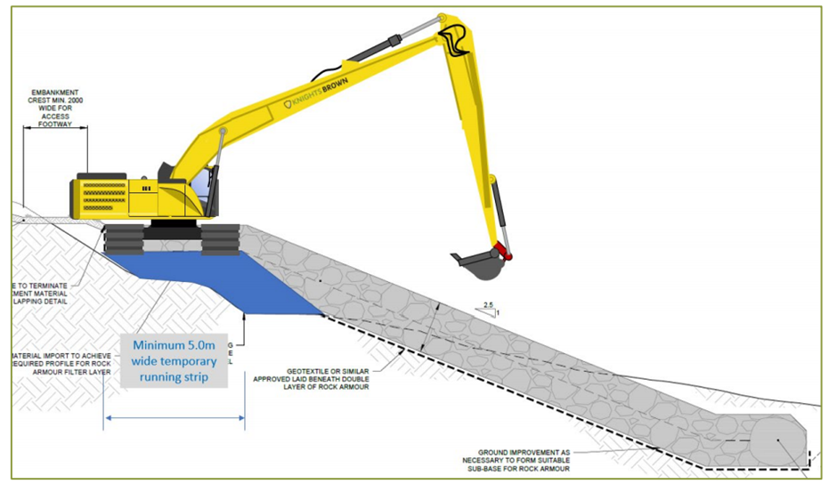
Figure A1: Construction methodology for location 11
The proposed construction sequence would mirror that for section 1a (western extent) and section 1b above as follows:
1. Stockpile rock armour
2. Carry out initial excavation to form the crest
3. Install geotextile and sufficient depth of stone along the length of the crest to provide a running surface / access track for plant.
4. This will be constructed in line with permanent construction specification, but used as temporary access platform.
5. Most imported stone will be reused within the permanent works.
6. Construct embankment using long reach excavator situated on crest.
7. Complete crest construction
8. Install / tie in topsoil

Location 12
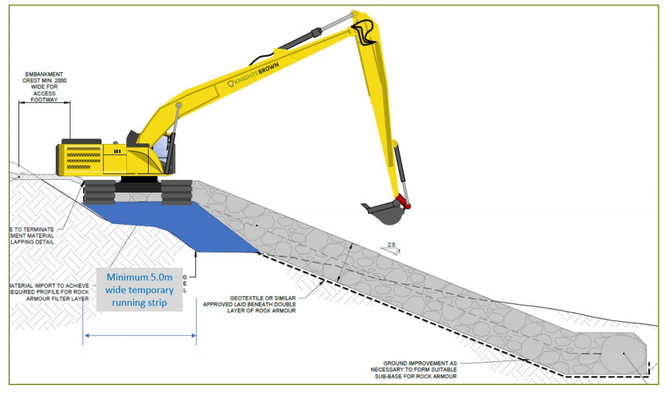
Figure A2: Construction methodology for location 12
Significant pre-construction works may be required in these locations. Stabilisation of the cliff line along the old frag tip may be required prior to the main works in order to allow plant movement. The basic sequence of works will be to install a temporary access track into the works up to approximate midpoint between access points and then to construct the permanent works on the way out.
The proposed construction sequence would be:
1. Stockpile rock armour
2. Carry out initial excavation to form the crest
3. Install geotextile and sufficient depth of stone along the length crest to provide a running surface / access track for plant movement. This will be constructed in line with permanent construction specification, but used as temporary access platform. Therefore most of the temporary imported stone will be reused within the permanent works.
6. Construct embankment using long reach excavator situated on crest.
7. Complete crest construction
8. Install embankment fill / topsoil.
Page Break

Locations 21 & 31
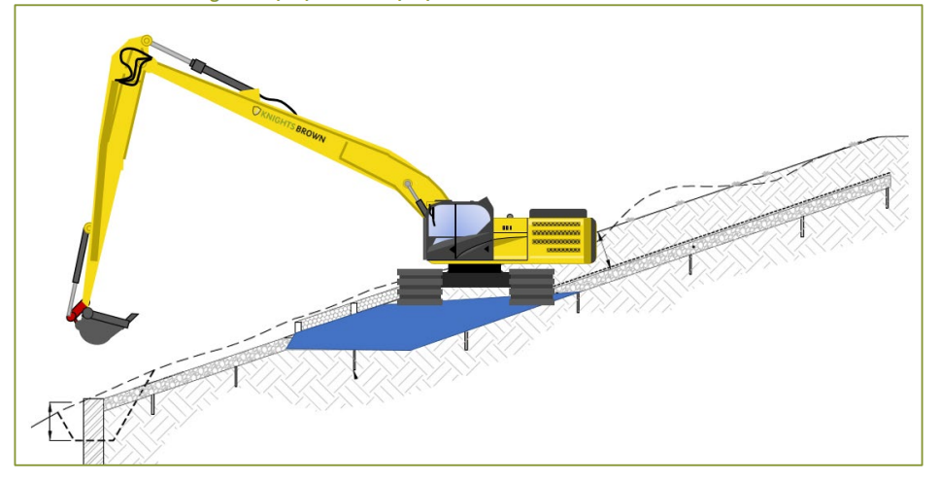
Figure A3: Construction methodology for locations 21 and 31
The high-level construction sequence would be as follows, this applies equally to both Locations 21 and 31 (note sketch above shows pile and trench option for securing the toe of the scour protection – a trench filled with rock armour is proposed):
1. Carry out initial excavation to provide access to mid platform level
2. Install geotextile and sufficient temporary stone along the width of this section to provide a running surface / access track for plant movement
3. Install scour protection from line of piles to mid-level platform.
4. Complete installation of scour protection. This will involve creating a trench which buries the toe of the scour protection. Ideally bulk bags will be utilised as a dewatering method, however this would be dependant on gaining access from the land side. Alternatively, working from the water may be required.
5. Construct embankment fill in over scour protection.
6. Install timber stakes and brushwood on upper slope.

Location 22
The high-level construction sequence would be:
1. Carry out initial excavation to form benches
2. Install geotextile and sufficient depth of stone along the width of the embankment to provide a running surface / access track for plant movement. This would be carried out using the absolute minimum thickness of stone to provide a stable running surface, and that it could remain in place permanently, with cohesive material placed on top. Alternatively, the stone could be removed on the way out and replaced with the cohesive material.
3. Construct embankment fill in layers.
4. Complete topsoil

Location 32
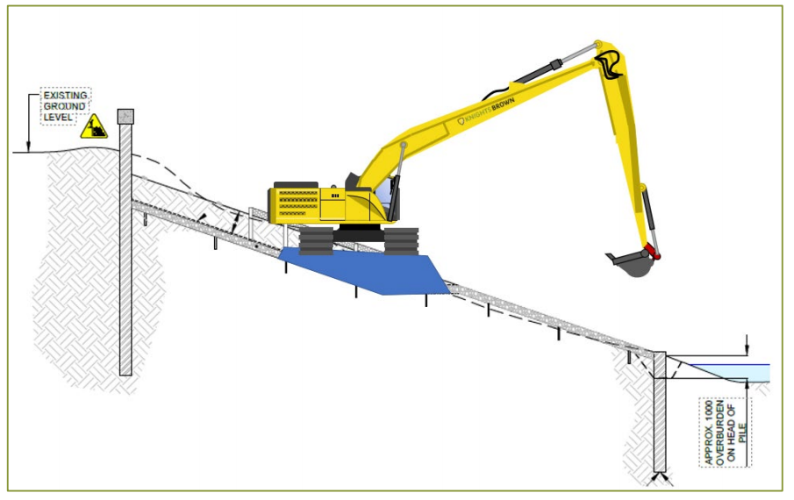
Figure A4: Construction methodology for location 32 (note toe piles no longer proposed within the channel, replaced by a rock trench)
The high-level construction sequence would be:
1. Carry out initial excavation to provide access to mid platform level
2. Install geotextile and sufficient temporary stone along the width of this section to provide a running surface / access track for plant movement
3. Install sheet piles along line of top of embankment – adjacent to highway
4. Complete excavation and Install scour protection from line of piles to mid-level platform.
5. Complete installation of scour protection. This will involve creating a trench which buries the toe of the scour protection. Working from the water may be required.
6. Replace mud material fill over scour protection.
7. Install timber stakes and brushwood.

Locations 42 & 52
Works to these areas are likely to be carried out concurrently since a single point of access off Lamby Way is proposed. The permanent works of Location 42 would provide access to Location 52.
Complete work at Location 52 and then complete the works working back towards Lamby Way.
1. Location 42 - Carry out initial excavation to form benches
2. Install geotextile and sufficient depth of stone along the width of the embankment to provide a running surface / access track for plant movement. This would be carried out using the absolute minimum thickness of stone to provide a stable running surface, and that it could remain in place permanently, with cohesive material placed on top. Alternatively, the stone could be removed on the way out and replaced with the cohesive material.
3. This will be required to provide access through Location 42 towards Location 52. In addition, we will extend the temporary access underneath the A4232 to Location 52.
4. Location 52 - Carry out initial excavation to provide access
5. Install geotextile and sufficient temporary stone along the width of this section to provide a running surface / piling platform.
6. Install sheet piles along line of top of embankment
7. Complete excavation and install scour protection.
8. Install timber stakes and brushwood
9. Location 52 / 42 - Construct embankment fill in layers.
10. Complete topsoil

Offices at
Coleshill
Doncaster
Dublin
Edinburgh
Exeter
Glasgow
Haywards Heath
Isle of Man
Limerick
Newcastle upon Tyne
Newport
Peterborough
Saltaire
Skipton
Tadcaster
Thirsk
Wallingford
Warrington

Registered Office
South Barn
Broughton Hall
SKIPTON
North Yorkshire
BD23 3AE
United Kingdom

+44(0)1756 799919
info@jbaconsulting.com

www.jbaconsulting.com
Follow us:

Jeremy Benn Associates Limited

Registered in England 3246693

JBA Group Ltd is certified to:
ISO 9001:2015
ISO 14001:2015
OHSAS 18001:2007

Environment Agency (2010) Assessing new modifications for compliance with WFD: detailed supplementary guidance: 488_10_SD01
https://www.gov.uk/guidance/water-framework-directive-assessment-estuarine-and-coastal-waters#scoping-identify-risks-to-receptors

