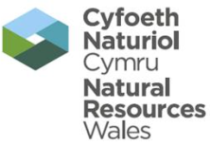 | EPR Compliance Assessment Report |  |  |  |  |  | Report ID: YP3992EN/151120
This form will report compliance with your permit as determined by an NRW officer
Site | Heads Of The Valley Salvage Limited |  |  |  |  | Permit Ref |  |  | EPR/YP3992EN
Operator/ Permit holder | Heads Of The Valley Salvage Limited
Date | 20/11/2015 |  |  |  |  | Time in |  |  | 14:00 |  |  | Out | 15:00
What parts of the permit were assessed | All
Assessment | Site inspection | EPR Activity: | Installation |  |  |  | Waste Op | X |  | Water Discharge
Recipient’s name/position | Mr Colin Williams
Officer’s name | Laoni Tye and Adam Ward |  |  |  | Date issued |  |  |  |  |  | 26/11/15

Section 1 - Compliance Assessment Summary
This is based on the requirements of the permit under the Environmental Permitting Regulations. A detailed explanation and any action you may need to take are given in the “Detailed Assessment of Compliance” (section 3). This summary details where we believe any non-compliance with the permit has occurred, the relevant condition and how the non-compliance has been categorised using our Compliance Classification Scheme (CCS). CCS scores can be consolidated or suspended, where appropriate, to reflect the impact of some non-compliances more accurately. For more details of our CCS scheme, contact your local office.
Permit Conditions and Compliance Summary |  |  |  |  |  | Condition(s) breached
a) Permitted activities | 1. Specified by permit |  | N
b) Infrastructure | 1. Engineering for prevention & control of pollution |  | *C3 |  |  | 2.4.1
b) Infrastructure | 2. Closure & decommissioning |  | N
b) Infrastructure | 3. Site drainage engineering (clean & foul) |  | *C3 |  |  | 3.1.1
b) Infrastructure | 4. Containment of stored materials |  | N
b) Infrastructure | 5. Plant and equipment |  | N
c) General management | 1. Staff competency/ training |  | N
c) General management | 2. Management system & operating procedures |  | *C3 |  |  | 1.1.1 and 2.4.1
c) General management | 3. Materials acceptance |  | *C3 |  |  | 2.2
c) General management | 4. Storage handling, labelling, segregation |  | C3 |  |  | 3.1.1
d) Incident management | 1. Site security |  | N
d) Incident management | 2. Accident, emergency & incident planning |  | N
e) Emissions | 1. Air |  | N
e) Emissions | 2. Land & Groundwater |  | N
e) Emissions | 3. Surface water |  | N
e) Emissions | 4. Sewer |  | N
e) Emissions | 5. Waste |  | N
f) Amenity | 1. Odour |  | N
f) Amenity | 2. Noise |  | N
f) Amenity | 3. Dust/fibres/particulates |  | N
f) Amenity | 4. Pests, birds & scavengers |  | N
f) Amenity | 5. Deposits on road |  | N
g) Monitoring and records, maintenance and reporting | 1. Monitoring of emissions & environment |  | N
g) Monitoring and records, maintenance and reporting | 2. Records of activity, site diary, journal & events |  | N
g) Monitoring and records, maintenance and reporting | 3. Maintenance records |  | N
g) Monitoring and records, maintenance and reporting | 4. Reporting & notification |  | N
h) Resource efficiency | 1. Efficient use of raw materials |  | N
h) Resource efficiency | 2. Energy |  | N
KEY: C1, C2, C3, C4 = CCS breach category ( * suspended scores are marked with an asterisk),
A = Assessed (no evidence of non-compliance), N = Not assessed, NA = Not Applicable
Number of breaches recorded |  | 5 |  | Total compliance score  (see section 5 for scoring scheme) |  |  | 4

If the Total No Breaches is greater than zero, then please see Section 3 for details of our proposed enforcement response

Section 2 – Compliance Assessment Report Detail
This section contains a report of our findings and will usually include information on:
- the part(s) of the permit that were assessed (e.g. maintenance, training, combustion plant, etc)  - where the type of assessment was ‘Data Review’ details of the report/results triggering the assessment  - any non-compliances identified  - any non-compliances with directly applicable legislation  - details of any multiple non-compliances | - information on the compliance score accrued inc. details of suspended or consolidated scores.  - details of advice given  - any other areas of concern  - all actions requested  - any examples of good practice.  - a reference to photos taken
This report should be clear, comprehensive, unambiguous and completed within 5 days of an assessment.

Environment officers Laoni Tye and Adam Ward visited site on the 20th November 2015 to conduct an inspection and site handover to the new regulatory officer. The weather was cold and dry at the time of the visit but it had previously been raining heavily. Please use the following contact details going forward:

Laoni.tye@naturalresourceswales.gov.uk
03000 65 4492

Breaches recorded
During the visit a number of compliance breaches were recorded as follows.

B1 Infrastructure – Engineering for prevention and control of emissions. *Category 3 breach.
Permit condition 2.4.1 States that the storage and treatment of waste motor vehicles shall meet the requirements of article 6 (1) of the End of Life Vehicles Directive. The drainage system on site is not a sealed system, which is a requirement of the standard rules permit. The system either needs to be a sealed sump with effluent tankered away, discharged to foul sewer or alternatively the permit will need to be varied to allow this activity.

Action: Please see the site improvement plan.
B3 infrastructure – Site drainage (Clean and foul). *Category 3 breach.
Condition 3.1.1 states that emissions not controlled by emissions limits (excluding odour) shall not cause pollution. During the visit we saw that there was waste oil in various areas across the site which included unmade ground. Oil could be seen in the ditch/stream after the oil interceptor which is not permitted.

Action: Conduct regular visual inspections of the interceptor and surface water outlet to ensure no oil is entering surface waters or ground waters. Ensure the interceptor is maintained on a regular basis by an approved contractor. Records of the maintenance need to be kept for your own reference and to be shown to NRW on request. If problems persist you may need to upgrade the interceptor. This is essential in order to minimise the risk of pollution to the environment and MUST happen with immediate effect.

We have enclosed the Environment Agencies guidance PPG3: Use and design of oil interceptors.

C2 Management – Management systems and operating procedures. *Category 3 breach.
Condition 1.1.1 states that the operator shall manage the activities in accordance with a written management system that identifies and minimises risks of pollution. There is no Environment management system (EMS) in place which is a fundamental breach of the permit conditions and a number of non-compliances can be attributed to the lack of an EMS. The breach may escalate if this problem persists.

Action: A comprehensive EMS must be developed which identifies how each operation and risk associated with that operation is managed on site. This must be implemented by the 4th January 2015 as written in your site improvement plan.

Please see the Environment Agencies guide on how to comply with your environmental permit which gives detailed information on what needs to be included in your EMS:

https://www.gov.uk/government/uploads/system/uploads/attachment_data/file/298102/LIT_7123_79744e.pdf

Permit condition 2.4.1 States that the storage and treatment of waste motor vehicles shall meet the requirements of article 6 (1) of the End of Life Vehicles Directive. You are currently storing engines that have not been fully de-polluted and drained of their hazardous liquids which is causing emissions to land and water. The root cause of this will be due to the lack of procedures in place and a comprehensive EMS.

Action: Ensure all vehicles are fully de-polluted in line with the ELV Directive with immediate effect.

C3 Management – Waste Acceptance. *Category 3 breach.
Condition 2.2 specifies that waste shall only be accepted if it is of a type and quantity listed in Table 2.2. You have been storing and importing scrap metal which is not authorised under this permit. As discussed if you wish to store or treat scrap metal you will need to gain authorisation to do so either by registering an exemption or varying your existing permit, if the conditions of the exemption cannot be complied with.

We have enclosed the T9 exemption conditions for you to read and consider. More information on waste exemptions and how to register can be found online at:

http://naturalresources.wales/apply-for-a-permit/waste/waste-exemptions/?lang=en

Action: Speak to NRW and apply to change your existing permit or register an exemption which will cover the additional waste types within 2 months. There must not be any more unpermitted waste types imported onto site until a permit has been granted, an exemption has been registered or until otherwise agreed in writing with NRW.

C4 Management – Storage, handling, labelling and segregation. Category 3 breach.
Permit condition 3.1.1 Table 3.1 states that all glass, ferrous and non-ferrous metals arising from the treatment of end of life vehicles shall be stored on hardstanding or an impermeable surface with sealed drainage system. You are currently storing ELVs, car shells and other metal wastes on unmade ground. This is not allowed under the conditions of your permit and improvements will need to be made to allow the correct storage of wastes going forwards.

Action: Please move waste onto areas of hardstanding or impermeable surface within 3 months of the date of this CAR form. Alternatively waste will need to be removed from site or infrastructure improvements will need to be made.

Photo’s
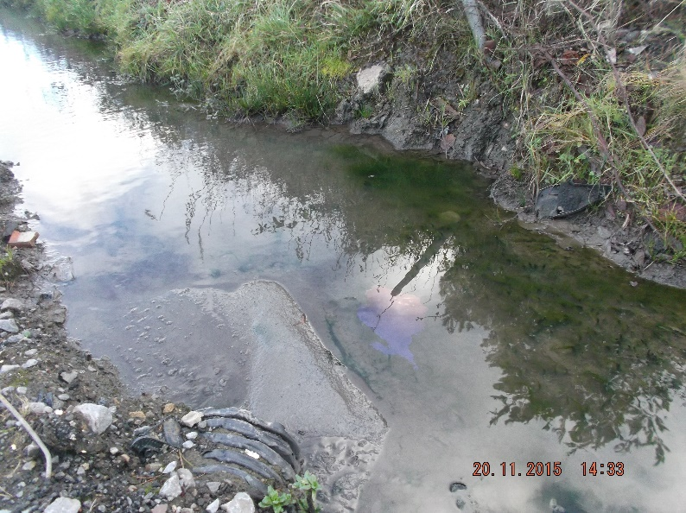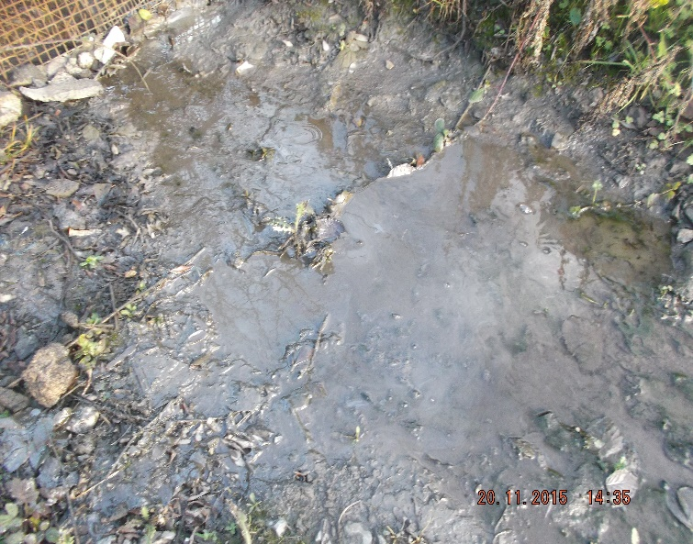

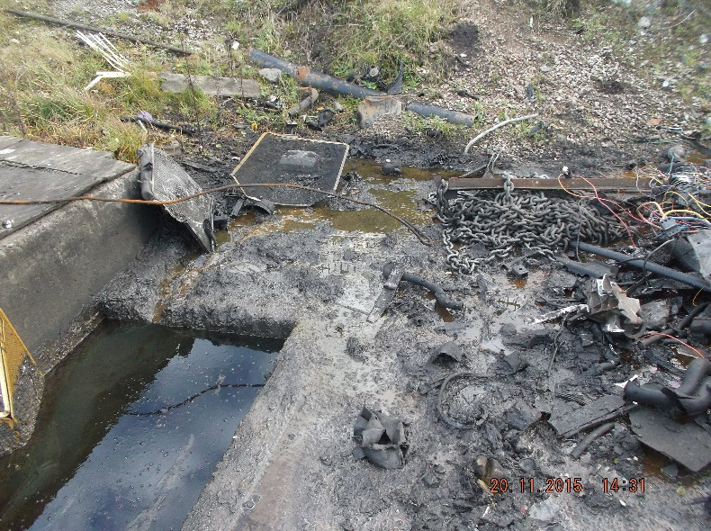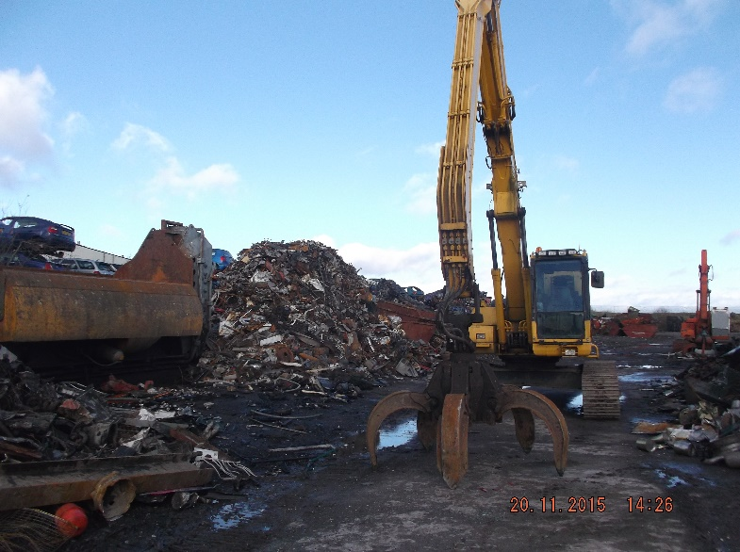

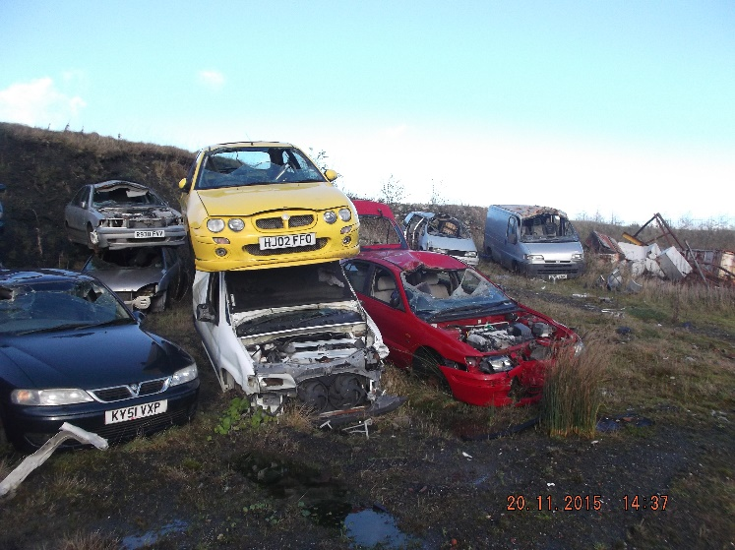

If you have any questions or comments about this CAR form or any of the associated documents please get in touch using the contact details provided. It is up to you as the site operator to rectify any issues and bring the site back into compliance with its permit conditions.

Kind regards

Laoni Tye

 | EPR Compliance Assessment Report |  | Report ID: YP3992EN/151120
This form will report compliance with your permit as determined by an NRW officer
Site | Heads Of The Valley Salvage Limited | Permit |  | EPR/YP3992EN
Operator/ Permit | Heads Of The Valley Salvage Limited | Date |  | 20/11/2015

Section 3- Enforcement Response | Only one of the boxes below should be ticked
You must take immediate action to rectify any non-compliance and prevent repetition.
Non-compliance with your permit conditions constitutes an offence and can result in criminal prosecutions and/or suspension or revocation of a permit. Please read the detailed assessment in Section 2 and the steps you need to take in Section 4 below.
Other than the provision of advice and guidance, at present we do not intend to take further enforcement action in respect of the non-compliance identified above. This does not preclude us from taking enforcement action if further relevant information comes to light or advice isn’t followed.
In respect of the above non-compliance you have been issued with a warning. At present we do not intend to take further enforcement action. This does not preclude us from taking additional enforcement action if further relevant information comes to light or offences continue. |  | X
We will now consider what enforcement action is appropriate and notify you, referencing this form.

Section 4- Action(s)
Where non-compliance has been detected and an enforcement response has been selected above, this section summarises the steps you need to take to return to compliance and also provides timescales for this to be done.
Criteria Ref. | CCS Category | Action Required/Advised | Due Date
See Section 1 above
B1 | C3
B3 | C3 | Conduct regular visual inspections of the interceptor and surface water outlet to ensure no oil is entering surface waters or ground waters. Ensure the interceptor is maintained on a regular basis by an approved contractor. Records of the maintenance need to be kept for your own reference and to be shown to NRW on request. If problems persist you may need to upgrade the interceptor. | Immediately
C2 | C3 | A comprehensive EMS must be developed which identifies how each operation and risk associated with that operation is managed on site. | 04/01/2015
C3 | C3 | Speak to NRW and apply to change your existing permit or register an exemption which will cover the additional waste types within 2 months. There must not be any more unpermitted waste types imported onto site until a permit has been granted, an exemption has been registered or until otherwise agreed in writing with NRW. | Within 2 months and immediately
C4 | C3 | Please move waste onto areas of hardstanding or impermeable surface within 3 months of the date of this CAR form. Alternatively waste will need to be removed from site or infrastructure improvements will need to be made. | Within 3 months

Section 5 - Compliance notes for the Operator |  |  |  | Section 6 – General Information
To ensure you correct actual or potential non-compliance we may  advise on corrective actions verbally or in writing  require you to take specific actions in writing  issue a notice  require you to review your procedures or management system  change some of the conditions of your permit  decide to undertake a full review of your permit |  |  |  | Data protection notice  The information on this form will be processed by the Natural Resources Wales (NRW) to fulfill its regulatory and monitoring functions and to maintain the relevant public register(s). The NRW may also use and/or disclose it in connection with:  offering/providing you with its literature/services relating to environmental matters  consulting with the public, public bodies and other organisations (e.g. Health and Safety Executive, local authorities) on environmental issues  carrying out statistical analysis, research and development on environmental issues  providing public register information to enquirers  investigating possible breaches of environmental law and taking any resulting action  preventing breaches of environmental law  assessing customer service satisfaction and improving its service  Freedom of Information Act/Environmental Information Regulations request.  The NRW may pass it on to its agents/representatives to do these things on its behalf. You should ensure that any persons named on this form are informed of the contents of this data protection notice.
Any breach of a permit condition is an offence and we may take legal action against you.

We will normally provide advice and guidance to assist you to come back into compliance either after an offence is committed or where we consider that an offence is likely to be committed. This is without prejudice to any other enforcement response that we consider may be required.
Enforcement action can include the issue of a formal caution, prosecution, the service of a notice and or suspension or revocation of the permit.
See our Enforcement and Civil Sanctions guidance for further information
This report does not relieve the site operator of the responsibility to
ensure you comply with the conditions of the permit at all times and prevent pollution of the environment
ensure you comply with other legislative provisions which may apply.
Non-compliance scores and categories |  |  |  | Disclosure of information  The NRW will provide a copy of this report to the public register(s). However, if you consider that any information contained in this report should not be released to the public register(s) on the grounds of commercial confidentiality, you must write to your local area office within twenty working days of receipt of this form indicating which information it concerns and why it should not be released, giving your reasons in full.
CCS category | Description | Score
C1 | A non-compliance which could have a major environmental effect | 60
C2 | A non-compliance which could have a significant environmental effect | 31
C3 | A non-compliance which could have a minor environmental effect | 4 |  | Customer charter  What can I do if I disagree with this compliance assessment report?  If you are unable to resolve the issue with your site officer, you should firstly discuss the matter with the officer’s line managers. If you wish to raise your dispute further through our official Complaints and Commendations procedure, phone our general enquiry number 0300 065 3000 (Mon to Fri 08.00–18.00) and ask for the Customer Contact team or send an email to enquiries@naturalresourceswales.gov.uk. If you are still dissatisfied you can make a complaint to the Public Services Ombudsman for Wales. For advice on how to complain to the Ombudsman phone their helpline on 0845 607 0987.
C4 | A non-compliance which has no potential environmental effect | 0.1
Operational Risk Appraisal (Opra) - Compliance assessment findings may affect your Opra score and/or your charges. This score influences the resource we use to assess permit compliance.

