Wrexham PFI
Operations Report
- Weather data
1.1 Site Op Data (using Kestrel 5500)
Location (see plan for locations) | Weather conditions | Time | Wind direction | Wind speed (MPH) | Temperature (˚C)
SP1–Downwind IVC | Sunny/Hot | 11:02 | E | 1.7 | 26
SP2- Upwind IVC | Sunny/Hot | 11:18 | SSW | 1.2 | 23
SP3-Downwind MBT | Sunny/Hot | 11:55 | SSW | 1.1 | 27.9
SP4-Upwind MBT | Sunny/Hot | 12:02 | SSW | 0.7 | 30.1
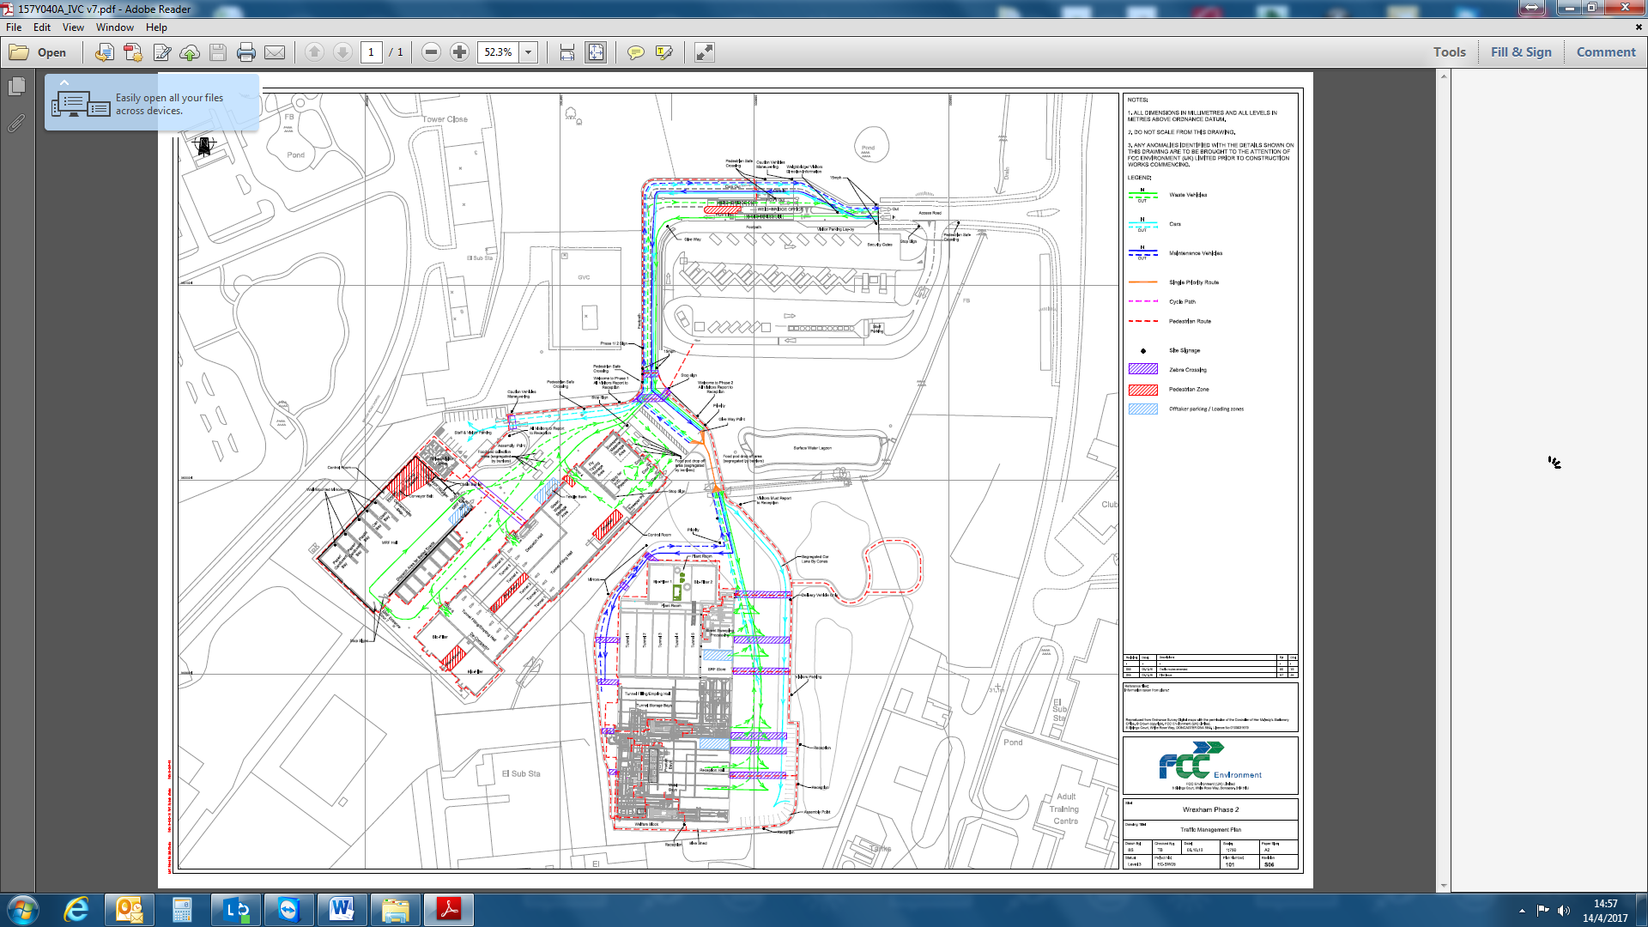
SP1
SP2
SP3
SP4

1.2 Weather station data

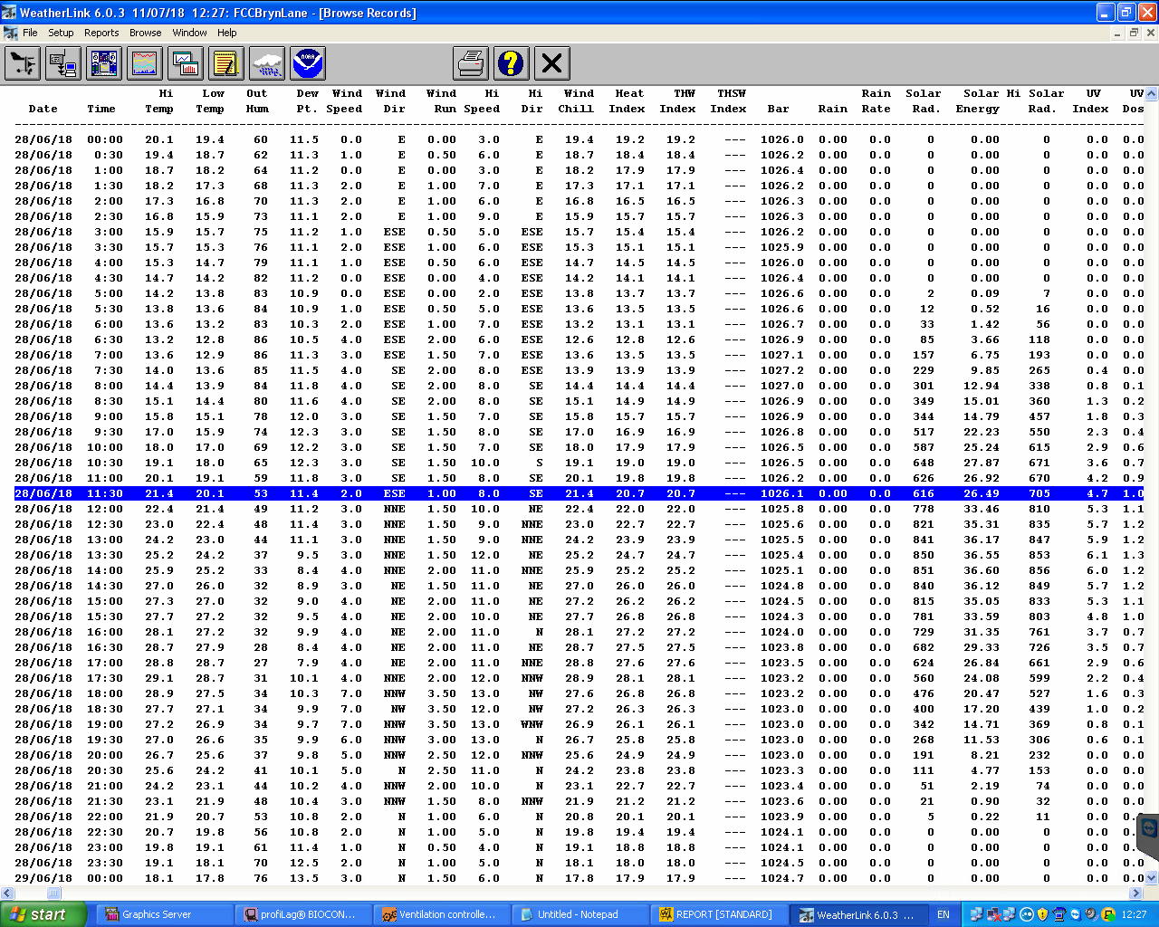

- Site activities

Site  (IVC/TS/MRF/MBT) | Activity | Waste stream | Tonnages
MBT | Pre-treatment shredding | MSW | 173.12
MBT | Bio-drying Tunnel 1 – phase 8 | RDF | 404.19
MBT | Bio-drying Tunnel 2 – phase 8 | RDF | 401.1
MBT | Bio-drying Tunnel 3 – phase 8 | RDF | 371.5
MBT | Bio-drying Tunnel 4 – Empting | RDF | 402.94
MBT | Bio-drying Tunnel 5 – phase 8 | RDF | 410.71
MBT | RDF dispatch | RDF | 171
MRF | Baling | Ali Cans | 1
MRF | Baling | Steel cans | 2
MRF | Baling | Plastics/Card | No baling
IVC | Tunnel’s 1,2,3,4,6 Hygenise | Green | 1000
IVC | Mulch dispatch | Mulch | 100

- Bio filter data

  - Phase 1

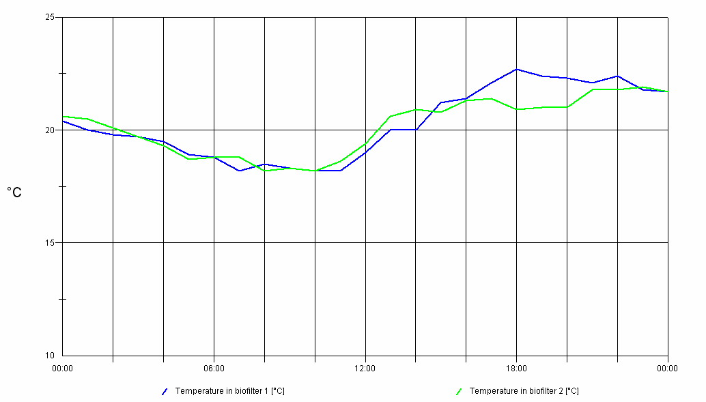

  - Phase 2

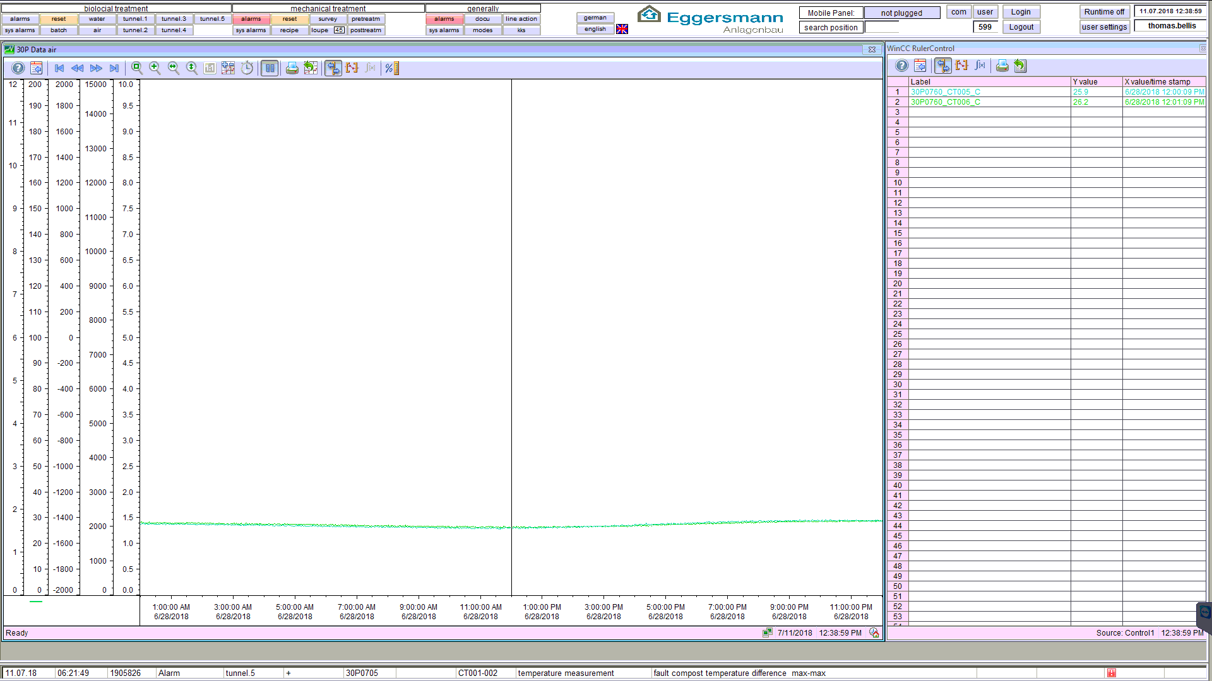

  - Moisture data

Phase1
Filter 1 = 66%
Filter 2 = 62%
Phase 2
Filter 1 = 58%
Filter 2 = 68%
- Site Observations
Phase1
No Shredding due to mechanical issues or screening in dispatch during the monitoring.
Phase 2
Emptying of Tunnel 4 during the monitoring and shredding in pre-treatment. During monitoring at SP3 2 vehicles drove past delivering waste to site. At 12:16 reception door openend for vehicle tipping

