Ein cyf/Our ref: XP3036MG

Dyddiad/Date: 25 Sept 2018

Mr R Parker
Cefn Mawr Poultry
Cefn Mawr Bungalow
Cefn Mawr Lane
Monkswood
Usk
Monmouthshire
NP15 1PX

Dear Mr Parker

Pig and Poultry Assurance Scheme: Compliant Inspection
Farm Name: Cefn Mawr Poultry Farm
Permit Number: XP3036MG

Thank you for taking part in the inspection by Edward Davies on 25 September 2018.

I am pleased to confirm that at the time of inspection you were compliant with your permit.

As discussed, please ensure that the gutters and downpipes are cleaned, repaired and maintained. I have suspended this non compliance as you indicated that you would address the issue. Please carry out all necessary work by 25/11/2018 to avoid the below permit breach.

A.R. 5.1 Permit Condition 3.1 – Emissions
- House 3 gutters not maintained to prevent overflow – weed growing.
- CCS Score 4

During the next review of your management plans please revise any references to the ‘Environment Agency’, Natural Resources Wales is the regulatory body for Wales and must be notified in the event of any incidents.

Finally, I have included a copy of the BAT regulations. As specified in your permit, these must be met by 2021. Those that apply to your site are No.s 1-15, 19, 23-27, 29 and 32.

Many thanks for your time, should you have any questions regarding this letter please feel free to contact Natural Resources Wales using the details below.

Yours sincerely

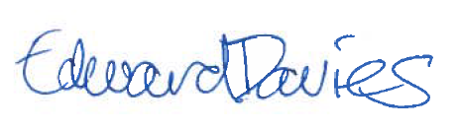

Edward Davies

Swyddog Amgylchedd / Environment Officer
Cyfoeth Naturiol Cymru / Natural Resources Wales
Ffôn/Tel: 03000 654972
Ebost/Email:
edward.j.davies@cyfoethnaturiolcymru.gov.uk
edward.j.davies@naturalresourceswales.gov.uk

