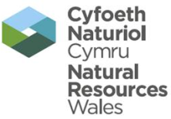 | EPR Compliance Assessment Report |  |  |  |  |  | Report ID: 06305
This form will report compliance with your permit as determined by an NRW officer
Site | Puma Energy Limited |  |  |  |  | Permit Ref |  |  | KP3036AX
Operator/ Permit holder | Puma Energy Limited
Date | 5th October 2015 |  |  |  |  | Time in |  |  | 10:00 |  |  | Out | 14:00
What parts of the permit were assessed | Environment Management Systems (Maintenance ETP, Noise and Odour Management Plan)
Assessment | Choose an item. | EPR Activity: | Installation | X |  |  | Waste Op |  |  | Water Discharge
Recipient’s name/position | Richard Livock – Environmental Engineer
Officer’s name | Gary Evans |  |  |  | Date issued |  |  |  |  |  | 26th October 2015

Section 1 - Compliance Assessment Summary
This is based on the requirements of the permit under the Environmental Permitting Regulations. A detailed explanation and any action you may need to take are given in the “Detailed Assessment of Compliance” (section 3). This summary details where we believe any non-compliance with the permit has occurred, the relevant condition and how the non-compliance has been categorised using our Compliance Classification Scheme (CCS). CCS scores can be consolidated or suspended, where appropriate, to reflect the impact of some non-compliances more accurately. For more details of our CCS scheme, contact your local office.
Permit Conditions and Compliance Summary |  |  |  |  |  | Condition(s) breached
a) Permitted activities | 1. Specified by permit |  | A
b) Infrastructure | 1. Engineering for prevention & control of pollution |  | A
b) Infrastructure | 2. Closure & decommissioning |  | N
b) Infrastructure | 3. Site drainage engineering (clean & foul) |  | N
b) Infrastructure | 4. Containment of stored materials |  | N
b) Infrastructure | 5. Plant and equipment |  | N
c) General management | 1. Staff competency/ training |  | N
c) General management | 2. Management system & operating procedures |  | A
c) General management | 3. Materials acceptance |  | N
c) General management | 4. Storage handling, labelling, segregation |  | N
d) Incident management | 1. Site security |  | N
d) Incident management | 2. Accident, emergency & incident planning |  | N
e) Emissions | 1. Air |  | N
e) Emissions | 2. Land & Groundwater |  | NA
e) Emissions | 3. Surface water |  | NA
e) Emissions | 4. Sewer |  | NA
e) Emissions | 5. Waste |  | A
f) Amenity | 1. Odour |  | A
f) Amenity | 2. Noise |  | A
f) Amenity | 3. Dust/fibres/particulates |  | NA
f) Amenity | 4. Pests, birds & scavengers |  | NA
f) Amenity | 5. Deposits on road |  | NA
g) Monitoring and records, maintenance and reporting | 1. Monitoring of emissions & environment |  | A
g) Monitoring and records, maintenance and reporting | 2. Records of activity, site diary, journal & events |  | A
g) Monitoring and records, maintenance and reporting | 3. Maintenance records |  | A
g) Monitoring and records, maintenance and reporting | 4. Reporting & notification |  | N
h) Resource efficiency | 1. Efficient use of raw materials |  | N
h) Resource efficiency | 2. Energy |  | N
KEY: C1, C2, C3, C4 = CCS breach category ( * suspended scores are marked with an asterisk),
A = Assessed or assessed in part (no evidence of non-compliance), N = Not assessed, NA = Not Applicable
Number of breaches recorded |  | 0 |  | Total compliance score  (see section 5 for scoring scheme) |  |  | 0

If the Total No Breaches is greater than zero, then please see Section 3 for details of our proposed enforcement response

Section 2 – Compliance Assessment Report Detail
This section contains a report of our findings and will usually include information on:
- the part(s) of the permit that were assessed (e.g. maintenance, training, combustion plant, etc)  - where the type of assessment was ‘Data Review’ details of the report/results triggering the assessment  - any non-compliances identified  - any non-compliances with directly applicable legislation  - details of any multiple non-compliances | - information on the compliance score accrued inc. details of suspended or consolidated scores.  - details of advice given  - any other areas of concern  - all actions requested  - any examples of good practice.  - a reference to photos taken

Overview of the Process

Puma Energy Limited now operate the former Murco Refinery Installation under permit number FB3393NV as Fuel Storage and Distribution Terminal. The permit was transferred to Puma Energy Ltd on the 1st of July 2015; the installation boundary has not changed with Puma retaining full operational control of the permitted facility. This includes the old refinery process area which is being dismantled by specialist contractors.

The company is currently utilising the crude oil storage at the facility, along with importing, storing and distributing fuels such as diesel, kerosene and gasoline. The company remain to operate the rail terminal feeding three other UK Terminals (Bedworth, Theale and Westerleigh). The rail continues to operate approximately 10 -12 loads per week.

The majority of the facility is utilised for crude storage and currently Tanks 10 and 7 are out for inspection. The company have also changed the duty on some gasoline tanks to crude oil.

Puma are reviewing their current business plan for the facility and have recently undertaken a full review of potential projects for the Milford site. These projects will be clarified in the near future with approximate timescales.

The company have already started to install a new maintenance program to replace their current SAP system, with TAG. This system is already in place at the terminals and in the near future all Puma facilities will operate the TAG system.

The Milford Haven facility operates as installation under the Environmental Permitting Regulations for the storage of Crude oil. NRW along with the other UK Regulators will be carrying out a Permit Review of activities in line with Best Available Technology (BAT) in the coming months. It is anticipated that EPR Installations under the 1.2 Scheduled activities will receive a written request to review their current operations and submit a response to NRW. The review of these activities will take place during the same time as the EU Refinery BREF Permit Reviews. The timing of the requests has not yet been confirmed; however the written requests could be issued as early as end of November 2015.

Removal of Process Units

Puma Energy Limited remain responsible for all activities on the Milford Haven site, however the company have a contracted company in place for the removal and demolition of the process area (ex Refinery Process Units). The company have already installed a perimeter fence around this area as the remainder of the site will continue to operate as a Fuel Terminal.

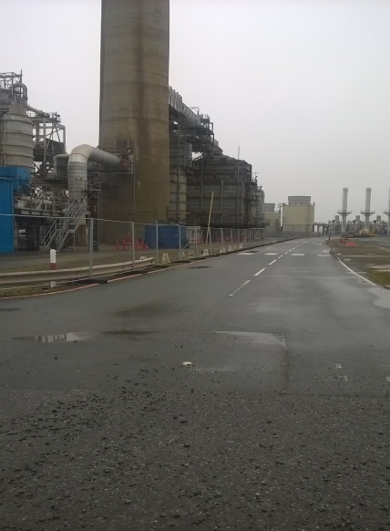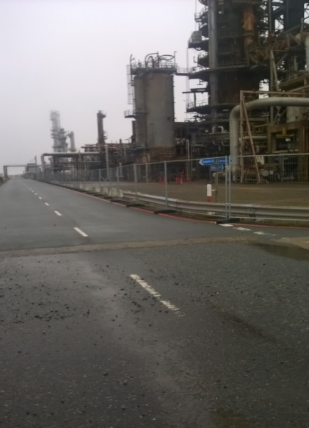

The dismantling process is unlike to start prior to the end of 2015. It is important to note that Puma currently operate the whole facility will be managing the permit compliance and therefore will have to ensure that all activities within the permitting operate in compliance with EPR Permit. This will include the update of the site closure plan, noise and odour management plans along with other conditions surrounding waste and effluent control. Any permit breach will be assessed in line with Compliance Classification Scheme and appropriate action will be taken.

These above aspects were outlined during the sale of the facility to Puma, with the company having to notify NRW in accordance with Schedule 6 of the Permit.

Environmental Management Systems (Noise and Odour Management Plans)

As an operating facility with a transferred EPR Permit, the majority of the operational procedures remain unchanged, however the scale of the operations have reduced with Puma now reviewing and updating the management systems to incorporate the Puma corporate requirements.

The SEQ Team at Milford Haven are currently carrying out a gap analysis on the accredited systems for safety, quality and environment. The company are incorporating the current site operations into an updated Noise and Odour Management Plans, as the noise and odour sources have changed. These plans need to be reviewed to be in line with the current Horizontal Guides for Noise and Odour.

As outlined above these plans need to incorporate all on site activities, including the partial site closure.

Maintenance of the Effluent Treatment Facility

Since the facility has stopped refining the effluent load has reduced significantly, resulting in no permit breaches and potential improvement in final effluent quality. The company have a maintenance programme for the effluent treatment process (lagoons), however this was based on the refinery operating and the increased effluent loads. The company needs to review their maintenance plans for this process to produce a revised program, for example de slugging activities.

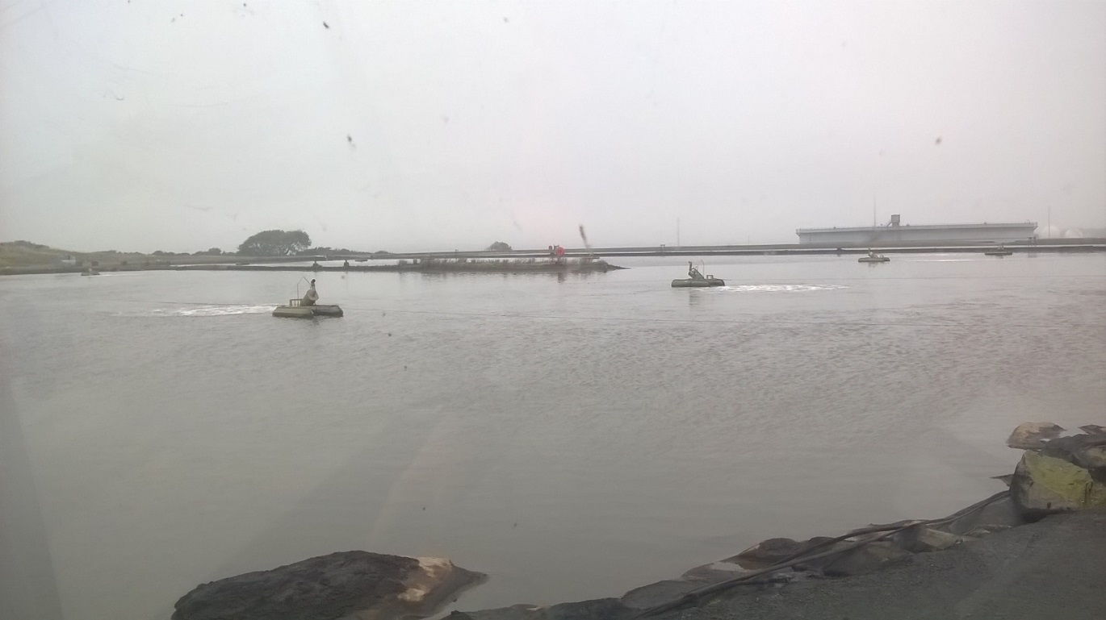

During the visit, the lagoons were inspected and as shown above the aeration continues to operate to maintain the treatment of effluent. At the time of inspection one of the aerators was out for maintenance. This process is now one of the key environmental aspects for the facility as it has the potential to discharge effluent into Milford Haven along with potential odour if the sludge levels aren’t managed appropriately.

Action: Review current sludge levels in the effluent system and review appropriate timescales for maintenance.

Land Farm Potential Surrender Application.

As part of the historical activities on the site, the previous owner has operated a land farm for the treatment of sludges. This activity has not taken place for a number of years, however the permit remains extant. The company may wish to have further pre application discussions with NRW in the new year to review whether a surrender application can be made.

Temporary Boiler

Puma Energy have no direct gas connections, and have limited steam capability. The company have written to NRW outlining the use of a temporary boiler for utilisation of steam with a main aim of using the steam to heat fuel oil for potential off site export. This export activity has not taken place, however the boiler remains on site.

Below photographs of temporary boiler.

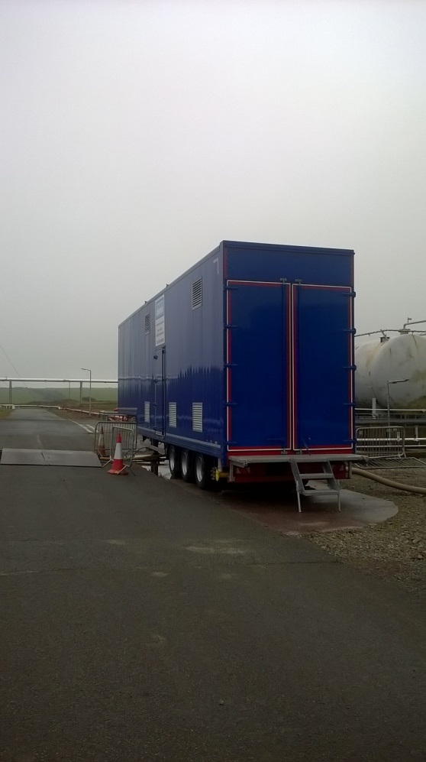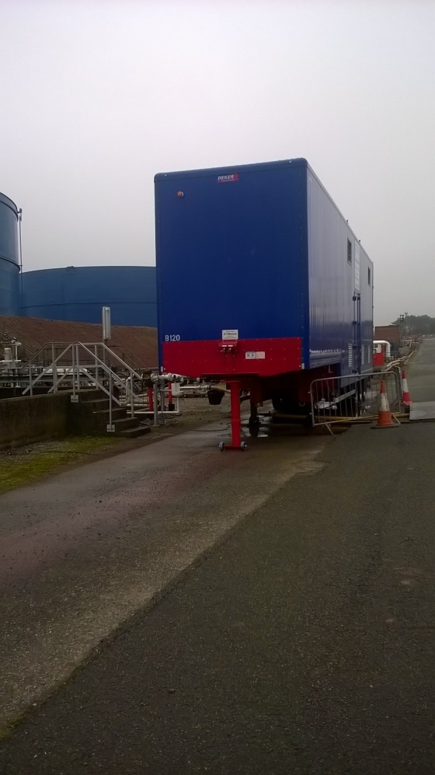

Action : Murco to inform NRW of any changes to the operation of the temporary boilers.

End

 | EPR Compliance Assessment Report |  | Report ID: 06305
This form will report non-compliance with your permit as determined by an NRW officer
Site |  | Permit
Operator/ Permit |  | Date

Section 3- Enforcement Response | Only one of the boxes below should be ticked
You must take immediate action to rectify any non-compliance and prevent repetition.
Non-compliance with your permit conditions constitutes an offence and can result in criminal prosecutions and/or suspension or revocation of a permit. Please read the detailed assessment in Section 2 and the steps you need to take in Section 4 below.
Other than the provision of advice and guidance, at present we do not intend to take further enforcement action in respect of the non-compliance identified above. This does not preclude us from taking enforcement action if further relevant information comes to light or advice isn’t followed.
In respect of the above non-compliance you have been issued with a warning. At present we do not intend to take further enforcement action. This does not preclude us from taking additional enforcement action if further relevant information comes to light or offences continue.
We will now consider what enforcement action is appropriate and notify you, referencing this form.

Section 4- Action(s)
Where a non - compliance has been detected and an enforcement response has been selected above, this section summarises the steps you need to take to return to compliance and also provides timescales for this to be done.
Criteria Ref. | CCS Category | Action Required/Advised | Due Date
See Section 1 above

Section 5 - Compliance notes for the Operator |  |  |  | Section 6 – General Information
To ensure you correct actual or potential non-compliance we may  advise on corrective actions verbally or in writing  require you to take specific actions in writing  issue a notice  require you to review your procedures or management system  change some of the conditions of your permit  decide to undertake a full review of your permit |  |  |  | Data protection notice  The information on this form will be processed by Natural Resources Wales (NRW) to fulfill its regulatory and monitoring functions and to maintain the relevant public register(s). NRW may also use and/or disclose it in connection with:  offering/providing you with its literature/services relating to environmental matters  consulting with the public, public bodies and other organisations (e.g. Health and Safety Executive, local authorities) on environmental issues  carrying out statistical analysis, research and development on environmental issues  providing public register information to enquirers  investigating possible breaches of environmental law and taking any resulting action  preventing breaches of environmental law  assessing customer service satisfaction and improving its service  Freedom of Information Act/Environmental Information Regulations request.  NRW may pass it on to its agents/representatives to do these things on its behalf. You should ensure that any persons named on this form are informed of the contents of this data protection notice.
Any breach of a permit condition is an offence and we may take legal action against you.

We will normally provide advice and guidance to assist you to come back into compliance either after an offence is committed or where we consider that an offence is likely to be committed. This is without prejudice to any other enforcement response that we consider may be required.
Enforcement action can include the issue of a formal caution, prosecution, the service of a notice and or suspension or revocation of the permit.
See our Enforcement and Civil Sanctions guidance for further information
This report does not relieve the site operator of the responsibility to
ensure you comply with the conditions of the permit at all times and prevent pollution of the environment
ensure you comply with other legislative provisions which may apply.
Non-compliance scores and categories |  |  |  | Disclosure of information  NRW will provide a copy of this report to the public register(s). However, if you consider that any information contained in this report should not be released to the public register(s) on the grounds of commercial confidentiality, you must write to your local area office within twenty working days of receipt of this form indicating which information it concerns and why it should not be released, giving your reasons in full.
CCS category | Description | Score
C1 | A non-compliance which could have a major environmental effect | 60
C2 | A non-compliance which could have a significant environmental effect | 31
C3 | A non-compliance which could have a minor environmental effect | 4 |  | Customer charter  What can I do if I disagree with this compliance assessment report?  If you are unable to resolve the issue with your site officer, you should firstly discuss the matter with the officer’s line managers. If you wish to raise your dispute further through our official Complaints and Commendations procedure, phone our general enquiry number 0300 065 3000 (Mon to Fri 08.00–18.00) and ask for the Customer Contact team or send an email to enquiries@naturalresourceswales.gov.uk If you are still dissatisfied you can make a complaint to the Public Services Ombudsman for Wales. For advice on how to complain to the Ombudsman phone their helpline on (0845) 601 0987.
C4 | A non-compliance which has no potential environmental effect | 0.1
Operational Risk Appraisal (Opra) - Compliance assessment findings may affect your Opra score and/or your charges. This score influences the resource we use to assess permit compliance.

