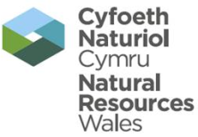 | EPR Compliance Assessment Report |  |  |  |  |  | Report ID: 6130
This form will report compliance with your permit as determined by an NRW officer
Site | Felinfach, Ceredigion |  |  |  |  | Permit Ref |  |  | BL5644IK
Operator/ Permit holder | Sensient Flavors Ltd
Date | 10 March 2016 |  |  |  |  | Time in |  |  | 10:00 |  |  | Out | 12:45
What parts of the permit were assessed | See agenda
Assessment | Site Inspection | EPR Activity: | Installation | X |  |  | Waste Op |  |  | Water Discharge
Recipient’s name/position | Tim Pink – EHS Manager
Officer’s name | Nick Jenkins & Douglas Cowie |  |  |  | Date issued |  |  |  |  |  | 27/04/16

Section 1 - Compliance Assessment Summary
This is based on the requirements of the permit under the Environmental Permitting Regulations. A detailed explanation and any action you may need to take are given in the “Detailed Assessment of Compliance” (section 3). This summary details where we believe any non-compliance with the permit has occurred, the relevant condition and how the non-compliance has been categorised using our Compliance Classification Scheme (CCS). CCS scores can be consolidated or suspended, where appropriate, to reflect the impact of some non-compliances more accurately. For more details of our CCS scheme, contact your local office.
Permit Conditions and Compliance Summary |  |  |  |  |  |  | Condition(s) breached
a) Permitted activities | 1. Specified by permit |  |  | A
b) Infrastructure | 1. Engineering for prevention & control of pollution |  |  | N
b) Infrastructure | 2. Closure & decommissioning |  |  | N
b) Infrastructure | 3. Site drainage engineering (clean & foul) |  |  | N
b) Infrastructure | 4. Containment of stored materials |  |  | N
b) Infrastructure | 5. Plant and equipment |  |  | N
c) General management | 1. Staff competency/ training |  |  | N
c) General management | 2. Management system & operating procedures |  |  | N
c) General management | 3. Materials acceptance |  |  | N
c) General management | 4. Storage handling, labelling, segregation |  |  | N
d) Incident management | 1. Site security |  |  | N
d) Incident management | 2. Accident, emergency & incident planning |  |  | N
e) Emissions | 1. Air |  |  | A
e) Emissions | 2. Land & Groundwater |  |  | N
e) Emissions | 3. Surface water |  |  | N
e) Emissions | 4. Sewer |  |  | N
e) Emissions | 5. Waste |  |  | N
f) Amenity | 1. Odour |  |  | N
f) Amenity | 2. Noise |  |  | N
f) Amenity | 3. Dust/fibres/particulates |  |  | N
f) Amenity | 4. Pests, birds & scavengers |  |  | N
f) Amenity | 5. Deposits on road |  |  | N
g) Monitoring and records, maintenance and reporting | 1. Monitoring of emissions & environment |  |  | N
g) Monitoring and records, maintenance and reporting | 2. Records of activity, site diary, journal & events |  |  | N
g) Monitoring and records, maintenance and reporting | 3. Maintenance records |  |  | N
g) Monitoring and records, maintenance and reporting | 4. Reporting & notification |  |  | N
h) Resource efficiency | 1. Efficient use of raw materials |  |  | N
h) Resource efficiency | 2. Energy |  |  | N
KEY: C1, C2, C3, C4 = CCS breach category ( * suspended scores are marked with an asterisk),
A = Assessed or assessed in part (no evidence of non-compliance), N = Not assessed, NA = Not Applicable
Number of breaches recorded |  | 0 | Total compliance score  (see section 5 for scoring scheme) |  |  |  |  | 0

If the Total No Breaches is greater than zero, then please see Section 3 for details of our proposed enforcement response

Section 2 – Compliance Assessment Report Detail
This section contains a report of our findings and will usually include information on:
- the part(s) of the permit that were assessed (e.g. maintenance, training, combustion plant, etc)  - where the type of assessment was ‘Data Review’ details of the report/results triggering the assessment  - any non-compliances identified  - any non-compliances with directly applicable legislation  - details of any multiple non-compliances | - information on the compliance score accrued inc. details of suspended or consolidated scores.  - details of advice given  - any other areas of concern  - all actions requested  - any examples of good practice.  - a reference to photos taken

Attendees
Tim Pink – EHS Manager (Sensient Flavors Ltd)
Andrew Davies – Engineering Manager (Sensient Flavours Ltd) Present for agenda point 1.
Douglas Cowie – PPC Officer (Natural Resources Wales)
Nick Jenkins – PPC Officer (Natural Resources Wales)

Agenda
- Progress with scrubber units
- Findings of Welsh Government abstraction meeting
- Progress with variation
- Odour management plan
- Any other business

- Progress with scrubber units
Andrew Davies provided an update on the installation and commissioning of the two replacement scrubber units (A4 and A5). Sensient took the appropriate action by first focussing on the least efficient scrubber unit i.e. A5 and the installing and commissioning of this unit therefore took precedence over the A4 unit. The assessment of the effectiveness had been completed by Odournet, a recognised company with a record for assisting industry and public organisations with environmental odour management.

The following table presents the key specifications from the existing scrubbers to the new units.
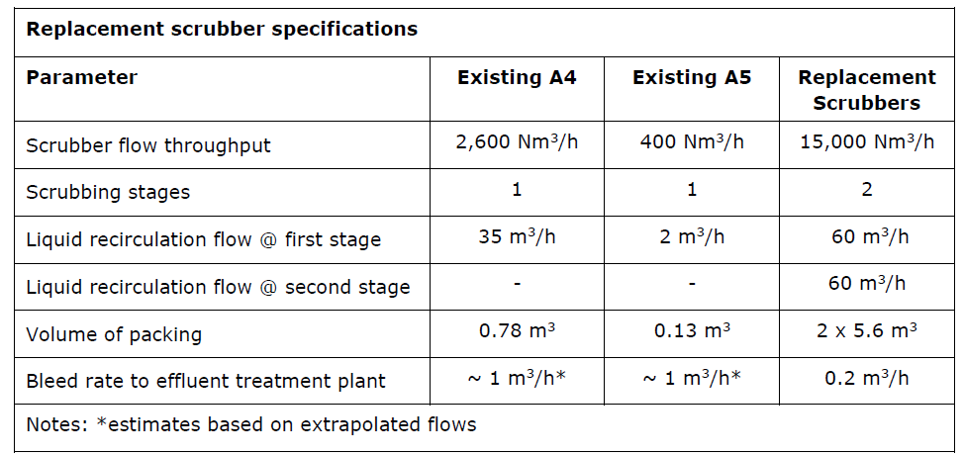

As identified in the table above, each replacement scrubber comprises of two sections arranged vertically to enable two-stage scrubbing:
- Stage 1 – acid is introduced to oxidise organic substances present in the gas stream; and
- Stage 2 – alkali is introduced to remove the oxidised organic substances and any residual oxidants from the gas stream.

Sensient advised that the A5 scrubber has been operational for around 3-4 weeks (from the time of the visit) and are monitoring the unit on a daily basis. Emission monitoring has been undertaken by an MCERTS accredited company and they are waiting for the results. Sensient are currently trialling the use of first stage scrubbing i.e. acid (hypochlorite) in combination with second stage clean water scrubbing to understand whether there is a necessity to fully use the second stage. If the results are not in compliance with permit conditions only then will Sensient implement stage two (alkali – caustic scrubbing). This would appear to be an appropriate consideration to avoid the use of unnecessary chemicals.

The A4 scrubber appeared to be complete on the day of our visit but subsequently we were informed that a faulty flange had been identified during the commissioning phase. Following the repair, the scrubber unit was back into commissioning and Sensient are awaiting the return of the MCERTS contractor to assess its performance. Once both commissioning phases for A4 and A5 have been completed and the emissions are within the permitted parameters, Sensient have committed to contracting Odournet to review the changes and following this we would recommend a further meeting with NRW to review the resultant report.

Below are photographs of the two new scrubbers.

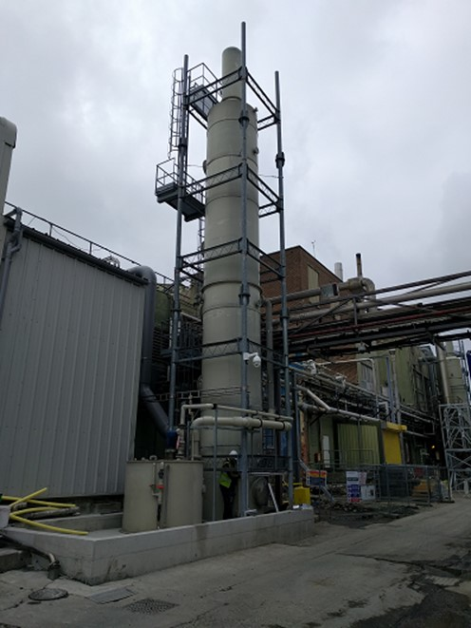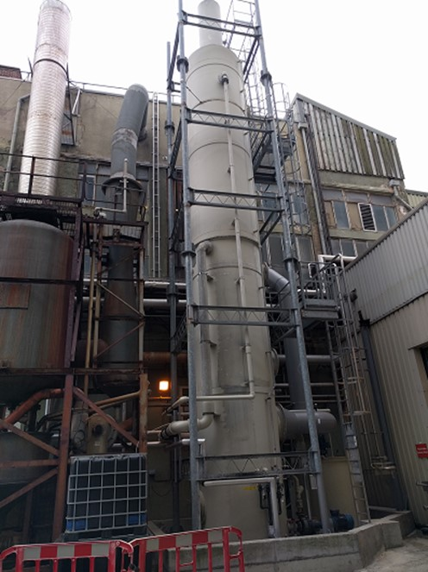
Photo 1 – A4 scrubber Photo 2 – A5 scrubber

Sensient confirmed that Ceredigion County Council’s Planning Department has been consulted regarding the height of the new A4 and A5 scrubbers and that no planning permission is required.

NRW are encouraged by the progress of this work and have welcomed Sensient’s commitment to resolving the issue by firstly contracting a specialist and secondly by acting upon the highlighted shortcomings of the units.

- Welsh Government abstraction meeting
Sensient rely on a significant volume of abstracted water to operate their plant. This water is currently abstracted from boreholes within an exempt zone (which is not regulated) but this is due to change. NRW’s plan is to take a light-touch, risk based approach to bring the majority of exempt abstractors into the licensing system to help balance the needs of all abstractors and the environment in Wales. This will enable NRW to better manage water at a river catchment level and is part of a much wider effort to manage our water resources in a sustainable way, now and for future generations. The proposed approach is to begin bringing New Authorisations into the licensing system in 2016. Some abstractions that are considered low risk will remain exempt. The consultation period on these changes closed 8 April 2016 and a report of the comments will be made by Welsh Government.

The South West Wales Industry Regulation team facilitated Sensient’s attendance at a recent Welsh Government meeting to discuss the new proposed approach to water abstractions. The meeting took place 17 March 2016 in Cardiff and Sensient advised that they had raised their concerns and we encourage the early discussions.

- Progress with permit variation (EPR BL5644IK/V004)
The operation of the new scrubbing system for emission points A4 and A5 required Sensient to apply for a variation to ensure that the installation’s permit reflects the current operations. This was also an opportunity for Sensient to bring other aspects of their operation into the variation including the use of LPG, the removal of the requirement to monitor for water emissions to the shared catch pit and the consolidation of the permit in a modern format.

Sensient has submitted the variation, which was duly made 12 January 2016 and is currently being determined by NRW’s permitting team. In addition to the points mentioned above, NRW has also requested the inclusion of improvement conditions (IC) 9.23 and 9.24 which have not been implemented into previous variations. We have also looked to remove emission points A8 and A15 as they are no longer operational at the installation.

Improvement conditions 9.23 and 9.24 have been discussed at length with Sensient and as a result we have asked the permitting team to place a deadline for 31 July 2017, which was agreed with Sensient. The required monitoring frequency for key emission points e.g. A4 and A5 is quarterly. Sensient should ensure that it describes the variability of its production process at Felinfach in sufficient detail when responding to IC 9.23.

When submitting its response to IC 9.24, NRW requests that Sensient provides details of which calculations have been used to derive the figures.

NRW’s permitting team will send a draft consolidated permit to the South West Wales Industry Regulation team for review before sending onto Sensient for their comments in due course.

- Odour Management Plan (OMP)
Included within the variation application was an updated OMP which was last reviewed June 2004. In light of the changes to the installation and the updated guidance provided in ‘How to comply with your environmental permit’, NRW requested Sensient to submit an up to date OMP.

We have reviewed the document and although we agree with many aspects of it there is no reference to Sensient’s investigation procedures once a complaint has been reported. NRW agreed a route for Sensient to travel once a complaint had been reported that covered Cilau Aeron. We do not require the route map to be included in the OMP but we would recommend reference to the route to be mentioned. Sensient advised that they will review and submit the updated plan to the permitting team i.e. Jacqui Collier.

- Any other business
- On 11 February 2016, NRW submitted a draft CAR form (ref 6109) for the review of Sensient’s 6 monthly reporting data. A number of scores were raised on the CAR form that related to air and water emission breaches. A score was also raised against staff competency/training as the data was submitted late but also because the same issue was raised in 2015 and hadn’t been resolved. NRW also queried whether Sensient had submitted data for the first half of 2015. This was expected to be received no later than 31 July 2015 but wasn’t available. Sensient advised that they would check their submission and would clarify if they had sent the forms to NRW along with the date it was sent. RECOMMENDATION – Sensient to clarify whether the emission report, which was due 31 July 2015 had been submitted to NRW. If records suggest that this has not been submitted, we expect this information no later than 6 May 2016. A separate CAR form will be produced to reflect the submission.

The operator advised that they have now included the dates into their electronic diary which should flag up the requirement to report at the end of January and July for each year.

- Permit condition 4.1.3 requires the operator to submit a report on the potential environmental improvements to the permitted installation and shall be updated every 36 months. NRW have not had sight of such a report in line with this permit condition. This is a key document which will focus the operator on the relevant guidance associated with the installation and the Best Available Techniques that may provide environment improvement. This report can then form part of any subsequent CAPEX meeting to allow the operator to request capital to make relevant upgraders. RECOMMENDTION – NRW request that this document is submitted to NRW in sufficient time for it to be reviewed before being considered at the CAPEX meeting for 2017/18.

- All surface water at the installation is directed to the shared catch pit before discharge to the consortium owned ETP. This includes clean rain water which can be diverted away from this process. By removing clean surface water from the system could reduce the burden on the ETP. We encourage Sensient to raise this as a point at the next consortium meeting but Sensient advised that this was already on the agenda. Other members of the ETP consortium have also approached NRW regarding this issue and we are happy to work with all parties to move this forward.

- Site tour – We walked around the perimeter of the installation with the intention of inspecting the new scrubber units. We viewed the third scrubber unit which was destined to be used as spares for A4 and A5 and was being repaired during our visit. Details of A4 and A5 are discussed above. On arrival at the site we did identify an odour in the main car park and at the entrance to the meeting room. We were unable to substantiate the odour at the car park, but at the entrance to the meeting room the source of the odour was thought to be the sensory analysis (flavour testing) room.

- Sensient raised the increased capacity of the new scrubber and the possibility of diverting fugitive emissions from inside the factory to the new units. We would welcome this and would recommend that this is raised to the board at the next opportunity.

[END]

 | EPR Compliance Assessment Report |  | Report ID: 6130
This form will report non-compliance with your permit as determined by an NRW officer
Site | Felinfach, Ceredigion | Permit Ref |  | BL5644IK
Operator/ Permit | Sensient Flavors Ltd | Date |  | 10/03/16

Section 3- Enforcement Response | Only one of the boxes below should be ticked
You must take immediate action to rectify any non-compliance and prevent repetition.
Non-compliance with your permit conditions constitutes an offence and can result in criminal prosecutions and/or suspension or revocation of a permit. Please read the detailed assessment in Section 2 and the steps you need to take in Section 4 below.
Other than the provision of advice and guidance, at present we do not intend to take further enforcement action in respect of the non-compliance identified above. This does not preclude us from taking enforcement action if further relevant information comes to light or advice isn’t followed.
In respect of the above non-compliance you have been issued with a warning. At present we do not intend to take further enforcement action. This does not preclude us from taking additional enforcement action if further relevant information comes to light or offences continue.
We will now consider what enforcement action is appropriate and notify you, referencing this form.

Section 4- Action(s)
Where a non - compliance has been detected and an enforcement response has been selected above, this section summarises the steps you need to take to return to compliance and also provides timescales for this to be done.
Criteria Ref. | CCS Category | Action Required/Advised | Due Date
See Section 1 above
NA

Section 5 - Compliance notes for the Operator |  |  |  | Section 6 – General Information
To ensure you correct actual or potential non-compliance we may  advise on corrective actions verbally or in writing  require you to take specific actions in writing  issue a notice  require you to review your procedures or management system  change some of the conditions of your permit  decide to undertake a full review of your permit |  |  |  | Data protection notice  The information on this form will be processed by Natural Resources Wales (NRW) to fulfill its regulatory and monitoring functions and to maintain the relevant public register(s). NRW may also use and/or disclose it in connection with:  offering/providing you with its literature/services relating to environmental matters  consulting with the public, public bodies and other organisations (e.g. Health and Safety Executive, local authorities) on environmental issues  carrying out statistical analysis, research and development on environmental issues  providing public register information to enquirers  investigating possible breaches of environmental law and taking any resulting action  preventing breaches of environmental law  assessing customer service satisfaction and improving its service  Freedom of Information Act/Environmental Information Regulations request.  NRW may pass it on to its agents/representatives to do these things on its behalf. You should ensure that any persons named on this form are informed of the contents of this data protection notice.
Any breach of a permit condition is an offence and we may take legal action against you.

We will normally provide advice and guidance to assist you to come back into compliance either after an offence is committed or where we consider that an offence is likely to be committed. This is without prejudice to any other enforcement response that we consider may be required.
Enforcement action can include the issue of a formal caution, prosecution, the service of a notice and or suspension or revocation of the permit.
See our Enforcement and Civil Sanctions guidance for further information
This report does not relieve the site operator of the responsibility to
ensure you comply with the conditions of the permit at all times and prevent pollution of the environment
ensure you comply with other legislative provisions which may apply.
Non-compliance scores and categories |  |  |  | Disclosure of information  NRW will provide a copy of this report to the public register(s). However, if you consider that any information contained in this report should not be released to the public register(s) on the grounds of commercial confidentiality, you must write to your local area office within twenty working days of receipt of this form indicating which information it concerns and why it should not be released, giving your reasons in full.
CCS category | Description | Score
C1 | A non-compliance which could have a major environmental effect | 60
C2 | A non-compliance which could have a significant environmental effect | 31
C3 | A non-compliance which could have a minor environmental effect | 4 |  | Customer charter  What can I do if I disagree with this compliance assessment report?  If you are unable to resolve the issue with your site officer, you should firstly discuss the matter with the officer’s line managers. If you wish to raise your dispute further through our official Complaints and Commendations procedure, phone our general enquiry number 0300 065 3000 (Mon to Fri 08.00–18.00) and ask for the Customer Contact team or send an email to enquiries@naturalresourceswales.gov.uk If you are still dissatisfied you can make a complaint to the Public Services Ombudsman for Wales. For advice on how to complain to the Ombudsman phone their helpline on (0845) 601 0987.
C4 | A non-compliance which has no potential environmental effect | 0.1
Operational Risk Appraisal (Opra) - Compliance assessment findings may affect your Opra score and/or your charges. This score influences the resource we use to assess permit compliance.

