CRoW Appendix 4 (140_10_SD02)  CRoW Act 2000: Natural Resources Wales application for permission - Formal Notice |  | 
Natural Resources Wales Formal Notice.
Requirements of Section 28I of the Wildlife & Countryside Act 1981 as amended by the Countryside and Rights of Way Act (CRoW) 2000.
Duty in relation to granting any consent, licence or permit for activities likely to damage Sites of Special Scientific Interest (SSSI).
Guide to filling in this form for Natural Resources Wales staff:
To be completed by Permitting Officers for any applications for a permission which the Natural Resources Wales has considered under S28G duties to protect and enhance SSSIs. This applies to all proposed permissions within a SSSI, and to operations outside the SSSI boundary which are likely to damage its special features.
Refer to OI 140_10 ‘Applying the Countryside and Rights of Way (CRoW) Act 2000 to applications for permits with potential for impact on Sites of Special Scientific Interest (SSSI)’, including the flowchart in Appendix 2.
Pink italic text – drafting notes, to be deleted before completion/consultation.
Blue text – examples, to be replaced with permission-specific information.
Ensure you have completed all sections.
- Natural Resources Wales area/region/NPS hub: | South East
- Name of SSSI: | Barry Island  Hayes Point to Bendrick Rock
- Type of permission: | Bespoke Waste Permit
- Date for Natural Resources Wales permit determination: | 01/08/2022
- Predicted 28 day date for response from NRW conservation/ecology (under S28 I(4)): | N/A – for information only
- Natural Resources Wales reference no: | PAN-015651
- National grid reference: | ST 13385 67275
- Description of proposal: | An application for a resource recycling facility, operating as a hazardous and non-hazardous site, receiving up to 75,000 tonnes of waste per year. Operations will take place between 06:00 and 21:00 daily.
- Is the proposed activity within (wholly or partially) the SSSI boundary? | NO  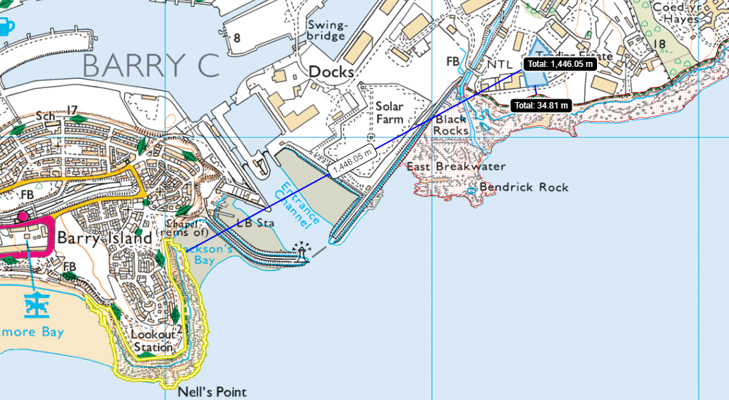  Barry Island SSSI lies approximately 1,500m west of the proposed site. Hayes Point to Bendrick Rock SSSI lies approximately 30m south of the site.
- Has there been any pre-application discussion or correspondence with NRW conservation/ecology | NO
- What aspect(s) of the proposed permission may damage the features which are of special interest for the SSSI?

Barry Island SSSI
The following ‘Operations Requiring Consent’ (or other activities associated with the permission) that may cause damage) are relevant to the proposed permission.

21. Construction, removal or destruction of roads, tracks, walls, fenses, hardstands, banks, ditches or other earthworks
23. Erection of permanent or temporary structures or the undertaking of engineering works, including the laying, maintenance or removal of pipelines and cables.

The following SSSI features and mechanisms of impact have been considered to assess the likelihood of damage:
Mercia Mudstone Group and Carboniferous Limestone vertical cliffs.

Hayes Point to Bendrick Rock SSSI
The following ‘Operations Requiring Consent’ (or other activities associated with the permission) that may cause damage) are relevant to the proposed permission.

21. Construction, removal or destruction of roads, tracks, walls, fenses, hardstands, banks, ditches or other earthworks
23. Erection of permanent or temporary structures or the undertaking of engineering works, including the laying, maintenance or removal of pipelines and cables.

The following SSSI features and mechanisms of impact have been considered to assess the likelihood of damage:
Rock exposures from 225 million years ago and preserved “dinosaur” footprints and tracks from the same period.

- Decision
i) The proposed permission is not likely to damage any of the flora, fauna or geological or physiological features which are of special interest.

None of the processes on site, or any section of site construction, should have any effect on the protected sites as neither SSSI will be damaged during the construction and site operation due to proximity. The sites will also not be effected by any potential odour or noise emissions from the site.

Natural Resources Wales is minded to:
Issue the permission

- Name and job title of Natural Resources Wales officer: | Rhiannon Smith  Permitting Officer
- Date form sent to NRW conservation/ecology | N/A
For Natural Resources Wales use only, once NRW conservation/ecology response received
- NRW conservation/ecology comment on assessment: | Please delete as appropriate:  i) NRW conservation/ecology advise the operation can go ahead  ii) NRW conservation/ecology advise the operation can go ahead with conditions  iii) NRW conservation/ecology advise against permitting the operation  Please ensure that the NRW conservation/ecology response is attached to this Formal Notice.
- Name and job title of NRW conservation/ecology officer:
- Date of receipt of NRW conservation/ecology response:

