- Application type
New full abstraction licence ☒ Give existing licence serial number and/
New temporary abstraction licence ☐ pre-application reference number
New licence to transfer water ☐
PPN-00214
Renewal of a time-limited abstraction licence ☐
Technical variation to an abstraction licence ☐

For hydropower abstractions, specify the capacity (in kilowatts) of your scheme.

25kW or less ☒ >25 to 50kW ☐ >50 to 100kW ☐ >100kW ☐

- Linked licences
2.1 Does your proposal involve water rights trading?
No ☒ Yes ☐ If yes, provide licence serial
number(s)

2.2 Is the licence (to be) aggregated with any other licences?
No ☒ Yes ☐ If yes, provide licence serial
number(s)

- Abstraction details

Provide details of all points of abstraction. Details of abstraction location(s) should correspond with any maps submitted.
If necessary, continue on a separate sheet and tick here to show that you have done this ☐
Abstraction  location name / reference | Type  (single point /  reach) | National Grid Reference  (12 digit) | If a reach, downstream National Grid Reference  (12 digit)
Celynog Uchaf, Bryn Coed Ifor, Rhydymain | Single point | SH80247 20191

- Means of abstraction
Detail the structure and equipment involved in the abstraction process. If this information is detailed in a supporting document, provide the document reference. For groundwater abstractions, include borehole depth and diameter and provide details of screening and lining.
If necessary, continue on a separate sheet and tick here to show that you have done this. ☐
Water will be abstracted through the construction of a new intake weir across the full width of the watercourse, with a 3mm screen. A powerhouse will be constructed to house the turbine and generator. The pipe will be 450mm HDPE and buried for the majority of its length.

Please see attached drawings:
Intake Dimensions and Fish Pass V2.2
Intake Dimensions Celynog Uchaf V2.2
Intake General Arrangement Celynog Uchaf V2.2
Forebay Tank Celynog Uchaf V2.0
Powerhouse GA and Dimensions Celynog Uchaf V2.0
General Layout Celynog Uchaf V3.1

- Abstraction quantities
Provide details of the abstraction quantities and periods proposed, including any deregulated abstractions (< 20 cubic metres per day) you currently have. Details of abstraction locations should correspond with any maps submitted.
Abstraction  location name / reference | Purpose which water will be used for | Abstraction period  (state ‘all year’ or give months) | Maximum annual abstraction volume  (cubic metres) | Maximum daily abstraction volume  (cubic metres) | Maximum hourly abstraction volume  (cubic metres) | Number of hours of abstraction per day | Peak abstraction rate  (litres per second)
Celynog Uchaf, Bryn Coed Ifor, Rhydymain | Hydro-electric | All year | 6086448 | 16675 | 694 | 24 | 193
 |  | Total | 6086448 | 16675 | 694

- Calculations and supporting information
Please provide further details of your intended use of water, including calculations in support of the quantities you have requested, your operational regime and any management agreements. See Guidance Note WRX for details of what is required. If your proposal involves the provision of a residual flow via a notch or orifice, provide information on how this has been calculated.
If necessary, continue on a separate sheet and tick here to show that you have done this. ☒
The water will be used for electricity generation. The hourly / daily / annual quantity calculations are based on the maximum expected instantaneous flow operating continuously over these periods. It will not be possible to over abstract due to the fixed residual flow notches in the intake weir structure.

Please see the following attached drawing for residual flow calculation:
Intake General Arrangement Celynog Uchaf V2.2

- Industry-specific requirements
Complete the relevant table in line with the purpose of your proposal to demonstrate a justification of need for the quantities proposed. For uses not covered here or to provide further details, please use a separate sheet and tick here to show that you have done this ☐
7.1 For agricultural use:
Crop type | Soil type  (for multiple soil types, indicate approximate split) | Maximum area of crop to be irrigated annually  (hectares) | Maximum annual depth of irrigation to be applied (millimetres)
e.g. Carrots | Silty clay | 10 | 90

Livestock type | Number of animals | Maximum daily quantity of water used  (cubic metres) | Comments
e.g. Sheep | 200 | 0.005 per animal | Drinking water
Provide details of any additional requirements (washing / cleaning)

7.2 For golf course irrigation:
Feature | Maximum area to be irrigated daily  (hectares) | Maximum depth of water to be applied daily (millimetres)
e.g. Greens | 0.9 | 220
Tees
Greens
Fairways
Others

7.3 For industrial use:
Industry sector or process type | Water use per unit produced  (state units) | Maximum units produced per year
e.g. Ice cream | 1.9 cubic metres per tonne of ice cream | 10,000 tonnes

7.4 For hydropower:
If you have submitted this information as part of your pre-application enquiry and no changes have been made to your proposal in the meantime, you are not required to provide these details again.
% abstraction and zone applied for (see HGN2) | Average gradient of depleted reach (%) | Catchment size above abstraction point (kilometres square d) | Net head between abstraction and discharge points  (metres)
Zone 1 (40%) | 7.5 | 3.9 | 70.4
Turbine efficiency (%) | System efficiency (%) | Maximum power output  (kilowatts) | Annual capacity (kilowatt hours)
86 | 75 | 100 | 876,000
995m

State the length of depleted reach (in metres)
Provide the flow data (in cubic metres per second) & ratios specified below:
Q95 | 0.027
Q10 | 0.529
Qmean | 0.228
What is the ratio of Q95:Qmean? | 1 : 8.4
What is the ratio of Q10:Qmean? | 2.3 : 1
Please send us a copy of the full flow duration curve for the site and confirm the method used to derive this. If you have used modelling software such as LowFlows, please provide us with a copy of the output (graph, data and catchment map) including the Long Term Average rainfall.

What low flow protection* do you propose to maintain in the depleted reach when the hydropower scheme is operating (in m³/s)?
* Low flow protection is the flow rate above
0.027m3/s

which abstraction can begin and is separate
to the abstraction % take, see HGN2 for details.

- Means of measurement
State how you intend to measure abstracted quantities at each abstraction point.
Meter ☐ Power Generated ☒ Other ☐

If other, please specify

- Water efficiency
Describe all steps you have taken or intend to introduce to ensure efficient use of water, such as water storage, re-use or conservation provision. If necessary, continue on a separate sheet and tick here to show that you have done this. ☐
All water is returned to the watercourse

- Fish and eel considerations (surface water abstractions only)

10.1 Confirm the fish species present at your site. If you are submitting a survey or report with your application, please tick here to show that you have done this. ☐

Pre - app advise has indicated fish and eel are present.

Please see drawing:
Intake Dimensions and Fish Pass V2.2

10.2 Does your proposal include measures to safeguard fish and eels? Only provide details of outfall screening if abstracted water is to be discharged back into a watercourse.
 | Intake | Outfall
Type of fish screen | Coanda | Bar
Screen aperture size (mm) | 3mm | 10mm

- Discharge details
11.1 If you intend to return any of the abstracted water to the environment, provide details below. Details of discharge location(s) should correspond with any maps submitted.
Discharge  location name / reference | National Grid Reference of discharge point  (12 digit) | Total volume to be discharged  (cubic metres) | Environmental  Permit for Water Discharge Activity number (if applicable)
Celynog Uchaf, Bryn Coed Ifor, Rhydymain | SH 79521 20443 | 6086448m3 yearly

11.2 Provide a description of the structure and equipment involved in discharge.

All water abstracted will pass through the pipeline and turbine and then be discharged back into the river. Residual flow discharge at weir intake will be provided by a hands-off flow notch to provide the Q95 flow and also a percentage residual flow notch that will provide the varying seasonal flows in addition to the Q95 flow.

- Other abstractors / water users

Provide details of nearby abstractors or users of water who could be affected by your proposal. This should include deregulated users (exempt activities or abstractions < 20 cubic metres per day), anglers and canoeists.

No other users will be affected by this proposal

- Planning application
Have you sought advice on your planning application?
No ☐ Yes ☒
If yes, submit a copy of the Planning Authority’s response.

(pre-app submitted to Snowdonia National Park 20/08/2018 – awaiting response – will forward once received)

- Declaration

Please see Guidance Note WRX for details of who can sign this section and note the information in that document relating to the Data Protection Act 1998.

By signing below, you are declaring that as far as you know and believe the information given in this form, on any map and in any supporting or additional information, is true.
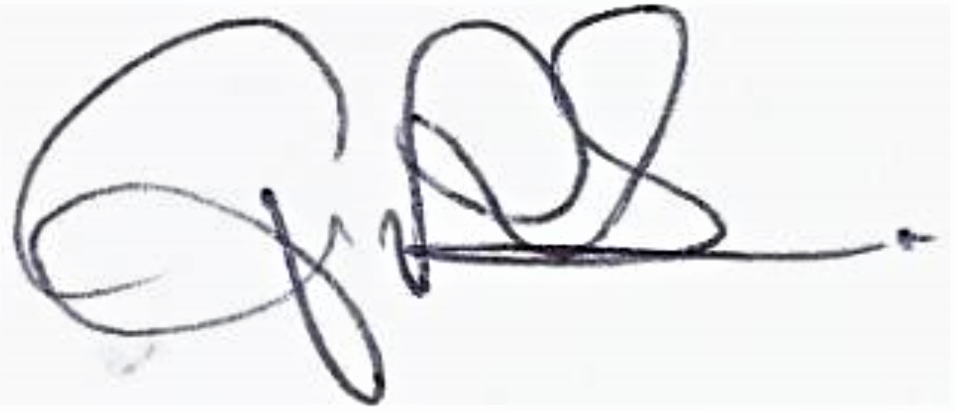

Signed

Gwyn Roberts

Print name

Director

Position

19/09/2018

Date

Application Checklist
Please tick the following checklist items to indicate that you have included the required information. If any sections of the form are left blank and no supporting information submitted, where we have insufficient information to make a decision on your application, we will return your application to you.

Essential:
Form WRA completed ☒
Map showing applicant’s land boundary with all abstraction and discharge point(s) clearly marked ☐
Evidence of negotiations of expected access rights, if applicable ☐
State number of continuation sheets (enter 0 if none included)
0

Where relevant:
Letter of authorisation from the applicant, allowing the agent to act as signatory ☐
Form WRE completed, if your proposal also requires an impoundment licence ☐
Further information requested in our pre-application response letter to you ☐
For hydropower applications, full flow duration curve for the site, confirmation of the method used to derive this and a copy of the output (graph, data and catchment map) including the Long Term Average rainfall, where available ☒
Planning Authority response, where available ☐
Additional supporting information - please list below:

Intake Dimensions and Fish Pass V2.2
Intake Dimensions Celynog Uchaf V2.2
Intake General Arrangement Celynog Uchaf V2.2
Forebay Tank Celynog Uchaf V2.0
Powerhouse GA and Dimensions Celynog Uchaf V2.0
General Layout Celynog Uchaf V3.1

Flow Duration Curve
LF results for outlet at (280276 320191)

Afon Celynog Geomorph Assessment
Afon Celynog upper scheme Ecology Report 200718

Photomap Geomorph V1.2
Geomorph Photo Survey 1-6 V2
Geomorph Photo Survey 7-12 V2
Geomorph Photo Survey 13-20 V2

