Our Ref: BL1096IB/0246694/RF | Hanson Cement
Mr S Ross  Natural Resources Wales  Chester Road  Buckley  Flintshire  CH7 3AJ | Padeswood Works  Chester Road  Padeswood, Mold  Flintshire CH7 4HB  Tel: 01244 550330  Fax: 01244 552548  www.hanson.com/uk
 | 29/01/2016

Dear Stuart

Re CAR: BL1096IB/0246694

In follow up to BL1096IB/0246694/R the response to the outstanding actions are as follows:

3.1.3 Cemfuel / Diesel Pumps & Pipework Bund

Action: Review signage and labelling and ensure that it meets all relevant standards (The Health and Safety (safety signs and signals) Regulations 1996 as amended by CLP Regulations 2015 – L64 3rd Edition Guidance, 1st June 2015.

Response: Signage meeting the relevant specifications is being progressed and will include a large area description sign, PPE and hazard awareness signs.

3.6 Kiln Bed 2

Action: Remove oil contaminated ground and dispose of at a suitably permitted site. Review the options available to prevent future spills and contamination and implement accordingly. Maintain records of the remediation work. Inform NRW of the action taken by 30/10/15.

Response: The support pillar has been steam cleaned to remove the oil residues and the contaminated ground will has been cleared and replaced with a concrete base. The pipe line down the station has had a tap fitted at the bottom to allow controlled flow to barrels.

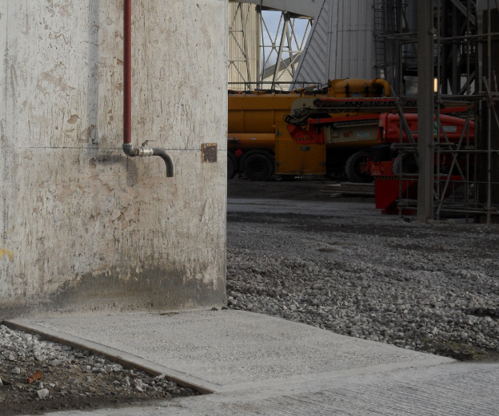

Permit Non-compliance

Action: Confirm the site surface water discharges (other than W1) and complete a pollution risk assessment to establish the pollution risk from these sources and whether adequate pollution prevention control measures are in place (e.g. oil/water interceptors, emergency shut off valve etc.). Report your findings to NRW.

Action: Review the accuracy of the site drainage plan and redraw to include the surface water lagoon and any pollution prevention equipment (the permit application refers to proposed installation of 1x Class 1 Bypass Oil/Petrol Separator or similar and 2 x particle interceptors (1 for new kiln 4 drainage and 1 for existing works).

Action: Add discharges to site emergency plan along with the required emergency response measures and train staff accordingly.

Action: The drainage plan indicates (in writing) areas of ‘cross contamination’ suggesting the materials other than surface water are entering the drainage system. Inform NRW of the nature of this cross contamination and whether action has been taken to address it.

Response

A CCTV survey of the drainage system has been completed to complement the drain survey done in 2012.

This has confirmed the routes of the drains and off-site water discharges. The outfall indicated north of the Clinker dome (WC03/SJ292623) on older plans does not exist and will be removed from future plans. There is an interceptor between the re-fuelling drains and the western outfall WC01/SJ288622, this drain runs under site from the Chester Road. An environmental risk assessment will be made of this area and outfall and the conclusions used to update the emergency response. (This will be carried out using the approach agreed to for dust minimisation as proposed 26/11/2015)

The drainage site plan will be updated as show below for the re-fuelling area and other amendments made as set out in the survey.

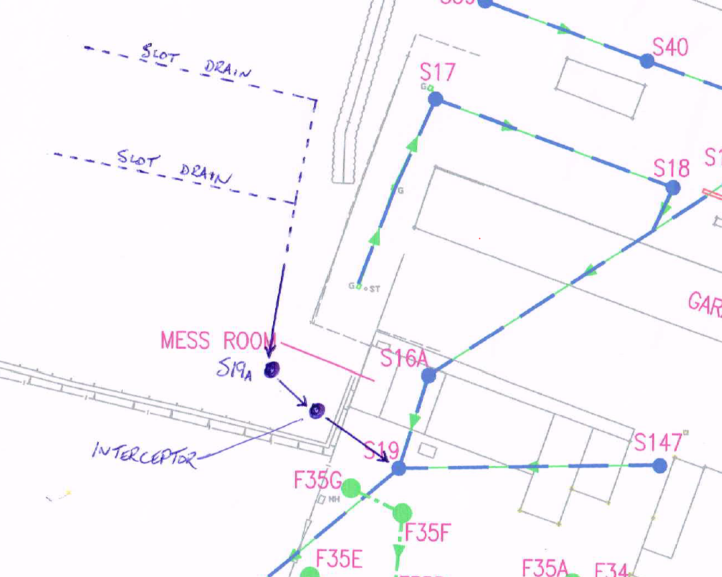

The amended plan will be merged with new site plans showing position of emergency response kits and will be included in the site documentation.

The survey confirmed one area of cross contamination which is believed to be foul entering the surface water drains outside the Mill house repair shop and welfare facilities. Investigations into the best solution to this will be carried in Q1 2016. This drain runs to the site logon via the oil separators, although BOD testing has been removed from the W1 lagoon exit point it is still carried out on the flow in this stream under the Landfill Permit EAWML/37012 above and below W1 in the watercourse.

Yours Faithfully

Victoria Smith
Quality and Environment Manager

