- Application type and fee
For the application types listed, complete this form and/or the relevant additional forms named below. Please tick which forms have been included with your application. Forms should be completed with reference to Guidance Note WRX.
* Pre-application enquiry (non-hydropower) ☐ Only complete this form
* Pre-application enquiry (hydropower) ☐ Also complete form WRB
* Application for a Groundwater Investigation Consent ☐ Only complete form WRC
New full abstraction licence ☒ Also complete form WRD
New temporary abstraction licence ☐ Also complete form WRD
New licence to transfer water ☐ Also complete form WRD
New impoundment licence ☒ Also complete form WRE
Renewal of a time-limited licence ☐ Also complete form WRD
Removal of an existing impoundment ☐ Also complete form WRE
Technical variation of an abstraction licence ☐ Also complete form WRD
Technical variation of an impoundment licence ☐ Also complete form WRE
* Administrative variations to existing licences ☐ Only complete form WRF
* No fee required

Please indicate how you wish to pay your application fee and provide a reference number where relevant.
Cheque ☐ BACS ☐ Credit or debit card ☒ Your reference number

- Applicant details

This is who the licence would be issued to and must be a legal entity such as an individual, registered company, charity or public body. If you are an agent acting on behalf of an applicant, provide their details here and yours in Section 3. See Guidance Note WRX for clarification of the details required and signatories permissible for organisations.

Applicant type:

Individual ☐ Limited company ☒ Charity ☐ Corporate body ☐ Partnership ☐ Sole trader ☐ Club ☐ Other ☐

If other, please specify

Title Full Name

Company, Charity or
Dolhendre Hydro Ltd
Trading Name
08127741
Company or Charity
Registration Number
50 High St
Mold
Flintshire

Postcode: CH7 1BH
Registered Address

Office: 01678 540348
Mobile: 07761 384654

Telephone Number
celynogisaf@outlook.com
Email Address

We will contact you by email unless you tick here ☐

Please specify who we should contact with regard to your site operation.
Site operations contact Applicant ☒ Agent ☐

For applications for abstraction licences, please also specify who we should contact for invoices and abstraction records (returns).
Invoice address* Applicant ☒ Agent ☐
Abstraction records contact* Applicant ☒ Agent ☐
* Not required for temporary or transfer licences.

Enter the agent’s details in Section 3, or provide details of alternative or additional contacts on a separate sheet and tick here to show that you have done so. ☐

Details of agent or individual authorised to act as application contact

This is who we will correspond with unless otherwise informed. If an agent has signed on behalf of an applicant, please include a letter of authorisation from the applicant allowing the agent to act as signatory.
Gwyn Roberts
Mr
Title Full Name
Dolhendre Hydro Ltd
Company, Charity or
Trading Name

Position in Company
Director
50 High St
Mold
Flintshire
Postcode: CH7 1BH
Registered Address

Office: 01678 540348
Mobile: 07761 384654
Telephone Number

Email Address
Celynogisaf@outlook.com

- Entitlement to apply (only required for abstraction licence applications)
Does the applicant have a legal right of access to the point of abstraction?
Has a right of access ☐ Has an expected right of access ☒
Owner/occupier of land ☐ Date these access rights are expected
For formal abstraction licence applications where you are the landowner/occupier, provide a map with the land boundary and all abstraction and discharge point(s) marked. Please tick here to show that you have done this. ☐
12/10/2018

For expected rights of access, please also provide the additional evidence as outlined in Guidance Note WRX. Please tick here to show that you have done this. ☒
- Application reference number
Have you undertaken a pre-application enquiry or had any previous discussions with us?
No ☐ Yes ☒ Provide reference
PPN-00216
number or staff
member’s name

- Remediation work
Is this proposal as a result of a Restoring Sustainable Abstraction programme or other work requested by us?
No ☒ Yes ☐ If yes, provide your

licence number
- Source of supply
7.1 State where you intend to abstract from
Surface Water ☒ Groundwater ☐

Give Groundwater Investigation Consent number
if applicable

7.2 Provide a 12 digit National Grid Reference for the proposed or existing abstraction or impoundment point (e.g. ST 19057 76826)

SH 79486 20446

Afon Celynog

7.3 Source of supply or location of
proposed impoundment

Celynog Isaf, Bryn Coed Ifor, Rhydymain, Dolgellau

7.4 Site name / reference

- Proposal summary
Please provide an outline of your proposal as described in Guidance Note WRX, including any sketches. If you are submitting a pre-application enquiry, this must include the quantities of water you propose to abstract. If necessary continue on a separate sheet and tick here to show that you have done this. ☐
The proposal is to build a 100Kw hydro scheme at Afon Celynog, Rhydymain. The project involves the refurbishing an old intake weir, with a new powerhouse to house the turbine and generator.

Please see attached drawings:

Intake Dimensions and Fish Pass Details Celynog Isaf V1.2
Intake Dimensions Celynog Isaf V1.5
Intake General Arrangement Celynog Isaf V2.0
Forebay Tank Celynog Isaf V2.0
Powerhouse GA and Dimensions Celynog Isaf V1.5
General Layout Celynog Isaf V3.2
- Declaration

Please see Guidance Note WRX for details of who can sign this section and note the information in that document relating to the Data Protection Act 1998.

By signing below, you are declaring that as far as you know and believe the information given in this form, on any map and in any supporting or additional information, is true.

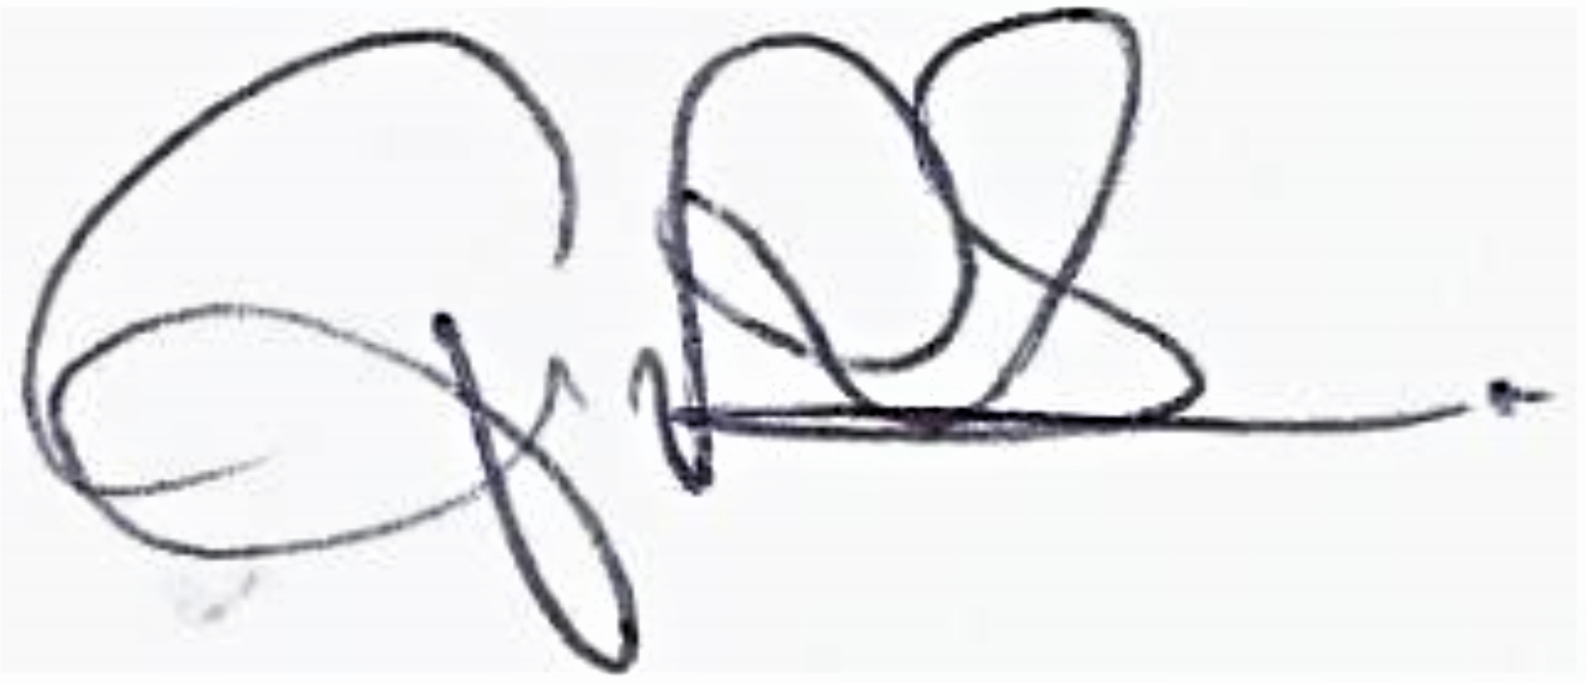

Signed

Print name
Gwyn Roberts

Director

Position

18/09/2018

Date

Application Checklist

Please tick the following checklist items to indicate that you have included the required information. If any sections of the form are left blank and no supporting information submitted, where we have insufficient information to make a decision on your application, we will return your application to you.

Essential:

Letter of authorisation from the applicant, allowing the agent to act as signatory ☐
Map showing the land ownership boundary with all abstraction and discharge point(s) clearly marked ☐

Where relevant:

Evidence of negotiations of expected access rights, if applicable ☒
For groundwater abstractions, results of pump test (if not previously submitted) ☐

For Natural Resources Wales’ use only:

Date received ________________________

Reference Number ________________________

Payment received Yes ☐ Amount received _______________________
No ☐ Not required ☐

