- Application type
New impoundment licence ☒
Removal of an existing impoundment ☐ Complete sections 2 and 4
To licence an existing impoundment ☐
Technical variation to an impoundment licence ☐
PPN-00216
Give existing licence or pre- application reference number(s)

2. Impoundment details
All information should correspond with any maps and drawings submitted with this application

2.1 Provide details of all impoundment points. For structures spanning a watercourse, provide a National Grid Reference for each bank. If necessary, continue on a separate sheet and tick here to show that you have done this. ☐

Impoundment  location name / reference | National Grid Reference for each bank,  looking downstream  (12 digit)
Impoundment  location name / reference | Left bank | Right bank
Celynog Isaf, Bryn Coed Ifor, Rhydymain | SH 79486 20445 | SH 79486 20447
2.2 Please provide a full description of the impoundment, outlining its purpose and how it will operate. If this information is detailed in a supporting document, provide the document title
or reference in the space below.
If necessary, continue on a separate sheet and tick here to show that you have done this. ☐
Water will be abstracted through the construction of a new intake weir across the full width of the watercourse, with a 3mm screen. A powerhouse will be constructed to house the turbine and generator. The pipe will be 560mm HDPE and buried for the majority of its length.

Please see drawings:
Intake Dimensions and Fish Pass Details Celynog Isaf V1.2
Intake Dimensions Celynog Isaf V1.5
Intake General Arrangement Celynog Isaf V2.0
Forebay Tank Celynog Isaf V2.0
Powerhouse GA and Dimensions Celynog Isaf V1.5
General Layout Celynog Isaf V3.2

- Description of impoundment

3.1 Name of watercourse
Afon Celynog

3.2 Will your proposed impoundment result in a change to the wetted perimeter (downstream) or new submerged areas behind (upstream of) the impounding works?
No ☒ Yes ☐ If yes, ensure this is shown on any map or drawings submitted

3.3 Will the ponded area created by the impoundment be lined? No ☐ Yes ☐
If yes, give details.
Impoundment will not raise river level

3.4 Give the height of the impoundment structure, from the downstream toe to crest or top of spillway (in metres above Ordnance Datum). If the proposal involves an existing impoundment, state the change in height (in millimetres).
Weir crest will be at crest of existing historical weir. New structure will not raise water levels (toe – 133.7mAOD / crest 135.4mAOD)

3.5 What is the overflow or crest level of the impoundment (in metres above Ordnance Datum)?
135.4 mAOD

3.6 What is the proposed capacity of the impoundment when full to spillway level (in cubic metres)?

3.7 Will the proposal create a raised reservoir? No ☒ Yes ☐

3.8 Does the proposal involve the controlled release of water to safeguard downstream flows? No ☐ Yes ☒ If yes, provide details

Residual flow provided by fixed notches, proposed design accompanying this application.

3.9 Is the impounded water to be used for a subsequent purpose? No ☐ Yes ☒

If yes, provide details (for abstractions, state the daily and annual quantities in cubic metres).

Electricity generation

Daily – 31881m3

Annual – 11636768m3

3.10 How will the impounded area be filled initially, and subsequently refilled if applicable?

- Fish and eel passage
4.1 Confirm the fish species present at your site.

Pre - app advise has indicated fish and eel are present. Please see drawing:
Intake Dimensions and Fish Pass Details Celynog Isaf V1.2

4.2 Complete the table below with full details of the measures you intend to take to safeguard these fish species.

 | Intake | Outfall
Type of fish screen | Coanda | Bar
Screen aperture size (mm) | 3mm | 10mm
Screen height and width (mm) | 700mm x 3200mm | 730mm (diameter)
Type of upstream fish passage | Rocky ramp
Proposed flow for fish pass (m/s) | 60% residual and Q95 – 0.041m3
Type of downstream fish passage | Rocky ramp
- Construction, maintenance and operation

5.1 Provide details of maintenance or activities relating to the operation of the impoundment. If necessary, continue on a separate sheet and tick here to show that you have done this. ☐

The intake screen will be regularly cleaned from debris and any blockage removed.

The intake weir will be checked regularly for any damage and repaired. Work that may be required include re-positioning of rocks and removal of vegetation.

5.2 Provide details of diversion works or removal of existing works.

Construction will occur at low flow with the weir constructed in 2 sections. One half of the river will be kept dry with the use of a temporary dam and pipe 5mtrs upstream of the intake location. The other half will then be kept dry using the same method.

- Planning application
Have you sought advice on your planning application?
No ☐ Yes ☒
If yes, submit a copy of the Planning Authority’s response.

(pre-app submitted to Snowdonia National Park 20/08/2018 – awaiting response – will forward once received)

- Declaration

Please see Guidance Note WRX for details of who can sign this section and note the information in that document relating to the Data Protection Act 1998.

By signing below, you are declaring that as far as you know and believe the information given in this form, on any map and in any supporting or additional information, is true.

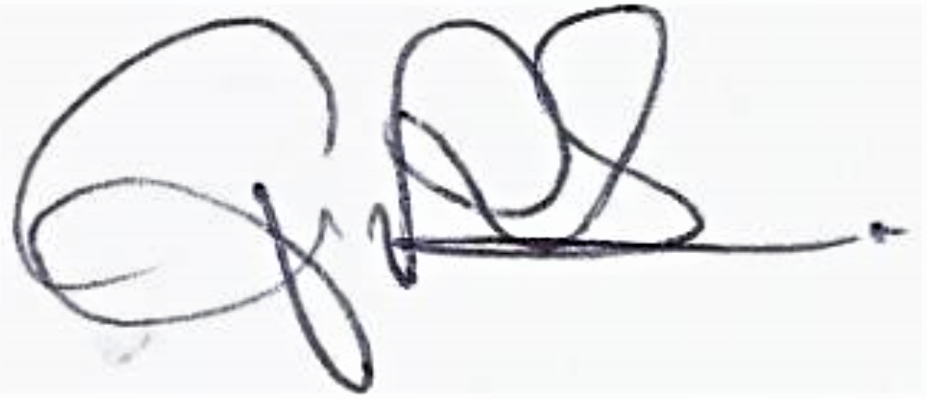

Signed

Print name
Gwyn Roberts

Director

Position

18/09/2018

Date

Application Checklist

Please tick the following checklist items to indicate that you have included the required information. If any sections of the form are left blank and no supporting information submitted, where we have insufficient information to make a decision
on your application, we will return your application to you.

Essential:
Form WRA completed, if there have been any changes since pre-application an updated Form WRA is required ☒
Map with all impoundment points and new wetted perimeters/submerged areas ☒
clearly marked
Drawings and Design Statement ☒
State number of continuation sheets (enter 0 if none included)

Where relevant:
Form WRD completed, if your proposal also requires an abstraction licence ☒
Stage 1 photo survey (contact us for more details on this requirement) ☒
Letter of authorisation from the applicant, allowing an agent to act as signatory ☐
Further information requested in our pre-application response letter to you ☒
Planning Authority response, where available ☐
Additional supporting information - please list below:

Intake Dimensions and Fish Pass Details Celynog Isaf V1.2
Intake Dimensions Celynog Isaf V1.5
Intake General Arrangement Celynog Isaf V2.0
Forebay Tank Celynog Isaf V2.0
Powerhouse GA and Dimensions Celynog Isaf V1.5
General Layout Celynog Isaf V3.2
FDC Celynog Isaf
LF results for outlet (279458 320471)
Photo Survey Geomorph V3.0
Afon Celynog Geomorph Assessment
Afon Celynog lower scheme Ecology Report 140818

