Surrender notice with introductory note
The Environmental Permitting (England & Wales) Regulations 2010

Morganite Electrical Carbon Limited

Electrical Carbon, Swansea
Upper Fforest Way
Morriston
Swansea
SA6 8PP

Surrender application number
EPR/VP3339PD/S007

Permit number

EPR/VP3339PD

Electrical Carbon, Swansea

Permit number EPR/VP3339PD

Introductory note

This introductory note does not form a part of the notice

The following notice gives notice of the surrender in part of an environmental permit.

This part surrender is removing parts of the installation which have never been used for part of the permitted activity. These areas being car parking, offices and landscaped/planted areas.

Any changes made as a result of the part surrender are set out in the schedules.

The status log of a permit sets out the permitting history, including any changes to the permit reference number.

Status log of the permit
Description | Date | Comments
Application VP3339PD (EPR/VP3339PD/A001) | Duly made 11/03/04
Additional information received | Requested 04/08/04 | Received 27/08/04 and 20/09/04
Permit determined VP3339PD (EPR/VP3339PD/A001) | 06/05/05
Regulation 16 Notice* Application | 14/06/05
Regulation 16 Notice Determined | 05/07/05
Variation application EP3533LE (EPR/VP3339PD/V002) | Duly made 30/10/05
Variation determined EP3533LE (EPR/VP3339PD/V002) | 05/01/06
Variation application EP3536LY (EPR/VP3339PD/V003) | Duly made 05/06/06
Variation determined EP3536LY (EPR/VP3339PD/V003) | 04/09/06
Variation application CP3331MX (EPR/VP3339PD/V004) | Duly made 21/12/06
Variation determined CP3331MX  (EPR/VP3339PD/V004) | 04/05/07
Variation application EPR/VP3339PD/V005 | Duly made 04/03/11
Variation determined EPR/VP3339PD/V005 | 17/06/11
Agency variation determined EPR/VP3339PD/V006 | 04/03/13 | Agency variation to implement the changes introduced by IED
Part Surrender application EPR/VP3339PD/S007 | Duly Made 16/05/2016 | Part surrender of non process areas of the site
Additional information received | 31/05/2016 | Plan showing new installation boundary
Part Surrender determined  EPR/VP3339PD/S007 | 18/07/2016 | Part Surrender Issued

End of introductory note

Notice of surrender
The Environmental Permitting (England and Wales) Regulations 2010

The Natural Resources Body for Wales (“Natural Resources Wales”) in exercise of its powers under regulation 25 of the Environmental Permitting (England and Wales) Regulations 2010 accepts the surrender in part of

Permit number

EPR/VP3339PD

issued to:

Morganite Electrical Carbon Limited (“the operator”)

whose registered office is

Upper Fforest Way

Morriston

Swansea

West Glamorgan

SA6 8PP

company registration number 01034653

to operate a regulated facility at

Electrical Carbon, Swansea

Upper Fforest Way

Morriston

Swansea

SA6 8PP

to the extent set out in the schedules.

The notice shall take effect from 18/07/2016.

Signed | Date
 | 18 July 2016

Eirian Macdonald

Authorised on behalf of Natural Resources Wales

Schedule 1 – conditions to be deleted

None.

Schedule 2 – conditions to be amended

None.

Schedule 3 – conditions to be added

None.

Schedule 4 – amended plan

The area of the site is reduced to that shown in the attached amended plan.

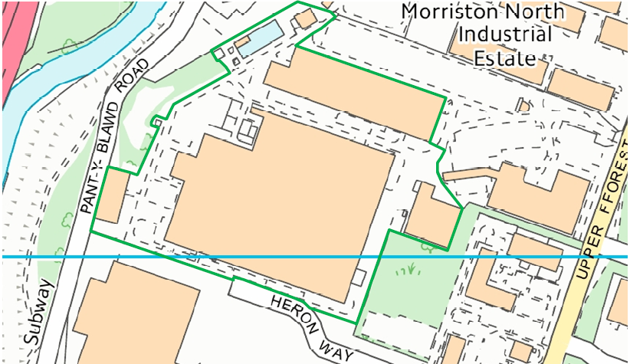

© Crown Copyright and database right 2016. Ordnance Survey licence number 100019741.

