Ein cyf/Our ref: XP3436ME

Eich cyf/Your ref:

Dyddiad/Date: 9 October 2018

P A and J Whittingham
Lower Pentwyn Poultry Farm
Lower Pentwyn
Nantyderry
Abergavenny
Monmouthshire
NP7 9DN

Dear Mr Whittingham

Pig and Poultry Assurance Scheme: Compliant Inspection
Farm Name: Lower Pentwyn
Permit Number: XP3436ME

Thank you for taking part in the inspection by your Farm Certification Body on 4 October 2018.

We are pleased to confirm that at the time of inspection you were compliant with your permit. Your farm will continue to remain in the scheme for the current year.
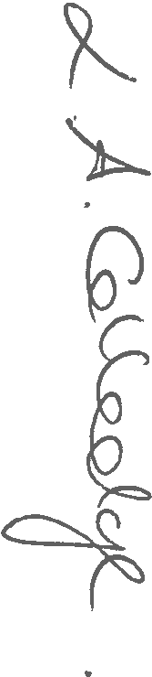
Please contact us should you have any questions about this letter.

Yours sincerely

LESLEY COLLEDGE
Swyddog Rheoleiddio / Regulatory Officer
Cyfoeth Naturiol Cymru / Natural Resources Wales
Ffôn/Tel: 0300 065 3492
E-bost uniongyrchol/Direct e-mail: lesley.colledge@cyfoethnaturiolcymru.gov.uk
Croesewir gohebiaeth yn y Gymraeg a'r Saesneg
Correspondence welcomed in Welsh and English

