Permit
The Environmental Permitting (England & Wales) Regulations 2016

Breedon Trading Limited

Borras Quarry
Borras Airfield
Holt Road
Holt
Wrexham
LL13 9SE

Permit number

EPR/CB3597FW

Permit
The Environmental Permitting (England and Wales) Regulations 2016

Permit number

EPR/CB3597FW

The Natural Resources Body for Wales (“Natural Resources Wales”) authorises, under regulation 13 of the Environmental Permitting (England and Wales) Regulations 2016

Breedon Trading Limited (“the operator”),

whose registered office is

Pinnacle House

Breedon Quarry

Breedon On The Hill

Derby

England

DE73 8AP

company registration number 00156531

to operate waste operations at

Borras Quarry

Borras Airfield

Holt Road

Holt

Wrexham

LL13 9SE

to the extent authorised by and subject to the conditions of this permit.

Under regulation 27(2) of the Regulations, standard rules SR2008 No11 are conditions of this permit.

Name | Date
Huw Davies | 28/06/2022

Authorised on behalf of Natural Resources Wales

Schedule 1 - Site plan

This is the plan referred to in the standard rules SR2008 No11

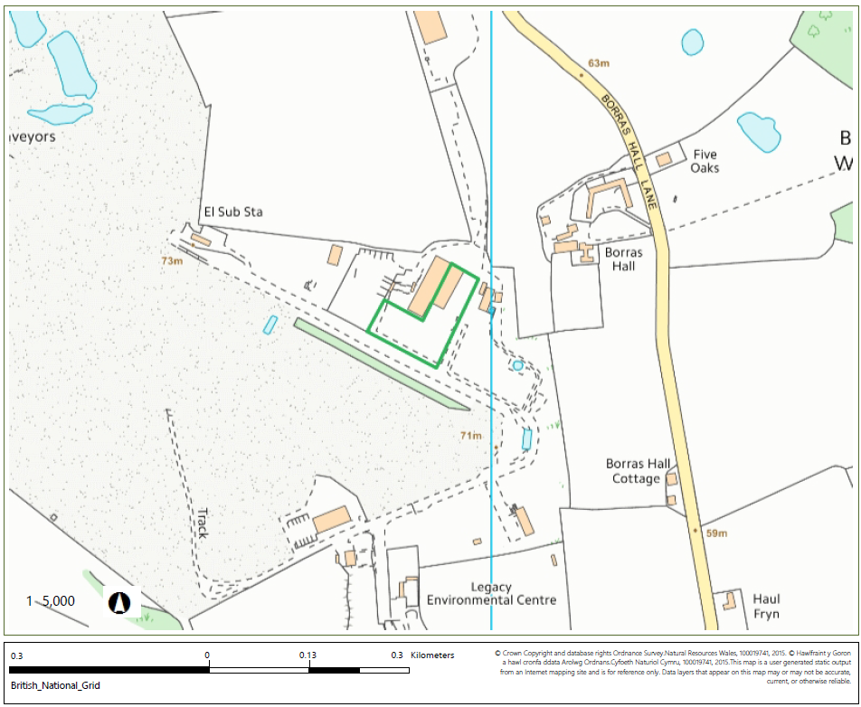

© Crown Copyright and database right 2022. Ordnance Survey licence number 100019741.

END OF PERMIT

