Bespoke Permit for Water Discharge

 | Water Management Plan
Date | 18/10/2021
Revision B 13/12/2021
Revision C 24/01/2022
Revision D 18/02/2022
Revision E 17/05/2022

 | Prepared
Author | Elliot Hutchings – Environmental Advisor
Signature | 
Checker Approver | Andrew Crossley – Environmental Advisor
Signature | 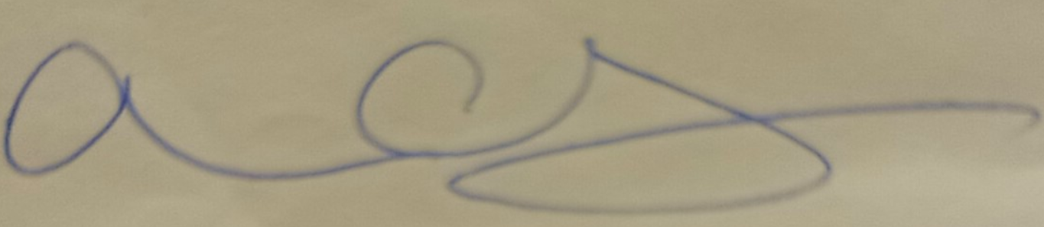

REVISION TABLE

General update – all pages have been revised.

TABLE OF CONTENTS
1 Preliminaries 5
1.1 Purpose 5
1.2 Scope 5
1.3 Definitions & abbreviations 5
1.4 Responsibilities 6
2 Compliance obligations 7
2.1 Environmental Permitting Regulations 2016 7
3 background and controls 7
3.1 Background 7
3.2 Procedural Control Measures (Surface water runoff) 7
4 Pollution mitigation 10
4.1 oil use, storage and Refuelling 10
4.2 Chemical use / Storage (CoSHH) 10
4.3 Permit to Pump 11
5 Monitoring 11
5.1 Siltbuster Check sheet 12
5.2 Soneco Check Sheet 12
6 Siltbuster HB Chemical Treatment System 12
6.1 overview Siltbuster 12
6.2 Siltbuster 2-Stage Chemical Pre-Treatment System 12
7 Soneco 3 stage Treatment system 14
7.1 Water Quality for Discharge 15
8 Passive Dewatering 16
9 Discharge Overviews 17
9.1 Siltbuster 17
9.2 Soneco 17
9.3 Passive Dewatering 18
10 Water Catchment on Average Rainfall 20
11 operational Arrangements 21
12 appendix 1 22
12.1 Aquatreat 22
12.2 Brenntag PAC 24
12.3 Caustic Soda Liquor 31
13 Appendix 2 – Siltbuster check sheet 39
14 Appendix 3 Soneco Check Sheet 40
15 Appendix 4 41
15.1 Rutpen A9 41
15.2 Water Lynx 360 43
15.3 Water Lynx 395 45
16 Appendix 5 – Floc mat Release Rate 48

Preliminaries

Purpose
The purpose of this Water Management Plan (WMP) is to identify the FVC / FCC works that may require a water discharge activity permit and control measures required to prevent such contamination of water courses by, interaction with water infrastructure or generated water effluent (Trade Effluent), and detail the management and monitoring in compliance with regulatory guidelines and advice.
- Dewatering of Excavation(s)
- Surface Water Runoff

Scope
FVC / FCC are constructing a 17.7km / 11 mile road known as the A465 Heads of the Valleys section 5 and 6. The project will extend between Hirwaun and Dowlais Top. It will leave the current A465 between the Hirwaun and Trewaun junctions for about a mile (1.4km) and between the Taf Fechan Viaduct and the Gurnos Farm underpass for about half a mile (0.8km).

Definitions & abbreviations
FVC | Future Valleys Construction
FCC | FCC Construction
NRW | Natural Resources Wales
TSS | Total Suspended Solids
AGC | Alun Griffiths Contractors
RB | Road Bridge
RPS | Regulatory Position Statement
NTU | Nephelometric Turbidity Units
TV | Thames Valley

Responsibilities
Responsibilities to prepare and maintain this document:

FVC / FCC
FVC / FCC as the principle contractor are responsible for driving Good Industry Practice to minimise the impacts of works on the water environment, by ensuring contractors undertake all measures to protect identified receptors of water courses by pathway means.
- Ensuring resources are available to contractors for mitigation measures;
- Updating and approving amendments to all relevant contractor documentation;
- Protecting water management infrastructure in their areas of work scope;
- Undertaking inspections, assessments and audits;
- Evaluating compliance on an ongoing basis, ensuring contractors are compliant;
- Monitoring;
- Supporting incident investigations in a timely manner;

FVC / FCC Environmental Manager/Advisor
- They will be responsible for updating this management plan and carrying out duties such as monitoring to ensure compliance and control measures are in place
- All the above 1.4.1 shall be within this scope of works

Construction Managers and Supervisors
- They will be responsible for ensuring a request has been submitted for a permit to pump before entering a new area and that adequate water management arrangements have been made.
- They will be responsible for ensuring any accidents that may have an impact on water quality have been reported to the FVC / FCC Environmental Team immediately to prevent further pollution from occurring.
- They (or a nominated deputy) will be responsible for the implementation of the control measures as detailed in this Water Management Plan. They will be responsible for the day to day checking and operation of equipment associated with water management.

Compliance obligations

Environmental Permitting Regulations 2016
These Regulations set out an environmental permitting and compliance regime that applies to various activities and industries. Permits set controls and emission standards to minimise pollution and allow operators of certain installations to operate. Any operational ‘regulated facility’ requires an environmental permit; a regulated facility means a water discharge, groundwater and radioactive substances activities.

background and controls

Background
There are a total of 58 water features: three main rivers, five significant tributaries and a further 50 channels that are crossed or which lie within a 500 m buffer zone around the extent of the scheme, the majority of which are already crossed by the existing road. These include two large tributaries of the Afon Taf (the Cwm Taf Fechan and Afon Taf Fawr) and the Afon Cynon.

Procedural Control Measures (Surface water runoff)
There shall be a Tier approach system to control and minimise surface water runoff. It is key to ensure that surface water is kept clear and away from excavations and earth works as best as reasonably practicable. Each Tier system shall be deployed to ensure the natural flow of water is not affect by works and diverted away, failure to carry out these requirements each tier approach shall be upped in measure. Where all systems are overwhelmed Tier 4 shall be implemented for active treatment and recognition with requirements of NRW / Local Authorities.

Tier 1
Mechanisms for reducing the volume of water and silt available for transfer to surface waters. Primary mechanism of control will be segregation. Surface water/runoff will be segregated and/or minimised from contact with the surface to reduce, as far as is practical, the volume of sediment contaminated water (Silt).
- Excavated drainage channels or stoned and lined V-drains (French Drainage).
- Weathering off of exposed areas, tracked in, sealed or covered
- Silt fencing, fibre rolls, geo-textiles and can be used to manage areas to prevent that of surface water runoff (Fig Below jute matting)
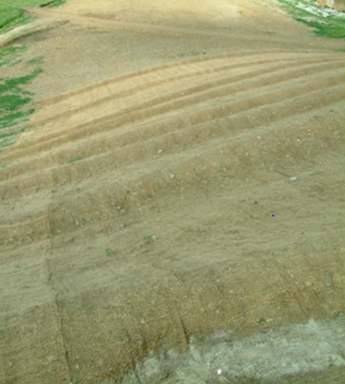

Tier 2
Mechanisms for slowing the flow of sediment rich water to help sediment dropout and treatment. This primarily involves increasing the retention of water as it passes through the Schemes drainage channels, allowing sediment to settle out naturally. Examples of potential mitigation methods include:
- Discharge to Vegetation
- Straw Bales
- Weirs
- Pea Shingle Beds
- Filter Fabrics
- Erosion Berms (Fig below)
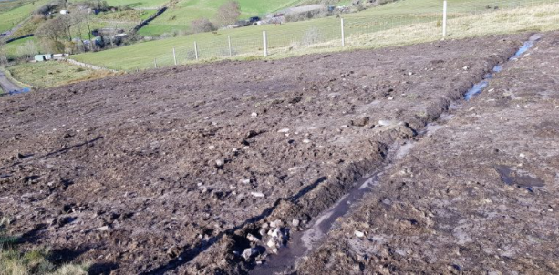

Tier 3
Mechanisms offer solutions for retaining sediment rich water, to allow further settlement prior to discharge or further treatment. This requires the inclusion of systems that allow sediment to settle out naturally, examples of potential mitigation methods include settlement lagoons or settlement systems.
- Attenuation / Settlement Lagoons – Sizing of such shall be determined on a site-by-site basis due to the site constraints, dynamics of excavation, sites shall vary in size across the scheme.
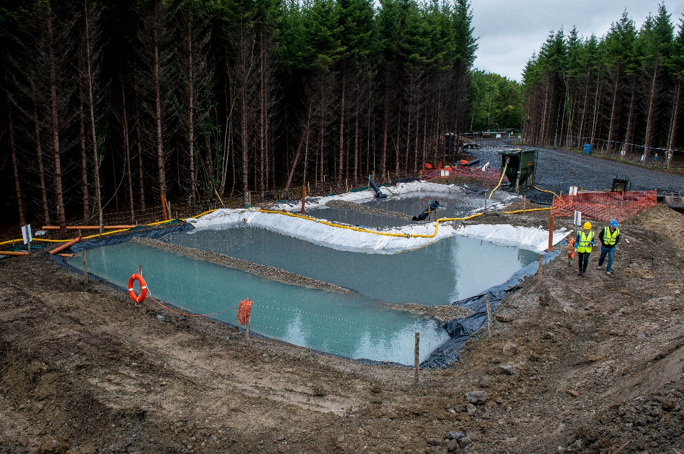

Tier 4
Active settlement and polishing of waters from excavations with use of flocculant-based materials. Where settlement can be achieved within lagoons added measure shall be used to help with NTU / TSS to reach a more acceptable discharge. Products shall be used at inlets of ponds and outlet drainage channels to ensure cleanliness remains to outfall point. See appendix for safety data sheets

Floc Mat
The floc mat is designed to treat and capture fine silts and suspended particles. Its main function is to flocculate fine sediments enabling settling and separation from water. Sediment is trapped within the matrix of the matting; a single matting can hold up to 50kg of sediment.
- Material – Coir (fibres, netting, rope),
- Dimensions – 2x1 x 0.1m
- WaterLynx Gel Flocculant 360
- WaterLynx Gel Flocculant 395
See appendix 14 for release rate based on 5, 10, 15 and 20 mat deployment

Rutpen Flocculant Block A9
The A9 shall be used in aid with settlement lagoons should the settlement not be sufficient. Visual checks will be carried out to confirm clarity of water to confirm requirement for use of A9. A9 block shall be suspended at inlet of ponds to allow water to flow over block which will actively promote settlement. The product is a synthetic anionic flocculant in the form of a solid block, designed to slowly dissolve and flocculate suspended solids. The A9 block comes in 3kgs. It is estimated on average 1 A9 block of 3kg shall last approximately 3 months.
Representative Example 1 Matt
Flow rate at inlet | 40m3 (Pump)
Dosage | 1 x A9 flocculant 3kg
Rinse of Polish | - Pump 40m3/h – 36,000m6/90days (3 months)  - A9 Block 3kg – 3,000,000mg  - 3,000,000 / 3,600,000ltrs  - A9 – 0.8mg/ltrs over 90 days if run at full ratio

Note – where active siltbuster treatment is ongoing, the above shall not be used in conjunction

Tier 5
Active Treatment Subject to site constraints, flow rates, elevated levels of sediment load, effectiveness of passive measures, etc. it may be necessary to implement active treatment techniques to mitigate sediment release.
Treatment options can include:
- Conditioning through use of coagulants i.e. ‘floc-blocks’
- Lamella clarifiers
- Hydro-cyclones
- Silt-buster settlement tanks, etc.

Pollution mitigation
All temporary and permanent site compounds shall be at least 15 m away from the top of the bank of main rivers or 8 m away from ordinary watercourses. No single skin storage containers containing hydrocarbons, only double skin mobile bowsers will be allowed. All storage of any hazardous substance will be within impervious or internal, bunded, secure areas.

oil use, storage and Refuelling
All oil storage above ground containing more than 200ltrs shall follow the guidelines of the Oil Storage Regulations (OSR) Wales 2016 and GPP2.
- Tanks shall be of sufficient strength and structural integrity to ensure that it won’t burst or leak in ordinary use
- There shall be no single skinned tanks present on site, where there are these shall be placed into a secondary containment system
- Double skinned tanks must be of the design that allows for 110% capacity of the volume of the tank
- All secondary containment must hold 110% of the volume
- All singular items of oils shall be store on secondary containment either of 110% capacity or 25% of the total capacity whichever is greater
- Secondary containment shall be covered from excess dependent rainfall
- Mobile bowsers with pipe shall be locked by padlock when not in use, parked away from any watercourse on impermeable grounds
- All refuelling of plant on site shall be carried out at platform designated refuelling point. Plant working near watercourse shall track back to point for refuelling.
- Regular daily maintenance of containers / tanks / delivery hoses shall be carried out to ensure integrity

Chemical use / Storage (CoSHH)
- All secondary containment must hold 110% of the volume
- All singular items of oils shall be store on secondary containment either of 110% capacity or 25% of the total capacity whichever is greater
- All chemicals must be accompanied with a valid Safety Data Sheet, and reference to section 6
- All chemicals shall be store in a designated area, away from access / egress ports utilised by plant and vehicles
- Only chemicals required for days work shall be out for use on platforms, all other chemicals shall be placed in storage as above
- All products brought onto site shall be of water based quality / WRAS certification
- Storage of chemical within containment tor secondary bunding shall be placed on impermeable ground or compacted hard stand ground at site

Permit to Pump
Before any works for dewatering commences all Contractors must submit a ‘Permit to Pump’ or similar works authorisation will be sought from the Environmental Team.
Therefore, AGC / RB / TV shall:
- Submit a Permit to Pump request to the FVC / FCC Environmental Team.
The following details will be included as a minimum:
- The location that the permit to pump will cover;
- The purpose of the permit to pump (i.e. draining of surface water, dewatering of excavations);
- A sketch plan showing the planned area for the permit to pump to cover including drainage arrangements.
- Proposal on mitigation measures in place to prevent pollution.
All permit requests will be completed by those preparing for the work e.g. section engineers or project managers, with the support of the FVC / FCC Environment Team.

Monitoring
Daily / Weekly physical checks will be completed in line with the requirements of each permit. For monitoring purposes and consistency, these checks will be completed at the location of the upstream (Lagoon[s]) and downstream (outlet[s]) as identified in the plans submitted. The checks will include the following:
- pH test
- TSS / NTU
- Turbidity
- Dissolved Oxygen
- Check for visible oil or grease (i.e. ‘rainbow’ sheen);
- Check that the pumping set up appears to be functioning as designed.
- Check for the build-up of solids; and
- Check the pollution prevention controls are in place.
Monitoring shall be carried out with the use of a calibrated Aquaread AP 800.
- pH4.01 Buffer
- ORP Cal Solution
- Zero Oxygen Solution
- 1000NTU Calibration Solution
The Monitoring Locations are listed below. Please note the NGRs provided in this list are approximate, as the exact location will vary according to waterway conditions; Additionally in some locations, access is restricted.

Discharge location | Monitoring location Upstream | Monitoring Location Downstream
Outlet 3: Taf Fawr East Discharge | SO 02761 07963 | SO 02822 07900
Outlet 2: Dowlais West Discharge | Excavation monitoring | SO 07637 08202
Outlet 1: Dowlais East Discharge | ST 91000 68000 | SO 08531 08635
Outlet 13: Section 2 (Nant Melyn) | SN 97898 06245 | SN 97927 06214
Outlet 10: Section 2 (Nant Hir Bridge) | Excavation monitoring | SN 98955 06987
Outlet 15: Afon Cynon Discharge | SN 96771 05321 | SN 96830 05320
Outlet 14: Section 2 (Croesbychan) | SN 97571 05692 | SN 97766 05570
Outlet 12: Section 2 (Nant Melyn North) | SN 97898 06245 | SN 97927 06214
Outlet 11: Section 2 (Culvert 5969) | NA permanent drainage design | SN 98450 06607
Outlet 9: Section 2 (Nant Hir East) | Excavation monitoring | SN 98955 06987
Outlet 8: Section 2 (Baverstock South) | SN 99814 07116 | SN 99764 06993
Outlet 7: Section 2 (Swansea Road) | SO 00825 07356 | SO 01454 07311
Outlet 4: Taf Fawr West | SO 02761 07963 | SO 02822 07900

Siltbuster Check sheet
Preoperational check sheets shall be used to ensure the unit(s) full system is operational before any water discharge activities begin. Such checks shall cover the following processes…
- General (Unusual sounds, pipework and connections, alarms and fault errors, cables)
- Mechanical (Motors running correctly, Vents, flowmeters, dosing pumps, sludge pumps)
- Consumables (Level of chemicals, damage occurred, storage containment of chemicals)
- Clarifier (Visual checks clear water outlet, solid build up, hoppers i.e. de-sludge)
- Reaction Tank (pH level of water 6-9, lines for blockages, visual check solids aggregating, cleaning of pH prob)
Note – see appendix for template

Soneco Check Sheet
Preoperational check sheets shall be used to ensure the unit(s) full system is operational before any water discharge activities begin. Such checks shall cover the following processes…
- Aluminium Dose mg/l
- Plate Life (Lamella)
- Mix tank 1 and 2 (Slurry build up)
- Water conductivity
- Treated Water TSS gage / set up

Siltbuster HB Chemical Treatment System

overview Siltbuster
The project has adopted the 2-stage chemical pre-treatment system (as and when required pH correct with Sodium Hydroxide).

Siltbuster 2-Stage Chemical Pre-Treatment System
Many of the Siltbusters are being used to treat surface run off following rain dependent fall and as such with regularly dry up upon cease of downfall. The 2-stage chemical pre-treatment system will comprise of the Silt-buster HB50. This unit is subject to treatment quantities of 5-60m3/h – slow settling solids. Set up system shall include the following process…
- Inlet electromagnetic flow meter to record the volume of water treated and allow flow proportional dosing of coagulant and polymer.
- Mix Tank to allow the controlled mixing of the treatment chemicals ensuring flocculation of the solids (size dependant on flow).
- Flow proportional control system for coagulant and flocculant polymer dosing. The use of flow proportional dosing system minimises the risk associated with the overdosing of the treatment chemicals.
- Coagulant dosing pump and associated pipework to allow the automatic flow proportional addition of the coagulant.
- Flocculant make-up system complete with 1000 litre make up tank, mixer bridge 110 V (32 Amp) mixer complete with paddle (potable water will be required on site for polymer dilution) and flow proportional dosing pump (peristaltic or similar).
- 1 No IBC spill stand/containment bunds for the temporary storage of chemicals.
Siltbuster HB50 Gravity Operated Settlement Units (Recovery of Suspended Solids)
- 2 No. Siltbuster HB50 Lamella Clarifiers (dependent on flow rate) to separate the suspended solids from the treated water.

Site Setup as provided by Silt-buster | 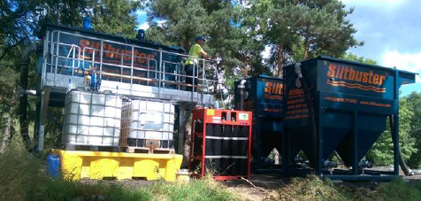

Treatment and dosing
Improved settling characteristics shall be achieved using two stage chemical pre-treatment in which…
- A coagulant (PAC) is added to the water to cause the fine particulates to aggregate together into larger particles.
- A flocculant (anionic polymer) is added to bind the particles together and increase the particle size, enhancing the settlement rate. The addition of the polymer shall enable near complete removal of the suspended solids.

Estimated Coagulant Consumption
At a dose rate of 12.5mg/l of PAC at a flow rate of 60m³/hr, it is estimated that 10.25 litres of coagulant will be consumed per hour. If consistently operated over a 24-hour period, we would expect 246.1 litres of coagulant be consumed per day.

Estimated Flocculant Consumption
At a dose rate of 2mg/l of EM533 at a flow rate of 60m³/hr, at a working strength of 0.2% it is estimated that 60 litres of flocculant as a working strength solution (water + flocculant) will be consumed per hour. This would equate to 59.6 litres of water only per hour, and 0.4 litres of flocculant only per hour. If consistently operated over a 24-hour period, expect 4.8 litres of neat flocculant to be consumed per day, and 1430.4 litres of water only to be consumed per day.

Sodium Hydroxide Consumption
Due to the nature of the predominantly upland landscape dominated by acid grassland and peatland habitats sections of the works generate acidic water. Where such waters are treated via siltbuster, the pH will be adjusted accordingly i.e. either to match the upstream pH or adjusted if it was to be discharged to existing vegetation, where that vegetation may be adversely affected by differences in pH.
NOTE – the above values are in place to give a direct concentration should operation be required around clock. It is not the intention to run such treatment for prolonged period of times.

Water Quality for Discharge
Direct water quality from the treated facility shall be free from solids as best a practicably possible due to Siltbuster operational usage. The aim is to remove solids (TSS) from the water and discharge water back into the receiving environment to which it has come from. Water shall be discharge direct back to surrounding waters as per upstream values indication. An example can be seen below for achievable measures.
Lab Result | Feed Water (From Lagoon) | Treated Outlet from Silt-buster
pH | 7.82 | 7.05
Total Suspended Solids (TTS) | 4294mg/l | 11mg/l
Evidence | 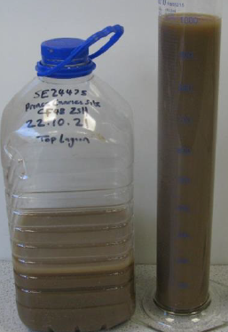 | 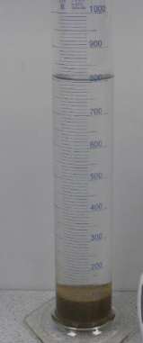

Soneco 3 stage Treatment system
The Soneco electro-generates Aluminium from a solid metal anode to condition water that has become contaminated during construction activities, (rainwater run-off). Conditioning the water allows the solids to be consolidated and removed in the lamella settling tank, and the treated water to be discharged as appropriate.
Three-stage treatment system
- 1. Soneco Process with Aluminium Electrodes
- 2. 2 Stage Flocculation Tank (no additional chemicals, this is a mix tank for settlement)
- 3. Lamella Settlement Unit for Solids Liquid Separation
Collected waters are pumped to the treatment system via the feed pump. The Soneco reactor electro-generates Aluminium which encourages the solids in the water to coagulate and then flocculate in the 2-stage flocculation tank. The bound particles are then settled in a lamella tank, which allows the clean water to overflow from the top of the tank, and the accumulated solids being pumped from the bottom the tank for disposal.
A flowmeter is used on the inlet to determine flow rate through the system and to proportionally add aluminium whilst an online turbidity monitor is used to monitor discharge water quality. Ultrasound is applied to manage passivation of the anodes.

Water Quality for Discharge
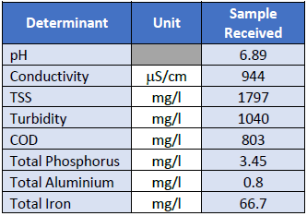
Sample of site waters pre testing

Post Testing of sampled water with active treatment
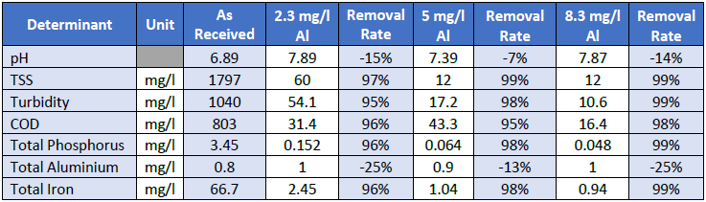
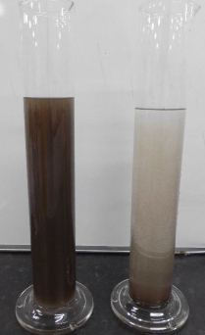  Dose rate of 2.3mg/l Al | 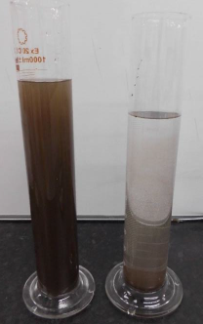  Dose Rate of 5mg/l Al | 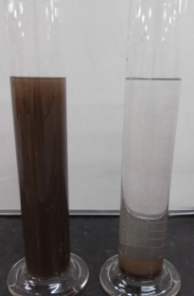  Dose rate 8.3mg/l Al

Passive Dewatering
Passive dewatering shall be carried out across site as and where flow rates can be controlled by the Tier approach system to a successful attenuation design. Where waters shall enter designed ponds on a Tier 3 basis, there shall be added Tier 4 approach to allow for greater settlement of TSS within water contained. Waters shall not be pumped from such containment but shall be allowed to fill and passively discharge. Within the passive approach there shall be use of the A9 Flocculant block at inlet of attenuation ponds, at the outlet, only if required there shall be added measures with flocculant matting for extra polish and removal of TSS to ensure NTU is of an acceptable clarity upon onsite monitoring.
- See section 3.2.4.2 and appendix for calculations of usage of flocculant material

Discharge Overviews

Siltbuster
Project | A465 Section 5 and 6 Hirwaun to Dowlais Top
Site Office | Baverstock Compound, Dynevor Arms, Llwydcoed, Aberdare CF44 0ND
Discharge Location | - Taf Fawr East - SO 02853 07963  - Dowlais West Discharge – SO 07668 08201  - Dowlais East Discharge – SO 08537 08631  - Section 2 (Nant Melyn East) - SO 97928 06232  - Section 2 (Nant Hir Bridge) – SO 98964 06973  - Section 2 (Baverstock South) – SO 00036 06815
Effluent Discharge | - Taf Fawr East Discharge  - Dowlais West Discharge (Direct to drainage ditch, flow to Dowlais Reservoir)  - Dowlais East Discharge (Surface Water Drainage, potential flow Nant Carno)  - Section 2 (Nant Melyn East)  - Section 2 (Nant Hir Bridge)  - Section 2 (Baverstock South)
Nature | Dewatering of excavations, capture of surface water run off to settlement ponds, treatment of water via chemical treatment before discharge to either existing drainage, ditch or direct to watercourse as per GPS Ref
Volume Calculation | The element of discharge rates is designed to be at a worst-case scenario upon rainfall dependent water creating excess flows at work face. It is not envisioned that such rates of pumping shall be required on a constant basis but rather a necessity for when require. Therefore, at each location noted it is the below estimation…  Siltbuster HB50 treatable of 5-60m3/h  3600sec (60secs to 1 min) – 13.8ltrs/s  10 hour working day, subject to operation over 10 hours this would conclude 300 to 600m3/Day, rainfall dependent  Note – unit shall be run below maximum to ensure full efficiency
Process of Treatment | Lagoon settlement, Primary Settlement, Chemical Settlement
Outline Drawing | See associated documents  - Taf Fawr East Discharge  - Section 2 Active Treatment Discharge  - Dowlais Discharge

Soneco
Project | A465 Section 5 and 6 Hirwaun to Dowlais Top
Site Office | Baverstock Compound, Dynevor Arms, Llwydcoed, Aberdare CF44 0ND
Discharge Location | - Afon Cynon – SN 96818 05324
Effluent Discharge | - Afon Cynon Discharge (to grassland or direct to Afon Cynon)
Nature | Dewatering of excavations, capture of surface water run, treatment of water via mechanical treatment before discharge to either existing drainage, ditch or direct to watercourse as per GPS Ref
Volume Calculation | The element of discharge rates is designed to be at a worst-case scenario upon rainfall dependent water creating excess flows at work face. It is not envisioned that such rates of pumping shall be required on a constant basis but rather a necessity for when require. Therefore, at each location noted it is the below estimation…  Soneco 3 stage treatment  3600sec (60secs to 1 min) – 13.8ltrs/s  10 hour working day, subject to operation over 10 hours this would conclude a maximum 100m3/Day, rainfall dependent. Unit is designed for 10m3/h  Note – unit shall be run below maximum to ensure full efficiency
Process of Treatment | Primary Settlement at culvert out point, Mechanical Settlement
Outline Drawing | See associated documentation  - Afon Cynon Discharge

Passive Dewatering
Project | A465 Section 5 and 6 Hirwaun to Dowlais Top
Site Office | Baverstock Compound, Dynevor Arms, Llwydcoed, Aberdare CF44 0ND
Discharge Location | - Section 2 (Croesbychan) – SN 97883 05518  - Section 2 (Nant Melyn North) – SN 97920 06254  - Section 2 (Culvert 5969) – SN 98361 06591  - Section 2 (Swansea Road) – SO 01451 07307  - Taf Fawr West – SO 02703 07993
Effluent Discharge | - Section 2 (Croesbychan)  - Section 2 (Nant Melyn North)  - Section 2 (Culvert 5969)  - Section 2 (Swansea Road)  - Taf Fawr West Discharge
Nature | Dewatering of excavations, capture of surface water run off to settlement ponds, treatment with flocculant products prior to natural flow into existing drainage ditches, land or watercourse as per GPS Ref
Volume Calculation | The element of discharge rates is designed to be at a worst-case scenario upon rainfall dependent water creating excess flows at work face. It is not envisioned that such rates of pumping shall be required on a constant basis but rather a necessity for when require. Therefore, at each location noted it is the below estimation…  Selwood pumps for hire 20-30m3/h  3600sec (60secs to 1 min) – 13.8ltrs/s  10 hour working day, subject to operation over 10 hours this would conclude 200-300m3/Day, rainfall dependent. This is waters pumped to a primary settlement and not a direct discharge but an overflow from attenuation via, floc and floc matt polish
Process of Treatment | Lagoon settlement, Primary Settlement, Chemical Settlement
Outline Drawing | See associated document  - Section 2 Passive Discharge  - Nant Ffrwd East West  - Taf Fawr West Discharge

Siltbuster Waste Arisings
Waste arisings shall be processed by means of drying out to allow moisture content to demise. There shall be no off-site removal of material from this process as the slurry or silt shall be tested as per client materials management plan criteria to ascertain if material is good for landscape fill process.

Water Catchment on Average Rainfall
The below table is an estimated summary of each site inclusive of its catchment area along with the average rainfall prediction as per Natural Resource Wales measuring station situated at Hirwain 2022. The information below is a guideline for a month period, as this cannot be assessed as each monthly rainfall event can change.
The calculation used to determine such runoff is concluded (Cumulative actual 301mm recorded February 2022) …
Average Rainfall (m) x Catchment Area (m2) x Surface Coefficient 0.1
Untreated Ground Catchments
Soil on slopes less 10% | 0.0 – 0.3
Rocky Natural Catchments | 0.2 – 0.5
Reference: Pacey, Arnold and Cullis, Adrian 1989, Rainwater Harvesting: The collection of rainfall and runoff in rural areas, Intermediate Technology Publications, London
Site Name | Catchment Area m2 | Surface run off estimate on average highest rainfall per 1 month (m3) | Attenuation Pond (m3)
Outlet 3: Taf Fawr East Discharge | 7,700 | 231 | 509
Outlet 2: Dowlais West Discharge | 24,891 | 747 | 2000
Outlet 1: Dowlais East Discharge | 95,730 | 2,872 | 1500+350
Outlet 14: Section 2 (Nant Melyn East) | 8,040 | 241 | 675
Outlet 10: Section 2 (Nant Hir Bridge) | 9,670 | 290 | 800
Outlet 15: Afon Cynon Discharge | 13,708 | 411 | 1744 + 798
Section 2 (Croesbychan) | 110,000 | 3300 | 1318
Outlet 13: Section 2 (Nant Melyn North) | 5,774 | 173 | 675
Outlet 11: Section 2 (Culvert 5969) | 432 | 13 | 1683
Outlet 9: Section 2 (Nant Hir East) | 19,997 | 599 | 800
Outlet 8: Section 2 (Baverstock South) | 128,779 | 3863 | 1992
Outlet 7: Section 2 (Swansea Road) | 42,275 | 1268 | 1714
Outlet 4: Taf Fawr West | 6,142 | 184 | 100

Operational Arrangements
FVC shall operate the Silt-buster unit at location on a daily basis. The operational outfit shall follow the daily pattern of works, Monday to Friday 0700hrs to 1700hrs. Only at which there is consistent heavy down pour causing sub sequential flooding of excavations shall the unit be operated at night. This shall be monitored with weather patterns on daily basis and notice given for dedicated night / weekend shift team when required. Provision is catered for 24/7 hour support to Siltbuster operation.

appendix 1

Aquatreat
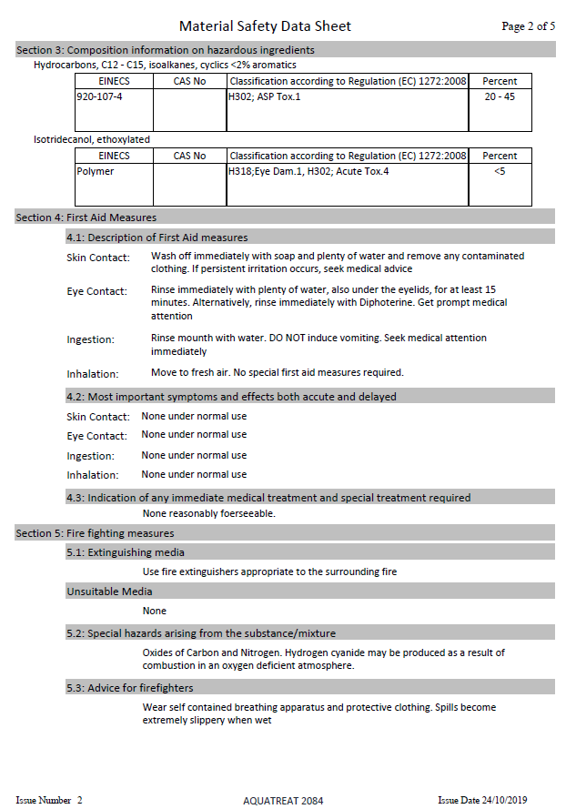
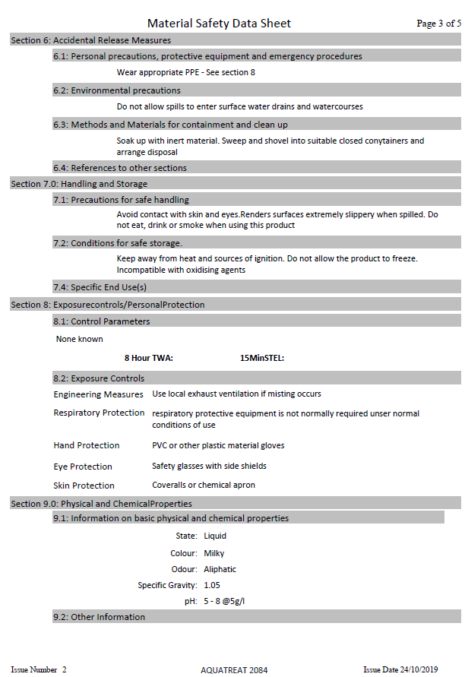
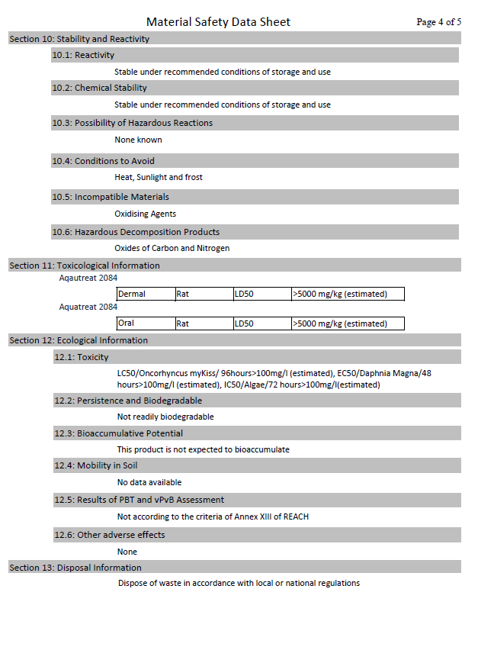
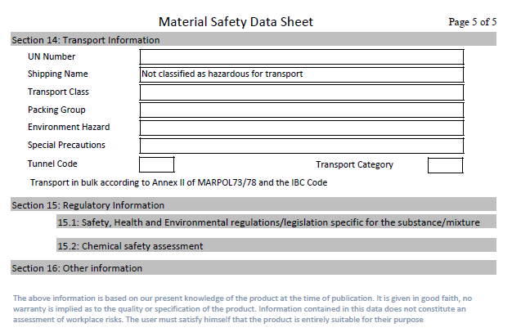

Brenntag PAC
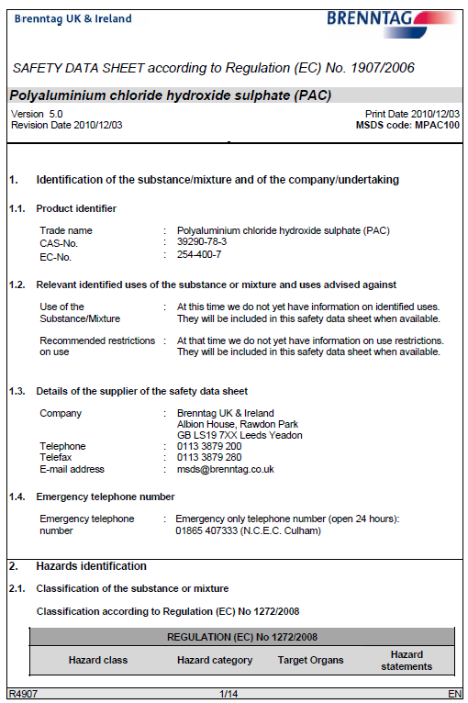
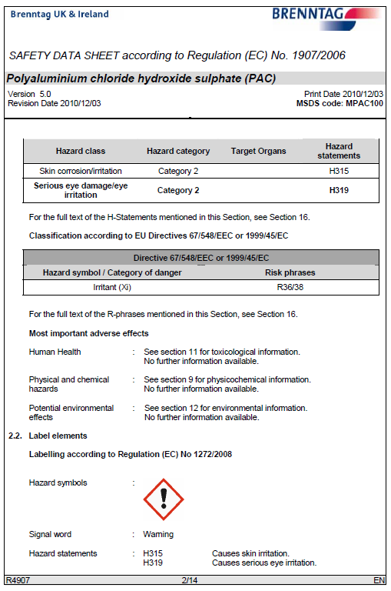
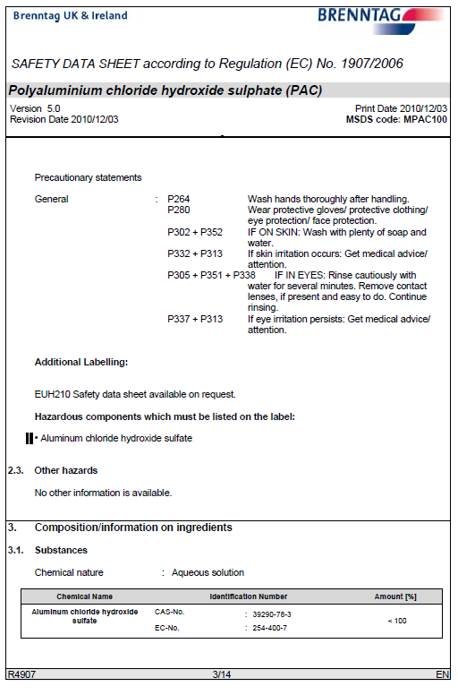
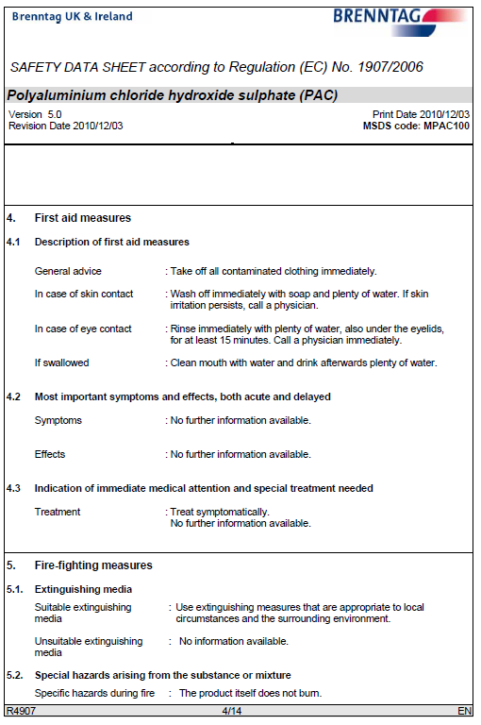
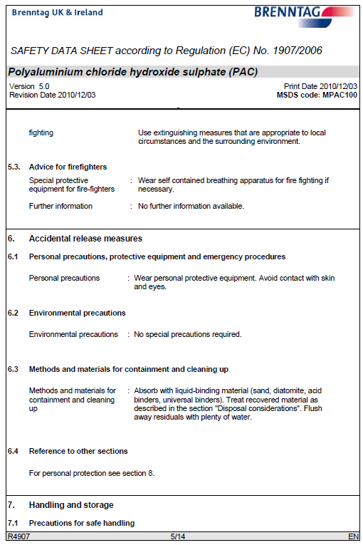
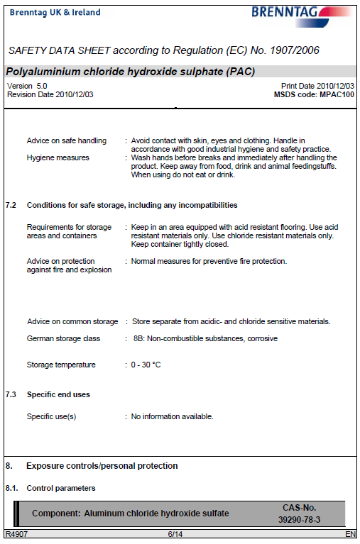
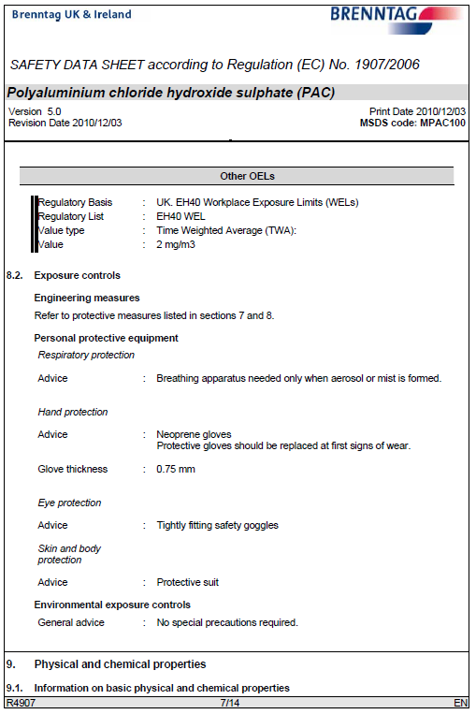
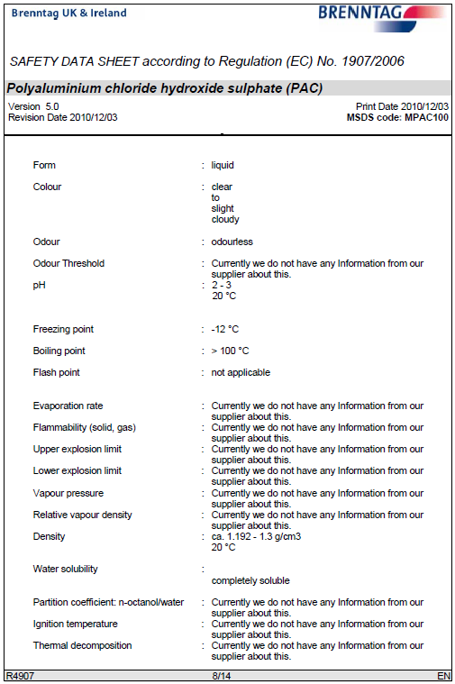
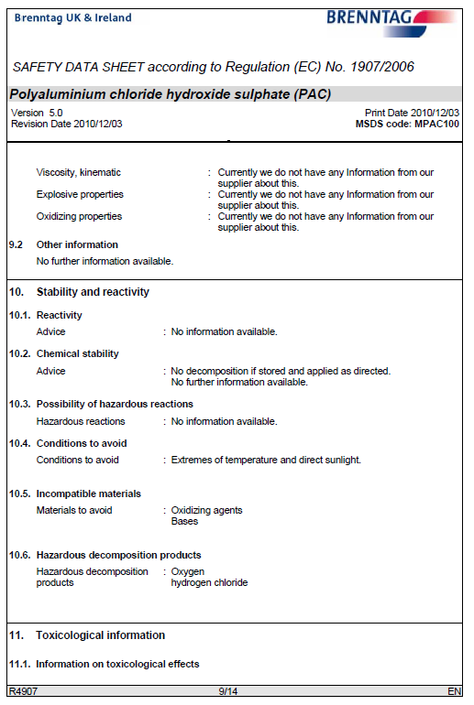
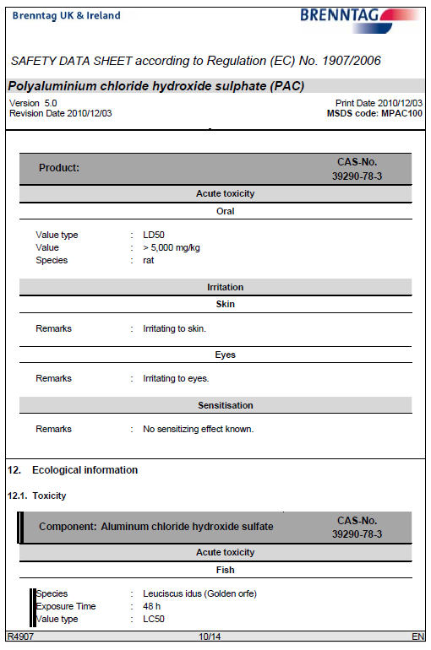
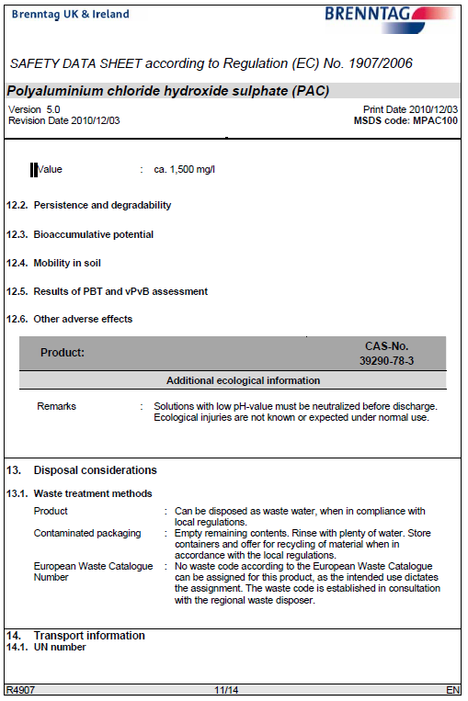
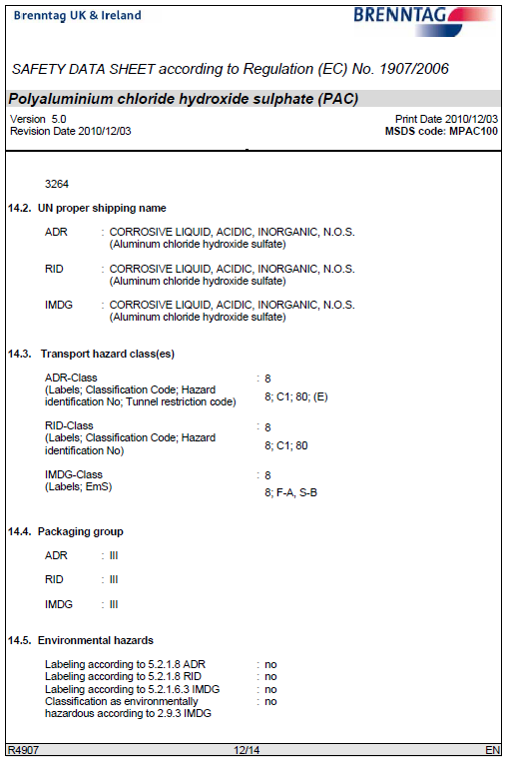
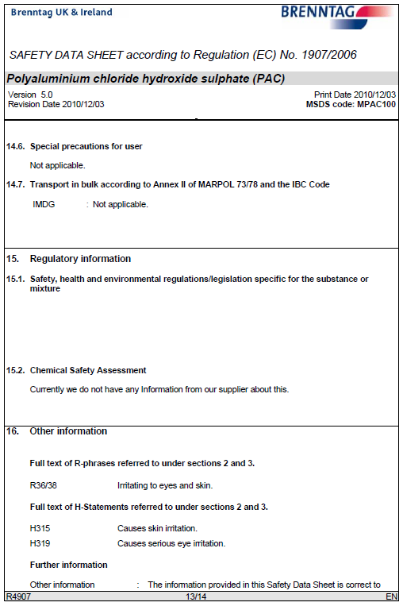

Caustic Soda Liquor
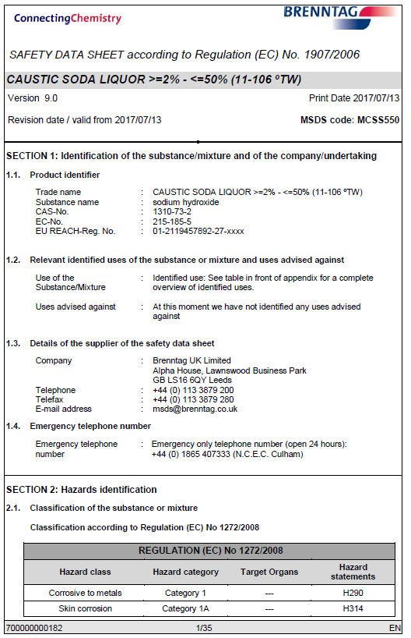
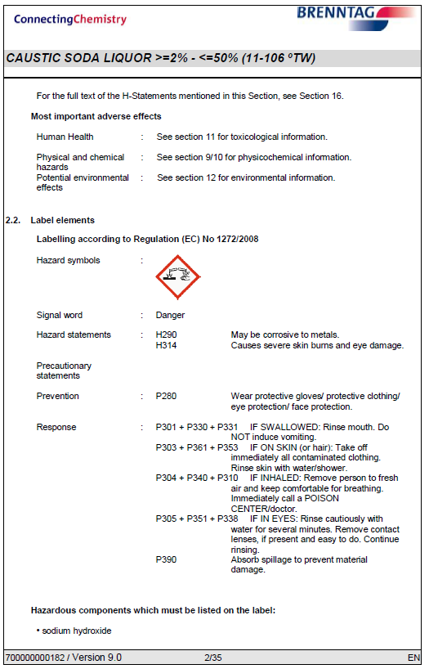
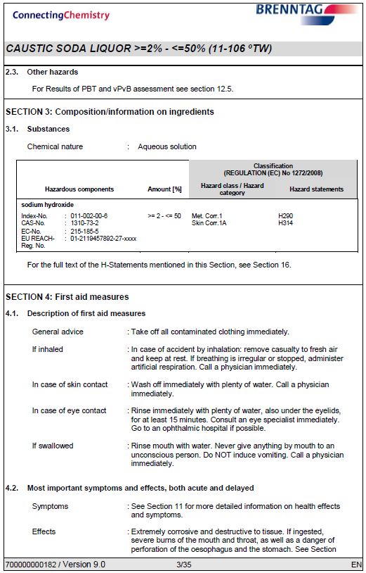
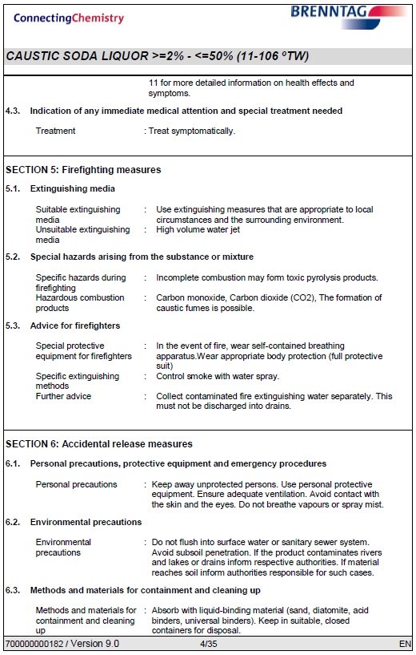
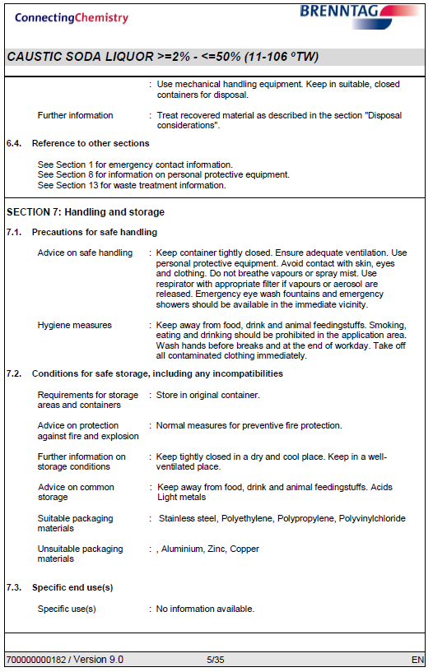
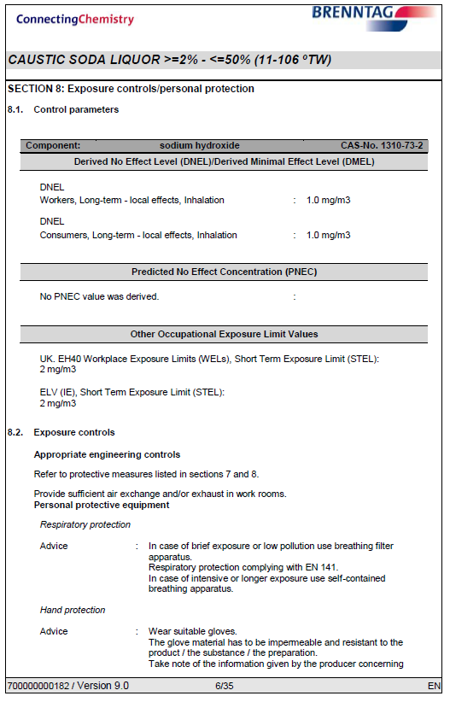
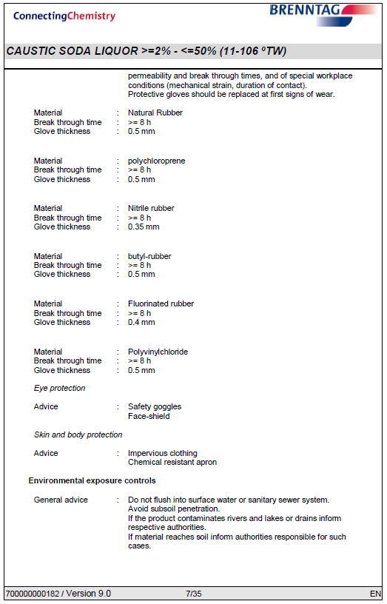
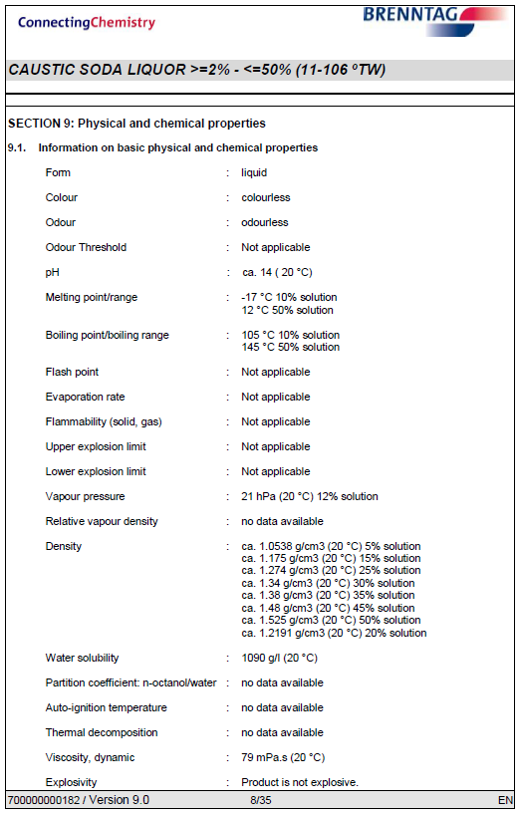
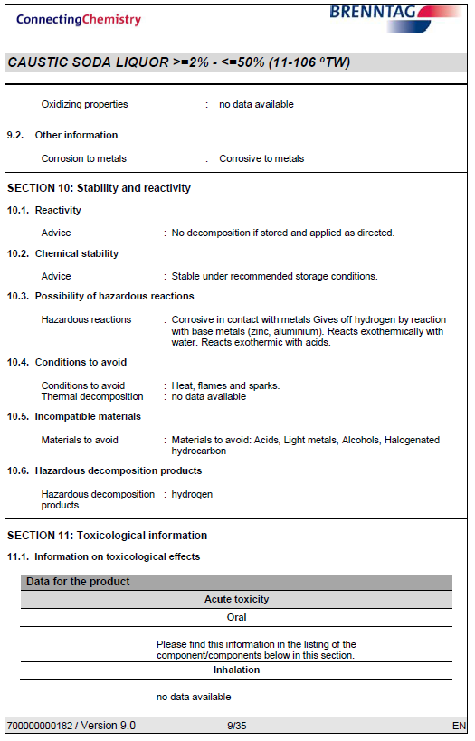
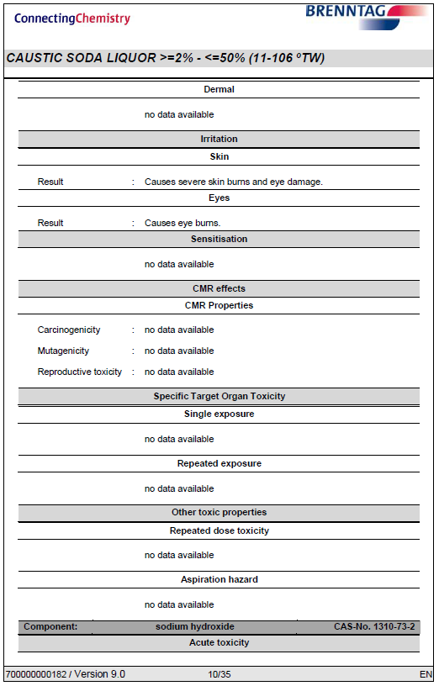
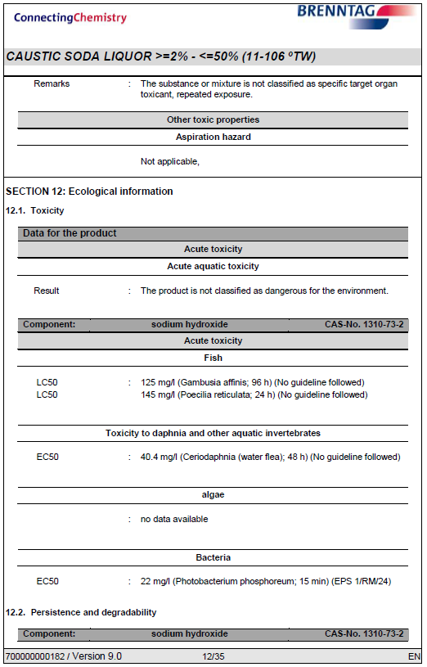
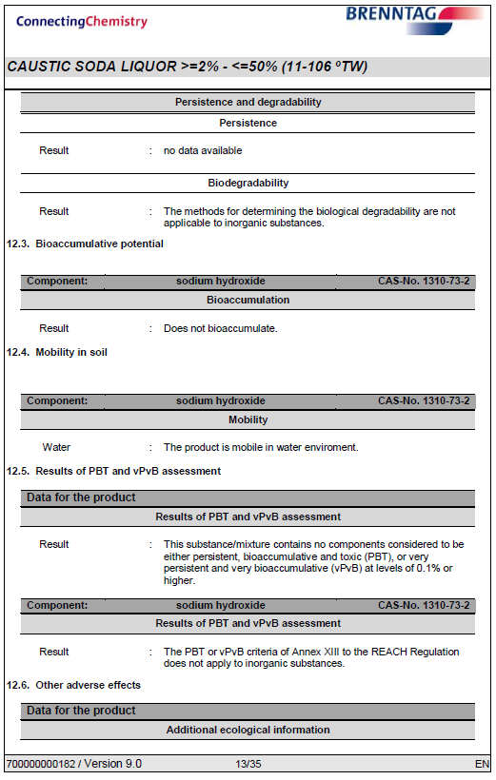
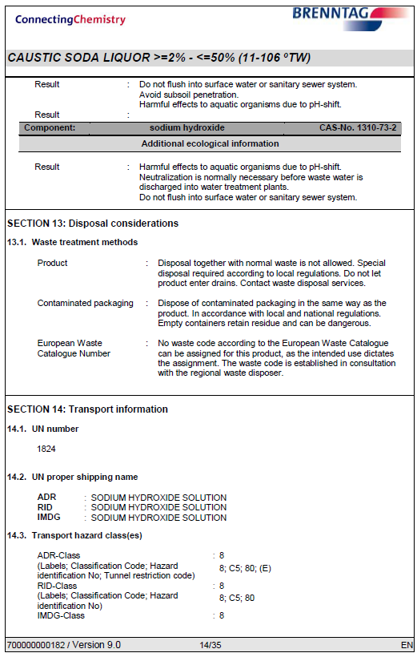

Appendix 2 – Siltbuster check sheet
Silt Buster Daily Check Sheet
Description | Check | Outcome (tick all good) | Issues / Action
General | Any unusual sounds, vibrations or smells
General | Pipework checks, leaks, frozen, wear and tear
General | Control panel check no faults or alarms
General | Power cables in working order, Visual
Mechanical | Motors running, no signs of sticking, bearing noise
Mechanical | Motor vents clear and free from debris
Mechanical | Flowmeter registering presence of water
Mechanical | Chemical dosing pump head in auto mode
Mechanical | Sludge pump activities in auto / manual mode
Consumables | Check level of Coagulant
Consumables | Check level of Flocculant
Consumables | Bunding of chemicals not compromised
Clarifier | Visual check of clear water at outlet of clarifier
Clarifier | Lamella plates free from solid build up
Clarifier | Hoppers de-sludge
Reaction Tank | Check pH level on controls 6-9
Reaction Tank | Check chemical dosing line blockage, solution entering
Reaction Tank | Wipe clean pH probe
Check by |  | Company
pH Level |  | Further Comment
Coagulant pump rate | l/hr | Further Comment
Flocculant pump rate | l/hr | Further Comment

Appendix 3 Soneco Check Sheet
Soneco Check Sheet
Measurement |  | Units | Value |  | Max | Comment
Balance Tank Level |  | M
Instantaneous flow |  | M3/h
Feed Pump |  | RPM
Aluminium Dose |  | Mg/l
Plate Life |  | Days
Mix Tank 1 |  | RPM
Mix Tank 2 |  | RPM
Water Conductivity |  | µS/cm
Treated Water TSS |  | Mg/l
Check by |  |  | Flow rate discharge set |  |  | Further Comment
Company |  |  | Flow rate discharge set |  |  | Further Comment

Appendix 4

Rutpen A9
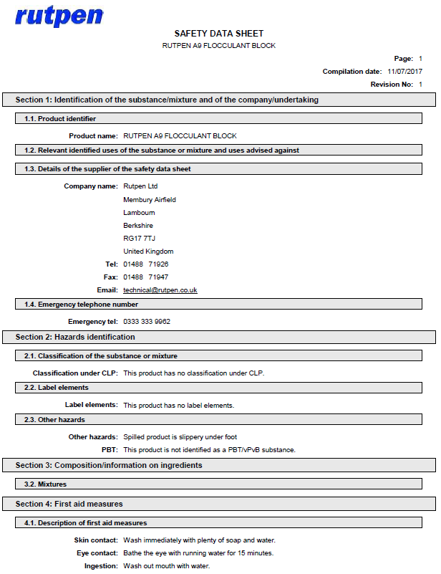
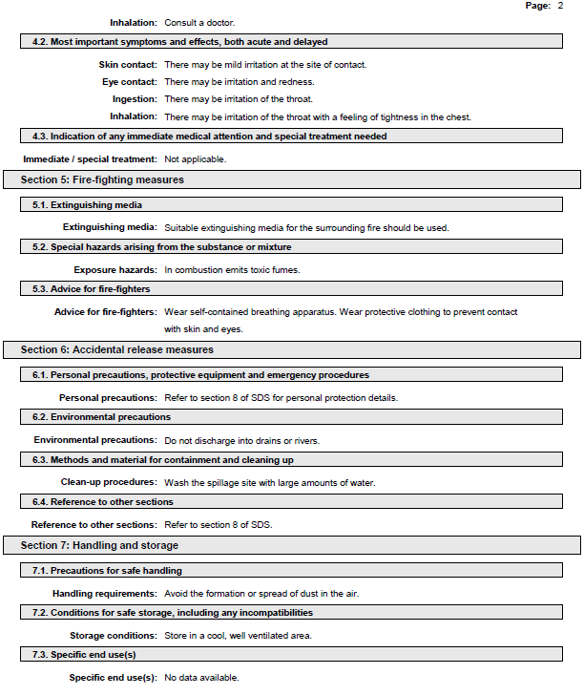
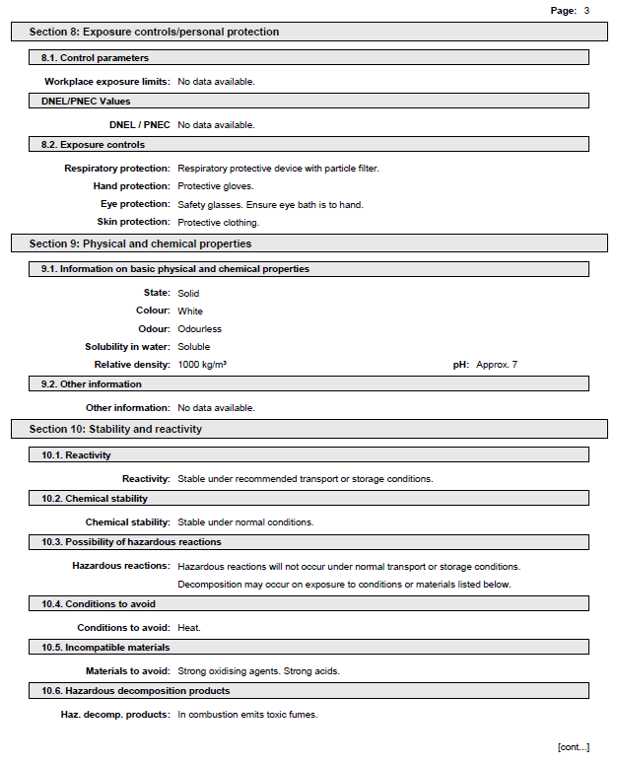
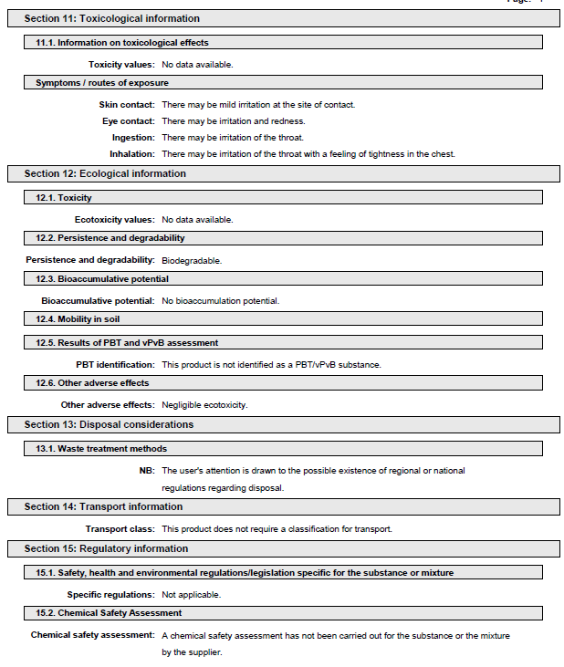
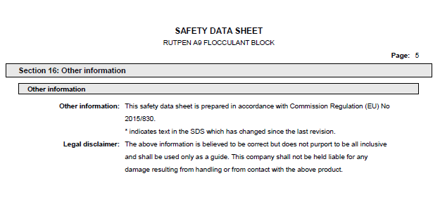

Water Lynx 360
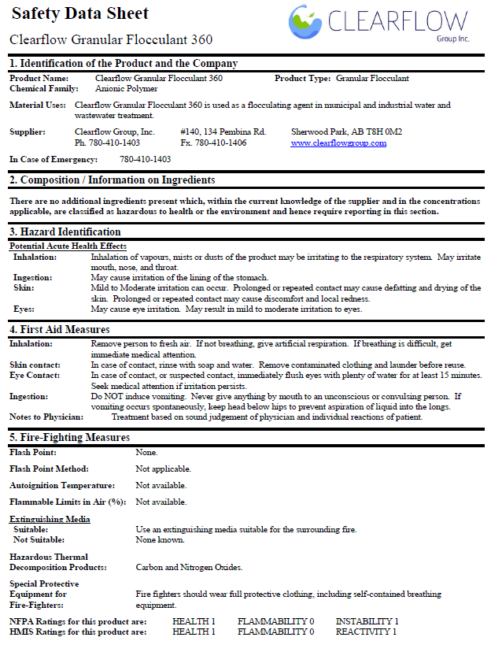
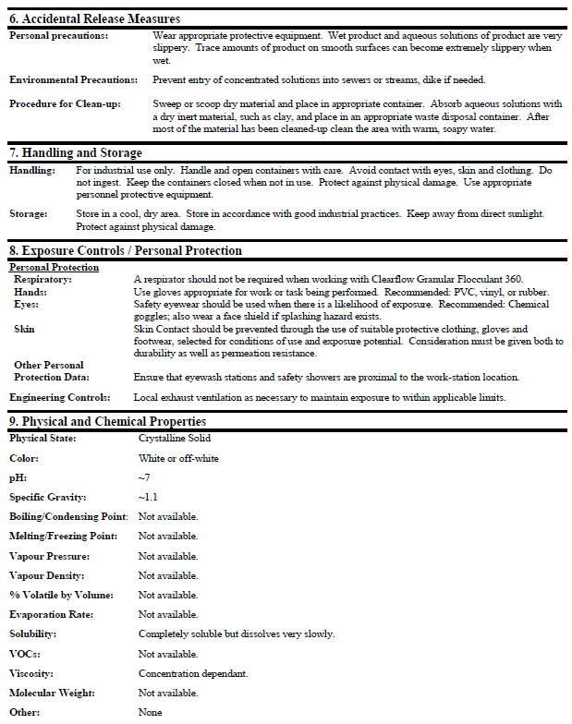
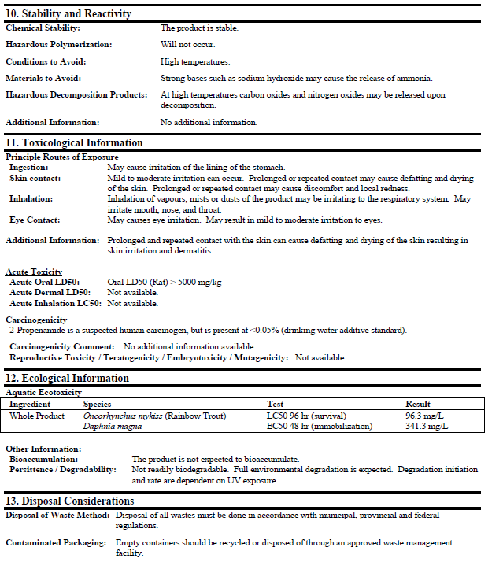
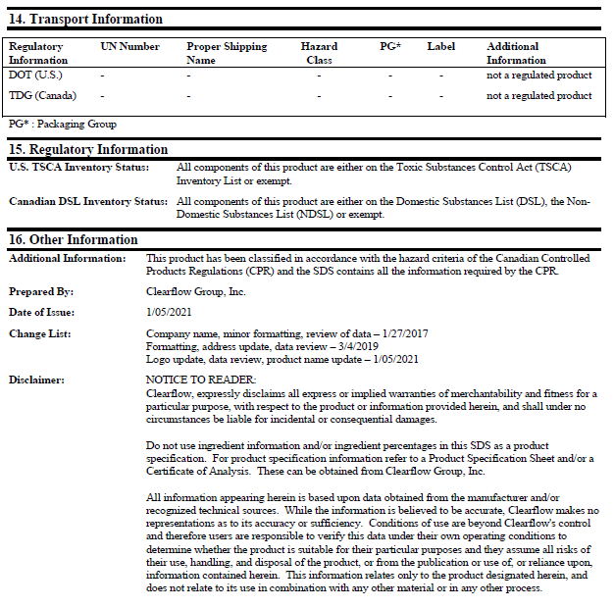

Water Lynx 395
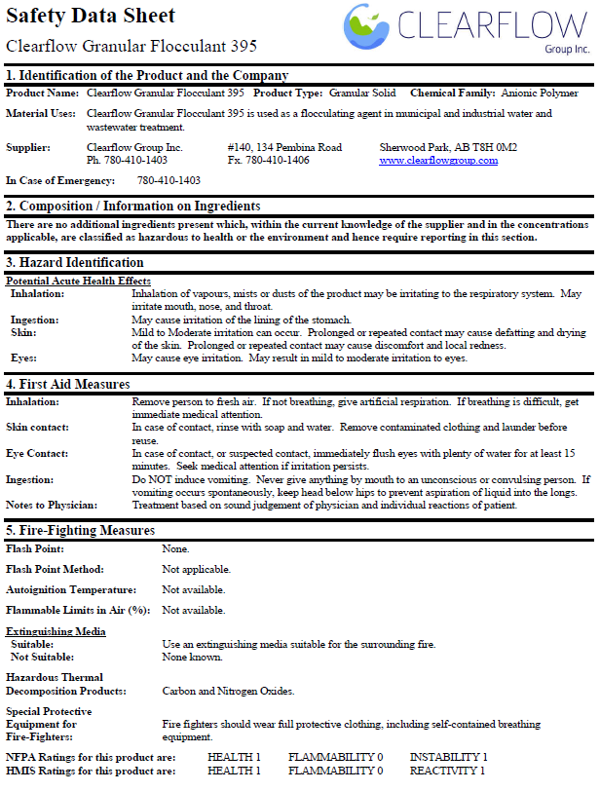
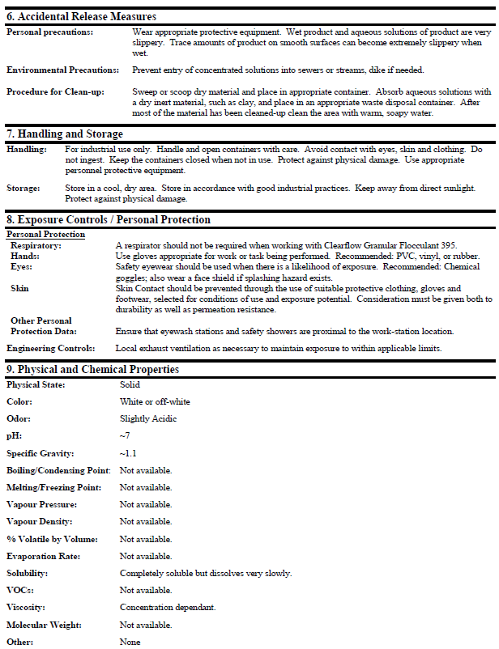

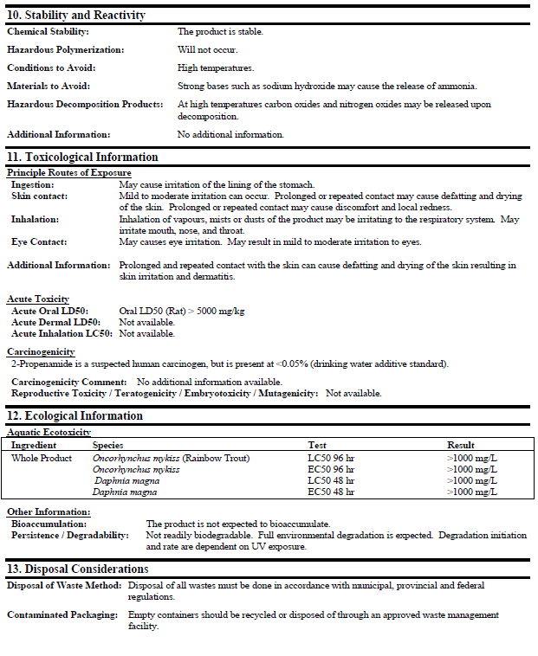

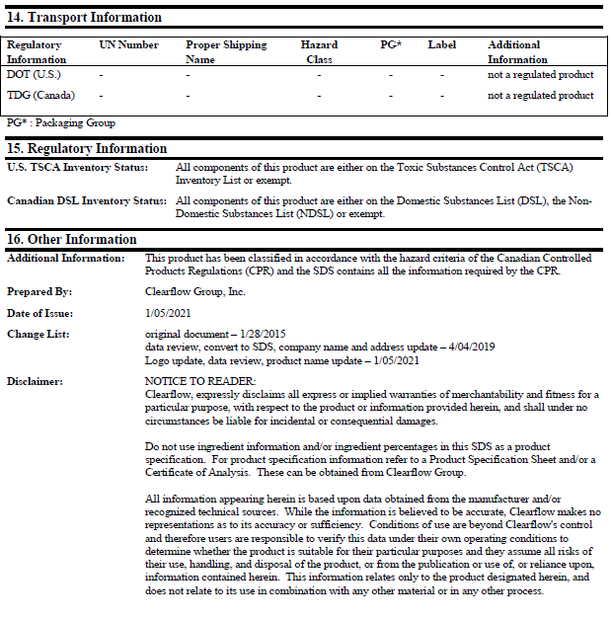

Appendix 5 – Floc mat Release Rate


