Basic site information:

Site Address:
Celynog Isaf, Bryn Coed Ifor, Rhydymain LL40 2AW

Weir grid reference and height:
SH 79486 20446 135.4 mAOD

Outfall grid reference and outfall pipe invert:
SH 79206 20669 94.3mAOD m

Powerhouse grid reference and floor height:
SH 79202 20668 95.75 mAOD

Length and gradient of depleted reach:
Length: 380m
Gradient: 11.1%

1. Safle 1 - SH 79593 20266 (site 1)

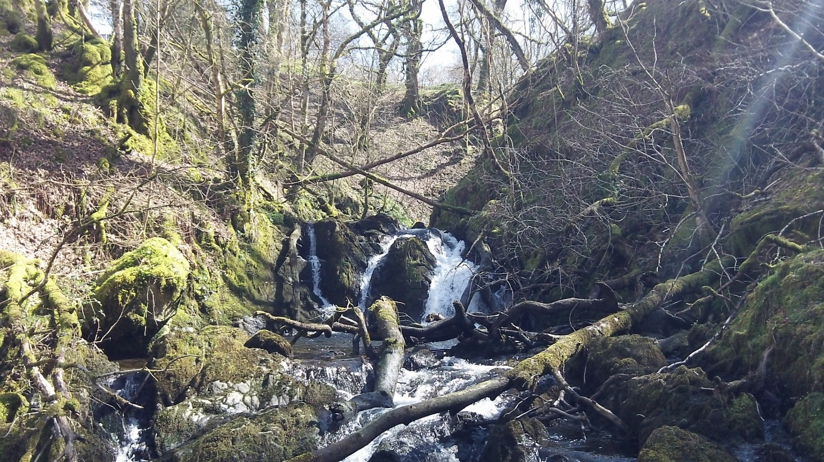
1 - Edrych i fyny’r afon (looking up the river)

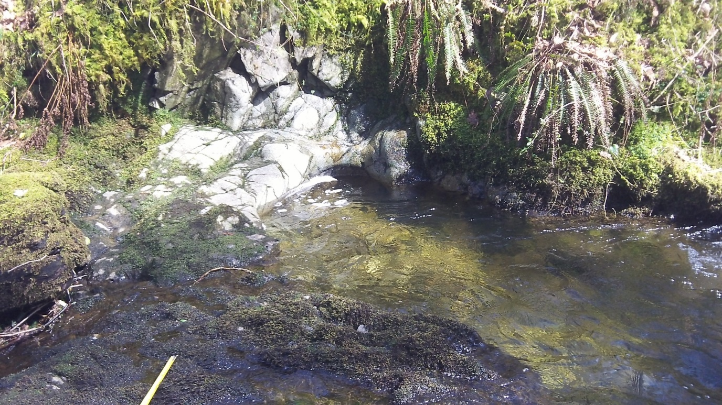
1 - Glan yr afon ochr dde (right bank)

1 – Glan yr afon ochr chwith (left bank)

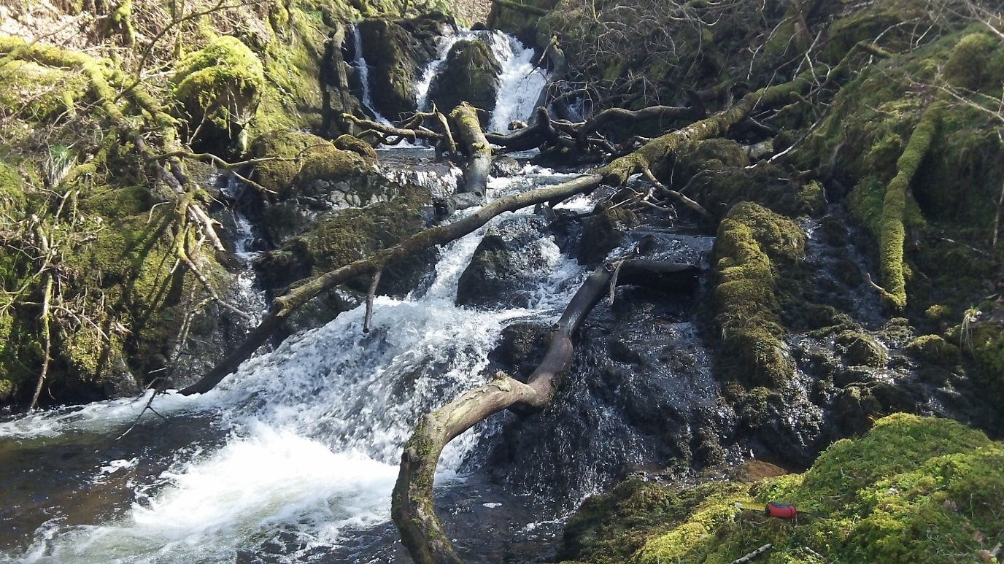

1 - Edrych i lawr ar y swbstrad (looking down at the substrate)
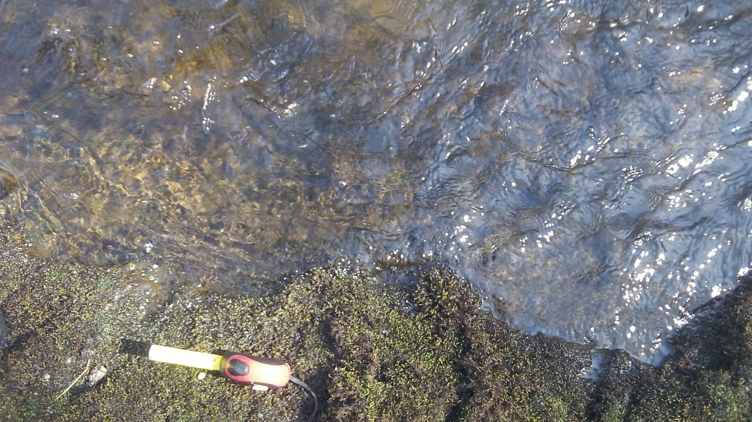

2. Safle 2 – SH 79543 20359

2 – Glan yr afon ochr dde (right bank)
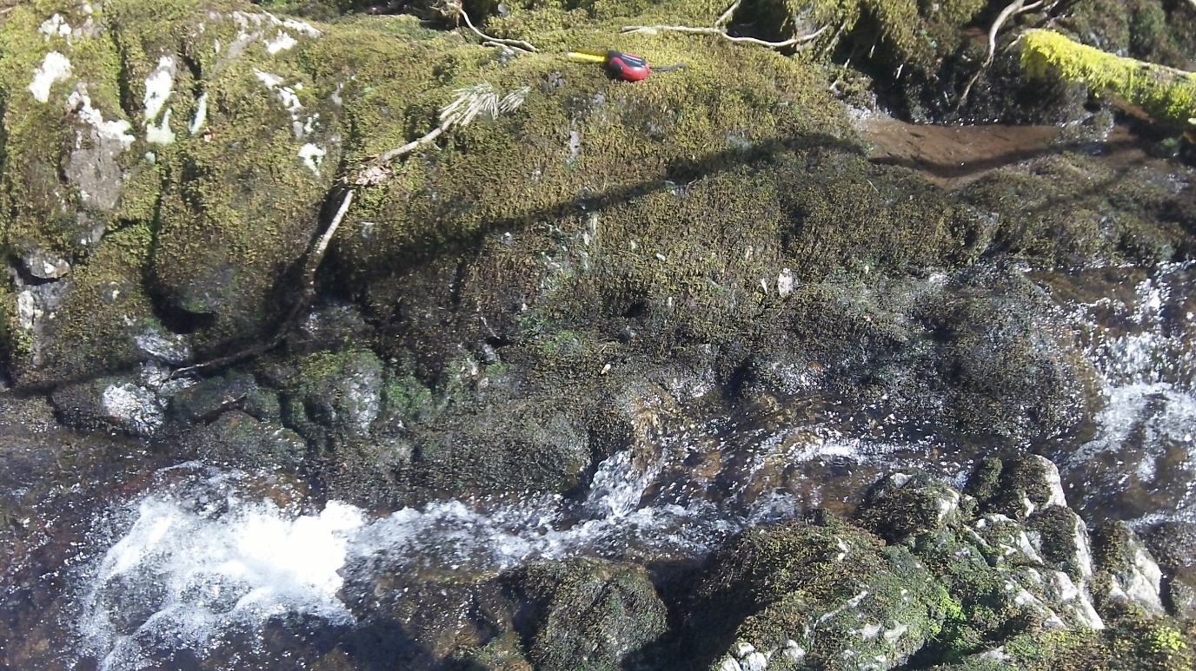

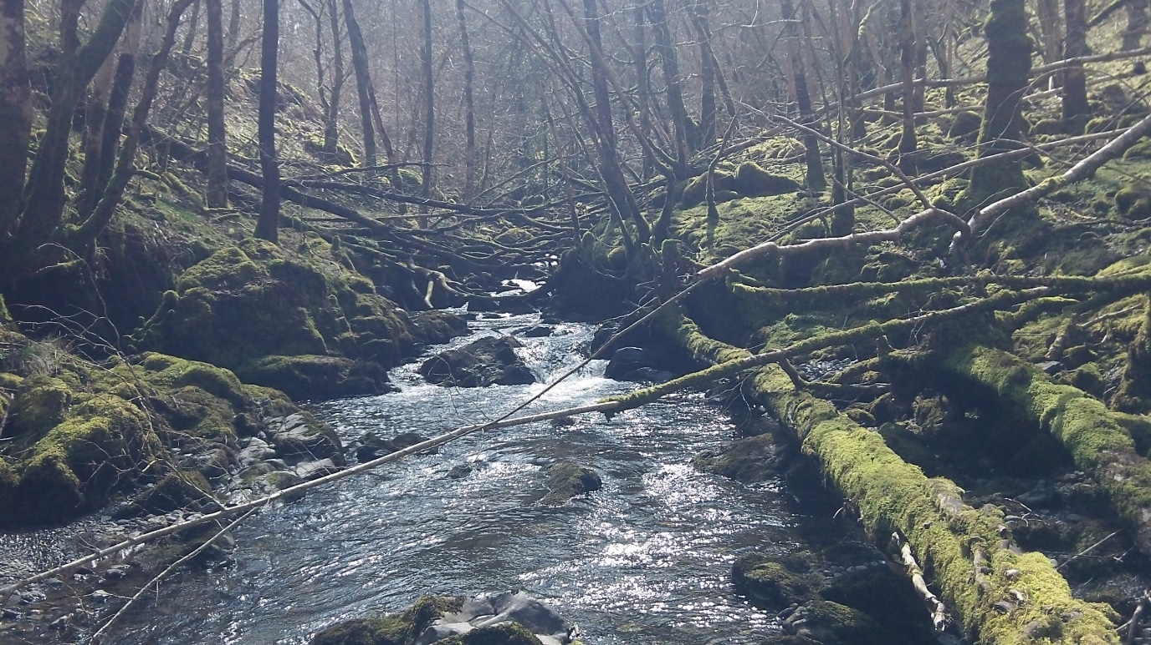
2 – Edrych i fyny’r afon (looking up the river)

2 – Glan yr afon ochr chwith (left bank)
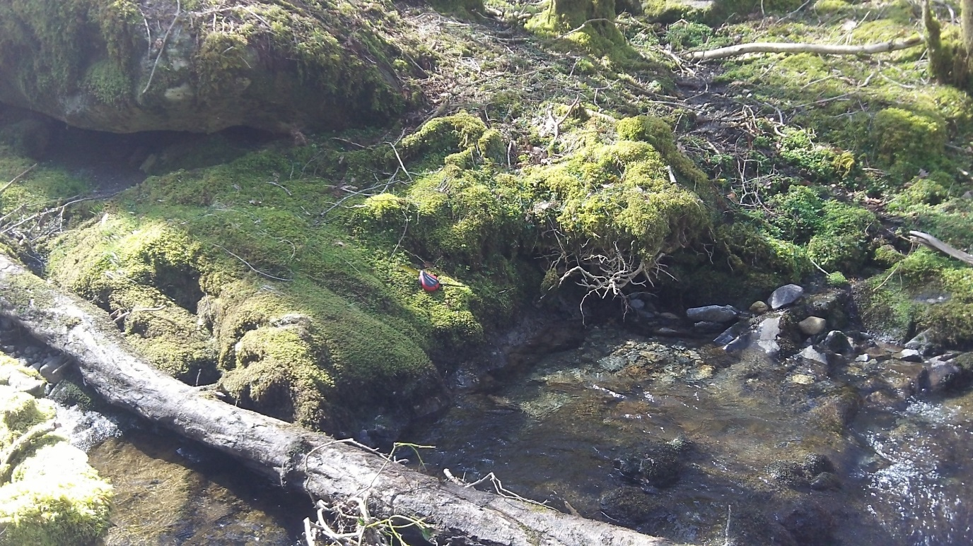
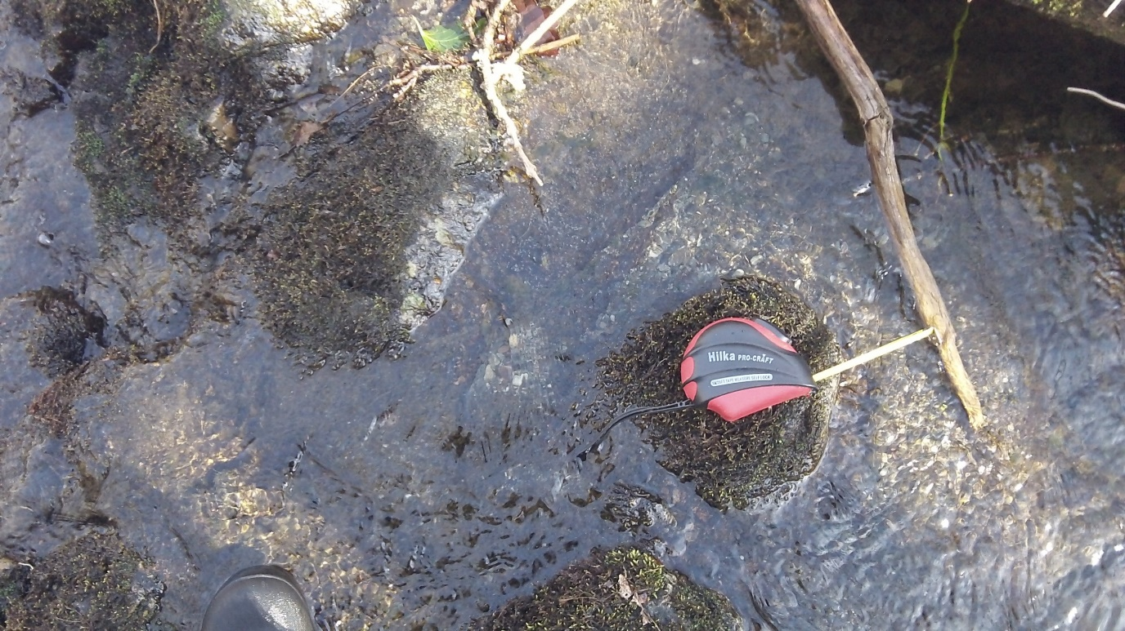

2 – Edrych i lawr ar y swbstrad (looking down at the substrate)

3. Safle 22 - SH 79509 20444 (Site 2)

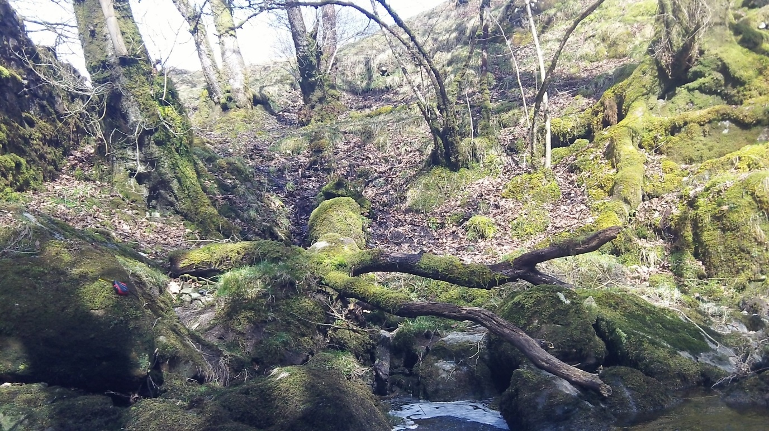
3 - Glan yr afon ochr dde (right bank)

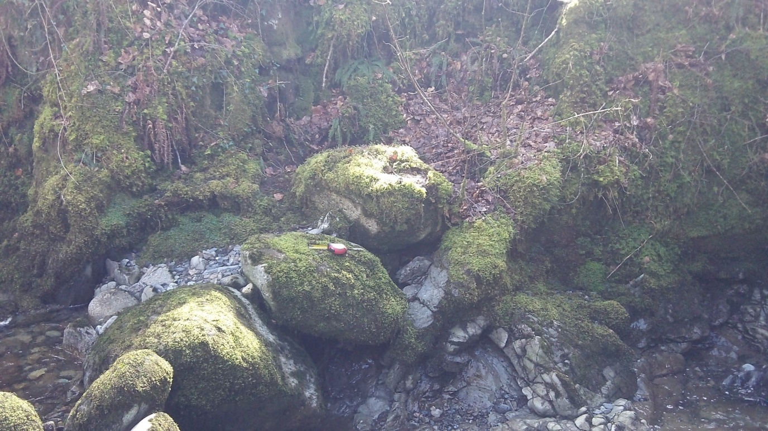
3 – Glan yr afon ochr chwith (left bank)

3 – Edrych i lawr ar y swbstrad (looking down at the substrate)
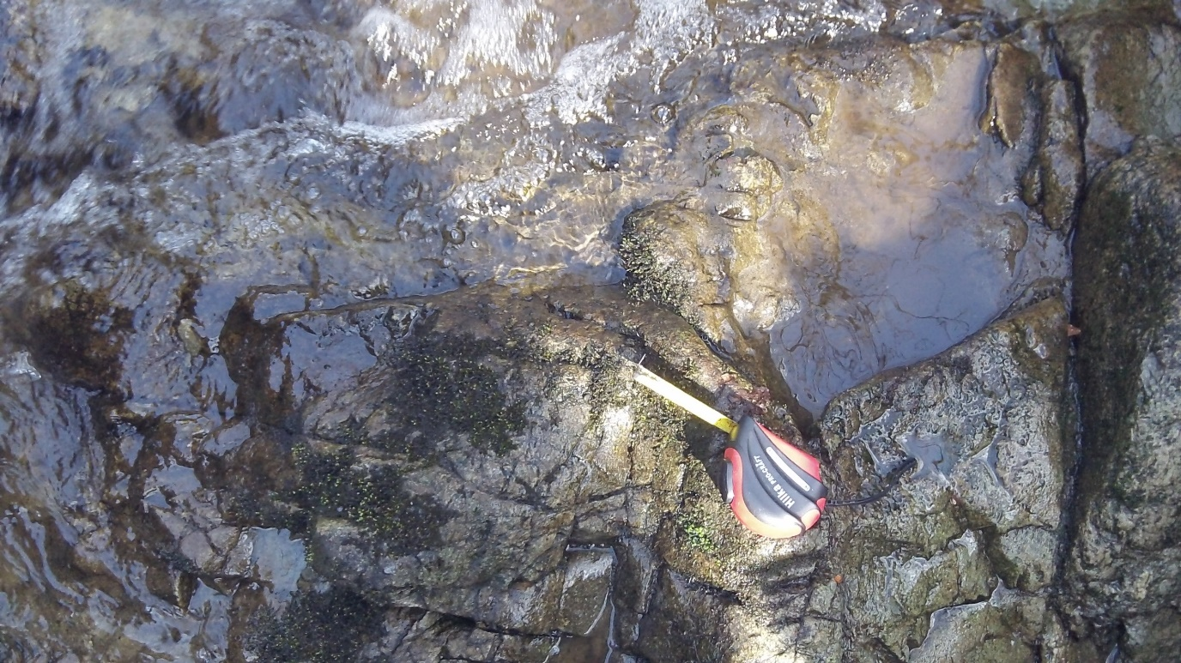

3 – Edrych i fyny’r afon (looking up the river)
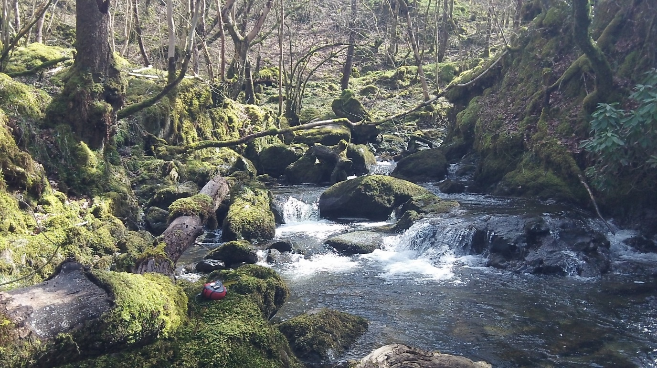

4. Safle 4 - SH 79467 20450 – Cored hanesyddol (Site 4 – historical weir)

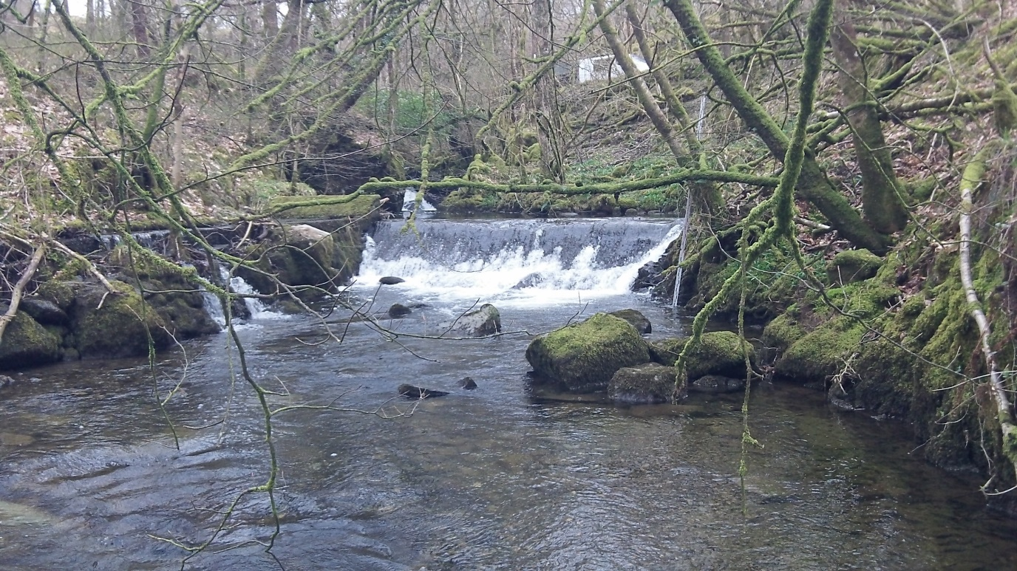

5. Safle 5 - SH 79464 20448 (Site 5)

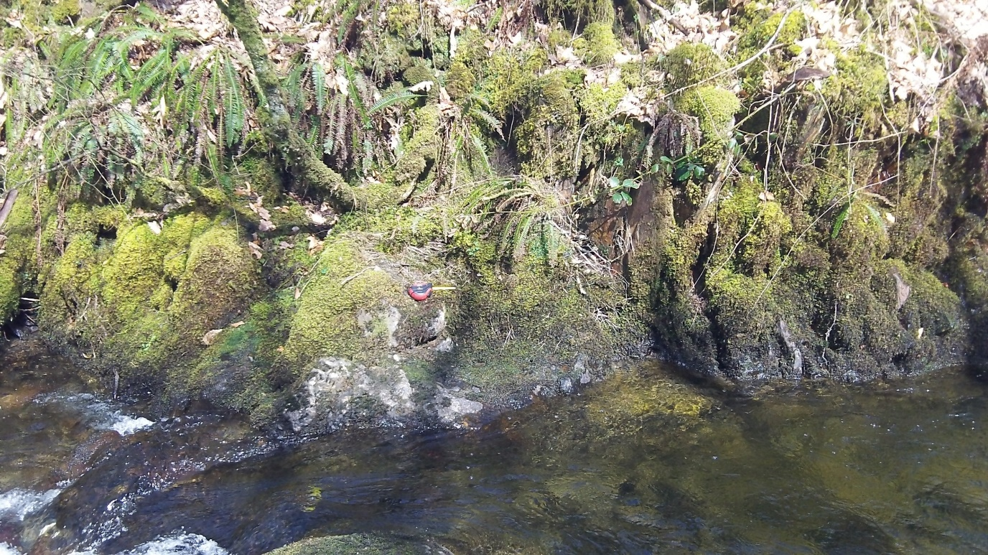
5 – Glan yr afon ochr dde (right bank)

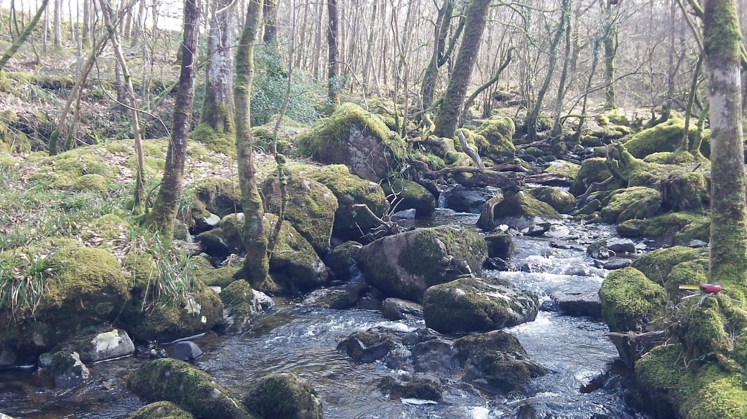
5 – Edrych i fyny’r afon (looking up the river)

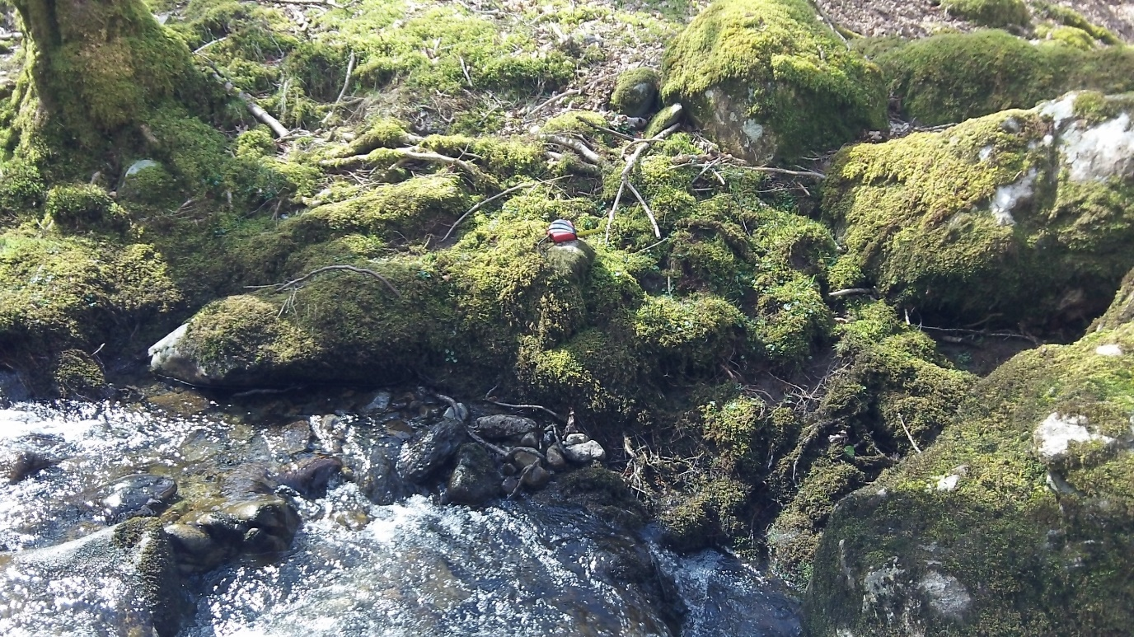
5 – Glan yr afon ochr chwith (left bank)

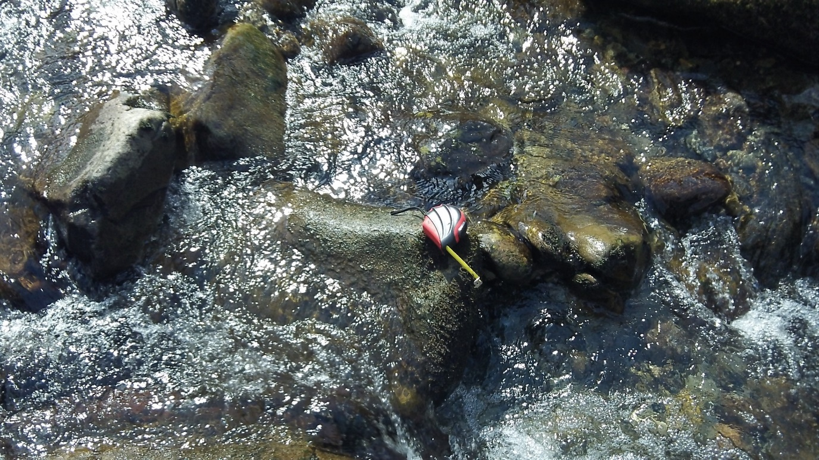
5 – Edrych i lawr ar y swbstrad (looking down at the substrate)

6. Safle 6 - SH 79351 20536 – Rhaeadr (Site 5 - waterfall)

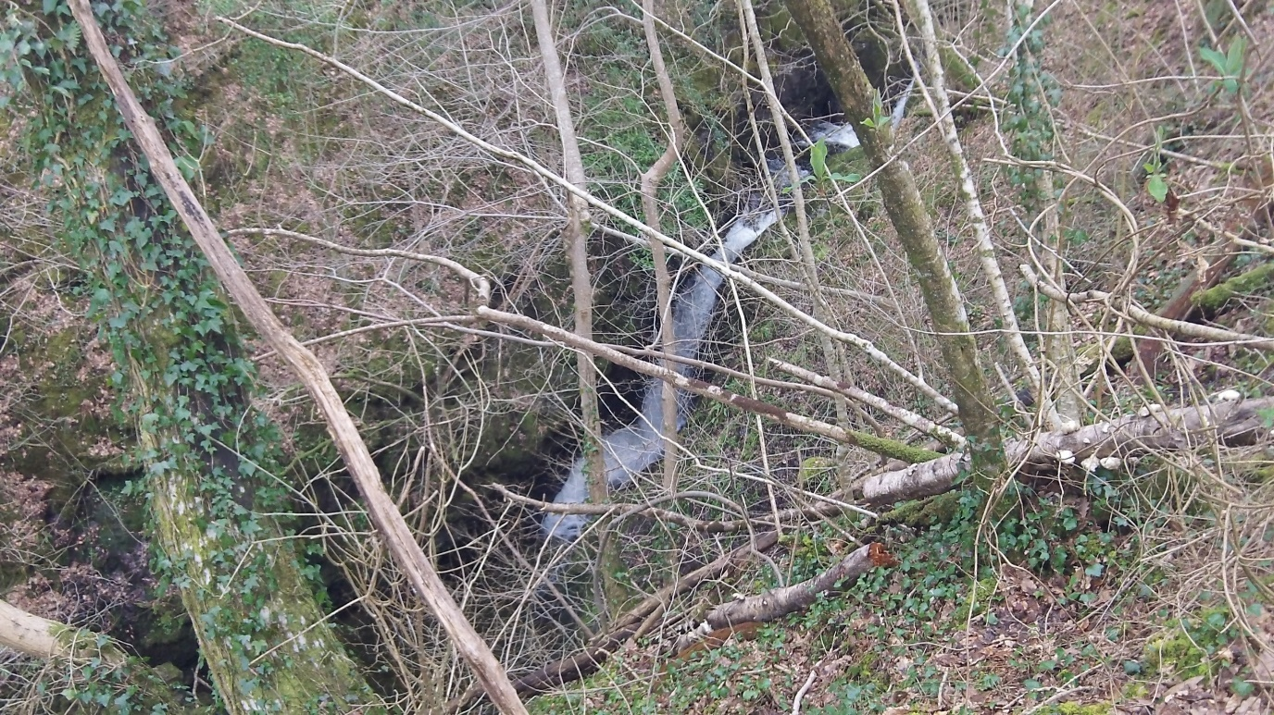

6 – Edrych i lawr tuag at y ceunant a’r rhaeadr (looking down towards the gorge and the waterfall)

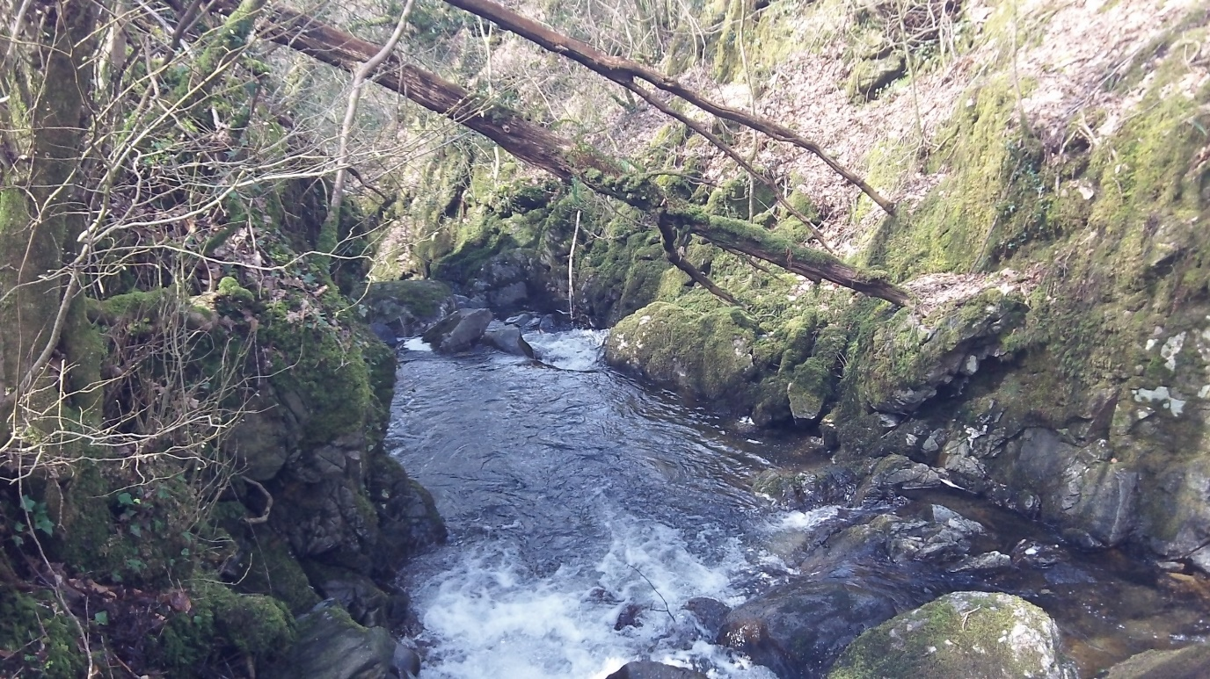

7. Safle 7 – SH 79263 20590 (site 7)

7 – Glan yr afon ochr dde (right bank)
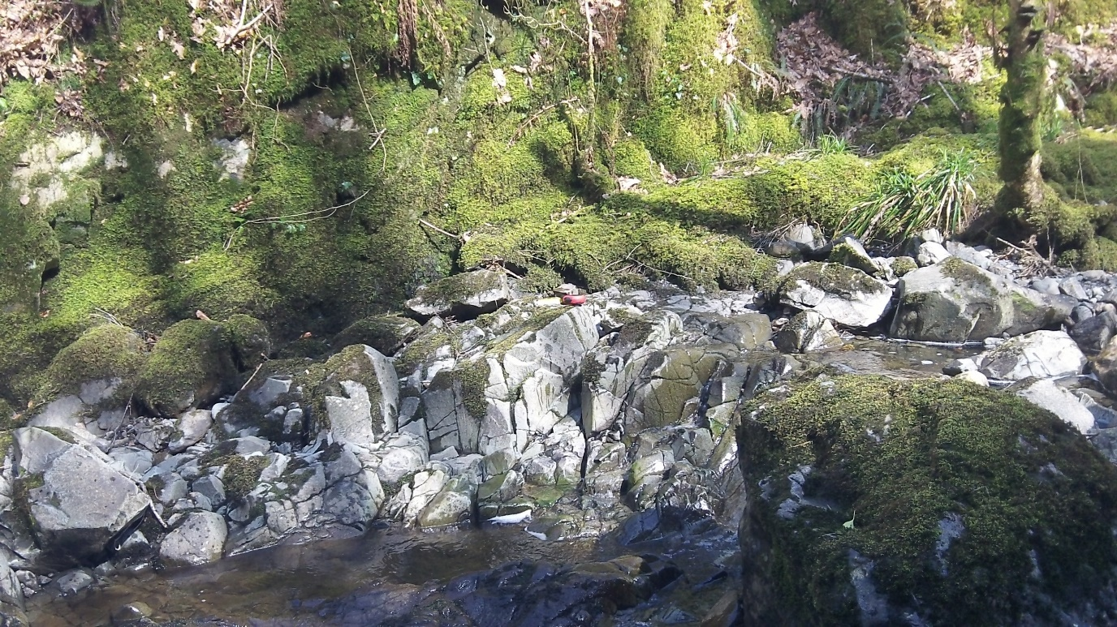

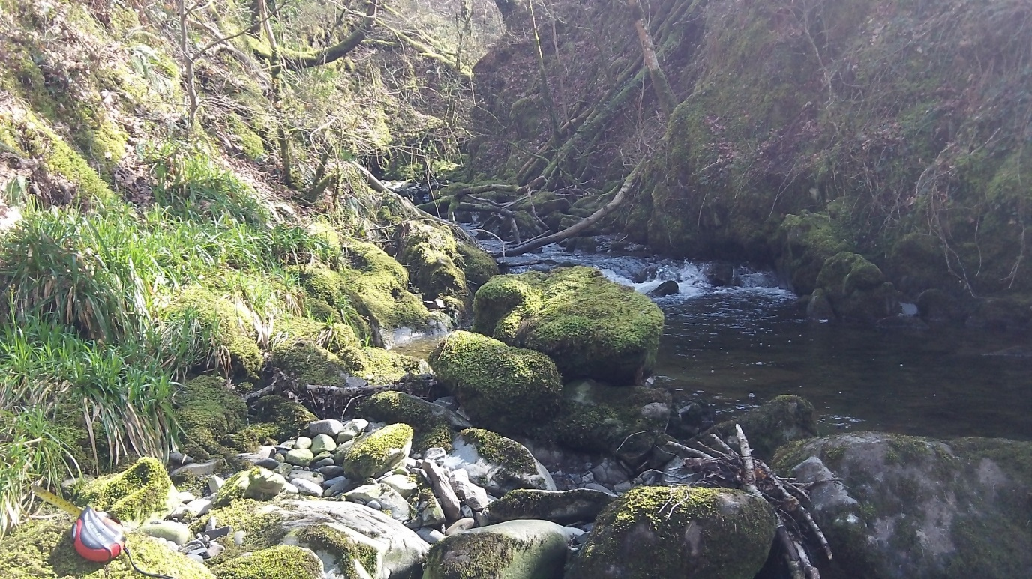
7 – Edrych i fyny’r afon (looking up the river)

7 - Glan yr afon ochr chwith (left bank)
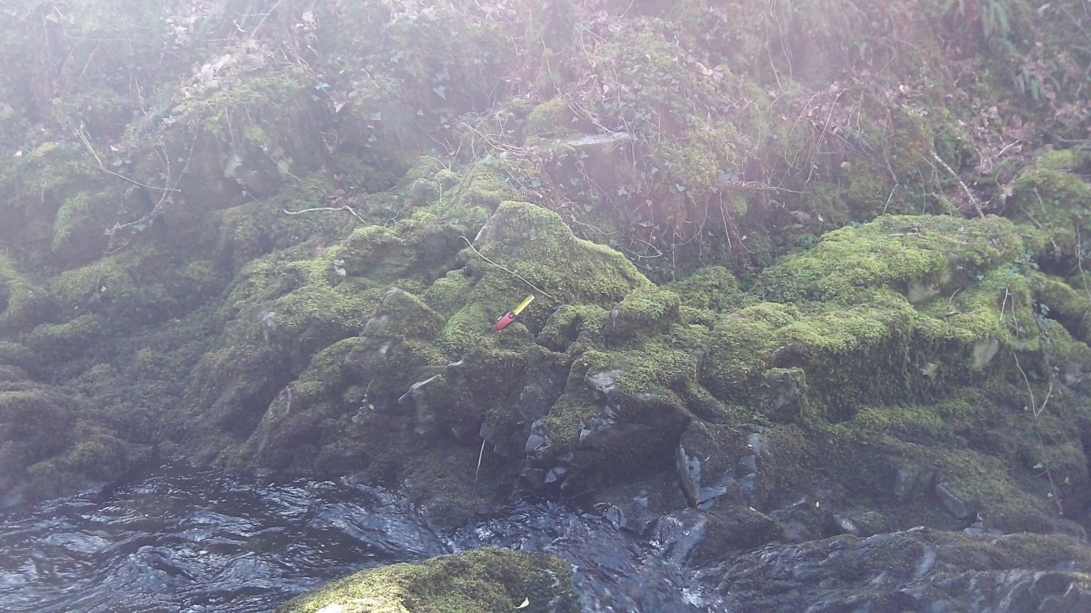

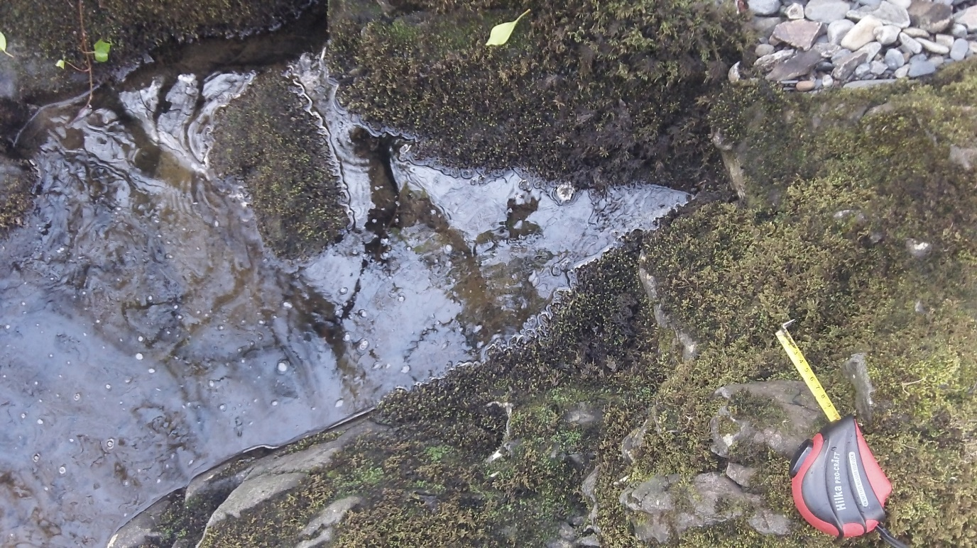
7 – Edrych i lawr ar y swbstrad (looking down at the substrate)

8. Safle 8 – SH 79206 20674 – Pwerdy ac Arllwysiad (Site 8 – Powerhouse and discharge point)

8 - Edrych i fyny’r afon (looking up the river)
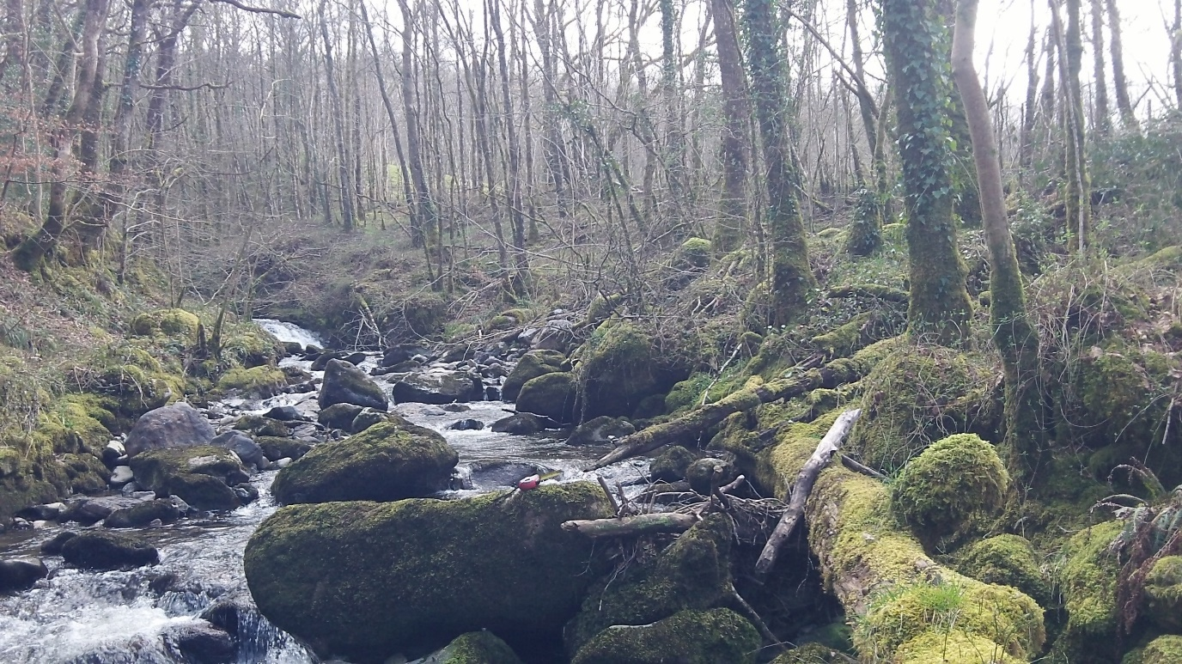

8 – Glan yr afon ochr chwith (left bank)
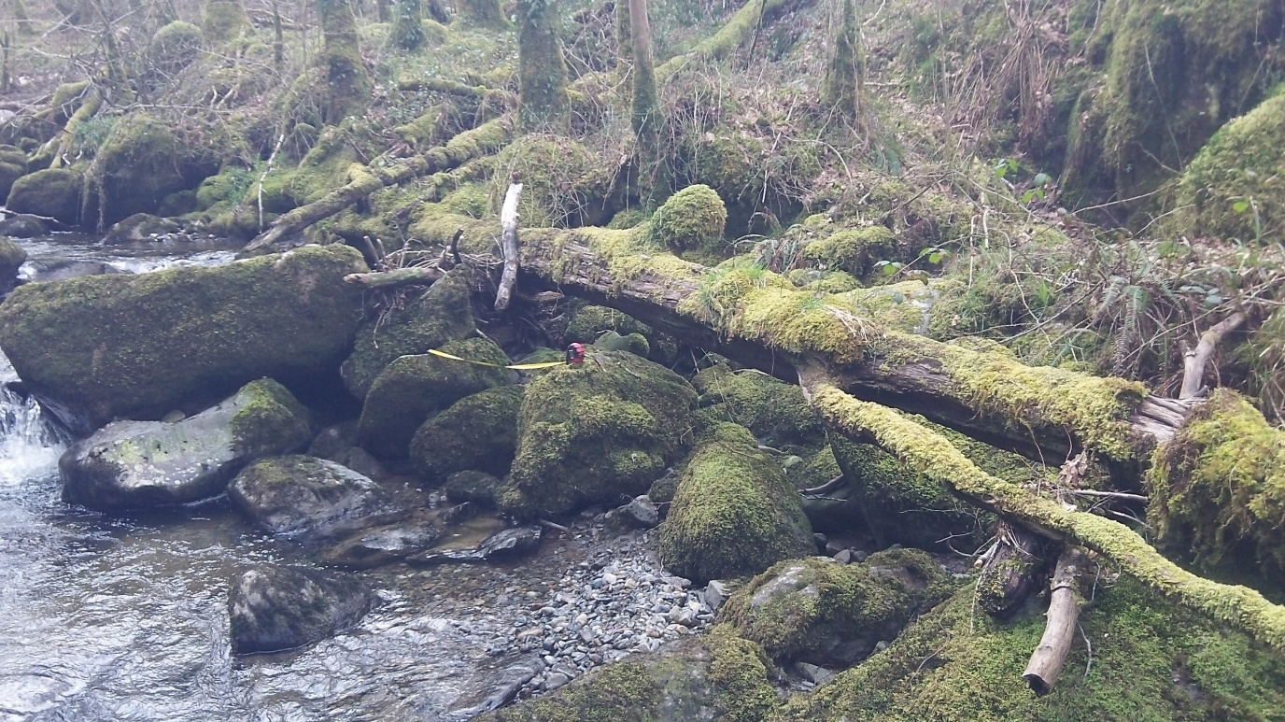

8 – Glan yr afon ochr dde (right bank)

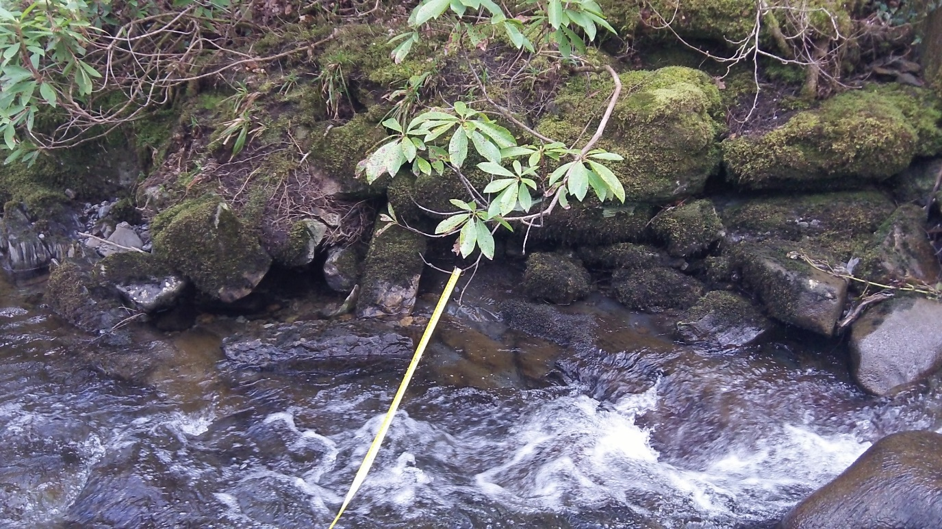

8 - Edrych i lawr ar y swbstrad (looking down at the substrate)
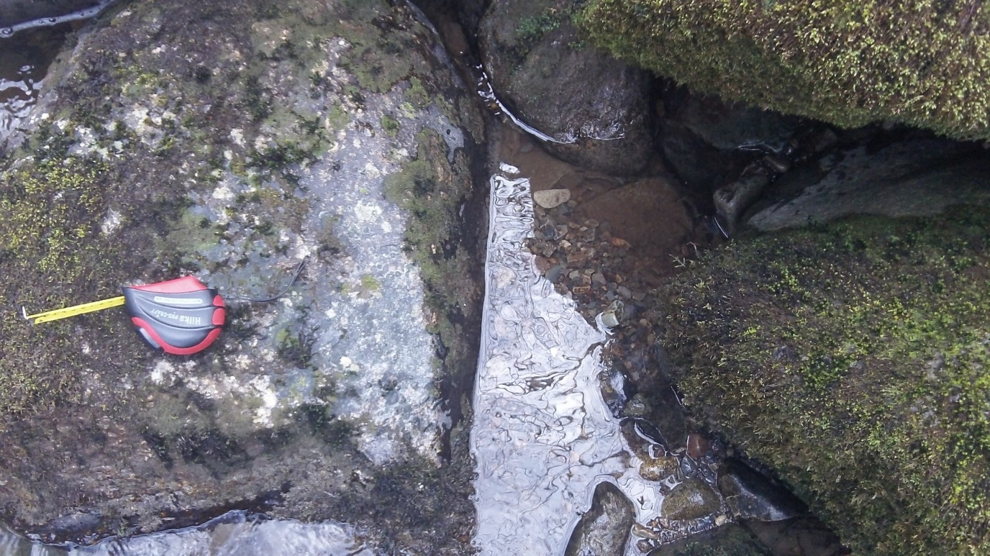

9. Safle 9 - SH 79200 20693 Afon Celynog yn ymuno ac Afon Wnion (site 9 – where the Afon Celynog meets the Afon Wnion)
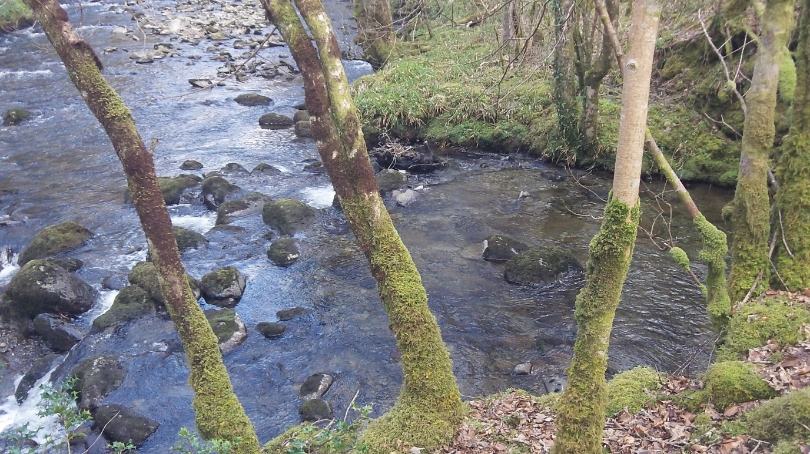

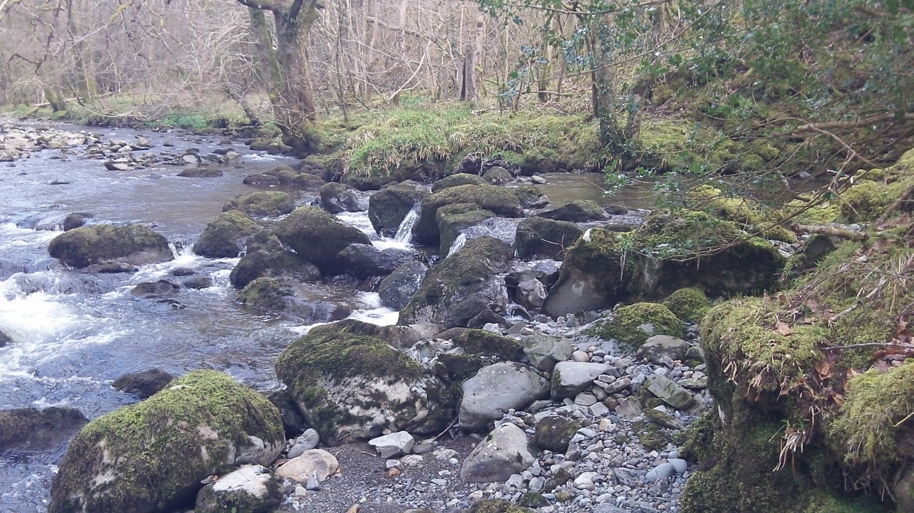
9 -

10. Llwybr y beipen (pipeline path)
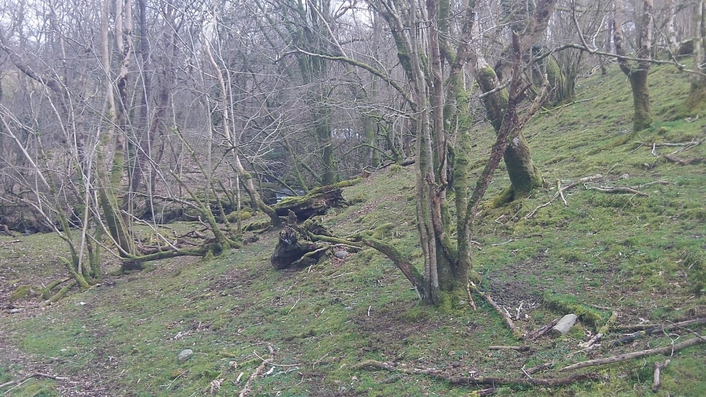

11. Llwybr y beipen (pipeline path)


