- Application type
New impoundment licence ☒
Removal of an existing impoundment ☐ Complete sections 2 and 4
To licence an existing impoundment ☐
Technical variation to an impoundment licence ☐

Give existing licence or pre- application reference number(s)

2. Impoundment details
All information should correspond with any maps and drawings submitted with this application

2.1 Provide details of all impoundment points. For structures spanning a watercourse, provide a National Grid Reference for each bank. If necessary, continue on a separate sheet and tick here to show that you have done this. ☐

Impoundment  location name / reference | National Grid Reference for each bank,  looking downstream  (12 digit)
Impoundment  location name / reference | Left bank | Right bank
Ty’n yr Onnen | SH53950 59204
2.2 Please provide a full description of the impoundment, outlining its purpose and how it will operate. If this information is detailed in a supporting document, provide the document title
or reference in the space below.
If necessary, continue on a separate sheet and tick here to show that you have done this. ☐
Water will be abstracted through the construction of a new intake weir across the full width of the watercourse, with a 3mm screen. A powerhouse will be constructed to house the turbine and generator. The pipe will be 280mm HDPE and buried for its length.

Please see drawings:
170403MP01-v1 Nant y Betws Intake Front Elevation, Levels and Take Calcs
170403MP02-v1 Nant y Betws Intake Long Section
170403MP03-v1 Nant y Betws Intake GA and Nomenclature
170403MP04-v1 Nant y Betws Intake Overall Dimensions

- Description of impoundment

3.1 Name of watercourse

3.2 Will your proposed impoundment result in a change to the wetted perimeter (downstream) or new submerged areas behind (upstream of) the impounding works?
No ☒ Yes ☐ If yes, ensure this is shown on any map or drawings submitted

3.3 Will the ponded area created by the impoundment be lined? No ☐ Yes ☐
If yes, give details.
Impoundment will not raise river level

3.4 Give the height of the impoundment structure, from the downstream toe to crest or top of spillway (in metres above Ordnance Datum). If the proposal involves an existing impoundment, state the change in height (in millimetres).
Height 1108mm (Toe 235,833mAOD / Crest 236,941mAOD)

3.5 What is the overflow or crest level of the impoundment (in metres above Ordnance Datum)?
236,941mAOD

3.6 What is the proposed capacity of the impoundment when full to spillway level (in cubic metres)?

3.7 Will the proposal create a raised reservoir? No ☒ Yes ☐

3.8 Does the proposal involve the controlled release of water to safeguard downstream flows? No ☐ Yes ☒ If yes, provide details

Residual flow provided by fixed notches, proposed design accompanying this application.

3.9 Is the impounded water to be used for a subsequent purpose? No ☐ Yes ☒

If yes, provide details (for abstractions, state the daily and annual quantities in cubic metres).

Electricity generation

Daily – 6480m3

Annual – 2365200m3

3.10 How will the impounded area be filled initially, and subsequently refilled if applicable?

- Fish and eel passage
4.1 Confirm the fish species present at your site.

4.2 Complete the table below with full details of the measures you intend to take to safeguard these fish species.

 | Intake | Outfall
Type of fish screen | Stainless steel | Bar
Screen aperture size (mm) | 3mm | 10mm
Screen height and width (mm) | 1008mm x 1400mm | 450mm (diamedr)
Type of upstream fish passage | Rocky ramp
Proposed flow for fish pass (m/s) | 30% residual and Q95 – 0.0117m3
Type of downstream fish passage | Rocky ramp
- Construction, maintenance and operation

5.1 Provide details of maintenance or activities relating to the operation of the impoundment. If necessary, continue on a separate sheet and tick here to show that you have done this. ☐

The intake screen will be regularly cleaned from debris and any blockage removed.

The intake weir will be checked regularly for any damage and repaired. Work that may be required include re-positioning of rocks and removal of vegetation.

5.2 Provide details of diversion works or removal of existing works.
A temporary dam will be constructed upstream and the water will carried through a temporary pipe.

Please see the following drawing for further details:

170403MP02-v1 Nant y Betws Intake Long Section

- Planning application
Have you sought advice on your planning application?
No ☐ Yes ☒
If yes, submit a copy of the Planning Authority’s response.

- Declaration

Please see Guidance Note WRX for details of who can sign this section and note the information in that document relating to the Data Protection Act 1998.

By signing below, you are declaring that as far as you know and believe the information given in this form, on any map and in any supporting or additional information, is true.

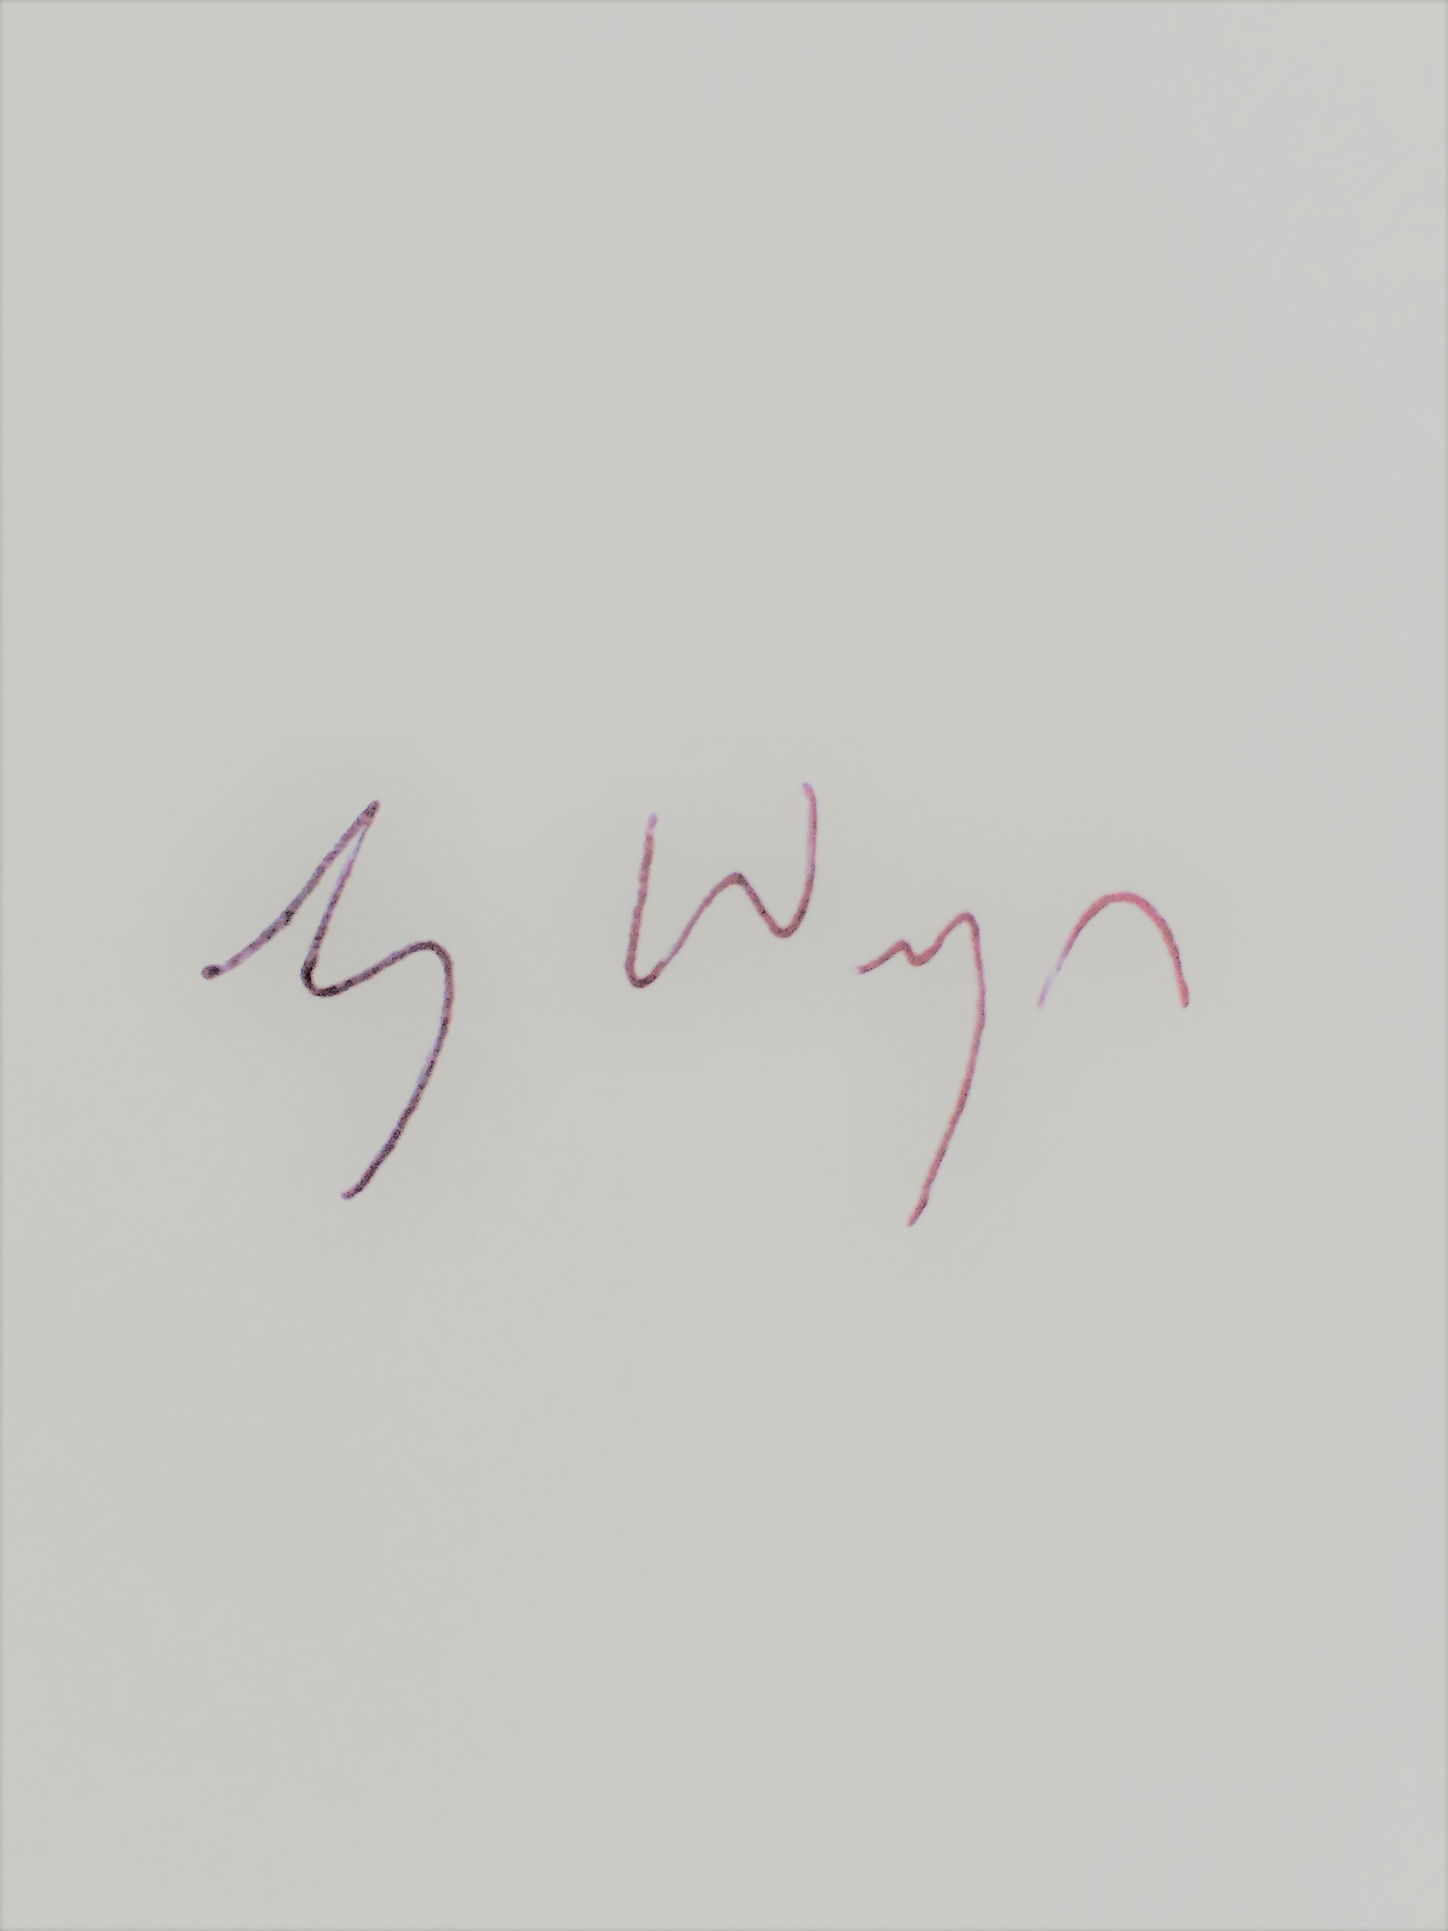

Signed

Print name
Gruff Wyn

Agent

Position

18/10/2018

Date

Application Checklist

Please tick the following checklist items to indicate that you have included the required information. If any sections of the form are left blank and no supporting information submitted, where we have insufficient information to make a decision
on your application, we will return your application to you.

Essential:
Form WRA completed, if there have been any changes since pre-application an updated Form WRA is required ☒
Map with all impoundment points and new wetted perimeters/submerged areas ☒
clearly marked
Drawings and Design Statement ☒
State number of continuation sheets (enter 0 if none included)

Where relevant:
Form WRD completed, if your proposal also requires an abstraction licence ☒
Stage 1 photo survey (contact us for more details on this requirement) ☐
Letter of authorisation from the applicant, allowing an agent to act as signatory ☒
Further information requested in our pre-application response letter to you ☐
Planning Authority response, where available ☐
Additional supporting information - please list below:

Drawing List:

170403MP01-v1 Nant y Betws Intake Front Elevation, Levels and Take Calcs
170403MP02-v1 Nant y Betws Intake Long Section
170403MP03-v1 Nant y Betws Intake GA and Nomenclature
170403MP04-v1 Nant y Betws Intake Overall Dimensions
170607MP01 Nant y Betws Powerhouse Section, Levels and Outfall
170607MP02 Nant y Betws Powerhouse Plan View
170607MP03 Nant y Betws Powerhouse Sections A and B
170607MP04 Nant y Betws Powerhouse Nomenclature
170607MP05 Nant y Betws Powerhouse Elevations
151206LB02-V2 Site Location Plan

