CRoW Appendix 4 (140_10_SD02)  CRoW Act 2000: Natural Resources Wales application for permission - Formal Notice  FOR INFORMATION ONLY |  | 
Natural Resources Wales Formal Notice.
Requirements of Section 28I of the Wildlife & Countryside Act 1981 as amended by the Countryside and Rights of Way Act (CRoW) 2000.
Duty in relation to granting any consent, licence or permit for activities likely to damage Sites of Special Scientific Interest (SSSI).
Guide to filling in this form for Natural Resources Wales staff:
To be completed by Permitting Officers for any applications for a permission which the Natural Resources Wales has considered under S28G duties to protect and enhance SSSIs. This applies to all proposed permissions within a SSSI, and to operations outside the SSSI boundary which are likely to damage its special features.
Refer to OI 140_10 ‘Applying the Countryside and Rights of Way (CRoW) Act 2000 to applications for permits with potential for impact on Sites of Special Scientific Interest (SSSI)’, including the flowchart in Appendix 2.
Pink italic text – drafting notes, to be deleted before completion/consultation.
Blue text – examples, to be replaced with permission-specific information.
Ensure you have completed all sections.
- Natural Resources Wales area/region/NPS hub: | South West Wales
- Name of SSSI: | 1. Caeau Capel Hendre SSSI (2 areas)  2. Caeau Blaenau Mawr SSSI (2 areas)  3. Caeau Lotwen SSSI (2 areas)  4. Broad Oak and Thornhill Meadows SSSI (3 areas)  5. Caeau Gwynfryn SSSI  6. Felin Fach Meadows, Cwmgwilli SSSI (5 areas)  7. Caeau Ffos Fach SSSI
- Type of permission: | Variation to bespoke permit for a clinical waste transfer station with treatment.
- Date for Natural Resources Wales permit determination:
- Predicted 28 day date for response from NRW conservation/ecology (under S28 I(4)):
- Natural Resources Wales reference no: | PAN 015849
- National grid reference: | The Grid Reference of the permitted facility is: SN 59321 11008
- Description of proposal: | The proposal is to vary an existing permitted clinical waste transfer station with treatment.  The facility is permitted to receive clinical and healthcare waste and to store, treat, repackage and send these wastes for disposal or recovery.  Waste inputs may consist of sourse-segregated non-hazardous and hazardous clinical and healthcare wastes.  Treatment operations shall be limited to manual and/or mechnical sorting, separation, washing, screening, bailing, shredding, crushing, compaction and pelletisation of permitted wastes for the purposes of recovery or disposal. Mechanical treatment may include the use of bespoke equipment to wash and shred waste to aid physical separation and recovery.  This variation makes the following amendments to the permit:  - Adding a waste sterilisation process to treat infectious clinical waste (18 01 03* and 18 02 02*) as well as non-hazardous waste absorbent hygiene products (20 01 99)  - Adding the waste code 19 08 01 (sewage screenings) to the list of permitted wastes.  - Extending the permit boundary.  NOTE: The permit boundary extension is not going to be used for activities associated with waste treatment and storage.
- Is the proposed activity within (wholly or partially) the SSSI boundary? | No – the Sites of Special Scientific Interest are shown on the map below (red shaded areas). The proposed Facility is show by the Green square. And a 2km buffer is shown by the green circle. Each SSSI is indicated by the number it is given in section 2 of this document.  All SSSI are located between 550m from the site boundary to 2km from the site boundary. All to the SW, W, NW, and N of the site.  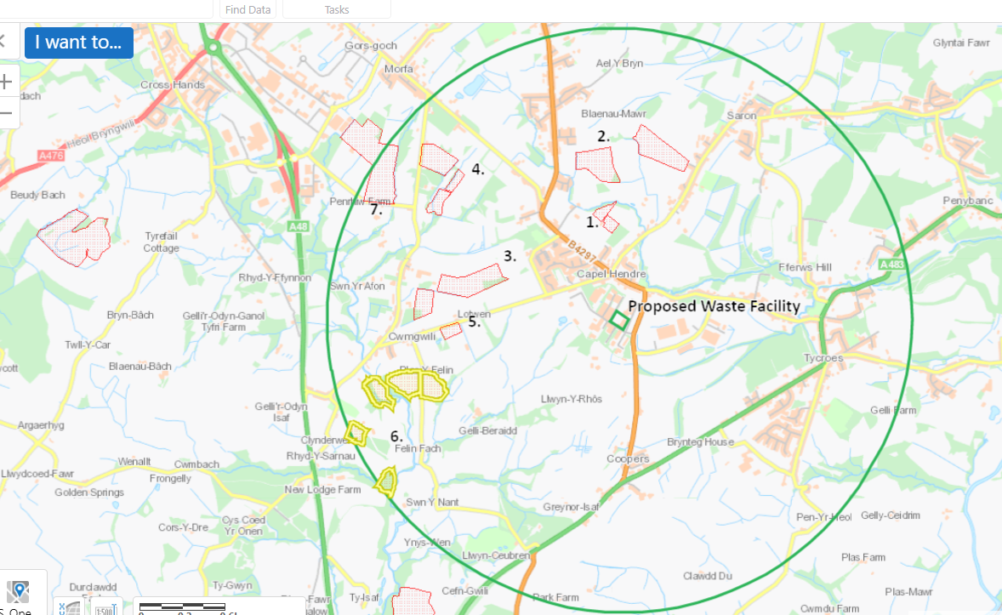
- Has there been any pre-application discussion or correspondence with NRW conservation/ecology | NO
- What aspect(s) of the proposed permission may damage the features which are of special interest for the SSSI?
The following ‘Operations Requiring Consent’ (or other activities associated with the permission) that may cause damage) are relevant to the proposed permission.

The following are the relevant operations requiring consent for all listed SSSI accept Caeau Blaenau Mawr SSSI:

7. Dumping, spreading or discharging of any materials

The following are the relevant operations requiring consent for Caeau Blaenau Mawr SSSI:

7. Dumping, spreading or discharging of any materials
22. Storage of Materials

The following SSSI features and mechanisms of impact have been considered to assess the likelihood of damage:

- Protected habitats (eg. Pastures and Meadows) and their supported invertebrate biology affected by suspended solids, and nutrients in run-off water from the proposed site.
- Protected habitats (eg. Pastures and Meadows) and their supported invertebrate biology affected by deposition of fugitive dust emissions from the proposed site.
- Decision
i) The proposed permission is not likely to damage any of the flora, fauna or geological or physiological features which are of special interest.

All SSSI - Discharges of site run-off and discharges to land.

The site activities are currently limited to being undertaken inside a building with impermeable surface and sealed drainage. The current permit does not allow for any point source emissions into surface waters, or ground water except for surface water from roofs or from areas of the site not being used in connection with the storing and/or treating of waste. This is not changing as a result of proposal in this variation application.

The boundary extension requested as part of the proposed variation has not been requested to be used for any activities associated with the treatment and/or storage of waste. For the additional site area brought in under this variation to be used for any activities associated with storage or treatment of waste a subsequent variation application would have to be submitted and accepted through the permitting process.

The nature of the facility only allowing waste treatment activities (storage/treatment) within a building withan impermeable surface with sealed drainage prevents there being any discharges to land.

As all waste is treated inside the existing building on-site which has an impermeable surface with sealed drainage, we do not consider there is a pathway for emissions from the site to impact the features of the special interest through discharges of site run off and discharges to land.

All SSSI – Emissions to air.

The site activities are currently limited to being undertaken inside a building with impermeable surface and sealed drainage. The existing site activities are undertaken exclusively within a building with the following standard controls applied:
- Waste is only accepted in sealed bags or UN approved containers
- Hazardous waste is kept in sealed lockable containers
- Waste processing to be carried out within sealed or shielded equipment to minimise the emission of airborne dust
- Processing equipment for dry dusty materials to be fitted with filters and or dust extraction systems where applicable to reduce generation of harmful airborne dust
- Surfaces of process equipment and floor area regularly cleaned down
- Waste to be transferred or treated as soon as practicable to reduce time in storage
- All waste activities to take place within the building.
- Doors to treatment and transfer areas to be kept closed when operational

These controls are not changing as a result of this variation. In addition, the new waste treatment activities, and waste codes accepted on site following this variation are consistent with the activities and waste currently undertaken. As a result, we do not consider there is an increased risk of airborne emissions to impact

Natural Resources Wales is minded to:
Issue the permission

- Name and job title of Natural Resources Wales officer: | Matthew Fryer  Permitting Officer
- Date form sent to NRW conservation/ecology

