CRoW Appendix 4 (140_10_SD02)  CRoW Act 2000: Natural Resources Wales application for permission - Formal Notice |  | 
Natural Resources Wales Formal Notice.
Requirements of Section 28I of the Wildlife & Countryside Act 1981 as amended by the Countryside and Rights of Way Act (CRoW) 2000.
Duty in relation to granting any consent, licence or permit for activities likely to damage Sites of Special Scientific Interest (SSSI).
- Natural Resources Wales area/region/NPS hub: | Southeast
- Name of SSSI: | Gwent Levels - Nash and Goldcliff  Gwlyptiroedd Casnewydd / Newport Wetlands  River Usk (Lower Usk) / Afon Wysg (Wysg Isaf)  Severn Estuary
- Type of permission: | Application to vary a tier 3 bespoke waste permit under the Environmental permitting regulations 2016
- Date for Natural Resources Wales permit determination: | 19/01/2022
- Predicted 28 day date for response from NRW conservation/ecology (under S28 I(4)): | n/a – saved for information only
- Natural Resources Wales reference no: | PAN-016672
- National grid reference: | ST 33660 84090
- Description of proposal: | Welsh Water Organic Waste Limited (WWOWL) are applying for a normal variation for the following changes -  • Update the registered office address  • Increase the accepted annual waste tonnage to site to 74,999 tonnes
- Is the proposed activity within (wholly or partially) the SSSI boundary? | NO  Gwent Levels - Nash and Goldcliff is 242m to the southeast of the site boundry  Gwlyptiroedd Casnewydd / Newport Wetlands is 601m to the south of the site boundry  River Usk (Lower Usk) / Afon Wysg (Wysg Isaf) is 306m to the nortwest of the site boundry  Severn Estuary is 1376m to the south of the site boundary  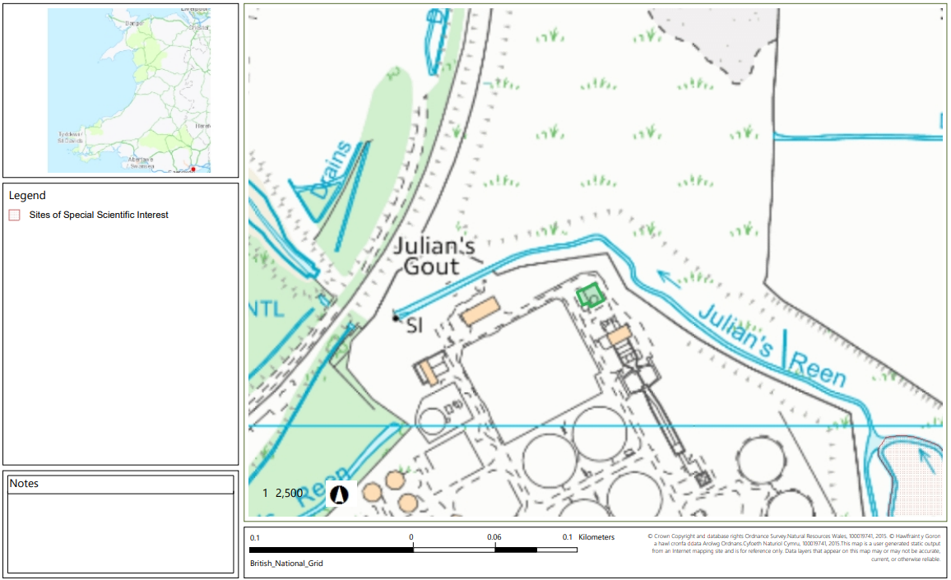  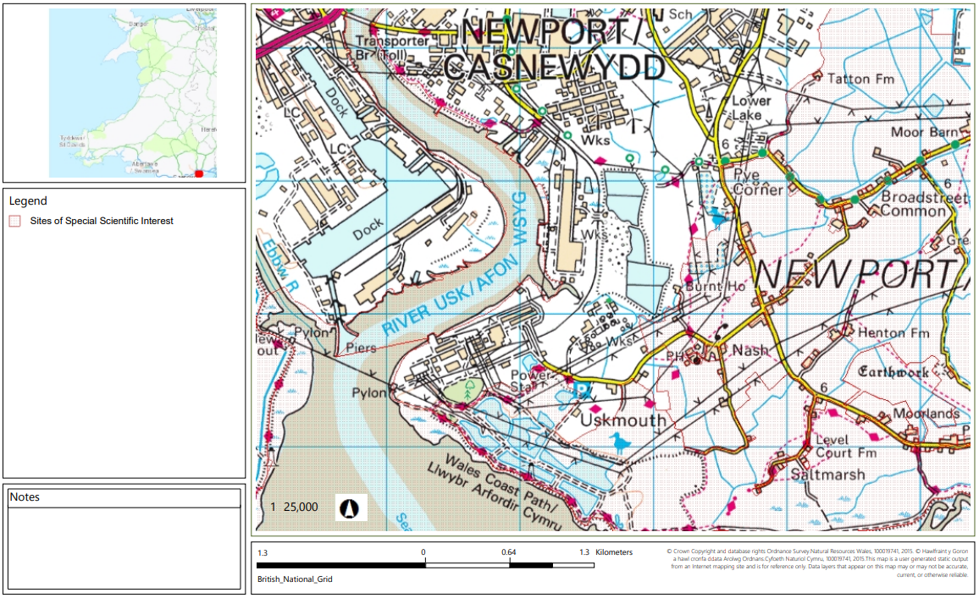
- Has there been any pre-application discussion or correspondence with NRW conservation/ecology | NO
- What aspect(s) of the proposed permission may damage the features which are of special interest for the SSSI?
The following ‘Operations Requiring Consent’ (or other activities associated with the permission) that may cause damage) are relevant to the proposed permission.

Gwent Levels - Nash and Goldcliff
Storage of materials.

Gwlyptiroedd Casnewydd / Newport Wetlands
Storage of materials.

River Usk (Lower Usk) / Afon Wysg (Wysg Isaf)
No relevant operations are associated with the permission.

Severn Estuary
Storage of materials.

Please note that none of the above activities under this deployment application are occurring on or within the SSSI.

The following SSSI features and mechanisms of impact have been considered to assess the likelihood of damage:
The site does not have any emission points therefore, it will have no effect on the SSSIs.
- Decision
i) The proposed permission is not likely to damage any of the flora, fauna or geological or physiological features which are of special interest because there is no conceivable impact pathway.

Natural Resources Wales is minded to: Issue the permission

- Name and job title of Natural Resources Wales officer: | Sion Sleep  Waste Permitting Officer
- Date form sent to NRW conservation/ecology | n/a – saved for information only

