Benthic Subtidal and Intertidal Surveys Scope
RPSCON0222
V01
JULY 2022

CONWY TO DOUGLAS PIPELINE SPILL MONITORING

Subtidal and Intertidal Sampling and Analysis Plan

Document status
Version | Purpose of document | Authored by | Reviewed by | Approved by | Review date
Rev01 | Internal draft | Elena Cappelli | Ross Griffin

Approval for issue
4 July 2022

The report has been prepared for the exclusive use and benefit of our client and solely for the purpose for which it is provided. Unless otherwise agreed in writing by RPS Group Plc, any of its subsidiaries, or a related entity (collectively 'RPS') no part of this report should be reproduced, distributed or communicated to any third party. RPS does not accept any liability if this report is used for an alternative purpose from which it is intended, nor to any third party in respect of this report. The report does not account for any changes relating to the subject matter of the report, or any legislative or regulatory changes that have occurred since the report was produced and that may affect the report.
The report has been prepared using the information provided to RPS by its client, or others on behalf of its client. To the fullest extent permitted by law, RPS shall not be liable for any loss or damage suffered by the client arising from fraud, misrepresentation, withholding of information material relevant to the report or required by RPS, or other default relating to such information, whether on the client’s part or that of the other information sources, unless such fraud, misrepresentation, withholding or such other default is evident to RPS without further enquiry. It is expressly stated that no independent verification of any documents or information supplied by the client or others on behalf of the client has been made. The report shall be used for general information only.

Prepared by: | Prepared for:
RPS Energy Ltd | Eni UK Limited
Rand Romas  Helen Nagle  Daniel Collins  Marine Consultant | Raffaella Cislaghi  HSE Interface Coordinator
Riverside Court  Chepstow, Monmouthshire NP16 5UH | 10 Ebury Bridge Road  London SW1W 8PZ
T + 44 1483 746500  E rand.romas@rpsgroup.com | T  E Raffaella.Cislaghi@eni.com

Contents
Acronyms iv
Units iv
1 Introduction 1
1.1 Project Overview 1
1.1.1 Project Location 1
1.1.2 Designated Sites 1
1.2 Aims and Objectives 2
2 Approach To survey scoping 4
2.1 Review of Existing Datasets 4
3 Summary of Existing data 5
4 Survey Design 9
4.1 Rationale 9
4.2 Proposed Sampling Strategy 9
4.2.1 Subtidal Benthic Survey 10
4.2.2 Ruptured Pipeline Subtidal Survey (Cruciform design) 11
4.2.3 Intertidal Benthic Survey 11
4.3 Grab and Drop-Down Camera (DDC) Sampling Design 13
4.3.1 Subtidal Stations 13
4.3.2 Ruptured Pipeline Stations (Cruciform) 14
4.4 Water Sampling Design 14
4.4.1 Subtidal Stations 14
4.4.2 Ruptured Pipeline Stations (Cruciform) 14
4.5 Hand Coring sampling Design 14
4.5.1 Intertidal Stations 14
4.5.2 Shellfish Stations 15
4.6 Timing 15
5 survey methods 16
5.1 Survey Vessel 16
5.2 Hovercraft 16
5.3 Equipment 17
5.4 Seabed Imagery Collection 17
5.4.1 Drop-Down Video System 17
5.5 Benthic Grab Sampling 18
5.5.1 Sample Collection 18
5.5.2 Grab Sample Processing (PSA & MACROFAUNA) 18
5.5.3 Grab Sample Processing (SEDIMENT CHEMISTRY) 18
5.6 Water Sampling 19
5.6.1 Water Profiling 19
5.7 Hand Coring Sampling 19
5.8 Shellfish sampling 19
6 Sample Analysis 20
6.1 Benthic Infauna 20
6.2 Particle Size 21
6.3 Contaminant Analysis 22
6.4 Seabed Imagery Analysis 23
6.4.1 Tier 1 Analysis 23
6.4.2 Tier 2 Analysis 24
7 References 25

Figures
Figure 1-1: Location of the Conwy and Douglas Platforms, connecting subsea pipeline and designated areas. 3
Figure 3-1: Illustrates the Predicted EUNIS Habitats from the EUSeaMap 2021 for the Douglas complex and other existing data sources. 7
Figure 3-2: Annex I Sandbanks, Annex I Reefs, and OSPAR Threatened and Declining Habitats in proximity of the Douglas complex. 8
Figure 4-1 Proposed locations of subtidal DDC, grab and water sampling stations, and of intertidal sediment cores and shellfish stations. 12

Tables
Table 4-1 Overview of proposed subtidal DDC, grab and water sampling stations to be sampled as part of the Conwy to Douglas Pipeline Oil Spill Monitoring. 14
Table 4-2 Overview of proposed ruptured pipeline subtidal DDC, grab and water sampling stations to be sampled as part of the Conwy to Douglas Pipeline Oil Spill Monitoring 14
Table 4-3 Overview of proposed intertidal sampling stations to be sampled as part of the Conwy to Douglas Pipeline Oil Spill Monitoring. 15
Table 4-4 Overview of proposed shellfish sampling stations to be sampled as part of the Conwy to Douglas Pipeline Oil Spill Monitoring. 15
Table 5-1 Vessel Details 16
Table 5-2 Equipment list to be utilised onboard the Argyll Explorer. 17
Table 6-1 Sieve series employed for PSD analysis by dry sieving. 21
Table 6-2 The classification used for defining sediment type based on the Wentworth Classification System (Wentworth 1922). 22
Table 6-3 Characteristics of stony reef (Irving 2009). 23
Table 6-4 Characteristics of Sabellaria spinulosa reef (Gubbay 2007). 23

Acronyms
Acronym | Description
BIIGLE | Bio-Image Indexing and Graphical Labelling Environment
BSH | Broad-Scale Habitat
DDC | Drop Down Camera
EMODnet | European Marine Observation and Data Network
ENI | Ente Nazionale Idrocarburi
EUNIS | European University Information Systems
FOCI | Feature of Conservation Importance
HOCI | Habitat of Conservation Importance
IQI | Infauna Quality Index
JNCC | Joint Nature Conservation Committee
LAT | Lowest Astronomical Tide
MCZ | Marine Conservation Zone
MMO | Marine Management Organisation
MPA | Marine Protected Area
NMBAQC | National Marine Biological Analytical Quality Control
OEL | Ocean Ecology Limited
OWF | Offshore Wind Farm
PAH | Polycyclic Aromatic Hydrocarbon
PSA | Particle Size Analysis
PSD | Particle Size Distribution
PMCC | Premiam Monitoring Coordination Cell
SAC | Special Area of Conservation
SAP | Sampling and Analysis Plan
SPA | Special Protection Area
SSSI | Scientific Site of Special Interest
THC | Total Hydrocarbon Content
TOC | Total Organic Carbon
UKAS | United Kingdom Accreditation Services

Units
Unit | Description
km | Kilometre
m² | Square Metre
mm | Millimetre
nm | Nautical Mile
µm | Micrometre

Introduction
This document presents the scope of the proposed subtidal and intertidal surveys to be undertaken to assess the impacts of an oil spill which occurred due to a rupture on the Conwy to Douglas pipeline in proximity to the Douglas platform on the 14th February 2022 (Figure 1-1).
It is intended that this document will provide adequate information to allow the Premiam Monitoring Coordination Cell (PMCC) Team to agree the scope of the proposed survey.

Project Overview

Project Location
The Douglas complex, operated by Ente Nazionale Idrocarburi (ENI), is a system of three bridge-linked platforms in the East Irish Sea, approximately 23 km off the coast of North Wales, UK, covering water depths varying from 0 to 29 m. A 12 km long subsea pipeline connects the Douglas platform to the Conwy Platform (Figure 1-1).

Designated Sites
Several designated sites occur in proximity of the Douglas complex. Of particular interest to the benthic subtidal and intertidal surveys are the Liverpool Bay / Bae Lerpwl Special Protected area (SPA), the Shell Flat and Lune Deep Special Area of Conservation (SAC), the Fylde Marine Conservation Zone (MCZ), the Ribble and Alt Estuaries Ramsar site and the Sefton Coast Site of Special Scientific Interest (SSSI).

Liverpool Bay / Bae Lerpwl SPA
Liverpool Bay / Bae Lerpwl SPA is in the East Irish Sea, bordering the coastlines of north-west England and north Wales. The boundary of Liverpool Bay / Bae Lerpwl SPA extends beyond 12 nautical miles and therefore lies partly in Welsh and English territorial waters and partly in offshore waters; hence it is a site for which Natural England, Natural Resources Wales, and JNCC have responsibility to provide statutory advice. It is classified for the protection of red-throated diver (Gavia stellata), common scoter (Melanitta nigra), and little gull (Hydrocoloeus minutus) in the non-breeding season; common tern (Sterna hirundo) and little tern (Sterna albifrons) in the breeding season, and an internationally important waterbird assemblage. The overarching conservation objectives for the protected features of this site are to ensure they either remain in or reach favourable condition. The ability of a designated feature to remain in or reach favourable condition can be affected by its sensitivity to pressures associated with activities taking place within or near a protected site.

Shell Flat and Lune Deep SAC
The Shell Flat and Lune Deep SAC is located between approximately 3 and 20 km to the east off the Lancashire Coast, at the mouth of Morecambe Bay. The site gets its name from the deep water channel (Lune Deep) and the large sandbank features (Shell Flat) situated to the north and the south.
Qualifying features of the SAC are sandbanks which are slightly covered by sea water all the time and reefs. These features are considered representative of boulder and cobble reefs, and sandbanks that are present in the eastern part of the Irish Sea.

Fylde MCZ
Fylde MCZ was designated in 2013 in order to protect the local broad scale habitat (BSH) “subtidal sand” and the habitat of conservation importance (HOCI) ”subtidal sands and gravels”. The Fylde MCZ overlaps the Liverpool Bay SPA. Qualifying features of the MCZ are subtidal sand and subtidal mud which are highly productive and support diverse populations of crabs, starfish, crustaceans, and bivalve species, including: nut-shell (Nucula nitidosa), razor shell (Pharus legumen) and the white furrow shell (Abra alba). Flatfish, including sole (Solea solea) and plaice (Pleuronectes platessa), in addition to whiting (Merlangius merlangus) are also supported by the habitat within the site.

Ribble & Alt Estuaries Ramsar Site
The Ribble and Alt Estuaries Ramsar site occupies a stretch of coastline between Liverpool and Preston on the north-west coast of England and covers a large area of about 13,460 ha, including two estuaries, extensive sand and mudflats, saltmarsh and dunes. The tidal flats and saltmarsh support internationally important populations of wintering waterbirds. Internationally important vegetation communities and amphibian populations occur in the sand dunes.

Sefton Coast SSSI
The Sefton Coast SSSI encompasses a series of habitats and species that are primary reasons for selection of this site:
Embryonic shifting dunes, Shifting dunes along the shoreline with Ammophila arenaria ('White dunes'), Fixed dunes with herbaceous vegetation ('Grey dunes'), Dunes with Salix repens ssp. argentea (Salicion arenariae), Humid dune slacks and Petalwort, Petalophyllum ralfsii. Additional qualifying features are Atlantic decalcified fixed dunes (Calluno-Ulicetea), and the Great crested newt, Triturus cristatus.

Aims and Objectives
ENI propose to undertake subtidal and intertidal surveys to assess the impacts of an oil spill which occurred following a rupture on the Conwy to Douglas pipeline in proximity to the Douglas platform on the 14th February 2022.
As set out below, there is existing benthic ecology information from other developments and studies located within the vicinity of the Douglas complex. The proposed survey data will be used alongside oil spill modelling data and aerial imagery of the oil spill obtained as part of ENI Oil Pollution Emergency Plan as well as desktop data sources to ensure that all potential habitats that could be impacted by the oil spill are captured as part of the survey.
This document details the proposed subtidal and intertidal surveys, including survey extent/coverage and proposed methodologies. This document is planned to be provided to PMCC for review and sign off, such that the proposed surveys can be undertaken in an efficient and effective manner.

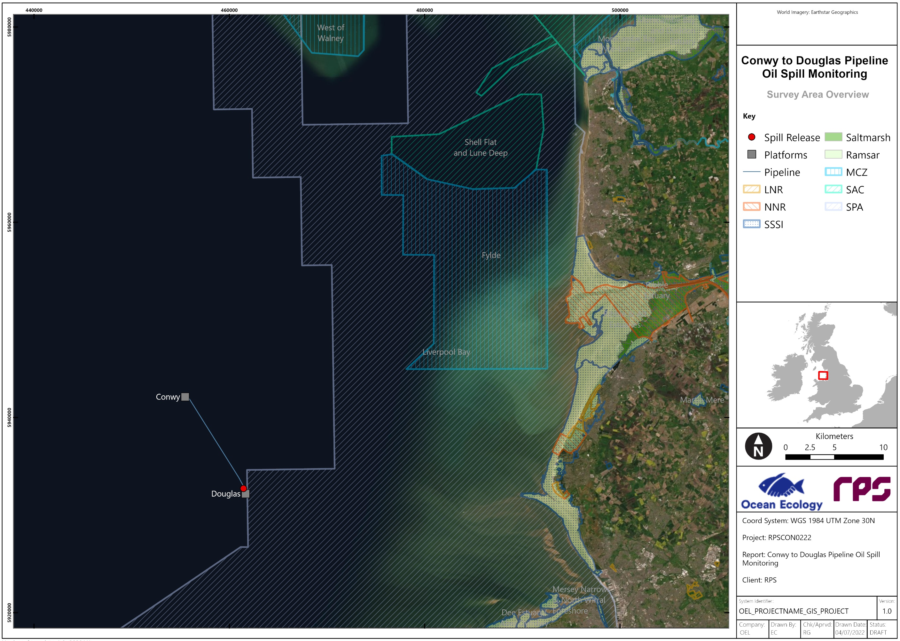
Figure 1-1: Location of the Conwy and Douglas Platforms, connecting subsea pipeline and designated areas.

Approach To survey scoping

Review of Existing Datasets
There are multiple desktop benthic ecology data sources available for the Douglas complex from a variety of site-specific surveys and broadscale habitat mapping in the area.
The design of the survey scope has been informed by a review of existing data for the regional area sourced using Cefas open science portal OneBenthic. Data were obtained for the following projects/surveys:
- Predicted European Union Nature Information Systems (EUNIS) habitats from the EUSeaMap 2021
- Area 457 (North-West dredging region) Regional Seabed Monitoring Plan (2001, 2015, 2019)
- Shell Flats NE Habitats Directive Benthic Survey (2012 & 2017)
- Liverpool Bay WFD Benthic Survey (2007 & 2012)
- Hilbre Swash (Area 392-393) Regional Seabed Monitoring Plan (2011)
- Gwynt y Môr, North Hoyle II (2002 & 2003/2004)
- West of Duddon Sands OWF Baseline Benthic Survey (2005)
- Burbo Bank Offshore Wind Farm (OWF) Construction Phase Benthic Grab Survey (2006)
- Mersey Mouth WFD Benthic Invertebrate Survey (2013)
Following the desktop review, the results of the oil spill modelling study and aerial imagery of the region taken after the oil spill, the subtidal and intertidal benthic surveys sampling locations have been designed to provide adequate coverage of all areas and habitat types in proximity of the oil spill.
The benthic sampling array and sampling methodologies have been designed using best practice guidelines for effective and efficient benthic sampling, including JNCC Marine Monitoring Handbook (Davies et al. 2001) and Noble-James et al. (2018).

Summary of Existing data
The following sections provide a brief overview of the existing datasets for the purposes of informing the benthic subtidal and intertidal survey scope.
EUSeaMap, 2021
The EUSeaMap 2021 data are shown in Figure 3-1 for the Douglas complex and surrounding region.
The EUSeaMap data indicate that the sediments are dominated by deep circalittoral coarse sediment, deep circalittoral sand, circalittoral fine sand, circalittoral muddy sand and circalittoral sandy mud, with smaller areas of deep circalittoral mud, circalittoral coarse sediment, circalittoral mixed sediments (EU SeaMap, 2021). Deep circalittoral coarse sediment (A5.15) is the dominant sediment type at the location of the two platforms (Conwy and Douglas) and along the pipeline as well as to the northwest of the Douglas complex. Closer to the coast, circalittoral fine sand (A5.25) and muddy sand (A5.26) dominate to the east of the Douglas platform, while circalittoral sandy mud (A5.35) dominates to the north (EU SeaMap, 2021).
The 2021 EUSeaMap broad-scale predictive model classifies and maps seabed sediment types according to the European Nature Information Systems (EUNIS) classification criteria. The system is able to identify keystone species that have been evidenced to inhabit areas with certain environmental conditions and can therefore act as an indicator, allowing inferences of overall community composition.
According to EUSeaMap 2021 data, the following EUNIS seabed classifications dominate the seabed in the area potentially impacted by the oil spill based on modelling studies (ref to model study):
- A5.45: Deep Circalittoral Mixed Sediments – These habitats are often highly diverse with a high number of infaunal polychaete and bivalve species. Animal communities in this habitat are closely related to offshore gravels and coarse sands and in some areas populations of the horse mussel Modiolus modiolus may develop.
- A5.15: Deep Circalittoral Coarse Sediment – These habitats are quite diverse compared to their shallower versions and generally characterised by robust infaunal polychaete and bivalve species. Animal communities in this habitat are closely related to offshore mixed sediments and in some area’s settlement of Modiolus larvae may occur and consequently these habitats may occasionally have large numbers of juvenile M. modiolus. In areas where the mussels reach maturity their byssus threats bind the sediment together, increasing stability and allowing an increased deposition of silt.
- A5.27: Deep Circalittoral Sand - Offshore deep habitat with fine sand or non-cohesive muddy sands. Communities are typically dominated by polychaetes, amphipods, bivalves and echinoderms.
- A5.14: Circalittoral Coarse Sediment – This habitat may be characterised by robust infaunal polychaetes, mobile crustacea and bivalves. Certain species of sea cucumber (e.g. Neopentadactyla) may also be prevalent in these areas along with the lancelet Branchiostoma lanceolatum;
- A5.25: Circalittoral Fine Sand – Characterised by a range of echinoderms including the sea urchin Echinocyamus pusillus, polychaetes and bivalves. This habitat is generally more stable than infralittoral fine sand and subsequently supports a more diverse faunal assemblage.
- A5.26: Circalittoral Muddy Sand – This habitat supports animal-dominated communities characterised by a variety of polychaetes, bivalves (Abra alba and Nucula nitidosa) and echinoderms (Amphiura spp., Ophiura spp. and Astropecten irregularis). These circalittoral habitats tend to be more stable than their infralittoral counterparts and as such support a richer infaunal community.
- A5.35: Circalittoral Sandy Mud – Sea pens such as Virgularia mirabilis and brittlestars such as Amphiura spp. are particularly characteristic of this habitat whilst infaunal species include the tube building polychaetes Lagis koreni and Owenia fusiformis, and deposit feeding bivalves such as Kurtiella bidentata and Abra spp.
Utilising data obtained from the Joint Nature Conservation Committee (JNCC) and the European Marine Observation and Data Network (EMODnet), there were found to be Annex I Sandbanks and Annex I Reefs in the area potentially affected by the oil spill based on the modelling study. Conversely no OSPAR threatened and declining habitats are located within the potentially impacted oil spill area; however, mussel beds are located both north and south of the modelled area. In the intertidal zone, shellfish protected waters under the Water Framework Directive (WFD) Regulations 2017 are located in the Ribble estuary and North Wirral (Figure 3-2).
Regional Seabed Monitoring Plan
The Regional Seabed Monitoring Plan (RSMP) is an innovative approach to monitoring the condition of the seabed, adopted by the UK marine aggregate dredging industry in 2014. It aims to ensure the seabed can support recolonisation, and the return of a similar animal community type after dredging activities have ended to improve and maintain environmental sustainability (Cooper 2013, Cooper & Barry 2017). RSMP surveys are being planned or undertaken in aggregate dredging regions around the UK coast as part of the monitoring programme funded by the marine aggregate industry. As part of this, Area 457 and Areas 392 and 393 (Hilbre Swash) have been consistently monitored over the years by means of analysing both macrofauna and sediment samples. These areas are located within the zone potentially affected by the oil spill and will provide valuable background information of the local environment prior to the spill (Figure 3-1).
Special Area of Conservation (SAC) Monitoring Plan
A monitoring programme of SAC is in place to assess the condition of their protected features over time. Regular environmental surveys are carried out with the intent of gather data on the distribution, extent and range of communities associated with the SAC protected features. The Shell Flat and Lune Deep SAC has been monitored over the years to collect data on the structure and distribution of biological communities within the sediments of the SAC and to provide information for condition assessment of sediment features such as sandbanks. Therefore, these monitoring surveys will provide useful information to assess the impact of the oil spill in the area by means of comparison (Error! Reference source not found.).
Water Framework Directive (WFD) Benthic Invertebrate Surveys
The WFD requires the ecology of coastal and estuarine waterbodies to be assessed to determine where action is needed to improve the water environment. As such benthic invertebrate populations are monitored across the various WFD waterbodies as indicators of disturbance or environmental ‘pressures’. The Liverpool Bay WFD waterbody and the Mersey Mouth WFD waterbody are both located in the vicinity of the oil spill and will provide critical information to contextualise the data that will be collected during the proposed subtidal and intertidal surveys (Figure 3-1).
Offshore Wind Farm (OWF) Environmental Baseline and Monitoring Surveys
Three OWFs are located in the vicinity of the Douglas complex and within or around the area potentially affected by the oil spill based on modelling reconstructions. These OWFs are Burbo Bank, located approximately 15 km east of the oil spill release location, Gwynt y Môr, situated about 7.5 km south of the oil spill, and West of Duddon Sands, located 43 km north of the oil spill, outside of the modelled area of impact.
To determine the environmental impacts of OWFs on the local environments, a series of environmental surveys are required to comply with current legislations. These surveys establish baseline conditions prior to the construction of OWFs as well as they recur over the years to monitor local benthic habitats and evaluate and assess potential impacts after the construction and during the operation of OWFs. As such a wealth of information on local benthic habitats (both sediment physicochemical properties and macrofauna) is available at these sites and will be used to provide context and means of comparisons with the data that will be collected during the proposed surveys (Figure 3-1).

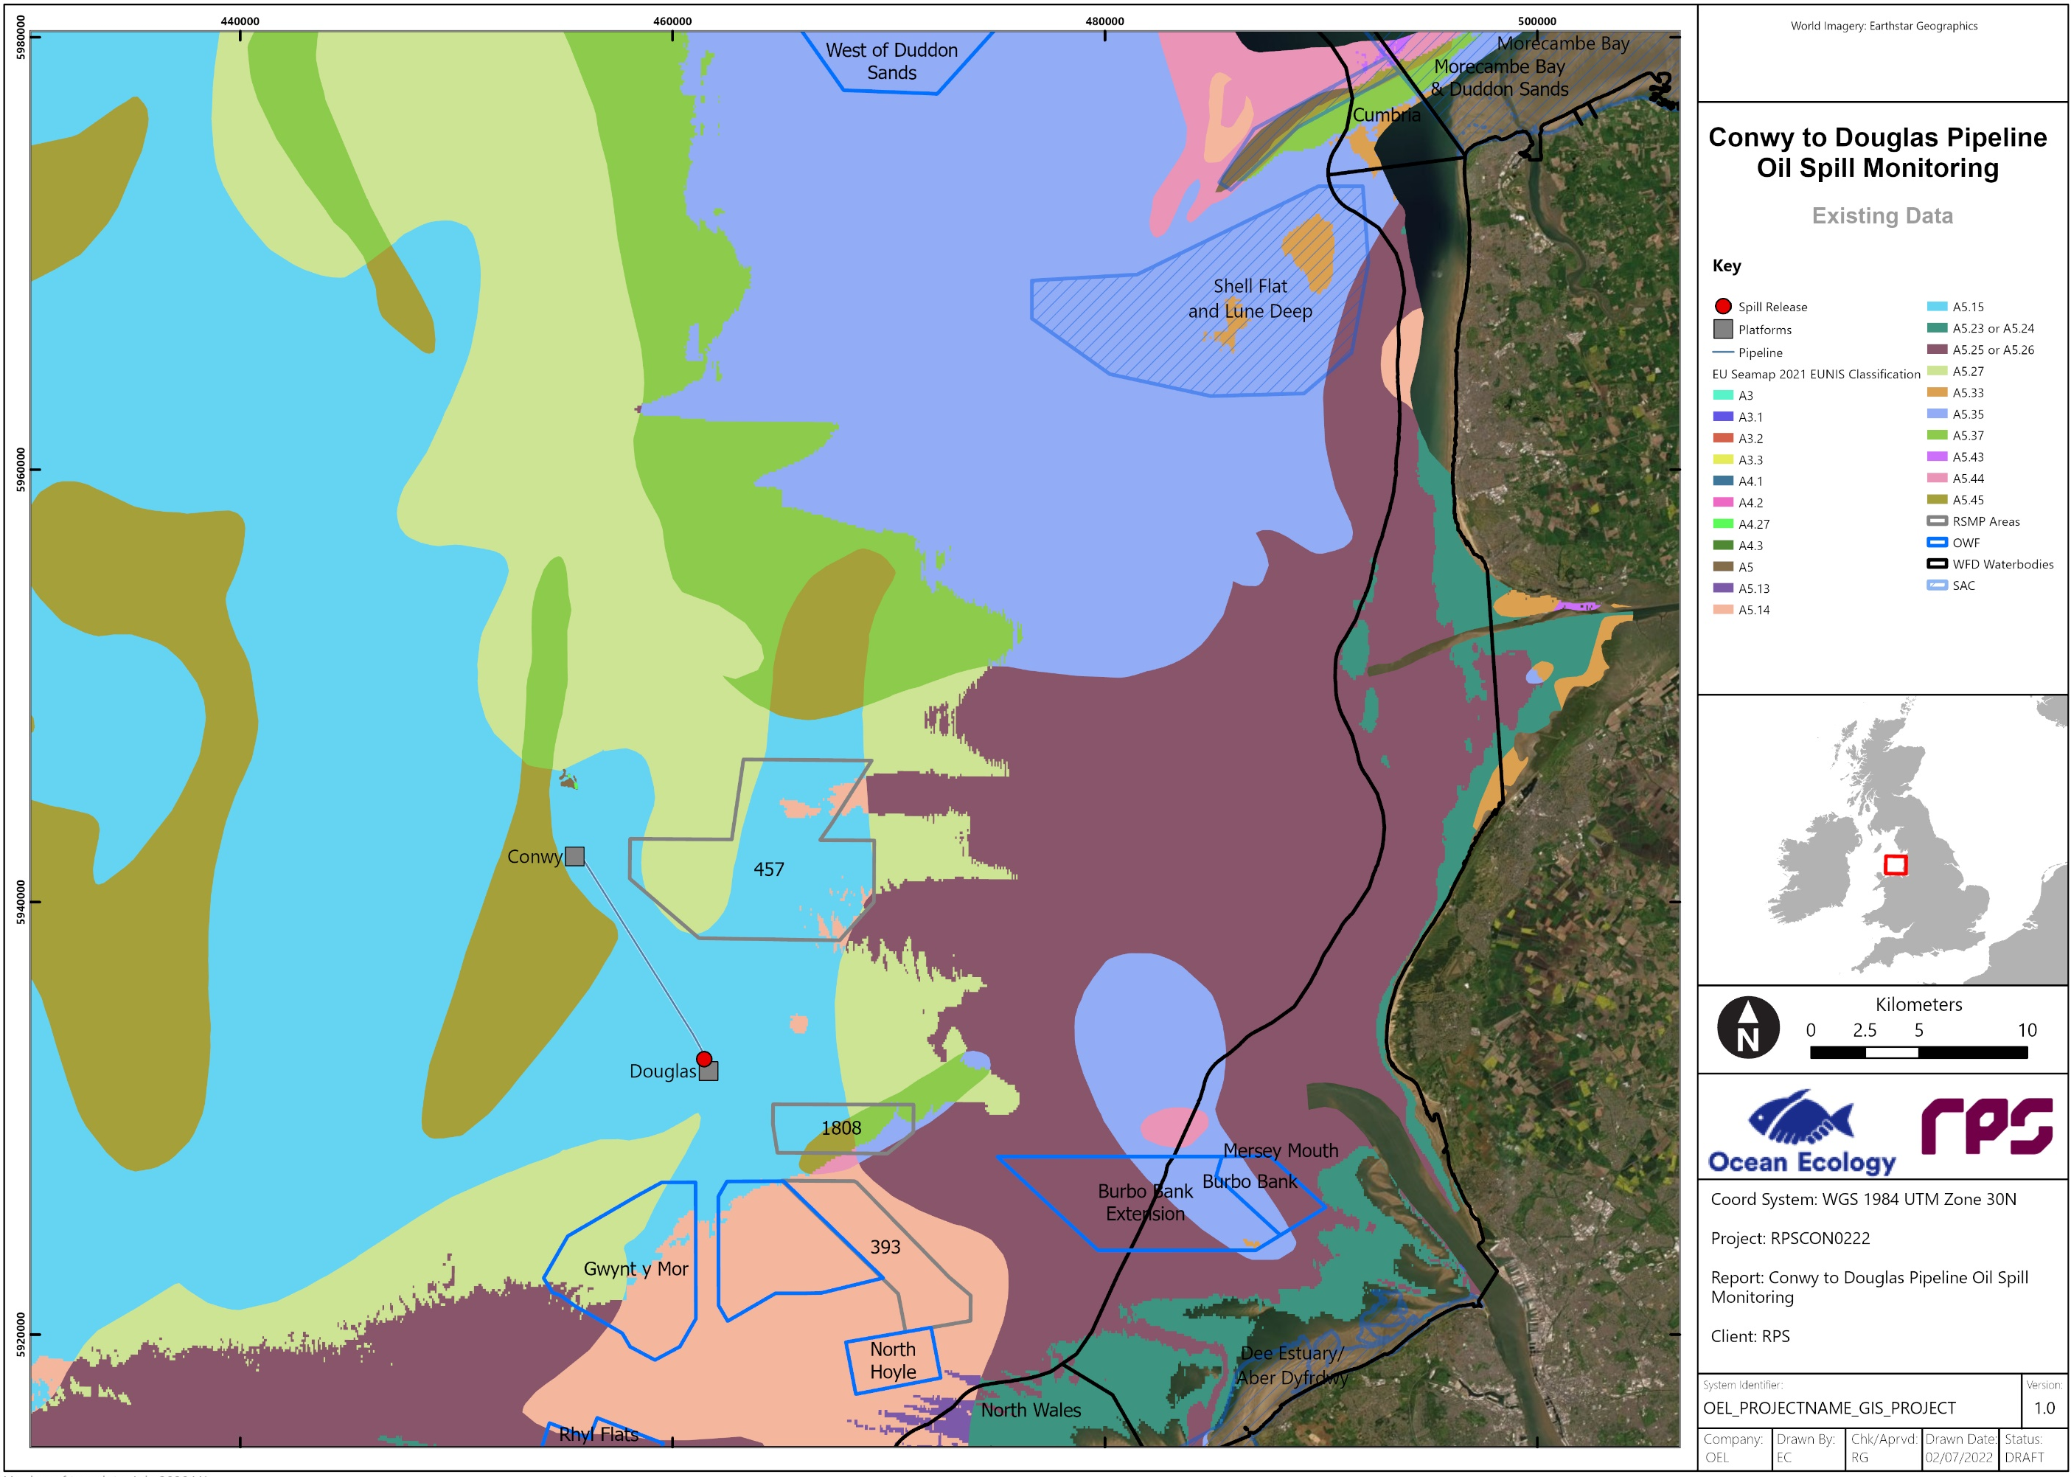
Figure 3-1: Illustrates the Predicted EUNIS Habitats from the EUSeaMap 2021 for the Douglas complex and other existing data sources.
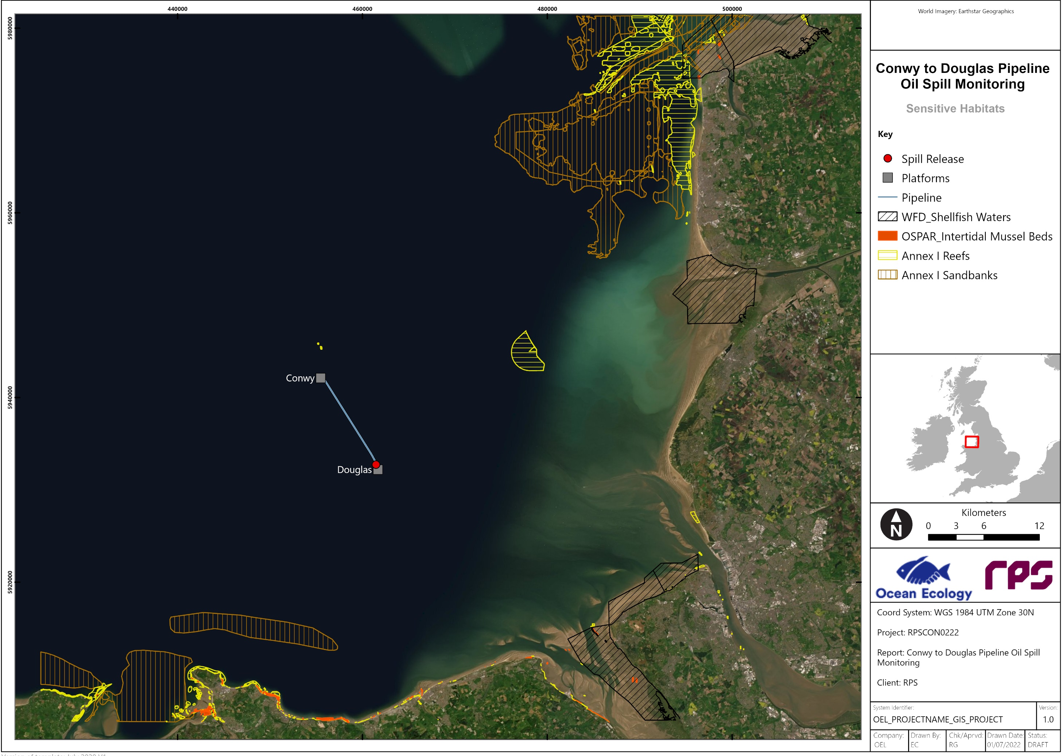
Figure 3-2: Annex I Sandbanks, Annex I Reefs, and OSPAR Threatened and Declining Habitats in proximity of the Douglas complex.

Survey Design

Rationale
As outlined in section 1.2, the purpose of the proposed benthic subtidal and intertidal surveys is to assess the impact of an oil spill following a rupture on the Conwy to Douglas pipeline.
The proposed sampling strategy has therefore been designed to adequately sample the areas which could be potentially impacted by the oil spill providing accurate, up-to-date data on the subtidal and intertidal benthic habitats, communities, and species within reach of the oil spill. The broad principles behind the survey are:
- Ensure adequate coverage across the area potentially affected by the oil spill and ensure that impacts can be accurately assessed by comparing data with pre-spill (historic) data as well as with ‘reference/clean’ data from sampling locations in the vicinity of the oil spill and likely to have similar sediments and biotopes as the potentially impacted locations but where no impacts from the oil spill were modelled.
- Ensure representative sampling across all broadscale sediment types as indicated by the desktop data sources.
- Ensure representative examples of all potential features of conservation interest are adequately sampled.
There are three key elements of the proposed surveys:
- Ruptured Pipeline Subtidal Sampling – this survey is targeted to assess the near-field impacts of the oil spill.
- Broad-Scale Subtidal Sampling – the aim of this survey is to assess for impacts of the oil spill across the modelled spill area on a broad scale.
- Intertidal Benthic Sampling – this survey is targeted to assess impacts of the oil spill along the shoreline, with particular attention to potential impacts on commercial shellfish (cockles) and therefore on food safety.

Proposed Sampling Strategy
The sampling plan has been developed to provide maximum geographic coverage of the modelled oil spill area, whilst also ensuring that all key habitats and communities likely to be affected by the oil spill are adequately targeted. Micro-siting of sampling stations has been adopted in consideration of all surface, subsurface and subsea hazards and their respective exclusion / buffer zones. The following components were assessed in the development of the sampling plan:
- Modelling oil spill study
- Aerial Imagery collected after the oil spill
- Interpretation of seabed classification from EUSeaMap 2021
- All available GIS shapefiles and rasters in ESRI format to include all oil and gas and OWF surface, subsurface and subsea infrastructures and the latest relevant Marine Protected Areas (MPA) boundaries
- All previous surveys and / or technical reports available for the area.
The sampling plan consists of several elements: subtidal Drop-Down Camera (DDC), grab and water sampling locations, and intertidal sediment core and shellfish (cockles) sampling locations (Table 4-1). Details on each is provided in the sections below. Sampling plan shapefiles are provided in Appendix I. An overview of the proposed sampling stations is also presented in Figure 4-1.

Ruptured Pipeline Subtidal Sampling (Cruciform design)
The Ruptured Pipeline Subtidal Sampling will collect benthic grab samples for subsequent macrobenthic, sediment particle size analysis (PSA) and sediment chemistry analysis at a total of 11 sampling stations across a cruciform design. Seabed imagery will be collected with a DDC system at each of the 11 grab sampling stations prior to grab deployment to ensure the target location is clear of any obstruction (e.g., subsea cables) or protected habitat (e.g., Annex I habitats). In addition, water sampling will be undertaken at three of the 11 DDC and grab sampling stations for subsequent chemical analysis. Seabed imagery, grabs and water samples will be collected along a cruciform design centred at the oil spill release site and branching out along the pipeline and in the main direction of the modelled oil spill to aid in the assessment of near-field impacts associated with the oil spill.

Broad-Scale Subtidal Sampling
The broad-scale subtidal sampling will collect benthic grab samples for subsequent macrobenthic, sediment PSA and sediment chemistry analysis at a total of 18 sampling stations across the proposed survey area. Seabed imagery will be collected with a DDC system at each of the 18 grab sampling stations prior to grab. In addition, water sampling will be undertaken at 9 of the DDC and grab sampling stations for subsequent chemical analysis.

Intertidal Benthic Sampling
The intertidal survey will collect sediment cores for subsequent macrobenthic, PSA and sediment chemistry analysis at a total of 15 sampling stations across the proposed survey area.
An additional 8 intertidal stations will be sampled for shellfish (cockles) flesh samples to assess for food safety.

Table 4-1 Summary of the sampling strategy.
Survey | Sampling Type
Survey | DDC |  |  | Grab |  |  | Intertidal Core |  |  | Shellfish |  |  | Water Sampling
Survey | Stations | Reps | Total | Stations | Reps | Total | Stations | Reps | Total | Stations | Reps | Total | Stations | Reps | Total
Ruptured Pipeline Subtidal Sampling | 11 | 1 | 11 | 11 | 3 | 33 | - | - | - | - | - | - | 3 | 3 | 9
Broad-Scale Subtidal Sampling | 18 | 1 | 18 | 18 | 3 | 54 | - | - | - | - | - | - | 9 | 3 | 27
Intertidal Benthic Sampling | - | - | - | - | - | - | 15 | 3 | 45 | 8 | 3 | 24 | - | - | -

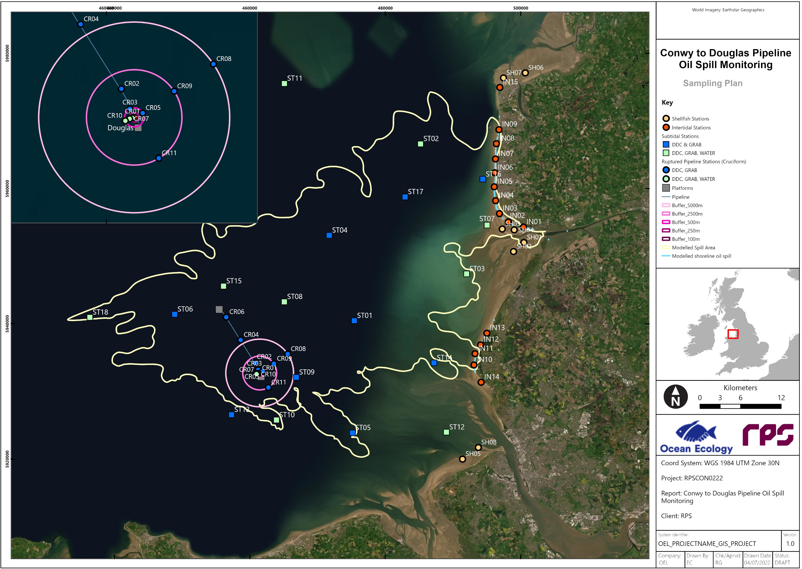
Figure 4-1 Proposed locations of subtidal DDC, grab and water sampling stations, and of intertidal sediment cores and shellfish stations.

Sampling Approach

Ruptured Pipeline Subtidal Sampling (Cruciform)
To capture near-field impacts from the oil spill, 11 stations will be sampled in a cruciform arrangement centred at the location of the oil spill release site and radiating out to the northwest along the pipeline itself, to the northeast following the main direction of the modelled oil spill and to the southeast and southwest to cover the full extent of the modelled oil spill in these directions. Eight stations have been positioned at 100 m, 250 m, 500 m, 2,500 m and 5,000 m from the oil spill release site to capture the impacts of the oil spill on the local environment. Additionally, a further three stations have been located along the pipeline (50 m buffer) to monitor potential impacts to benthic habitats between the Douglas and Conwy platforms (Figure 4-1). Water samples and water column profiles will also be collected at a subset of three of the 11 ruptured pipeline sampling stations.
At each station, three deployments of a 0.1 m² Dual Van Veen grab sampler will be used to collect 6 0.1 m² undisturbed surface sediment samples of up to 10 L in volume for subsequent laboratory analysis. Three of the 6 replicates will undergo macrobenthic analysis whilst the remaining three replicates will undergo physio-chemical analysis including particle size distribution (PSD) analysis and chemical sediment analysis inclusive of testing for Polyaromatic Hydrocarbons (PAHs), total hydrocarbons and metals (contaminants). The samples will be collected within 20 m of the target sampling locations. Where a suitable sample cannot be collected after three attempts within a 20 m radius of the target location, the sampling location will be moved by up to 50 m from the original target location. Should a further attempt be unsuccessful, the largest of the first three attempts will be taken and the volume noted. If no samples are acquired from the 4 attempts then the station will be abandoned.
DDC sampling will be undertaken at each location prior to any proposed grab sampling. This is in line with relevant guidance notes (Hitchin et al. 2015) that state that grab samples are to be avoided in areas where protected features might be present to prevent unnecessary damage to such features. Additionally, DDC investigation prior to grab sampling is to provide additional information on the sediment / substrate surface to determine suitability to collect grab samples such as confirming the absence of any obstruction (e.g., subsea cables) not identified during the desktop study. All DDC footage will be reviewed and assessed in real time during the surveys following the latest best practice guidance (Gubbay 2007, Irving 2009, Parry 2019, Golding et al. 2020a). If, following onboard review of the DDC footage, an Annex I habitat or other seabed feature is confirmed at a location, sampling will be limited to DDC only, rather than a combination of benthic grab sampling and DDC.
Water samples will be collected in triplicate (surface, middle and bottom of the water column) and subsequently analysed for PAHs and total hydrocarbons. A water column profile will also be recorded in situ from sea surface to near seabed at each of the water sampling stations measuring depth, conductivity, dissolved oxygen, turbidity, pH and temperature.
An overview of the distribution of sampling stations is provided below in Table 4-2 and presented visually in Figure 4-1. Corresponding shapefiles are also provided in Appendix I.
Table 4-2 Overview of proposed ruptured pipeline subtidal DDC, grab and water sampling stations to be sampled as part of the Conwy to Douglas Pipeline Oil Spill Monitoring.
Station ID | Type | Rationale
CR01 | DDC, GRAB, WATER | 100 m W of oil spill
CR02 | DDC, GRAB | Along the ruptured pipeline
CR03 | DDC, GRAB | Along the ruptured pipeline 500 m NW from spill
CR04 | DDC, GRAB | Along the ruptured pipeline
CR05 | DDC, GRAB | 500 m NE of spill
CR06 | DDC, GRAB | Along the ruptured pipeline
CR07 | DDC, GRAB, WATER | 250 m SW of oil spill
CR08 | DDC, GRAB | 5,000 m NE of oil spill
CR09 | DDC, GRAB | 2,500 m NE of oil spill
CR10 | DDC, GRAB, WATER | 500 m SW of oil spill
CR11 | DDC, GRAB | 2,500 m SE of the spill

Broad-Scale Subtidal Sampling
To identify broad-scale benthic habitats that might have been impacted by the oil spill, 18 stations will be sampled across the modelled area of the oil spill.
DDC sampling will be undertaken at each location prior to any proposed grab sampling.
At a subset of 9 of the 18 subtidal grab and DDC sampling stations, water samples will be collected in triplicate (surface, middle and bottom of the water column) and subsequently analysed for PAHs and total hydrocarbons.
Sampling at each station will follow that described in Section 4.3.1.
An overview of the distribution of sampling stations is provided below in Table 4-3 and presented visually in Figure 4-1 whilst the corresponding GIS shapefiles are also provided in Appendix I.
Table 4-3 Overview of proposed subtidal DDC, grab and water sampling stations to be sampled as part of the Conwy to Douglas Pipeline Oil Spill Monitoring.
Station ID | Type | BSH | Designation | Historic data
ST01 | DDC & GRAB | A5.25 or A5.26 | Liverpool Bay SPA | RSMP Area 457
ST02 | DDC, GRAB, WATER | A5.35 | Shell Flat ad Lune Deep SAC | Shell Flats NE Habitat Directive Benthic Survey
ST03 | DDC, GRAB, WATER | A5.25 or A5.26 | Fylde MCZ | Liverpool Bay WFD
ST04 | DDC & GRAB | A5.37 | Liverpool Bay SPA | -
ST05 | DDC & GRAB | A5.25 or A5.26 | Liverpool Bay SPA | RSMP Area 393
ST06 | DDC & GRAB | A5.15 | - | -
ST07 | DDC, GRAB, WATER | A5.25 or A5.26 | Liverpool Bay SPA | Liverpool Bay WFD
ST08 | DDC, GRAB, WATER | A5.15 | - | RSMP Area 457
ST09 | DDC & GRAB | A5.15 | Liverpool Bay SPA | RSMP Area 457
ST10 | DDC, GRAB, WATER | A5.14 | Liverpool Bay SPA | Gwynt y Môr OWF
ST11 | DDC, GRAB, WATER | A5.35 | Liverpool Bay SPA | West of Duddon Sands OWF
ST12 | DDC, GRAB, WATER | A5.25 or A5.26 | Liverpool Bay SPA | Burbo OWF
ST13 | DDC & GRAB | A5.27 | - | Gwynt y Môr OWF
ST14 | DDC & GRAB | A5.25 or A5.26 | Liverpool Bay SPA | Liverpool Bay WFD
ST15 | DDC, GRAB, WATER | A5.15 | - | RSMP Area 457
ST16 | DDC & GRAB | A5.25 or A5.26 | Liverpool Bay SPA | Mersey Mouth WFD
ST17 | DDC & GRAB | A5.35 | Fylde MCZ | -
ST18 | DDC, GRAB, WATER | A5.45 | - | -

Intertidal Benthic Sampling
To capture the impacts of the oil spill, 15 sampling stations will be sampled along the shoreline indicated by the modelling study as potentially affected by the oil spill. A 0.01 m² intertidal hand corer will be used to collect 6 sediment samples down to a depth of 15 cm at each sampling station. Three of the 6 replicates will undergo macrobenthic analysis whilst the remaining three replicates will undergo physio-chemical analysis including particle size distribution (PSD) analysis and chemical sediment analysis inclusive of testing for PAHs, total hydrocarbons and metals (contaminants).
To capture the impact of the oil spill on shellfish (cockles) and indirectly assess food safety, 8 stations will also be sampled in triplicate across the intertidal area where known commercial shellfish beds are located and within WFD shellfish waters. Shellfish samples will be analysed for PAHs, total hydrocarbons and metals to provide data relevant to food safety.
An overview of the distribution of sediment core and shellfish sampling stations is provided below in Table 4-4 and presented visually in Figure 4-1. The corresponding shapefiles are also provided in Appendix I.

Table 4-4 Overview of proposed intertidal sampling stations to be sampled as part of the Conwy to Douglas Pipeline Oil Spill Monitoring.
Station ID | Sampling Type | Designation | Rationale
IN01 | Core | - | Along modelled shoreline oil and within WFD Ribble shellfish waters
IN02 | Core | - | Along modelled shoreline oil and within WFD Ribble shellfish waters
IN03 | Core | Ribble Estuary SSSI & Ribble and Alt Estuaries Ramsar site | Along modelled shoreline oil
IN04 | Core | Ribble Estuary SSSI & Ribble and Alt Estuaries Ramsar site | Along modelled shoreline oil
IN05 | Core | - | Along modelled shoreline oil
IN06 | Core | - | Along modelled shoreline oil
IN07 | Core | - | Along modelled shoreline oil
IN08 | Core | - | Along modelled shoreline oil
IN09 | Core | - | Along modelled shoreline oil
IN10 | Core | Sefton Coast SSSI | In proximity of modelled shoreline oil
IN11 | Core | Sefton Coast SSSI & Ribble and Alt Estuaries Ramsar site | In proximity of modelled shoreline oil
IN12 | Core | Ainsdale Sand Dunes NNR, Sefton Coast SSSI, Ribble and Alt Estuaries Ramsar site | Along modelled shoreline oil
IN13 | Core | Ainsdale and Birkdale Hills LNR, Sefton Coast SSSI, Ribble and Alt Estuaries Ramsar site | Along modelled shoreline oil
IN14 | Core | Sefton Coast SSSI & Ribble and Alt Estuaries Ramsar site | Control, away from shoreline oil
IN15 | Core | Morecombe Bay Ramsar site | Control, within WFD Lune shellfish waters
SH01 | Shellfish | Ribble Estuary NNR, Ribble and Alt Estuaries Ramsar site | within WFD Ribble shellfish waters
SH02 | Shellfish | Ribble Estuary SSSI & Ribble and Alt Estuaries Ramsar site | within WFD Ribble shellfish waters
SH03 | Shellfish | Ribble Estuary SSSI & Ribble and Alt Estuaries Ramsar site | within WFD Ribble shellfish waters
SH04 | Shellfish | Ribble Estuary SSSI & Ribble and Alt Estuaries Ramsar site | within WFD Ribble shellfish waters
SH05 | Shellfish | - | Control, within WFD North Wirral shellfish waters
SH06 | Shellfish | Lune estuary SSSI, Morcambe Bay Ramsar site | Control, within WFD Lune shellfish waters
SH07 | Shellfish | Lune estuary SSSI, Morcambe Bay Ramsar site | Control, within WFD Lune shellfish waters
SH08 | Shellfish | - | Control, within WFD North Wirral shellfish waters

Timing
The subtidal and intertidal surveys will be undertaken in August and September 2022 following the sign off of this SAP by the PMCC team.

survey methods

Survey Vessels

Argyll Explorer
All sampling will be undertaken aboard Ocean Ecology Limited (OEL) 11.7 m dedicated category 2 survey vessel Argyll Explorer (), on a 12-hour operational basis (
Table 5-1).

Table 5-1 Vessel Details
Vessel Name | Argyll Explorer
Mobilisation Port | Liverpool Marina (or similar)
Length | 11.7 m
Beam | 5.5 m
Draft | 1.5 m

Redshank
All intertidal sampling will be undertaken aboard OEL’s BBV4 4.9 m hovercraft Redshank (Plate 5-1).

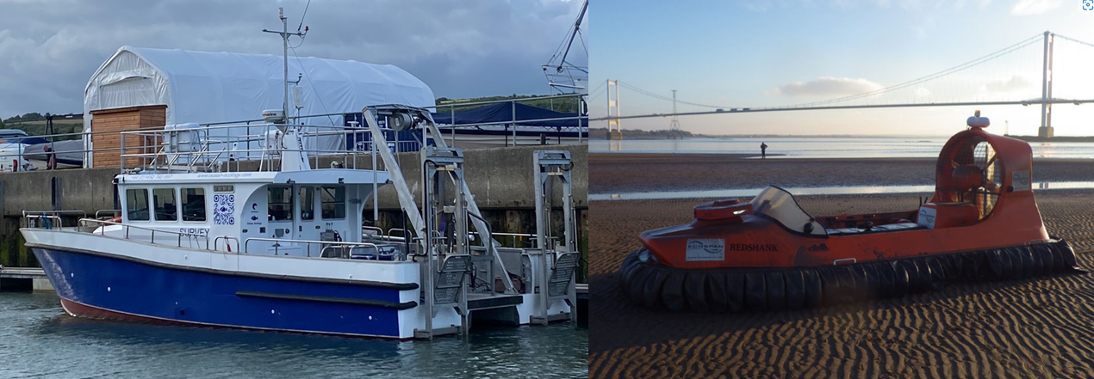
Plate 5-1 Argyll Explorer (left) and Redshank (right).

Seabed Imagery Collection

Drop-Down Video System
Seabed imagery (simultaneous video and stills) will be acquired at DDC stations using OEL’s Rayfin PLE Camera System to collect 4K video and high-resolution (up to 21 megapixels (MP)) still images. The camera system (Plate 5-2) consists of a SubC Imaging Rayfin PLE camera, seabed frame equipped with freshwater housing (Jones et al. 2021), two LED strip lights, two 5 kW green dot lasers (set to 10 cm distance for scale), a 300 m umbilical and topside computer. The camera is powered with the use of an Uninterruptable Power Supply (UPS) to ensure no damage is caused should the vessel lose power or cause a power surge. The freshwater housing is height and angle adjustable providing a variety of options for view, lighting, and focal length to maximise data quality with respect to prevailing conditions (e.g., high turbidity).
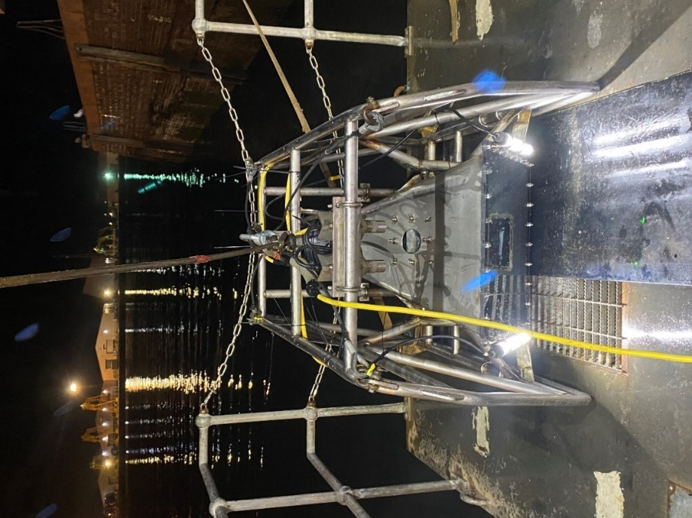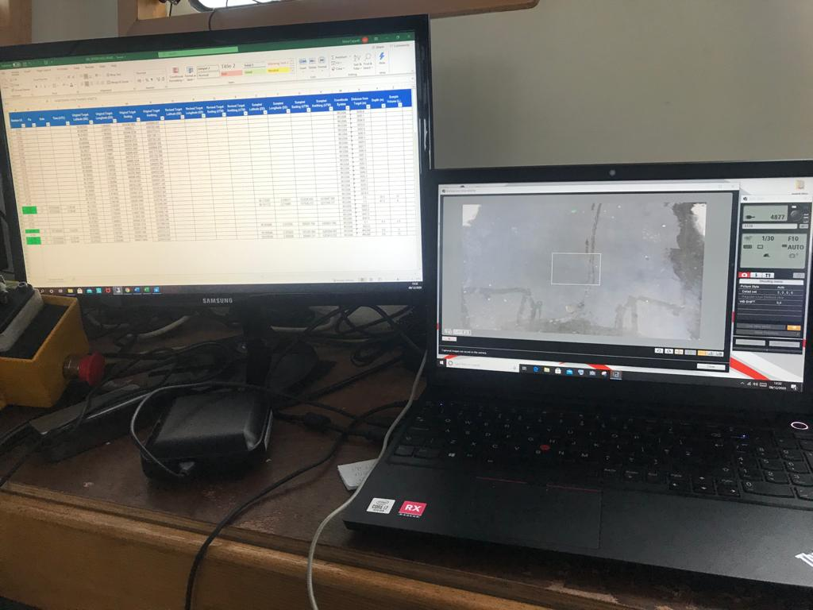
Plate 5-2 Left: OEL freshwater housing camera system. Right: The camera system topside setup.
All DDC stations will be sampled in line with the JNCC epibiota remote monitoring operational guidelines (Hitchin et al. 2015). All footage will undergo a preliminary review in situ by the OEL’s marine ecologists.
The camera system will be deployed as follows:
- Vessel approach target location and alerts deck personnel to prepare camera and umbilical.
- Sea fastening on camera frame to be released to allow deployment from the deck.
- Umbilical released overboard with sufficient length paid out to cover water depth.
- Camera to be raised and lowered into the water column to within 5 m of the seabed.
- Ecologist switches on video recording and the camera lowered until gently landing on the seabed at which point a positional fix will be taken.
- The ecologist waits for any suspended sediments in the field of view to disperse before taking an image and confirming with the skipper to move on.
- The camera will then be raised from the seabed and moved along the transect 5-10 m. Where possible the seabed will be maintained in view at all times.
- Following the capture of the final image, the camera will be lifted, video recording stopped, and the camera retrieved to the surface.
- The winch operator will then take the tension on the winch cable whilst the ecologist ensures the camera umbilical is free for recovery.
- Once the camera was on the surface, the vessel will be positioned to minimise pitch and roll (e.g., into wind/tide).
- The vessel skipper will then confirm that sea conditions are suitable for retrieval and the camera system recovered aboard.
- The camera frame will then be lowered onto the deck and the tension released.

Grab Sampling
Sediment samples will be collected within 20 m of the target sampling location using OEL’s 0.1m² Dual Van Veen grab sampler. A 0.1m² mini Hamon Grab will be available as backup to sample coarser sediments should there be issues with recovery using the Dual Van Veen grab.
The grab will be deployed from the A-frame on the aft deck of the Argyll Explorer.

Sample Collection
To ensure consistency in sampling, grab samples will be screened by the lead marine ecologist and considered unacceptable if:
- The sample is less than 5 L. i.e., the sample represents less than approx. a half of the 10 L capacity of the grab used.
- The jaws fail to close completely or are jammed open by an obstruction, allowing fines to pass through (washout or partial washout).
- The sample is taken at an unacceptable distance from the target location (beyond 20 m).
- There is obvious contamination of the sample from survey equipment, paint chips etc.

Sample Processing (PSA & Macrofauna)
Initial grab sample processing will be undertaken onboard the vessel in line with the following methodology:
- Initial visual assessment of sample size and acceptability made.
- Photograph of the sample with station details and scale bar to be taken.
- Sub-sample removed for PSD analysis and transferred to a labelled tray.
- Remaining sample emptied onto 1.0 mm sieve net laid over 4.0 mm sieve table and washed through using gentle rinsing with seawater hose.
- Remaining sample for faunal sorting and identification backwashed into a suitable sized sample container and diluted 10% formalin solution added to fix the sample prior to laboratory analysis.
- Sample containers will be clearly labelled internally and externally with date, sample ID and project name.
Detailed field notes will be taken including station number, fix number, number of attempts, sample volume, sediment type, conspicuous fauna, any sign of protected features and water depth.

Sample Processing (Sediment Chemistry)
Separate grab samples will be taken for sediment chemistry analyses. Sample processing will be undertaken onboard the vessel using the following methodology:
- Inspection cover lifted and general assessment of sample size and acceptability made ensuring sediment surface is undisturbed and no obvious sign of contamination. NB ensure no grease, oils or lubes enter the sample once the inspection cover is open.
- pH / Redox probe placed into sediment sample and allowed to settle for 2 minutes before taking readings in field logs.
- Sediment samples will be sub-sampled and decanted into the recommended sample containers provided by SOCOTEC, the contaminant laboratory specialists for the required analyses as below:
- Moisture Content
- Total organic matter (by loss on ignition)
- Total Organic Carbon (TOC)
- Total content and the content of the labile form of heavy metals (Pb, Cu, Zn, Ni, Cd, Cr, As, Hg);
- Total Hydrocarbon Content (THC)
- Polycyclic aromatic hydrocarbons (PAHs 16);

Water Sampling
Water samples will be taken at 2 m above the seabed, mid-water depth and 2 m below the surface using a 5 L Niskin bottle attached the deployment cable using bulldog clips and friction tape. When the equipment is at the desired depth a messenger weight will be attached to the deployment wire and sent to trip the sampler. Sufficient time will be allowed for this to travel to the sampler, depending on water depth. When the equipment reaches the surface it will be recovered to deck and the sampler removed, with water decanted into the required laboratory sample containers. Water samples will be sub-sampled with the containers for the required analyses provided by the analytical laboratory. Samples will be taken in either 1 litre amber glass bottles, 1 litre PTFE bottles or 40ml amber vials with no headspace. A YSI EXO 2 water profiler will be used at all water sampling locations to collect in situ water column profiles. Profiles will be acquired from sea surface to near seabed, measuring depth, conductivity, dissolved oxygen, turbidity, pH and temperature.
The following procedure will be used for deployment and recovery:
- The water profiler will be checked against calibration standards (pH probe) and in oxygen saturated water (DO probe) prior to deployment.
- Logging will be initiated in the profiler and the blanking plug attached. The water profiler will be set up to record as per Manual.
- The profiler will then be shackled to the end of the deployment cable.
- The equipment will be lowered into the water and held at 1-2m water depth for 2 minutes to allow the sensors to stabilise.
- The profiler will then be lowered to just above the seabed at a low speed (0.5 m/s⁻¹) based upon the latest bathymetry data available.
- Once at the seabed the profiler will be recovered to the surface and brought back onboard for data download.
- Winch speed for continuation of deployment or recovery was slow (0.5 m/s⁻¹).
- Water profile data will be processed onboard as follows:
- Data uploaded from the water profiler using the KOR software.
- Data then exported in a .csv file format and cross-checked in a standardised template datasheet.
The following criteria will be used for field QC of water profiles:
- All data must be within expected values for seawater (e.g. pH = 7.8 to 8.5; DO = approximately 100 % at surface and declines with depth);
- Data should be collected for the duration of both the down and up casts;
- Data should be consistent between down and up casts.

Intertidal Coring
Within a 1 m radius of each sediment core sampling station, a 0.01 m² hand core will be used to collect six replicate core samples to a depth of 15 cm. Three will be fixed in formalin for subsequent macrobenthic analysis and the remaining three will be retained for physio-chemical analysis.

Shellfish Sampling
At each of the shellfish sampling stations, a 0.1 m² quadrat will be placed on the sediment surface. All sediment down to a depth of 5 cm will be dug out and shaken and/or puddled through a 2 mm mesh sieve. All cockles remaining on the sieve will be retained and placed into labelled bags for subsequent analysis. The above process will be repeated at each sampling station until a minimum of 50 cockles (and ideally more) are sampled. If after the 3rd quadrat no or very few cockles are sampled then the sampling station will be relocated to the nearest nearby area of suitable cockle habitat. The above processed will then be repeated at each sampling station a further two times resulting in three replicates of 50 or more cockles.

LABORATORY Analysis

Seabed Imagery Analysis
All seabed imagery analysis collected by DDC will be undertaken in consideration of the latest NMBAQC/JNCC Epibiota Quality Assurance Framework (QAF) guidance and identification protocols available on the NMBAQC website. Final datasets will be presented using the latest NMBAQC/JNCC epibiota monitoring proformas available for stills and video footage and will be quality assured using the Quality Assurance Framework (QAF) form check and comparison tools.
The seabed imagery analysis Bio-Image Indexing and Graphical Labelling Environment (BIIGLE) annotation platform (Langenkämper et al. 2017) and Analysis of still images will be undertaken in two stages. The first stage, “Tier 1”, will consist of labels that refer to the whole image being assigned providing appropriate metadata for the image including European Nature Information System (EUNIS) habitat classifications assigned in line with Parry (2019). The second stage, “Tier 2”, will be used for enumerating epibiotal abundance and cover within each image and to assign percentage cover of reef types.
A full reef habitat assessment (HA) will be conducted on all DDC imagery to determine whether habitats meet the definitions of Annex I reef habitats as detailed in (Table 6-3 and Table 6-4). The latest JNCC guidance on the characterisation of ‘low resemblance’ Annex I stony reef will also be considered (Golding et al. 2020b).
The annotation label tree to be used during analysis will have major headings for each of the reef types. Under each reef type, labels will be assigned for each of the categories required to determine whether Annex I reef habitat is present (Table 6-3 and Table 6-4).
Table 6-3 Characteristics of stony reef (Irving 2009).
Characteristic | ‘Reefiness’
Characteristic | Not a Reef | Low | Medium | High
Composition (proportion of boulders/cobbles (>64 mm)) | <10 % | 10-40 % matrix supported | 40-95 % | >95 % clast-supported
Elevation | Flat seabed | <64 mm | 64 mm - 5 m | >5 m
Extent | <25 m² | >25 m²
Biota | Dominated by infaunal species | >80 % of species present composed of epibiotal species
Table 6-4 Characteristics of Sabellaria spinulosa reef (Gubbay 2007).
Characteristic | ‘Reefiness’
Characteristic | Not a Reef | Low | Medium | High
Elevation (cm) | < 2 | 2 - 5 | 5 – 10 | > 10
Extent (m²) | < 25 | 25 – 10,000 | 10,000 – 1,000,000 | > 1,000,000
Patchiness (% Cover) | < 10 | 10 - 20 | 20 – 30 | > 30

Tier 1 Analysis
The first stage, “Tier 1”, will consist of assigning labels that referred to the whole image, providing appropriate metadata for the image. Metadata “Image Labels” include:
- Broadscale Habitat (BSH) type.
- Substrate type (and percentage cover in 10% intervals).
- Bedforms present.
- The presence of any Annex I habitats, Features of Conservation Importance (FOCI) or Habitats of Conservation Importance (HOCI).
- The presence of any visible impacts or other modifiers (such as discarded fishing gear or marine litter (as per the Marine Strategy Framework Directive categories), visible physical damage to the seabed, evidence of strong currents, non-native species, etc.).
- Image quality categories (including “Not Analysable” category).
Depending on the presence of reef, this will also include:
- Extent: As it is not possible to fully determine the extent of reef habitats from a single image alone this label will be used to identify areas that are highly unlikely to constitute reef habitats. An example is an image that shows a large boulder being preceded and succeeded by images of unconsolidated sandy sediments.
- Biota: Labels assigned to determine whether epifauna dominate the biological community observed.
- Elevation: Labels assigned depending on reef type. Laser points will be used to assist in the assignment of categories.

Tier 2 Analysis
The second stage, “Tier 2”, will be used to assess epibiotal abundance data as “annotations” within each image for all visible flora and fauna. This will be undertaken as follows:
- Using the BIIGLE Annotation Platform, (detailed below) enumeration of all visible taxa will be undertaken using points for enumerable “count” taxa and polygons for ground-covering taxa; to enable calculation of percentage cover for these taxa.
- Where an individual of a “count” taxon overlay a ground-cover taxon, then this individual is still counted (i.e., a point annotation will be added for the count taxa over the polygon of the ground-cover taxon).
The substratum observed in each still image will be recorded as a percentage cover of CATAMI (Althaus et al. 2015) substratum types where possible. Determination of sediment type (such as coarse, mixed, sand etc.) will be facilitated using the adapted Folk sediment trigon (Long 2006) incorporated into a sediment category correlation table. Percentage cover of the different substrate types will be used to determine and assign EUNIS codes and BSH.

Macrobenthic Analysis
All elutriation, extraction, identification, and enumeration will be undertaken at OEL’s NE Atlantic Marine Biological Analytical Quality Control (NMBAQC) scheme participating laboratory in line with the NMBAQC Processing Requirement Protocol (Worsfold & Hall 2010). All processing information and macrobenthic records will be recorded using OEL’s cloud-based data management application ABACUS that employs MEDIN validated, controlled vocabularies ensuring all sample information, nomenclature, qualifiers, and metadata are recorded in line with international data standards.
Sediment samples for macrobenthic analysis will be processed through a 1 mm sieve for all subtidal samples and through a 0.5 mm sieve for those intertidal samples located within a WFD estuarine waterbody. Intertidal sediment samples belonging to coastal waterbodies will be sieved over a 1 mm sieve. This distinction is necessary for the appropriate calculation of the Infaunal Quality Index (IQI) as per the WFD regulations. The IQI is recommended to be calculated as an indicator of stressed environments and therefore as a means to assess for the potential impacts of the oil spill.
For each macrobenthic sample, the excess formalin will be drained off into a labelled container in a well-ventilated area. The samples will then be re-sieved over a 1 mm mesh sieve (or 0.5 mm) to remove all remaining fine sediment and fixative. The low-density fauna will then be separated by elutriation with freshwater, poured over a 1 mm mesh sieve (or 0.5 mm), transferred into a Nalgene and preserved in 70 % Industrial Denatured Alcohol (IDA). The remaining sediment from each sample will subsequently be separated into 0.5 mm, 1 mm, 2 mm and 4 mm fractions and sorted under a stereomicroscope to extract any remaining fauna (e.g., high-density bivalves not ‘floated’ off during elutriation).
All fauna present will be identified to species level, where possible, and enumerated by trained benthic taxonomists using the most up to date taxonomic literature and checks against existing reference collections. Nomenclature will utilise the live link within ABACUS to the WoRMS web services to ensure the most up to date taxonomic classifications are recorded. Colonial fauna (e.g., hydroids and bryozoans) will be identified to species level where possible and recorded as present (P). For subsequent data analysis, taxa recorded as P will be given the numerical value of 1. A full reference collection will be retained including at least one example specimen of each taxon.
Biomass will be measured as blotted wet weight in grams to at least 4 decimal places for all countable taxa (i.e., at species level where possible). As a standard, the conventional conversion factors as defined by Eleftheriou & Basford (1989) will be applied to biomass data to provide equivalent dry weight biomass (Ash Free Dry Weight).
The conversion factors applied are as follows:
- Annelida = 15.5%
- Crustacea = 22.5%
- Mollusca = 8.5%
- Echinodermata = 8.0%
- Miscellaneous = 15.5%

Particle Size Distribution Analysis
PSD analysis of the sediment samples will be undertaken by in-house laboratory technicians at OEL’s NMBAQC participating laboratory in line with NMBAQC best practice guidance (Mason 2016).
Frozen sediment samples will first be transferred to a drying oven and thawed at 80°C for at least 6 hours before visual assessment of sediment type. Before any further processing (e.g., sieving or sub-sample removal), samples will be mixed thoroughly with a spatula and all conspicuous fauna (>1 mm) which appeared to have been alive at the time of sampling removed from the sample. A representative sub-sample of the whole sample will then be removed for laser diffraction analysis before the remaining sample screened over a 1 mm sieve to sort coarse and fine fractions. The >1 mm fraction will then be returned to a drying oven and dried at 80°C for at least 24 hours before dry sieving. Once dry, the sediment sample will be run through a series of Endecott BS 410 test sieves (nested at 0.5 φ intervals) using a Retsch AS200 sieve shaker to fractionate the samples into particle size classes. The dry sieve mesh apertures to be used are given in Table 6-1.
Table 6-1 Sieve series employed for PSD analysis by dry sieving.
Sieve aperture (mm)
63 | 45 | 32 | 22.5 | 16 | 11.2 | 8 | 5.6 | 4 | 2.8 | 2 | 1.4 | 1

The sample will then be transferred onto the coarsest sieve at the top of the sieve stack and shaken for a standardised period of 20 minutes. The sieve stack will be checked to ensure the components of the sample had been fractioned as far down the sieve stack as their diameter would allow. A further 10 minutes of shaking may be undertaken if there is evidence that particles had not been properly sorted.
The sub-sample for laser diffraction will be first screened over a 1 mm sieve and the fine fraction residue (<1 mm sediments) transferred to a suitable container and allowed to settle for 24 hours before excess water syphoned from above the sediment surface until a paste texture is achieved. The fine fraction will then be analysed by laser diffraction using a Beckman Coulter LS13 320. For silty sediments, ultrasound will be used to agitate particles and prevent aggregation of fines.
The dry sieve and laser data will then be merged for each sample with the results expressed as a percentage of the whole sample. Once data is merged, PSD statistics and sediment classifications will be generated from the percentages of the sediment determined for each sediment fraction using Gradistat v8 software.
Sediment descriptions will be defined by their size class based on the Wentworth classification system (Wentworth 1922) (Table 6-2). Statistics such as mean and median grain size, sorting coefficient, skewness and bulk sediment classes (percentage silt, sand and gravel) will also be derived following the Folk classification (Folk 1954).

Table 6-2 The classification used for defining sediment type based on the Wentworth Classification System (Wentworth 1922).
Wentworth Scale | Phi Units (φ) | Sediment Types
>64 mm | <-6 | Cobble and boulders
32 – 64 mm | -5 to -6 | Pebble
16 – 32 mm | -4 to -5 | Pebble
8 – 16 mm | -3 to -4 | Pebble
4 - 8 mm | -3 to -2 | Pebble
2 - 4 mm | -2 to -1 | Granule
1 - 2 mm | -1 to 0 | Very coarse sand
0.5 - 1 mm | 0 – 1 | Coarse sand
250 - 500 µm | 1 – 2 | Medium sand
125 - 250 µm | 2 – 3 | Fine sand
63 - 125 µm | 3 – 4 | Very fine sand
31.25 – 63 µm | 4 – 5 | Very coarse silt
15.63 – 31.25 µm | 5 – 6 | Coarse silt
7.813 – 15.63 µm | 6 – 7 | Medium silt
3.91 – 7.81 µm | 7 – 8 | Fine silt
1.95 – 3.91 µm | 8 – 9 | Very fine silt
<1.95 µm | <9 | Clay

In addition to OEL’s standard quality control procedures, the PSD sample processing will be subject to external quality control checks by an independent, competent benthic laboratory participant in the NMBAQC scheme as per the RSMP protocol (Ware et al. 2011, Cooper & Mason 2019).

Chemical Analysis
All chemical analysis will be undertaken by laboratories accredited through the United Kingdom Accreditation Service (UKAS).
Grab, intertidal core and shellfish flesh samples will be processed and analysed for the following:
- Trace metals: Arsenic, Mercury, Cadmium, Chromium, Copper, Nickel, Lead, and Zinc;
- Total Hydrocarbons;
- Poly Aromatic Hydrocarbons (PAH) and Total Petroleum Hydrocarbons (THC).

References
Althaus F, Hill N, Ferrari R, Edwards L, Przeslawski R, Schönberg CHL, Stuart-Smith R, Barrett N, Edgar G, Colquhoun J, Tran M, Jordan A, Rees T, Gowlett-Holmes K (2015) A Standardised Vocabulary for Identifying Benthic Biota and Substrata from Underwater Imagery: The CATAMI Classification Scheme. PLoS One 10.
Cooper K (2013) Marine Aggregate Dredging: A New Regional Approach to Environmental Monitoring. PhD Thesis. University of East Anglia: UK.
Cooper K, Mason C (2019) Regional Seabed Monitoring Programme (RSMP) Protocol for Sample Collection and Processing. Version 8.0.
Cooper KM, Barry J (2017) A big data approach to macrofaunal baseline assessment, monitoring and sustainable exploitation of the seabed. Sci Rep 7:12431.
Davies J, Baxter J, Bradley M, Connor D, Khan J, Murray E, Sanderson W, Turnbull C, Vincent M (2001) Marine Monitoring Handbook March 2001.
Eleftheriou A, Basford D. (1989) The macrobenthic infauna of the offshore northern North Sea. J Mar Biol Assoc 69:123–143.
Folk R. (1954) The distribution between grain size and mineral composition in sedimentary rock nomenclature. J Geol 62:344–359.
Golding N., Albrecht J, McBreen F. (2020a) Refining the criteria for defining areas with a ‘ low resemblance ’ to Annex I stony reef.
Golding N, Albrecht J, McBreen F (2020b) Refining the criteria for defining areas with a ‘low resemblance’ to Annex I stony reef. JNCC Rep No 656.
Gubbay S (2007) Defining and managing Sabellaria spinulosa reefs: Report of an inter-agency workshop. JNCC Rep No405 44:22.
Hitchin R, Turner J, Verling E (2015) Epibiota Remote Monitoring from Digital Imagery: Operational Guidelines. NMBAQC JNCC.
Irving R (2009) The identification of the main characteristics of stony reef habitats under the Habitats Directive. JNCC Rep No 432:44.
Jones RE, Unsworth RKF, Hawes J, Griffin RA (2021) Improving benthic biodiversity assessments in turbid aquatic environments. Aquat Conserv Mar Freshw Ecosyst 31:1379–1391.
Langenkämper D, Zurowietz M, Schoening T, Nattkemper TW (2017) BIIGLE 2.0 - Browsing and Annotating Large Marine Image Collections. Front Mar Sci 4:1–10.
Long D (2006) BGS detailed explanation of seabed sediment modified folk classification. Folk.
Mason C (2016) NMBAQC’s Best Practice Guidance - Particle Size Analysis (PSA) for Supporting Biological Analysis.
Noble-James T, Jesus A, Fionnuala M (2018) Monitoring guidance for marine benthic habitats (Revised 2018).
Parry ME V (2019) Guidance on Assigning Benthic Biotopes using EUNIS or the Marine Habitat Classification of Britain and Ireland (Revised 2019).
Ware SJ, Kenny AJ, Curtis M, Froján CB, Cooper K, Reach I, Bussell J, Service M, Boyd A, Sotheran I, Egerton J, Pearce LSB (2011) Guidelines for the Conduct of Benthic Studies at Marine Aggregate Extraction Sites. Mar Aggreg Levy Sustain Fund 2:80.
Wentworth C. (1922) A scale of grade and class terms for clastic sediments. J Geol 30:377–392.
Worsfold T, Hall D (2010) Guidelines for processing marine macrobenthic invertebrate samples: a Processing Requirements Protocol.

