Site location and proximity to human occupation
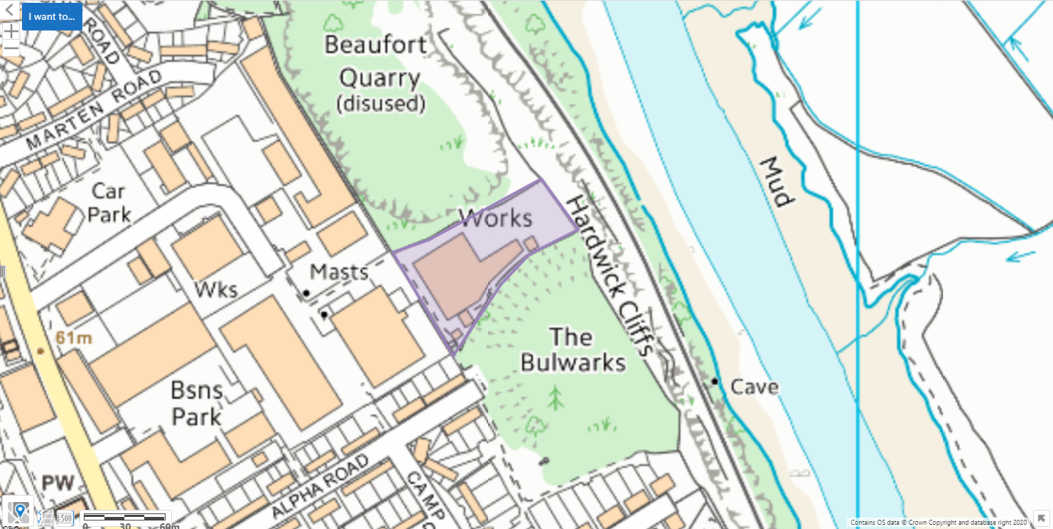

SSSI- immidate vacinity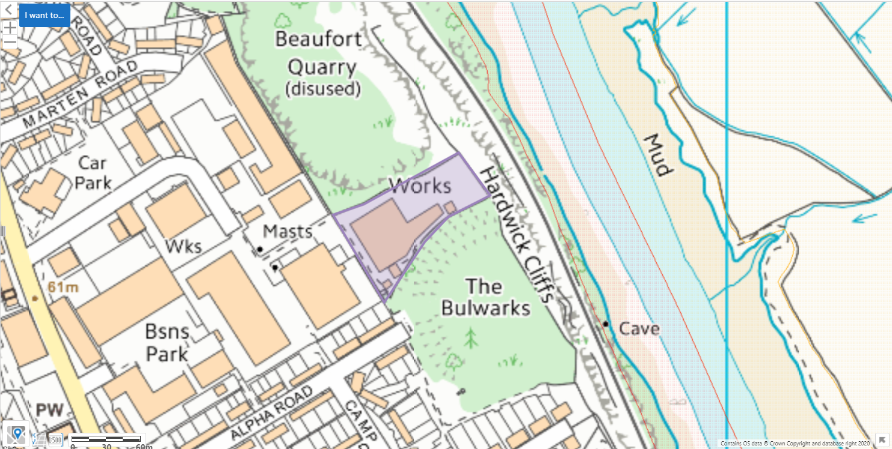
Wales:
- River Wye (Lower Wye) / Afon Gwy (Gwy Isaf) apprx 46 meters away
England:
- Pennsylvania Fields, Sedbury approx. 182 meters away
- River Wye apprx 46 meters away
SSSI- 2km search radius
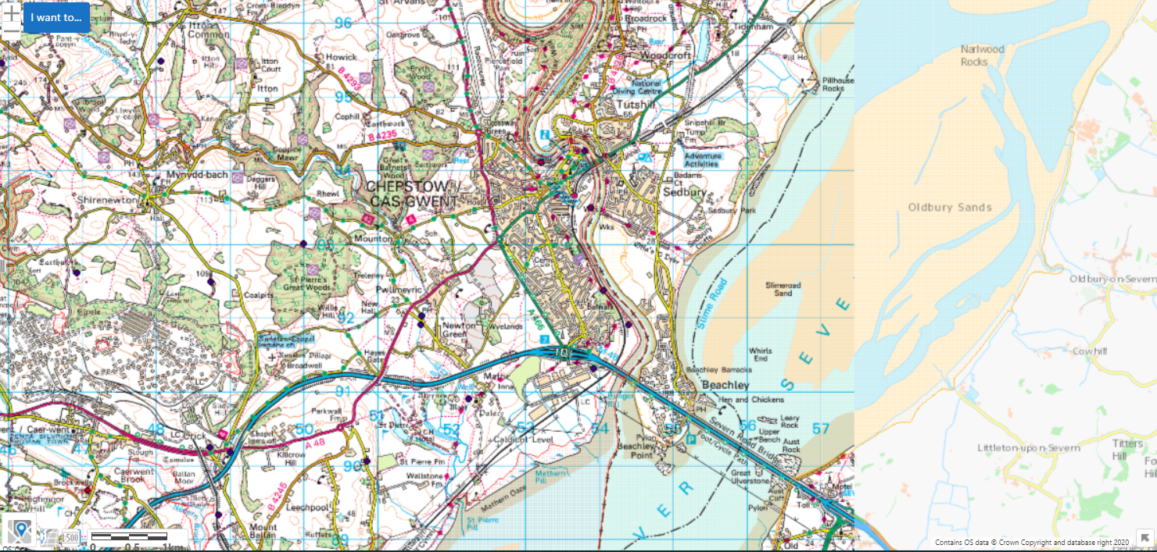
England: Wales:
- Pennsylvania Fields, Sedbury - Pierce, Alcove And Piercefield Woods
- River Wye - River Wye (Lower Wye) / Afon Gwy (Gwy Isaf)
- Lower Wye Gorge - Severn Estuary
- Severn Estuary

SAC, SPA and Ramsar- immediate vicinity
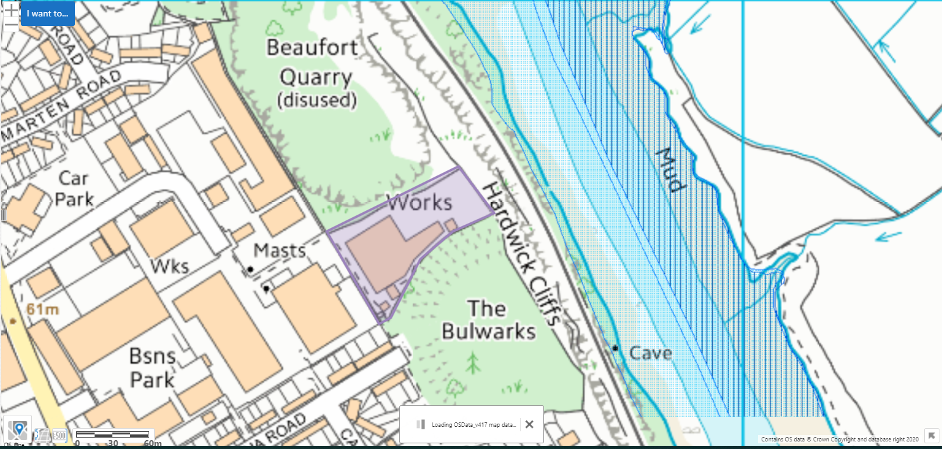

SAC: England: River Wye approx. 107 meters
SAC: River Wye / Afon Gwy (England) approx. 107 meters
SAC: River Wye / Afon Gwy (Wales) apprx 46 meters away

SAC, SPA and Ramsar- 1 km
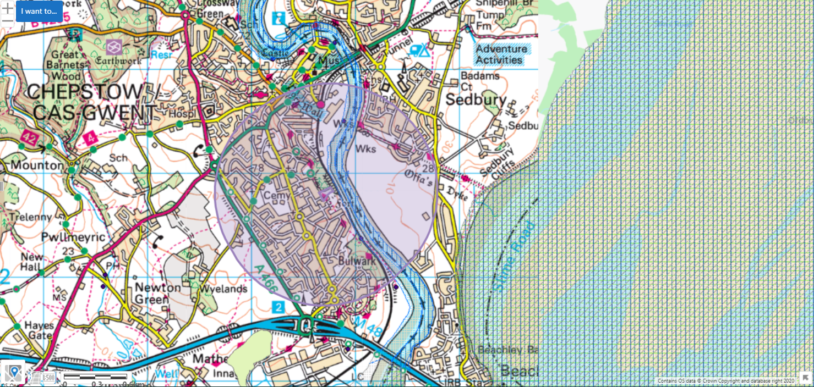
SAC: England: River Wye
SAC: River Wye / Afon Gwy (England)
SAC: River Wye / Afon Gwy (Wales)

Aquifer Designation (Superficial)
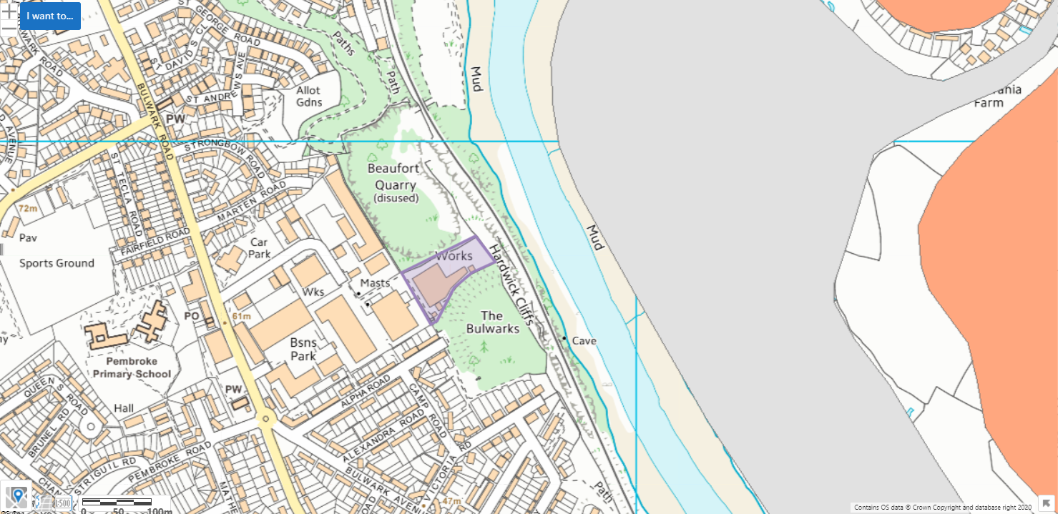

Aquifer Designation (Bedrock)
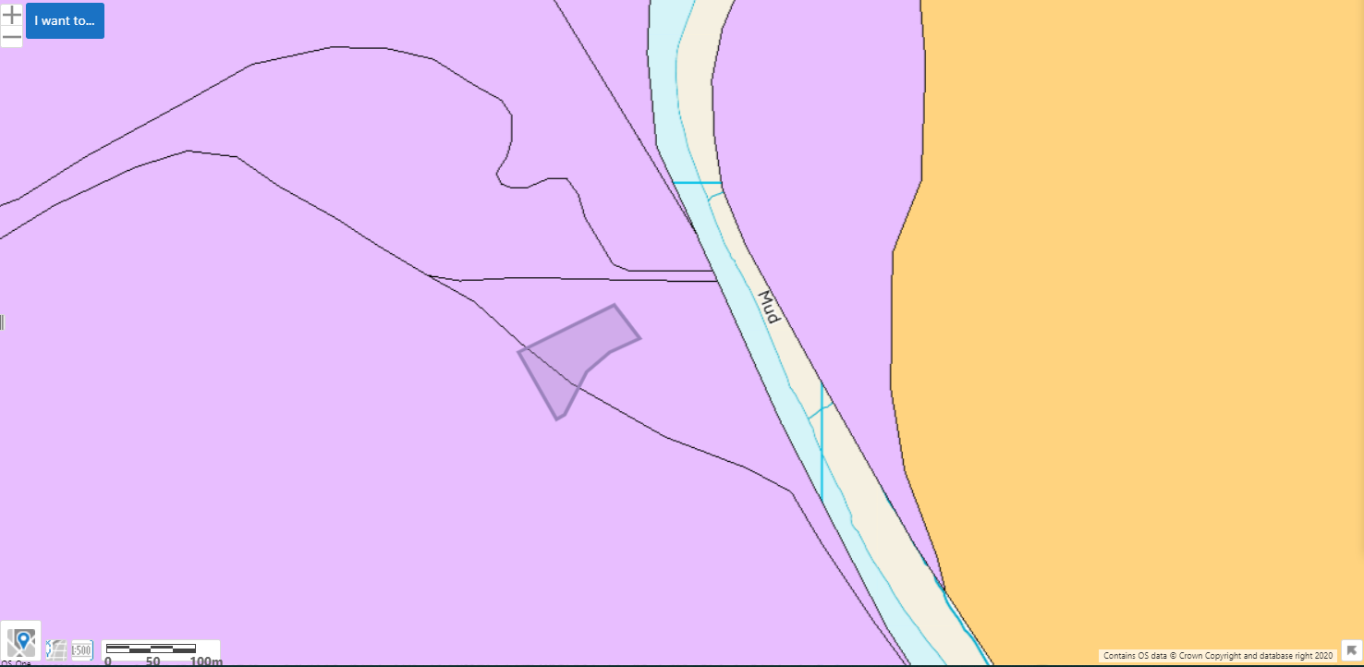

AQMA- 2km
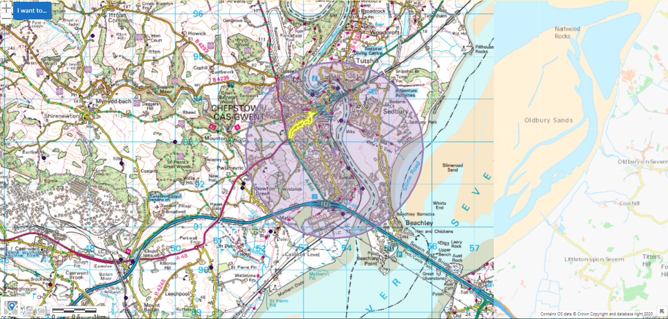
Monmouthshire Council- Chepstow AQMA- An area encompassing properties either side of the A48, between the roundabout with the A466 to the west and extending east just beyond the junction with the B4293 at Hardwick Terrace.
- Pollutants- NO2

Flood plain
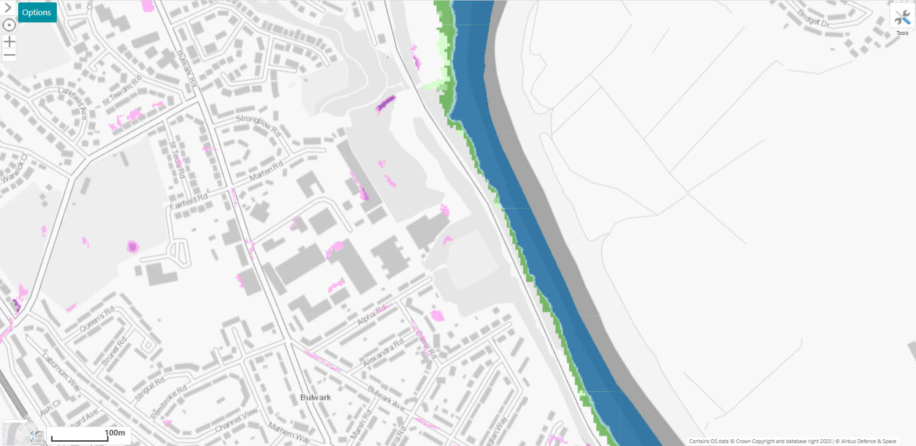

Surface water courses
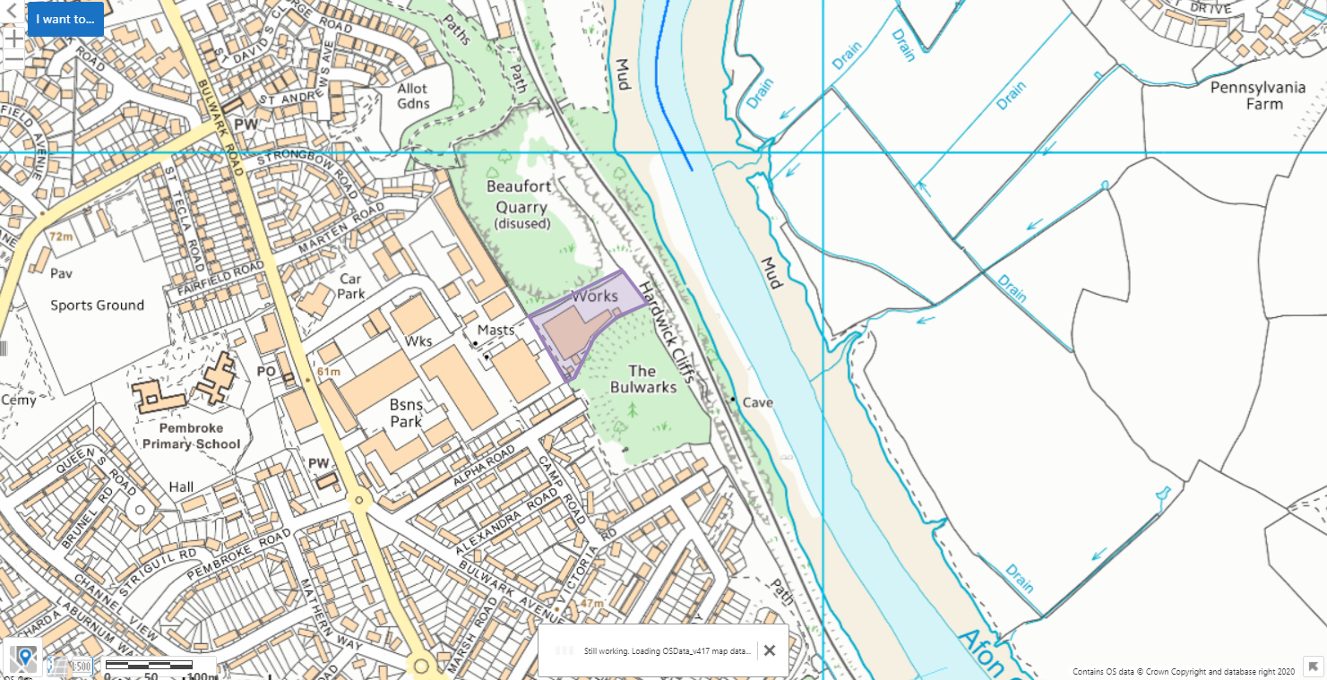
River Wye approx.40 meters from the site

Protected species and habitats
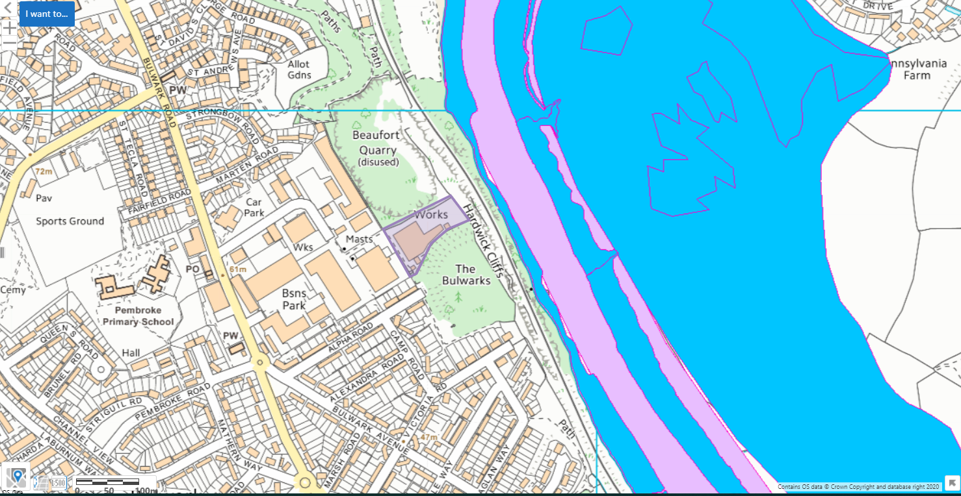
Habitats: Intertidal mudflats, Mudflats, Coastal and floodplain grazing marsh
Species: migratory routes for River Lamprey, Atlantic Salmon, Twaite Shad, Unidentified Shad, European Eel, Sea Lamprey

Listed Buildings, Historic Monuments, Scheduled Monuments, World Heritage Sites, Heritage Coast
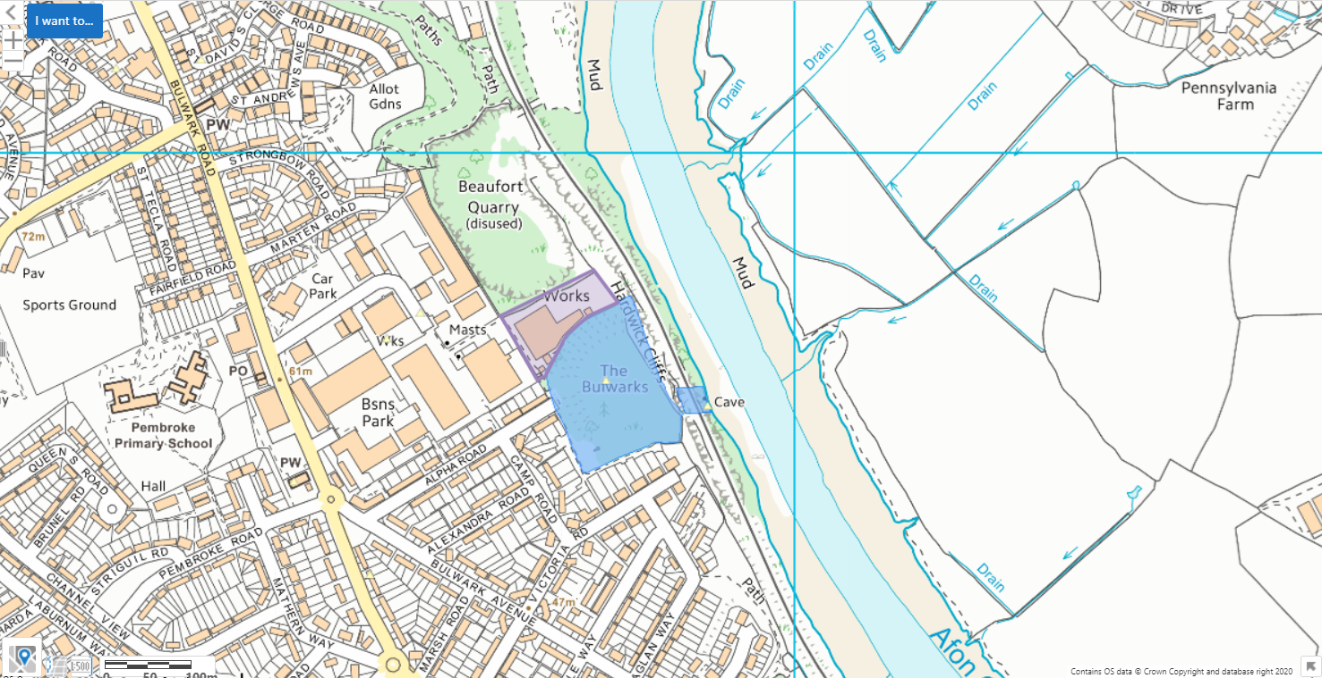
Historic Monuments: CHEPSTOW: THE BULWARKS and ST PETER'S CAVE
Scheduled Monuments: Bulwarks Camp and St Peter's Cave

Ancient Woodland
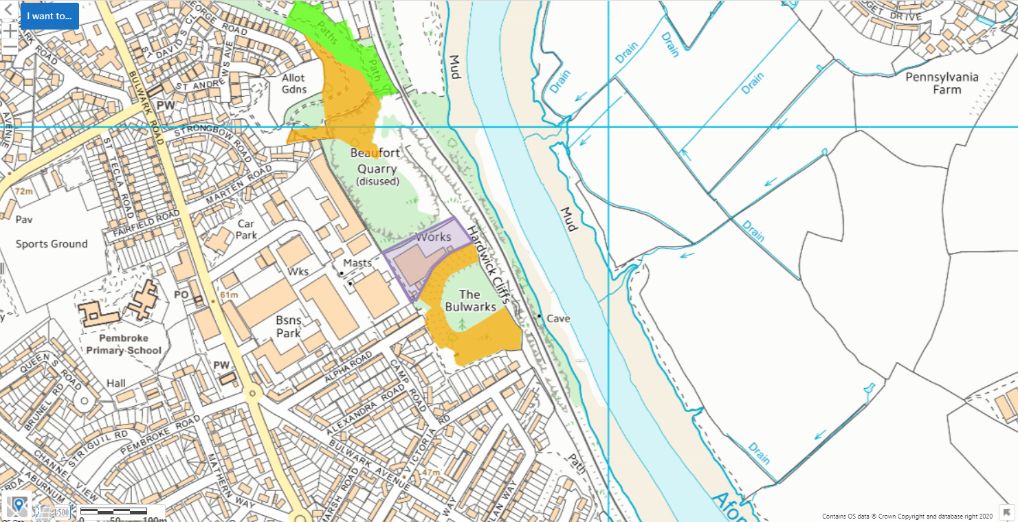

Local Wildlife Sites (SINCs)


