CRoW Appendix 4 (140_10_SD02)  CRoW Act 2000: Natural Resources Wales application for permission - Formal Notice |  | 
Natural Resources Wales Formal Notice.
Requirements of Section 28I of the Wildlife & Countryside Act 1981 as amended by the Countryside and Rights of Way Act (CRoW) 2000.
Duty in relation to granting any consent, licence or permit for activities likely to damage Sites of Special Scientific Interest (SSSI).
- Natural Resources Wales area/region/NPS hub: | North
- Name of SSSI: | Malltraeth Marsh / Cors Ddyga
- Type of permission: | Application to vary a tier 3 bespoke waste permit under the Environmental permitting regulations 2016
- Date for Natural Resources Wales permit determination: | 18/08/2022
- Predicted 28 day date for response from NRW conservation/ecology (under S28 I(4)): | n/a – saved for information only
- Natural Resources Wales reference no: | PAN-017102
- National grid reference: | SH 47708 71609
- Description of proposal: | This variation permits the operator to accept additional waste type 19 12 02. Similar waste types are already accepted at the site.
- Is the proposed activity within (wholly or partially) the SSSI boundary? | NO  The SSSI is 1372m to the west of the site.  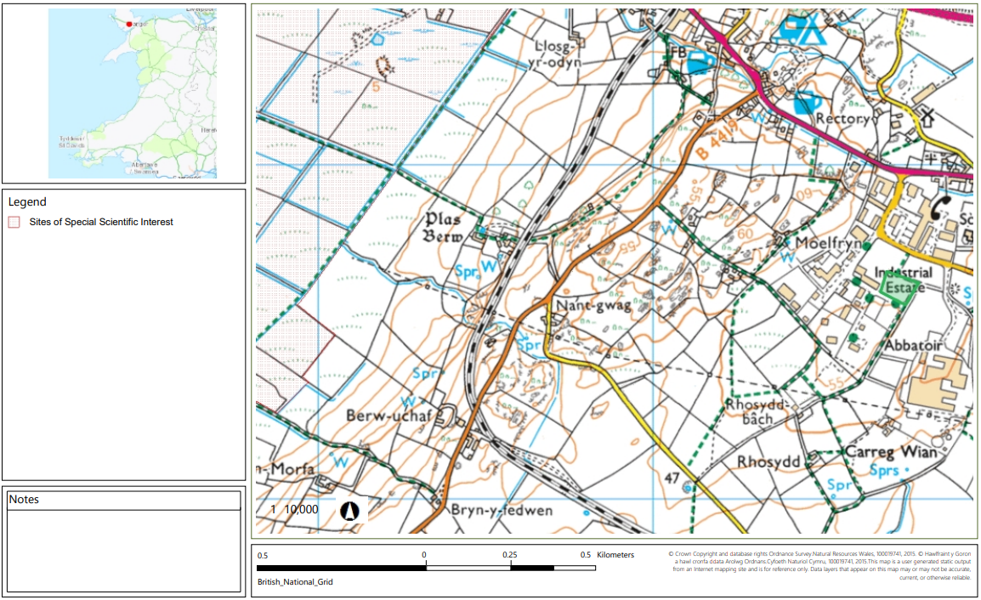
- Has there been any pre-application discussion or correspondence with NRW conservation/ecology | NO
- What aspect(s) of the proposed permission may damage the features which are of special interest for the SSSI?
The following ‘Operations Requiring Consent’ (or other activities associated with the permission) that may cause damage) are relevant to the proposed permission.

No relevant operations are associated with the permission.

The following SSSI features and mechanisms of impact have been considered to assess the likelihood of damage:

The site does not have any emission points therefore, it will have no effect on the SSSI.
- Decision
i) The proposed permission is not likely to damage any of the flora, fauna or geological or physiological features which are of special interest because there is no conceivable impact pathway.

Natural Resources Wales is minded to:
Issue the permission

- Name and job title of Natural Resources Wales officer: | Sion Sleep  Waste Permitting Officer
- Date form sent to NRW conservation/ecology | n/a – saved for information purposes only

