Fields Fron 16, 17, 18 and 19
Contours
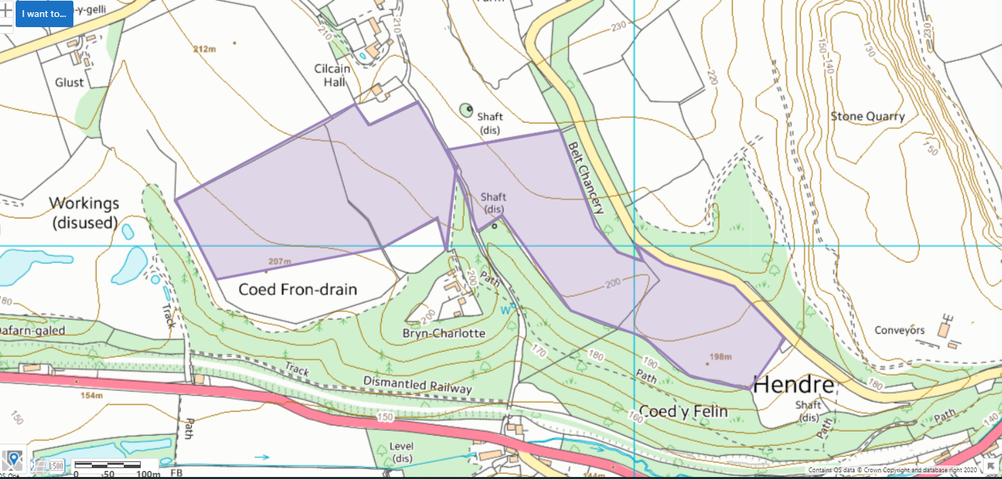

Protected Habitats- Lowland calcareous grassland
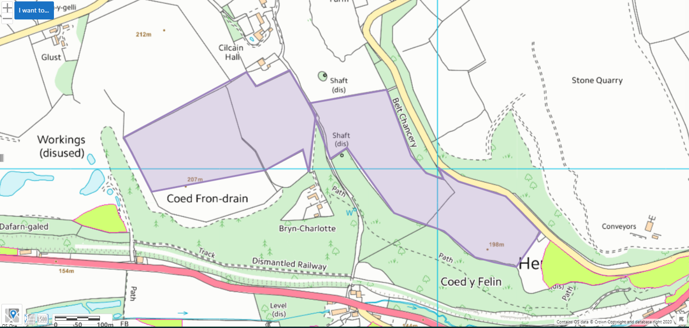

Detailed River Network- no watercourses within 10 meters, no spring well or borehole within 50 meters
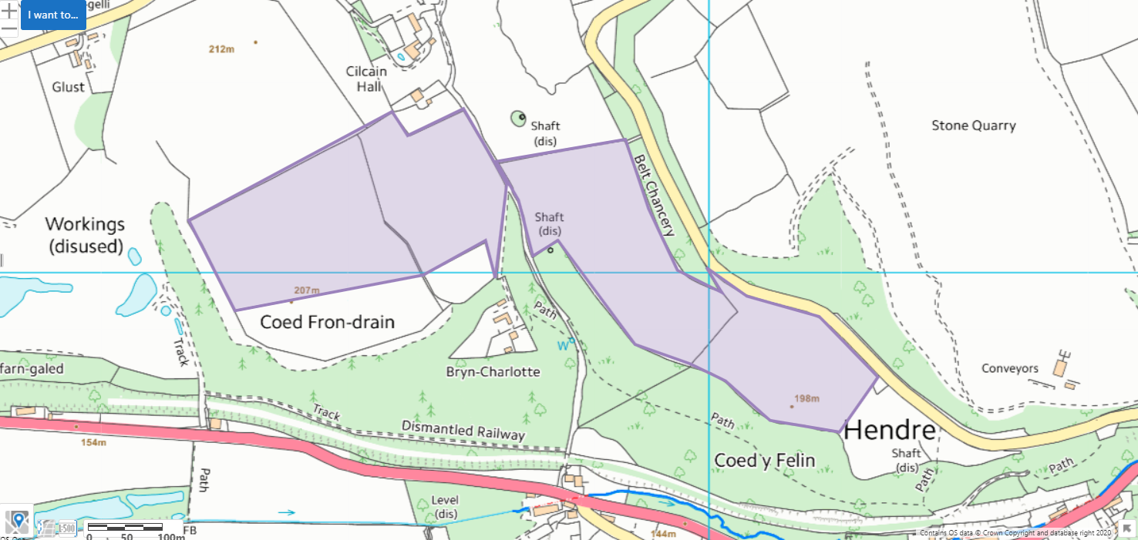

SSSI- Tyddyn-y-barcut
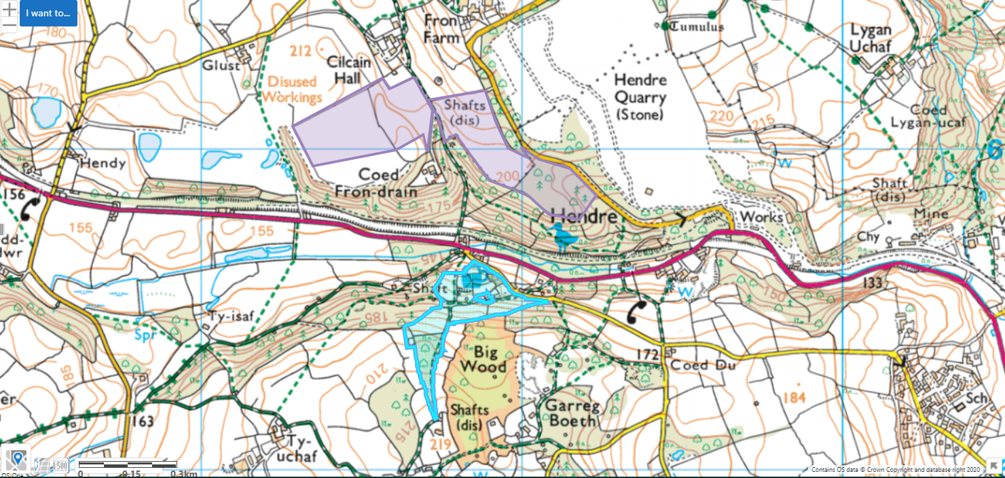

Approx. 254 metres away across the other side of the valley
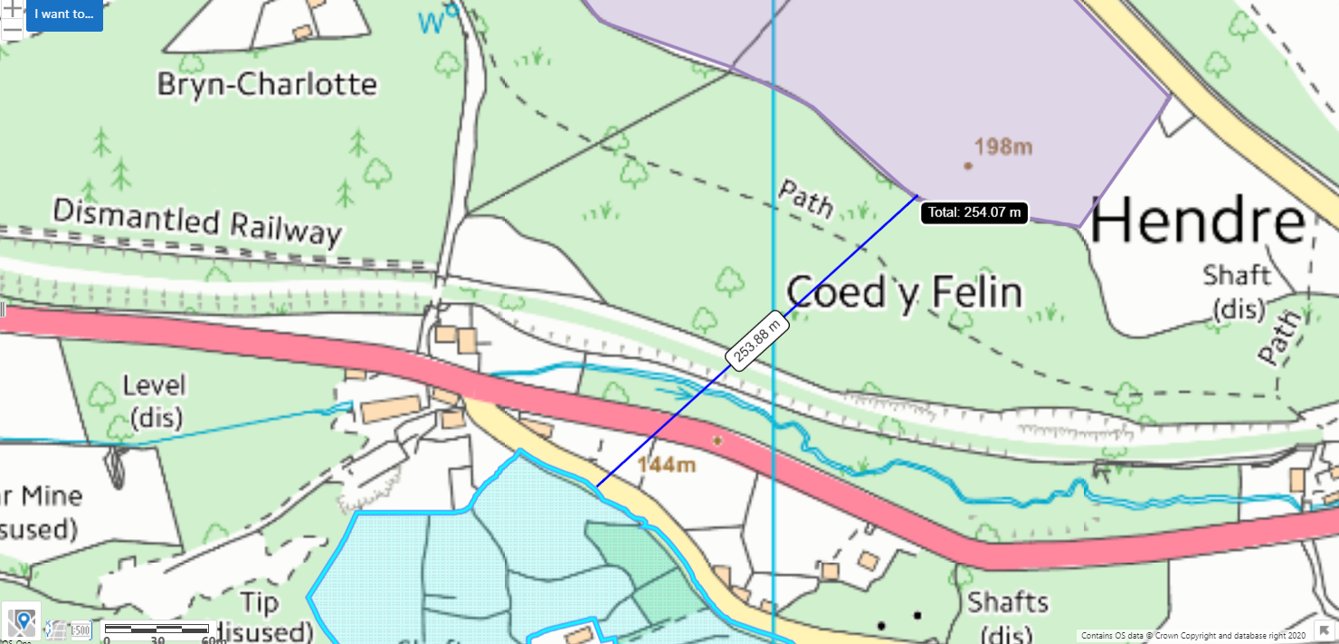

Ancient woodland
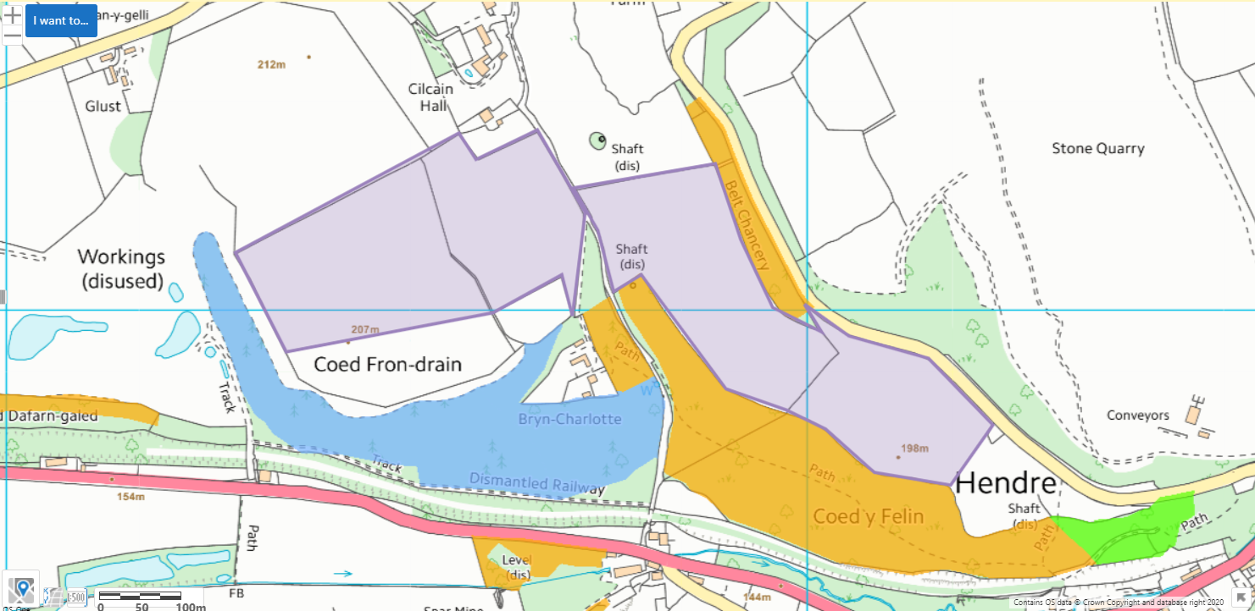

Local Wildlife Site
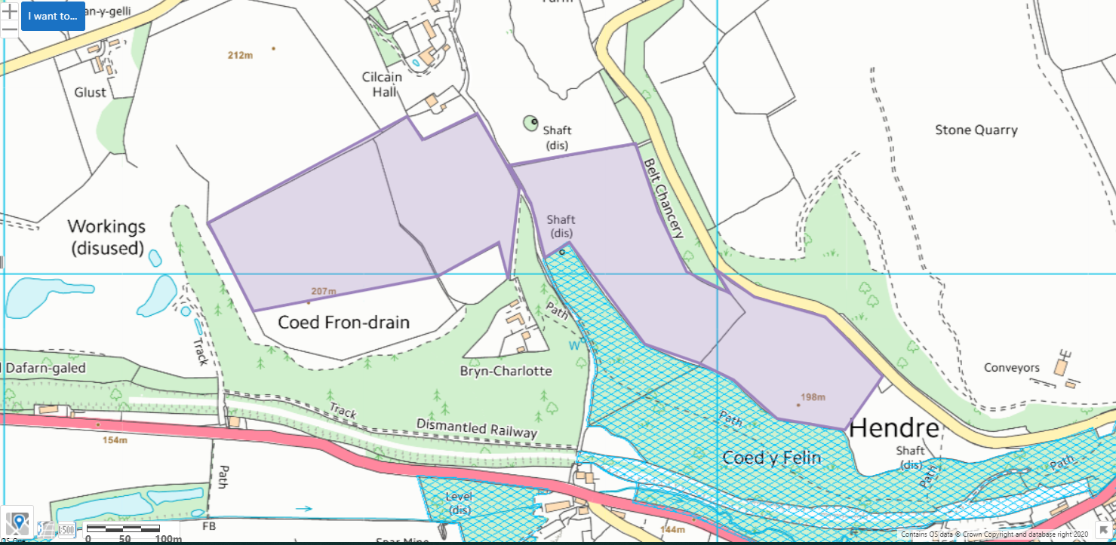

NVZ
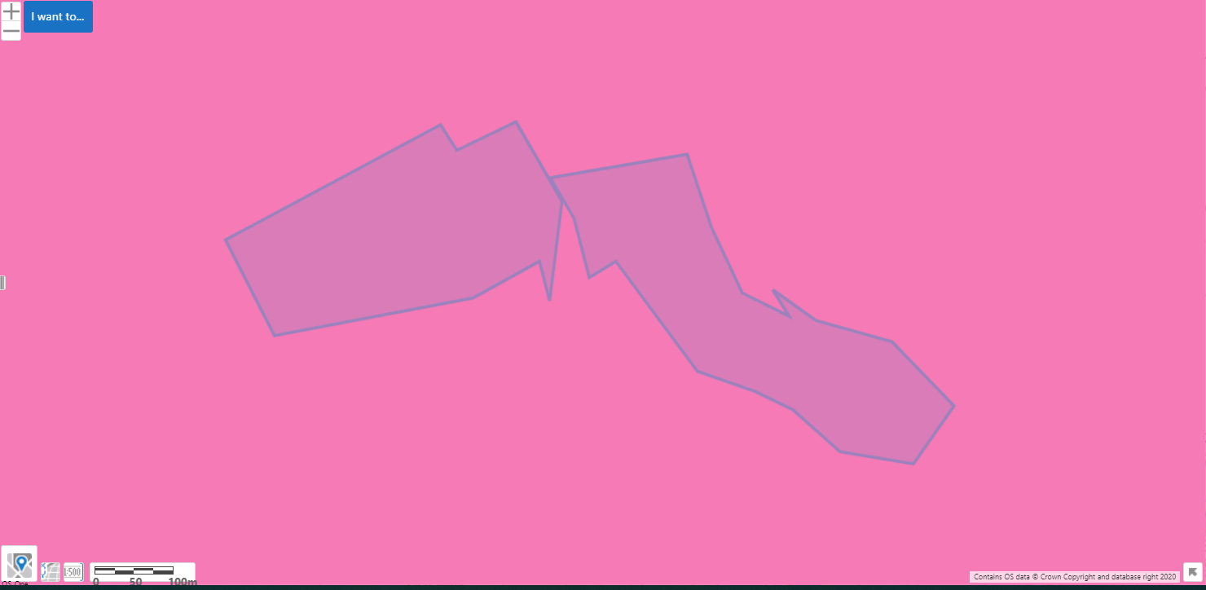

Slope
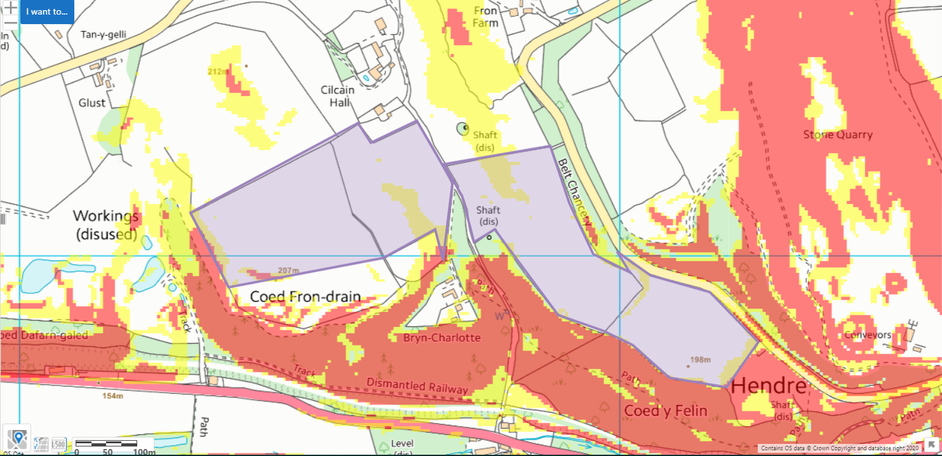

Fields Fron 1, 2, 3 ,4, 5, 6, 7, 8, 9, 10, 11, 12, 13, 14
Contours
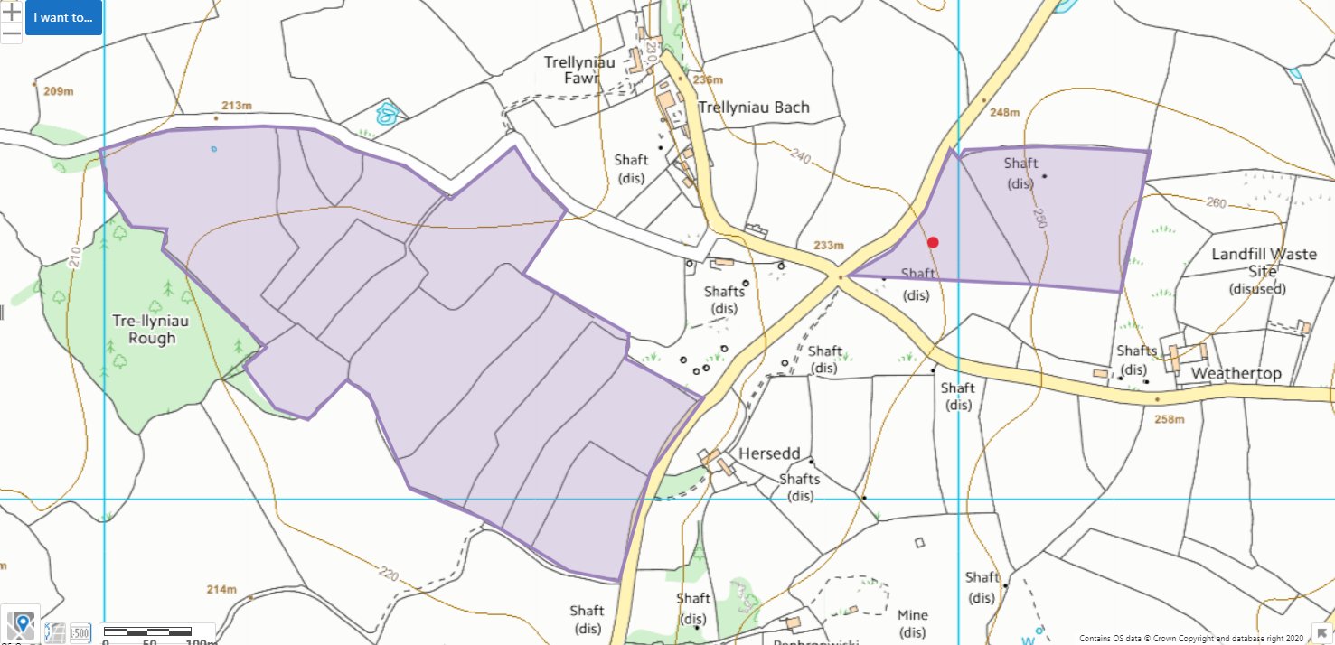

Protected Habitats- Lowland dry acid grassland and Lowland calcareous grassland
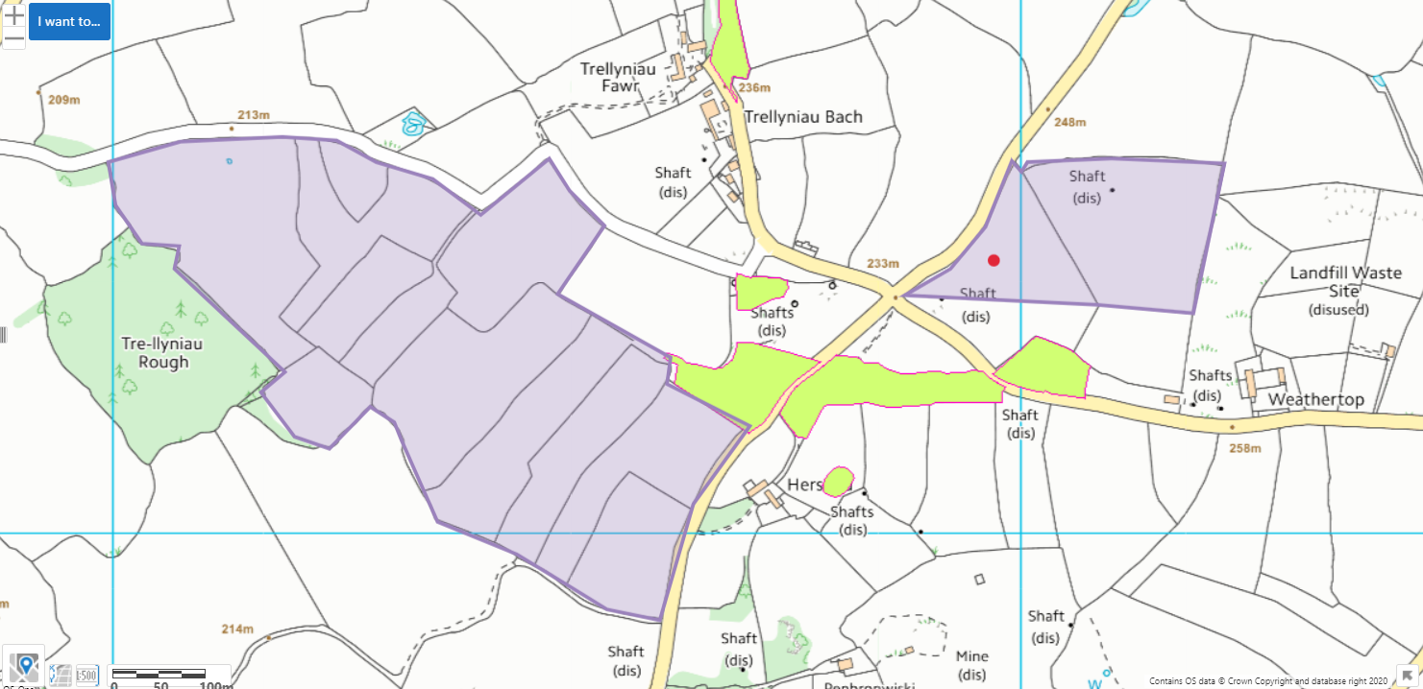

Protected Species
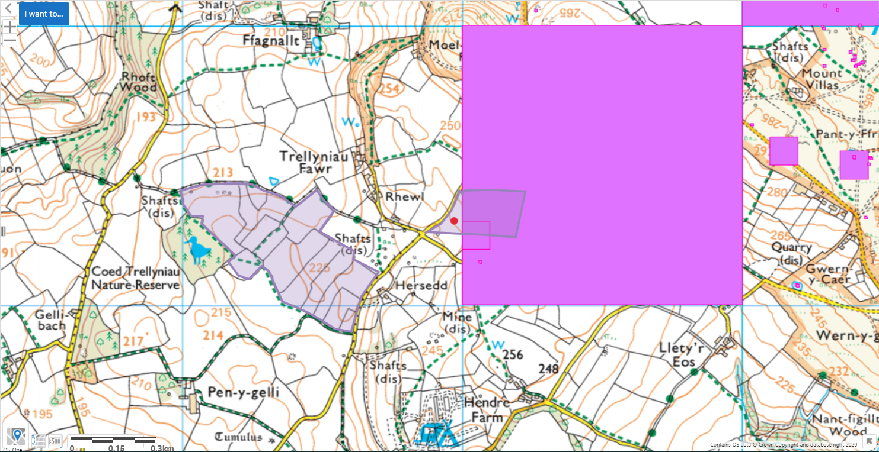

Detailed River Network- no streams or rivers. One pond in field 13. No springs, wells or boreholes.
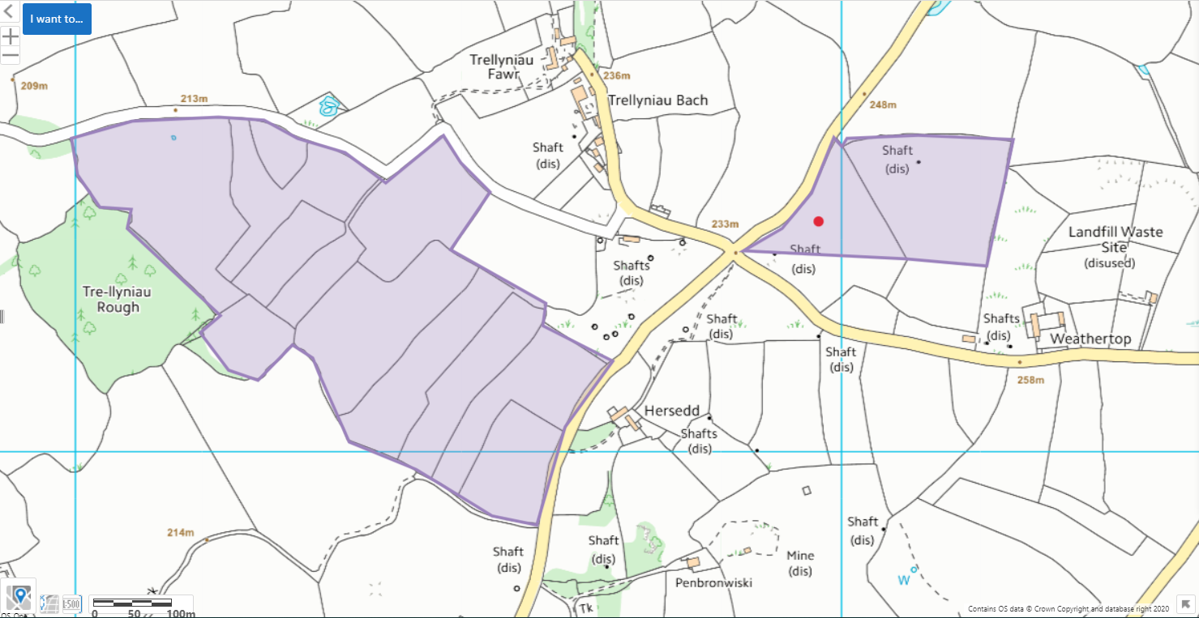

SAC- Halkyn Mountain / Mynydd Helygain (fragmented SAC)
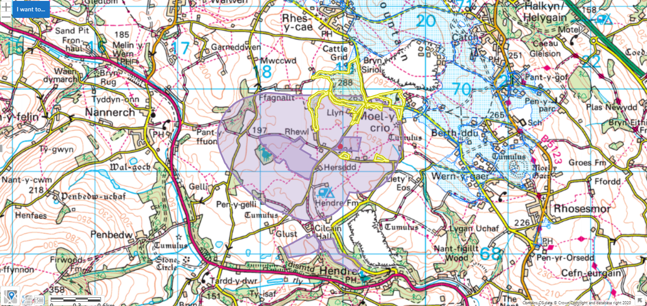

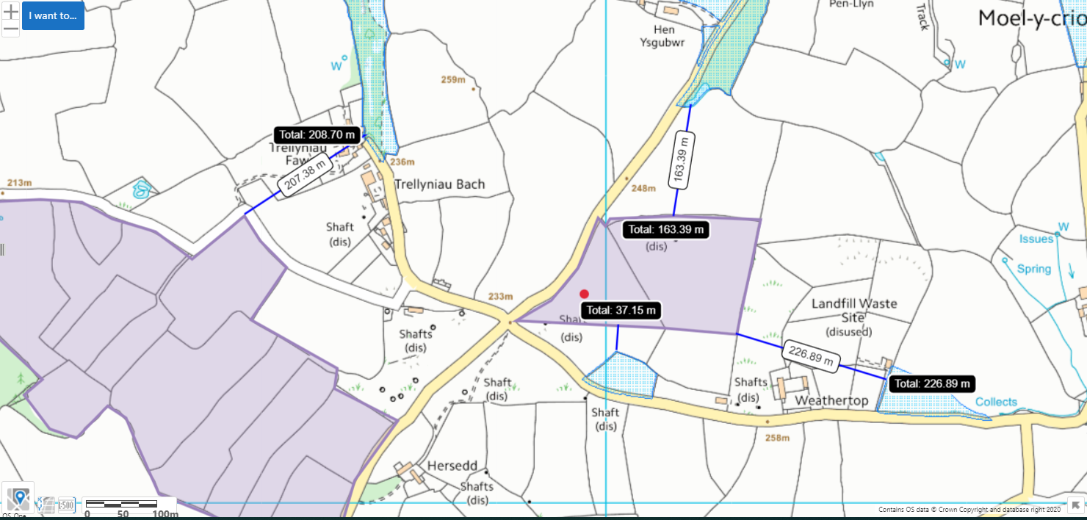Approx. 40 meters from field 1
Approx. 208 meters from field 8
Approx. 164 meters from field 2
Approx. 227 meters from field 2

SSSI- Comin Helygain a Glaswelltiroedd Treffynnon / Halkyn Common and Holywell Grasslands (large, fragmented SSSI)
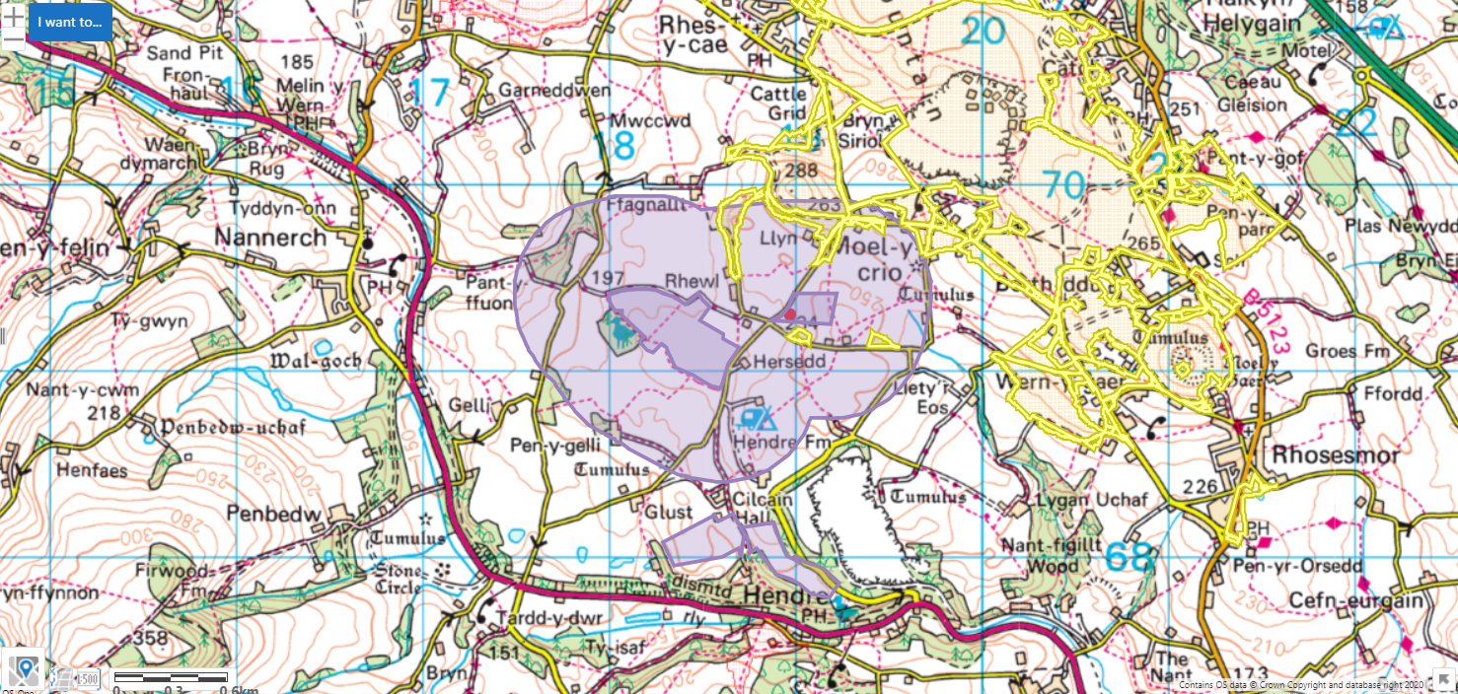
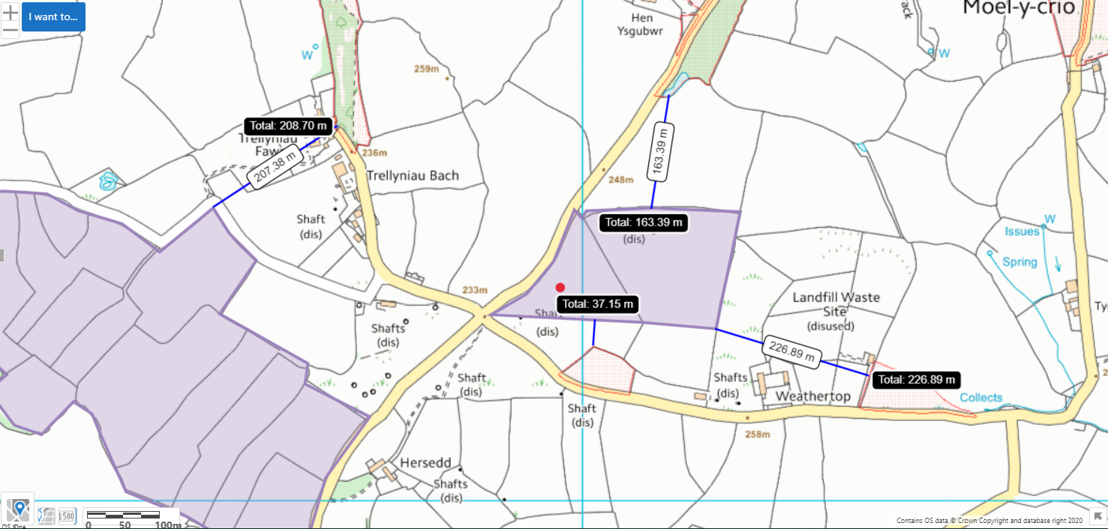
Approx. 40 meters from field 1
Approx. 208 meters from field 8
Approx. 164 meters from field 2
Approx. 227 meters from field 2
Ancient woodland
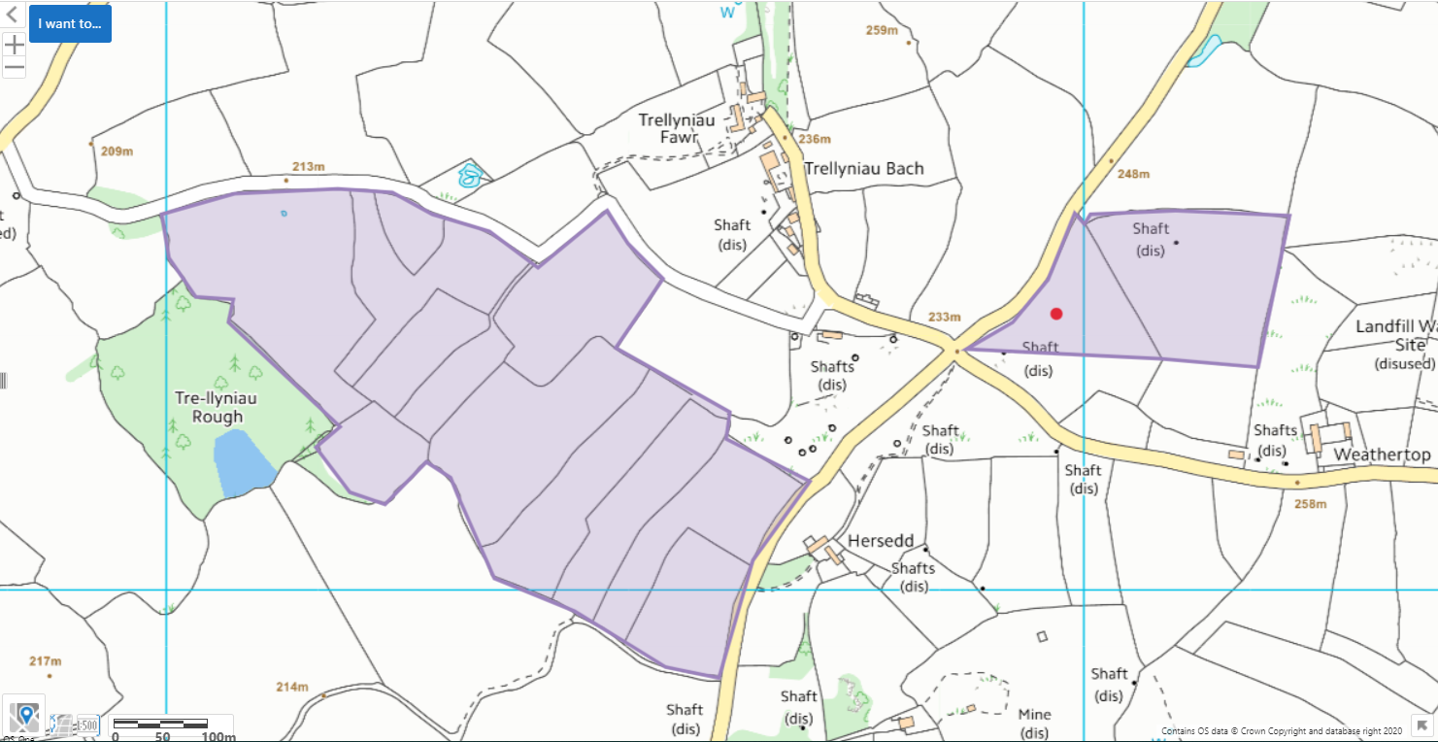

Local Wildlife Site
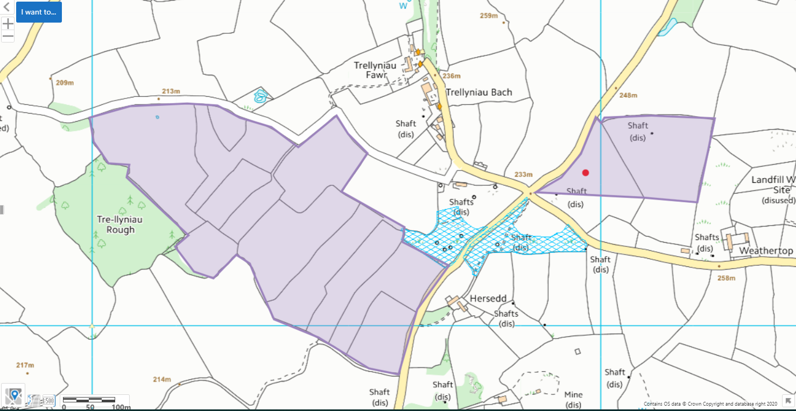

NVZ
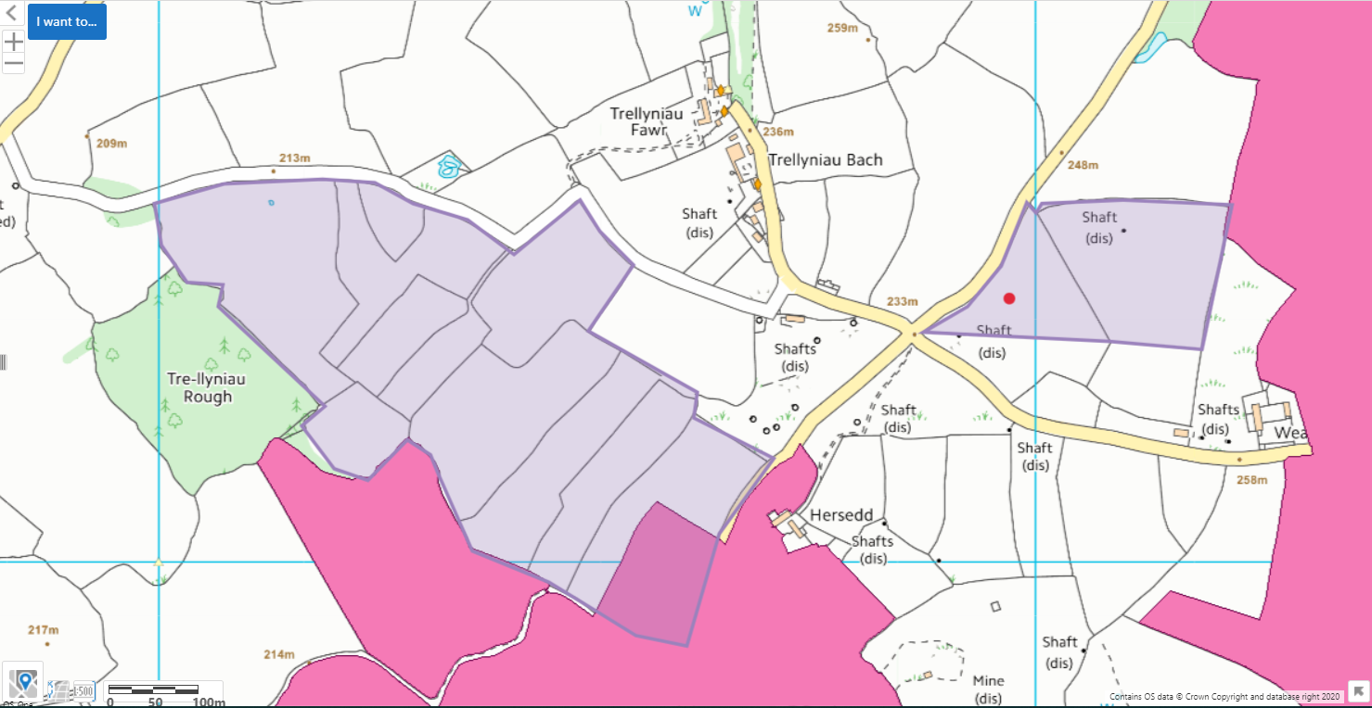

Slope
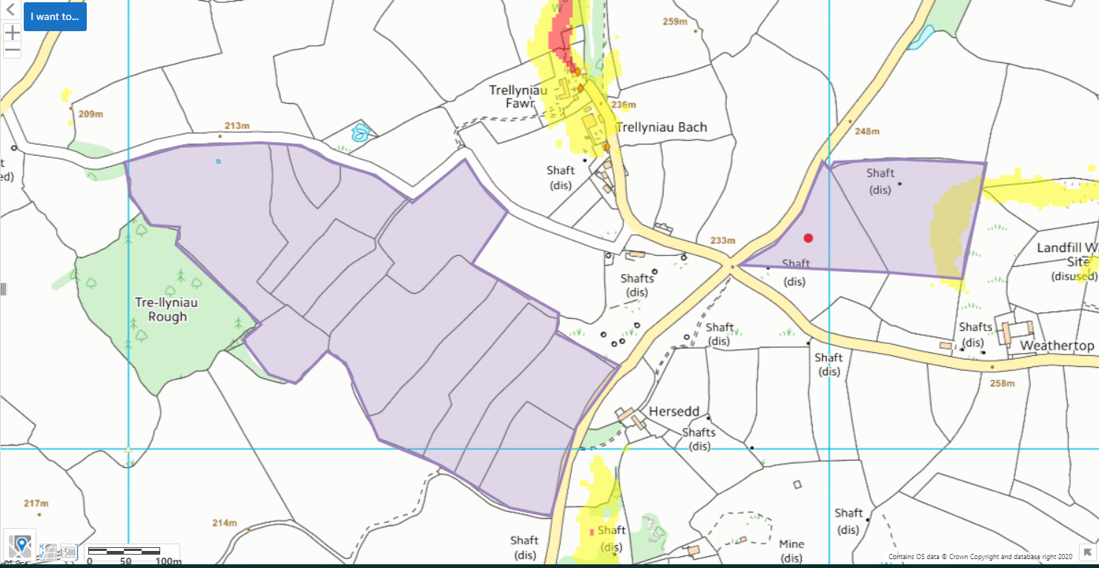

Fields 1 and 2- Public rights of way
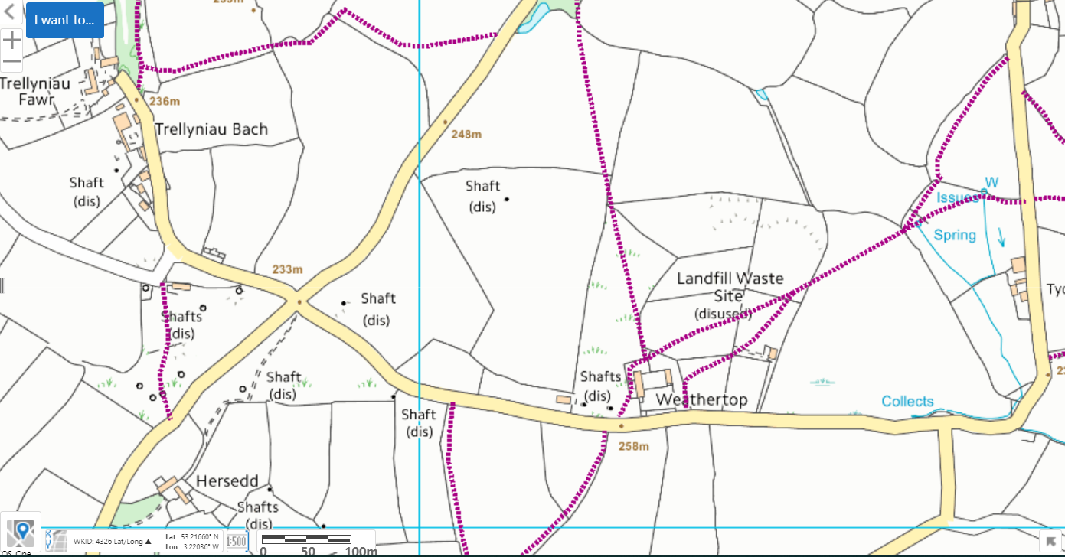

Fields 3-15- Public rights of way
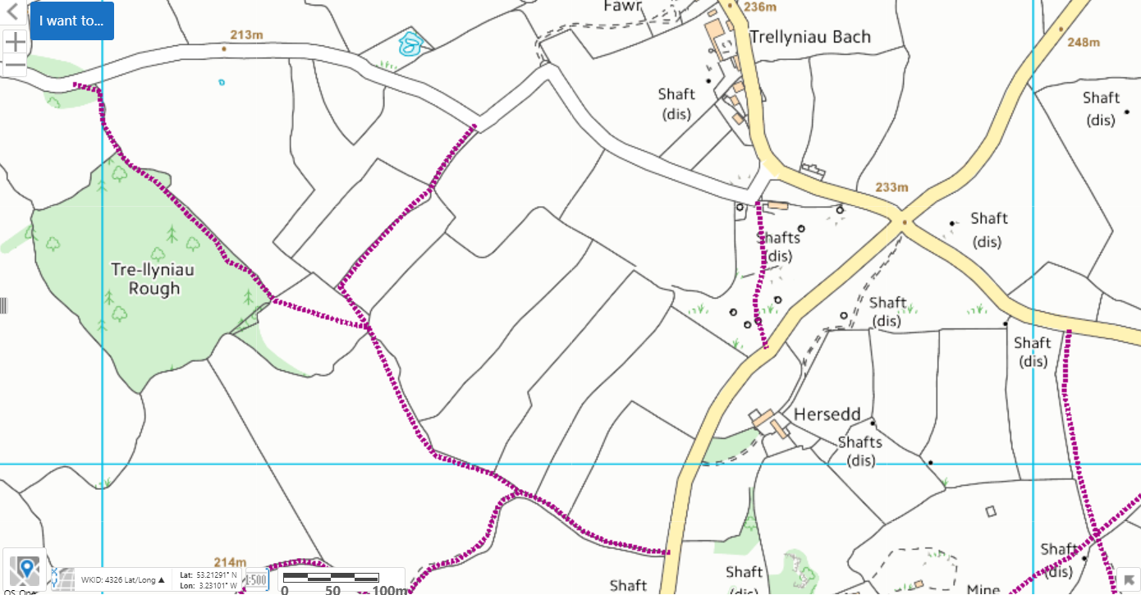

Fields 16-19- Public Rights of Way


