Sychtyn AD Plant Site Visit Photographs

22nd September 2022

Photographs taken by Malcolm Dines

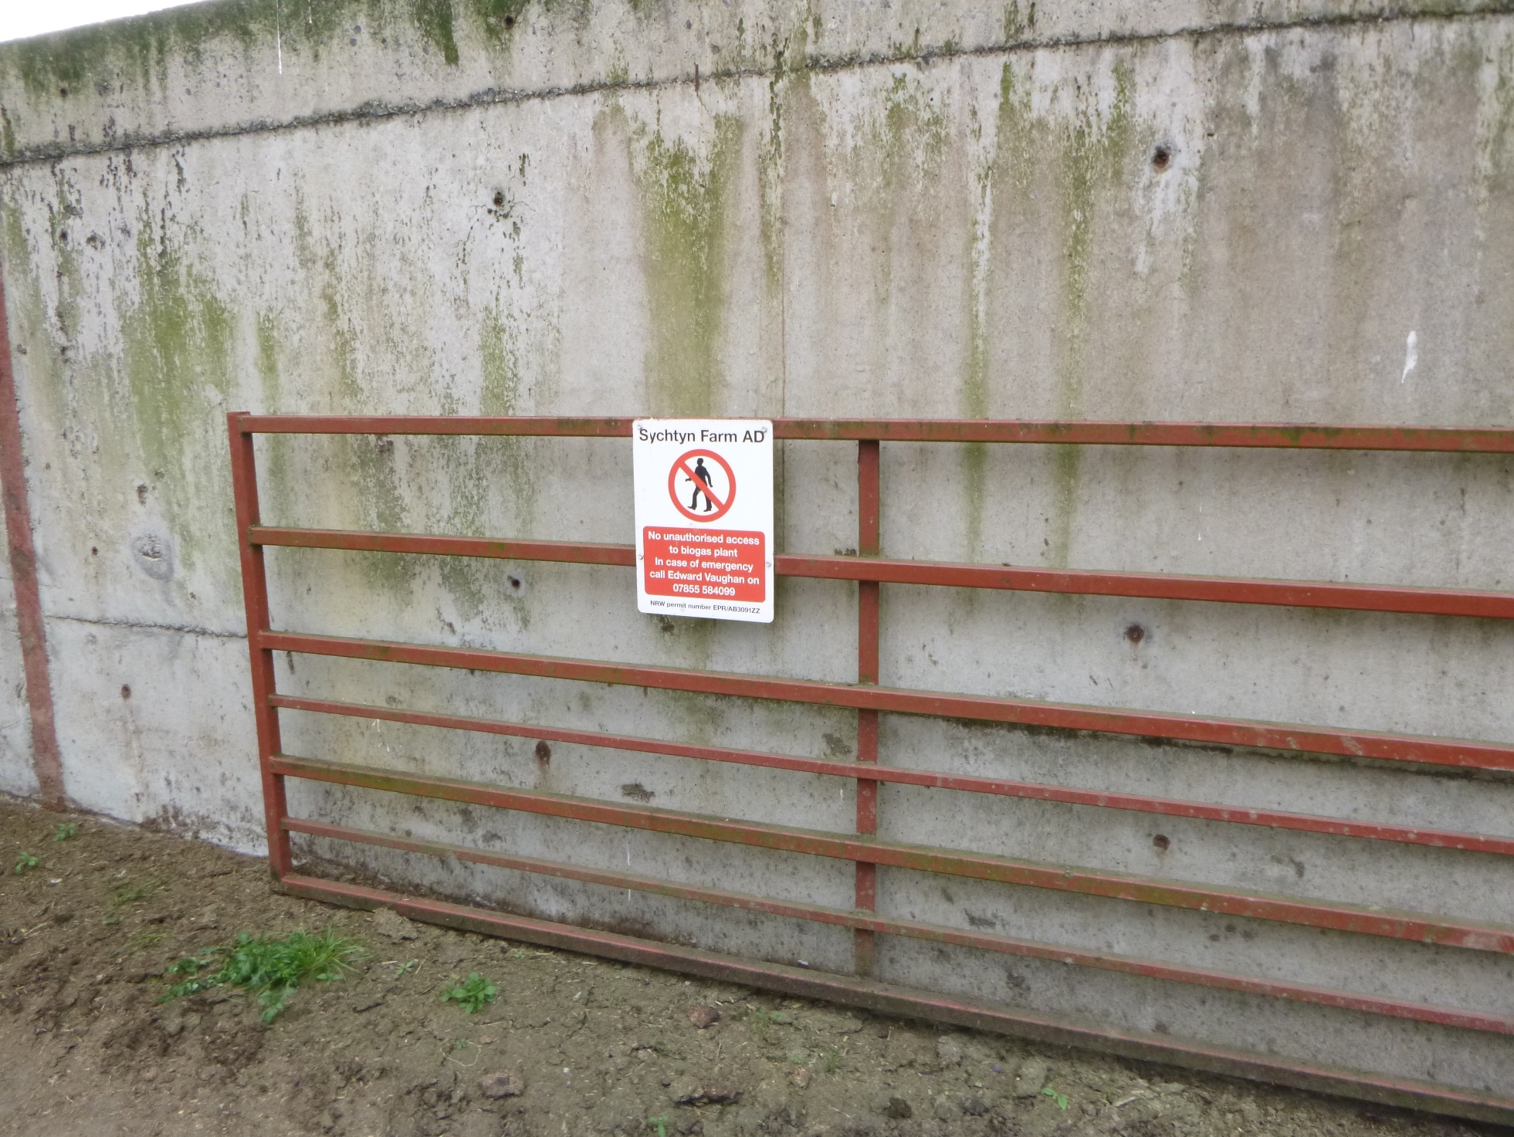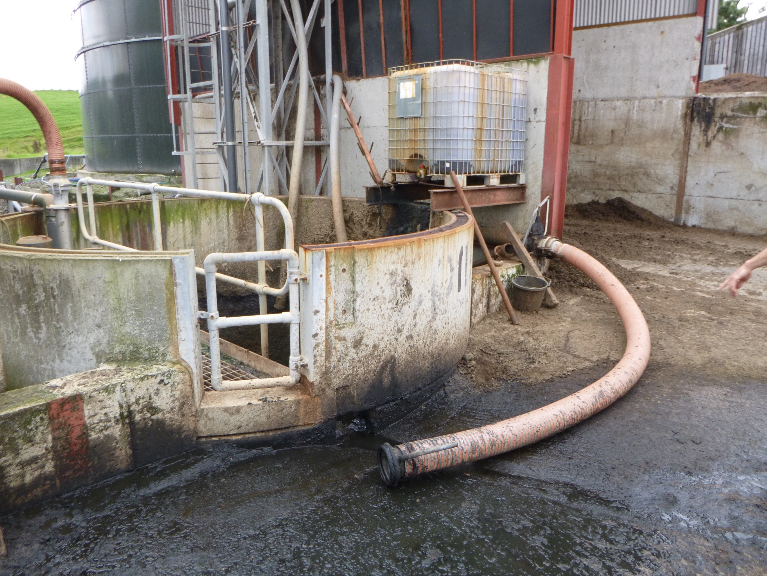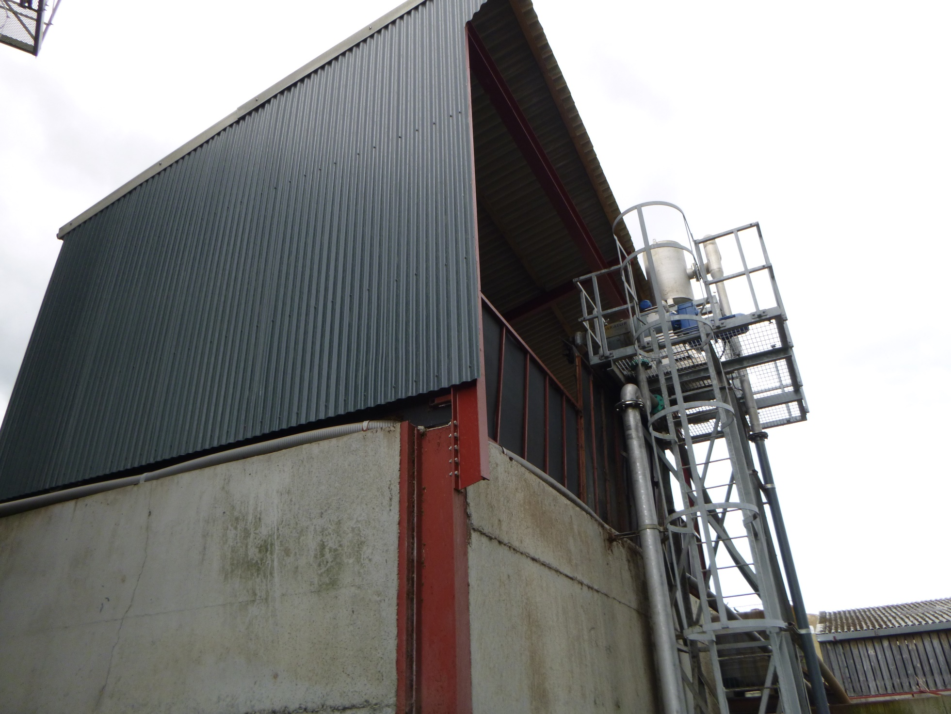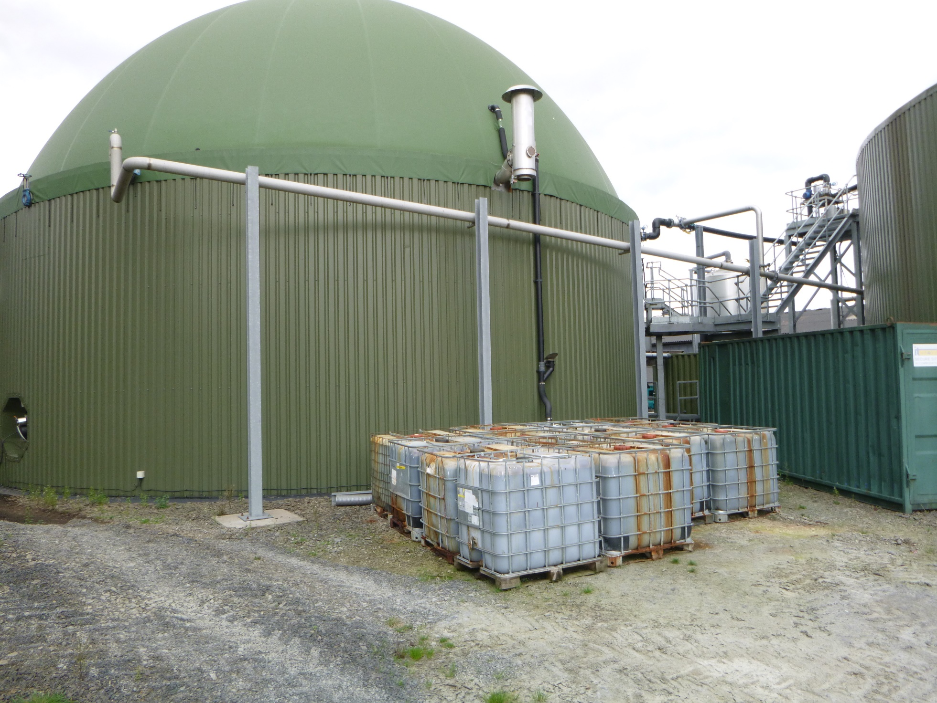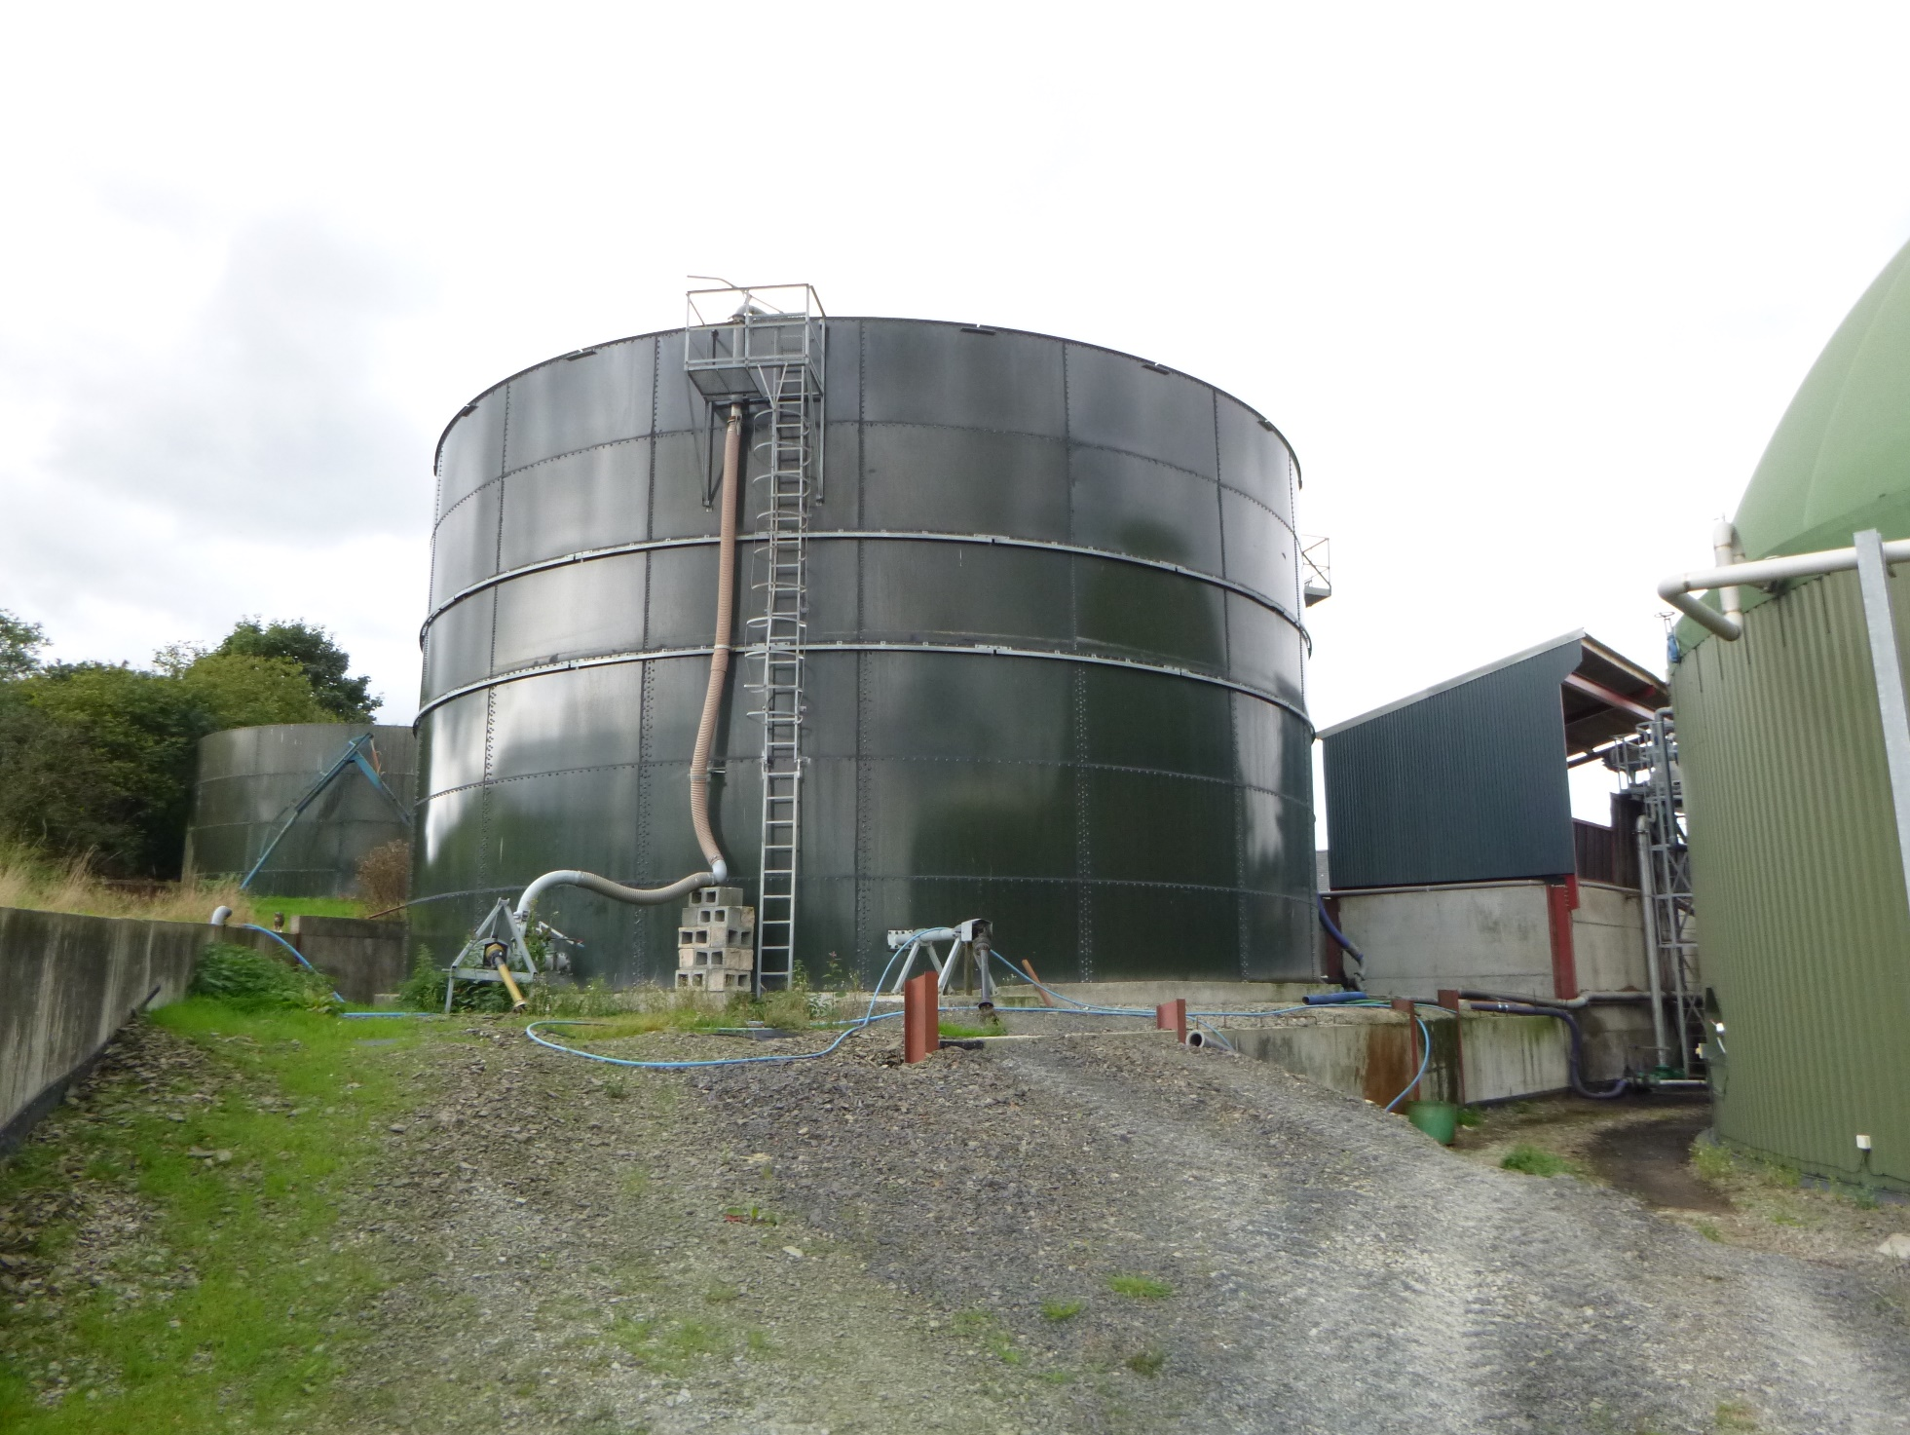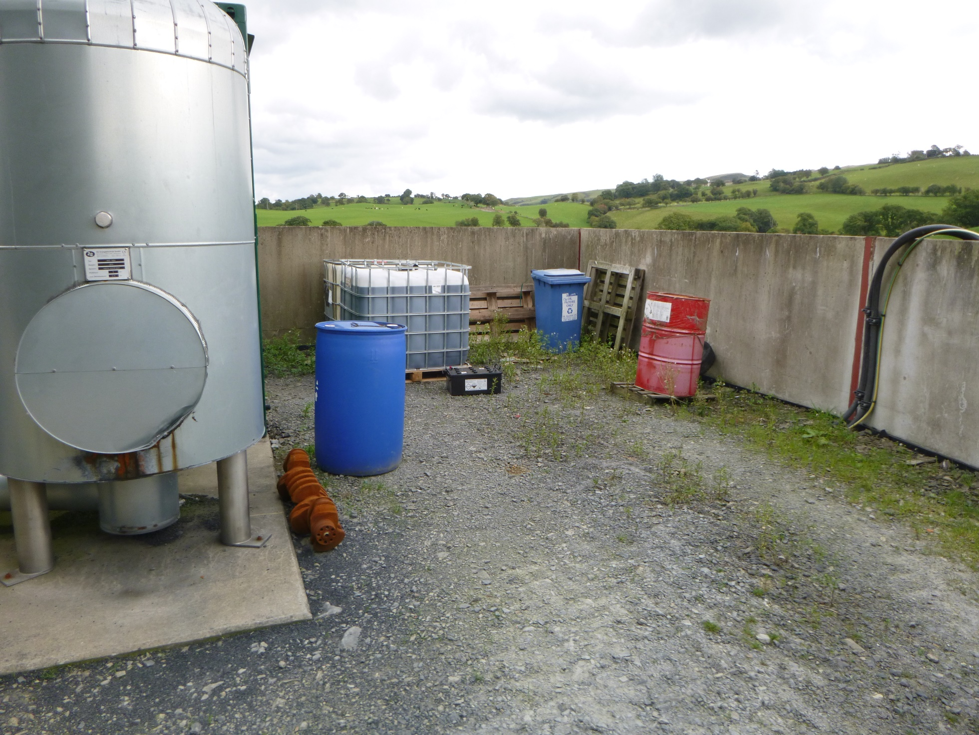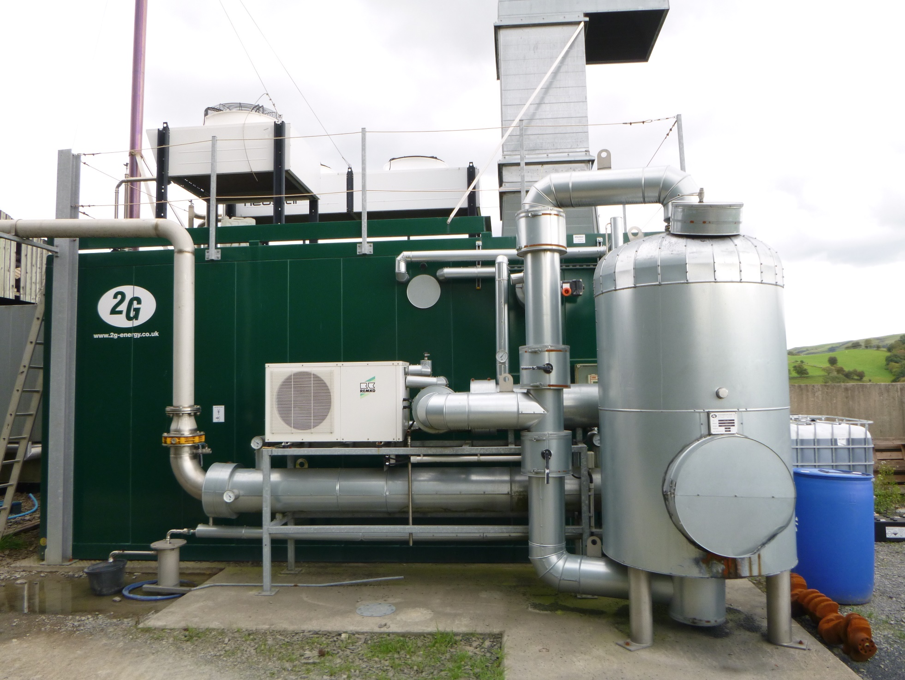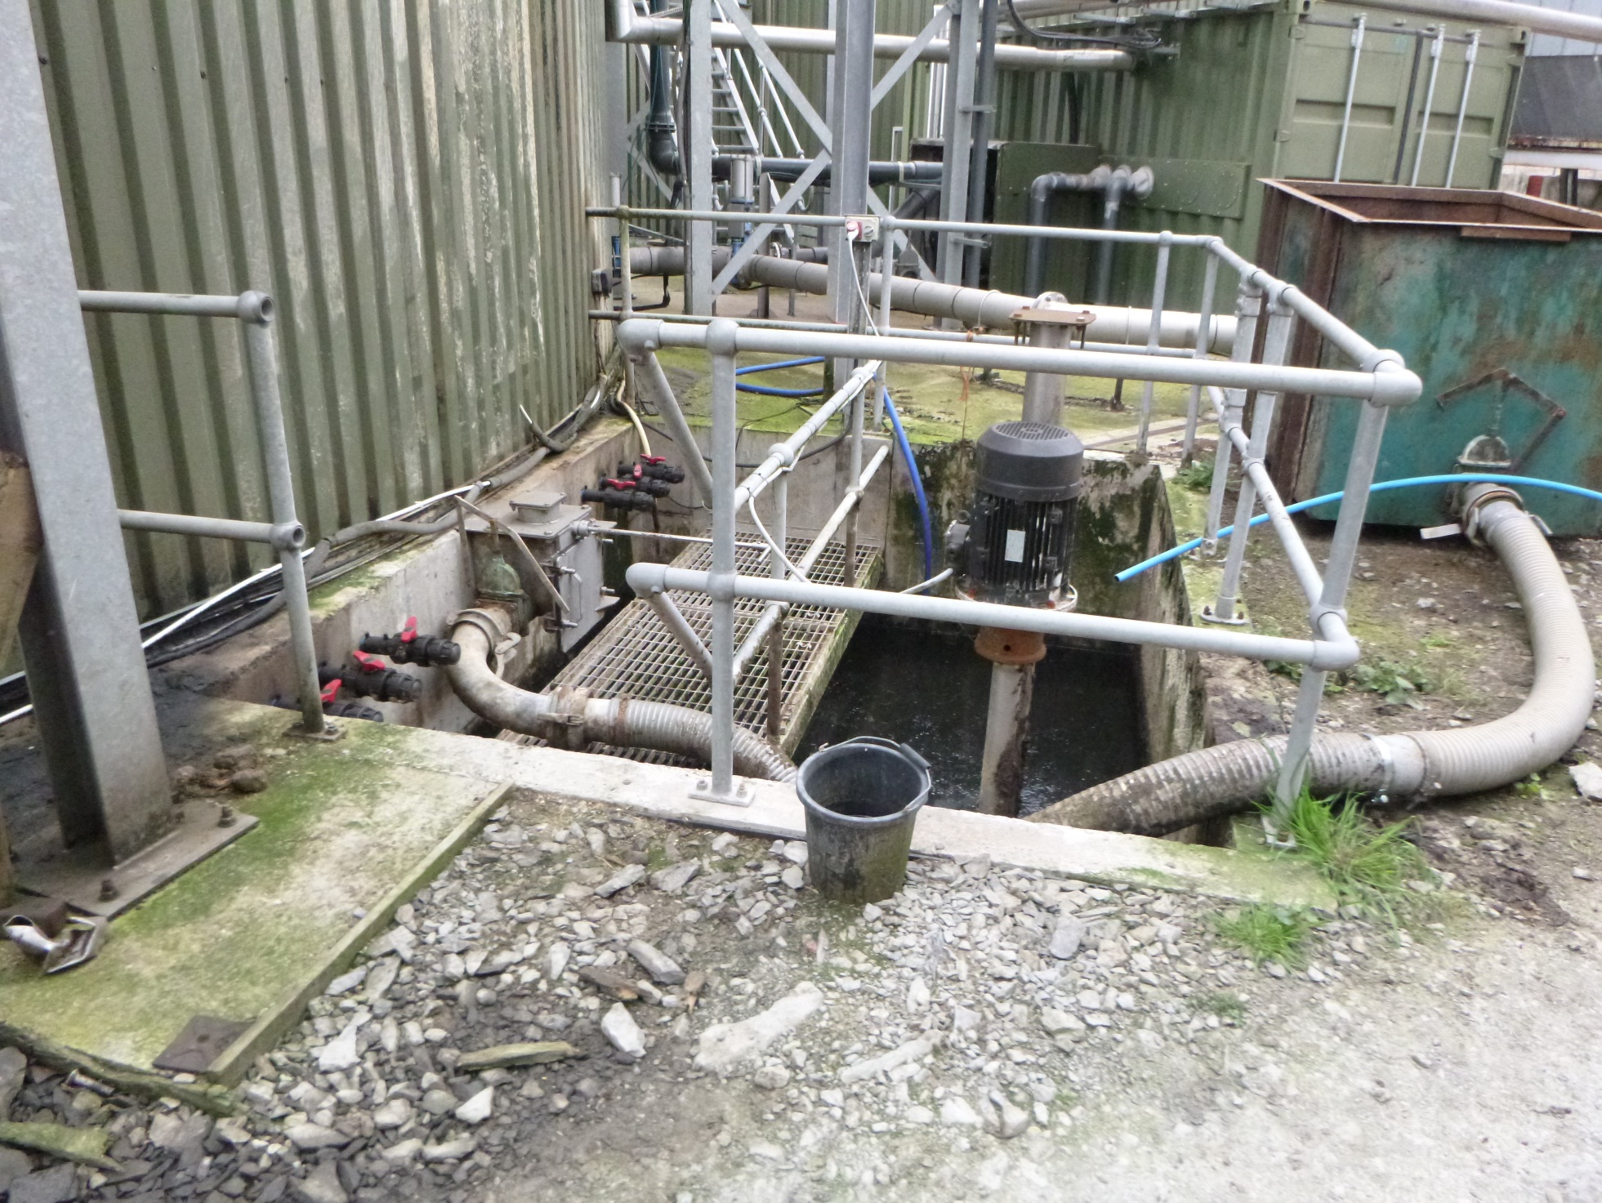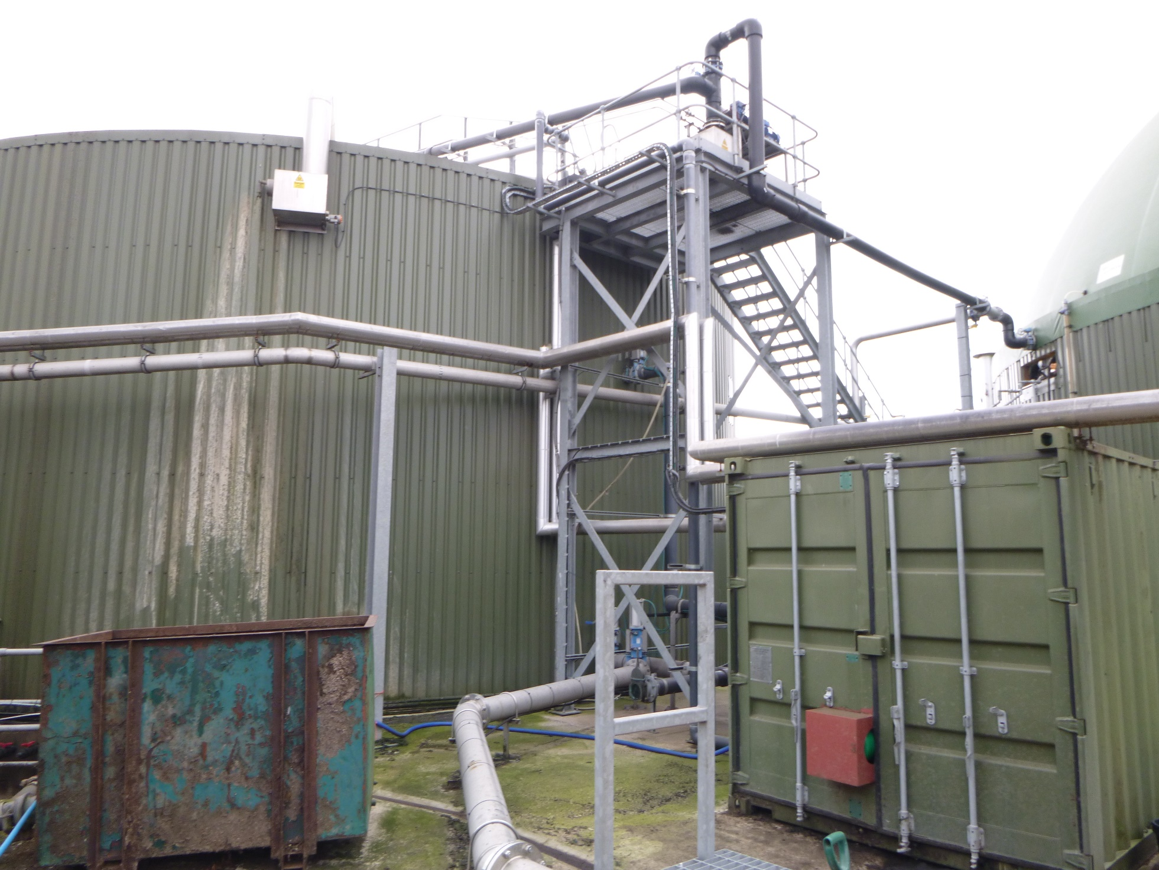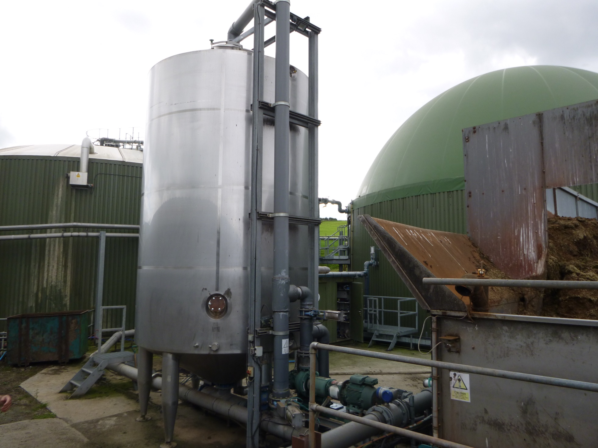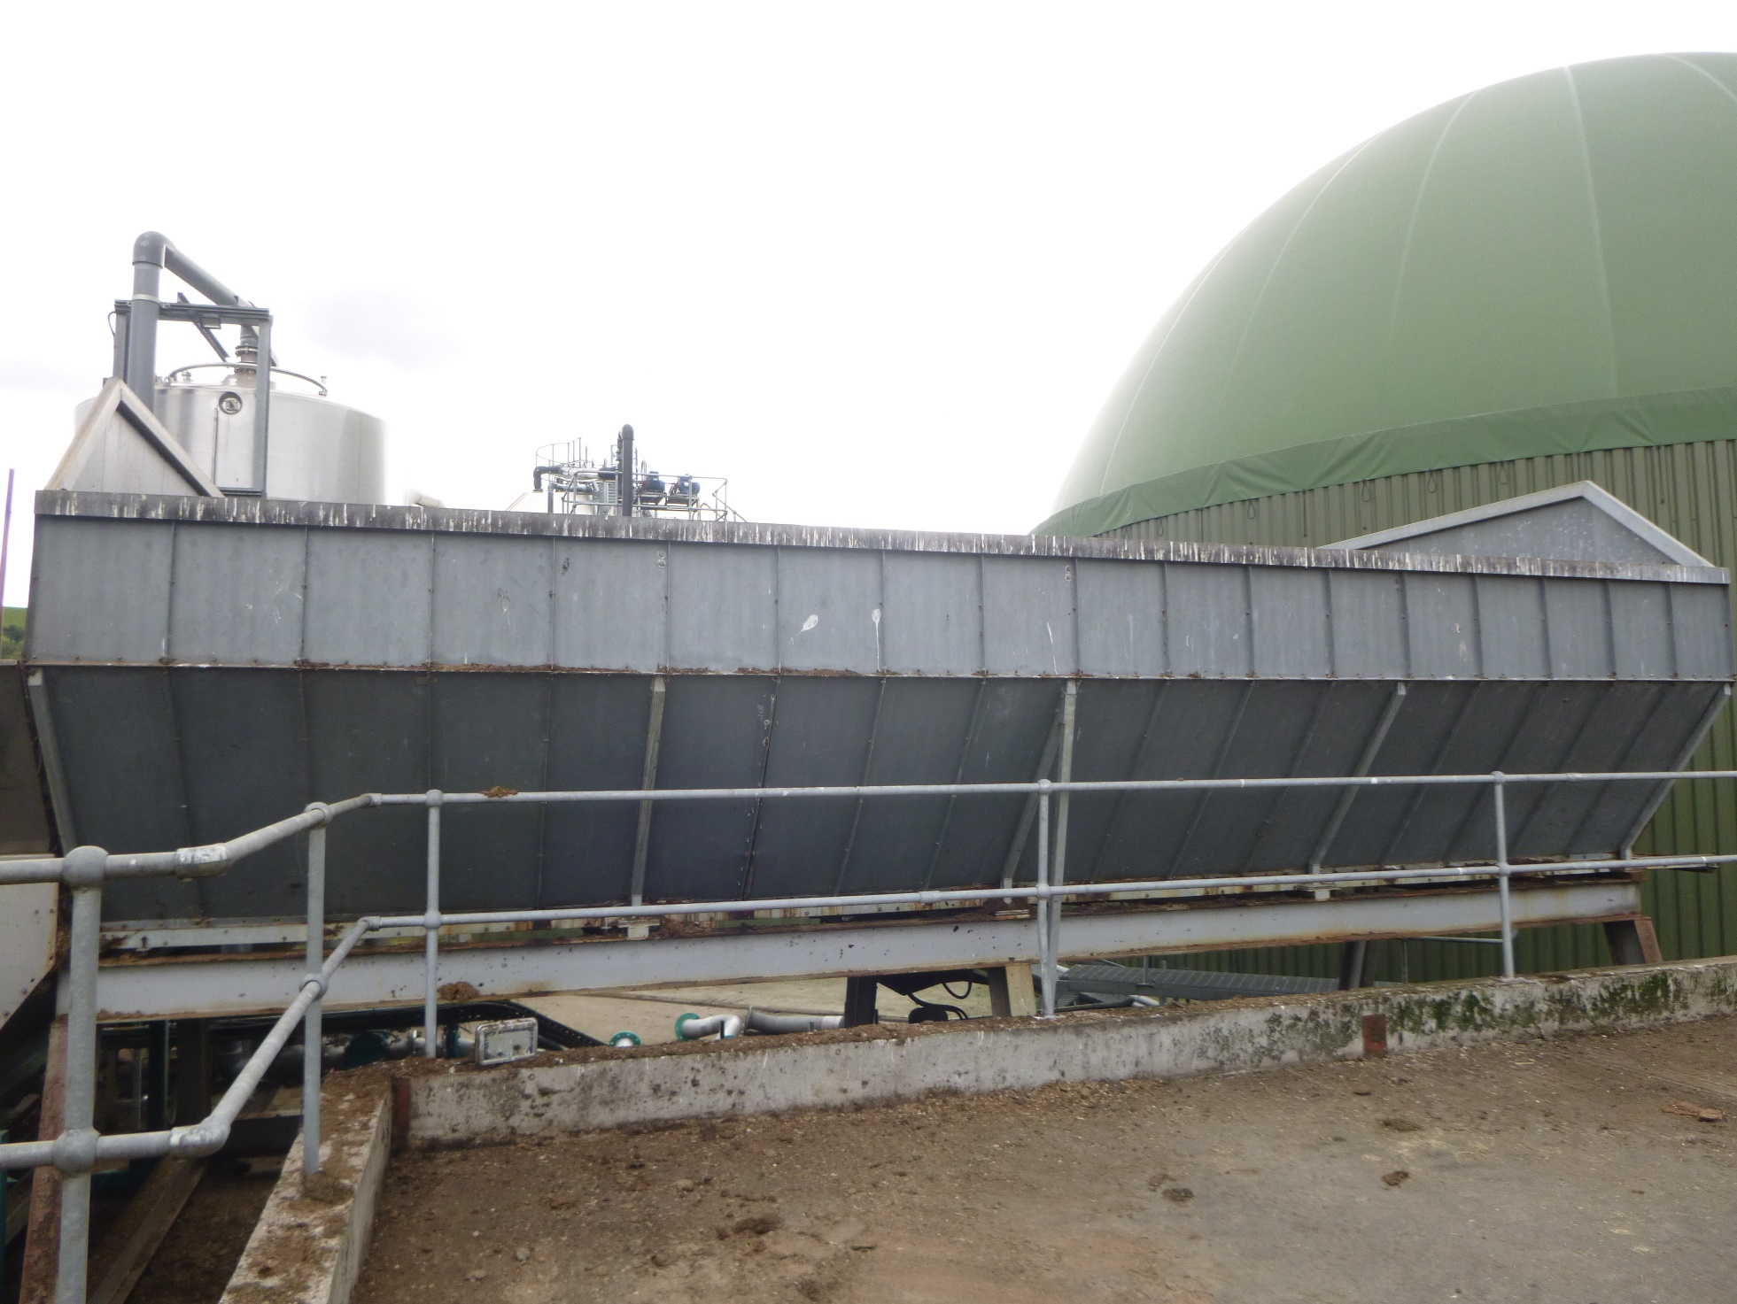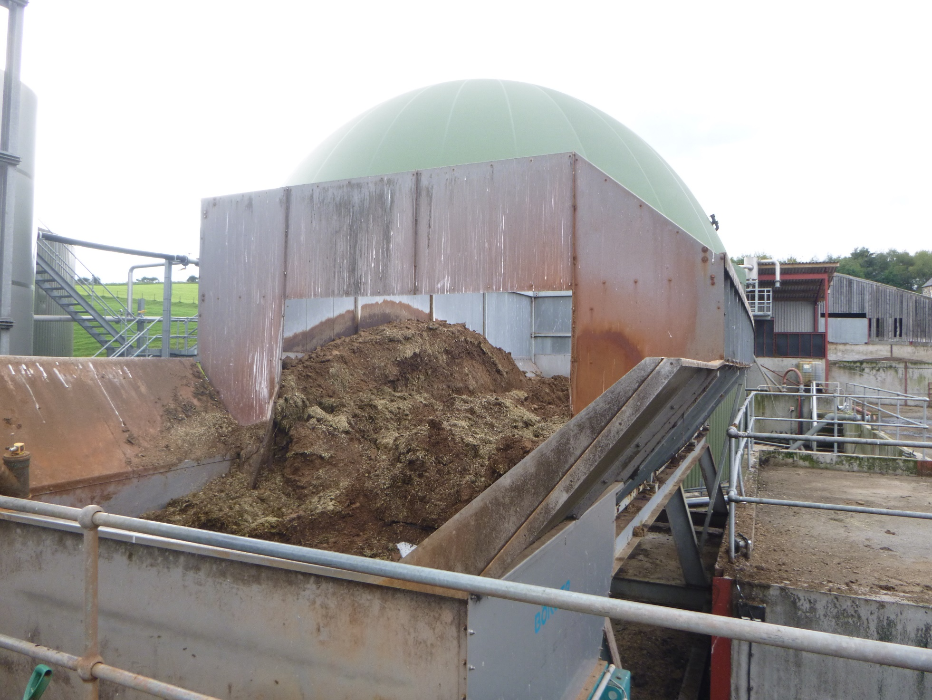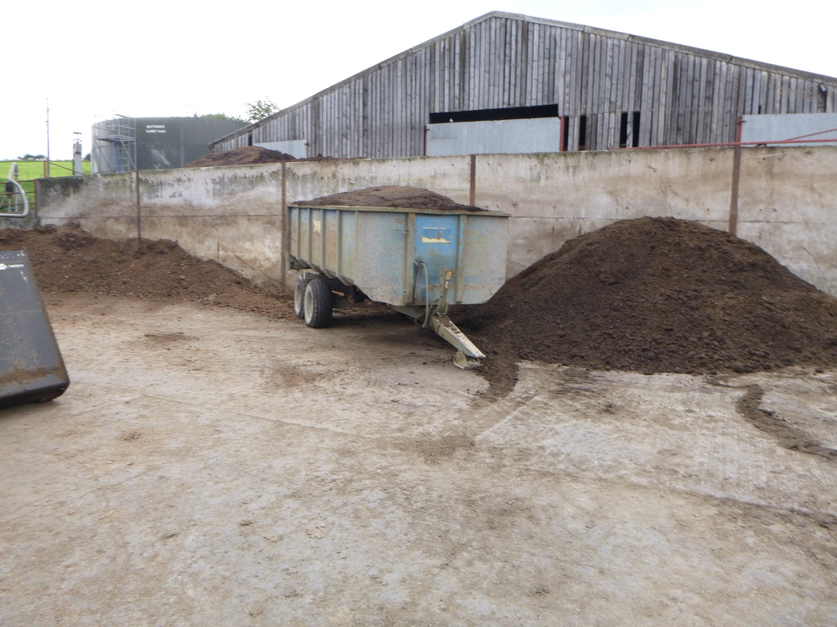
Site entrance and information sign
Liquid digestate collection point that drains back to the digestate collection storage tank
Digestate separator
Secondary Digestor Tank: showing take-off pipe to gas engines and IBCs of ferric acid
Digestate Storage Tank: with aerator pump and stirrer at base.
Oil storage area, adjacent to gas engines. All within fully bunded tankfarm so any spills are fully contained
250KW Gas Engine
Grit chamber adjacent to Primary Digestor: Grit is pumped out to skip and then spread to land
R-L: Control Room in container; Primary Digestor and Grit skip
Hydrolyser for pasteurisation: currently not used as all digestate spread to own land
Loading hopper
Loading hopper with feedstock
Chicken manure feedstock storage
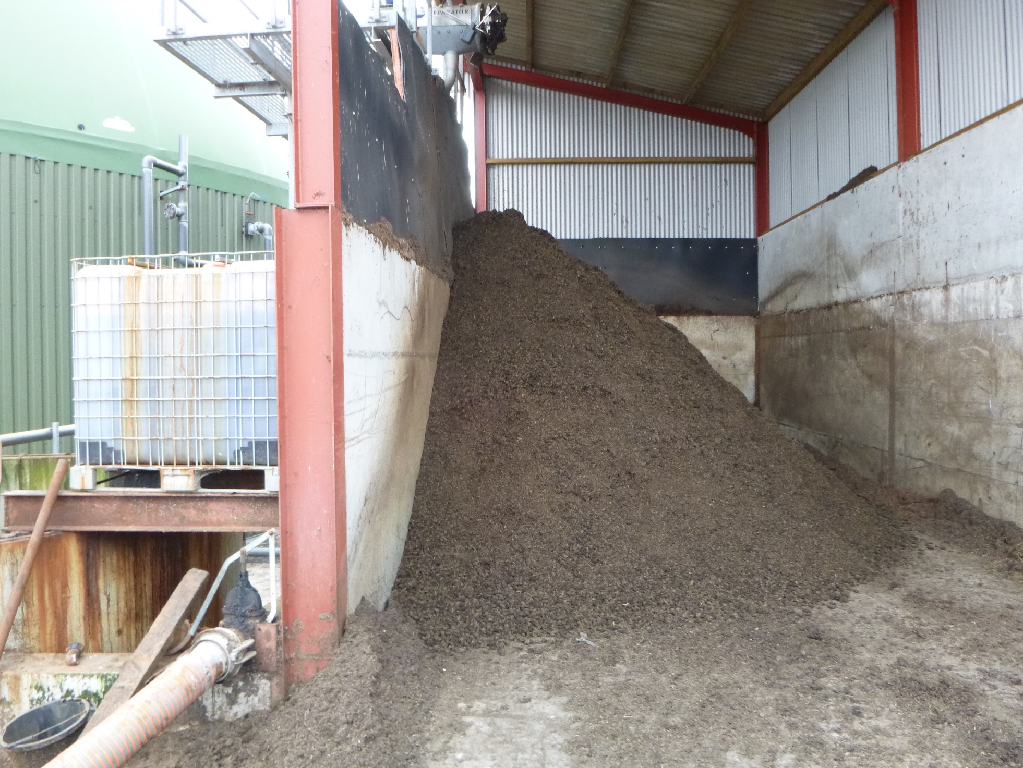
Dried digestate storage

