File Note – 20/03/2019 - WA0640004027
At 15:15 on the 20th of March 2019. Richard Vaughan, the licence holder came to Dolgellau office to discuss a non-compliance on his HEP abstraction and Impoundment licence.

The meeting was to discuss a shortfall of the licences, where it does not list a fish plunge pool as a condition in the licences, describing the fall point if the cascading water as “stream bed as existing” (see Schematic 1). The extent of the area as stream bed as existing is not overtly clear on the schematics of the licences. However, a concrete slab has been put in place which is a potential threat to downstream migrating fish (see picture 1).

Llyr Thomas discussed the issue with Thomas Hughes (fisheries officer), Ollie Low (Geomorphologist), and Victoria Brisoce (Water Resources Environment Officer) to get their take on the matter.

It was discussed to either put in a series of small boulders to reduce the fall distance to the concrete slab, and/or install a small impoundment at the end of the concrete slab to generate a small pool, like a wooden plank with a notch in it.

Conclusion was that some small change to the HEP scheme would not merit a variation on the impoundment licence because there would be no impact on the water abstracted, nor on geomorphological processes, and would only serve to better protect fish.

Richard Vaughan in the meeting said he could do something to help the issue. We discussed using boulders or putting in a small impoundment board with a notch in it. He said he would try to put in boulders first to see if that worked. I said it’s up to him, but they might move. He said he would try that first and then see how things went. We agreed that he would be able to do it by the end of the Summer (2019). He said he would email me a brief method statement and pictures of what he had done.

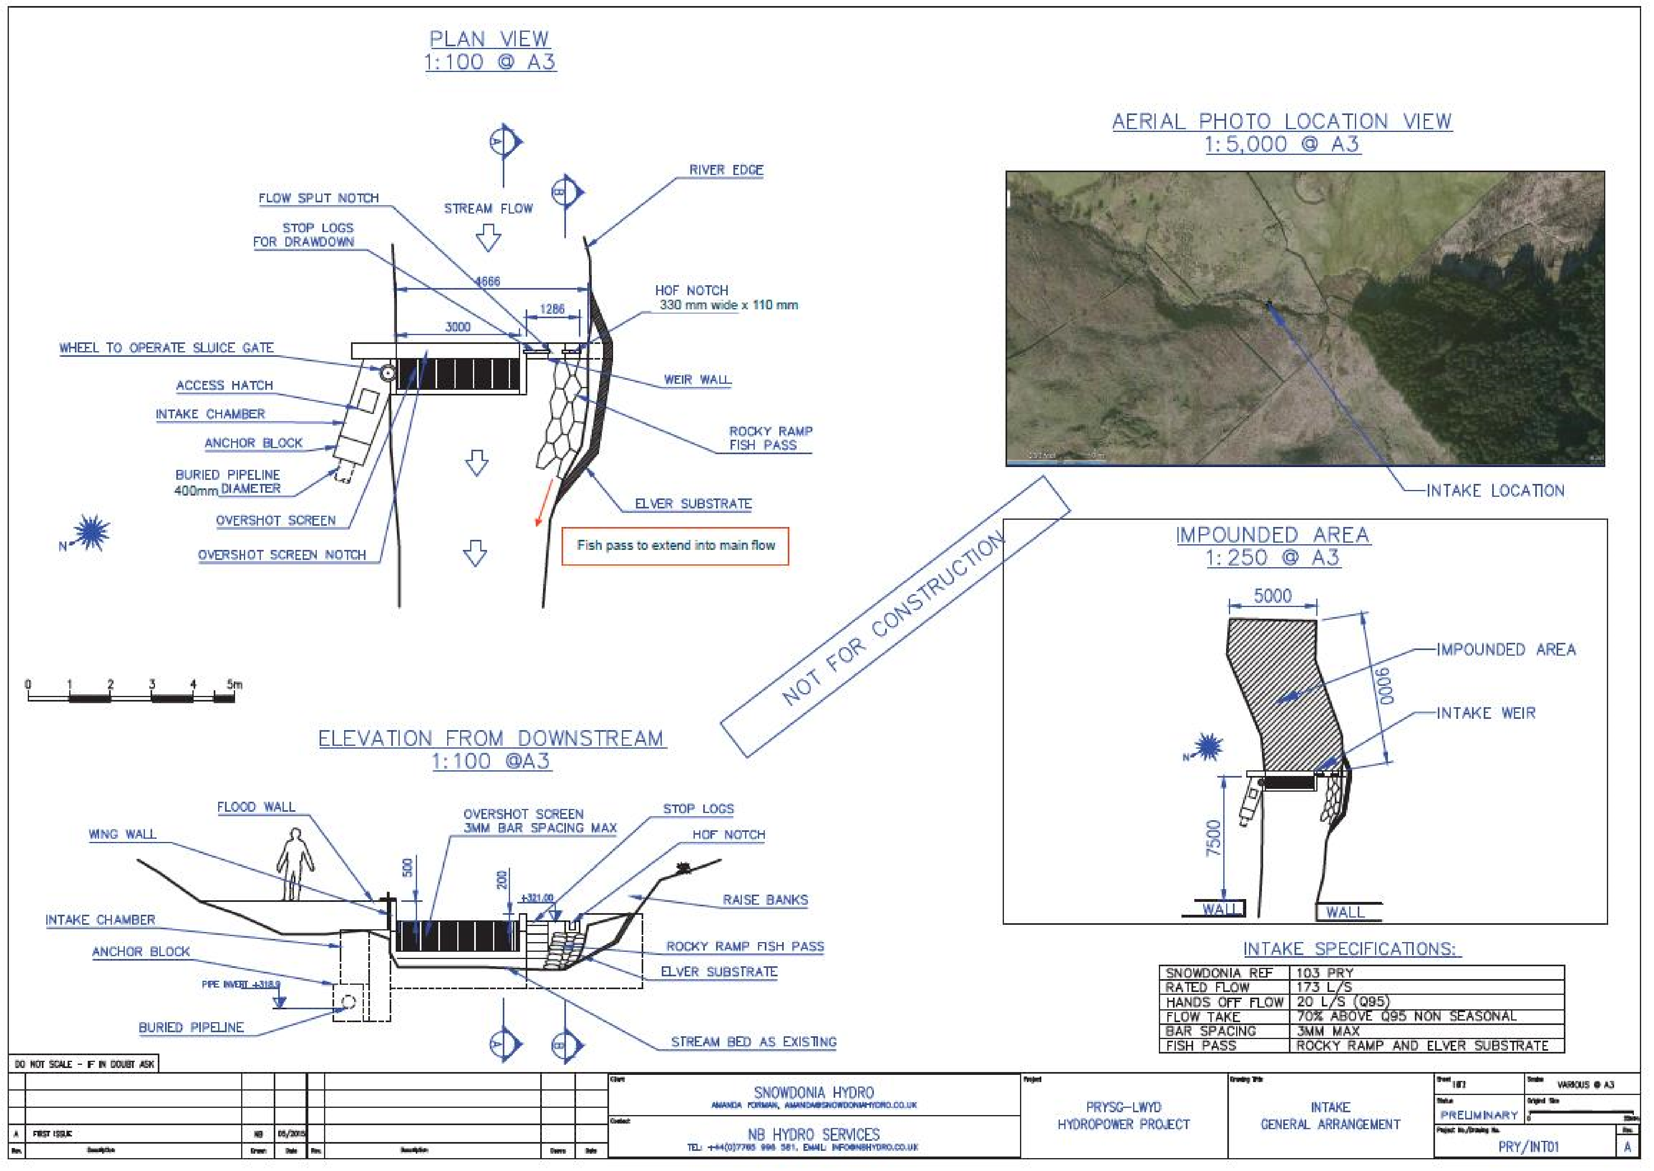

Schematic 1.

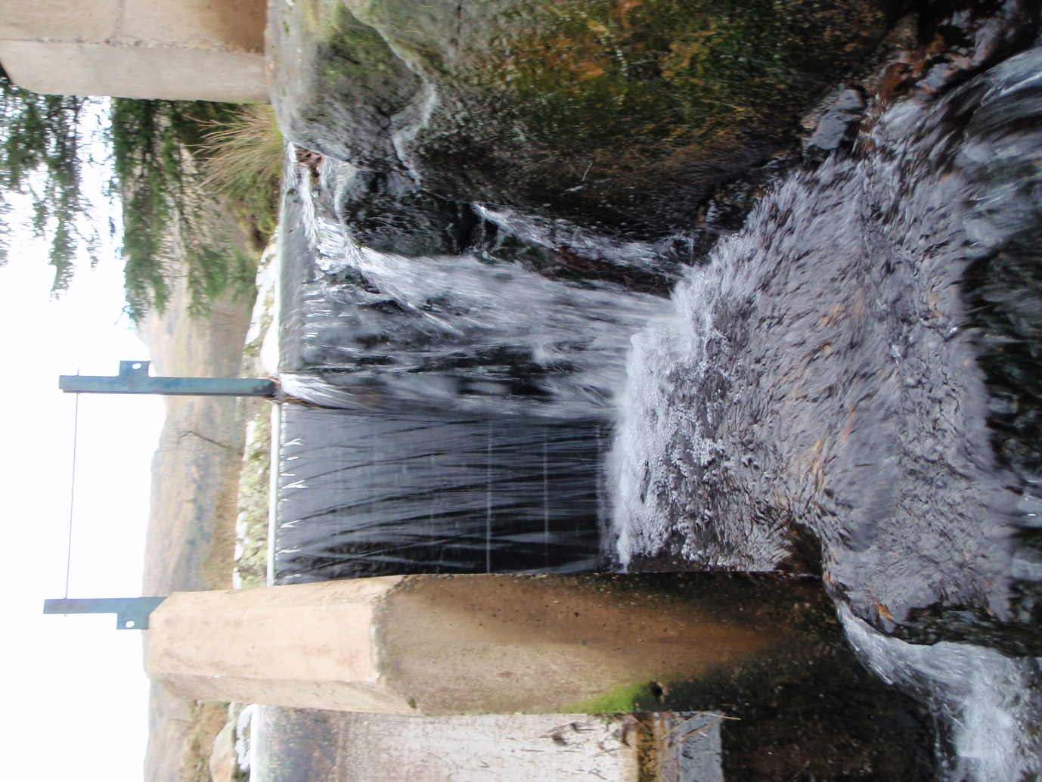
Picture 1.

