CRoW Appendix 4 (140_10_SD02)  CRoW Act 2000: Natural Resources Wales application for permission - Formal Notice |  | 
Natural Resources Wales Formal Notice.
Requirements of Section 28I of the Wildlife & Countryside Act 1981 as amended by the Countryside and Rights of Way Act (CRoW) 2000.
Duty in relation to granting any consent, licence or permit for activities likely to damage Sites of Special Scientific Interest (SSSI).
Guide to filling in this form for Natural Resources Wales staff:
To be completed by Permitting Officers for any applications for a permission which the Natural Resources Wales has considered under S28G duties to protect and enhance SSSIs. This applies to all proposed permissions within a SSSI, and to operations outside the SSSI boundary which are likely to damage its special features.
Refer to OI 140_10 ‘Applying the Countryside and Rights of Way (CRoW) Act 2000 to applications for permits with potential for impact on Sites of Special Scientific Interest (SSSI)’, including the flowchart in Appendix 2.
- Natural Resources Wales area/region/NPS hub: | Permitting: Wales-wide team  Protected Sites Advisors: Newport Caerphilly and Blaenau Gwent Environment Team
- Name of SSSI: | Gwent Levels – St Brides
- Type of permission: | Environmental Permit substantial variation  Section 1.1 Combustion Activities- Part A (1) (a) Burning any fuel in an appliance with a rated thermal input of 50 or more megawatts.  Newport Data Centre – provision of backup power generation only in the event of a power failure supply from the National Grid – they do not run all of the time and are normally off other than very limited hours for testing / maintenance. See section 8 below. Application to increase from 77 diesel engines to 202, increasing total site capacity from 146 MW_{th} to 520 MW_{th}.
- Date for Natural Resources Wales permit determination: | Statutory determination date has expired, 14/08/22.  Target determination date (internal) 31/10/22.
- Predicted 28 day date for response from NRW conservation/ecology (under S28 I(4)): | 21/09/22 – but owing to statutory determination date having passed, a response ASAP is requested.
- Natural Resources Wales reference no: | PAN-015219 (EPR-BB3599CW)  - Internal DMS link  Online Public Register Link (external)
- National grid reference: | NGR - ST 2819 8463
- Description of proposal: | Substantial variation to existing Permitted site (backup power generation to data centre) to increase from 77 diesel engines to 202, increasing total site capacity from 146 MW_{th} to 520 MW_{th}. Each of the proposed new engines has a capacity of 2.987 MW_{th}. Other site details (fuel supply and containment, waste management etc) are unaffected by the proposed variation and are not considered relevant to this assessment.  These engines provide back-up generation in event of a power failure supply from the National Grid – they do not run all of the time and are normally off. They are also operated for testing/maintenance for very limited hours each year as explained below. Each engine has its own individual stack (height 3.184-3.937m for existing engines, 12.3m for proposed new engines). Key issues of operation are as follows:  - The only planned operation of engines is for testing/maintenance, with none of the testing overlapping. Each engine is scheduled for individual quarterly testing (2 x 2 hour per year, and 2 x 15 minute per year). Cells of engines (4-9 engines, most cells 5 engines) are tested together for 15 minutes (twice per year). There may be short duration testing after engine fault/unplanned maintenance, but the duration will be minimal. Thus total planned operational time of engines on the site is ~550h/year (6% of the year) and of cells of >1 engine is <20h/year (0.2%)  - Extensive (BAT) measures are in place to minimise likelihood and duration of national grid power failure to site (dual HV connection direct to “super grid” each of which is capable of powering the entire site, extensive inventory of electrical spares on site, etc – as further detailed in application). National Grid reliability is ≥ 99.999964%. Emergency operation is therefore not “expected”, but impacts have been assessed for this eventuality. Emergency planning classifies a 2 hour outage as a 1 in 20 year event – the actual frequency is considered lower. The permit application proposes an absolute limit on emergency operation of 500h/year, but the actual emergency operation is expected to be far lower.  - In over 2 years since the permit was granted, the site has not yet operated all engines in emergency mode. Very minor supply interruption events have occurred, which have resulted in a proportion of engines running for minutes to hours, with incident analysis and corrective action in place to minimise frequency and duration of any recurrence.  - If the National Grid supply to the site failed, generators would operate in emergency mode. Initially all 202 engines would run, and after 10 minutes the number of engines would reduce to the actual site load (there are redundant engines per cell, and the actual power requirement may also be below the maximum rating). This would be a significant event for the site, and for the National Grid network, and would be immediately reported to NRW and managed as necessary as an incident.  - The emissions in the exhaust gas will comprise of:  - Oxides of nitrogen [NOX as NO2] (up to 2000 mg/Nm³@ 5%O₂)  - Particulate matter [PM] (<4 mg/Nm³@ 5%O for new engines; BAT limit is 80).  - Carbon Monoxide [CO] (650 mg/Nm³@ 5%O_{2 for} new engines)  - Sulphur Dioxide [SO2] (low sulphur fuel will be used, 0.1%, approx. emission concentration 65 mg/Nm³@ 5%O₂)  - Carbon Dioxide [CO2]  - This is considered BAT for the facility type (backup plant, data centre). MCPD or other Emission Limit Values (ELV) are not applied to these limited operating hours plant (<500h/engine/year)  Each engine has a suitably bunded fuel tank, supply lines and fill points, with sufficient fuel for 48h continuous engine operation. All fluids stored on site (fuel, oil coolant) has appropriate containment to minimise the risk of accidental release. Arrangements are comparable to those already permitted for
- Is the proposed activity within (wholly or partially) the SSSI boundary? | No – the installation boundary is approximately 550m from the SSSI boundary at the closest point.  Orientation map – SSSI red, green marker ~550m frm the SSSI indicates the closest point of the installation:  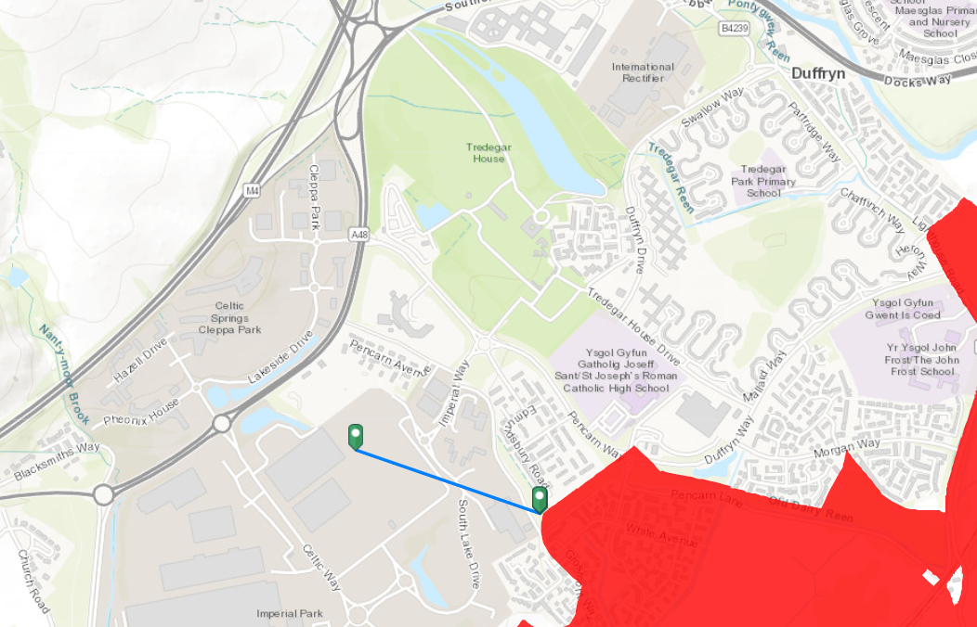
- Has there been any pre-application discussion or correspondence with NRW conservation/ecology | Not for this variation. The original permitting of the site was subject to Appendix 4 consultation dated 15/08/2019 and response by Nick Hudson
- What aspect(s) of the proposed permission may damage the features which are of special interest for the SSSI?
The following ‘Operations Requiring Consent’ (or other activities associated with the permission) that may cause damage) are relevant to the proposed permission.

7 Dumping, spreading or discharging of any waste materials – i.e., the emission to air of relevant pollutants NOX and SO2 from combustion in the engines and for which there is an environmental standard (ES) for ecological receptors. No other impact pathways are considered relevant – direct impacts (such as from construction) are irrelevant >500m from the site) and emission to water is not relevant as the only consented discharge is of uncontaminated surface water. Containment measures are in place to effectively prevent accidental releases and are unchanged in nature from the original permit consent.

The following SSSI features and mechanisms of impact have been considered to assess the likelihood of damage:

All relevant protected features of the SSSI are protected by the assessment against relevant critical levels and loads for aerial pollutants – in this case emitted NOX and SOX critical levels, and critical load screening for nutrient nitrogen (from emitted NOX) and acidification (from both NOX and SO2 emitted).

- Decision

Assessment:
The applicant undertook detailed dispersion modelling to quantify the impact of engine emissions on receptors using precautionary assumptions. Modelling has been audited in detail by NRW. Of the combustion products identified above as emitted from the engines, only NOX and SO2 have an ecological Environmental Standard (ES) relevant to assessment, along with associated deposition critical loads for nutrient nitrogen and acidification. The main impact of interest is as compared with short-term ES owing to the intermittent nature of emissions, although the contribution to long-term averages is also assessed. .

The St Brides Gwent Levels SSSI is about 550m from the installation at the closest point. For most of the quantitative assessments of impact on ecological sites, the applicant has focused on the most impacted (closest) sites, which are local wildlife sites considerably closer to the installation and/or more directly downwind (Celtic Springs, 120m away and LG Duffryn, 300m away but more downwind). The impact at the SSSI will be correspondingly lower.

NO_{X} as NO₂
The short-term ecological ES for NOX is 75 µg/m³ as a 24-hour average. The long-term ecological ES for NOX is 30 µg/m³ as an annual average. These are the same for all protected ecological sites.

Planned testing
The application states that the ES is not predicted to be breached at any ecological receptor as a result of planned engine testing. NRW check modelling supports the conclusion that the short-term ES for NOX for ecological sites is unlikely to be breached at the St Brides SSSI, taking into account background pollution concentration. The contribution of planned testing to long-term (annual) ES for NOX is considered insignificant at the SSSI (<1% contribution).

Emergency Operation
Quantification of unexpected emergency emissions is not usually required in permit applications, and an appropriate approach is needed for backup engines, which goes beyond what we would normally require. As explained above, emergency operation of all of the engines to provide backup power is a very rare event (1 in 20 year event for 2 hours of emergency operation). Detailed modelling which considers every year of operation for 5 years of meteorological data, has found that the absolute maximum impact on the St Brides Gwent Levels SSSI could be above the short term ES, at 450 µg/m³ as a daily average based on the engines running for 1 hour. However, for this impact to occur, worst case weather (dispersion) characteristics would have to occur for the full 24 hours at the same time as a very rare power supply interruption. Even if it were to occur, it would be with an anticipated frequency of exceedance of much less than 1 day a year

Statistical calculations made by the operator of probability of a breach of the human health NOX standard at closer receptors (<200m) puts the probability of exceedance at considerably less than 1%, based on the number of hours per year when dispersion characteristics mean that the ES would be exceeded. It is considered that the likelihood of exceedance of the ecological ES at the SSSI during infrequent emergency operation is similarly low.

There are no standard permitting criteria for assessing risk from possible, but unlikely emergency events. Given that an air emission level is regarded as insignificant if it is <1% of the ES, it is considered (on a case-specific basis) that a <1% likelihood of exceedance in an emergency is similarly an insignificant risk to the protected site. Permit conditions limit the number of hours of emergency operation, and permit conditions would be reviewed if the likelihood of emergency operation substantially changed.

The contribution of emergency operation of a few hours a year to long-term ES for NOX is considered insignificant at the Severn Estuary (<1% contribution).

SO₂
There is no short-term ecological ES for SO2. The lowest long-term ecological ES for SO2 is 10 µg/m³ as an annual average. Given the use of low-sulphur (<0.1%) and the low operational hours of the engines (both planned and emergency operation), the impact of both can be considered insignificant (<1% of ES) at the SSSI.

Deposition – Nutrient Nitrogen and Acid
As noted above, the annual average contribution of NOX and SOX from the proposed engines (emergency and testing) are themselves insignificant, so the resultant contribution to deposition critical loads will also be low.

Although site-specific critical loads for the SSSI have not been confirmed, the applicant has provided screening calculations for nutrient nitrogen and acid deposition based on the most sensitive receptors available for any habitat.

For nitrogen deposition, considering the expected hours of engine operation, and for the most impacted ecological receptor which is closer to the site than the SSSI, the maximum impact is insignificant, 0.2% of the screening critical load (3kg/ha/yr). The impact at the SSSI will be somewhat lower and is insignificant.

The contribution of NOX and SOX from the proposed engines on acid deposition at the most impacted ecological receptor calculated as 0.001 Kgeq/ha/yr. Although site-specific acid critical load has not been confirmed, the impact at the SSSI will be lower and is insignificant (<1%) when compared against any potentially relevant acid critical load.

Conclusion:
ii) The permission is not likely to damage any of the flora, fauna or geological or physiological features

Engine performance specification limits the emission concentration of key pollutants to the levels modelled.
Permit conditions limit the testing and emergency operation hours, and ensure that review will take place if emergency operation frequency / likelihood / duration changes significantly. These are part of the general permitting approach to the facility (primarily for protection of human health) and are not specifically “conditions” to control impact on the SSSI, but will nevertheless be protective of it.

Natural Resources Wales is minded to: Issue the permission.
- Name and job title of Natural Resources Wales officer: | Dr David Poole, Senior Specialist Permitting Officer, Installations & RSR
- Date form sent to NRW conservation/ecology | 24/08/22
For Natural Resources Wales use only, once NRW conservation/ecology response received
- NRW conservation/ecology comment on assessment: | i) NRW conservation/ecology advise the operation can go ahead
- Name and job title of NRW conservation/ecology officer: | Emma Sharp, Officer 2 (Conservation), Newport, Caerphilly and Blaenau Gwent Environment Team
- Date of receipt of NRW conservation/ecology response: | 22/09/2022

