Site boundary
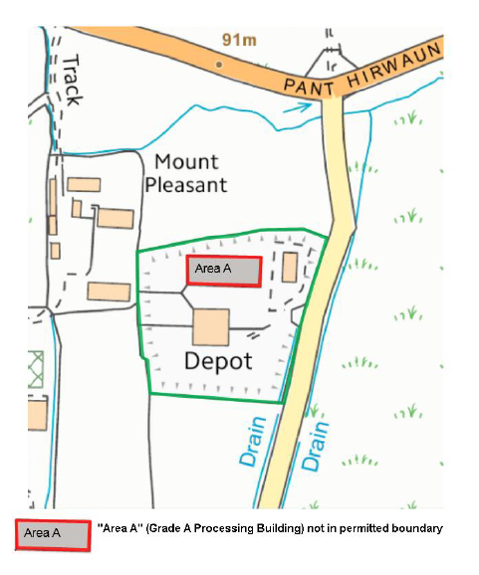

Proximity to human occupation
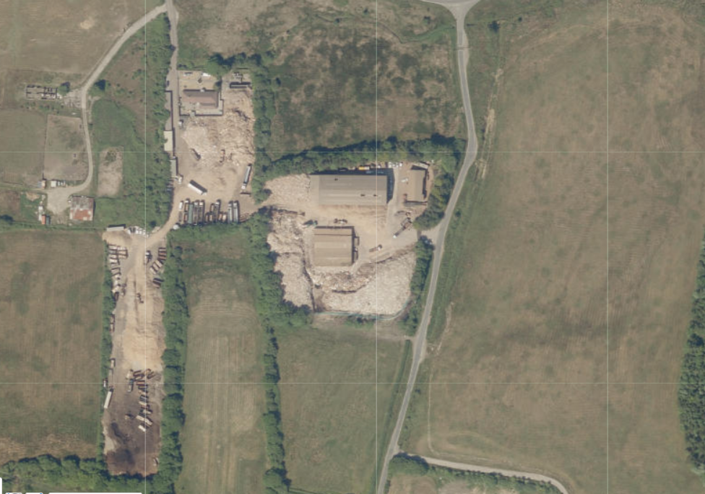

SSSI within 2km of the site- Blackmill Woodlands
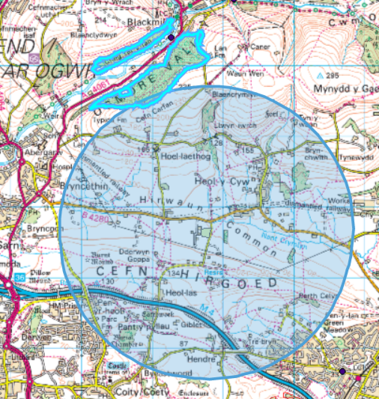

There are no Sac, SPA or Ramsar within 1km of the site

Aquifer Designation (Superficial)
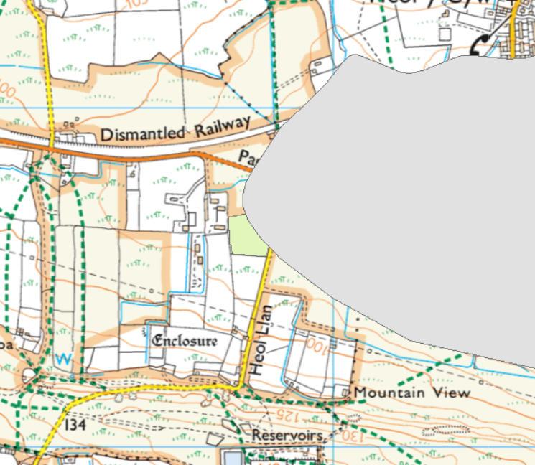
- no SPZ

Aquifer Designation (Bedrock)
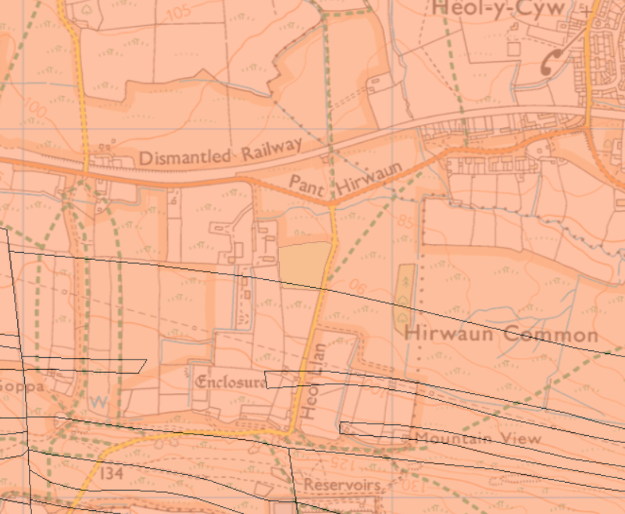
- no SPZ

Sensitivty of surface water
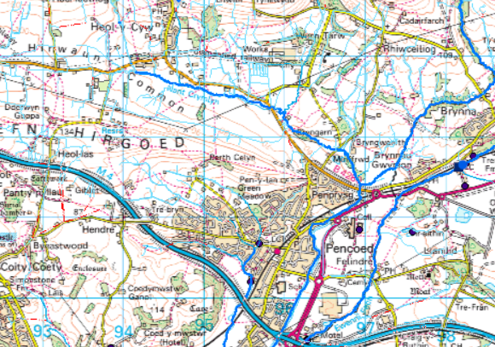
- no classified stretch within 1km of the site

Flood risk


