CRoW Appendix 4 (140_10_SD02)  CRoW Act 2000: Natural Resources Wales application for permission - Formal Notice |  | 
Natural Resources Wales Formal Notice.
Requirements of Section 28I of the Wildlife & Countryside Act 1981 as amended by the Countryside and Rights of Way Act (CRoW) 2000.
Duty in relation to granting any consent, licence or permit for activities likely to damage Sites of Special Scientific Interest (SSSI).
Guide to filling in this form for Natural Resources Wales staff:
To be completed by Permitting Officers for any applications for a permission which the Natural Resources Wales has considered under S28G duties to protect and enhance SSSIs. This applies to all proposed permissions within a SSSI, and to operations outside the SSSI boundary which are likely to damage its special features.
Refer to OI 140_10 ‘Applying the Countryside and Rights of Way (CRoW) Act 2000 to applications for permits with potential for impact on Sites of Special Scientific Interest (SSSI)’, including the flowchart in Appendix 2.
Pink italic text – drafting notes, to be deleted before completion/consultation.
Blue text – examples, to be replaced with permission-specific information.
Ensure you have completed all sections.
- Natural Resources Wales area/region/NPS hub: | Permitting Service (Cardiff)
- Name of SSSI: | Afon Tywi SSSI  Cors Goch Llanllwch SSSI  Maesyprior SSSI (Geomorphological)
- Type of permission: | Bespoke Permit for a Waste Operation – A11 Household, Commercial and Industrial with treatment.
- Date for Natural Resources Wales permit determination: | 14/10/2022
- Predicted 28 day date for response from NRW conservation/ecology (under S28 I(4)): | N/A – Saved for information purposes only
- Natural Resources Wales reference no: | PAN 016183
- National grid reference: | The NGR for the proposed site is: SN 39042 18892
- Description of proposal: | The proposal is for a bespoke permit for a waste operation. The proposal is for a A11 Household, Commercial, and Industrial Waste Transfer Station with Treatment. Treatment operations are limited to manual sorting, separation, bulking, and baling of permitted wastes. Treatment is for the purpose of recovery and/or disposal. Permitted waste types are limited to tyres and agricultural plastics.  The intention of the site is to accept mainly waste tyres (and some agricultural plastics) each waste stream will be separately stored on site and then baled using a mechanical baler. The baled tyres and/or plastics will then be stored on-site (in separate stockpiles) before being exported form site for recovery or disposal elsewhere.  No other waste treatment activities or waste codes are permitted.  There are no direct discharges from the site to air, land or water. The site has a hardstanding surface.
- Is the proposed activity within (wholly or partially) the SSSI boundary? | No  The proposed waste operation is located at T D Tyre Recycling, Plot 7 (rear of Gordon’s Garage), Cillefwr Road West, Carmarthen, SA31 3RB  The following protected sites locations are shown on the figure below:  Afon Tywi SSSI (approx. – 1.3km SE of the site)  Corse Goch Llanllwch SSSI (approx. – 1.83 NW of the site)  Maesy Prior SSSI (approx. – 1.83 W of the site)  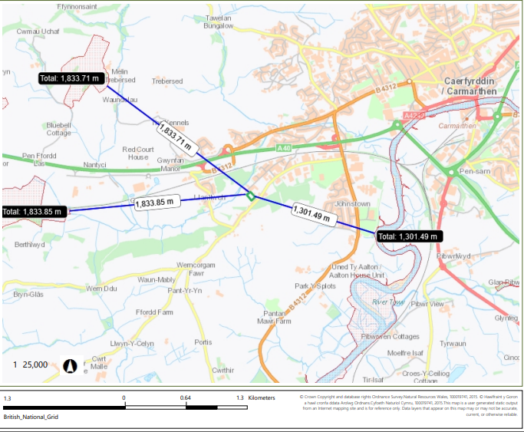
- Has there been any pre-application discussion or correspondence with NRW conservation/ecology | No
- What aspect(s) of the proposed permission may damage the features which are of special interest for the SSSI?
The following ‘Operations Requiring Consent’ (or other activities associated with the permission) that may cause damage) are relevant to the proposed permission.

Afon Tywi SSSI, Cors Goch Llanllwch SSSI, and Maesyprior SSSI

- 7. Dumping, spreading or discharging of any materials.
- 22. Storage of materials

The following SSSI features and mechanisms of impact have been considered to assess the likelihood of damage:

Cors Goch Llanllwch SSSI

- Protected habitats (eg. Raised bogs) and their supported invertebrate biology affected by suspended solids, and nutrients, and contaminants in run-off water from the proposed site.

- Protected habitats (eg. Raised bogs) and their supported invertebrate biology affected by deposition of fugitive dust emissions from the proposed site.

Afon Tywi SSSI

- Protected habitats and their supported flora and fauna affected by suspended solids, and nutrients and contaminants in run-off water from the proposed site.

- Protected habitats and their supported flora and fauna affected by deposition of fugitive dust emissions from the proposed site.

Maesyprior SSSI

- The features of SSSI are geomorphological and as the activities undertaken at the proposed site will not be undertaken within the SSSI there can be no impact pathway. (eg. they aren’t storing waste on landforms, or discharging directly into the SSSI).

- Decision
The proposed permission is not likely to damage any of the flora, fauna or geological or physiological features which are of special interest.

The proposed permission is not likely to damage the SSSI features via contamination surface waters as there are no point source emissions associated with this permission site.

The site is located over 1km away from Afon Tywi, Cors Goch Llanllwch and Maesy Prior SSSIs. Due to the proposed sites location in regards to the Corse Goch Llanllwch SSSI and Maesyprior SSSi surface water run-off could not impact the protected sites as the local water network flows away from them.

The site is located 100m from a small stream which flows towards the Afon Tywi via the Tawelan brook. Although there is a pathway for any contaminated run-off that reaches the small water course 100m north of the site to reach the Afon Tywi SSSI this is unlikely to occur due to:

- Normal activities should not pose a risk as there is no direct discharges.
- Any surface water run-off would have to cross a road and another industrial unit prior to reaching the small watercourse.
- Although the site surface is not impermeable the site is also only permitted to take a specific list of waste codes which are considered non-hazardous by our WM3 Waste Classification Technical Guidance and therefore the waste does not have any hazardous properties.
- The sites Environmental Management System also confirms that no fuel is stored on site.
- The sites Fire Prevention Mitigation Plan also outlines how they will control contaminated Firefighting Water should a fire occur on site these controls are inline with our GN16 Fire Prevention and Mitigation Plan Guidance – Waste Management. The site will contain any firewater run-off on site using the permitter bund, sandbags and a boom across the site entrance. The water will then be removed from site via a relevant waste contractor as soon as possible and will not be left standing on the site for a long time.

The proposed permission is not likely to damage any of the SSSI features via emissions to air as there is no source of air emissions. The site does not have any direct emissions to air and the waste types (tyres and agricultural plastics) and treatments (eg. sorting, bulking, and bailing) will not generate dust emissions or other fugitive releases.

Natural Resources Wales is minded to:
Issue the permission

- Name and job title of Natural Resources Wales officer: | Matthew Fryer  Permitting Officer
- Date form sent to NRW conservation/ecology | N/A – App 4 for Information Only.

