CRoW Appendix 4 (140_10_SD02)  CRoW Act 2000: Natural Resources Wales application for permission - Formal Notice |  | 
Natural Resources Wales Formal Notice.
Requirements of Section 28I of the Wildlife & Countryside Act 1981 as amended by the Countryside and Rights of Way Act (CRoW) 2000.
Duty in relation to granting any consent, licence or permit for activities likely to damage Sites of Special Scientific Interest (SSSI).
Guide to filling in this form for Natural Resources Wales staff:
To be completed by Permitting Officers for any applications for a permission which the Natural Resources Wales has considered under S28G duties to protect and enhance SSSIs. This applies to all proposed permissions within a SSSI, and to operations outside the SSSI boundary which are likely to damage its special features.
Refer to OI 140_10 ‘Applying the Countryside and Rights of Way (CRoW) Act 2000 to applications for permits with potential for impact on Sites of Special Scientific Interest (SSSI)’, including the flowchart in Appendix 2.
Pink italic text – drafting notes, to be deleted before completion/consultation.
Blue text – examples, to be replaced with permission-specific information.
Ensure you have completed all sections.
- Natural Resources Wales area/region/NPS hub: | North
- Name of SSSI: | Gatewen March
- Type of permission: | Landspreading deployment under SR2010 No4
- Date for Natural Resources Wales permit determination: | 12/09/2022. This will change following the sending of the RFI.
- Predicted 28 day date for response from NRW conservation/ecology (under S28 I(4)):
- Natural Resources Wales reference no: | PAN-018879
- National grid reference: | Fields:  1 5503 SJ 31548 52029  2 0750 SJ 32078 51510  3 0634 SJ 32060 51352  4 1622 SJ 32160 51226  5 9715 SJ 31991 51140  6 HJLO05 SJ 36041 50700  7 HJLO06 SJ 36250 50740  Storage:  1 SJ 35592 50715  2 SJ 31618 51967  3 SJ 32025 51455
- Description of proposal: | A landspreading application to spread 1974 tonnes of water clarification sludge (19 09 02) across 28.2ha of land at Pendine Farm, Summerhill Road, Stansty, Wrexham, LL11 4YE. Spreading will occur immediately prior to cultivation and planting at a rate of 70 tonnes/ha by a rear much spreader. Wastes will be stored in 3 field heaps prior to spreading.
- Is the proposed activity within (wholly or partially) the SSSI boundary? | NO  The SSSI is immediately adjacent to fields 9715 and 0634, parallel to field 0750 and approximately 200m from field 5503.  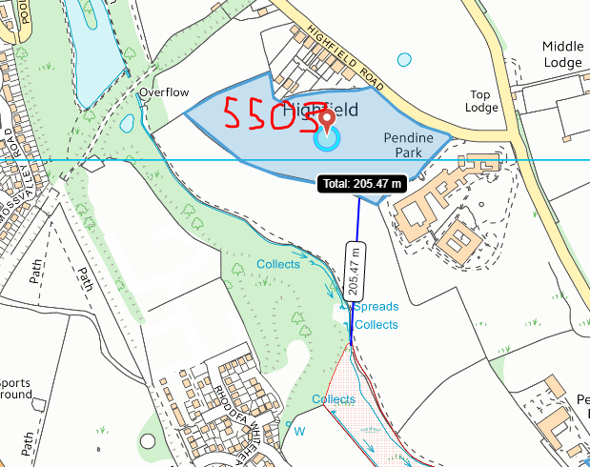  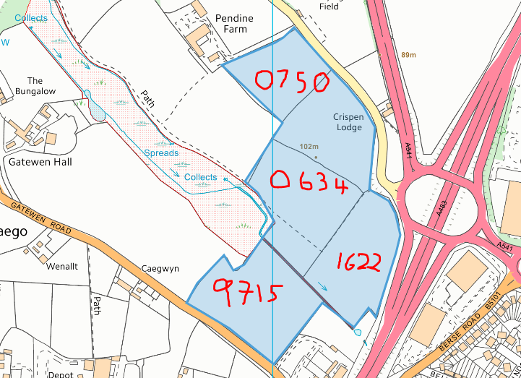
- Has there been any pre-application discussion or correspondence with NRW conservation/ecology | NO
- What aspect(s) of the proposed permission may damage the features which are of special interest for the SSSI?
The following ‘Operations Requiring Consent’ (or other activities associated with the permission) that may cause damage) are relevant to the proposed permission.

- Cultivation, including ploughing, rotovating, harrowing and re-seeding
5. Application of manure, fertilisers and lime
7. Dumping, spreading or discharging of any waste materials
26. Use of vehicles likely to damage marsh vegetation

The following SSSI features and mechanisms of impact have been considered to assess the likelihood of damage:
Marshland species: “The marsh is unusual in containing substantial stands of Great Reedmace Typha latifolia in
shallow water with Brooklime Veronica beccabunga, Water Plantain Alisma plantago-aguatica and Bottle Sedge Carex strata. The fringes of these areas support stands of Common Spike-rush Eleocharis palustris with Water Mint Mentha aguatica, Gipsy-wort Lycopus europaeus, Narrow-leaved Water-parsnip Berula erecta and Lesser Spearwort Ranunculus flammula. Further north are stands of Great Pond-sedge Carex riparia and Burreed Sparganium erectum with Reed-grass Phalaris arundinacea on the fringes and Broad-leaved Pondweed Potamogeton natans in open channels. Willows Salix spp. are establishing in part of the site and the area adjacent to the colliery spoil banks is dominated by Great Hairy Willow-herb Epilobium hirsutum suggesting past disturbance.”.

Mechanisms/pathways for impact:
- Run-off via the sandy soils
- Leeching into the SSSI itself or via water courses between the SSSI and the fields
- Dust entering the SSSI from the waste where it is stored or spread
- Decision
i) The proposed permission is not likely to damage any of the flora, fauna or geological or physiological features which are of special interest.

Field 0750 is approximately 144m away running directly parallel to the site, and not considered a risk to the SSSI as the majority of the field is flat, with the one area of 7-12 degree slope on an angle facing away from the site.

Field 5503 is of no concern due to gradient and proximity to site.

Field 0634 has been removed from the application as of 18/10/2022 and will not be spread on.

Field 9715 has buffer zones of 30m alongside the edges closest to the water courses.

Natural Resources Wales is minded to:
Issue the permission

- Name and job title of Natural Resources Wales officer: | Rhiannon Smith  Permitting Officer
- Date form sent to NRW conservation/ecology | N/A
For Natural Resources Wales use only, once NRW conservation/ecology response received
- NRW conservation/ecology comment on assessment: | Please delete as appropriate:  i) NRW conservation/ecology advise the operation can go ahead  ii) NRW conservation/ecology advise the operation can go ahead with conditions  iii) NRW conservation/ecology advise against permitting the operation  Please ensure that the NRW conservation/ecology response is attached to this Formal Notice.
- Name and job title of NRW conservation/ecology officer:
- Date of receipt of NRW conservation/ecology response:

