Permit
The Environmental Permitting (England & Wales) Regulations 2016

Towy Metals Limited

The Smithy
Aberarth
Aberaeron
SA46 0LD

Permit number

EPR/CB3698ZW

Permit
The Environmental Permitting (England and Wales) Regulations 2016
Permit number

EPR/CB3698ZW

The Natural Resources Body for Wales (“Natural Resources Wales”) authorises, under regulation 13 of the Environmental Permitting (England and Wales) Regulations 2016

Towy Metals Limited (“the operator”),

whose registered office is

Towy Metals Towy Terrace

Ffairfach

Llandeilo

SA19 6ST

company registration number 10837322

to operate waste operations at

The Smithy

Aberarth

Aberaeron

SA46 0LD

to the extent authorised by and subject to the conditions of this permit.

Under regulation 27(2) of the Regulations, standard rules SR2012 No14 are conditions of this permit.

Name | Date
Huw Davies | 21/10/2022

Authorised on behalf of Natural Resources Wales

Schedule 1 - Site plan

This is the plan referred to in the standard rules SR2012 No14

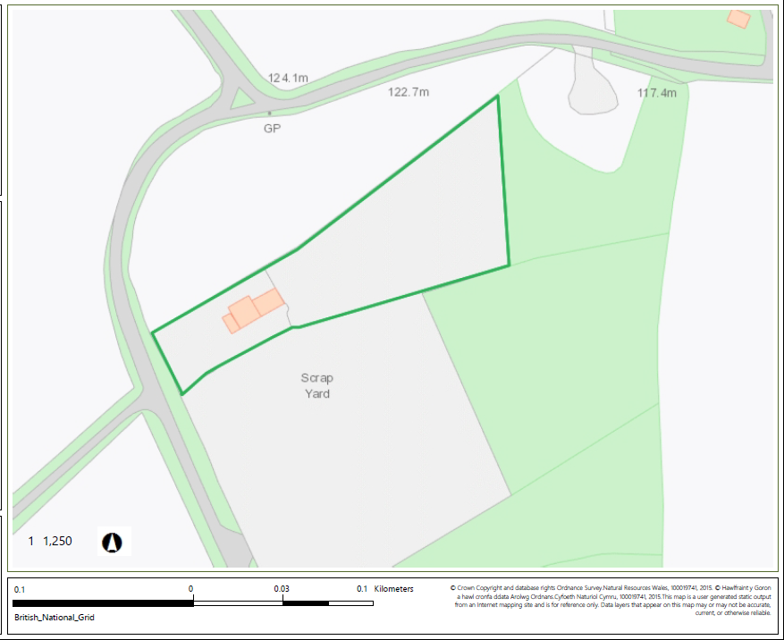

© Crown Copyright and database copyright 2022. Ordnance Survey licence number 100019741.

END OF PERMIT

