CRoW Appendix 4 (140_10_SD02)  CRoW Act 2000: Natural Resources Wales application for permission - Formal Notice |  | 
Natural Resources Wales Formal Notice.
Requirements of Section 28I of the Wildlife & Countryside Act 1981 as amended by the Countryside and Rights of Way Act (CRoW) 2000.
Duty in relation to granting any consent, licence or permit for activities likely to damage Sites of Special Scientific Interest (SSSI).
- Natural Resources Wales area/region/NPS hub: | NE Wales
- Name of SSSI: | Stryt Las a'r Hafod SSSI
- Type of permission: | Tier 3 bespoke permit for a hazardous and non-hazardous waste physical treatment facility
- Date for Natural Resources Wales permit determination: | 05/02/2023 at time of duly making- liable to change
- Predicted 28 day date for response from NRW conservation/ecology (under S28 I(4)): | n/a saved for information only
- Natural Resources Wales reference no: | PAN-018118
- National grid reference: | SJ 30505 45326
- Description of proposal: | Application for an A16a Hazardous Waste Physical Treatment Facility. The site will allow for the acceptance, storage and treatment of predominantly plastic for recovery.  Waste treatment processes to be carried out on site may include the following: Manual sorting, separation, screening, baling, pelletising, flaking, dehydrating, washing, shredding, granulating, crushing or compaction of waste into different components for disposal, or recovery (by mechanical means)  The majority of inputs will consist of High Density Poly Ethylene (HDPE) plastic in baled form and also as IBC containers and other bulk containers.  UNIT 9: - Comprises a building measuring approximately 1,700m2, approximately 45m2 of this is dedicated for offices, staff training and welfare. The remaining part of the building is made up of the plastics wash plant, wood pelleting plant and Biomass Boiler. There are five roller shutter access points to the east of the building for deliveries/removals of waste material.  The external areas of the site will be used for storing material prior to loading into the items of plant internally and product storage which will be in the 6 no. shipping containers to the north of the site near the site access. Although the plastic wash plant can shred the waste as part of the line, an external shredder may be used on occasions to treat waste prior to being fed; this would be done to reduce any backlogs in the event of a breakdown.
UNIT 10: - Comprises a building measuring approximately 570m2, which will be used for storage of recycled plastic flake and wooden pellets (non-waste).
The external area of the site will be used for acceptance and storage of plastic waste including a designated area for manual washing of containers to remove them of any hazardous substances.

SSSI covers 69.4 ha of land. SSSI is split into 4 areas. Proposed permitted site is within relevant distance of all parts but is closest to the South East section:
- Approximately 20 metres between unit 9 boundary of the site and the SE SSSI.
- Approximately 95 metres between unit 10 boundary of the site and the SE SSSI.
- Approximately 290 metres between unit 10 boundary of the site and the SW SSSI.
- Approximately 570 metres between unit 10 boundary of the site and the NW SSSI.
- Approximately 630 metres between unit 10 boundary of the site and the NE SSSI.

The proposed permitted site is 20 meters from the SSSI at its closest point, however the Ruabon-Barmouth railway line separates the site from the SSSI, and no waste is stored at the eastern site boundary and the building in Unit 9 forms a barrier.

Hazardous waste will only be stored and treated (via washing) in unit 10.

Management of sources of harm
Dust / particulates
- All main operations with the potential to create dust take place inside an industrial building.
- Although external shredding may take place on occasions, the waste being shredded will not create dust.
- All areas with store and treat waste benefit from an impermeable concrete surface with sealed drainage system.
- Reference should be made to Section 2.6 of the operator’s FPMP in relation to preventative maintenance check to reduce the likelihood of fixed or mobile plant failure.
- All fixed and mobile plant will be checked at least twice daily for the presence of dust/fluff and cleaned as necessary.
- Reference should be made to Section 4.5 of the EMS (Doc Ref. VIE- 2704-A in terms of dust control but in addition, the site will implement the following measures to reduce the impact of dust:
  - Keep drop heights to minimum.
  - Cleaning of any spillages using wet cleaning i.e. hoses and having a continuous water supply on site.
  - Ensure any potential dust outlets from processing plants are covered and all conveyors/drop points are enclosed
  - Use the complaint’s procedure from the EMS (Section 4.10) to ensure any dust complaints are addressed and substantiated.

Odour
- Strict waste acceptance procedures into both areas of the site to identify potentially odorous wastes and their containment.
- The site does not receive any waste types which would be regarded as having significant odour potential.
- Any rejected wastes found on site to be removed off site as soon as practicable.
- Reference should be made to Section 2.6 of the operator’s Fire Prevention & Mitigation Plan [FPMP (Doc. Ref. VIE-2704-B)] in relation to preventative maintenance checks to reduce the likelihood of fixed or mobile plant failure.
- Reference should be made to Section 4.6 of EMS with regards to odour control.
- Use the complaint’s procedure from the EMS (Section 4.10) to ensure any odour complaints are addressed and substantiated.
- Low residence times for all wastes.
Litter
- Reference should be made to section 4.7 of the EMS regarding litter control.
- No light wastes generally accepted at the site as any light waste accepted will be in baled form.
- All waste storage will take place in secure concrete bays below the height of the bay by at least 1m.
- Use the complaint’s procedure from the EMS (Section 4.10) to ensure any odour complaints are addressed and substantiated.

Noise/ vibration
- Reference should be made to Section 2.6 of the operator’s Noise & Vibration Management Plan [NVMP (Doc. Ref. VIE-2704-I)] in relation to preventative maintenance checks to reduce the likelihood of fixed or mobile plant failure.
- The only noisy activity taking place externally will be the shredding of plastic, but this will not be continuous and only to prevent a backlog of waste on site. All other mechanical treatment of waste and potentially noisy activities will take place inside the existing industrial building.
- The noise will not cause issue to the SSSI / SAC due to the type of species.
- Busy railway line to the east of the site will create a high background noise level
- Sensitive Receptors are located >300m from the site with large industrial properties between them.
- Use the complaint’s procedure from the EMS (Section 4.10) to ensure any noise complaints are addressed and substantiated.

Pests
- Site inspections daily
- Rejected waste procedures (Section 2.8 of EMS)
- Strict waste acceptance procedures (Sections 3.1 & 3.2 of EMS)
- Refer to Section 3.7.5 of in terms of daily inspections EMS
- Reference should be made to Section 4.8 of EMS with regards to pest control, however, the site does not receive any waste types which would be regarded as putrescible/ biodegradable and attract such pests.
- Pest controller called in the event of pests being present at the site or complaints received from receptors

Fire/ smoke / particulates
- Reference should be made to the operator’s FPMP which references all potential fire risks from the site including mitigation to reduce the impact pollution to human health and the environment.
- Reference should be made to Section 2.6 of the FPMP in relation to preventative maintenance checks to reduce the likelihood of fixed or mobile plant failure which is considered to be source of most fires from waste sites.

Leachate
- Waste storage/treatment is undertaken on an impermeable concrete surface with sealed drainage and refer to Section 3.7.5 of the EMS in terms of daily inspections.
- Section 6.5 of the EMS details staff training procedures in recognition of accepted waste types.
- Regular (minimum daily) checks of site surface infrastructure (as above).
- Any spillages identified will be dealt with in accordance with the spillage procedures outlined in section 4.1 of the EMS.
- Dedicated mobile quarantine area for intercepted leachable wastes found during initial inspections ensuring isolation and quick removal off site; see Section 2.8 of EMS.
- Any wastes which are liable to give rise to contamination will be removed from site or placed into the quarantine skip/area (see Section 2.8 of EMS).
- No fuel storage at the site.
Hydrocarbons including release of gases/fumes/ vapours/ volatiles
- No fuel storage at the site.
- All plant manoeuvring takes place on an impermeable concrete surface with sealed drainage and refer to Section 3.7.5 of the EMS in terms of daily inspections.
- Where plant is operated; drip trays will be available to ensure that fuels are contained.
- Spill kits kept close to source(s) of hazards as shown on Drawing No. VIE/2704/03.
- Reference should be made to Section 2.6 of the FPMP in relation to preventative maintenance checks to reduce the likelihood of fixed or mobile plant failure which is considered to be source of most fires from waste sites.
- Any spillages identified will be dealt with in accordance with the spillage procedures outlined in section 4.1 of the EMS.
- Dedicated mobile quarantine skip for intercepted l wastes found during initial inspections ensuring isolation and quick removal off site. The skip may be positioned in various positions of the site depending how operations permit (see Section 2.8 of EMS).
- Ensure all waste storage areas are stored as per the waste storage table and locations shown on Drawing No. VIE/2704/03 to reduce the risk reactions of stored waste, fire and collisions between plant causing release of fumes.
- No gas is stored at the site.
- Is the proposed activity within (wholly or partially) the SSSI boundary? | No
- Has there been any pre-application discussion or correspondence with NRW conservation/ecology | No
- What aspect(s) of the proposed permission may damage the features which are of special interest for the SSSI?
The following ‘Operations Requiring Consent’ (or other activities associated with the permission) that may cause damage) are relevant to the proposed permission.
7. Dumping, spreading or discharging of any materials and 22. Storage of materials, although neither of these activities are occurring on or next to the SSSI.

The following SSSI features have been considered to assess the likelihood of damage:
- A population of great crested newt
- An assemblage of the five widespread amphibian species namely common frog, common
toad, palmate newt, common newt and great crested newt
- Secondary broadleaved woodland, grassland, and scrub together with linear or point structures such as hedgerows, streams, ponds, or individual trees.

The following mechanisms of impact have been considered to assess the likelihood of damage:
- Deposition of waste via air emission
- Damage to water habitats via site drainage
- Decision
The proposed permission is not likely to damage any of the flora, fauna or geological or physiological features which are of special interest.

The proposed site is on an existing industrial estate, there is limited to no pathway for features to be affected as the due to the lack of linked habitats, distance to the breading ponds, and the operational measures undertaken on site.

Natural Resources Wales is minded to issue the permission
- Name and job title of Natural Resources Wales officer: | Louise Bailey  Permitting Officer
- Date form sent to NRW conservation/ecology | n/a saved for information only

Site Plan
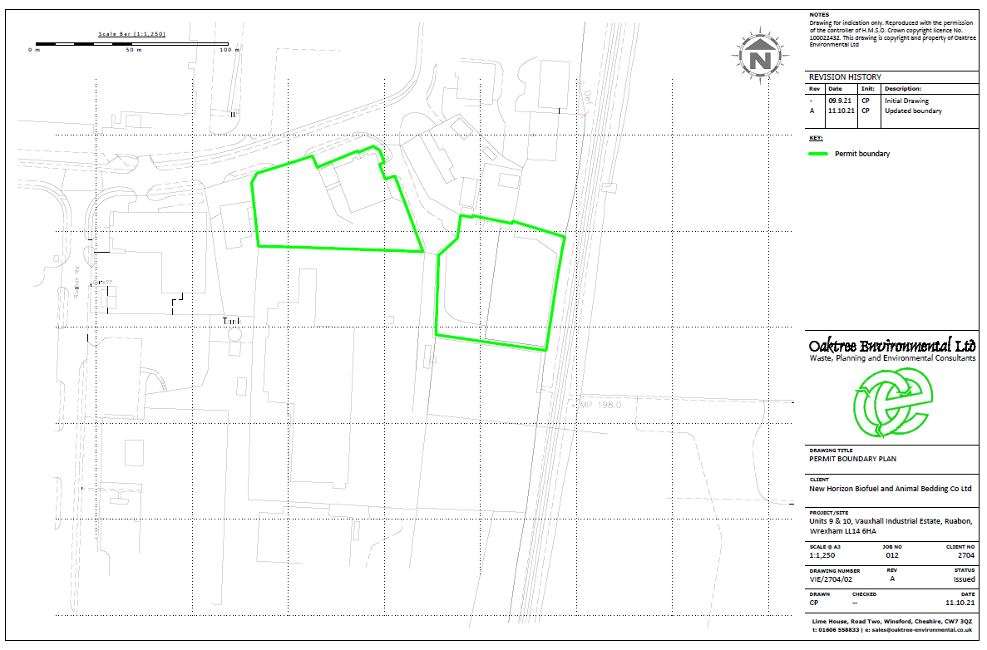

Site location (MyMap)
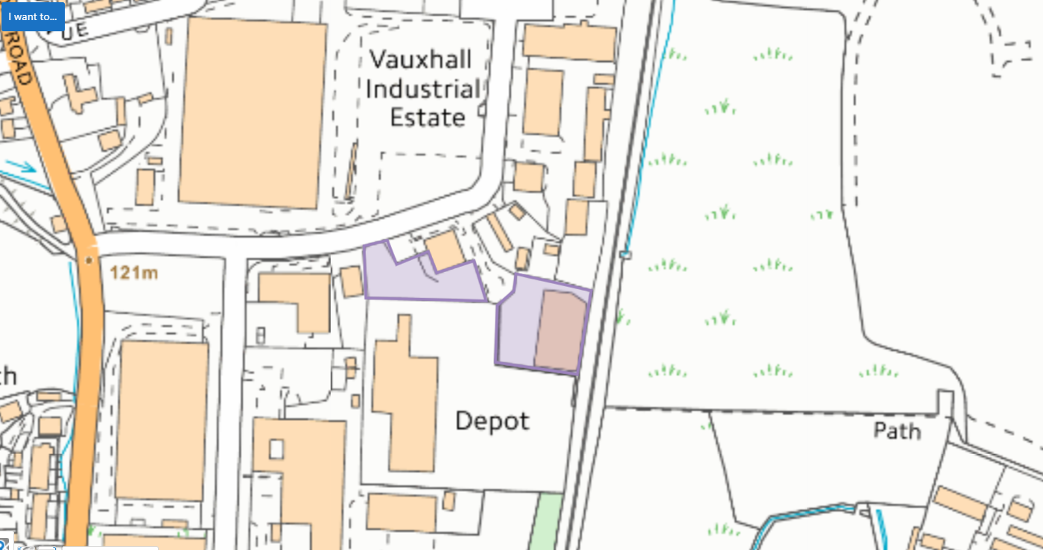

Site location (aerial)
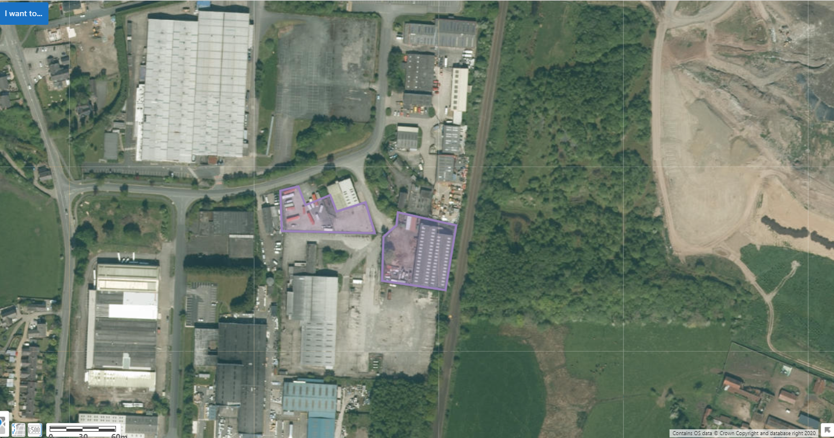

Full extent of SSSI:
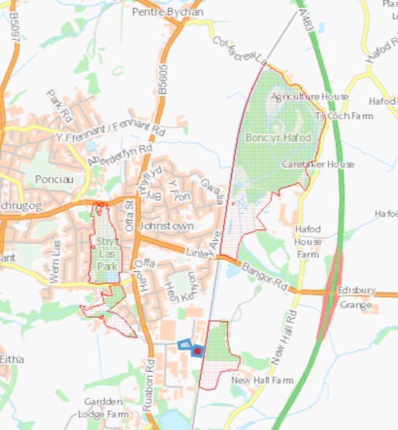

Stryt Las a'r Hafod SSSI
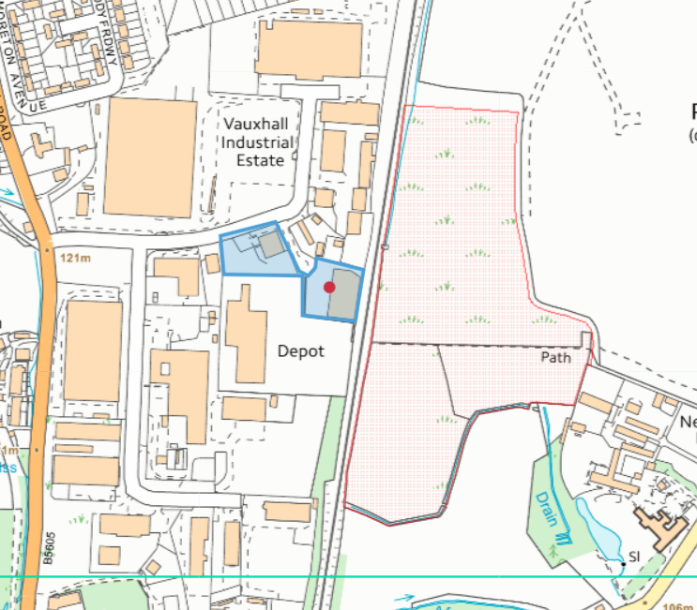

Distance from site; 95 meters from unit 10, and 20 meters from unit 9:
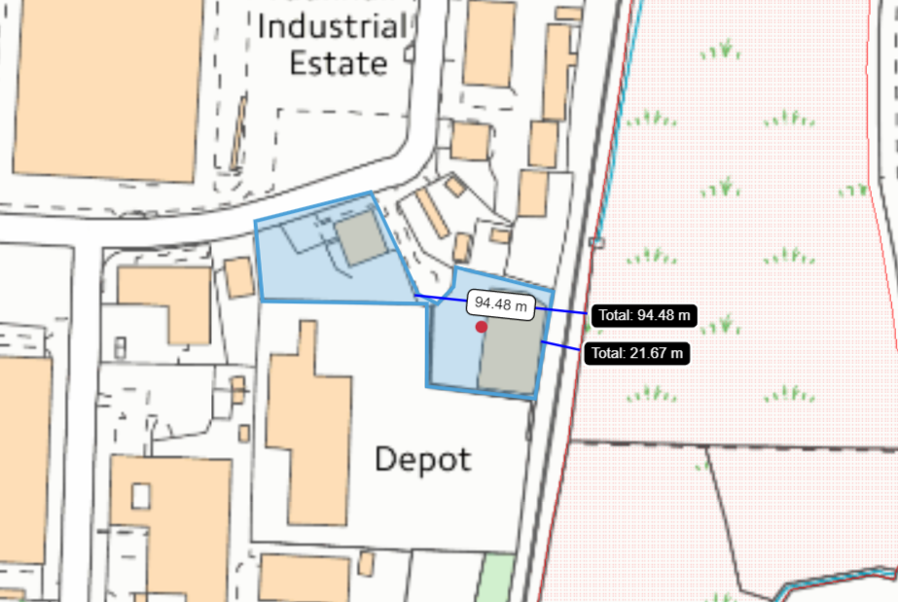

Unit 10 layout
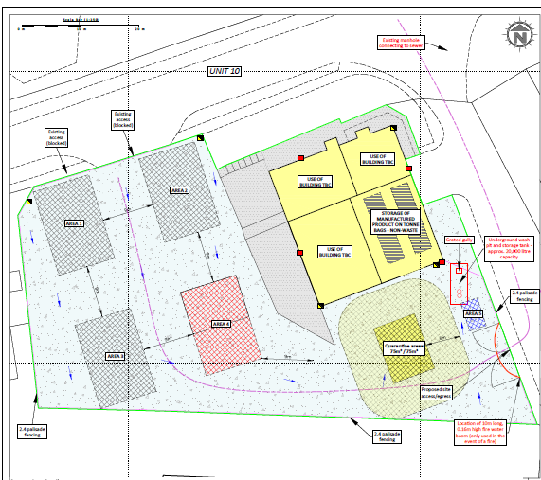

Unit 9 layout


