Permit
The Environmental Permitting (England & Wales) Regulations 2016

Mr Raymond Fleming

Hill Farm
Unit 13
The Hill Farm
Raglan
Monmouthshire
NP15 2JH

Permit number

EPR/CB3699ZZR

Permit
The Environmental Permitting (England and Wales) Regulations 2016
Permit number

EPR/CB3699ZZR

The Natural Resources Body for Wales (“Natural Resources Wales”) authorises, under regulation 13 of the Environmental Permitting (England and Wales) Regulations 2016

Mr Raymond Fleming (“the operator”),

of

23 Mile End Road

Coleford

Gloucestershire

GL16 7QD

to operate waste operations at

Hill Farm

Unit 13

The Hill Farm

Raglan

Monmouthshire

NP15 2JH

to the extent authorised by and subject to the conditions of this permit.

Under regulation 27(2) of the Regulations, standard rules SR2011 No 3 are conditions of this permit.

Name | Date
Huw Davies | 27/10/2022

Authorised on behalf of Natural Resources Wales

Schedule 1 - Site plan

This is the plan referred to in the standard rules SR2011 No3

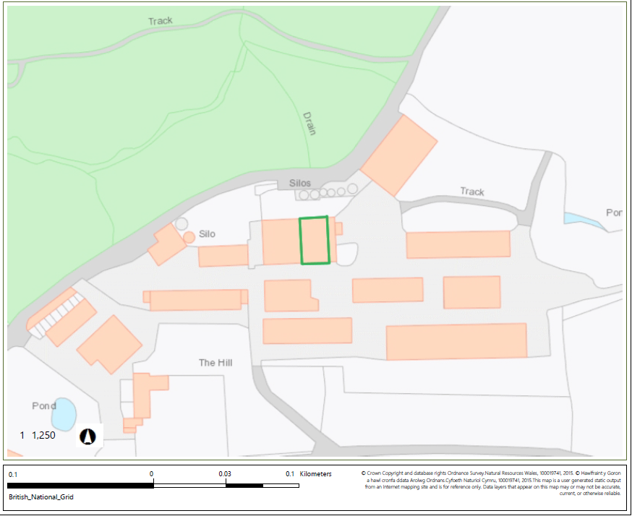

© Crown Copyright and database copyright 2022. Ordnance Survey licence number 100019741.

END OF PERMIT

