Permit
The Environmental Permitting (England & Wales) Regulations 2016

LCS Scrap Metals Limited

LCS Scrap Metals
Begelly
Kilgetty
Pembrokeshire
SA68 0XN

Permit number

EPR/CB3790FG

Permit
The Environmental Permitting (England and Wales) Regulations 2016
Permit number

EPR/CB3790FG

The Natural Resources Body for Wales (“Natural Resources Wales”) authorises, under regulation 13 of the Environmental Permitting (England and Wales) Regulations 2016

LCS Scrap Metals Limited (“the operator”),

whose registered office is

Strawberry Fields

Clayford Road

Cilgeti

Sir Benfro

SA68 0RR

company registration number 13080941

to operate waste operations at

LCS Scrap Metals

Begelly

Kilgetty

Pembrokeshire

SA68 0XN

to the extent authorised by and subject to the conditions of this permit.

Under regulation 27(2) of the Regulations, standard rules SR2012 No14 are conditions of this permit.

Name | Date
Huw Davies | 31/10/2022

Authorised on behalf of Natural Resources Wales

Schedule 1 - Site plan

This is the plan referred to in the standard rules SR2012 No14

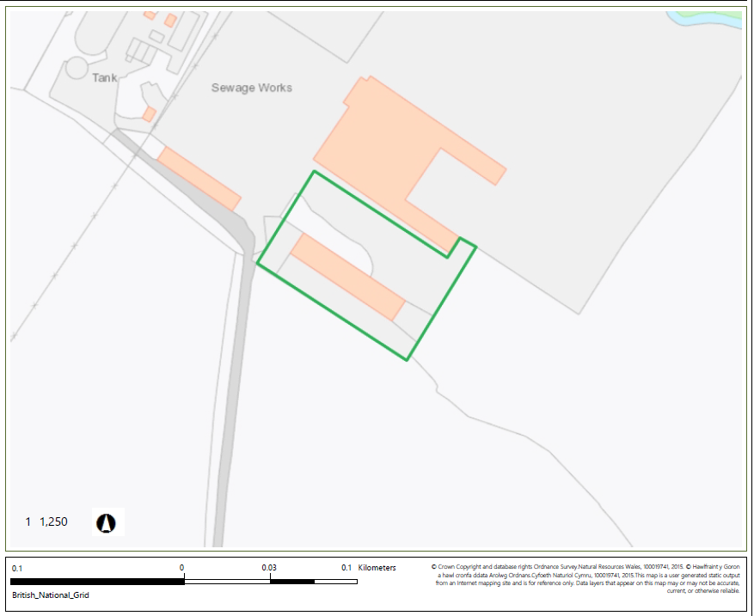

© Crown Copyright and database copyright 2022. Ordnance Survey licence number 100019741.

END OF PERMIT

