Permit
The Environmental Permitting (England & Wales) Regulations 2016

Western Power Distribution South Wales

Llanfihangel-ar-arth,
Pedcader,
Carmarthenshire,
SA39 9HT

Permit number

EPR/ AB3598HR

Permit
The Environmental Permitting (England and Wales) Regulations 2016
Permit number

EPR/AB3598HR

The Natural Resources Body for Wales (“Natural Resources Wales”) authorises, under regulation 13 of the Environmental Permitting (England and Wales) Regulations 2016

Western Power Distribution South Wales (“the operator”),

whose registered office is

Feeder Road

Avonbank

Bristol

BS2 0TB

company registration number 2366985

to operate waste operations at

Llanfihangel-ar-arth,

Pedcader,

Carmarthenshire,

SA39 9HT

to the extent authorised by and subject to the conditions of this permit.

Under regulation 27(2) of the Regulations, standard rules SR2012 No15 are conditions of this permit.

Name | Date
Holly Noble | 25/10/2017

Authorised on behalf of Natural Resources Wales

Schedule 1 - Site plan

This is the plan referred to in the standard rules SR2012 No15

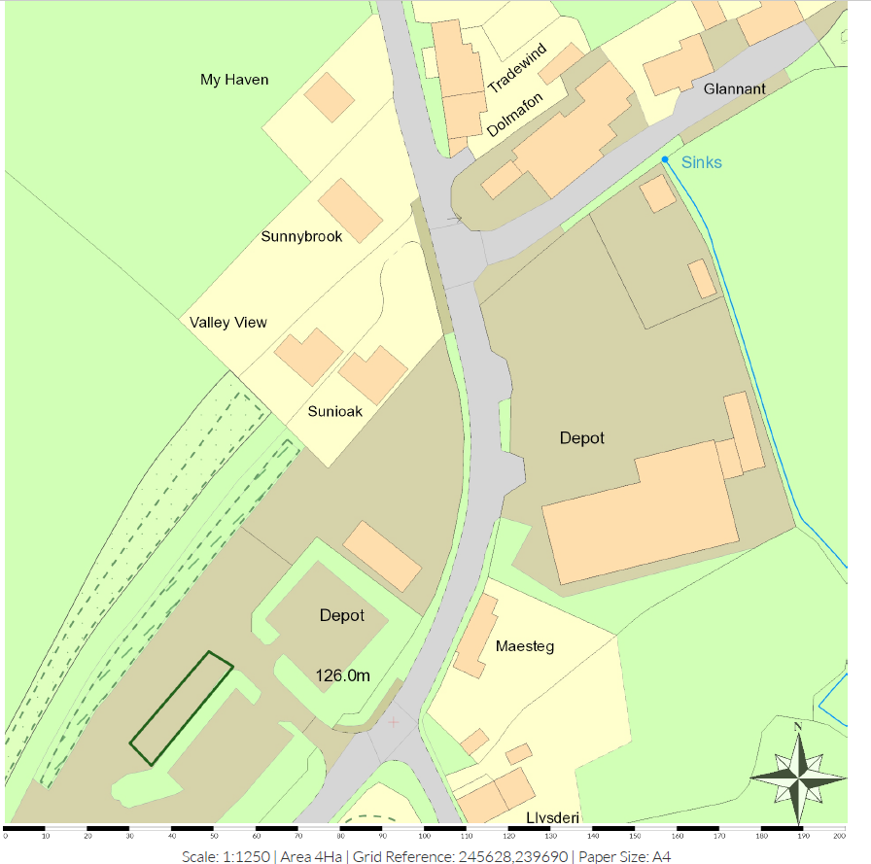

© Crown Copyright and database right [2017]. Ordnance Survey licence number 100019741.

END OF PERMIT

