

Hirael Flood Protection
Environmental Impact Assessment Screening Opinion Report

CPF7720

CPF6445

Document Control Sheet

Document Title: | Environmental Impact Assessment Screening Opinion Report
Document Author(s): | Elin Mirain Roberts
Project Ref / Title: | 7720: Hirael Flood Protection
Project Manager: | Emyr Gareth

Revision History
Date | Version No. | Summary of Changes
19/11/2021 | 0.01 | First version
06/12/2021 | 0.01 | Draft review and approval
10/11/2022 | 0.02 | Update following completion of detailed design. Rock armour included as a design option.

Reviews
Name | Title | Date | Version
Owain Griffith | Principal Engineer | 06/12/2021 | 0.01
Rhys Thomas | Senior Environment Officer | 10/11/2022 | 0.02

Approvals
Name | Title | Date | Version
Owain Griffith | Principal Engineer | 06/12/2021 | 0.01
David Harries | Principal Ecologist | 14/11/22 | 0.02

Distribution
Name | Title | Date | Version
Designated Officer | Planning Department | 07/12/2021 | 0.01

© 2022 - 23 Gwynedd Council / YGC. All Rights Reserved.  Copyright in any or all of this documentation belongs to Gwynedd Council / YGC of Council Offices, Shirehall Street, Caernarfon, Gwynedd, LL55 1SH (the 'Owner') and may not be used, sold, transferred, copied or reproduced in whole or in part, in any manner of form or on any media to any person other than in accordance with the terms of the Owner's agreement or otherwise without the prior written consent of the Owner. | 

Contents

1.0 Introduction . . . . . . . . .

2.0 Development . . . . . . . . .
Figure 1: Location of Development . . . . . .

3.0 Screening of Significant Environmental Effects . . . . .
3.1 Characteristics of the Development . . . . . .
3.2 Location of the Development . . . . . . .
3.3 Types and Characteristics of the Potential Impact . . . .

4.0 Other relevant information . . . . . . .

Appendix A: General Arrangement Drawing

1.0 Introduction
YGC, on behalf of Gwynedd Council, are developing a project to construct a new coastal flood defence through the installation of a new sea wall at Hirael, Bangor.

As the development meets the thresholds of Schedule 2 of the Town and Country Planning (Environmental Impact Assessment) (Wales) Regulations 2017, a screening opinion from the relevant planning authority is required to confirm whether Environmental Impact Assessment is necessary. The screening process determines whether or not the development is likely to have significant effects on the environment, for which an Environmental Impact Assessment would be required.

Regulation 6(2) and (3) of the current EIA legislation requires certain information to be provided by the person seeking planning permission/exercising permitted development rights, taking into account the selection criteria in Schedule 3. In accordance with regulation 5(8), when making a screening decision, the decision-maker must now consider that information, the available results of other environmental assessments as well as the selection criteria in Schedule 3. The aim of this EIA Screening report is therefore to provide supporting information, in accordance with Schedule 3, to assist the relevant planning authority in determining whether there are likely to be significant environmental effects as a result of the development and hence whether Environmental Impact Assessment is required.

2.0 The Development
The proposal area consists of a 550m length foreshore, a narrow beach and a recreational water front open space. Behind the proposal site is Beach Road, which is part of the A5 and one of the main gateways into the city of Bangor. Immediately behind Beach Road is a densely populated area of residential and commercial properties. The area is at risk of flooding from sea and surface water.

Following the initial selection of a preferred option and preparation of outline design, the project has proceeded through detailed design, with a scheme design now in place. The site of proposed works has been split into four key sections. The scheme design is as follows:

Section 1 – section at Beach Road East carpark
Installation of new concrete wall between the existing field and cycle path. Cycle path to be graded and aligned at a constant gradient down from the A5 to the Beach Road East carpark. Reconstruction of slipway to provide access to the foreshore with a flood gate installed at the top of said slipway. The slipway entrance marks the starting point of Section 2.

Section 2 – sea wall at promenade frontage
Construct a retaining wall to replace existing gabions at the promenade, from Beach Road East carpark to Welsh Water pumping station. The new defence will be constructed through a sheet pilling method on the same footprint as the existing wall. The space between the new sheet piled wall and the existing gabions will be backfilled. A coping stone and handrail will be installed on the new wall to provide edge protection. Rock armour will be placed in front of the sheet piled wall along the western extent of the promenade frontage. The rock armour will be placed along a 135m length of the promenade wall, to a height of 2m up the wall, and will extend 4m out into the bay from the sheet pile wall.

Section 3 – embankment behind Welsh Water pumping station
A compacted 1m wide crest topsoil and clay embankment is proposed for construction between the DCWW compound and Beach Road West carpark. A raised cycle path is proposed to be installed directly behind the embankment. The construction of a reinforced concrete wall, clad both sides is also proposed to tie into existing slate pile at Watkin Jones property (which is directly adjacent to Welsh Water pumping station). At the access to the pumping station, a 9m wide floodgate will be placed to provide both flood defence and vehicular access to the compound (flood gate will be placed between embankment and reinforced concrete wall).

Section 4 – Glandŵr Road
An approximate 20m section of road at Glandwr Road is scheduled to be raised slightly (highest point of increase is 0.5m). The construction of a new reinforced concrete wall is scheduled for two sections at this location. The first at the foreshore in front of Gwymon property and the second along the carpark, tying into the slate waste pile owned by Watkin Jones (previously known as Dickies boatyard). A 6m flood gate will also be placed on Glandŵr Road which will provide both flood protection and access to the properties.

Within 500m of the site of the proposed works there are several features of interest. These include the Menai Strait and Conwy Bay SAC, Traeth Lafan SPA (also a designated SSSI), Coedydd Afon Menai SSSI, a World Heritage Site, Historic Gardens, Scheduled Ancient Monuments and listed buildings.

The site is located at NGR Easting: 258723 Northing: 372814 (see Figure 1 below).

The general arrangement of the development is shown in Appendix A of this report.

Figure 1: Location of development

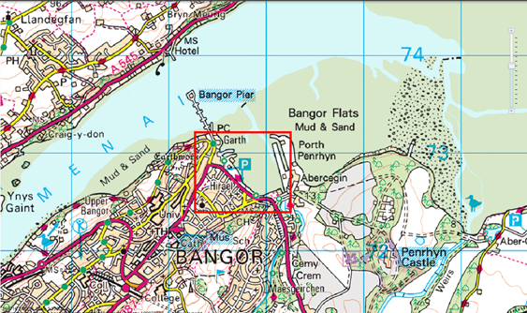

3.0 Screening for Significant Environmental Effects

3.1 Characteristics of the Development

Using the selection criteria provided in Schedule 3 of the Town and Country Planning (Environmental Impact Assessment) (Wales) Regulations 2017, the characteristics of the development have been considered with regard to the criteria contained in Table 3.1.

Table 3.1: Characteristics of the development
a) the size and design of the development | The proposed area of works is estimated to be in the region of approximately 0.5ha taking into consideration the possible need for a contractor’s compound and welfare facilities and temporary areas that are required to accommodate the construction phase.  The main section of works will take place on the footprint of existing sea wall, apart from the addition of rock armour in front of the new sheet pile wall, which will extend out onto the foreshore by 4m (approx. 540m2). Each of the four sections of works scheduled for the site will take place in an already developed and urban area.  The exact area and location of the construction compound is not known as the contractors have not yet been appointed. It is expected that the compound will be located close to the works, possibly using one of the carparks located on Beach Road.
b) the cumulation with other existing development and/or approved development | There is a property development proposal under discussion with the planning authority for the Old Dickies boatyard site, where two sections of the defence are scheduled to tie into. Authority for this development has not been yet obtained. It is therefore not envisaged that there is a potential for significant combined impacts with the development.  No other proposed works known of that could generate a cumulative impact with the proposals.
c) the use of natural resources, in particular land, soil, water and biodiversity | Access from the Bangor Flats, which is where the rivers Adda and Cegin discharge into the Menai Strait, will be required to carry out preparation works. However, the construction of the new coastal wall is scheduled to take place from dry land to minimise the need for plant machinery on the seaward side. Access onto the foreshore will be required to place rock armour in front of sheet pile wall, however this activity will not require any excavation work. A Construction Environmental Management Plan will be produced in order to stipulate the steps taken to prevent construction derived pollution.  No water will be extracted from the watercourse during the course of the works. There will be some permanent land take on the foreshore (approx. 540m2) in order to place rock armour in front of the sheet pile wall along the western extent of the promenade. Additional land may be temporarily used to provide a site compound but the exact location of the construction compound is currently not known as the contractors have not yet been appointed.  Potential impacts on biodiversity have been considered in a Habitat Regulations Assessment (HRA), a Preliminary Ecological Appraisal (PEA) and an Ecological Impact Assessment (EcIA). Biodiversity enhancement within the proposed works has been considered and suggested as part of these assessments.  No natural resources would be required during the operation of the proposal.
d) the production of waste | All measures shall be taken to minimise waste during construction and all relevant regulations that governs the transfer of waste and material shall be adhered to in full.  Materials expected to be used during the construction include aggregates, concrete, steel, soil, masonry and tarmacadam. These materials should be obtained by a reputable supplier and source and only the amount needed shall be ordered in order to minimise the risk of waste on site.  Successful contractors must be able to comply with waste legislation and will implement and adhere to a Site Waste Management Plan during the course of the works.
e) pollution and nuisances | There is a temporary risk of pollution of the watercourse through accidental spillages especially during the removal of existing gabions and during the construction phase. Pollution control will be maintained during the course of the construction and it is expected that the contractor will adopt all practical measures described in relevant guidance such as the Pollution Prevention Guidelines.  Due to the location and nature of the works it will be subject to Marine Licensing. A Flood Consequent Assessment, a Water Framework Directive Assessment and Construction Environmental Management Plan will also be required for the proposal.  Construction-generated noise and vibration could result in temporary nuisance during the course of the works, especially to residential properties and features of Traeth Lafan SPA, wintering birds. However, this is temporary and is not anticipated to be significantly higher than existing traffic noise. Working hours and noise and vibration limits can be restricted as terms of the construction contract to minimise impacts on the local residents.
f) the risk of major accidents and/or disasters relevant to the development concerned, including those caused by climate change, in accordance with scientific knowledge | The proposal is not considered likely to increase the risk of any major accidents or disasters during the construction or operation of works.  The proposal aims to provide a positive impact on the local area by providing a flood defence not only to Hirael and Garth wards but also to Bangor as a whole.
g) the risks to human health (for example due to water contamination or air pollution) | No risks to human health are foreseen during the operation of the proposal.  During construction, temporary nuisance associated with air quality, noise / vibration and water pollution would be addressed via the best practice and consenting procedures discussed above.

3.2 Location of the Development

Using the selection criteria provided in Schedule 3 of the Town and Country Planning (Environmental Impact Assessment) (Wales) Regulations 2017, the environmental sensitivity of geographical areas likely to be affected by the development has been considered with regard to the criteria contained in Table 3.2.

Table 3.2: Location of the development
a) the existing and approved land use | The land in which the scheme is proposed on is currently used as a coastal frontage. The proposal seeks to replace the existing wall to create a formal coastal flood defence. The surrounding area of the works is mainly an urbanised, developed area with some recreational use.
b) the relative abundance, availability, quality and regenerative capacity of natural resources (including soil, land, water and biodiversity) in the area and its underground | Littoral sediment, intertidal mudflats are a Welsh Priority Habitat and is sensitive to pollution and in particular, human disturbance. There is a temporary risk of pollution of the marine environment through accidental spillages especially during the gabion removal and construction phase. Pollution control will be maintained during the course of the construction and it is expected that the contractor will adopt all practical measures described in relevant guidance such as the Pollution Prevention Guidelines.  The proposal will be subject to a Marine License from Natural Resources Wales. It is likely that a Flood Consequent Assessment and a Water Framework Directive Assessment will also be required for the proposal.  A selection of trees are scheduled for felling to accommodate the project. These trees have been surveyed in a Preliminary Ecological Appraisal and along with an Arboricultural Assessment
c) the absorption capacity of the natural environment, paying particular attention to the following areas—  (i) wetlands, riparian areas, river mouths;  (ii) coastal zones and the marine environment;  (iii) mountain and forest areas;  (iv) nature reserves and parks;  (v) European sites and other areas classified or protected under national legislation;  (vi) areas in which there has already been a failure to meet the environmental quality standards laid down in Union legislation and relevant to the project, or in which it is considered there is such a failure;  (vii) densely populated areas;  (viii) landscapes and sites of historical, cultural or archaeological significance. | i) The proposed new sea defence will be constructed near the estuary of Afon Adda and Cegin, both classed as main rivers. It is not anticipated that these features are at risk from water pollution and disturbance during the works, primarily as Afon Adda is culverted and Cegin is approximately 300m from the works. Construction activities will also be carried out within an area which is classed as a Flood Zone 2 and 3.  ii) The proposed works will be partially carried out from the foreshore, during the removal of existing gabions and for placement of rock armour. The placement of rock armour will result in some land take of the foreshore, extending out 4m from the wall. The foreshore area where rock armour will be placed comprises of made ground of a rocky substrate nature. The works does pose potential risk of water pollution and disturbance during the course of the works. However, these risks could be reduced through mitigation measures.  iii) Not applicable  vi) Not applicable  v) The proposal site is not located within any European sites or any other classified or protected areas. However Traeth Lafan SPA (and SSSI), Menai Straits and Conwy Bay SAC and Coedydd Afon Menai SSSI are all located within 500m of the proposal.  vi) Not applicable  vii) Not applicable  viii) The scheme is not located within a historical or cultural designation however there are several sites of cultural and historical importance in the vicinity of the works. These include Porth Penrhyn which is part of an UNESCO World Heritage Site, two scheduled ancient monuments and listed buildings.

3.3 Types and Characteristics of the Potential Impact
Using the selection criteria provided in Schedule 3 of the Town and Country Planning (Environmental Impact Assessment) (Wales) Regulations 2017, the likely significant effects of the development on the environment have been considered in relation to the criteria contained within Tables 3.1 and 3.2 and with regard to the impact of the development on the following factors specified in Regulation 4(2), and summarised in Table 3.3:
(a) population and human health;
(b) biodiversity, with particular attention to species and habitats protected under Directive 92/43/EEC and Directive 2009/147/EC;
(c) land, soil, water, air and climate;
(d) material assets, cultural heritage and the landscape; and
(e) the interaction between the factors listed in sub-paragraphs (a) to (d).

Table 3.3: Types and characteristics of the potential impact
a) the magnitude and spatial extent of the impact (for example geographical area and size of the population likely to be affected) | The nature, size and location of the proposal is not considered likely to generate a significant geographical impact on the area. Any impacts would be local in scale and restricted to the site and adjacent area. Both Hirael and Garth wards collectively have a population of 2,703. The proposal would be a positive development in the area as it would provide a tidal flood defence to the area. The current sea wall is not sufficient to combat potential future flooding, especially in light of additional factors such as climate change.
b) the nature of the impact | Temporary impact that could occur during the construction phase:  - Pollution to the marine environment caused by accidental spillages;  - Nuisance to the local area and residents due to increased noise and vibration levels;  - Potential damage to surrounding land during construction phase;  - Temporary disturbance to local wildlife and biodiversity.  Permanent impact that could occur on completion of the works:  - Visual impacts caused by the construction of a new sea defence  - Loss of intertidal habitat through placement of rock armour on foreshore.
c) the transboundary nature of the impact | Not applicable as any impact likely to occur would be only of a local scale and confined to the site.
d) the intensity and complexity of the impact | It is anticipated that any environmental impacts generated by the proposals would be relatively simple and localised and can therefore be managed with confidence.
e) the probability of the impact | The probability of nuisance to the local population from increased noise/vibration is thought to be moderate, given the already busy urban setting. However, the scale of the impact can be managed through proactive planning of the construction phase, sensitive site management and maintaining liaison with affected third parties.  Without mitigation, the probability of impacts upon the water environment and disturbance to sensitive species is also of moderate risk. As the works, in particular regard to section 2, is subject to a Marine License any stipulations listed within the Marine License should be adhered to and best practice measures should also be followed, including the Pollution Prevention Guidelines which is key to managing this risk. The Ecological Impact Assessment sets out mitigation measures to reduce impact on the ecologically sensitive features in the area. These considerations and measures will be followed during the works. They include conditions such as seasonal timings of works. A Construction Environmental Management Plan (CEMP) will also be produced and all risk mitigation measures will be included and adhered to.  The probability of loss of habitat as a result of the proposed work is low. The placement of rock armour on the foreshore will result in replacing the current rocky substrate with another (man-made) rocky substrate. The area will remain intertidal in nature, and will eventually be colonised by intertidal species. To further reduce any potential losses, compensatory measures will be adopted, i.e. installation of artificial intertidal pool features, reinstating any trees that are removed, installing bat boxes etc.  There is a moderate probability of adverse visual impacts associated with the proposed work, predominantly due to the construction of the new defence and associated works, which could have localised impact on the character of the area. However, the magnitude of the impact is likely to be small due to the overall positive impact of improvement and positive impact the work will have on the flood defence of the area.
f) the expected onset, duration, frequency and reversibility of the impact | The construction phase impacts (nuisance, pollution, habitat damage / disturbance and waste) would occur from the commencement of the works and would continue until completion.  The proposed work is expected to commence in April 2023 and last approximately 12 months.
g) the cumulation of the impact with the impact of other existing and/or approved development | There are no other works currently going on at or near the site of proposed works. However, there is a section of land, the Old Dickies Boatyard, where two sections of the sea wall are scheduled to tie into that is subject to ongoing planning discussions for a housing development. At this present stage it is highly unlikely that any development works will be carried out at this site during the course of the sea wall construction works.  No other proposed works known of that could generate a cumulative impact with the proposals.
h) the possibility of effectively reducing the impact | The impact of the development can effectively be reduced through the implementation of mitigation measures. The mitigation measures for the scheme are mainly included in the Habitat Regulations Assessment (HRA), Ecological Impact Assessment (EcIA) and Heritage Impact Assessment (HIA) and other supporting documents. All of which can be found to support this report.

4.0 Other relevant information
There are several environmentally and culturally sensitive designated areas within 500m of the proposal. These sites include the Menai Strait and Conwy Bay SAC, Traeth Lafan SPA (also a designated SSSI), Coedydd Afon Menai SSSI, Porth Penrhyn Candidate World Heritage Site, Historic Gardens, Scheduled Ancient Monuments and listed buildings.
All of the above sites have been considered in relation to the development in a Heritage Impact Assessment, Ecological Impact Assessment and Habitat Regulations Assessment. These assessments have explored the features of the proposal against the protected features of the designations and have stipulated mitigation measures and considerations to prevent what might otherwise have been significant adverse effects on the environment.

5.0 Conclusions
It can be concluded that from the nature of the works and with the mitigation measures stipulated in the documents listed in 4.0 an Environmental Impact Assessment will not be required for the works. By adhering fully to the mitigation measures and safe practices listed it can be ruled that any impact is likely to be low and/or temporary.

Appendix A: General Arrangement Drawing

Section 1: Beach Road East
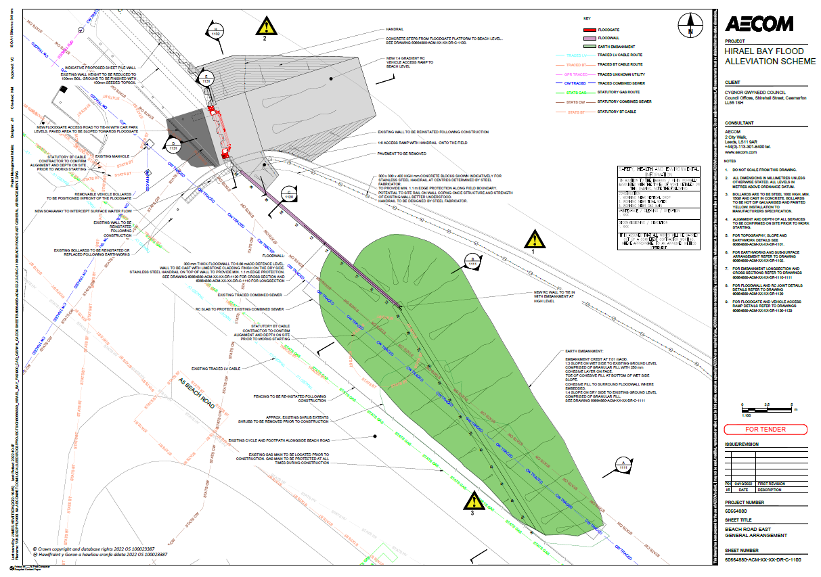

Section 2: Promenade
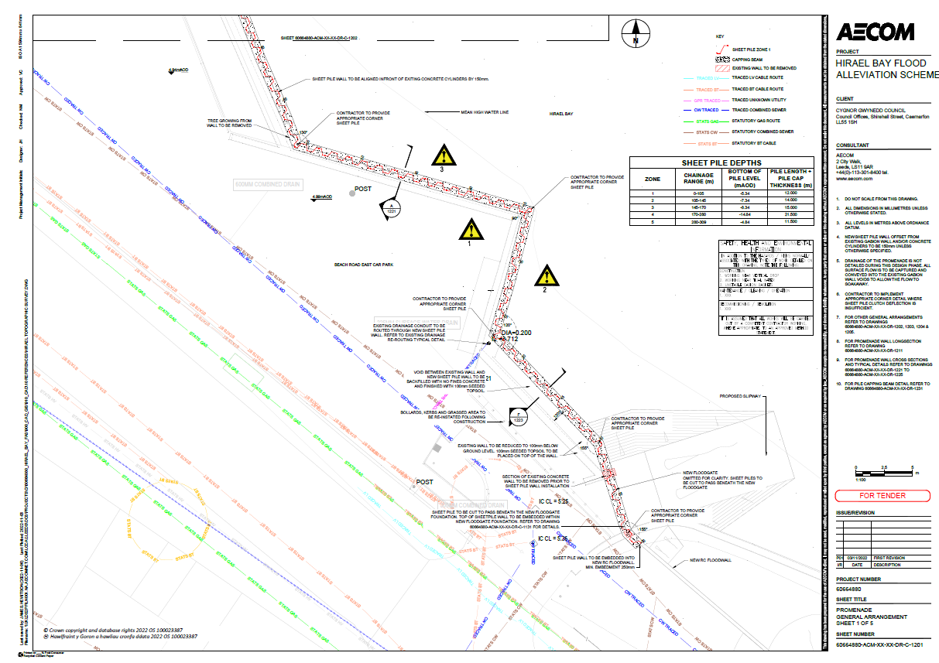
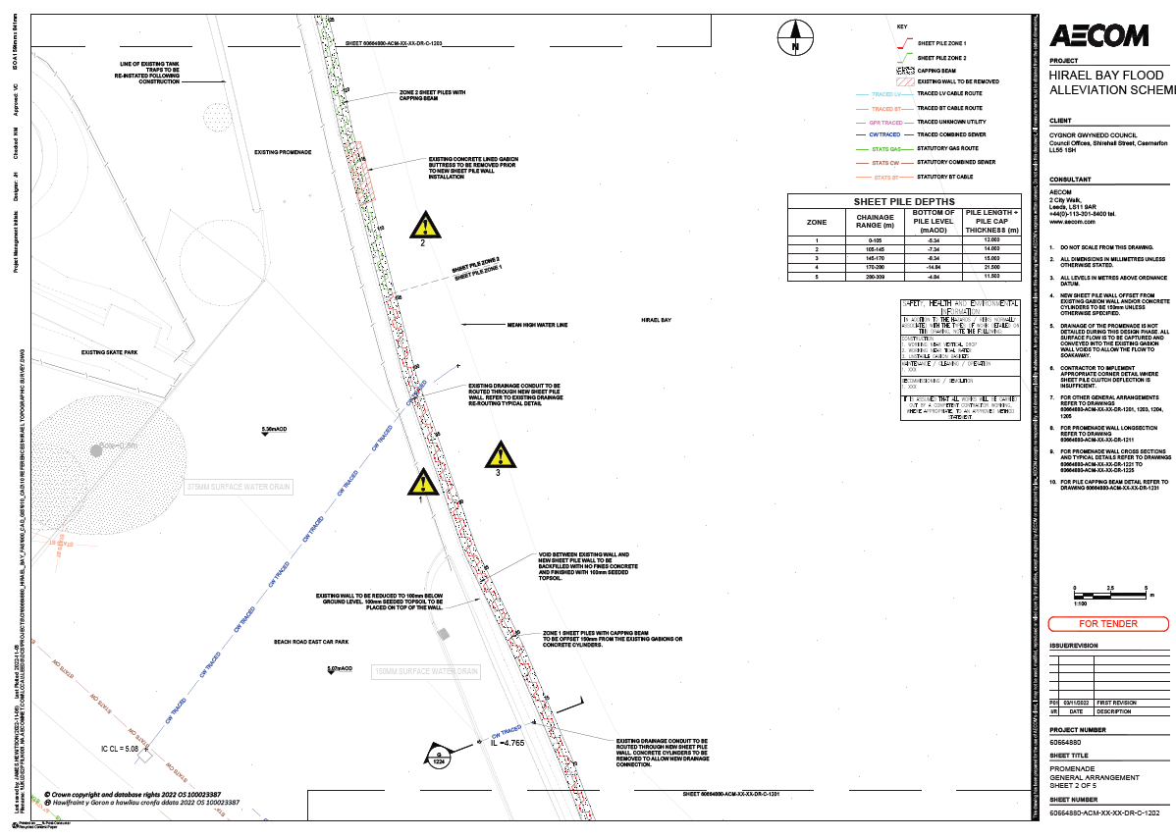
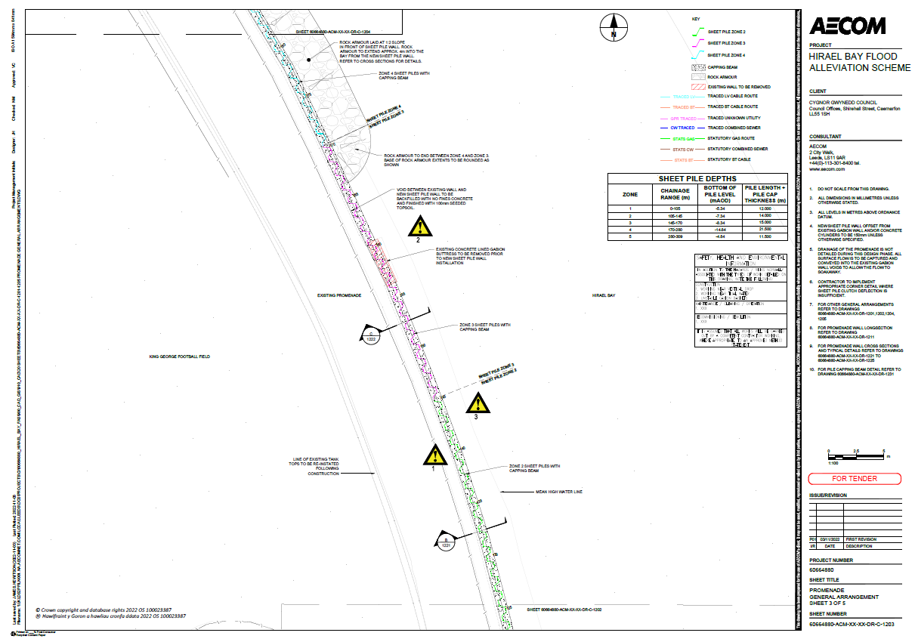
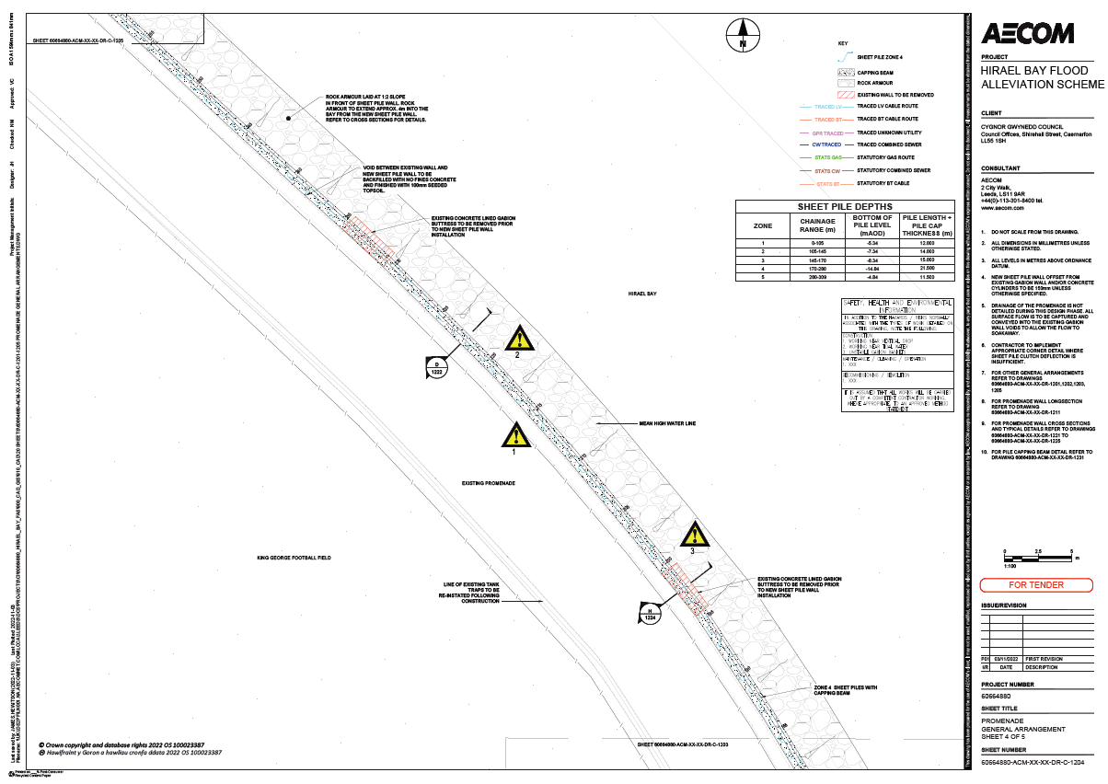
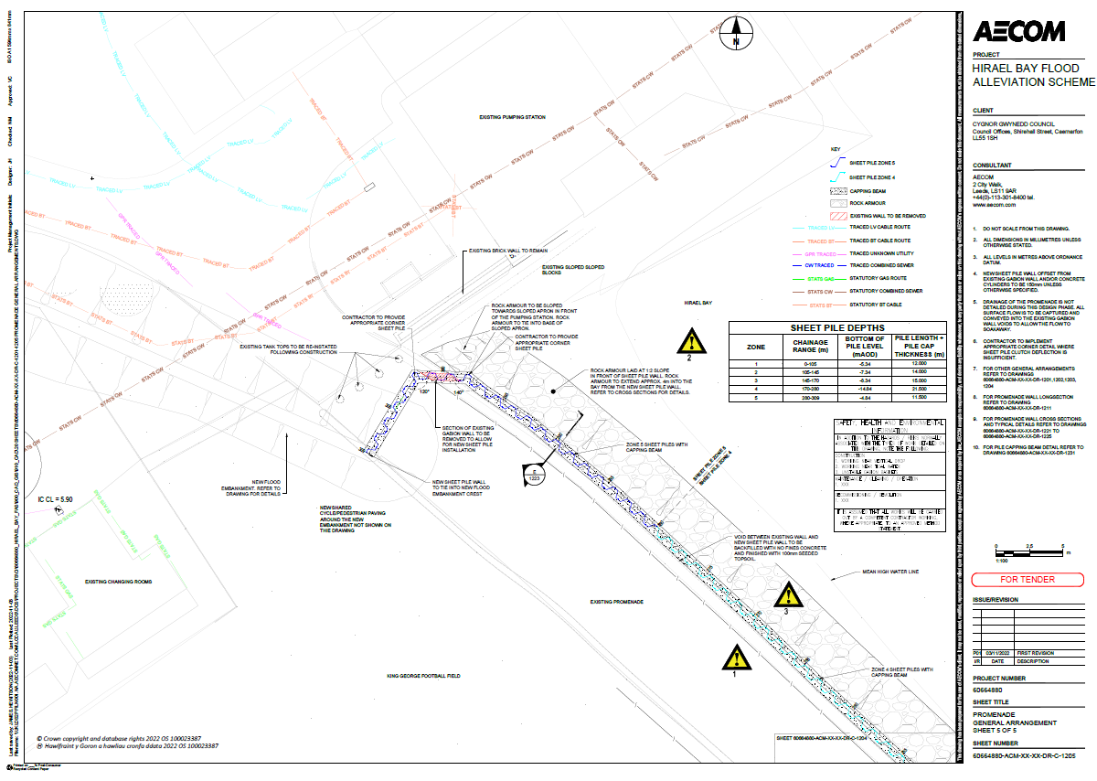
Section 3: Dŵr Cymru Pumping Station
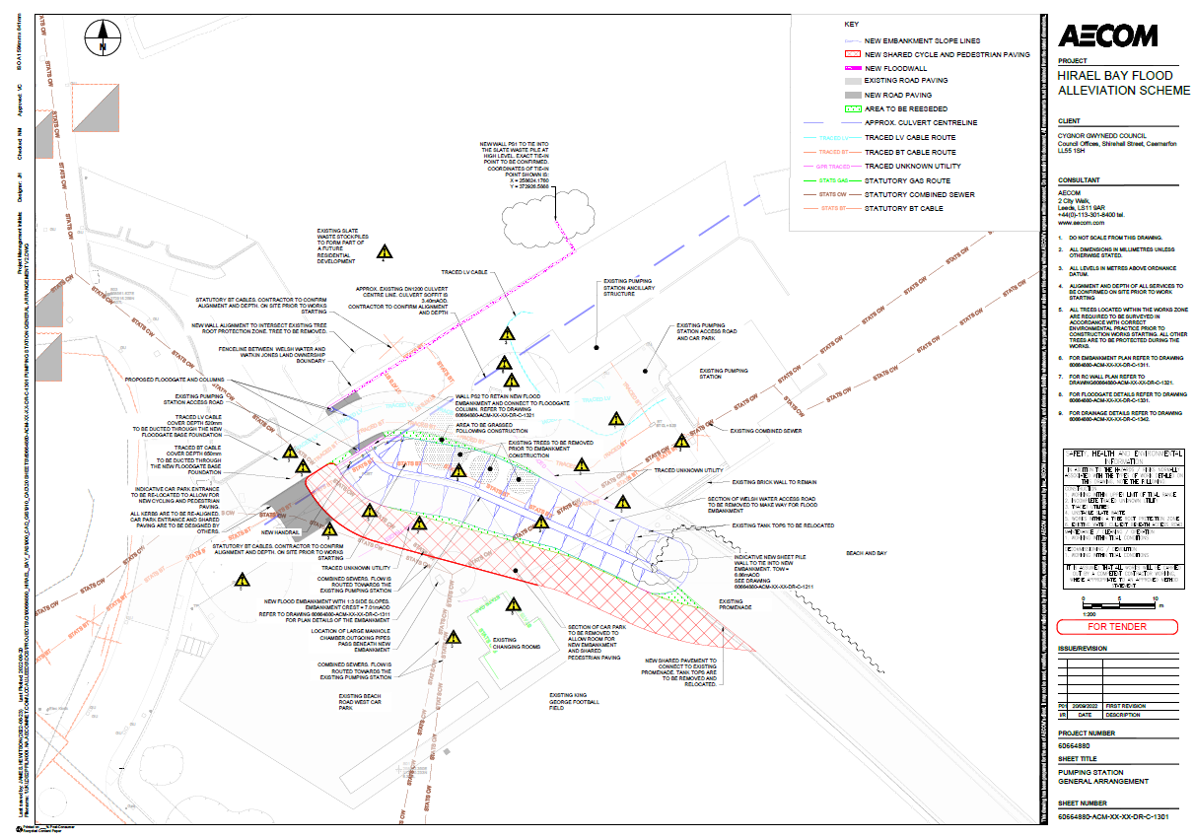
Section 4: Glandŵr Road


