

Hirael Flood Alleviation Scheme
Ecological Impact Assessment

CPF7720

Document Control Sheet

Document Title: | Ecological Impact Assessment
Document Author(s): | David Harries
Project Ref / Title: | 7720 Hirael Flood Alleviation Scheme
Project Manager: | Emyr Gareth

Revision History
Date | Version No. | Summary of Changes
21/01/2020 | 0.01 | Initial draft version
9/04/2020 | 0.02 | Draft revision following review
16/04/2020 | 0.03 | Draft revision following approval
17/04/2020 | 0.04 | Final draft to project sponsor for acceptance
15/11/2021 | 0.05 | Production of ECIA from PEA
15/11/2022 | 0.06 | Update due to detailed design

Reviews
Name | Title | Date | Version
Christian Middle | Ecologist / Environment Officer | 15/11/2021 | 0.05

Approvals
Name | Title | Date | Version
Rhys Meilyr Thomas | Senior Environment Officer | 15/11/2022 | 0.06

Distribution
Name | Title | Date | Version
Emyr Gareth | Prif Beiriannydd | 15/11/2022 | 0.06

© 2022 - 23 Gwynedd Council / YGC. All Rights Reserved.  Copyright in any or all of this documentation belongs to Gwynedd Council / YGC of Council Offices, Shirehall Street, Caernarfon, Gwynedd, LL55 1SH (the 'Owner') and may not be used, sold, transferred, copied or reproduced in whole or in part, in any manner of form or on any media to any person other than in accordance with the terms of the Owner's agreement or otherwise without the prior written consent of the Owner. | 

Contents
1.0 Introduction 4
1.1 Background and Purpose of the Report 4
1.2 Report Aim 5
2.0 Planning Policy and Legislation 5
2.1 Policy 5
2.2 Legislation 7
3.0 Methodology 9
3.1 Desk Study 9
3.2 Field Survey 9
4.0 Baseline Ecological Conditions 10
4.1 Designated Sites 10
4.1.1 Internationally Designated Sites 10
4.1.2 Nationally Designated Sites 11
4.1.3 Other Sites 12
4.2 Habitats 13
4.2.1 Intertidal 13
4.2.2 Amenity Grassland 13
4.3 Species 14
4.3.1 Mammals 14
4.3.2 Birds 15
4.3.3 Reptiles and Amphibians 16
4.3.4 Invertebrates 16
4.3.5 Plants 17
4.3.6 Invasive Non-Native Species (INNS) 17
5.0 Ecological Constraints and Opportunities 18
5.1 Habitat recommendations 18
5.2 Species Recommendations 18
5.2.1 Bats 19
5.2.3 Otter 19
5.2.4 Badger 19
5.2.5 Birds - inc. Wintering sea birds 20
5.2.6 Reptiles and Amphibians 25
5.2.7 Other mammals 25
5.2.8 Invasive non-native species (INNS) 26
6.0 Cumulative Effects 26
7.0 Summary 27
9.0 References 29

Introduction
YGC were commissioned by Gwynedd County Council / Welsh Government to undertake an Ecological Impact Assessment and subsequently produce a report for the Hirael Flood Alleviation Scheme in Bangor to reduce flood risk (SH 58704 72826) (see figure 1 below).
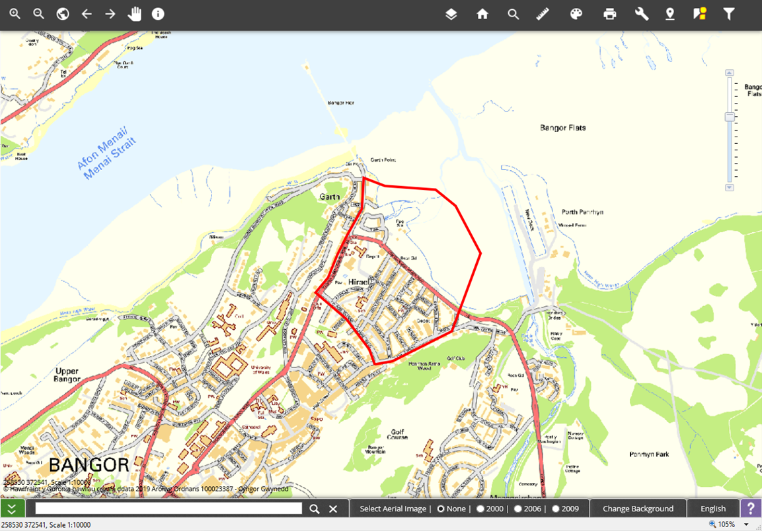
Figure 1 Location plan of proposed scheme

1.1 Background and Purpose of the Report
Hirael is located north east of Bangor within a low lying basin with a catchment area which includes most of the city of Bangor. The area consists of a 550m length foreshore, a narrow beach and a recreational water front open space. Immediately behind Beach Road is a densely populated area of residential and commercial properties. The area is at risk of flooding from sea and surface water, and an Outline Business Case (OBC)was developed to consider options of managing the risk of flooding around the coastline. This report has been produced to support both the OBC and detailed design for the flood alleviation scheme.
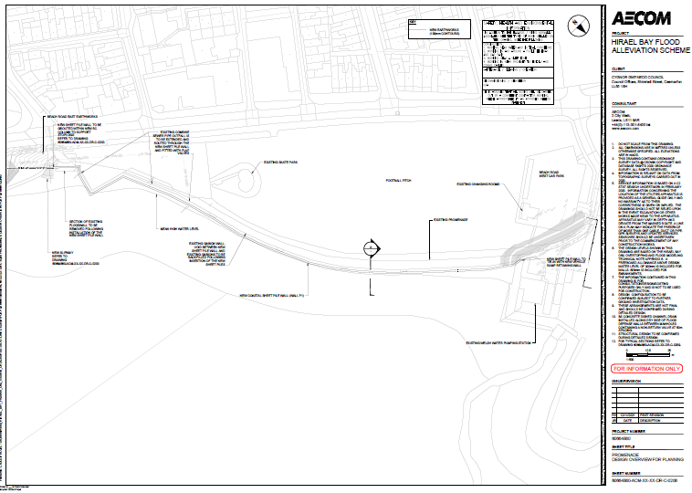
Figure 2 location of the prefered option to be assessed

1.2 Report Aim
As An ECIA, the purpose of this report is as follows:
- to identify key ecological constraints to the proposal;
- to make recommendations to allow significant ecological effects to be avoided or minimised wherever possible;
- to inform the development of potential mitigation and/or compensation measures; and
- to design enhancement options into the project.

2.0 Planning Policy and Legislation

2.1 Policy
The national and local policies described below may be relevant to the proposal:

Technical Advice Note (TAN) 5: Nature Conservation and Planning (2009)
TAN 5 provides advice to local planning authorities on the application of the law relating to planning and nature conservation and its impact within the land use planning system. The most recent revision of TAN 5 brings it in line with the strategic policy in PPW 2016 and advises how planning policy with regard to ecology needs to be interpreted to be in compliance with Planning Policy Wales. It provides advice on the following:
Positive planning for nature conservation;
Nature conservation and Local Development Plans;
Nature conservation in development management procedures;
Development affecting protected internationally and nationally designated sites and habitats; and
Development affecting protected and priority habitats and species.

Planning Policy Wales - Edition 10 (December 2018)
Of particular relevance to this assessment is PPW Chapter 5 - Distinctive and Natural Places which outlines the Welsh Government’s commitments to Nature Conservation. The Welsh Government’s objectives for the conservation and improvement of the natural heritage are to:
- Support the conservation of biodiversity, in particular the conservation of wildlife and habitats;
- ensure action in Wales contributes to meeting international responsibilities and obligations for biodiversity and habitats;
- ensure statutorily and non-statutorily designated sites are properly protected and managed;
- safeguard protected and priority species and existing biodiversity assets from impacts which directly affect their nature conservation
- interests and compromise the resilience of ecological networks and the components which underpin them, such as water and soil, including peat; and
- • secure enhancement of and improvements to ecosystem resilience by improving diversity, condition, extent and connectivity of ecological networks.

Wales Environment Strategy (2006 to 2026)
The Environment Strategy is the Welsh Government’s long-term strategy for the environment of Wales setting the strategic direction for the next 20 years. The strategy has five main themes:
Addressing climate change;
Sustainable resource use;
Distinctive biodiversity, landscape and seascapes;
Our local environment; and
Environmental hazards.

Local Biodiversity Action Plans (LBAPs)
In 1992 the UK signed the Convention on Biological Diversity at the Rio Earth Summit pledging to develop national strategies for the conservation and sustainable use of biological diversity. The UK Government subsequently produced Biodiversity: The UK Biodiversity Action Plan in 1994 which described the biological resources of the UK as a whole and in turn led to the production of Biodiversity Action Plans for individual habitats and species. Biodiversity: The UK Biodiversity Steering Group Report was published in 1995. This recognised that to successfully implement the UKBAP at a local level and translate national policy into action, it would be necessary to produce Local Biodiversity Action Plans across the UK. In response to this, local authorities throughout the UK produced LBAPs; the Gwynedd LBAP is of relevance to the proposed works and the species and habitats included within it have been considered and included within this assessment where relevant.

2.2 Legislation
The following legislation is likely to be relevant to the proposal:
Environment (Wales) Act (2016)
This act became law in Wales on 21st March 2016, and includes legislation that supersedes the Natural Environment and Rural Communities (NERC) Act 2006. Part 1 of the Act sets out Wales’ approach to planning and managing natural resources at a national and local level with a general purpose linked to statutory ‘principles of sustainable management of natural resources’ defined within the Act.
Section 6 of the Act places a duty on public authorities to ‘seek to maintain and enhance biodiversity’ so far as it is consistent with the proper exercise of those functions. In doing so, public authorities must also seek to ‘promote the resilience of ecosystems.’ Public authorities will be required to report on the actions they are taking to improve biodiversity and promote ecosystem resilience.
Section 7 replaces the duty in Section 42 of the NERC Act 2006. The Welsh Ministers will publish, review and revise lists of living organisms and types of habitat in Wales, which they consider are of principle importance for the conservation and enhancement of biodiversity in Wales. The Welsh Ministers must also take all reasonable steps to maintain and enhance the living organisms and habitats included in any list published under this section, and encourage others to take such steps. A number of habitats and species included under Section 7 of this act have been recorded in the vicinity of the scheme and are therefore considered in the assessment.

Conservation of Habitats and Species Regulations (2017)
The Conservation of Habitats and Species Regulations 2017 transpose Council Directive 92/43/EEC on the conservation of natural habitats and of wild fauna and flora (the EC Habitats Directive) into national law. The Regulations provide for the designation and protection of European sites and the protection of European protected species and habitats as listed in the EC Habitats Directive and EC Birds Directive (Council Directive 2009/147/EC). The regulations provide guidance on undertaking assessment of impacts on European and Protected Sites (Special Areas of Conservation - SACs, Special Protection Areas – SPAs and Ramsar sites) through the Assessment of Implications on European Sites (AIES) process. The survey area provides potential habitat potential foraging habitat for bats and otter, which are European Protected Species under these Regulations.

Wildlife and Countryside Act (1981, as amended)
The Wildlife and Countryside Act (WCA) governs the designation and protection of Sites of Special Scientific Interest (SSSI) and National Nature Reserves (NNR), and protection of various plant and animal species. Schedule 1 of the Act lists protected bird species, Schedule 5 lists other protected animal species, and Schedule 8 lists protected plant species. Schedule 9 of the Act lists invasive alien species which it is an offence to introduce or allow to spread in the wild. There are records of bats and reptiles within the vicinity of the proposed works, which have full protection under Schedule 5 of this act.

The Protection of Badgers Act (1992)
This legislation protects badgers against wilful killing, injury or ill-treatment, and disturbance in their setts, and also prohibits interference with or obstruction of badger setts. Although primarily intended to protect badgers against deliberate persecution, the legislation is also relevant in the context of development work. This Act is relevant to the scheme because there are records of badger, and there is suitable habitat for badgers within the survey area.

Methodology

3.1 Desk Study
A desktop study was undertaken to inform the baseline conditions, impact assessment and scoping process, including data from the following sources:
A search of biodiversity records held by the North Wales Environmental Information Service (Cofnod) was undertaken in January 2020, providing records of sites, habitats and priority species within a 1km buffer of the survey area;
Gwynedd Council’s GIS system (Map Gwynedd) provided information on statutory and non-statutory designated sites (within a 1km buffer);
Detailed information about protected sites was obtained from the JNCC (Joint Nature Conservation Committee) and NRW websites; and
Information about drainage and watercourses was obtained from Map Gwynedd.

3.2 Field Survey
A Preliminary Ecological Appraisal (including an Extended Phase 1 Habitat Survey) of the site was undertaken on 15th January 2020 by senior ecologist David Harries (MSc, CEnv), in order to identify the habitats present and search for any signs of protected species within the survey area and to inform this ECIA. Target notes were used to describe and highlight features of interest with regard to habitat types, protected species and invasive non-native species (INNS) and a list was compiled of species recorded during the survey. Extended Phase 1 Habitat survey methodology and mapping was based on the standard Phase 1 methodology provided in the Nature Conservancy Council’s ‘Handbook for Phase 1 Habitat Survey (1990)’. With respect to legally protected species, the following characteristics were specifically searched for:
- Suitable habitat for roosting bats including structures, buildings and/or trees with cracks, crevices, holes and/or substantial growth of ivy that may potentially provide roosting locations and field signs of roosting bats (e.g. droppings, fur oil and urine staining, scratch marks and feeding remains);
- Suitable habitat for and field signs of otter (Lutra lutra) activity (e.g. Holts, resting places, spraints, tracks, feeding remains, runs and pathways);
- Suitable habitat for and field signs of reptile and amphibian species such as great crested newt (Triturus cristatus), palmate newt (Lissotriton helveticus) and smooth newt (Lissotriton vulgaris), common lizard (Lacerta vivipara), slow worm (Anguis fragilis), grass snake (Natrix natrix), adder (Vipera berus), common toad (Bufo bufo) and common frog (Rana temporaria) (e.g. still and slow flowing waterbodies, potentially suitable hibernacula, shed skin sloughs, spawn, egg cases); and
- Suitable habitat for and field signs of badger (Meles meles) (e.g. setts, footprints, trapped hairs, dung-pits/latrines, foraging scrapes, runs and pathways).
- Suitable habitat for and field signs of wintering and breeding birds and active bird nests.
In addition to the protected species mentioned above and in accordance with the guidelines of the Chartered Institute of Ecology and Environmental Management (CIEEM), evidence of any other protected, priority and/or invasive non-native species found during the course of the survey has been highlighted in this report.
The weather on the 15th January 2020 was overcast with occasional light rain, posing no limitations on the survey. However, there were some seasonal restrictions relating to plant identification, although it is considered that key dominant and invasive plant species were identified.

4.0 Baseline Ecological Conditions

4.1 Designated Sites

4.1.1 Internationally Designated Sites
Internationally designated sites (as protected under the Conservation of Habitats and Species Regulations 2017) considered to be potentially affected by the proposal include all those within 2km of the survey area boundary, as it is not anticipated that the proposal would have significant effects on sites located further away due to the scale and nature of the proposed works.

There are two European designated site within 2km of the survey area, Menai Strait & Conwy Bay SAC which is located 150m north of the survey area, and Traeth Lafan SPA which is located 188m north east of survey area (See figure 2). A Test of Likely Significant Effects will need to be carried out if any works are likely to impact these sites due to the wintering bird assemblages associated with the sites.

In terms of the screening distance for mobile species, there are four SAC’s within the 25km and 30km screening distance for Otters and Lesser Horseshoe Bats. These are; Afon Gwyrfai and Llyn Cwellyn SAC (Otters), Glynllifon SAC (Bats), Meirionnydd Oakwoods and Bat Sites SAC (Bats), and Gwydir Forest Mines SAC (Bats). These will need to be considered should any of the works be likely to impact otter or bat habitat.
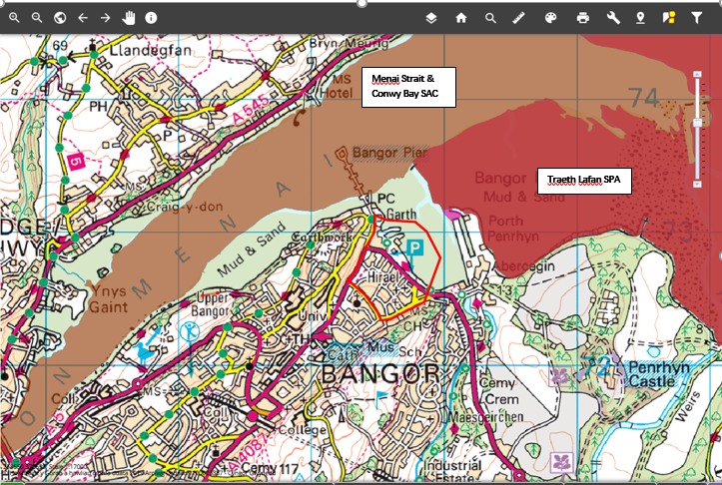
Figure 3, internationally designated sites in relation to the proposed scheme

4.1.2 Nationally Designated Sites
Nationally designated sites (as protected under the Wildlife and Countryside Act 1981) considered to be potentially affected by the proposal include all those within 500m of the survey area boundary, as it is not anticipated that the proposal would have any significant effects on sites beyond this distance.

There are two nationally designated sites within 500m of the survey area. Traeth Lafan SSSI is located 188m north east of the survey area, and Coedydd Afon Menai SSSI is located 200m west (see figure 4). NRW should be consulted if any works are likely to impact these designated sites.

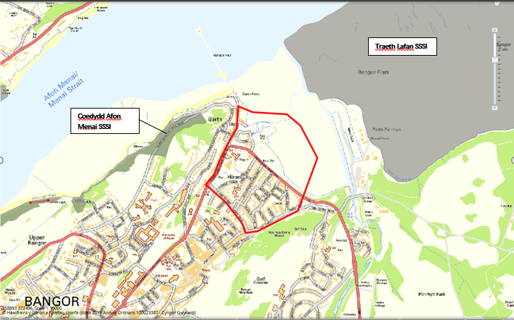

Figure 4 - Nationally designated sites in relation to the proposed scheme (red).

4.1.3 Other Sites
Although not protected by national or international legislation, local sites are considered to be of local to regional importance. Locally designated sites considered to be potentially affected by the proposal include all those within 500m of the survey area boundary, as it is not anticipated that the proposal would have any significant effects on sites beyond this distance.

Traeth Lafan area is also designated a Local Nature Reserve (see figure 5). There are several Local Wildlife Sites (LWS) within 500m of the survey area as is shown in figure 4. One of these sites, Porth Penrhyn & Menai LWS is within the survey area.
Further information about these sites can be found on NRW’s website, including detailed maps and information about the qualifying features and threats to and management of these features.
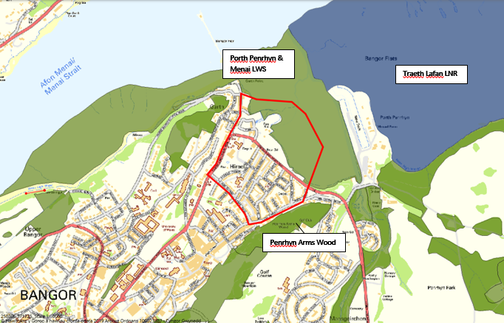
Figure 5 - Locally designated sites in relation to the survey area. Key: Red line = survey area. Blue shading = LNR. Green Shading = LWS. Source: Map Gwynedd

4.2 Habitats
The Preliminary Ecological Appraisal (PEA) survey found the survey area to be mostly comprised of amenity grassland, hardstanding parking and recreational areas, sea wall defences and intertidal habitats.

The habitats present within the survey area that are of importance to nature conservation either locally, on a wider geographical scale or for socio economic reasons, are described below.

4.2.1 Intertidal
The eulittoral mid shore out to 30m from the existing sea defence on the eastern side of the study area was made up stable boulders and cobbles including slate waste characterised by a dense canopy of Fucus vesiculosus and some Ascophyllum nodosum on the upper shore which was classified as biotope LR.LLR.FVS.AscVs, ‘Ascophyllum nodosum and Fucus vesiculosus on variable salinity mid eulittoral rock’. This is a common biotope type of the upper intertidal areas of the Menai straits. There was limited interest immediately adjacent to and up to 10m from the existing wall which consisted of strandline communities only on a slate waste substrate.

4.2.2 Amenity Grassland
The survey area landward of the existing sea wall comprises amenity grassland in the form of open spaces and playing fields predominantly comprised of perennial ryegrass Lolium perenne. Standard semi mature/mature trees (Ash Fraxinus excelsior, Acer sp., Sweet chestnut Castanea Sativa, Sorbus sp., Poplar sp., Cupressus sp. and Tilia sp.) are located to the west of the survey area bordering Beach Road and around the Eastern carpark. A separate arboricultural assessment has been commissioned which will assess all trees on site. The land bordering this grassland especially to the East comprises tall ruderal vegetation leading to scrub with species such as bramble Rubus fruticosus and hawthorn Crataegus monogyna. But is restricted to narrow bands outside the proposed development area. There are also a number of formal ornamental flower beds and boxes throughout the survey area with many non-native (but not deemed invasive) species.

4.3 Species

4.3.1 Mammals

Bats (Order: Chiroptera)
The Cofnod data shows that several bat species have been recorded within the survey area and within 1km of the proposed works, including brown long-eared bat (Plecotus auritus), soprano pipistrelle (Pipistrellus pygmaeus), noctule (Nyctalus noctulli), Brant’s bat Myotis brandtii, whiskered bat (Myotis mystacinus), and common pipistrelle (pipistrelle pipistrellus). The closest bat record is a single common pipistrelle > 150m from the proposed scheme.

The survey area is considered to provide low suitability foraging and commuting habitat for bat species due to the lack of connecting habitat and suitable foraging habitat. The mature standard trees identified within the survey area may provide roosting habitat for bats, including those listed on Section 7 of the Environment (Wales) Act 2016.

All bat species are protected as European Protected Species under the Habitats Regulations 2017 and are also fully protected under the Wildlife and Countryside Act (1981, as amended). Several species, including common and soprano pipistrelle (Pipistrellus pipistrellus and Pipistrellus pygmaeus respectively) brown long-eared bat (Plecotus auritus), are listed under Section 7 of the Environment (Wales) Act 2016.

Otter (Lutra lutra)
There are 6 records of otter (Lutra lutra) evidence within 1km of the proposed scheme. Many of these records are located along the Afon Gegin approximately 700m from the survey site, including evidence of spraints, resting places and live sightings.

Although no evidence of otters was found during the survey, the intertidal area and scrub within the survey area do provide suitable foraging and resting habitat for otters.

Otters are protected as European Protected Species under the Conservation of Habitats and Species Regulations 2017. Otters receive full protection under the Wildlife and Countryside Act 1981 (as amended). It is an offence to deliberately kill, injure or take an otter without a licence to disturb, damage or destroy holts or other places of shelter. Otters are listed on Section 7 of the Environment (Wales) Act 2016.

Badger (Meles meles)
There are 2 Cofnod records of badger within 1km of the proposals, but no recorded setts.
No evidence of badger was found within 50m of the proposed works. However, the scrub and grassland to the east of the site provide suitable foraging habitat for badger, and badger prey species are likely to be present within the survey area.

Badgers and their habitat are afforded protection on a domestic level through the Protection of Badgers Act 1992. They are also included on Schedule 6 of the Wildlife and Countryside Act 1981 (as amended), and Appendix III of the Bern Convention. It is illegal to kill, injure or take any badger or attempt to do any of these things to intentionally or recklessly damage, destroy or obstruct access to any part of a badger sett.

Other Mammals
The following additional mammal species of importance to nature conservation have also previously been recorded within 1km of the survey area according to the Cofnod data.

Polecat (Mustela putorius)
There is one Cofnod record of polecat within 1km of the proposed works however this record is over 100 years old.

There is some suitable foraging and resting habitat for polecat within and adjacent to the survey area provided by the woodland, hedgerows and scrub.

Polecat is listed as Section 7 Priority Species under the Environment (Wales) Act 2016.

Hedgehog (Erinaceus europaeus)
There are 2 Cofnod records of hedgehogs within 1km of the proposed development sites and the scrub within the survey area does offer suitable foraging and hibernation habitat for this species.

Hedgehogs are listed on Section 7 of the Environment (Wales) Act 2016 and are a UK BAP Priority Species according to the Joint Nature Conservation Committee (JNCC).

4.3.2 Birds
Schedule 1, Section 7 and LBAP Species
There are several records of bird species within the survey area and within 1km of the proposals, including species listed on Schedule 1 of the Wildlife and Countryside Act 1981 (as amended), such as red kite (Milvus milvus) and peregrine falcon (Falco peregrinus).

Species listed on Section 7 of the Environment (Wales) Act 2016 recorded within 1km include but are not limited to, lapwing (Vanellus vanellus), cuckoo (Cuculus canorus) and house sparrow (Passer domesticus). The intertidal habitat, trees and scrub, within the survey area provide suitable foraging and nesting habitat for birds.
All bird species (with certain exceptions) are protected from intentional killing, injuring or taking and intentional taking, damaging or destruction of an active nest or eggs under the Wildlife and Countryside Act (1981, as amended).

Marine birds

The local European designated site of Lafan sands SPA is designated for its importance for wintering waterbirds, especially Oystercatcher (Haematopus ostralegus) and Curlew (Numenius arquata). In conditions of severe winter weather, Traeth Lafan acts as a refuge area for Oystercatchers displaced from the Dee Estuary. The site is also an important moulting roost for Great Crested Grebe (Podiceps cristatus) in late summer/early autumn. A single curlew was recorded foraging on St Georges playing field confirming the importance of the area for wintering bird species.

4.3.3 Reptiles and Amphibians
Reptiles
There are 12 Cofnod records of reptiles within 1km of the survey area, including one common lizard (Vivipara zootoca) located approximately 800m South east, one grass snake Natrix natrix from over 100 years ago and 10 slow worm records (Anguis fragilis) with the closest approximately 350m to the West.

No reptiles were found during the site survey, however, the scrub and ruderal vegetation within the survey area provide potential to support common species of reptile such as slow worm and common lizard. See Appendix II: Extended Phase 1 Habitat Survey Plan and Appendix III: Site Photographs.

The species listed above are partially protected in the UK under the Wildlife and Countryside Act 1981. Although not fully protected under Schedule 5 of this act, they receive protection against intentional killing, injuring or taking under Part 1, Section 9 of the Schedule. Common lizard, slow worm, grass snake and adder are also listed on Section 7 of the Environment (Wales) Act 2016.

Amphibians
There are 2 records of amphibians within 1km of the survey area. Common toad (Bufo bufo) has been recorded approximately 500m west of the proposals with common frog (Rana temporaria) recorded 350m from the scheme.

No amphibians were found during the survey, although the survey area does provide some suitable foraging habitat for the species listed above provided by the ruderal vegetation and scrub. There are no ponds present that provide suitable habitat for breeding within the vicinity of the scheme.

Common toad is listed as a Section 7 Priority Species under the Environment (Wales) Act 2016.

4.3.4 Invertebrates
There are several records of invertebrate species within 1km of the proposed scheme, including buff ermine (Spilarctia luteum), small heath (Coenonympha pamphilus) and wall (Lasiommata megera). These species are all also listed on Section 7 of the Environment (Wales) Act 2016.

The scrub and standard trees within the survey area provides suitable habitat for a number of invertebrate species, including those which provide important ecosystem services; and it is likely that a number of these species occur within the survey area.

4.3.5 Plants
There are no records of notable plant species within or adjacent to the scheme proposals.

No other notable plant species were recorded during the site survey.

4.3.6 Invasive Non-Native Species (INNS)
Plants
There are a large number of invasive non-native species Cofnod records within 1km of the proposed works. Invasive non-native plant species recorded within 1km include Himalayan balsam (Impatiens glandulifera), Japanese Knotweed (Fallopia japonica), Montbretia (Crocosmia pottsii x aurea = C. x crocosmiiflora), Entire-leaved Cotoneaster
(Cotoneaster integrifolius), rhododendron (Rhododendron ponticum), and Three-cornered Garlic (Allium triquetrum) these are all listed on Schedule 9 of the Wildlife and Countryside Act 1981 (as amended).

Japanese knotweed was recorded during the site visit approximately 80m to the east along the shoreline. The stand was extensive and reached the upper shore where it would be subject to saline inundation (photo 1 & 2). Recommendations for INNS have been made in Section 5.2.

There is also a local record (from residents) of a small stand close to the beach at Glandwr Road. This area has been extensively surveyed since 2020 with no knotweed recorded.

Mammals
American mink (Neovison vison) has been recorded twice within 1km of the scheme with one record 250m offshore of the proposals.

No evidence of invasive mammals were found during the site survey, although it is considered that mink frequent the habitats in and around the development. No further work is required with regards to invasive mammal species.

Invertebrates

Austrominius modestus is a non-native barnacle species from Australia and New Zealand has been recorded four times within 1km of the scheme with the closed record being approximately 100m from the northern extreme of the available options. Austrominius modestus not only competes with endemic British species, particularly Balanus balanoides, but has colonized some sheltered and estuarine habitats not previously inhabited by them (Bassingdale, 1964).
No evidence of invasive invertebrates were found during the site survey, although it is considered that Austrominius modestus frequent the intertidal habitats in and around the development. Further recommendations are included in Section 5.2.

5.0 Ecological Constraints and Opportunities

5.1 Habitat recommendations

The design has very limited impact on terrestrial habitats as it is largely confined to the existing promenade and upper foreshore. There will be an impact on the upper intertidal through the provision of rock armour up to 4m from the existing line of the gabion baskets. This habitat consists of strand line communities over a slate waste substrate.

Mitigation/Compensation
The following measures should therefore be undertaken to avoid/minimise potential impacts on habitats:
- Use of tree root protection measures where construction is required in close proximity to retained trees, in accordance with BS5837:2012; with any arboriculture work to conform to BS3998,
- All trees are to be retained where possible and tree removal should be kept to a minimum; and
- Where trees require removal, these should be compensated for by planting native trees within the locality of the scheme at a ratio of 3:1;
- Ensure working width in the intertidal zone is kept to a minimum to limit the temporary disturbance to the foreshore.

Enhancement
Under section 6 of the Environment (Wales) Act 2016 places a duty on public authorities to ‘seek to maintain and enhance biodiversity’ and ‘promote the resilience of ecosystems’, so this should also be taken into consideration. The following enhancement measures would help to ensure compliance with Section 6 of this Act:
- Planting additional locally-occurring native trees and shrubs throughout the proposed work area could serve as an enhancement measure to increase habitat connectivity and replace any lost nesting and foraging habitat for a variety of species. Additional native species could also be planted within the existing scrub within the survey area to increase biodiversity.
- Sympathetic landscaping of the finished area could incorporate features to enhance biodiversity, these could include provision for invertebrate habitat which in turn increases food availability to birds and mammals such as bats.
- Marine intertidal areas will be protected through the provision of the sheet pile method of construction above the mean high water mark with associated rock armour. This method will also allow the retro fitting of marine enhancements such as “verti pools” on any exposed sheet piles or cored pools in the rock armour. These will create man made pools to mimic naturally occurring rockpools.
Residual Effects
No residual effects on habitats are likely provided that the above measures are put in place.

5.2 Species Recommendations

5.2.1 Bats
The proposed loss of trees could have an adverse impact on bats that may use these habitats for shelter, foraging and commuting. However, the project plans to retain or replant trees that would be lost. Currently no trees with bat roost potential will be removed as part of the proposed works, and therefore there will be no loss of potential roosting habitat. Despite this, due to the proximity of suitable roosting habitat and known roosts nearby, it is considered that bats could be disturbed as a result of the works.

Further Survey
- Unless there is a change from the preferred option there will be no need to carry out further bat surveys.

Mitigation/Compensation
- No night time working to avoid impacts to nocturnal animals;
- Use of tree protection measures where construction is required in close proximity to retained trees, in accordance with BS5837:2012; and
- The reinstatement or replanting of trees and minimising and/or compensatory planting as recommended above would ensure that there is no permanent loss of foraging and commuting habitat for bats.

Enhancement
Bat boxes could be provided as part of the scheme such as the Schwegler 2F to increase roosting opportunities for bats. The location of these boxes must be agreed in advance with a suitably-licenced ecologist.
Residual Effects
No residual effects on bats are likely provided that the above measures are put in place.

5.2.3 Otter
Further Survey
- A pre-construction survey for otter (which may be completed at any time of year) is recommended if the proposals have not progressed within 12 months of the site visit to confirm and ascertain if an NRW EPS licence to disturb otters or destroy an otter resting site is required. This is due to the cavities in the existing retaining wall and the number of historic local records.

5.2.4 Badger
Mitigation/Compensation
- A pre-construction survey for badger (which may be completed at any time of year) is recommended if the proposals have not progressed within 12 months of the site visit to confirm their presence or absence on site. This will enable an appropriate mitigation strategy to be identified and will determine if consultation with Natural Resources Wales (NRW) would be required for any proposals to progress; and
- Works should only be carried out during daytime hours to prevent adverse impacts to badgers and other nocturnal animals.

5.2.5 Birds - inc. Wintering Sea Birds
Any removal of trees or scrub would result in loss of potential bird nesting habitat and disturbance to nesting birds without mitigation measures in place. Although loss of the nesting/foraging habitat within the area of proposed works is unlikely to represent a significant impact to the local bird population, mitigation is required to ensure that there is no breach of legislation.

Wintering and marine birds will potentially be disturbed due to the proximity of the proposed works to the foreshore. There is likely to be seasonal constraints on the works but further assessment of the bird assemblage is required.

Further Survey

Undertake a suite of surveys at and adjacent to the proposed flood alleviation scheme to record and quantify the bird species wintering there and to identify habitat features within the survey area that are important to them. Surveys will follow the Wetland Bird Survey (WeBS) methodologies, employing monthly Core Counts at high and low tides between September and March.
The results of these field surveys will need to be supported by existing background data from the BTO and from Cofnod, the results of which will inform the HRA process.

Update Nov 2021

Wintering bird survey has now been completed conclusions are as follows,

Recommendations
- The short-term disturbance impact of the proposed works on the favourable conservation status of the populations of the three Lavan Sands SPA qualifying species would almost certainly be negligible. The disturbance produced by the works would, however, certainly have a negative impact on important high tide roost sites used by waders within Bangor Harbour if undertaken during the winter months. These negative impacts can be mitigated through considering the seasonal timing of works (especially those stages that generate high levels of noise) and, during winter months, by adopting sensitive working methods and by establishing disturbance buffers around the roost sites at high tide.
- Waders and wildfowl are typically most numerous at coastal and estuary sites during the autumn winter months. Figure 6 below broadly outlines the varying sensitivity of these groups to construction activity throughout the year. Timing of works to avoid the most sensitive periods has the potential to reduce impact levels substantially, including the reduction in disturbance effects.

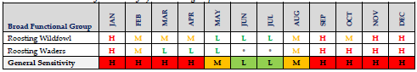
Figure 6 - Broad monthly sensitivity of waterbird groups in relation to construction works

- It is recommended, therefore, that construction work is avoided wherever possible during the autumn and winter months. Those activities that will generate high-level disturbance stimuli, notably sheet piling, should be undertaken April-August when the impact on roosting waders will be minimal.
- To avoid disturbance of roosting birds, any works undertaken during the autumn and winter months (from September through to the end of March) should not be undertaken within 150 m of Roost 1 or Roost 2 for a period extending 1.5 hours either side of high water (3 hours in total).

- Birds can become quickly habituated to slow-moving plant and machinery and can soon become tolerant of these forms of construction activity. They are, however, significantly less tolerant of humans and will respond to this form of disturbance more readily. Sensitive working methods can minimise these disturbance responses. Best practice working methods that avoid generating high-level disturbance stimuli should be adopted. Those activities that generate such disturbance are outlined in the table in the Appendix but include driving and operating plant and machinery slowly and plant operators only entering and exiting their vehicles at designated sites away from the roost locations.
- Works undertaken March-September have the potential to damage or destroy nests. Only small areas of vegetation suitable for nesting birds exist within the construction zone so the risk in these areas is minimal. One species recorded within the CSA – Rock Pipit – nests in recesses in walls or on steep banks. The harbour wall contains many suitable nests sites for this species. Removal of vegetation or the dismantling of the existing wall should be preceded by a check for nests. Should an active nest be located, no development-related works would be permitted within a prescribed exclusion zone around any found until such time that the breeding attempt had concluded.

CONCLUSION
- Coastal wintering bird surveys in Hirael, Bangor were undertaken to inform an assessment of the potential impact that the construction of a proposed flood alleviation scheme along this section of the waterfront would have on wintering birds (primarily waders and wildfowl), notably, species associated with the nearby Lavan Sands (Traeth Lafan) Special Protection Area (SPA). The SPA is primarily designated for nationally important wintering and passage populations of three regularly occurring species: Oystercatcher, Curlew and Great Crested Grebe
- The project proposes the removal of the existing sea wall followed by construction of a continuous line of defences from Beach Road East car park to the Welsh Water pumping station. A short length of defence is also required adjacent to Glandwr Road. The new flood defences will comprise sheet piled walls which will be cladded on both sides.
- Monthly survey visits following the WeBS methodology were undertaken in daylight throughout the 2020/21 winter months at high tide (September to March, inclusive) and at low tide (November to February, inclusive). The location and extent of flocks and individual waterbirds were recorded directly onto a 1:4500 scale Ordnance Survey base map of the study area (and adjacent land) with a 100 m grid. The full survey area extended 500 m from the proposed work area and, for ease of recording, was divided into numbered compartments (1-3). Compartments 1 and 2 were subdivided and suffixed A and B. Suffix A represents the “Core Survey Area” (CSA) – the 0-250 m zone from the coastal wall where work activity is more likely to be disturbing to birds; suffix B indicates the 250-500 m zone where the disturbance impact is expected to be significantly less.
- The surveys recorded a total of 25 species (waders being most numerous) across the wider survey area, including the three SPA qualifying species and two Annex II species noted in the Lavan Sands SPA citation: Redshank and Red-breasted Merganser.
- High tide surveys recorded a total of 24 species. The number of birds recorded at high tide each month increased gradually from the start of the survey and peaked in the period December-February, numbers reducing in March. Most birds registered were roosting either on-shore (waders) or on open water (wildfowl) in the southeast sectors of the survey area (compartments 1A and 1B). Low tide surveys recorded 17 species, mostly feeding waders, with the highest densities located outside the CSA in survey compartment 2B to the east of Bangor Pier, more than 250 m from the proposed construction zone. Monthly counts of all species at low tide peaked in November and steadily declined thereafter.
- High tide surveys identified two important wader roost sites within the CSA – Roost 1, used by Oystercatcher, Dunlin, Knot, Redshank and Curlew, and Roost 2 used almost exclusively by Redshank. Winter-roosting wildfowl, e.g. Wigeon, were almost exclusively found on open water at the southeast end of the harbour.
- The CSA does not appear to support significant proportions of the SPA populations of any of the qualifying species, although Roost 1 is an important location within Bangor Harbour for roosting Oystercatcher. The CSA population of Red-breasted Merganser represents a very small proportion of the SPA population. A significantly greater proportion of the SPA Redshank population roosts at high tide inside the CSA, notably at Roost 2.
- The proposed project would not result in the loss of any high tide roosting sites or of any important feeding ground. The principal (short-term) potential impacts of the scheme on wintering birds in the CSA, therefore, are disturbance of roosting birds and disturbance of feeding birds during the construction phase. Construction noise (especially during sheet piling operations) and movement of plant and site operatives are anticipated to be the main disturbance stimuli to birds within the CSA. However, given the site’s location on the edge of an urbanised area and responses observed during the survey, some level of habituation to these stimuli is assumed in the birds. It should also be noted that species will have differing responses to these stimuli.
- It is estimated that the CSA respectively supports only 1.3(-2.9)% and 0.4(-1.1)% of the wintering SPA populations of Oystercatcher and Curlew. With such small proportions of the SPA populations potentially effected, and with alternative roosting locations abundantly available within the SPA, the short-term disturbing effects of the proposed works on these species at high tide would be negligible. The CSA supports 0.3(-3.3)% of the SPA population of Great Crested Grebe. As a mobile species roosting on open water, it is considered that it would be less susceptible to disturbance as it is able to move away from the cause. The effect of the proposed works would also be negligible for this species.
- At high tide the CSA supports a significant proportion of the Lavan Sands SPA population of wintering and passage Redshank, most of these associated with Roost 2. At 155 m from its location, the effect of the proposed works on Redshank occupying Roost 2 at high tide are likely to be negligible. At Roost 1, however, it is probable that some, if not all, of the Redshank using that location at high tide would be displaced. The Redshank using Roost 1 at high tide represent 4(-14)% of the SPA wintering population. With alternative roost sites available within both the CSA, Bangor Harbour and within the SPA, the effect of this disturbance on the wintering SPA population is likely to be negligible. With only 0.4 (-2.6%) of the SPA population of Red-breasted Merganser, an open water species also able to move away from disturbance stimuli, no adverse effect on the SPA population is anticipated.
- Only a relatively small proportion (16.7%) of the birds feeding within the wider survey area occurred within the CSA. The three SPA qualifying species – Oystercatcher, Curlew and Great Crested Grebe were all recorded within that zone, but the numbers recorded are ≤1% of their SPA populations. The proposed works are therefore not anticipated to have any significant disturbing impact on these species feeding at low tide.
- Although the proposed works will have negligible impact on the favourable conservation status of the populations of the three Lavan Sands SPA qualifying species, the disturbance produced by the works would certainly have a negative impact on important high tide roost sites used by waders within Bangor Harbour if undertaken during the winter months. Recommendations have been made in this report to mitigate these negative impacts by considering the seasonal timing of works (especially those stages that generate high levels of noise) and, during winter months, by adopting sensitive working methods and by establishing disturbance buffers around the roost sites at high tide.
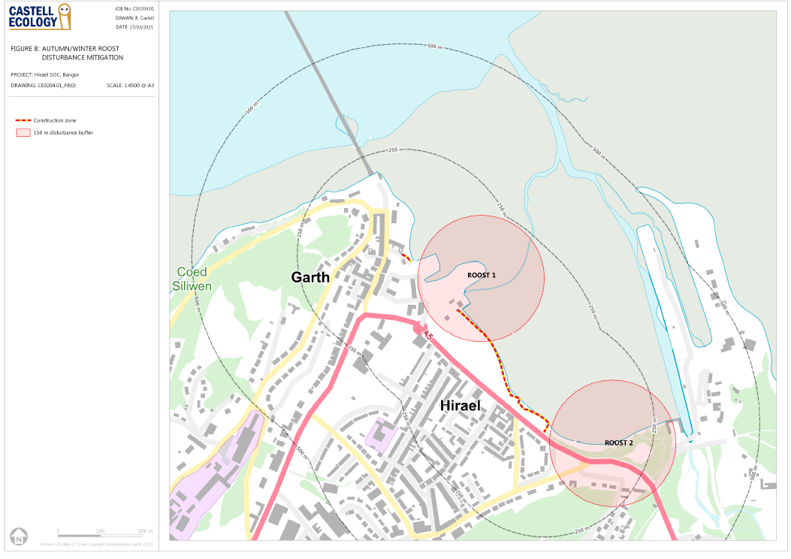
Figure 7 - Buffer zones for high tide works

Mitigation
- All vegetation removal should be undertaken outside of the bird nesting season if possible (March to August inclusive), or immediately preceded by a check for nesting birds by an ecologist, with works in that area postponed until all broods have fledged if active nests are recorded. The ecologist should recommend a suitable buffer distance from the active nest for works to proceed.
- Although the proposed works will have negligible impact on the favourable conservation status of the populations of the three Lavan Sands SPA qualifying species, the disturbance produced by the works would certainly have a negative impact on important high tide roost sites used by waders within Bangor Harbour if undertaken during the winter months. Recommendations to mitigate these negative impacts include the seasonal timing of works (especially those stages that generate high levels of noise) and if unavoidable any works during winter months will be mitigated by adopting sensitive working methods and by establishing disturbance buffers of 150m around the roost sites at high tide.

Enhancement
The habitat recommendations outlined in Section 5.1 above would help to compensate for any loss of bird nesting habitat in the long-term, however bird nest boxes suitable for house sparrows could be erected on the old changing rooms building as part of the scheme as a biodiversity enhancement measure. Any enhancement measures from the bird survey report should also be implemented.

Residual Effects
No residual effects on birds are likely provided that the mitigation measures outlined in the wintering bird report and HRA are put in place.

5.2.6 Reptiles and Amphibians
The potential removal of scrub is considered to have a potentially adverse impact on reptiles and amphibians.
Mitigation/Compensation
- All vegetation clearance should take place under a watching brief for reptiles and amphibians during the reptile active season of April to October inclusive; and
- All vegetation clearance and topsoil stripping should be completed under an ecological watching brief for reptiles and amphibians by a suitably experienced and qualified ecologist in the reptile and amphibian active period April to October inclusive in order to avoid potential impacts on hibernating reptiles and amphibians.

Enhancement
- As a biodiversity enhancement measure, it is recommended that the existing retained habitat is improved through provision of reptile hibernacula to allow use by reptiles, amphibians and small mammal species whilst also providing habitat for invertebrate prey species. Any arising materials from habitat clearance may be used to construct the hibernacula. Any materials arising from vegetation clearance could be utilised for constructing the hibernacula.

*It should be noted that due to the bird nesting season and reptile active season restrictions, the optimal time to complete vegetation clearance would be in late September or October.

Residual Effects
No residual effects on reptiles or amphibians are likely provided that the above measures are put in place.

5.2.7 Other mammals
Small mammals such as hedgehog (Erinaceus europaeus) and other species recorded in the vicinity of the scheme could be affected by the scheme due to loss of habitat. The removal of scrub and dry stone retaining walls, which small mammals may use for foraging, resting and hibernation is likely to cause a temporary adverse impact at a local scale.

Mitigation/Compensation
- The watching brief for reptiles and amphibians as recommended above should also be extended to incorporate small mammal species; and
- The habitat recommendations outlined in Section 5.0 above would prevent any permanent loss of habitat for small mammals.

Enhancement
- The habitat piles recommended above for reptiles and the compensatory measures recommended above would also help to minimise the impact on hedgehogs and other mammal species as well as invertebrates, which is not considered to be significant with all measures in place.

Residual Effects
No residual effects on other mammals are likely provided that the above measures are put in place.

5.2.8 Invasive non-native species (INNS)
There are stands of Japanese knotweed located just outside the survey area along the strandline to the east, this area is unlikely to be affected by the proposed works. There are also historic records of other INNS in the locality.
Austrominius modestus barnacle is also potentially present on site but is restricted to the intertidal area and has a very low potential to be spread due to the type of works proposed for the scheme. A biosecurity risk assessment and method statement will be required for the development to control and prevent future spread of invasive species on site.
Further Survey
A preconstruction survey should be carried out between May and October to accurately record any change in the status of INNS on site.
Mitigation
- Should any other INNS be found on site, best practice should be followed and INNS should be dealt with appropriately;
- Measures should be put in place to avoid ground disturbance in the areas with INNS;
- All invasive plants should be disposed of at a licenced waste facility in order to prevent its spread in the wild and an offence being committed under the Wildlife and Countryside Act 1981 (as amended);
- It is recommended that exclusion fencing is erected around areas with invasive species that are in close proximity to, but not affected by the scheme with its presence acknowledged during site inductions or tool box talks and
- A biosecurity risk assessment and method statement will be required for the works due to the presence of INNS in the surrounding area.

6.0 Cumulative Effects
No projects are known that could potentially cause a significant effect when considered in combination with this project.

7.0 Summary
To summarise, the following mitigation/compensation measures are required for the proposed works:
- It is recommended that a Preliminary Bat Roost and Nesting Bird Assessment (PRA) is completed on the trees surrounding the site as well as the buildings inside the options footprint.
- Undertake a suite of surveys at and adjacent to the proposed scheme to record and quantify the bird species wintering there and to identify habitat features within the survey area that are important to them. Surveys will follow the Wetland Bird Survey (WeBS) methodologies, employing monthly core counts at high and low tides between September and March.
- Use of tree root protection measures where construction is required in close proximity to retained trees, in accordance with BS5837:2012; with any arboriculture work to conform to BS3998,
- Any trees to be retained where possible or otherwise compensated for by planting native species-rich species of at least the number to be removed but greater if possible. The location of the replanted trees should be agreed in advance with an ecologist and landscape architect;
- Where trees require removal, these should be compensated for by planting native trees within the locality of the scheme and for every tree with potential roost features for bats 3 bat boxes will be installed on adjacent retained trees;
- The retaining of trees, and minimising and/or compensatory planting as recommended above would ensure that there is no permanent loss of foraging and commuting habitat for bats;
- It is recommended that a pre-construction otter and badger survey is carried out by a suitably-experienced ecologist, immediately prior to the commencement of the works in order to confirm their presence or absence. This will enable an appropriate mitigation strategy to be identified and will determine if consultation with Natural Resources Wales (NRW) would be required for any proposals to progress;
- Works should only be carried out during daytime hours to prevent adverse impacts on bats, badgers and other nocturnal animals;
- All vegetation removal should be undertaken outside of the bird nesting season if possible (March to August inclusive), or immediately preceded by a check for nesting birds by an ecologist, with works in that area postponed until all broods have fledged if active nests are recorded. The ecologist should recommend a suitable buffer distance from the active nest for works to proceed;
- All vegetation clearance, stone wall removal, and topsoil stripping of suitable habitat should be completed under an ecological watching brief for reptiles and amphibians by a suitably experienced and qualified ecologist. Suitable habitat for reptiles and amphibians should only be removed during the active season (April to October inclusive) and should not be undertaken in the reptile hibernation season November to March inclusive;
- The watching brief for reptiles and amphibians as recommended above should also be extended to incorporate small mammal species;
- The habitat recommendations outlined in Section 5.0 above would prevent any permanent loss of habitat for small mammals;
- A preconstruction survey should be carried out between May and October to accurately record any change in the status of INNS on site.
- Should any other INNS be found on site, best practice should be followed and INNS should be dealt with appropriately;
- Measures should be put in place to avoid ground disturbance in the areas with INNS;
- All invasive plants should be disposed of at a licenced waste facility in order to prevent its spread in the wild and an offence being committed under the Wildlife and Countryside Act 1981 (as amended);
- A biosecurity risk assessment and method statement will be required for the works due to the presence of INNS in the surrounding area.
- Consultation with NRW should be undertaken with regard to the findings of the recommended badger, otter and bat surveys and the potential requirement for licensing or RAMs if bat roost/otter resting place/sett will be disturbed and / or bat commuting and foraging habitat removed.
- Mitigation for wintering birds is fully described in the wintering bird report and above in section5.2.5.

The following further surveys are required for the proposed works:
- A pre-construction survey for otter (which may be completed at any time of year) is recommended if the proposals have not progressed within 12 months to confirm and ascertain if an NRW EPS licence to disturb otters or destroy an otter resting site is required; and
- A pre-construction survey for badger (which may be completed at any time of year) is recommended if the proposals have not progressed within 12 months to confirm their presence or absence on site.
- A preconstruction survey should be carried out between May and October to accurately record any change in the status of INNS on site.
The following enhancement measures are recommended to be incorporated within the proposed scheme in accordance with the Environment (Wales) Act 2016:
- Planting additional locally-occurring native trees and shrubs throughout the proposed work area could serve as an enhancement measure to increase habitat connectivity and replace any lost nesting and foraging habitat for a variety of species. Additional native species could also be planted within the existing scrub within the survey area to increase biodiversity.
- Bat boxes could be provided as part of the scheme such as the Schwegler 2F to increase roosting opportunities for bats. The location of these boxes must be agreed in advance with a suitably-licenced ecologist.
- The habitat recommendations outlined in Section 5.1 above would help to compensate for any loss of bird nesting habitat in the long-term, however a bird nest boxes suitable for house sparrows could be erected on the old changing rooms building as part of the scheme as a biodiversity enhancement measure; and
- It is recommended that the existing retained habitat is improved through sympathetic landscaping of the finished area. To include provision of reptile hibernacula to allow use by reptiles, amphibians and small mammal species whilst also providing habitat for invertebrate prey species. Any arisings from habitat clearance may be used to construct the hibernacula.
- Intertidal enhancements to include man made rock pool designs are to be incorporated into either the sheet pile wall or rock armour where appropriate.
- Any enhancement measures identified via further preconstruction surveys should also be incorporated into the scheme.

9.0 References

Bassindale, R., 1964. British Barnacles. London: The Linnean Society of London.[Synopses of the British Fauna, no. 14.]
CIEEM. 2016. Guidelines for Ecological Impact Assessment in the UK and Ireland: Terrestrial, Freshwater and Coastal, 2nd edition. Chartered Institute of Ecology and Environmental Management, Winchester.
Cofnod Biodiversity Records Centre. 2020. eMapper. Cofnod.
Joint Nature Conservation Committee (JNCC). 2010. Handbook for Phase 1 Habitat Survey. JNCC.
Natural Resources Wales (NRW). 2019. Designated Sites. Available from: https://naturalresources.wales/guidance-and-advice/environmental-topics/wildlife-and-biodiversity/find-protected-areas-of-land-and-seas/designated-sites/?lang=en
Rose, F. 2006. The Wildflower Key. Penguin Books Ltd, London.
The Highways Agency. 2005. Nature Conservation Advice in Relation to Reptiles and Roads. DMRB.
Wales Biodiversity Partnership (WBP). 2019. Section 7 Lists. WBP. Available from: https://www.biodiversitywales.org.uk/Environment-Wales-Bill

Appendix I: Site Photographs taken on 15th January 2020
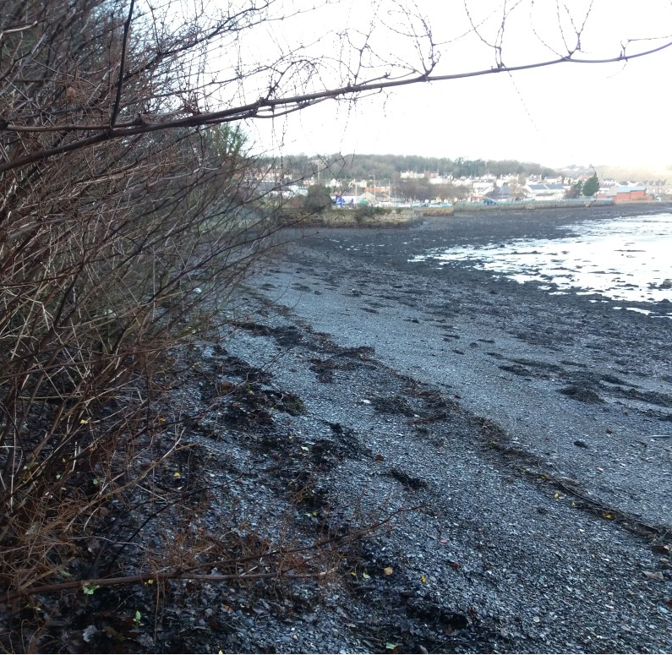
Photograph 1. Stand of Japanese knotweed 80m to the east of the survey area.
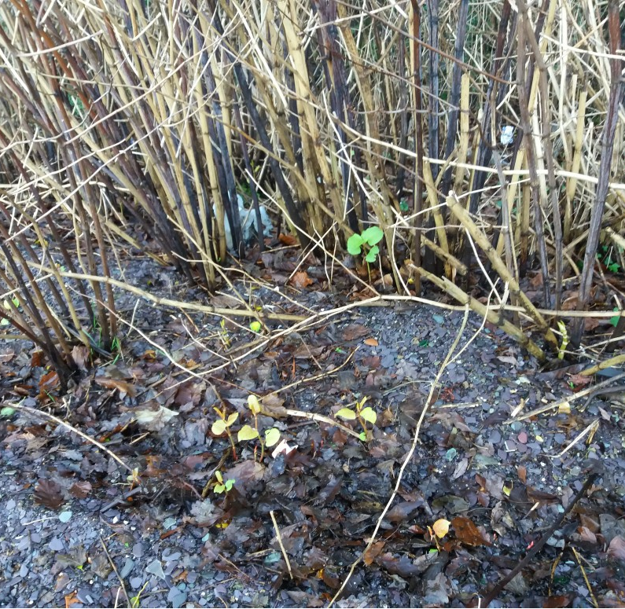
Photograph 2. Stand of Japanese knotweed 80m to the east of the survey area, very early emergent vegetation through the strandline.

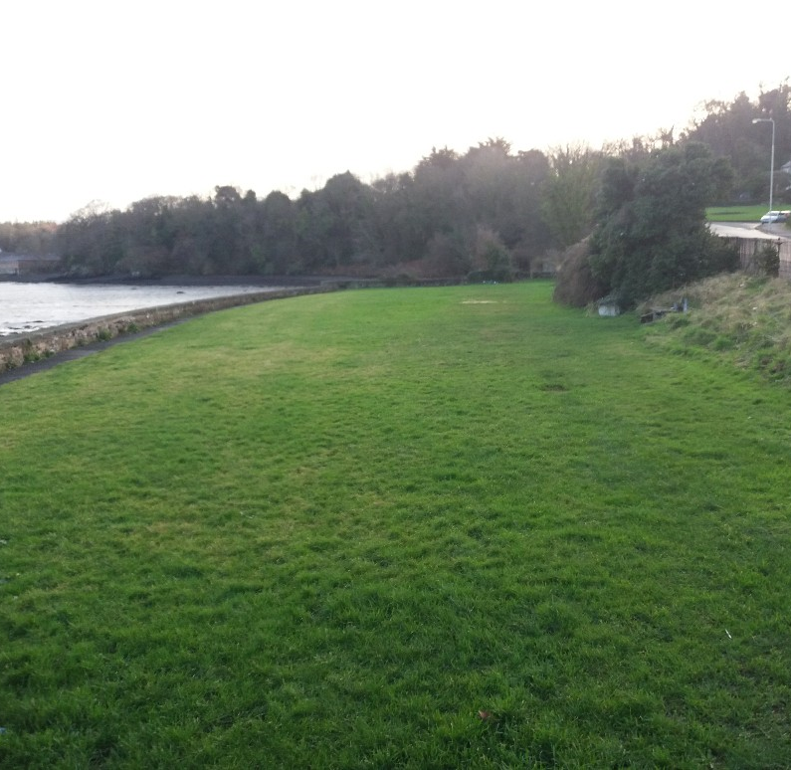
Photograph 3. View to the eastern boundary of the proposed scheme – amenity grassland.
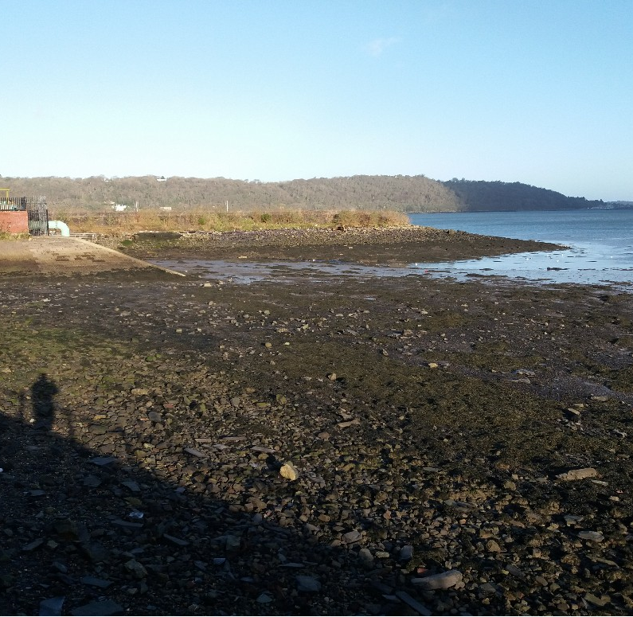
Photograph 4. Typical composition of the upper intertidal zone to the west of the survey area
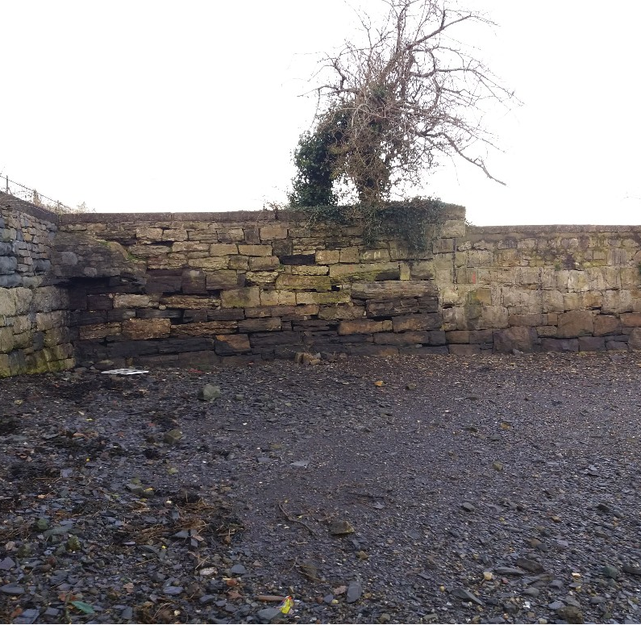
Photograph 5. Existing sea wall to the east of the survey area with slate waste foreshore
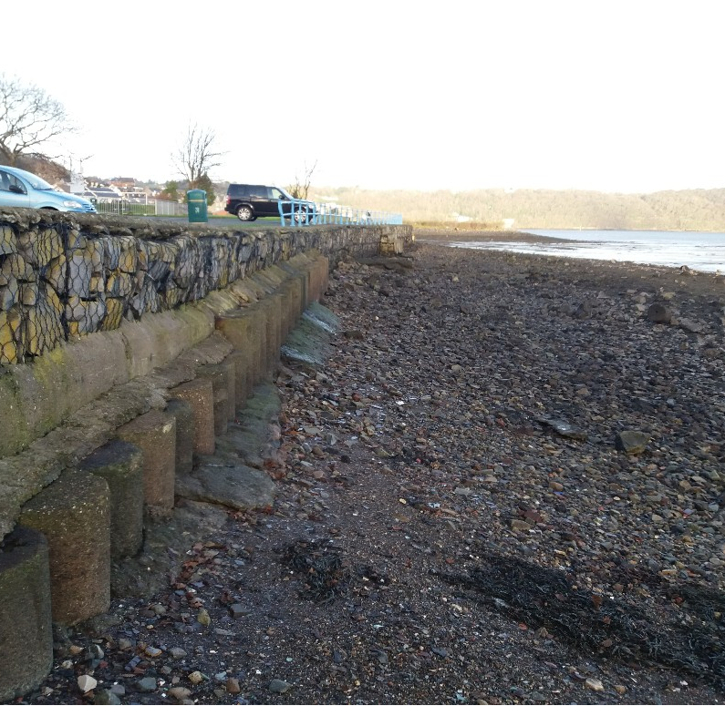
Photograph 6. View of existing sea wall and upper shore adjacent to the east end carpark.

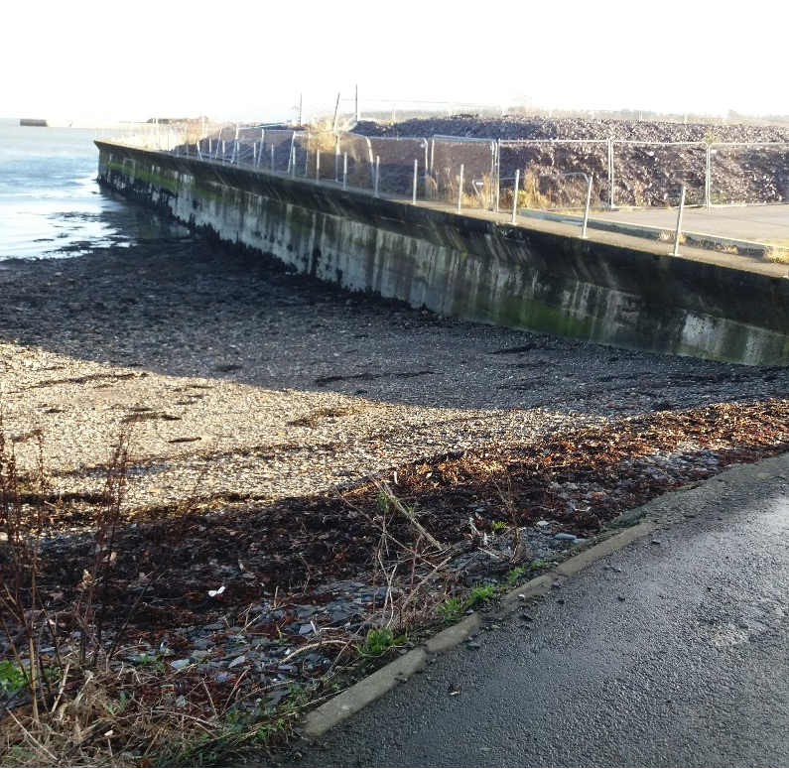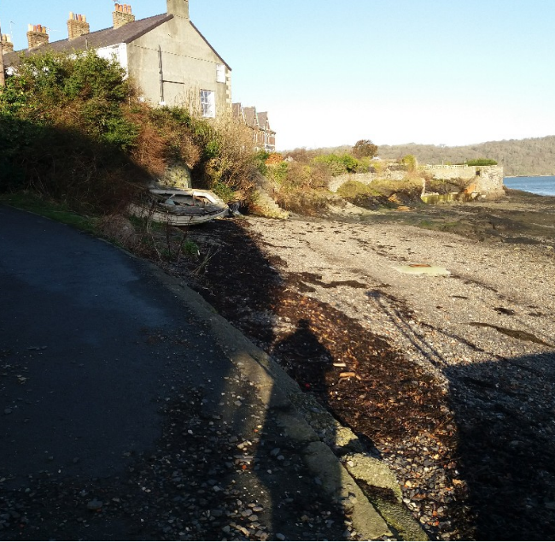
Photograph 7. Western boundary of the survey area just off Lon Glandwr
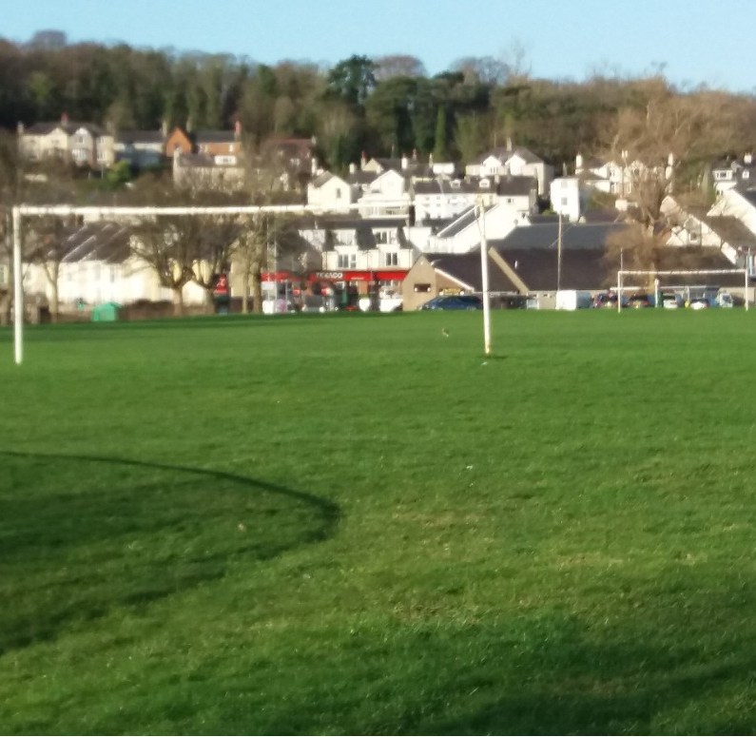
Photograph 8. St Georges playing field with solitary curlew feeding
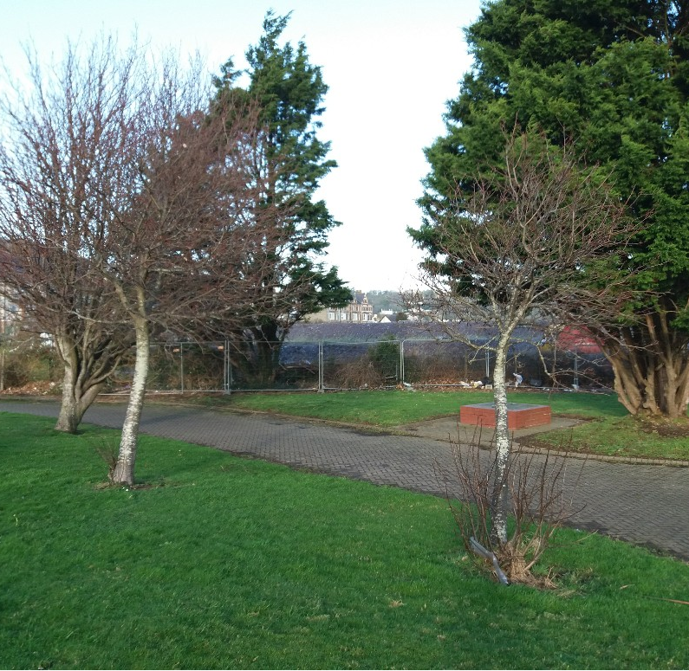
Photograph 9. Ornamental trees including Sorbus sp. Close to the pumping station

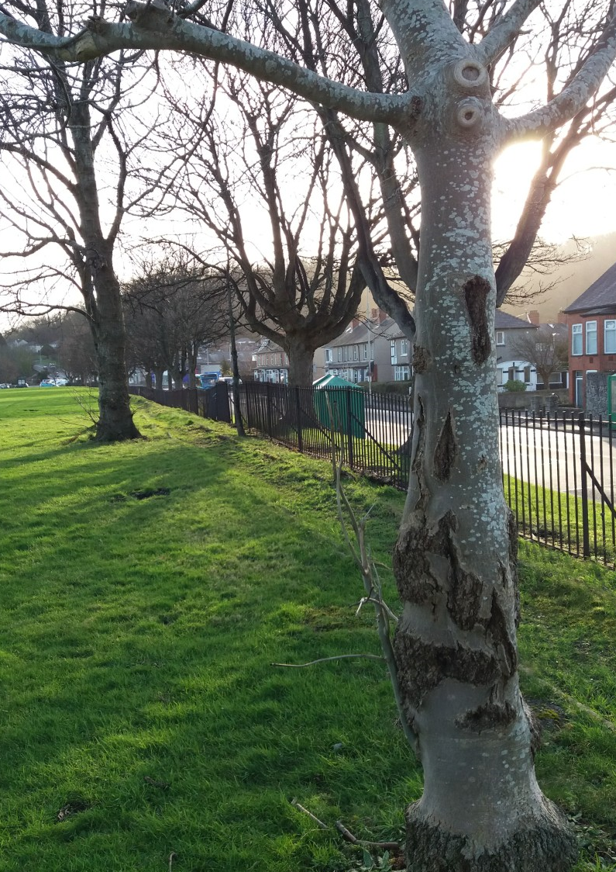
Photograph 10. Standard trees fronting Beach Road

Appendix II: Initial tree survey – full arb report and plan to follow
- Monterey cypress – multi stem, 5m Canopy radius
- Monterey cypress – multi stem, 3m Canopy radius
- Sorbus sp. Multi stem, 4m canopy radius
- Sorbus sp, DBH 18cm, 2m canopy radius
- Sorbus sp, DBH 12cm, 2m radius
- Poplar sp, DBH 86cm, 8m canopy radius
- Ash, DBH 22cm, 2.5m canopy radius
- Acer, DBH 55CM, 5m canopy radius
- Sweet chestnut, 56cm DBH, 6m canopy radius
- Ash, 30 cm DBH, 5m canopy radius
- Acer, 60cm DBH, 6m canopy radius
- Acer, 34cm DBH, 4m canopy radius
- Acer, 56cm DBH, 5m canopy radius
- Acer, 30cm DBH, 3m canopy radius
- Acer, 57cm DBH, 5m canopy radius
- Acer, 38cm DBH, 4m canopy radius
- Acer, 50cm DBH, 4m canopy radius
- Acer, 55cm DBH, 5m canopy radius
- Acer, 45cm DBH, 5m canopy radius
- Acer, 25cm DBH, 2m canopy radius
- Sweet chestnut, 16cm DBH, 1.5m canopy radius
- Acer, 44cm DBH, 4m canopy radius
- Cherry, 20cm DBH, 1.5m canopy radius
- Acer, 46cm DBH, 5m canopy radius
- Alder (Italian?), 55cm DBH, 4m canopy radius
- Acer, 38cm DBH, 4m canopy radius
- Acer, 30cm DBH, 3m canopy radius
- Acer, 30cm DBH, 3m canopy radius
- Acer, 40cm DBH, 4m canopy radius
- Acer, 60cm DBH (taken at 1m due to bulge), 4m canopy radius
- Lime sp, 26cm DBH, 3m canopy radius
- Sweet chestnut, codominant stems both 38cm DBH, 4m canopy radius
- Lime sp, 30cm DBH, 3m canopy radius
- Holly (moribund), significant dead wood throughout, canopy radius of <1m
- Sorbus sp, 20cm DBH, 1m canopy radius.

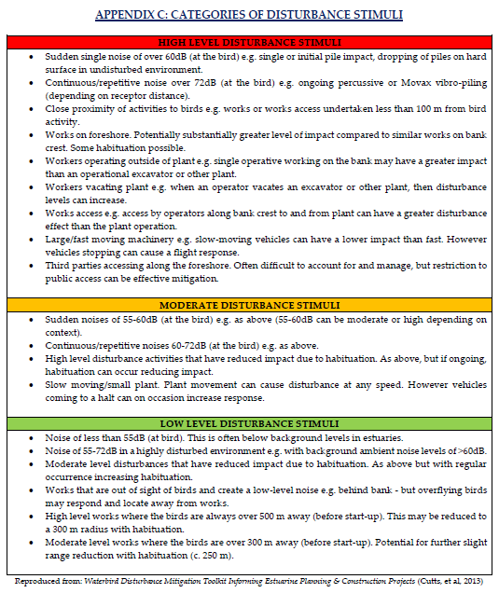

Statutory sites data originally sourced from NRW

