
Hirael Flood Protection
Water Framework
Directive
Assessment
CPF7720

Document Control Sheet
Document Title: | Water Framework Directive Assessment
Document Author(s): | Elin Mirain Roberts
Project Ref / Title: | CPF7720 – Hirael Flood Protection Scheme
Project Manager: | Emyr Gareth

Revision History
Date | Version No. | Summary of Changes
22/11/2021 | 0.01 | Initial draft version
01/12/2021 | 0.02 | Review
17/11/2022 | 0.03 | Changes to reflect amended design (rock armour)

Reviews
Name | Title | Date | Version
Owain Griffith | Principal Environment Officer | 06/12/2021 | 0.02
Rhys Thomas | Senior Environment Officer | 14/11/2022 | 0.03

Approvals
Name | Title | Date | Version
Emyr Gareth | Principal Engineer | 01/12/2021 | 0.02
Emyr Gareth | Principal Engineer | 17/11/2022 | 0.03

Distribution
Name | Title | Date | Version
Emyr Gareth | Principal Engineer |  | 0.0
Designated Officer | Marine Licensing Team, NRW |  | 0.0

© 2020 Gwynedd Council / YGC. All Rights Reserved.  Copyright in any or all of this documentation belongs to Gwynedd Council / YGC of Council Offices, Shirehall Street, Caernarfon, Gwynedd, LL55 1SH (the 'Owner') and may not be used, sold, transferred, copied or reproduced in whole or in part, in any manner of form or on any media to any person other than in accordance with the terms of the Owner's agreement or otherwise without the prior written consent of the Owner. | 

Content
Content |  | 3
Background |  | 4
Introduction |  | 4
Legislative Background |  | 5
WFD Assessment in Stages |  | 6
The Proposal |  | 6
WFD Assessment |  | 8
WFD Classification | 8
WFD Assessment - Screening: | 9
WFD Assessment – Scoping Exercise: | 9
Hydromorphology: | 9
Biology - habitats: | 10
Biology – fish | 11
Water Quality: | 11
WFD Protected Areas | 13
Invasive Non-Native Species (INNS) | 13
Summary of Scoping: | 14
Assessment of impacts on waterbody quality elements | 15
WFD Compliance | 15
Biology: habitats | 16
Water Quality | 16
Protected Areas | 16
Invasive Non-Native Species | 17
Conclusion |  | 17
Appendices |  | 18

This WFD Assessment updates a previous version (v 0.02) which was submitted in support of a Marine Licence Application in December 2021. This update is provided to reflect a design change – the introduction of rock-armour in front of a 130m section of the flood defence wall. The rock-armour is required in order to provide additional stability to the wall.
In order to assist with the review of this document, changes from the original WFD Assessment are highlighted in red.

Background
YGC have been commissioned to carry out Environmental Assessments, including a Water Framework Directive Assessment, in support of a Marine Licence application, for the construction of an increased level of protection to the existing sea defence at Hirael, Bangor. The site of proposed works is located at the north east end of Bangor, within a low-lying river basin with a catchment area that includes most of the city of Bangor.
Introduction
The area consists of approximately 550m of foreshore, a narrow beach and a recreational water front open space area. Immediately behind the area of proposed works is Beach Road (part of the A5) and a densely populated area of residential and commercial properties. The area is as risk of flooding from coastal, fluvial and surface water. The main purpose of the proposal is to build and improve the tidal flood defence in the area.
The proposed flood defence improvement works at Hirael is split into four key sections:

1: Flood defence improvements, re-alignment and improvements to the cycle path and reconstruction of slipway at the Beach Road East section;
2: Main promenade frontage sea wall improvements, including rock armour;
3: 50m (approx..) section of new embankment and multi user path behind Dŵr Cymru Welsh Water pumping station;
4: Glandŵr Road flood protection improvements

A detailed outline design will be submitted for planning approval with the formal detailed design stage to follow consent. It is not envisaged that design will change significantly during detailed design. The proposal is as follows:

Section 1 – section at Beach Road East carpark
Installation of new concrete wall between the existing field and cycle path. Cycle path to be graded and aligned at a constant gradient down from the A5 to the Beach Road East carpark. Reconstruction of slipway to provide access to the foreshore with a flood gate installed at the top of said slipway. The slipway entrance marks the starting point of Section 2.

Section 2 – sea wall at promenade frontage
Construct a retaining wall to replace existing gabions at the promenade, from Beach Road East carpark to Welsh Water pumping station. The new defence will be constructed through a sheet pilling method immediately in front of the existing wall. The space between the new sheet piled wall and the existing gabions (expected to be 2-300mm will be backfilled. A concrete coping and handrail will be installed on top of the sheet-piled wall for both aesthetic and structural reasons. Rock armour – 2m height / 4m in width (varies slightly depending on the height of the foreshore) will be placed in front of the northernmost 130m of the sheet pile wall. To ensure stability of the rock, a key-stone will be embedded on the toe. Any surplus excavated material will be deposited immediately landwards of the toe, to then be buried by the armour stone. The southern part of this section does not include rock armour.

Section 3 – embankment behind Welsh Water pumping station
A compacted topsoil and clay embankment, with 1m wide crest, is proposed for construction between the DCWW compound and Beach Road West carpark. A relocated cycle path is proposed to be installed directly behind the embankment. The construction of a reinforced concrete wall, clad both sides is also proposed to tie into existing raised ground (crushed slate deposits) at the adjacent Y Bae estate (which is directly adjacent to Welsh Water pumping station). At the access to the pumping station, a 9m wide floodgate will be placed to provide both flood defence and vehicular access to the compound (flood gate will be placed between embankment and reinforced concrete wall).

Section 4 – Glandŵr Road
An approximate 20m section of road at Glandwr Road is proposed to be raised slightly (highest point of increase is 0.5m). The construction of a new reinforced concrete flood wall is proposed for two sections at this location. The first at the foreshore in front of Gwymon property and the second along the edge of the carpark with Y Bae estate, tying into the raised ground (crushed slate) within the Y Bae estate (previously known as Dickies boatyard). A 6m flood gate will also be placed on Glandŵr Road which will provide both flood protection and access along the public right of way.

Works are expected to commence in March 2023 for a period up to 12 months.

The proposal is subject to a Marine Licence by Natural Resource Wales, and must also follow the guidelines set out by the WFD legislation and not cause negative effects to the water environment, water quality, ecosystems or biodiversity. This report therefore highlights any impacts the work could potentially have on the waterbody, along with mitigation and an assessment (if required) of whether the proposals complies with the Water Framework Directive.

A full method statement can be found as a supporting document, however the main works to be carried out include the following:

Legislative Background
The Water Framework Directive (WFD) is a European Directive which sets out a strategic planning process for the purposes of managing, protecting and improving the water environment. The WFD introduces new environmental requirements which aim to meet good status in all water bodies. For surface waters, good status is made up of ‘good ecological status (GES)’ (or good ecological potential (GEP) where artificial or heavily modified) and ‘good chemical status’. Ecological status and potential are made up of a number of biological, hydromorphological and physio-chemical quality elements. Chemical status is recorded as either good or failing. For groundwater to be in overall ‘good’ status, both quantitative and chemical status must be ‘good’. The WFD also requires prevention of deterioration in water body status including deterioration of any of the individual quality elements.
The main objectives of the WFD are to:
- Prevent deterioration in the status of aquatic ecosystems, protect them and improve the ecological condition of waters;
- Aim to achieve at least ‘Good Status’ for all waters by 2015 (2021 or 2027 where fully justified within an extended deadline under Article 4.4);
- Promote sustainable use of water;
- Conserve habitats and species that depend directly on water;
- Progressively reduce or phase out the release of individual pollutants or groups of pollutants that present a significant threat to the aquatic environment;
- Progressively reduce the pollution of groundwater and prevent or limit the entry of pollutants; and
- Help reduce the effects of floods and droughts.
New activities and schemes that affect the water environment may adversely impact biological, hydromorphological, physico-chemical and/or chemical quality elements (WFD quality elements), leading to deterioration in water body status. They may also render proposed improvement measures ineffective, leading to the water body failing to meet its WFD objectives for GES/GEP. Under the WFD, activities must not cause deterioration in water body status or prevent a water body from meeting GES/GEP by invalidating improvement measures.

WFD Assessment in Stages
The Water Framework Directive Assessment can have up to three stages, which are
- Screening Stage: excludes any activities that do not need to go through the scoping or impact assessment stages
- Scoping Stage: identifies the receptors that are potentially at risk from your activity and need impact assessment
- Impact Assessment Stage: considers the potential impacts of your activity, identifies ways to avoid or minimise impacts, and shows if your activity may cause deterioration or jeopardise the water body achieving good status
The Proposal
Your activity | Description, notes or more information
Name of activity | Hirael Flood Protection
Brief description of activity | Construction of a new coastal defence spanning the length from Beach Road East carpark to the Dwr Cymru Welsh Water (DCWW) pumping station. A section of defence will also be constructed at Glandwr Road and behind the DCWW pumping station. Realignment and improvement works will also be carried out to the cycle path.
Location of activity (central point XY coordinates or national grid reference) | Scheme location: Section 1 – X: 258794 Y: 372642 Section 2 - X: 258707 Y: 372825 Section 3 – X: 258617, Y: 372887 Section 4 – 285532 Y: 372994
Footprint of  activity (ha) | Approx. 600m in total. Proposal footprint totals approximately 0.5ha.
Timings of activity (including start and finish dates) | Start date: March 2023  End date: March 2024 (Maximum 12 months)*  *Exact timings to be confirmed on contractor appointment.
Extent of activity (for example size, scale frequency, expected volumes of output or discharge | Most of the construction of the sheet-piled wall being scheduled to be carried out from dry land. Plant machinery will be required on the foreshore for ground preparation works and construction of the new slipway.  The rock armour will extend 4m seaward of the sheet-piled wall, in order to provide additional stability to the sheet-piles. The armour will extend for 130m along the upper part of the foreshore, immediately in front of the wall. Much of this area is located landward of the MHW line.  To ensure stability of the rock, a key-stone will be embedded on the toe. Any surplus excavated material will be deposited immediately landwards of the toe, to then be buried by the armour stone.
Use or release of chemicals (state which ones) | None

WFD Assessment
WFD Classification
The WFD classification for a defined water body is produced by assessment of a wide variety of different ‘elements’ which includes:
- ‘biological elements’ such as fish, invertebrates, phytobenthos (which includes plants, macro-algae and phytoplankton);
- ‘supporting elements’ that include chemical measurements such as ammonia, dissolved oxygen, pH, phosphate, copper, zinc and temperature; and
- ‘supporting conditions’ (sometimes referred to as hydromorphology), that assess the physical attributes of the water body such as ‘quantity and dynamics of flow’ and ‘morphology’.
The assessment given for each element is also accompanied by a measure of certainty in the result. The status classification is published in the River Basin Management Plan (RBMP)¹ and provides a baseline condition against which compliance and future improvements can be measured.
The activity / proposal involves the Anglesey North waterbody, and a summary of key elements is provided below.
Water body¹ | Description, notes or more information
WFD water body name | Menai Strait
Water body ID | GB681010120000
River basin district name | Western Wales River Basin
Water body type (estuarine or coastal) | Coastal
Water body total area (ha) | 72.10km² which equals 7210ha
Overall water body status (2018) | Good
Ecological status | Good
Chemical status | Good
Target water body status and deadline | Not Designated
Hydromorphology status of water body | Not Designated
Heavily modified water body and for what use | No
Higher sensitivity habitats present | Mussel beds habitat within scheme footprint.

1
https://www.gov.uk/government/collections/river-basin-management-plans-2015#north-west-river-basin-district-rbmp:-2015

Lower sensitivity habitats present | Rocky shore (intertidal rock), gravel and cobbles (intertidal and subtidal coarse sediment), intertidal soft sediment (mudflats and sandflats).
Phytoplankton status | High
History of harmful algae | None
WFD protected areas within 2km | Menai Strait and Conwy Bay SAC, Traeth Lafan SPA (also a designated SSSI), Coedydd Afon Menai SSSI.

WFD Assessment - Screening:

The WFD is also required in support of a Band 2 Marine Licence Application, by NRW.
WFD Assessment – Scoping Exercise:
The scoping exercise is carried out to identify all the potential risks to each receptor element that are used to determine the status of the waterbody. The receptors / elements are:
- Hydromorphology
- biology – habitats
- biology – fish
- water quality
- protected areas
These receptors are based on the water body’s quality elements (supporting elements, biological elements, and chemical elements).
The scoping exercise has been undertaken following the template provided on the gov.uk² website.
Hydromorphology:
Consider if your activity: | Yes | No | Hydromorphology risk issue(s) / observations
Could impact on the hydro morphology (for example morphology or tidal patterns) of a water body at high status | Requires impact assessment | Impact assessment not required | The proposal seeks to maintain and improve the existing structure. The sheetpile wall will be on the same footprint as existing wall. However, for a 130m long section, rock armour will extend out 4m from wall.
Could significantly impact the hydro morphology of any water body | Requires impact assessment | Impact assessment not required | As above.

² https://www.gov.uk/guidance/water-framework-directive-assessment-estuarine-and-coastal-waters#contents

Is in a water body that is | Requires impact assessment | Impact | The proposed activity is not
heavily modified for the same | Requires impact assessment | assessment | within a waterbody classed as
use as your activity | Requires impact assessment | not required | heavily modified.

Biology - habitats:
Consider if habitats are at risk from your activity.
Higher sensitivity habitats 3 | Lower sensitivity habitats ⁴
chalk reef | cobbles, gravel and shingle
clam, cockle and oyster beds | intertidal soft sediments like sand and mud
intertidal seagrass | rocky shore
maerl | subtidal boulder fields
mussel beds, including blue and horse mussel | subtidal rocky reef
polychaete reef | subtidal soft sediments like sand and mud
saltmarsh
subtidal kelp beds
subtidal seagrass

Consider if the footprint⁵ of your activity is: | Yes | No | Biology habitats risk issue(s) / observations
0.5km² or larger | Yes to one or more – requires impact assessment | No to all  impact  assessment not  required | No – the total area of the proposed activity is 0.5ha, which equates to 0.005km2.
1% or more of the water body’s area | Yes to one or more – requires impact assessment | No to all  impact  assessment not  required | No - the total area of water body is 12600 ha, and area of proposed activity does not exceed 0.5ha, which represents less than 0.007% of the waterbody area.
Within 500m of any higher sensitivity habitat | Yes to one or more – requires impact assessment | No to all  impact  assessment not  required | Yes – The proposed work is within 500m and located directly adjacent to a mussel bed habitat. Due to the proximity of the higher sensitivity habitat and the tidal processes between both sites an impact assessment is
³ Higher sensitivity habitats have a low resistance to, and recovery rate, from human pressures.
⁴ Lower sensitivity habitats have a medium to high resistance to, and recovery rate from, human pressures.
⁵ Note that a footprint may also be a temperature or sediment plume. For dredging activity, a footprint is 1.5 times the dredge area.

 |  |  | required, as it cannot be ruled out at the scoping stage.
1% or more of any lower sensitivity habitat |  |  | No – There are lower sensitivity habitats within the area of the works. However, it is not believed that the footprint of the scheme would exceed a total area of more than 1% of the habitat area.

Biology – fish
Consider if fish are at risk from your activity, but only if your activity is in an estuary or could affect fish in or entering an estuary.
Consider if your activity: | Yes | No | Biology fish risk issue(s) / observations
Is in an estuary and could affect fish in the estuary, outside the estuary but could delay or prevent fish entering it or could affect fish migrating through the estuary | Continue with questions | Go to next section | Whilst the work is located on the lower reaches of Afon Adda and Cegin, the work does not involve creating any physical barriers within the watercourse that would impact fish movement. Pilling works are scheduled above mean high water level.
Could impact on normal fish behaviour like movement, migration or spawning (for example creating a physical barrier, noise, chemical change or a change in depth or flow) | Requires impact assessment | Impact assessment not required | Not applicable
Could cause entrainment or impingement of fish | Requires  impact  assessment | Impact  assessment  not required | Not applicable

Water Quality:
Consider if water quality is at risk from your activity.

Consider if your  activity: | Yes | No | Water quality risk issue(s) / observations
Could affect water clarity, temperature, salinity, oxygen levels, nutrients or microbial patterns continuously for longer than a spring neap tidal cycle (about 14 days) | Requires impact assessment | Impact assessment not required | No – the proposed work would predominantly be carried out above tide level, and therefore would not directly impact water clarity, temperature, oxygen levels, nutrients or microbial patters of the water body, especially not for continuous periods longer than 14 days. There may be some discolouration of water and sediment resuspension, however, this would clear within 1 tidal cycle i.e. high water – low water – high water
Is in a water body with a phytoplankton status of moderate, poor or bad | Requires impact assessment | Impact assessment not required | No – From available information, the waterbody does not have a phytoplankton status of moderate, poor or bad.
Is in a water body with a history of harmful algae | Requires impact assessment | Impact assessment not required | No – As far as we are aware, the waterbody does not have a history of harmful algae.

Consider if water quality is at risk from your activity through the use, release or disturbance of chemicals.
If your activity uses or releases chemicals (for example through sediment disturbance or building works) consider if: | Yes | No | Water quality risk issue(s) / observations
The chemicals are on the | Requires | Impact  assessment  not required | Plant machinery will be required to undertake the proposed activity, and therefore there is an inherent risk of releasing oils and fuels into the environment, albeit, the risk is considered to be low.
Environmental Quality | impact | Impact  assessment  not required
Standards Directive (EQSD) list | assessment | Impact  assessment  not required
It disturbs sediment with contaminants above Cefas Action Level 1 | Requires impact assessment | Impact assessment not required | No – we have no reason to believe that the activity would disturb sediments with contaminants above Cefas Action Level 1.

If your activity has a mixing zone (like a discharge pipeline or outfall) consider if: | Yes | No | Water quality risk issue(s) / observations
The chemicals released are on the Environmental Quality Standards Directive (EQSD) list | Requires impact assessment⁵ | Impact  assessment not required | No – the proposal does not use a chemical mixing zone.

WFD Protected Areas
Consider if WFD protected areas are at risk from your activity. These include:
- Special Areas of Conservation (SAC)
- Special Protection Areas (SPA)
- Shellfish waters
- Bathing Waters
- Nutrient Sensitive Areas
Consider if your activity is: | Yes | No | Protected areas risk issue(s) / observations
Within 2km of any WFD  protected area⁶ | Requires  impact  assessment | Impact  assessment not  required

Invasive Non-Native Species (INNS)
Consider if there is a risk your activity could introduce or spread INNS.
Risks of introducing or spreading INNS include:
- materials or equipment that have come from, had use in or travelled through other water bodies
- activities that help spread existing INNS, either within the immediate water body or other water bodies

Consider if your activity could: | Yes | No | INNS risk issue(s) / observations
Introduce | Requires | Impact | The NRW coastal risk assessment shows that the Menai Strait is at risk from the following INNS:  - American Oyster Drill  - Leathery Sea Squirt  - Colonial Tunicate  - Slipper Limper  And is at an overall INNS risk of deterioration by  2050.  No temporary working area will be required for the works. There will be presence of plant machinery on the foreshore, above mean high water level for a limited amount of time. The risk of introduction of marine INNS is low in this instance. However, it is common practice to wash down equipment following a period working in/near marine environments (to ensure longevity of equipment and reduce ongoing maintenance and repair costs), and risk should be managed by ensuring the plant are cleaned before leaving the existing / preceding site, and are clean on arrival onto this site. Following these pollution prevention measures will help reduce the risk further.
or spread | impact | assessment
INNS | assessment | not required

Summary of Scoping:
Receptor | Potential  risk to  receptor? | Note the risk issue(s) for impact assessment
Hydromorphology | Yes | It is concluded that it is unlikely that the sheet piled wall work would have any impact on hydromorphology, due to the maintenance and minor improvements nature of the works on the footprint of the existing wall. However, due to the placement of rock armour on a 130m long section of the foreshore, the impact could not be ruled out at the scoping stage.
Biology: habitats | Yes | There is a Higher Sensitivity Habitat located 26m away from the proposed work. Due to the close proximity the impact could not be ruled out at the scoping stage.

Biology: fish | No | Whilst the work is located on the lower reaches of Afon Cegin and Adda, the work does not involve creating any physical barriers within the watercourse that would impact fish movement. Piling works are scheduled to take place above mean high water level.
Water quality | Yes | Plant and machinery will be required to undertake the proposed activity, and therefore there is an inherent risk of releasing oils and fuels (PAHs) into the environment, albeit, the risk is considered to be low.
Protected areas | Yes | The proposed activity is being undertaken on the boundary of a protected area, therefore, potential impact to protected sites cannot be ruled out at scoping stage. Risk / issues for impact assessment include physical change, disturbance and pollution.
Invasive non-native species | Yes | Plant and machinery will be used but will not be submerged in water at any given point during the course of the works. However at this stage it cannot be ruled out completely that the plant would be free from INNS, as it is unknown where the plant would be used immediately prior to mobilisation to this site. Risk of introducing INNS to the waterbody cannot be ruled out at scoping stage.

Assessment of impacts on waterbody quality elements
WFD Compliance
There are three key objectives against which the impacts of proposed works on a water body need to be assessed to determine compliance with the overarching objectives of the WFD:
- Objective 1: The Scheme will not cause deterioration in any element of water body classification.
- Objective 2: The Scheme will not prevent the WFD status objectives from being reached within the water body or other downstream water bodies.
- Objective 3: The Scheme will contribute to the delivery of the relevant WFD objectives. In this case it will be what contribution the Scheme can make towards the water body reaching its objective Good Ecological Potential (GEP) through planned RBMP mitigation measures.
The first two objections must be met to avoid infraction of the WFD. The delivery of the third objective is central to the implementation of the WFD, where it can be supported through its operational activities. If it is considered that the scheme is likely to cause deterioration in water body status or prevent a water body from meeting its ecological objectives then an assessment would be

made against the conditions listed in Article 4.7 of the WFD. Article 4.7 can be invoked if; ‘new modifications’ are of overriding public interest and/or the environmental and social benefits of achieving the WFD objectives are outweighed by the benefits of the new modifications to human health, safety and sustainable development; there are no significantly better environmental options that are technically feasible or not disproportionately costly; and all practicable steps for mitigation have been taken.
Hydromorphology
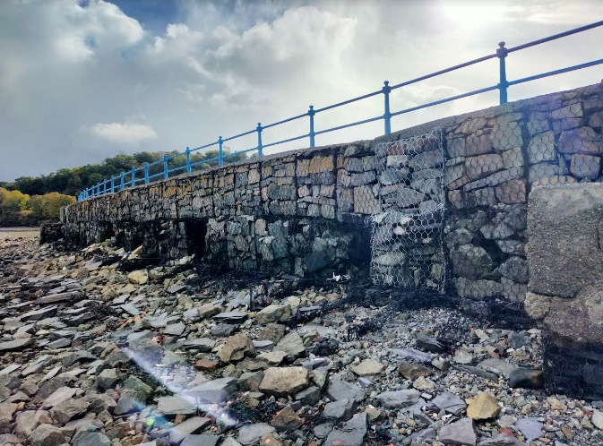
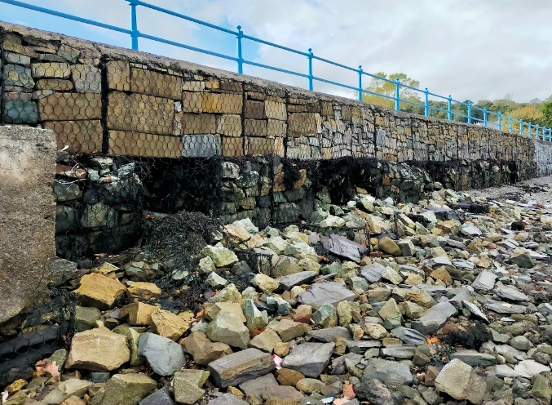
The scoping exercise (including discussions with NRW’s Senior Marine Advisor) identified that the proposed placement of rock armour in front of a section of the sea wall requires assessment from a hydromorphological perspective. The over-all footprint of this section is limited to approximately 410m² with the rock extending 4m seawards from the base of the sheet-piled wall.
The affected foreshore currently comprises of angular rocks – derived primarily from the historic land reclamation during the 19th century (slate waste) and degraded gabion stone. The angular nature of the rocks demonstrates the relatively low-energy environment at Hirael Bay – coastal processed have not rounded the rocks despite the material having been present on the foreshore for many years. The affected location is assessed not to currently contribute significantly to the sediment flux into Hirael Bay or the wider Menai Strait. The placement of armour stone (540 – 690kg / 550 – 640mm diameter) over part of this area is therefore expected to have a negligible impact (if any) on hydromorphology.

In terms of temporary work, to ensure stability of the rock, a key-stone will be embedded on the toe. Any surplus excavated material will be deposited immediately landwards of the toe, to then be buried by the armour stone.

The placement of the rock-armour can be expected to result in some minor short-term discolouration of the water. Excavation to embed the key-stone will be kept to a minimum (200mm at the toe – see drawing below). As this upper horizon of the foreshore consists primarily of rocks (gabion stone and slate), rather than finer material, the temporary work is expected to result in minimal mobilisation of sediment and therefore have a negligible impact on hydromorphology.

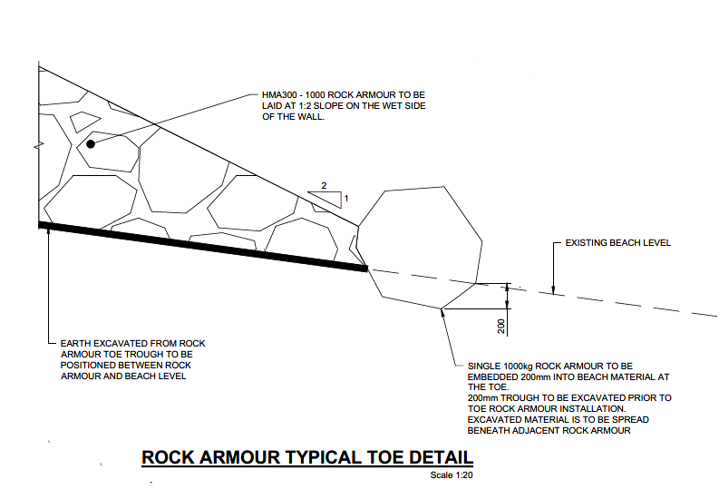
Biology: habitats
The scoping exercise identified that the proposed activity is within a Mussel bed that is a Habitat of Higher Sensitivity. The work is being undertaken on a coastal defence structure on the footprint of the existing wall. Whilst accepting that there is an impact pathway, the proposed work would not take any land from the Mussel bed. The historic mussel bed is shown to be under/near several highly developed areas. Therefore, given that the proposal seeks to improve the coastal defence on the same footprint as current wall it is considered unlikely that the proposed activity would contravene Objective 1 for this particular element.
Water Quality
Plant and machinery will be required to undertake the proposed activity, and therefore there is an inherent risk of releasing oils and fuels into the environment, although the risk is considered to be low due to no in water works, the impact on the waterbody could not be completely ruled out at the scoping stage. The following Reasonable Avoidance and Mitigation Measures will be implemented during the course of the proposed work:

- Use biodegradable lubricant and hydraulic oil in plant machinery if possible. Biodegradable oils are less toxic than most synthetic oil but should be stored to the same standards as other oils and prevented from entering the water environment;
- Implement best practice to ensure good housekeeping, for example ensuring all machinery used is kept to good repair and subject to regular checks;
- Ensure all fuel and other potentially hazardous chemicals is stored in a safe compound at a distance of at least 10m from the shoreline;
- Use of spill kits and personnel trained to use the kit will be available on site on case of oil leak.
- Good working practices will be taken, such as adhering to GPP5 Works and maintenance in or near water. Pollution prevention measures to be stipulated in a Construction Environmental Management Plan (CEMP)
- The contractor has a designated company, which they use to deal will accidental spillages this forms part of their emergency plan.
- NRW emergency help line (0300 065 3000) will be contacted in the case of an emergency spill.
Since the plant and machinery would not directly enter the waterbody, and assuming that machinery used are well maintained, it is considered unlikely that the proposed activity would result in a contravention of Objective 1. However, accidents do happen – and by having the above measures in place it will reduce any impact should an accident occur.
Protected Areas
The proposed work is located within 2km of WFD Protected Areas, namely Menai Strait and Conwy Bay SAC and Traeth Lafan SPA. Since there are engineering works within 2km of these protected areas, and a potential impact pathways in the form of tidal action, impact upon these receptors could not be ruled out at scoping stage
A Habitat Regulations Assessment (CPF7720 Hirael Flood Alleviation Scheme Habitat Regulations Assessment– available as a separate document), has been produced for the works. Whilst Likely Significant Effect could not be ruled out in the screening stage (Stage 1 – Test of Likely Significant Effect), due to potential disturbance, in particular due to noise on the wintering birds features of the Traeth Lafan SPA and potential pollution pathway from proposal site to the SAC. A conclusion of No likely Significant Effect was reached at Stage 2 with the implementation of Reasonable Avoidance Measures. Therefore it is considered that the proposed activity will not result in the contravention of Objective 1.
The mitigation measures can be found in Table 10 of the HRA.
Invasive Non Native Species

The NRW coastal risk assessment shows that the Menai Strait is at risk from the following INNS:
- American Oyster Drill
- Leathery Sea Squirt
- Colonial Tunicate
- Slipper Limper
And is at an overall INNS risk of deterioration by 2050.
There are no equipment scheduled to be placed directly in the water to carry out the works, however the scheme will require plant machinery to carry out site preparation works and slipway construction from the foreshore. The construction of coastal defence will be carried out from dry land. The risk of introduction of marine INNS is low in this instance, however risk should be managed by ensuring the plant are cleaned before leaving the existing / preceding site, and are clean on arrival onto this site.
By implementing the simple protocol of Check, Clean and Dry, it is considered that the proposed activity would not result in a contravention of Objective 1.
Conclusion
It is established through the assessment above that by implementing good working practices and reasonable avoidance measures that the proposed works would not lead to deterioration of any quality element of the waterbody (objective 1) nor would prevent the overall objectives for the waterbody being met (Objective 2).

Appendices

Hirael Flood Protection Detailed Design (as separate document)
Hirael Flood Protection Habitats Regulations Assessment (HRA) (as separate document)

Appendix A – Site outline

