Surface water courses
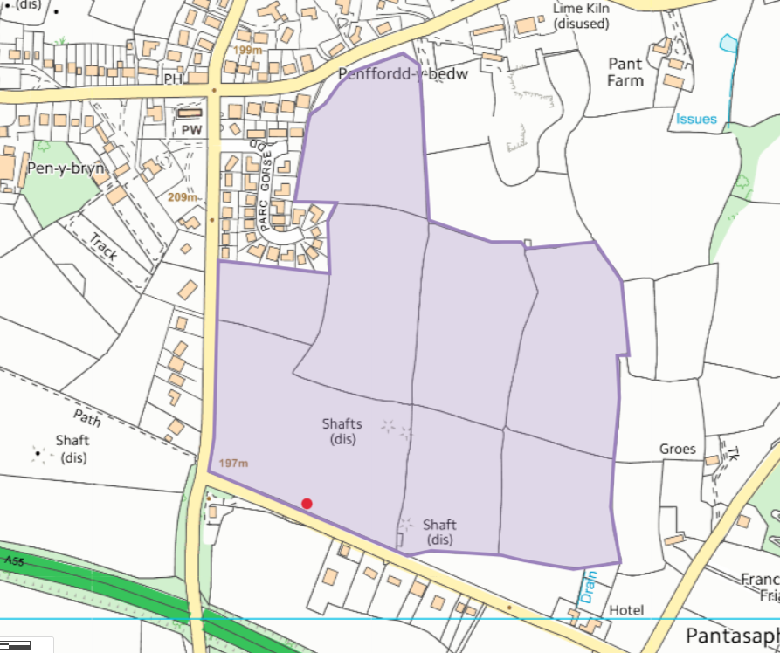
Public rights of way
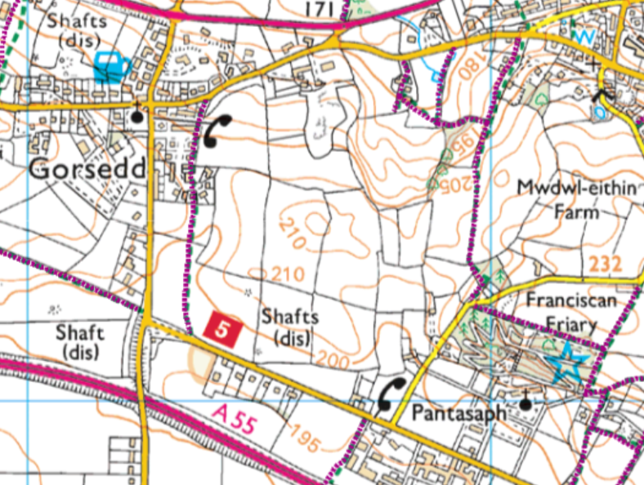

Protected habitats- Lowland dry acid grassland and Lowland calcareous grassland
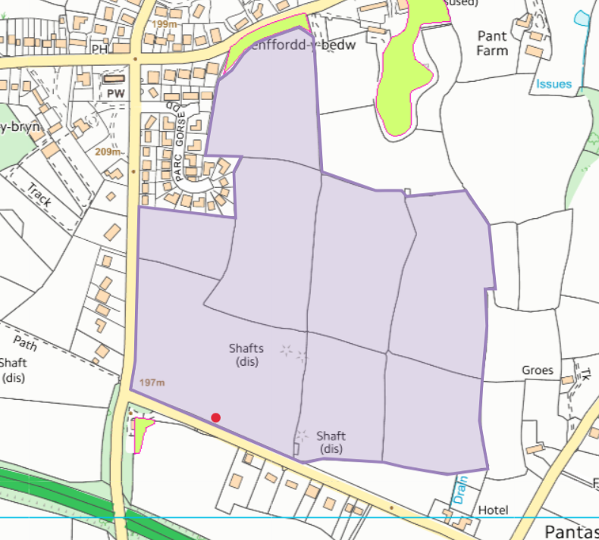
Local Wildlife site- Calvary Wood and Grange Quarries
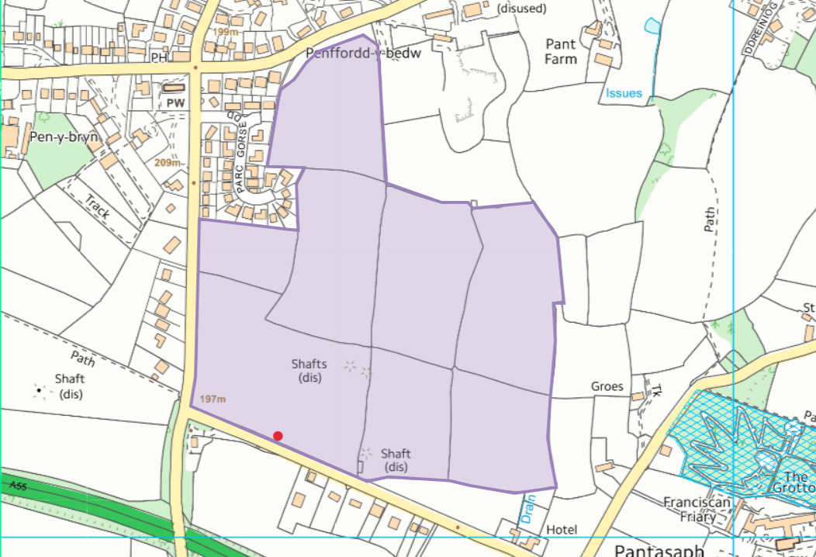
Slope


