CRoW Appendix 4 (140_10_SD02)  CRoW Act 2000: Natural Resources Wales application for permission - Formal Notice |  | 
Natural Resources Wales Formal Notice.
Requirements of Section 28I of the Wildlife & Countryside Act 1981 as amended by the Countryside and Rights of Way Act (CRoW) 2000.
Duty in relation to granting any consent, licence or permit for activities likely to damage Sites of Special Scientific Interest (SSSI).
Guide to filling in this form for Natural Resources Wales staff:
To be completed by Permitting Officers for any applications for a permission which the Natural Resources Wales has considered under S28G duties to protect and enhance SSSIs. This applies to all proposed permissions within a SSSI, and to operations outside the SSSI boundary which are likely to damage its special features.
Refer to OI 140_10 ‘Applying the Countryside and Rights of Way (CRoW) Act 2000 to applications for permits with potential for impact on Sites of Special Scientific Interest (SSSI)’, including the flowchart in Appendix 2.
Pink italic text – drafting notes, to be deleted before completion/consultation.
Blue text – examples, to be replaced with permission-specific information.
Ensure you have completed all sections.
- Natural Resources Wales area/region/NPS hub: | Bridgend, Rhondda Cynon Taff and Merthyr Tydfil Environment team
- Name of SSSI: | - Llantrisant Common and Pastures  - Rhos Tonyrefail
- Type of permission: | Environmental Permit
- Date for Natural Resources Wales permit determination: | 17/11/2022
- Predicted 28 day date for response from NRW conservation/ecology (under S28 I(4)): | N/A – filed for audit
- Natural Resources Wales reference no: | EPR/AB3894ZF/V002
- National grid reference: | ST 04131 84511
- Description of proposal: | Purolite Limited have applied for a normal variation to their permit to add new process line and a new steam boiler (510 KWth) to be added to their site Unit C located in Llantrisant.  The main changes to the permit as a result of this variation are:  - Point source emission to air of bromine from a bromine scrubber (proposed on the permit as a new emission point A6)  - Point source emission for the new steam boiler which would include emission of NOx and carbon monoxide (as a new emission point A5).  The boiler is below 1MW thermal input and therefore is not subject to the medium combustion plant directive. The new boiler will operate for 404 hours per year alongside an existing steam boiler (also 510 KWth).  There are no changes to the site layout as a result of this variation the discharge to sewer (which is subject to a trade effluent consent) or uncontaminated surface water runoff as a result of the variation.
- Is the proposed activity within (wholly or partially) the SSSI boundary? | No  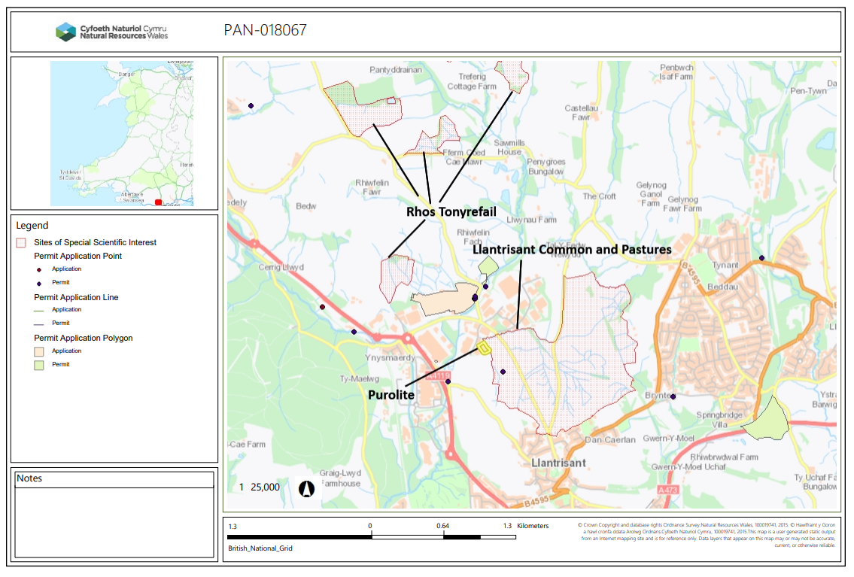  - Llantrisant Common and Pastures SSSI  The installation boundary borders the western boundary of this site  - Rhos Tonyrefail SSSI  The installation is 820 meters away from the nearest unit of this SSSI
- Has there been any pre-application discussion or correspondence with NRW conservation/ecology | No
- What aspect(s) of the proposed permission may damage the features which are of special interest for the SSSI?
The following ‘Operations Requiring Consent’ (or other activities associated with the permission) for both sites that may cause damage) are relevant to the proposed permission.

7. Dumping, spreading or discharging of any materials

This will be via point source emissions to air of nitrous oxide from the new proposed steam boiler.

Bromine and carbon monoxide do not have an environmental quality standard so have not been considered for ecological impact.

The main aspect of the proposal that could have a potential impact pathway to affect the feature of this site is through the emissions of oxides of nitrogen from the natural gas fuelled steam boilers that could cause damage through increase in NOx concentration and increase in smothering, nutrient nitrogen deposition and acidity through the deposition of NOx.

The following SSSI features and mechanisms of impact have been considered to assess the likelihood of damage:

Llantrisant Common and Pastures
- Marshy grassland
- Acid flush
- Acid grassland
- Species-rich neutral grassland
- Cornish moneywort
- Bog earwort

Rhos Tonyrefail
- marshy grassland,
- acid flush,
- species-rich
- neutral grassland,
- acid grassland
- wet heath
- blanket mire

Definitions

Please see below for list of definitions for technical terms used in this assessment:

Environmental standard | The concentration of pollutants in atmosphere above which possible significant harmful effects to receptors such as humans, plants, ecosystem or materials may occur
Critical Load | The quantity of deposition of a pollutant above which possible significant harmful effects to humans, plants, ecosystem or materials may occur.
Process contribution (PC) | The concentration of pollutants from the proposal/installation.
Predicted environmental concentration (PEC) | The predicted concentration of the pollutant from both the emission from the proposed process and the known background concentration of that pollutant in the area.
Nitrogen acidity | Acidity that originates from nitrogen acids
Total Acidity | The combined acidity from nitrogen and sulphur acid deposition
Minimum acid critical load  (MinClMaxS minCLMaxN minCLminN) | The lower acid critical load values of the designated site below which emissions screen out as insignificant.
Maximum critical load  (MaxClmaxS, MaxCLmaxN maxCLminN) | The highest acid critical load values of the designated site above which adverse impacts are likely

Llantrisant Common and Pastures SSSI

Atmospheric NOx

In the initial assessment provided by the applicant using the H1 tool, emissions of NO_{x} did not screen out for both process contribution and predicted environmental concentration (both long and short term emissions). As such the applicant has provided detailed modelling to determine the impacts of emissions of NO_{x} on the local ecological (and human) receptors.

The maximum process contribution for long term emissions of NO_{x} at this site was 12.5 µg/m³ which represents 43% of the long-term environmental standard (30 µg/m³) and is more than 1% of the environmental standard which means that the emissions cannot be ruled out as insignificant at this stage. The predicted environmental concentration (PEC) was calculated as 28.2 µg/m³ which is 94% of the environmental standard at the closet point from the installation. As this is less than 100% of the environmental standard (using modelling) the impact of atmospheric NO_{x} will not be significant and therefore no further assessment was required.

The applicant compared the maximum short term PC has been assessed against the upper limit ES of 200 µg/m³. The PC has been calculated to be 56.7 µg/m³ or 28% of the short term environmental standard (200 µg/m³) however. the predicted environmental concentration is 88.1 µg/m³ which represents 44% of the short term environmental standard of 200 µg/m³. Therefore, as PEC is less than 100% of the environmental standard (200 µg/m³) emissions are considered not significant.

Acidification

The applicant had assessed the contribution of deposition of nitrogen towards the acidification (Nitrogen-acidity and total acidity).

The process contribution of acidity was 0.0903 kg/Ha/year or 15.4% of the minimum total acid critical load (0.582 kg/ha/year). The predicted environmental concentration did not screen out at 271% of the minimum acid critical load, owing to the high background of 1.5 kg/ha/year or 256% of critical load.

As the acid deposition has does not screen out as insignificant, the applicant against the maximum critical load of total acidity (2.88 kg/ha/year) to determine if the acid deposition would result in adverse impact on the designated features of the site. The process contribution from the proposal was 3.1% of the maximum critical load for acidity (2.88 KgN/Ha/year) and the predicted environmental concentration was 55.2% of the acid maximum critical load .
As the PEC was less than 100% of the maximum acid critical load, we can conclude that the acidity from deposition will not likely lead to any adverse impacts to the site. .

Deposition of nutrient nitrogen

The applicant has supplied and air quality assessment along with modelling to assess the potential impact mechanism to the site’s feature through deposition. The highest process contribution (located at part of the SSSI closet to the installation site (1 meter away from the installation boundary)) was calculated by the applicant as 1.26 kgN/Ha/Year which is 16 % of the minimum critical load for nitrogen of 8 kgN/Ha/year. Therefore, the emissions do not screen out as insignificant. The predicted environmental concertation of Nutrient nitrogen deposition was 222% of the minimum critical load and as such the emissions cannot be determined to not be significant at this stage. Therefore we have to consider likelihood of adverse impacts

The proposed permission is not anticipated to be likely to damage the SSSI for the following reasons:

- The modelling done by the applicant assumes worst case emission for both boilers operating all year (for 8760 hours). In reality it is unlikely that both boiler (one already permitted and the new boiler) would be running. The operator has stated that the new boiler will run for 404 hours rather than the full 8760 hours used for modelling (The operational hours were accounted for H1 but not for the detailed modelling).

- The process contribution is less than 100% of the critical load. While the highest PC is not insignificant to be screened out this does not necessarily mean it is going to lead to a significant impact. The highest PC at 16% of the critical load represents the most conservative value against the minimum critical load. For the majority of the SSSI, the process contribution is less than 1% of the critical load and screens out as insignificant in these areas.

- This high PEC (222%) is due to the high background concentration ( ) of nutrient nitrogen in the SSSI which is already above 100% of critical load. This includes areas of the SSSI where the PC is below 1% of the critical load. The SSSI notification for Llantrisant Commons states the site has a long history of animal grazing which was one of the important reasons for the site to be designated habitat. This is most likely what is causing exceedance in nutrient nitrogen background and nitrogen acidity at the site which is backed up by Air Pollution Information System (APIS) breakdown^{iii} (figure 1) the local source attribution which shows livestock to contribute 36.6%.

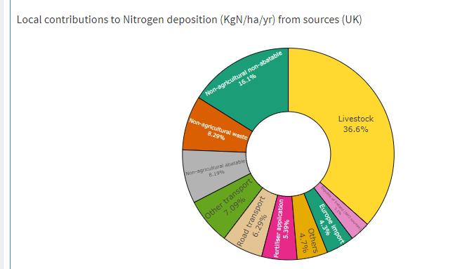
Figure 1: Local source attributions to nutrient nitrogen deposition of Llantrisant common and pastures taken from air pollution information system.

Rhos Tonyrefail

Atmospheric NOx
Detailed modelling provided by the applicant showed that the process contribution (PC) at the closest points of the SSSI for NOx long term was at its highest value 0.019 µg/m³ which comes out as 0.06% of the long term ES of 30 µg/m³. The short-term PC was calculated to be 0.28 µg/m³ which is 0.38% of the short term ES for NO_{x} (75 µg/m³).

As the long term is below 1% of the environmental standard and short term is below 10% of the ES the emissions can be screened out as insignificant and will not cause any impact through this pathway.

Deposition
Modelling provided by the applicant showed that the process contribution from the proposal towards nutrient nitrogen deposition was for grassland receptor was 0.002 kgN/ha/year which is 0.025% of the critical load of 8 kgN/ha/year and for woodland 0.002 kgN/ha/year which is 0.04% of the critical load for woodland of 5 kgN/ha/year. As these are below 1% of the minimum critical load using the most conservative values, the emissions screen out as insignificant and would not cause any impact through this pathway.

Acidity
Modelling of acidity resulting from deposition of NO_{x} from the proposed emissions showed that the highest process contribution was less than 1% of the critical load of the (lowest) minimum total acidity of the site for both woodland and grassland type habitats. Therefore, the impact from the emissions screens out as insignificant for this SSSI.

References
i Air emissions risk assessment for your environmental permit - GOV.UK (www.gov.uk)
ii SSSI NOTIFICATION/RENOTIFICATION MANAGEMENT STATEMENT - FORMAT (naturalresources.wales)
iii APIS app | Air Pollution Information System
- Decision
i) The proposed permission is not likely to damage any of the flora, fauna or geological or physiological features which are of special interest.

Llantrisant Common and Pastures – not likely to damage the features for the following reasons;

- Impacts from atmospheric NOx have screened out as insignificant emissions (both long term and short term).
- Acidity from nitrogen deposition was less than 1% of the maximum acid critical load therefore we can conclude that there are no likely adverse impacts.
- Nutrient nitrogen deposition did not screen out as insignificant as the process contribution was more than 1% and the predicted environmental concentration was above 100%, due to the exceedance in background.

However, while the deposition of nutrient nitrogen did not screen out as insignificant, it is unlikely to cause damage to the SSSI for the following reasons:

- The process contribution only exceeded in a small area of the SSSI closet to the installation. The majority of the SSSI has a process contribution of less than 1% (therefore insignificant emissions for the majority of the SSSI).
- The applicant has modelled on the boilers being run at full capacity all year (8,760 hours) to give the most conservative, worst case scenario against the minimum/ lower critical load. In reality the boilers will not be running for the whole year with the applicant stating that the new boiler would only operate for 404 hour or 4.6% of the time they have modelled for. Therefore, it is unlikely that the actual operation would lead to the long term exceedance in nitrogen deposition predicted by the modelling.

Rhos Tonyrefail – The process contribution from emissions of NOx towards atmospheric NOx and deposition of nutrient nitrogen and acidity all screen out as insignificant and therefore there is no pathway that would cause damage to the feature of this SSSI.

Natural Resources Wales is minded to:
Issue the permission

- Name and job title of Natural Resources Wales officer: | William Wallace  Permitting Officer
- Date form sent to NRW conservation/ecology | N/A – Filed for audit
For Natural Resources Wales use only, once NRW conservation/ecology response received
- NRW conservation/ecology comment on assessment: | N/A – filed for audit
- Name and job title of NRW conservation/ecology officer:
- Date of receipt of NRW conservation/ecology response:

