
Technical Note – Band 2 Marine Licence Application Supporting Document

Version 0.3 – Issued November 2022

Introduction
Blue Gem Wind (BGW) is the developer and seabed leaseholder for Project Erebus, a proposed floating offshore wind (FLOW) development in the Celtic Sea region. The project is located approximately 44 km southwest of the Pembrokeshire coastline, in an outline area of interest of approximately 43.5 km².
The work proposed is geotechnical survey along the Export Cable Corridor (ECC) to landfall at West Angle Bay and wind farm array of the Erebus Project. Geotechnical samples are also required at Port Talbot to understand the wet storge capabilities of the Port. The geotechnical survey is the responsibility of BGW’s lead consultant, OWC (the applicant). MarineSpace is the Environmental Impact Assessment (EIA) and consenting consultant for Project Erebus and are acting as the agent to obtain a marine licence for the geotechnical survey.

Geotechnical surveys
This will include: Cone penetration tests (CTP), vibrocore samples, push/piston core samples and geobor-s samples to an approximate depth of 10 m to 60 m at the offshore array area and up to 20 m along the ECC. Within the scope of works there will be up to 1,480 sediment samples within the array area, 230 sediment samples along the ECC and 200 sediment samples within Port Talbot.
The geotechnical survey area comprises the following sections:
- Windfarm Array Area: (43.5 km2): defined as between 70 m and 80 m water depth (WD);
- Offshore section of the export cable route: defined as >20 m WD contour seaward to Windfarm Array Area;
- Nearshore section of the export cable route: defined as <20 m WD landward to the Intertidal area;
- Port Talbot: defined as <20 m water depth.
Core samples will be taken from the vessel(s) and there could be a requirement for a jack-up barge to undertake the nearshore works. The vibrocorer comprises of a steel tube with an inner plastic liner is lowered to the seabed from the vessel from an A frame or crane. It is then vibrated into the sediment by an electric motor to the required depth. The vibrocorer is removed carefully to avoid disturbance to surrounding sediment, the plastic liner is then removed to expose the collected core sample. Piston corers use a similar methodology to vibrocores, however weights are used to lower it into the seabed rather than through vibration. Again, similar in methodology the geobor-s sample is highly adaptable and efficient at recovering samples from a variety of formation types.
No sediment is removed through CPT and are therefore non-marine licensable activities. Vibrocore, geobor-s and piston core samples all involve the extraction of sediment core samples from the seabed and therefore require a marine licence prior to works taking place.

Need for the surveys
Results from the geotechnical acquisition should provide information to inform the Environmental Impact Assessment (EIA). Specifically focussing on the following topics:
- Aid the mooring and cabling design for Detailed Design;
- Further develop the existing ground model, currently based on detailed existing geophysical and reconnaissance geotechnical data;
- Enable the final foundation solution to be defined;
- Enable the inter-array and export cable route to be confirmed, cable protection design to be completed and the cable installation strategy to be determined and undertaken;
- Soil classification and engineering properties (particle size distribution, density and shear strength, thermal properties, as appropriate);
- Peat, gravel and shell content of the shallow soils;
- Potential for exposed cabling over rocky seabed with anticipated protection from movement due to current or to man-made seabed activity;
- Trenchability;
- Geological substrate and its relationship with seabed bedforms; and
- Delivery of factual geotechnical report.

Geotechnical samples at Port Talbot will provide an understanding of the wet storge capabilities of the Port.

Survey Information

Survey Area
Figure 3.1, below, outlines the survey area within the proposed Project Erebus array site and along the export cable corridor. Figure 3.2, below, outlines the survey area within Port Talbot.

Survey Timing
The geotechnical surveys are expected to commence in April 2023 with an appropriate working weather window between March-August. Working hours offshore will be continuous 24-hour periods for intervals of at least 35 days between port calls.
Whilst the surveys should be completed within 35 days, a marine licence is being sought for a 12 month period, from March 2023 to March 2024 to ensure sufficient contingency and reduce the need for subsequent licence variations, should works be delayed.

Sample volumes
The total volume of material to be removed within the firm scope of works will not exceed 10.39 m³. Core barrel diameters will be no greater than 102 mm and sample depth will mostly range between 5 – 20 m however samples will have a depth of 60 m, these are located within the array area. The total area of samples collected will not exceed 1.21 m².
Estimates of the volume of sediment to be removed and the number of core samples are set out in Table 3.1, Table 3.2, Table 3.3 and Table 3.4.
Table 3.1. Estimated core sample volumes for the geotechnical surveys within the firm scope of work
Sample Type | Area | No. of Samples
Type A – Push/Piston | Project Erebus Array Site | 425
Type C - VibroCore | Project Erebus Array Site | 50
Type A - Geobor-S | Export Cable Corridor | 40
Type C - VibroCore | Export Cable Corridor | 75
Estimated total volume of all samples (m³) |  | 6.66

Table 3.2. Estimated core sample volumes for geotechnical surveys within the optional scope of work
Sample Type | Area | No. Of Samples
Type A – Push/Piston | Project Erebus Array Site | 835
Type A - Geobor-S | Project Erebus Array Site | 120
Type C - VibroCore | Project Erebus Array Site | 50
Type A - Geobor-S | Export Cable Corridor | 40
Type C - VibroCore | Export Cable Corridor | 75
Type A – Push/Piston | Port Talbot | 200
Estimated total volume of all samples (m³) |  | 3.73

Table 3.3 Total core sample volumes for geotechnical surveys
Sample Type | Area | No. of Samples | Total volume of samples (m³)
Type A – Push/Piston | Project Erebus Array Site | 1260 | 6.27
Type A – Geobor-S | Project Erebus Array Site | 120 | 0.50
Type C - Vibrocore | Project Erebus Array Site | 100 | 0.82
Type A – Geobor-S | Export Cable Corridor | 80 | 0.65
Type C - Vibrocore | Export Cable Corridor | 150 | 1.23
Type A – Push/Piston | Port Talbot | 200 | 0.92
Total |  | 1,910 | 10.39
Table 3.4 Additional Type B – Cone Penetration Test (CPT) samples
Sample Type | Area | No. Samples | Volume (m³)
Type B - CPT | Project Erebus Array Site | 20 | n/a
Type B - CPT | Export Cable Corridor | 74 | n/a
Total |  | 94 | n/a

Figure 3.1. Offshore consent boundary for Project Erebus geotechnical survey area
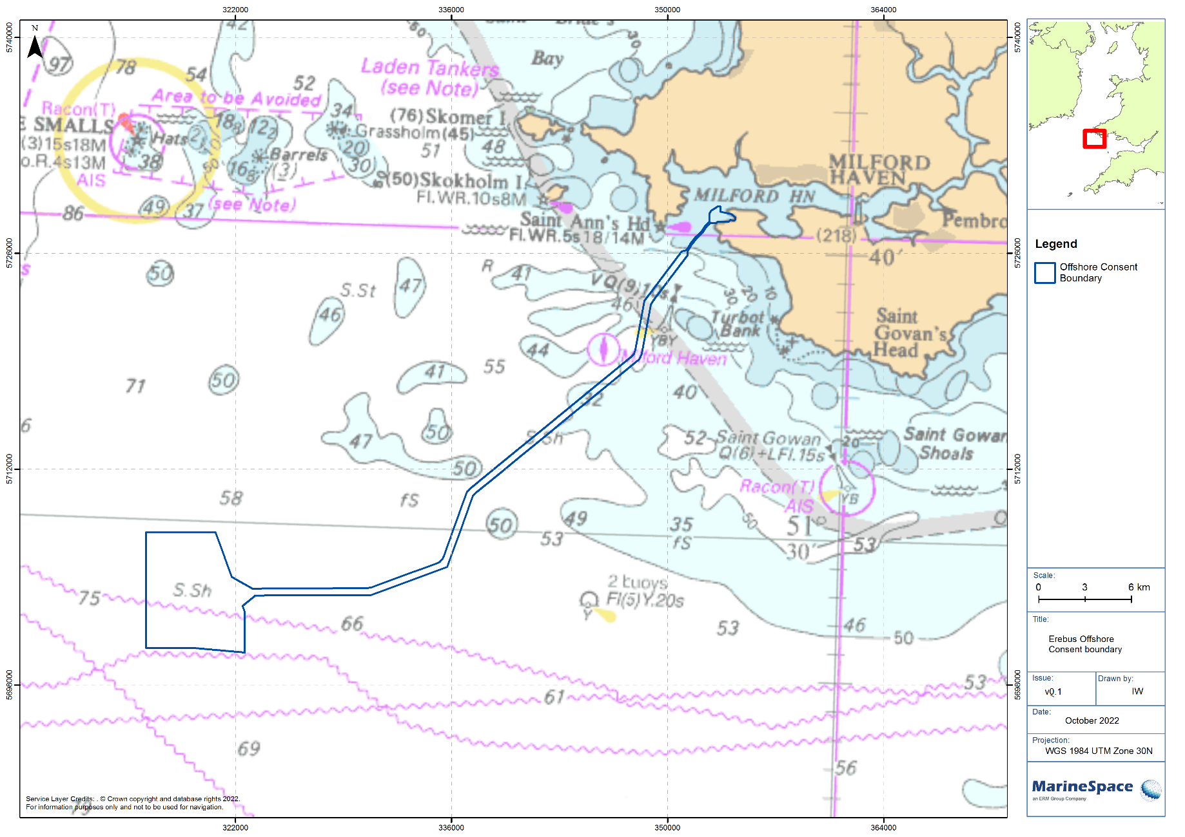
Figure 3.2. Offshore boundary for Port Talbot geotechnical survey area
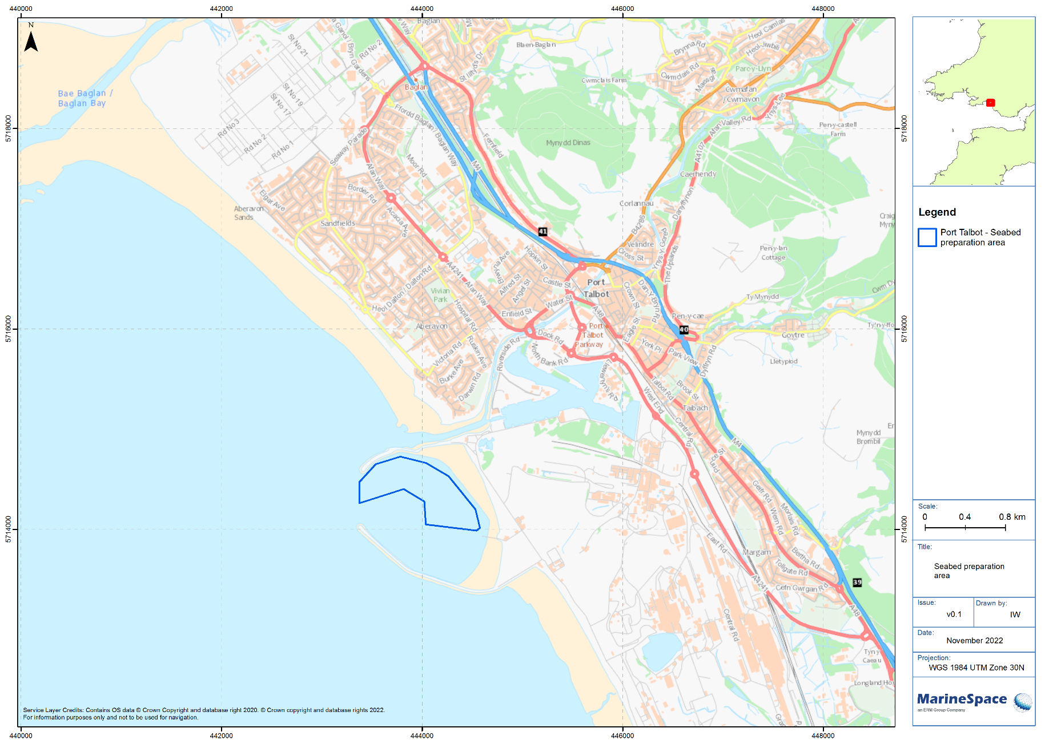

Designated sites and mitigation

Designated sites
The survey works will be within and close the following designated sites:
- Pembrokeshire Marine Special Area of Conservation (SAC);
- West Wales Marine SAC; and
- Skomer, Skokholm and the Seas off Pembrokeshire Special Protected Area (SPA).
Figure 4.1 shows the proposed survey works area of the Project Erebus array site and ECC in relation to designated sites.
The Skomer, Skokholm and the Seas off Pembrokeshire SPA is classified for the protection of: European storm-petrel Hydrobates pelagicus, Manx shearwater Puffinus puffinus, Atlantic puffin Fratercula arctica, and lesser black-backed gull Larus fuscus, as well as red-billed chough Pyrrhocorax pyrrhocorax, short-eared owl Asio flammeus and breeding seabird assemblage. The West Wales Marine SAC is designated for the presence of harbour porpoise Phocoena phocoena (1351) and Pembrokeshire Marine SAC is designated for estuaries (1130), large shallow inlets and bays (1160), reefs (1170), grey seal Halichoerus grypus (1364), and shore dock Rumex rupestris (1441).
Figure 4.2 shows the survey works area within Port Talbot, these works are not located within a close proximity to a designated site.

Proposed mitigation measures
The proposed works may pose a risk to these protected areas through increases in turbidity or contaminant concentrations following disturbance of benthic sediments. However, the volume of sediment disturbed is expected to be small and will therefore rapidly be diluted to background levels. Any changes will be highly localised in terms of spatial extent and limited in duration to within a single tidal cycle. Any changes can therefore be classed as temporary and will not pose a threat of adverse impacts upon any of the designated sites identified.
The following mitigation measures and environmental best practice will be adhered to throughout the survey work to minimise risk to the marine environment and designated sites:
- Relevant Guidance for Pollution Prevention (GPP) including PPG 6: Works and maintenance in or near water;
- All equipment, temporary structures, access tracks, waste and/or debris associated with the works will be removed on completion of the works;
- Bunding, storage facilities and spill kits will be employed to contain and prevent the release of fuel, oils and chemicals associated with the plant, refuelling and construction equipment into the marine environment;
- Plant, vehicles and machinery will not be refuelled on the foreshore.
- Coatings and treatments will be suitable for use in the marine environment and are used in accordance with best environmental practice; and
- All equipment, materials, machinery and PPE used will be in a clean condition prior to their arrival on site, and upon removal from site, to minimise risk of introducing non-native species into the marine environment.

Figure 4.1. Survey area for Project Erebus in relation to designated sites
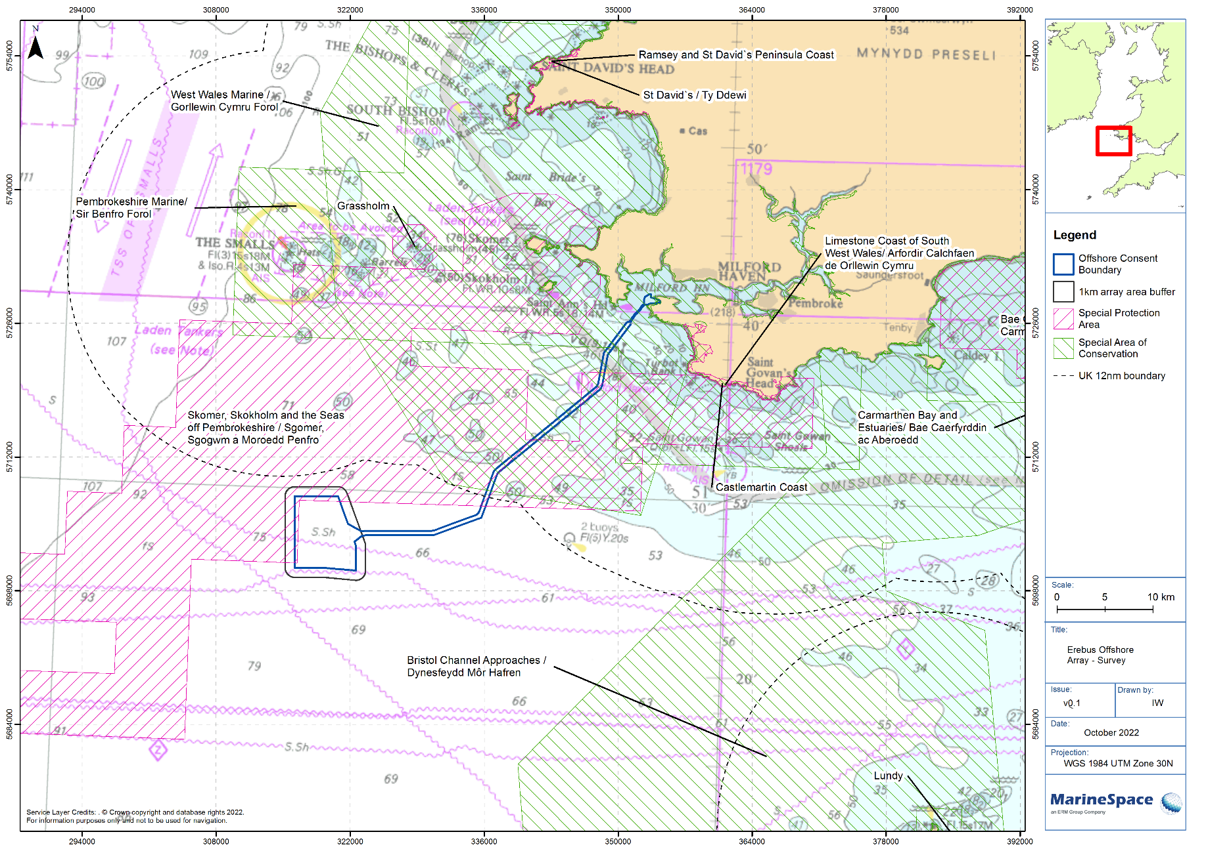
Figure 4.2. Survey area for Port Talbot in relation to designated sites
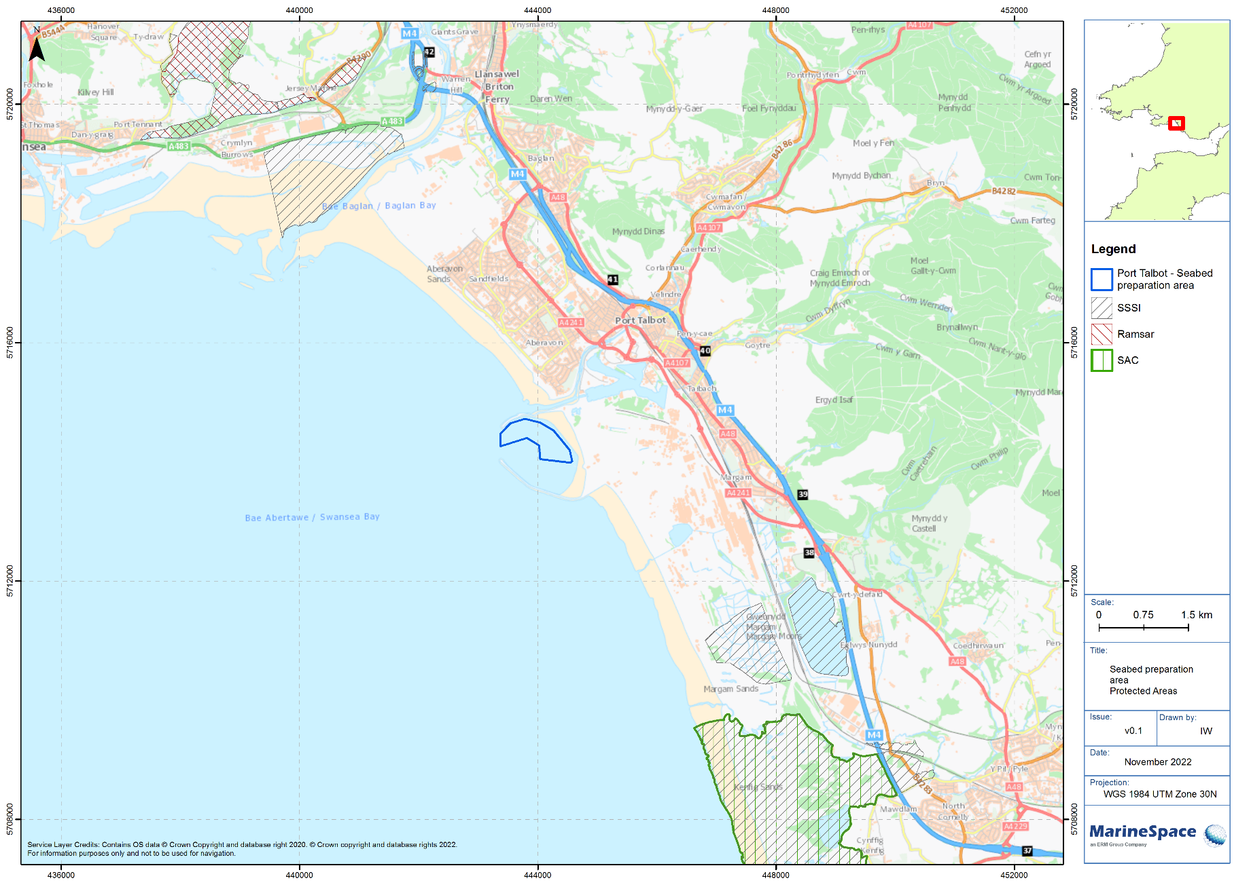

Navigation and other sea users
The works will adhere to the following:
- Comply with all maritime safety related legislation and guidance, including COLREGs;
- Issue local notification to marine users - including fisherman’s organisations, neighbouring port authorities and other local stakeholders - to ensure that they are made fully aware of the activity; and
- Notify HM Coastguard, in this case zone28@hmcg.gov.uk of the works prior to commencement.
BGW is in contact with the Ministry of Defence (MoD) and will initiate discussions in relation to survey activity in proximity to MoD activities in the area. The survey corridor will pass through the Castlemartin Sea Danger Area for approximately 20 km. The works will not start until written confirmation is received from relevant MoD contacts that the survey is acceptable to proceed.
BWG will obtain the relevant permits and permissions to undertake works within Milford Haven Port Authority and Port Talbot jurisdictions.

Archaeology
Best practice archaeological guidance will be adhered to minimise the risk to sites of archaeological interest. These include:
- English Heritage (2013) Marine Geophysics Data Acquisition, Processing and Interpretation: Guidance Note;
- Standard Guidance for Archaeological Geophysical Survey (CifA, 2016);
- Wessex Archaeology (2007) Historical Environment Guidance for the Offshore Renewable Energy Sector (COWRIE); and
- Offshore Geotechnical Investigations and Historic Environment Analysis: Guidance for the Renewable Energy Sector (Gribble and Leather, 2011).

