- Application type
New impoundment licence ☒
Removal of an existing impoundment ☒ Complete sections 2 and 4
To licence an existing impoundment ☐
Technical variation to an impoundment licence ☐

Give existing licence or pre- application reference number(s)

2. Impoundment details
All information should correspond with any maps and drawings submitted with this application

2.1 Provide details of all impoundment points. For structures spanning a watercourse, provide a National Grid Reference for each bank. If necessary, continue on a separate sheet and tick here to show that you have done this. ☐

Impoundment  location name / reference | National Grid Reference for each bank,  looking downstream  (12 digit)
Impoundment  location name / reference | Left bank | Right bank
Erbistock Weir | SJ3543942180 | SJ3545142145
2.2 Please provide a full description of the impoundment, outlining its purpose and how it will operate. If this information is detailed in a supporting document, provide the document title
or reference in the space below.
If necessary, continue on a separate sheet and tick here to show that you have done this. ☐

Erbistock weir lies within a Special Area of Conservation and is associated with a historic mill which is currently used as a holiday let. The weir is approximately 2.5m high and 70m wide, placed at an angle so that the flow exits on a bend in the river. There is an existing baulk fish pass which is in poor condition and modified concrete slope on the right bank of the weir.

The structure is not listed.

There is a breach in the downstream face that has occurred in the last few years.

The scheme aims to improve fish passage and restore geomorphological processes in the Dee by partially removing approximately 50% of the width of Erbistock weir towards the centre and right of the structure down to bed level, to improve the longitudinal ecosystem connectivity and to maintain the remaining section of weir on the left bank for the landowner.

Ref to AECOM report for further details.

- Description of impoundment

3.1 Name of watercourse
River Dee

3.2 Will your proposed impoundment result in a change to the wetted perimeter (downstream) or new submerged areas behind (upstream of) the impounding works?
No ☐ Yes ☒ If yes, ensure this is shown on any map or drawings submitted

3.3 Will the ponded area created by the impoundment be lined? No ☒ Yes ☐
If yes, give details.
The impounded area will be reduced by the weir removal. River will be restored to its original pre-impoundment width.

3.4 Give the height of the impoundment structure, from the downstream toe to crest or top of spillway (in metres above Ordnance Datum). If the proposal involves an existing impoundment, state the change in height (in millimetres).
Change in height approximately 2500mm

3.5 What is the overflow or crest level of the impoundment (in metres above Ordnance Datum)?
Existing crest level is 21 mAOD

3.6 What is the proposed capacity of the impoundment when full to spillway level (in cubic metres)?
N/A

3.7 Will the proposal create a raised reservoir? No ☒ Yes ☐

3.8 Does the proposal involve the controlled release of water to safeguard downstream flows? No ☒ Yes ☐ If yes, provide details

N/A

3.9 Is the impounded water to be used for a subsequent purpose? No ☒ Yes ☐

If yes, provide details (for abstractions, state the daily and annual quantities in cubic metres).

N/A

3.10 How will the impounded area be filled initially, and subsequently refilled if applicable?

N/A

- Fish and eel passage
4.1 Confirm the fish species present at your site.
Salmonids, eel, bullhead, lamprey and all coarse fish present in Dee.

4.2 Complete the table below with full details of the measures you intend to take to safeguard these fish species.

 | Intake | Outfall
Type of fish screen | N/A | N/A
Screen aperture size (mm) | N/A | N/A
Screen height and width (mm) | N/A | N/A
Type of upstream fish passage | N/A
Proposed flow for fish pass (m/s) | N/A
Type of downstream fish passage | Restoration to natural channel
- Construction, maintenance and operation

5.1 Provide details of maintenance or activities relating to the operation of the impoundment. If necessary, continue on a separate sheet and tick here to show that you have done this. ☐

Removal of the weir will restore channel to original width/state. No future maintenance is envisaged at weir removal site.

Further investigation into the riverbanks in the currently impounded area will be undertaken at the detailed design stage.

5.2 Provide details of diversion works or removal of existing works.
Contractor has not been appointed. Full method statement will be provided on award.

- Planning application
Have you sought advice on your planning application?
No ☐ Yes ☒
If yes, submit a copy of the Planning Authority’s response.

We are awaiting response from planning following consultation.

- Declaration

Please see Guidance Note WRX for details of who can sign this section and note the information in that document relating to the Data Protection Act 1998.

By signing below, you are declaring that as far as you know and believe the information given in this form, on any map and in any supporting or additional information, is true.
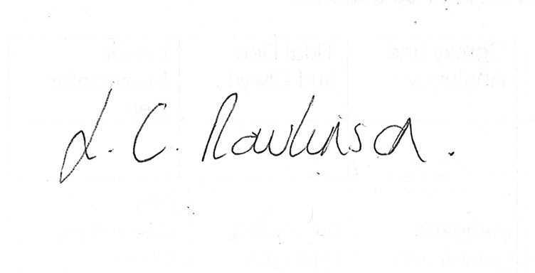

Signed

Lyndsey Rawlinson

Print name

Head of North East Wales Operations

Position

15th November 2022

Date

Application Checklist

Please tick the following checklist items to indicate that you have included the required information. If any sections of the form are left blank and no supporting information submitted, where we have insufficient information to make a decision
on your application, we will return your application to you.

Essential:
Form WRA completed, if there have been any changes since pre-application an updated Form WRA is required ☒
Map with all impoundment points and new wetted perimeters/submerged areas ☒
clearly marked
Within AECOM report
Drawings and Design Statement ☒
Within AECOM report
State number of continuation sheets (enter 0 if none included)

Where relevant:
Form WRD completed, if your proposal also requires an abstraction licence ☐
Stage 1 photo survey (contact us for more details on this requirement) ☒
Within AECOM report
Letter of authorisation from the applicant, allowing an agent to act as signatory ☐
Further information requested in our pre-application response letter to you ☐
Planning Authority response, where available ☐
Additional supporting information - please list below:

