- Application type and fee
For the application types listed, complete this form and/or the relevant additional forms named below. Please tick which forms have been included with your application. Forms should be completed with reference to Guidance Note WRX.
* Pre-application enquiry (non-hydropower) ☐ Only complete this form
* Pre-application enquiry (hydropower) ☐ Also complete form WRB
* Application for a Groundwater Investigation Consent ☐ Only complete form WRC
New full abstraction licence ☐ Also complete form WRD
New temporary abstraction licence ☐ Also complete form WRD
New licence to transfer water ☐ Also complete form WRD
New impoundment licence ☒ Also complete form WRE
Renewal of a time-limited licence ☐ Also complete form WRD
Removal of an existing impoundment ☐ Also complete form WRE
Technical variation of an abstraction licence ☐ Also complete form WRD
Technical variation of an impoundment licence ☐ Also complete form WRE
* Administrative variations to existing licences ☐ Only complete form WRF
* No fee required

Please indicate how you wish to pay your application fee and provide a reference number where relevant.
Cheque ☐ BACS ☐ Credit or debit card ☐ Your reference number

- Applicant details

This is who the licence would be issued to and must be a legal entity such as an individual, registered company, charity or public body. If you are an agent acting on behalf of an applicant, provide their details here and yours in Section 3. See Guidance Note WRX for clarification of the details required and signatories permissible for organisations.

Applicant type:

Individual ☐ Limited company ☐ Charity ☐ Corporate body ☒ Partnership ☐ Sole trader ☐ Club ☐ Other ☐

If other, please specify

Gethin Morris
Mr
Title Full Name

Company, Charity or
Natural Resources Wales
Trading Name

Company or Charity
Registration Number
Cambria House
29 Newport Road
Cardiff
CF240TP

Postcode:
Registered Address

Office:
Mobile:07770883732

Telephone Number
Gethin.morris@cyfoethnaturiolcymru.gov.uk
Email Address

We will contact you by email unless you tick here ☐

Please specify who we should contact with regard to your site operation.
Site operations contact Applicant ☒ Agent ☐

For applications for abstraction licences, please also specify who we should contact for invoices and abstraction records (returns).
Invoice address* Applicant ☐ Agent ☐
Abstraction records contact* Applicant ☐ Agent ☐
* Not required for temporary or transfer licences.

Enter the agent’s details in Section 3, or provide details of alternative or additional contacts on a separate sheet and tick here to show that you have done so. ☐

Details of agent or individual authorised to act as application contact

This is who we will correspond with unless otherwise informed. If an agent has signed on behalf of an applicant, please include a letter of authorisation from the applicant allowing the agent to act as signatory.
N/A

Title Full Name

Company, Charity or
Trading Name

Position in Company

Postcode:
Registered Address

Office:
Mobile:

Telephone Number

Email Address

- Entitlement to apply (only required for abstraction licence applications)
Does the applicant have a legal right of access to the point of abstraction?
Has a right of access ☐ Has an expected right of access ☐
Owner/occupier of land ☐ Date these access rights are expected
For formal abstraction licence applications where you are the landowner/occupier, provide a map with the land boundary and all abstraction and discharge point(s) marked. Please tick here to show that you have done this. ☐
N/A

For expected rights of access, please also provide the additional evidence as outlined in Guidance Note WRX. Please tick here to show that you have done this. ☐
- Application reference number
Have you undertaken a pre-application enquiry or had any previous discussions with us?
No ☐ Yes ☒ Provide reference
Hannah Pierce

number or staff
member’s name

- Remediation work
Is this proposal as a result of a Restoring Sustainable Abstraction programme or other work requested by us?
No ☒ Yes ☐ If yes, provide your

licence number
- Source of supply
7.1 State where you intend to abstract from
Surface Water ☐ Groundwater ☐

N/A
Give Groundwater Investigation Consent number
if applicable

7.2 Provide a 12 digit National Grid Reference for the proposed or existing abstraction or impoundment point (e.g. ST 19057 76826)
SJ
35447
42175

Erbistock Ferry Road, Overton Bridge, Erbistock, Wrexham. LL13 0DR
7.3 Source of supply or location of
proposed impoundment

Erbistock Weir

7.4 Site name / reference

- Proposal summary
Please provide an outline of your proposal as described in Guidance Note WRX, including any sketches. If you are submitting a pre-application enquiry, this must include the quantities of water you propose to abstract. If necessary continue on a separate sheet and tick here to show that you have done this. ☐
The aim of LIFE18 NAT/UK/000743 river restoration project (LIFEDeeRiver) is to restore the freshwater features in The River Dee and Bala Lake/Afon Dyfrdwy a Llyn Tegid SAC.
Erbistock weir is approximatly 70m wide, stone built, set at an angle to the flow approximately 54km from the tidal limit. A baulk fish pass is present and is suitable for a limited range of species (mostly salmonids) but is in a bad state due partial collapse.
The project proposes to remove approximately 40m of the weir on the right bank (looking downstream) to create a new primary flow channel. This will mimic the natural width of the river so removal imitates the natural morphology present, encouraging natural processes to re-establish.
The Project team have been in discussion of the landowner who fully supports the aims and objectives of this proposal. With the landowners full consent AECOM consultants have been appointed and have undertaken topographical, heritage, contaminated land and utilities searches.

- Declaration

Please see Guidance Note WRX for details of who can sign this section and note the information in that document relating to the Data Protection Act 1998.

By signing below, you are declaring that as far as you know and believe the information given in this form, on any map and in any supporting or additional information, is true.
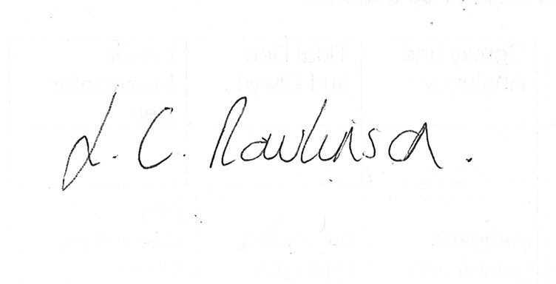

Signed

Lyndsey Rawlinson

Print name

Head of North East Wales Operations

Position

15th November 2022

Date

Application Checklist

Please tick the following checklist items to indicate that you have included the required information. If any sections of the form are left blank and no supporting information submitted, where we have insufficient information to make a decision on your application, we will return your application to you.

Essential:

Letter of authorisation from the applicant, allowing the agent to act as signatory ☐
N/A as impoundment licence
Map showing the land ownership boundary with all abstraction and discharge point(s) clearly marked ☐
N/A

Where relevant:

Evidence of negotiations of expected access rights, if applicable ☐
For groundwater abstractions, results of pump test (if not previously submitted) ☐

For Natural Resources Wales’ use only:

Date received ________________________

Reference Number ________________________

Payment received Yes ☐ Amount received _______________________
No ☐ Not required ☐

