
LIFE Dee River is a major large-scale project to transform the River Dee and its catchment by restoring the river and surroundings back to its natural state. This will bring many benefits to the environment, most notably improving the numbers of salmon, lamprey and freshwater pearl mussels to help them become more sustainable in future.
Erbistock weir partial removal-SJ35445 42167
Erbistock weir is the first major barrier on the non-tidal section of the river Dee for salmon (S salar), sea lamprey (P marinus), European bullhead (C gobio), river lamprey (L fluviatilis) and brook lamprey (L planeri)
The weir is 80m wide, stone built and set at an angle to the flow circa 46km from the tidal limit. A baulk fish pass is located on the right bank looking downstream which is in a bad state of repair and is only suitable for a limited range of species (mainly salmonids) at certain flows.
Erbistock weir
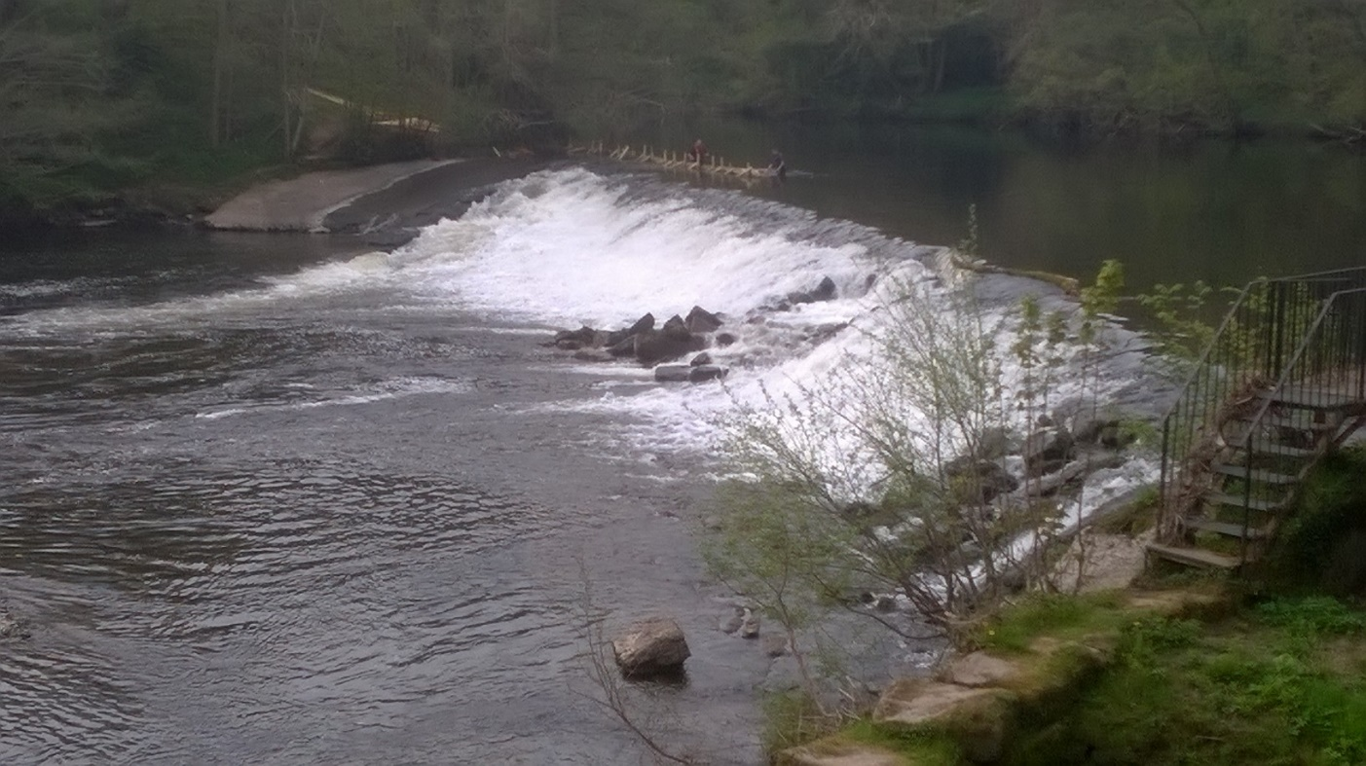
The proposed project will remove a 40m section of the weir on the right bank (looking downstream) to create a new primary flow channel. This will mimic the natural width of the river to imitate the natural morphology present to encourage natural processes to re-establish.
Location Map of Erbistock Weir
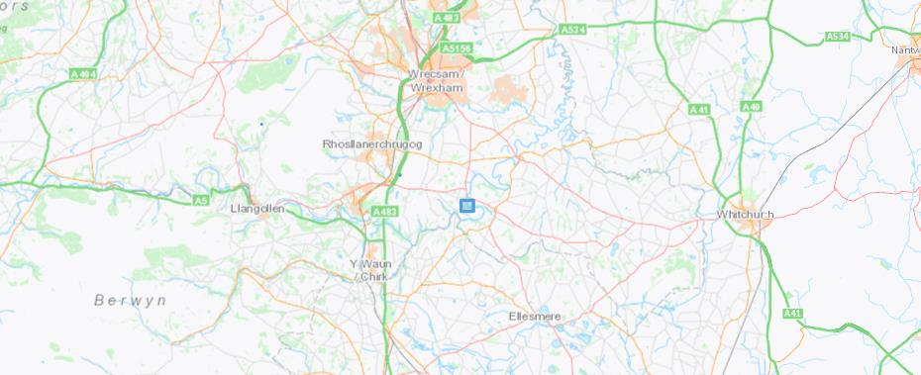

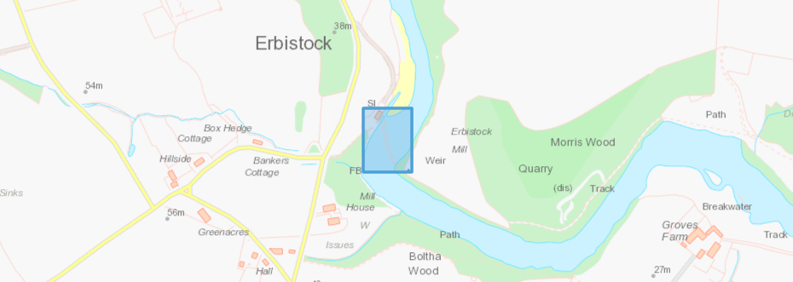

Manmade barriers in rivers impede fish movement. River connectivity is vital for upstream and downstream migration and will have an impact on spawning success. Due to their lifecycle a critical threat to fish is posed through the loss of longitudinal connectivity and habitat fragmentation caused by barriers in rivers.
Removing barriers will allow a river to transport sediment in a natural way thus restoring and improving river geomorphology. Barrier removal is common across the world, with redundant barriers being removed as the importance of stream connectivity is better understood.
Currently there is an impounded area of approx. 600m behind Erbistock weir. When removed this area will revert into a flowing river channel creating additional river habitat.

Proposed work
Erbistock weir is an 80m weir that spans the width of the River Dee located next to Erbistock Mill. Currently the mill is used as a holiday home but previously was a working corn mill.
Erbistock weir is believed to be the upper limit for sea lamprey and a partial barrier to many fish spices including salmon. Currently the baulk fish pass is in a very bad condition and if it continues to deteriorate it could become impassable.
It is proposed to remove a 40m section of the weir to riverbed level, leaving a small section of wall on the right bank and a larger section on the left bank. The owners of the weir and mill are requesting that these sections are repaired and left in place as the structure has a historic value. Removing a 40m section will return the river to its original width, matching the surrounding river in this area.

Aerial view of weir and proposed section to be removed.
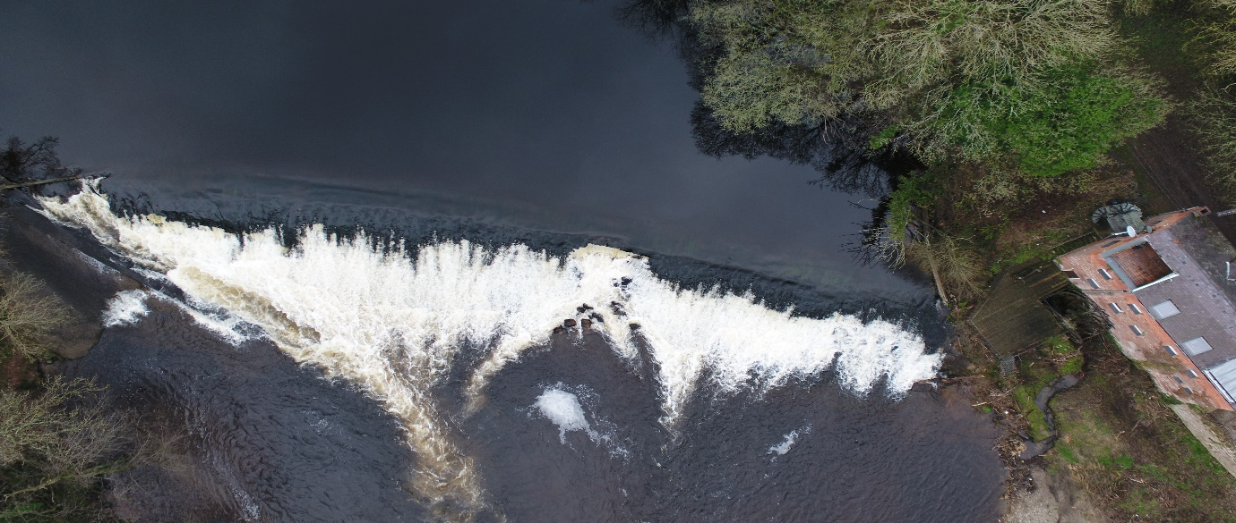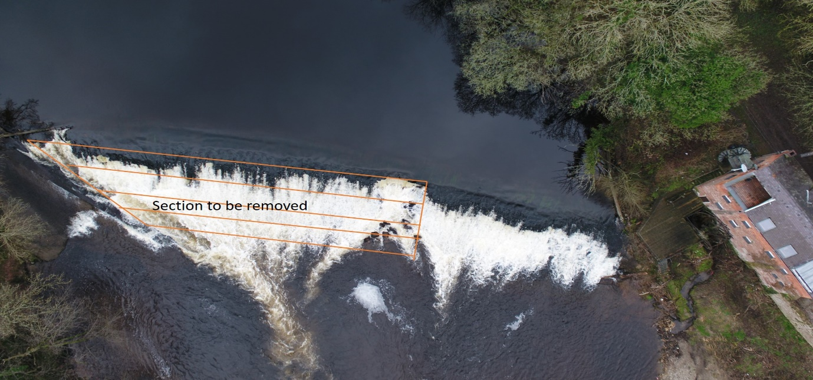

Side view of section to be removed.
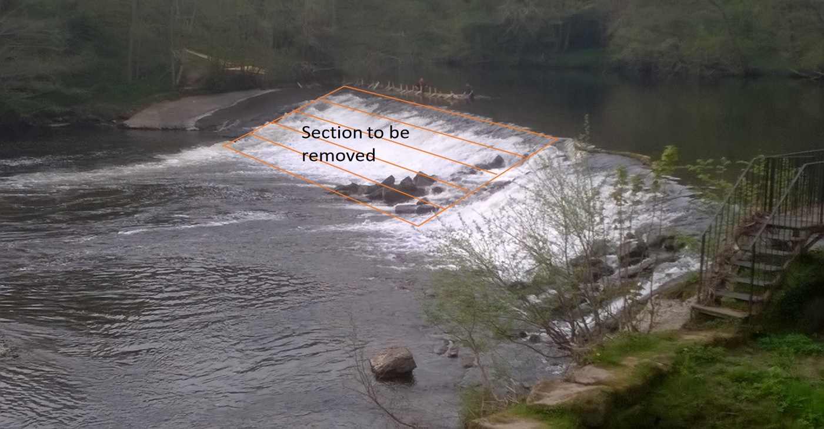

View showing current damage to weir face.
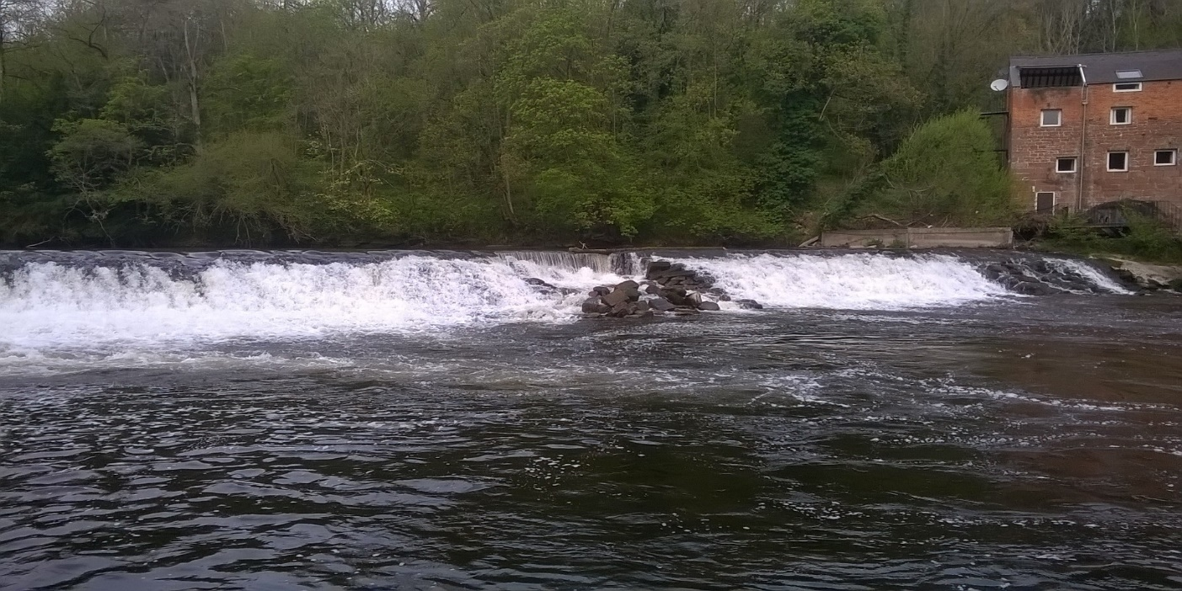

View showing stones from weir falling and blocking baulk fish pass.
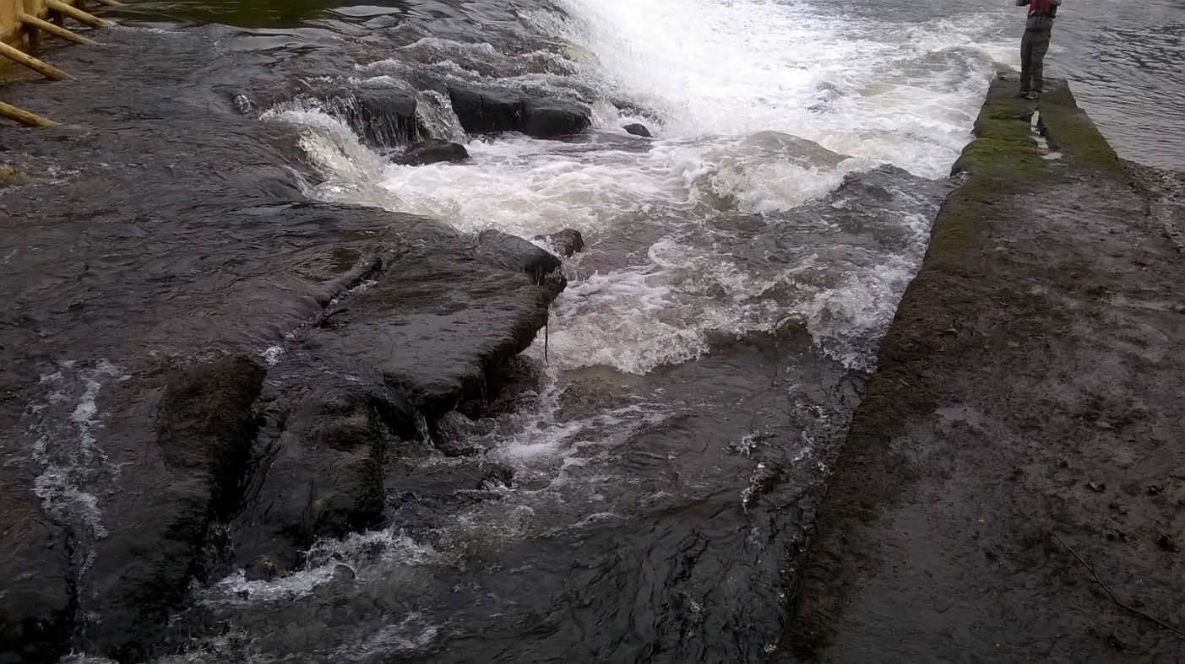

View showing weir failing and bad condition of baulk fish pass
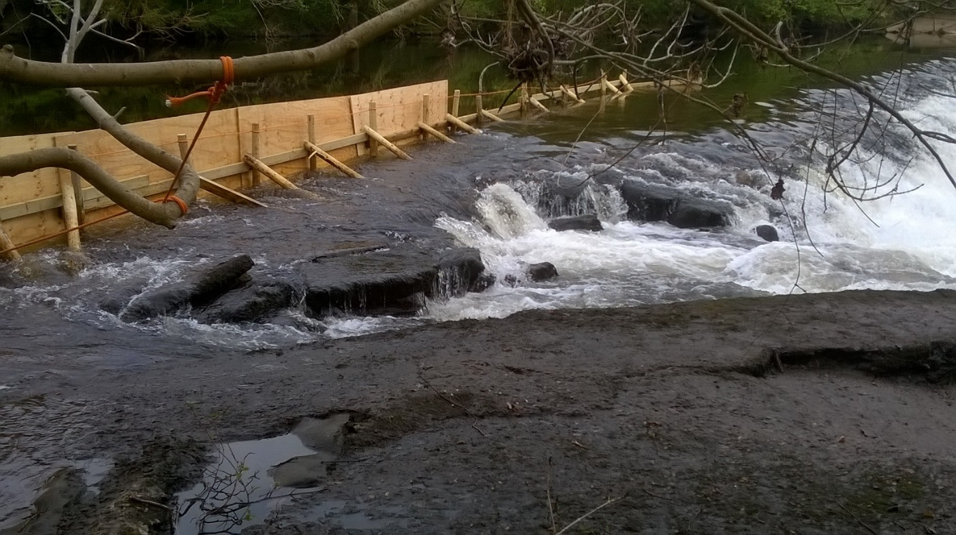

View showing impounded area above weir
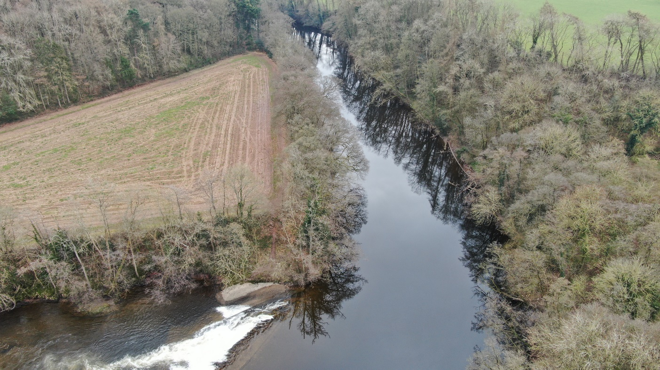

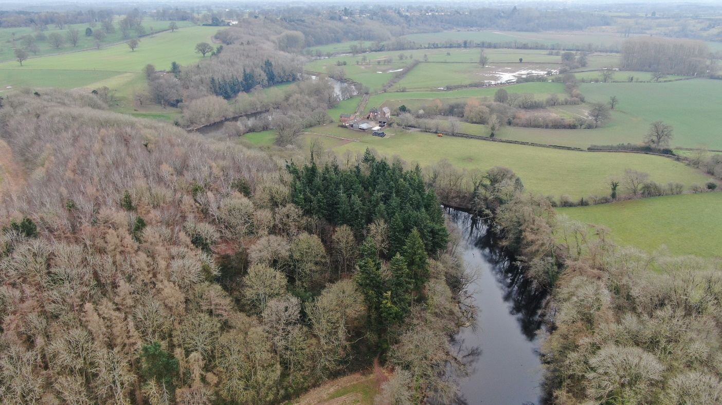

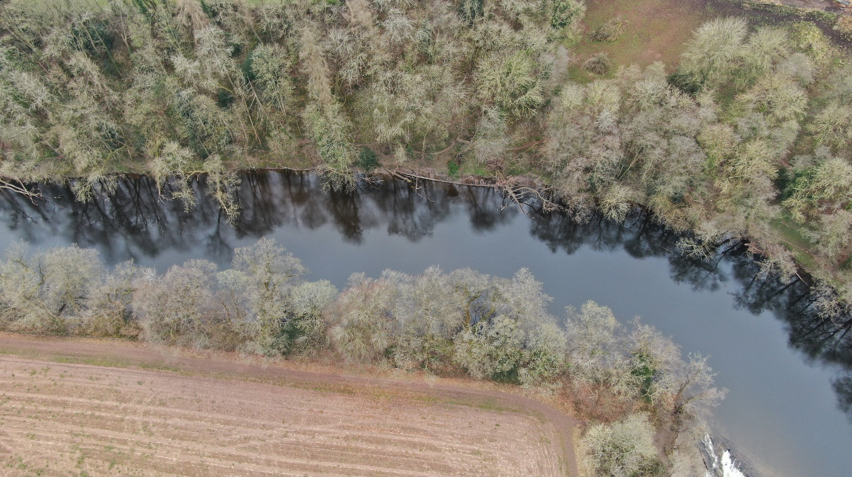

For more information, please email:
lifedeeriver@cyfoethnaturiolcymru.gov.uk or visit our webpage

