Site boundary
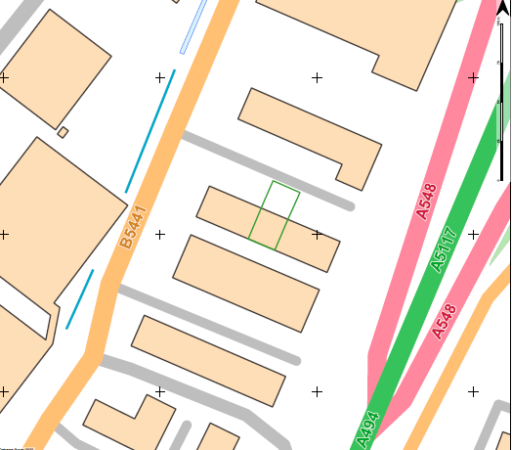

Site setting
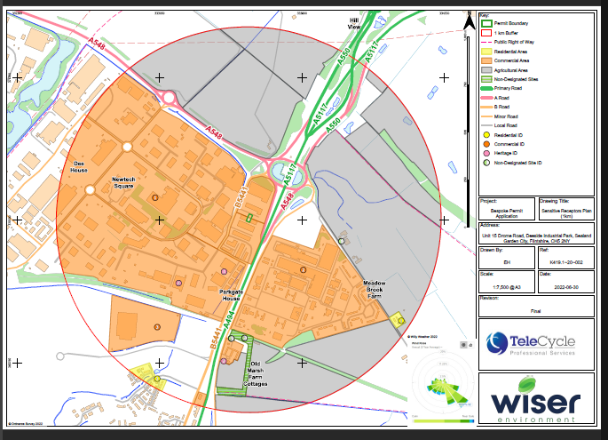
Location:
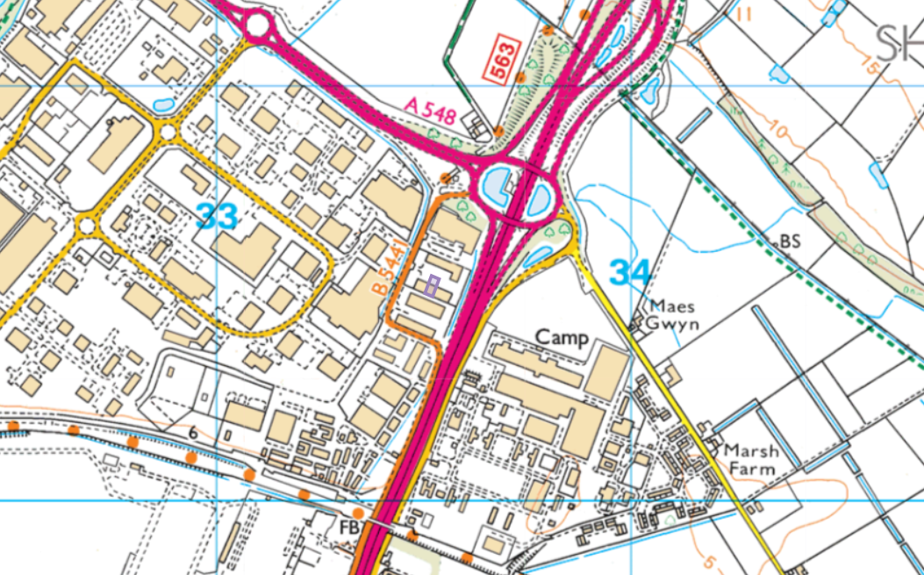
Proximity of human occupation:
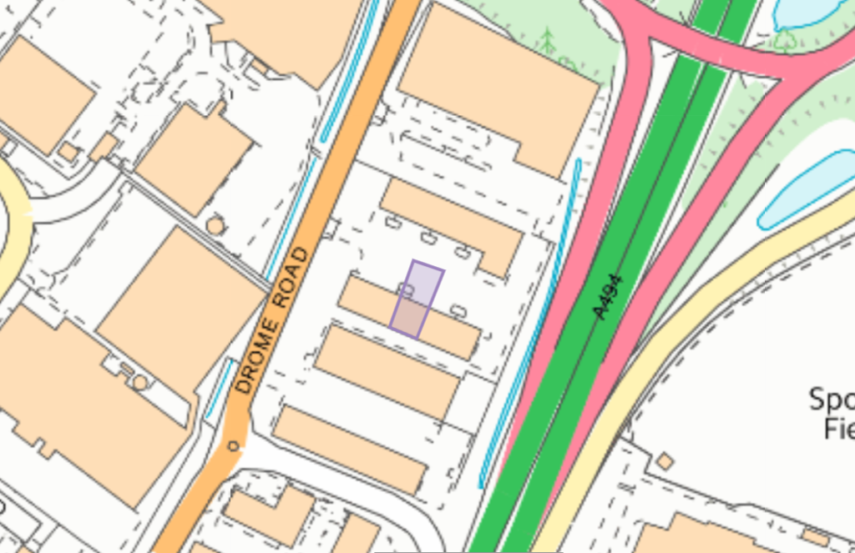
<50 meters
SAC, pSAC, SPA, pSPA, Ramsar, SSSI:
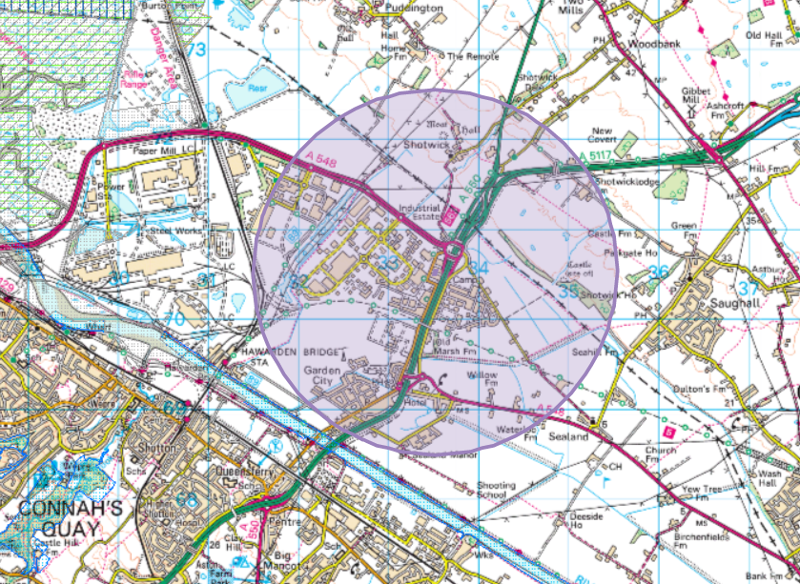
None within 2km
Aquifer Designation (Superficial):
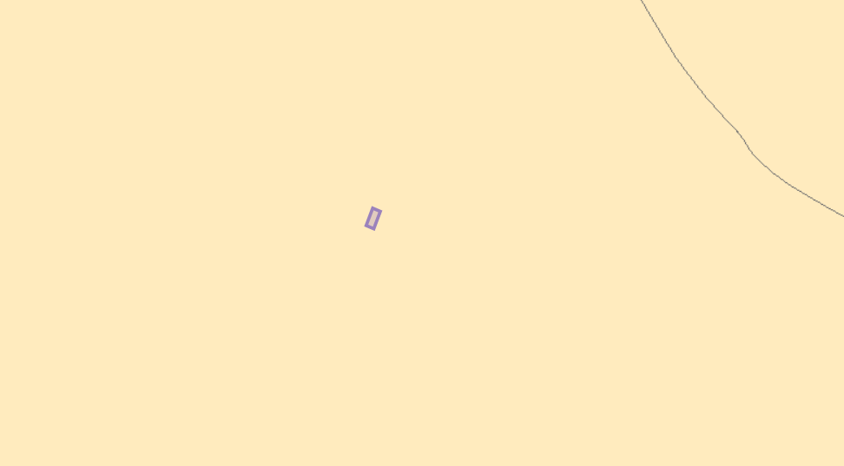
No Groundwater Source Protection Zones

Aquifer Designation (Bedrock)
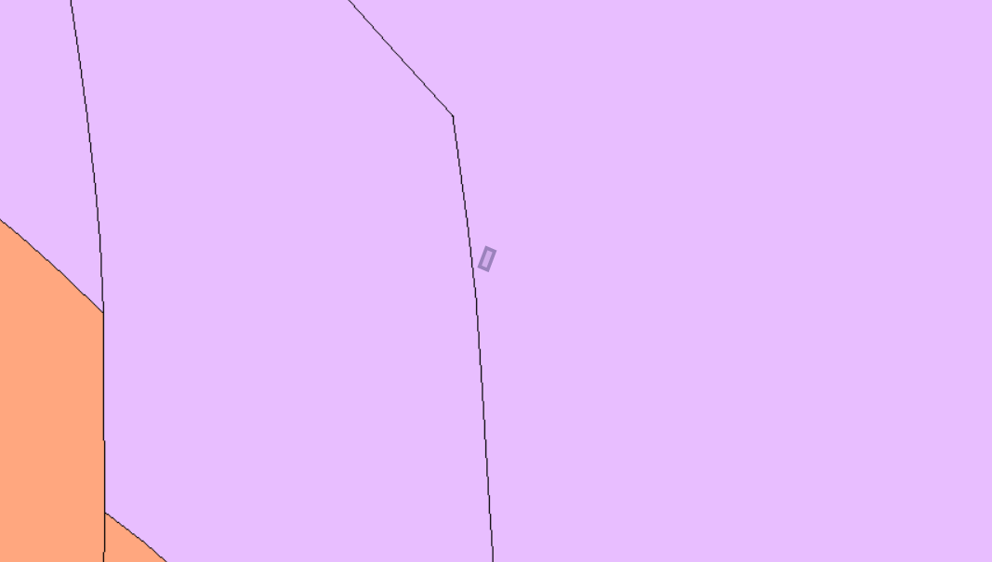No Groundwater Source Protection Zones

Detailed River Network
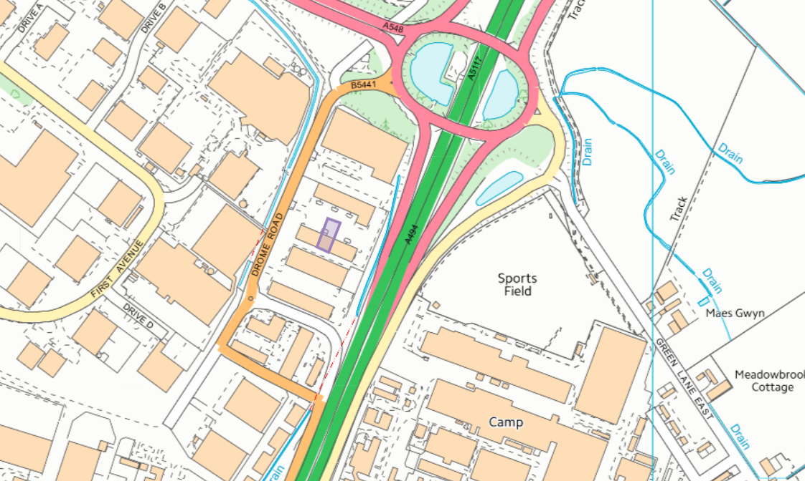

Protected Habitats for Permitting Screening (1km)
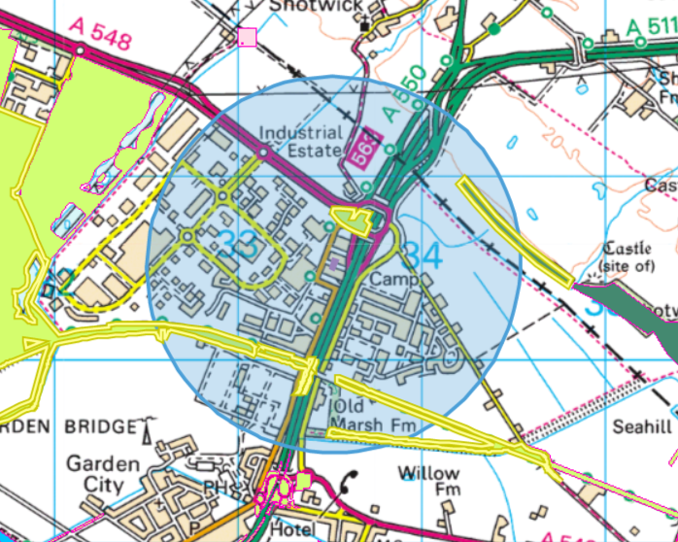
North, South West, South of the site: Lowland dry acid grassland and Lowland calcareous grassland
NE of the site: Deciduous woodland
* No Protected Species for Permitting Screening found
Listed Buildings, Historic Monuments, Scheduled Monuments, World Heritage Sites, Heritage Coast
Historic monuments:
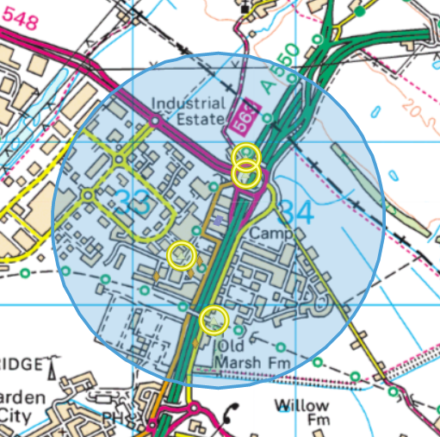
Sealand Airfield and 3 Pillboxes

Listed buildings:
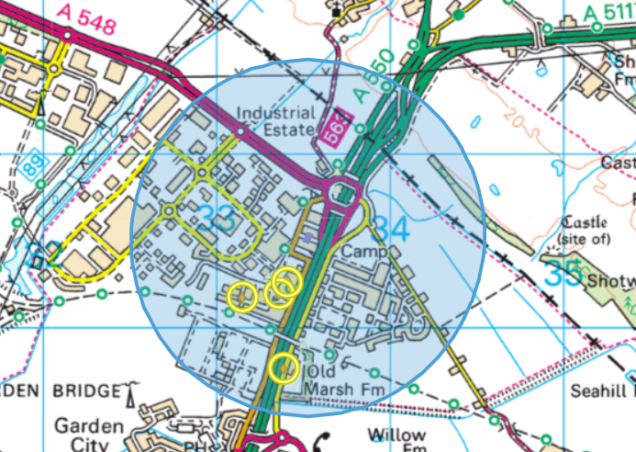
3 aircraft hangars and Old March Farm

Ancient Woodland Inventory 2011
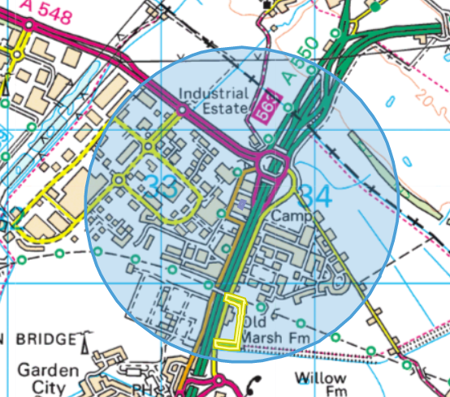
South of the site: Ancient Semi Natural Woodland

Flood Risk from Rivers
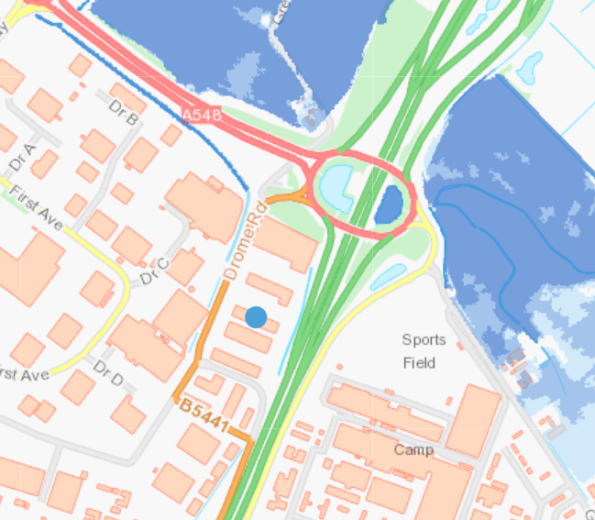

Flood Risk from the Sea
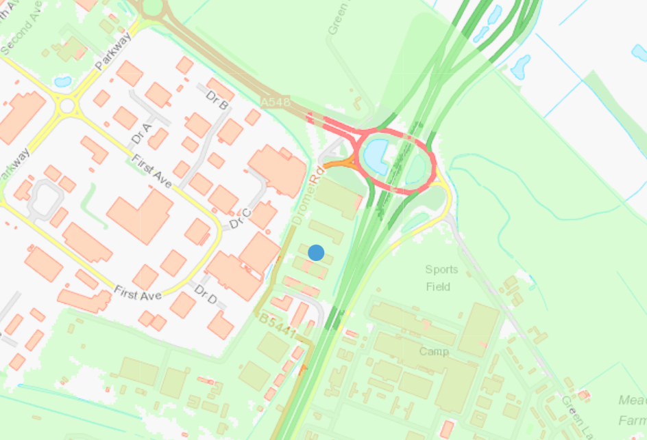
Low risk
Flood Risk from Surface Water & Small Watercourses
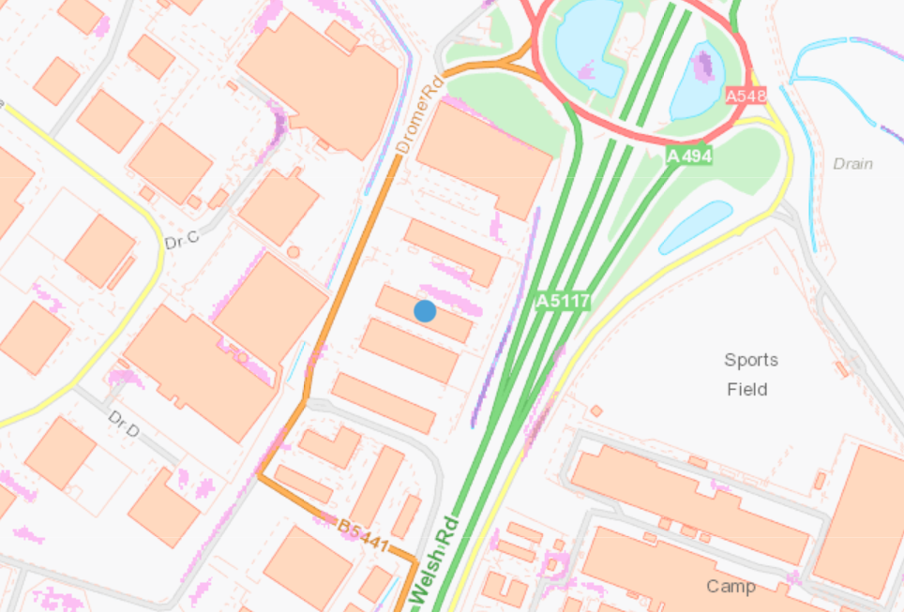
Medium and Low Risk

No Local Wildlife Sites, Local Nature Reserves, National Nature Reserves, National Parks or Areas of Outstanding Natural Beauty within 1km of the site

