
Document Ref.: J/9/1/22 | Originator: Liam Porter
Date: 12/12/2022 | Circulation: Restricted - Commercial-in-confidence

Appendix A: Conwy Wild Oysters Restoration Project: Habitats Regulations Assessment

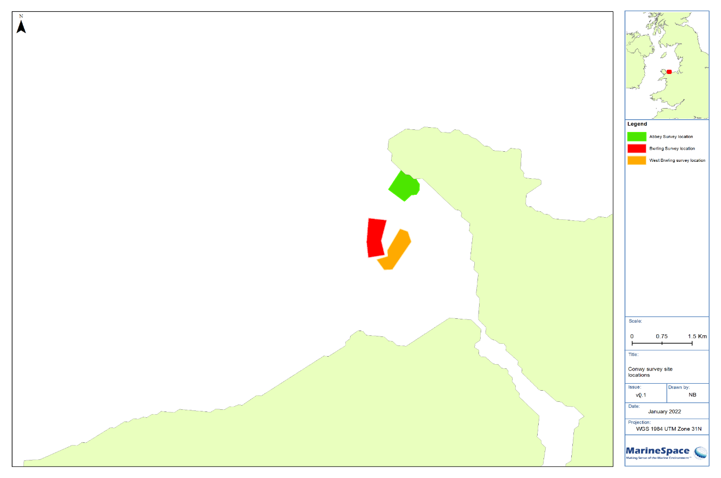

Appendix A: Conwy Wild Oysters Restoration Project: Habitats Regulations Assessment

Prepared by:

MarineSpace Ltd

 | MarineSpace Ltd  Ocean Village Innovation Centre  Ocean Way  Southampton  SO14 3JZ
Prepared for:

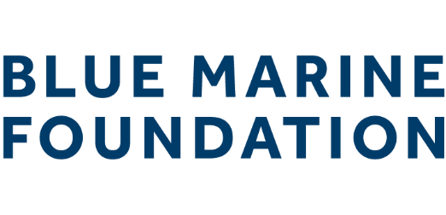 | South Building  Somerset House  London  WC2R 1LA

Date | Originator | Version | Action | Signature
15/02/2022 | Liam Porter | 0.1 | Internal Draft | 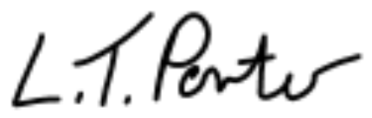
13/04/2022 | Damien Kirby | 0.2 | Technical Review / Editorial Review | 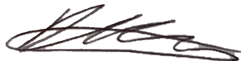
14/04/2022 | Liam Porter | 0.3 | Internal Draft
28/07/2022 | Liam Porter | 0.4 | Internal Draft
23/08/2022 | Dafydd Lloyd Jones | 0.5 | Technical Review / Editorial Review | 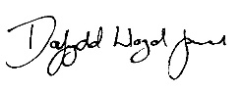
23/08/2022 | Dafydd Lloyd Jones | 0.6 | Internal Draft
23/08/2022 | Dafydd Lloyd Jones | 1.0 | Director Sign-off / External Document
20/10/2022 | Liam Porter | 1.1 | Internal Draft - Addressing Client / Regulator Comments
07/12/2022 | Liam Porter | 1.2 | Internal Draft - Addressing Client / Regulator Comments
13/12/2022 | Jonny Lewis | 2.0 | Director Sign-off / External Document | 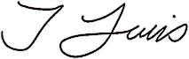

Any reproduction must include acknowledgement of the source of the material. This report should be cited as:
MarineSpace Ltd, 2022. Appendix A: Conwy Wild Oysters Restoration Project: Habitats Regulations Assessment.
All advice or information presented in this report from MarineSpace Ltd is intended only for use in the UK by those who will evaluate the significance and limitations of its contents and take responsibility for its use and application. No liability (including that for negligence) for any loss resulting from such advice or information is accepted by MarineSpace Ltd, subcontractors, suppliers or advisors.

The cover is Conwy Bay Wild Oyster Restoration Sites © Blue Marine Foundation 2022. All rights reserved.
Data Licences
© Crown Copyright 2022. All rights reserved.
Charts NOT TO BE USED FOR NAVIGATION.

Contents
1 Introduction 1-1
1.1 Background 1-1
1.2 Summary of Project 1-3
1.2.1 Deposition of Cultch 1-3
1.2.2 Introduction of Native Oyster 1-3
1.2.3 Post Deployment Monitoring 1-3
1.2.4 Decommissioning 1-4
2 Approach to Assessment 2-1
2.1 Assessment Parameters 2-1
2.2 Habitats Regulations Assessment 2-2
2.2.1 Habitats Regulations Assessment Legislation 2-2
2.3 Marine Conservation Zone Risk Assessment 2-5
3 Habitats Regulations Assessment Stage 1: Screening for Likely Significant Effect 3-1
3.1 Screening for Special Areas of Conservation 3-1
3.1.1 Y Fenai a Bae Conwy / Menai Strait and Conwy Bay Special Area of Conservation 3-1
3.1.2 Dee Estuary / Aber Dyfrdwy Special Area of Conservation 3-15
3.1.3 Glannau Môn: Cors heli / Anglesey Coast: Saltmarsh Special Area of Conservation 3-20
3.1.4 Pen Llŷn a’r Sarnau / Lleyn Peninsula and the Sarnau Special Area of Conservation 3-25
3.1.5 Bae Cemlyn / Cemlyn Bay Special Area of Conservation 3-32
3.1.6 North Anglesey Marine / Gogledd Môn Forol Special Area of Conservation 3-34
3.2 Screening for Special Protection Areas 3-36
3.2.1 Liverpool Bay / Bae Lerpwl Special Protection Area 3-36
3.2.2 Traeth Lafan / Lavan Sands, Conway Bay Special Protection Area 3-46
3.2.3 Anglesey Terns / Morwenoliaid Ynys Môn Special Protection Area 3-48
3.2.4 Ynys Seiriol / Puffin Island Special Protection Area and Ramsar Site 3-52
3.2.5 The Dee Estuary Special Protection Area and Ramsar Site 3-54
3.2.6 Mersey Narrows and North Wirral Foreshore Special Protection Area and Ramsar Site 3-63
4 Habitats Regulations Assessment Stage 2: Appropriate Assessment 4-1
4.1 Y Fenai a Bae Conwy / Menai Strait and Conwy Bay Special Area of Conservation Annex I Reef (H1170) 4-1
5 References 5-1

List of Figures
Figure 1.2: Conwy Wild Oysters Restoration project sites and 50 km buffer, Special Areas of Conservation, Special Protection Areas and Ramsar Sites 1-2
Figure 3.1: Y Fenai a Bae Conwy / Menai Strait and Conwy Bay Special Area of Conservation designated feature map (from: NRW, 2016) 3-5

List of Tables
Table 2.1: Summary of project details used to inform the Habitats Regulations Assessment 2-1
Table 3.1: Overview of Y Fenai a Bae Conwy / Menai Strait and Conwy Bay Special Area of Conservation 3-2
Table 3.2: Summary of advice on operations for activities related to the proposed works (Source: NRW, 2018a) 3-7
Table 3.3: Screening for Likely Significant Effect on Y Fenai a Bae Conwy / Menai Strait and Conwy Bay Special Area of Conservation 3-8
Table 3.4: Overview of Dee Estuary / Aber Dyfrdwy Special Area of Conservation 3-15
Table 3.5: Overview of Glannau Môn: Cors heli / Anglesey Coast: Saltmarsh Special Area of Conservation 3-20
Table 3.6: Overview of Pen Llŷn a'r Sarnau / Lleyn Peninsula and the Sarnau Special Area of Conservation 3-25
Table 3.7: Overview of Bae Cemlyn / Cemlyn Bay Special Area of Conservation 3-32
Table 3.8: Overview of Y Fenai a Bae Conwy / Menai Strait and Conwy Bay Special Area of Conservation 3-34
Table 3.9: Overview of Liverpool Bay / Bae Lerpwl Special Protection Area 3-36
Table 3.10: Pressures associated with the project that may cause deterioration or disturbance to the classified features of the Liverpool Bay / Bae Lerpwl Special Protection Area (Source: NE and CCW, 2012) 3-38
Table 3.11: Screening for Likely Significant Effect on Liverpool Bay / Bae Lerpwl Special Protection Area 3-40
Table 3.12: Overview of Traeth Lafan / Lavan Sands, Conway Bay Special Protection Area 3-46
Table 3.13: Overview of Anglesey Terns / Morwenoliaid Ynys Môn Special Protection Area 3-48
Table 3.14: Overview of Ynys Seiriol / Puffin Island Special Protection Area 3-52
Table 3.15: Overview of The Dee Estuary Special Protection Area 3-54
Table 3.16: Screening for Likely Significant Effect on The Dee Estuary Special Protection Area and Ramsar Site 3-56
Table 3.17: Overview of the Mersey Narrows and North Wirral Foreshore Special Protection Area 3-63
Table 4.1: Characteristics used to determine Annex I stony reef (Source: Irving, 2009) 4-1

Introduction

Background
MarineSpace Ltd (MarineSpace) has been commissioned by Blue Marine Foundation (Blue Marine), and its partners, the Zoological Society of London (ZSL) and British Marine, to conduct a Habitats Regulations Assessment (HRA) and a Marine Conservation Zone Risk Assessment (MCZRA) for the Conwy Wild Oyster Restoration Project. The project involves introduction of cultch and juvenile native oyster Ostrea edulis, and subsequent monitoring, at the sites located within Conwy Bay. The project consists of 3 sites within Conwy Bay: Abbey (north), Bwrling (southwest) and West Bwrling (southeast) (Figure 1.1).
Figure 1.1: Conwy Wild Oysters Restoration project sites and 50 km buffer, Special Areas of Conservation, Special Protection Areas and Ramsar Sites
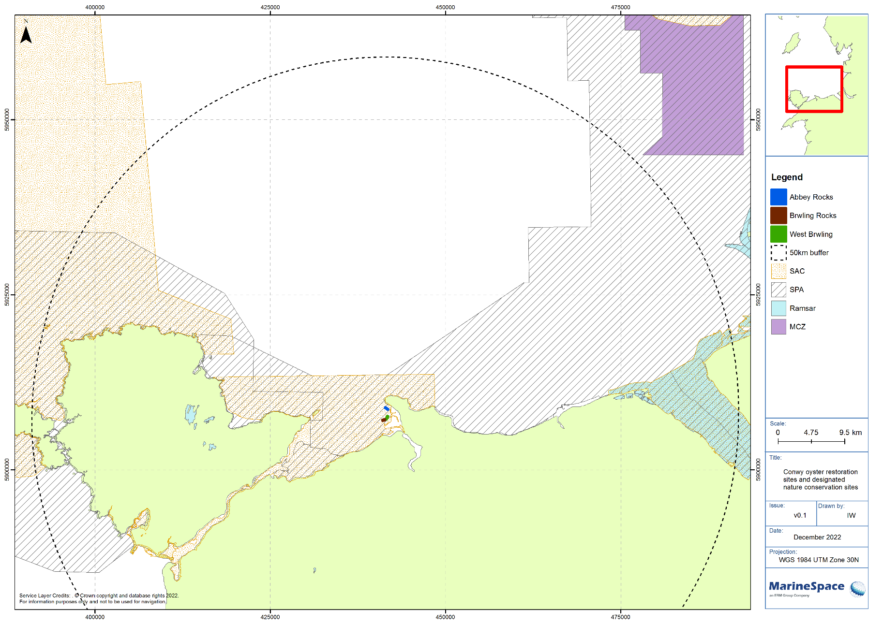

Summary of Project
Please refer to the Site Information Document (SID) for a detailed project description.
The oyster restoration project will include the following key components:
- Deposition of cultch;
- Introduction of native oyster;
- Post deployment monitoring.

Deposition of Cultch
Cultch material, consisting of molluscan shell (including, but not limited to, cockle, blue mussel, and scallop shell) and local gravels of fluvial origin (of a similar sediment composition to that present within the region), will be deposited on the seabed. Biological material (shells and shell fragments) will be weathered for a period of at least 6 months, prior to introduction to the marine environment, to ensure breakdown of all biological material and prevent introduction of any native or non-native living organisms.
Cultch will be deposited using a small vessel (either a hopper vessel or flat-bottomed barge), as appropriate for the small-scale of the project (0.20 km²), and shallow water depths (up to 3.0 m). This will be undertaken between spring (April) and late summer (September) and will take a period of up to 2 weeks, depending on volume of cultch to be deposited (up to 5,000 m³).
The cultch will be deposited over an area no larger than 225 × 225 m (50,650 m², or 0.05 km²) and will protrude no more than 50 cm above the relative seabed level (aRSL).

Introduction of Native Oyster
Following deposition of cultch, live juvenile native oyster will be introduced to the environment. This will involve collection of spat from approved UK donor sites and subsequent introduction at the cultch site using a small vessel. The vessel used for oyster introduction will be smaller than that used for deposition of cultch, and will drift over the site at a fixed course and speed in order to achieve a dispersal density of approximately 1 per 1 m² (up to 50,000 individuals). Oyster introduction will take place year-round, depending on when sprat can be collected and translocated, and dependent on weather conditions for vessel access to the site.

Post Deployment Monitoring

Cultch
A single beam bathymetry survey will be undertaken following the deposition of cultch. This will be conducted from a small survey vessel in order to determine the exact extent and height aRSL of each deposition area. The survey will be carried out shortly after deposition and is expected to take a few days.

Native Oysters
After introduction of live oysters, some monitoring will take place. This will involve underwater video surveys as well as grab sampling. This will be undertaken in order to understand native oyster density post-seeding and to compare to the baseline and control sites outside the licensed area, but also to ensure that oysters remain within the boundary of the site. The grab samples will be taken in order to track changes in particle size over the course of the project.

Decommissioning
Once in situ the cultch and native oysters will be left, with some post-deployment monitoring as described above. As the aim of the project is restore historical native oyster beds, there is no intention to ‘decommission’ or remove cultch and oysters at the end of the project.
Restoration of native oyster beds is expected to provide benefits to the environment, including provision of nursery grounds for fish and shellfish, and to provide biofiltration, improving water and sediment quality.

Approach to Assessment

Assessment Parameters
Table 2.1 presents a summary of the information provided in the SID and outlined in Section 1.2; this information has been used to inform the HRA and MCZRA.
Table 2.1: Summary of project details used to inform the Habitats Regulations Assessment
Parameter |  | Value
Spatial Extent | Area 1 (Abbey) | 0.06 km²
Spatial Extent | Area 2 (Bwrling) | 0.06 km²
Spatial Extent | Area 3 (West Bwrling) | 0.08 km²
Spatial Extent | Total | 0.20 km²
Water Depth | Area 1 (Abbey) | 1-3 m
Water Depth | Area 2 (Bwrling) | 1-3 m
Water Depth | Area 3 (West Bwrling) | 1 m
Distance from Shore | Area 1 (Abbey) | 700 m
Distance from Shore | Area 2 (Bwrling) | 2,200 m
Distance from Shore | Area 3 (West Bwrling) | 1,600 m
Cultch | Timing | April-September
Cultch | Volume | 5,000 m³
Cultch | Height | 0.5 m
Cultch | Spatial Extent | 0.05 km² (225 × 225 m)
Native Oyster Ostrea edulis | Timing | Year-round
Native Oyster Ostrea edulis | Density | 1 per 1 m²
Native Oyster Ostrea edulis | Total Count | 50,000
Post-introduction Monitoring | Geophysical | Single beam bathymetry
Post-introduction Monitoring | Physical | Sediment grab samples
Post-introduction Monitoring | Biological | Underwater video
Vessels | Cultch Deposition | Hopper/flat-bottomed barge
Vessels | Oyster Introduction | Small inshore vessel
Vessels | Surveys | Small inshore survey vessel

Habitats Regulations Assessment

Habitats Regulations Assessment Legislation
This document has been produced to inform the HRA screening process for the Conwy Oyster Restoration Project. It provides information to enable the screening of the application with respect to its potential to have a Likely Significant Effect (LSE) on any qualifying feature of a Natura 2000 site.
Following the United Kingdom’s (UK’s) exit from the European Union (EU), and the end of the transition period on the 31 December 2020, legislation has been passed to remove the domestic constitutional basis for EU law in the UK. However, The Conservation of Habitats and Species Regulations 2017 (as amended) and The Conservation of Offshore Marine Habitats and Species Regulations 2017 (as amended) transpose the EU Habitats Directive (Council Directive 92/43/EEC) and certain elements of the Wild Birds Directive (Directive 2009/147/EC) (known together as the Nature Directives) into UK law. All European protected sites and species retain the same level of protection now that the UK has left the EU. However, the 2019 Conservation Regulations now provide for the creation of a “national site network” within the UK territory. This is comprised of the European protected sites already designated under the Nature Directives (Natura 2000 network) and any further sites designated after exit day under the 2019 Regulations.
References to “European sites” and “Natura 2000 sites” throughout this report, are to be read as references to either European sites and Natura 2000 sites within the European Union, or “European sites within the UK national site network” designated before the UK left the EU; or designated after the UK left the EU under the Conservation of Habitats and Species (Amendment) (EU Exit) Regulations 2019.
Sites within the Natura 2000 network are defined as Special Areas of Conservation (SACs), Special Protection Areas (SPAs), and Sites of Community Importance (SCIs). UK Government policy (ODPM, 2005) states that internationally important wetlands designated under the Ramsar Convention 1971 (Ramsar sites and potential Ramsar sites) are afforded the same protection as SPAs and SACs, for the purpose of considering development proposals that may affect them. Therefore, Ramsar sites have also been considered within this HRA screening report.
HRA guidance (PINS, 2017; EC, 2018) sets out stages for assessment of the effects of projects or plans on designated sites.
The HRA process comprises 4 main stages, which are:
- Stage 1 Screening to identify the likely impacts of a project on a European site and consider whether the impacts are likely to be significant;
- Stage 2 Appropriate Assessment to determine whether the integrity of the European site will be adversely affected by the project;
- Stage 3 Assessment of Alternative Solutions to establish if there are any that will result in a lesser effect on the European site; and
- Stage 4 Imperative Reasons of Overriding Public Interest (IROPI) and Compensatory Measures to establish whether it is necessary for the project to proceed despite the effects on the European site, and to confirm that necessary compensatory measures are in place to maintain the coherence of the Natura 2000 network.
This report contains the Screening Stage, where identification of LSE is reported for sites and species, and the RIAA. For the purpose of this report, the Hoskin and Tyldesley (2006) definition of LSE is used:
“…any effect that may reasonably be predicted as a consequence of a plan or project that may significantly affect the conservation or management objectives of the features for which the site was designated, but excluding trivial or inconsequential effects [de minimis]”.

Stage 1: Screening
The screening stage examines the likely effects of a project either alone, or in combination with other projects and plans on a Natura 2000 site or Ramsar site and seeks to answer the question “can it be concluded that no likely significant effect will occur?”. To determine if the activities in question are likely to have any significant effects on the designated site the following issues will be considered:
- Could the proposals affect the qualifying interest and is the qualifying interest sensitive or vulnerable to the effect;
- The probability of the effect happening;
- The likely consequences for the conservation objectives of the site should the effect occur;
- The magnitude, duration, and reversibility of the effect.
Outcomes of the screening stage will allow determination of 1 of the following 3 conclusions:
- No likely significant effect;
- A likely significant effect;
- It cannot be concluded that there will be no likely significant effect.
Where the assessment concludes outcomes 2 or 3, then the need for an AA will be triggered.
LSE in this context is any effect that may reasonably be predicted as a consequence of the project, that may significantly affect the conservation or management objectives of the features for which a site was designated, excluding trivial or inconsequential effects (EN, 1999).
Screening for likely significant effect will ensure compliance with the ‘Managing Natura 2000 sites guidance’ (EC, 2018). The 2018 EC guidance included how to take account of recent case law such as the Court of Justice of the European Union (CJEU) case law ‘People Over Wind & Sweetman (Case C 323/17)’. The CJEU’s ruling in ‘People Over Wind’ – that it is not appropriate at the screening stage of HRA to take account of measures to avoid or reduce harmful effects on a Natura 2000 site or Ramsar site – will be fully considered and applied.

Stage 2: Appropriate Assessment
The aim of an AA is to assess whether the proposals will have any adverse effects on the integrity of any Natura 2000 site. There is no legal definition of the term ‘integrity’ within the UK Habitats Regulations or the EU Directive. However, the Managing Natura 2000 sites guidance (EC, 2018) define integrity as:
“…the coherent sum of the site’s ecological structure, function and ecological processes, across its whole area, which enables it to sustain the habitats, complex of habitats and/or populations of species for which the site is designated”.
The AA should answer the question “can it be demonstrated that the proposals will not adversely affect the integrity of the site?” focusing on the qualifying features for which the site is designated. In accordance with the Waddenzee judgment (ECJ Case 127/02), the European Court of Justice ruled that a plan or project may be authorised only if a competent authority has made certain that the plan or project will not adversely affect the integrity of the site. “That is the case where no reasonable scientific doubt remains as to the absence of such effects”. In terms of what is reasonable, guidance from Scottish Natural Heritage (SNH) states “to identify the potential risks, so far as they may be reasonably foreseeable in the light of such information as can be reasonably obtained” (SNH, 2001).
The ‘Managing Natura 2000’ guidance document (EC, 2018) emphasises the conservation objectives of a site as the basis for defining adverse effect:
“The integrity of the site involves its constitutive characteristics and ecological functions. The decision as to whether it is adversely affected should focus on and be limited to the habitats and species for which the site has been designated and the site’s conservation objectives”.
The decision on whether the integrity of the site could be adversely affected by the proposals should focus on, and be limited to, the site’s conservation objectives.
The conservation objectives set out what needs to be achieved for the Natura 2000 site to make the appropriate contribution to the conservation status of the features for which the site is designated, and thus deliver the aims of the Habitats and Birds Directives, i.e. favourable conservation status for the designated sites as described under the Conservation of Habitats and Species Regulations 2017 (as amended).
The assessment also accounts for any avoidance or mitigation measures which will be implemented to avoid or reduce the level of impact from the activity. The competent authority may also consider the use of further/additional conditions or restrictions to help avoid adverse effects on site integrity.
If the AA concludes that the proposals will not adversely affect the integrity of the national site network, either alone or in combination with other plans and projects, then permission may be granted. However, if the AA concludes that there will be an adverse effect on the integrity of the Natura 2000 site, or that there is uncertainty and a precautionary approach is taken, then consent can only be granted through a derogation process, if there are no alternative solutions, and there are IROPI and compensatory measures have been secured.

Marine Conservation Zone Risk Assessment
There are no Marine Conservation Zones (MCZs) within a 50 km radius of the project sites within Conwy Bay (Figure 1.1). The nearest MCZ is the Fylde MCZ, located approximately 50.8 km to the northeast. Due to the distance between MCZs and the project sites, and the small scale of the proposed works, all MCZs are screened out and No Likely Significant Risk is determined. Therefore, the proposed works do not proceed past the Screening stage, and a full MCZ Risk Assessment (MCZRA) is not required.

Habitats Regulations Assessment Stage 1: Screening for Likely Significant Effect
Due to the small spatial and temporal scale of potential impact associated with the project, screening for SACs, SPAs, and Ramsar Sites was conducted based on a 50 km radius around the project sites (Figure 1.1). Although only a small proportion of one site is going to be utilised for the project, the site and exact location are not known at present, and therefore, the 50 km search radius was applied to all 3 sites cumulatively. Any SAC, SPA or Ramsar Site within 50 km, which interacts with or has designated features that interact with the marine environment was screened for Likely Significant Effect (LSE). In the case that no LSE could not be determined, or if LSE was determined, the sites were taken forward to Stage 2 of the HRA process: Appropriate Assessment.

Screening for Special Areas of Conservation
There are 4 SACs with marine components within 50 km of the project sites (Figure 1.1):
- Y Fenai a Bae Conwy / Menai Strait and Conwy Bay SAC (UK0030202);
- Dee Estuary / Aber Dyfrdwy SAC (UK0030131);
- Bae Cemlyn / Cemlyn Bay SAC (UK0030114);
- North Anglesey Marine / Gogledd Môn Forol SAC (UK0030398).

Y Fenai a Bae Conwy / Menai Strait and Conwy Bay Special Area of Conservation

Site Overview
All 3 of the project sites are located entirely within Y Fenai a Bae Conwy / Menai Strait and Conwy Bay SAC. The designated features and conservation objectives of Y Fenai a Bae Conwy / Menai Strait and Conwy Bay SAC are presented in Table 3.1. The extent and distribution of the designated features within the SAC are displayed in Figure 3.1. The project sites are located within Conwy Marina and Deganwy Marina, within the Large shallow inlets and bays feature, in the vicinity of potential mudflats and sandflats and potential reef features (Figure 3.1).
As observed in Figure 3.1, the project sites do not directly overlap with all Annex I habitat features of the SAC, and, due to the small scale and localised zone of influence associated with the project, the proposed works will not interact with all habitat features. Features where direct interaction may occur (i.e. where there is overlap between the project sites and the designated feature) include large shallow inlets and bays. Features which can only be affected by secondary impacts (i.e. there is no direct overlap) include mudflats and sandflats not covered by sea water at low tide; sandbanks, and reefs. Due to the small spatial extent of impacts and the small scale of the project, there is no spatial interaction with the submerged or partially submerged sea caves feature of the SAC.
Table 3.1: Overview of Y Fenai a Bae Conwy / Menai Strait and Conwy Bay Special Area of Conservation
Y Fenai a Bae Conwy / Menai Strait and Conwy Bay SAC (UK0030202)
https://naturalresources.wales/media/688114/sac_uk0030202_enreg_37.pdf
Qualifying Features | Annex I Habitats  - Mudflats and sand flats not covered by sea water at low tide;  - Reefs;  - Sandbanks slightly covered by sea water all the time;  - Large shallow inlets and bays;  - Submerged or partially submerged sea caves.
Conservation Objectives (NRW, 2018a) | 5.2.1 Habitat Features  - Mudflats and sandflats not covered by seawater at low tide  - Reefs  - Sandbanks which are slightly covered by seawater all the time  - Large shallow inlets and bays  - Submerged or partially submerged sea caves  5.2.2 Range  The overall distribution and extent of the habitat features within the site, and each of their main component parts is stable or increasing.  For the intertidal mudflats and sandflats feature these include;  - Muddy gravel communities  - Dwarf eelgrass, Zostera noltii beds  - Sediment communities at Traeth Lafan  For the reef feature these include;  - Reef communities in high energy wave-sheltered, tide-swept conditions  - Under-boulder, overhand and crevice communities  - Limestone reef communities  - Clay outcrop reef communities  For the large shallow bay feature these include;  - Organically enriched muddy sediment areas  5.2.3 Structure and function  The physical biological and chemical structure and functions necessary for the long-term maintenance and quality of the habitat are not degraded. Important elements include;  - Geology  - Sedimentology  - Geomorphology  - Hydrography and meteorology  - Water and sediment chemistry  - Biological interactions.  This includes a need for nutrient levels in the water column and sediments to be:  - At or below existing statutory guideline concentrations  - Within ranges that are not potentially detrimental to the long term maintenance of the features species populations, their abundance and range.  Contaminant levels in the water column and sediments derived from human activity to be:  - At or below existing statutory guideline concentrations  - Below levels that would potentially result in increase in contaminant concentrations within sediments or biota  - Below levels potentially detrimental to the long-term maintenance of the feature species populations, their abundance or range taking into account bioaccumulation and biomagnification.  Restoration and recovery  This includes the need for restoration of some reef features such as underboulder, overhand and crevice communities, and of some mudflat and sandflat features such as the muddy gravel habitats and sheltered muddy habitats. All of these habitats are also part of the large inlets and bays feature  5.2.4 Typical Species  The presence, abundance, condition and diversity of typical species is such that habitat quality is not degraded. Important elements include:  - Species richness  - Population structure and dynamics  - Physiological health  - Reproductive capacity  - Recruitment  - Mobility  - Range.  As part of this conservation objective it should be noted that:  - Populations of typical species subject to existing commercial fisheries need to be at an abundance equal to or greater than that required to achieve maximum sustainable yield and secure in the long term  - The management and control of activities or operations likely to adversely affect the habitat feature is appropriate for maintaining it in favourable condition and is secure in the long term.

Figure 3.1: Y Fenai a Bae Conwy / Menai Strait and Conwy Bay Special Area of Conservation designated feature map (from: NRW, 2016)
Note: The project sites within Conwy Bay are represented by black outlines
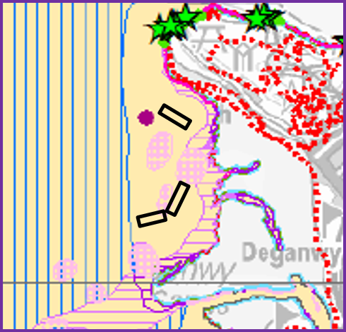
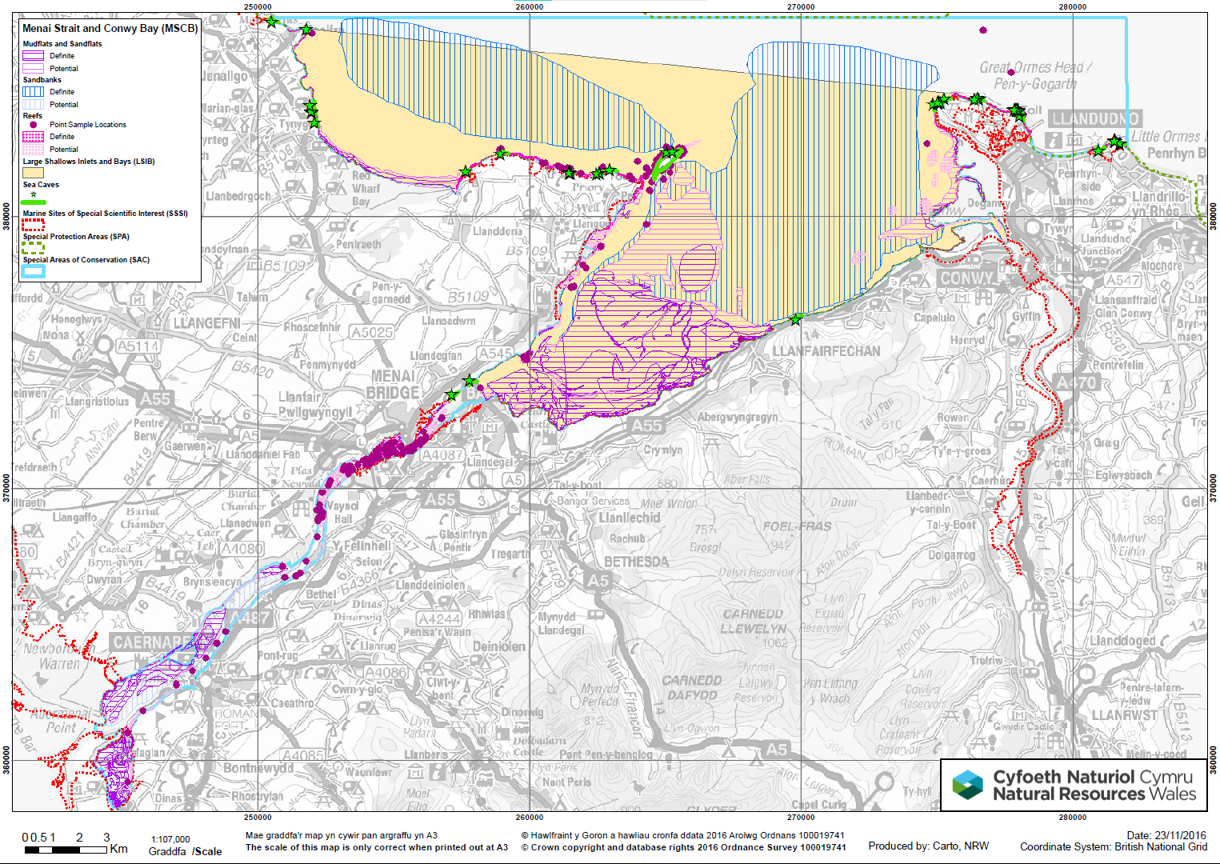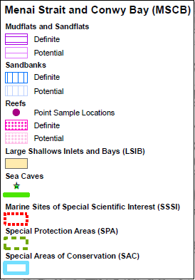

Screening for Likely Significant Effect
NRW’s advice, provided under Regulation 37 of the Conservation of Habitats and Species Regulations 2017, for Y Fenai a Bae Conwy / Menai Strait and Conwy Bay SAC has been used to screen for LSE. Where NRW (2018a) has identified that a pressure associated with the proposed works may interact with a sensitive feature of the SAC, the pressure has been screened for LSE. The activities “Aquaculture: molluscan ‘ranching’” and “Shipping: vessel traffic” have been used, as these most closely the resemble activities under the proposed works. In addition to the pressures identified by NRW (2018a) (Table 3.2), the following pressures are assessed:
- Abrasion/disturbance of the substrate on the surface of the seabed;
- Penetration and/or disturbance of the substratum below the surface of the seabed, including abrasion;
- Physical change (to another seabed type).
Table 3.4: Summary of advice on operations for activities related to the proposed works (Source: NRW, 2018a)
Activity | Relevant Factors | Features |  |  |  |  | Most likely relevant components and effects
Activity | Relevant Factors | Mud and Sand Flats | Reefs | Sandbanks | Inlets and Bays | Sea Caves
Aquaculture: molluscan ‘ranching’ | Fundamental environmental parameters: oxygen depletion.  Environmental quality: toxic and non-toxic contamination, nutrient and organic enrichment; possible addition of pesticides and antifoulants.  Other factors: introduction of non-native species. | ✓ | ✓ | ✓ | ✓ | ✓ | Extent and distribution: potential decrease in (intertidal) habitat extent.  Structure and function: modification of habitat structure, sedimentology, sediment processes, water and sediment chemistry (increase in nutrients, toxic and non-toxic contaminants, oxygen demand).  Conservation status of typical species and species features: local modification of species physiological health, variety, composition within zone of influence; modification of behaviour and range of predatory species (including species features).  Operation-specific information required: location, extent and scale; species and aquaculture practices; maintenance requirements and frequency; relevant location-specific biotic and abiotic information.
Shipping: vessel traffic | Geophysical regime: vessel wash – substrate erosion, local modification of wave exposure regime.  Fundamental environmental parameters: turbidity.  Physical disturbance: collision, noise, visual. | ✓ | ✓ | ✓ | ✓ | ✓ | Structure and function: local effects to sediment habitat structure; noise/visual disturbance effecting mobile species particularly mammals; potential for collision with seals; local modification of physical processes with elevated levels of suspended sediments effecting benthic flora, and smothering sessile benthic fauna; modification to biological processes including food availability, and changes to biological interactions due to modification of habitat and physical factors.  Conservation status of typical species and species features: particularly effecting the diversity, health and extent of wave-sheltered communities and the distribution of communities along physical gradients. Also an interaction/reduction in quality of communities/populations containing species sensitive to changes in turbidity, light, oxygen and smothering (particularly shallow subtidal algal and eelgrass communities, species-rich sediment infaunal communities, and sessile faunal turb communities).  Operation-specific information required: location, frequency and duration of operation; scale of effect of wash and water movement from vessel movement dependent on vessel size, activity, speed and proximity to sensitive (sheltered, intertidal and/or shallow subtidal) habitats/communities and species; relevant location-specific biotic and abiotic information; baseline data (occurrence and status) on non-native species present within the site.

Interaction with Annex I Habitat Features and Project Site Refinement
The target seabed sediment composition for deployment is ‘mixed sediments’, and as such, geophysical surveys were undertaken across the full extent of the original project sites in order to identify specific areas suitable for deployment. Sidescan sonar data were collected across the 3 project sites (Abbey: 0.38 km²; Bwrling: 0.41 km²; and West Bwrling: 0.42 km²) and the data were interpreted based on seabed reflectivity in order to determine the seabed substrate. The results of the interpretation are presented in Figure 3.2.
As can be seen in Figure 3.2, the project sites cover a variety of seabed sediments, including sands and mixed sediments, as well as areas of mixed sediment and hard substrate. Subtidal sands and gravels (EUNIS habitat ‘Sublittoral mixed sediment’ (A5.4)) is considered to be the most suitable substrate for deployment; however, this habitat was often not distinguishable from ‘Atlantic and Mediterranean moderate energy infralittoral rock’ (A3.2) or ‘Atlantic and Mediterranean moderate energy circalittoral rock’ (A4.2). The A3.2 and A4.2 habitats may represent Annex I reef within the Y Fenai a Bae Conwy / Menai Strait and Conwy Bay SAC. As such, the need for further data collection and ground-truthing areas of potential reef was identified.

Figure 3.2: EUNIS (European Union Nature Information System) Level 3 habitat map based on geophysical and imagery data (From: OEL, 2022)
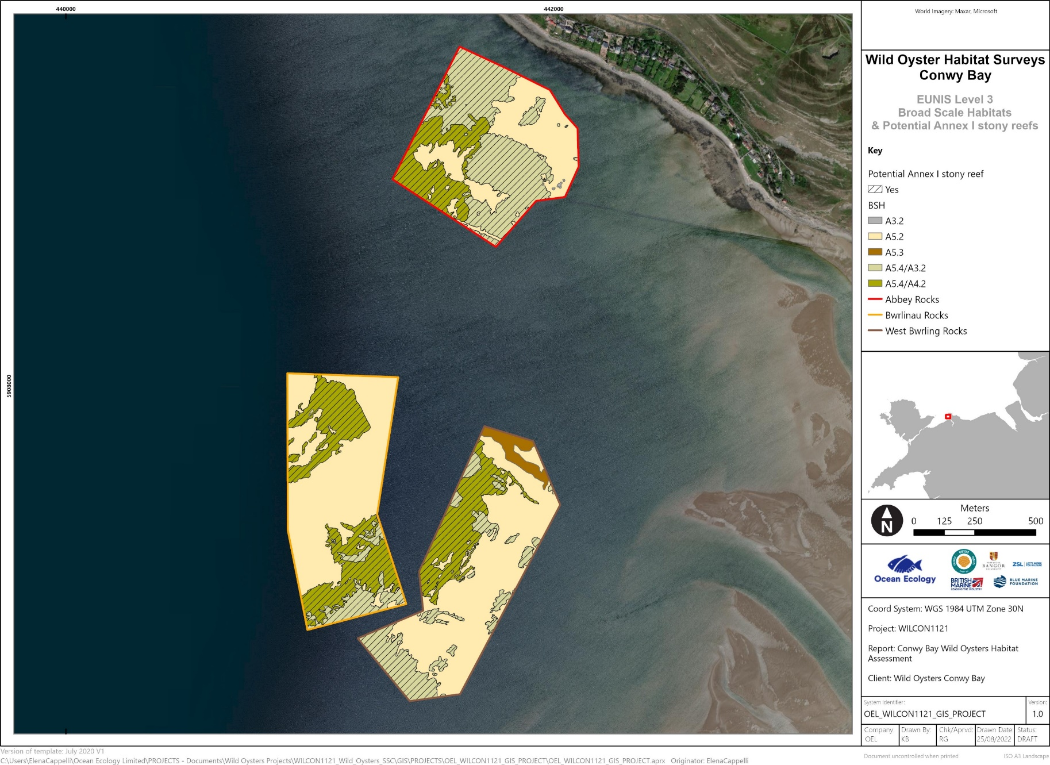
Further site-specific surveys, comprising particle size analysis and seabed imagery analysis, as well as habitat mapping, were undertaken in order to refine the site boundaries and to select areas which are both suitable for deployment, and avoid the most prominent areas of potential Annex I reef (OEL, 2022). The survey array covered the initial 3 project sites, with the array presented in Figure 3.2. Seabed image analysis was assessed against criteria outlined by Irving (2009) to determine whether areas of consolidated sediment and hard substrate meet the definitions of Annex I reef (Table 4.1).
Table 3.2: Characteristics used to determine Annex I stony reef (Source: Irving, 2009)
Characteristic | ‘Reefiness’
Characteristic | Not Reef | Low | Medium | High
Composition (proportion of boulders/cobbles) | <10% | 10-40% | 40-95% | >95%
Elevation (above relative seabed level) | Flat | <64 mm | <5 m | >5 m
Extent (continuous) | <25 m² |  | >25 m²
Biota | Infaunal |  | >80% epifaunal taxa

A total of 29 stations were sampled, 10 within the Abbey site, 9 within Bwrling, and 10 within West Bwrling. Potential Annex I stony reef was identified at 13 sampling stations, with approximate equal split across the 3 sites (OEL, 2022). The majority of these sites were determined to be representative of low resemblance stony reef, however, 3 records were representative of medium resemblance. No stations were high resemblance stony reef (Table 3.3).

Table 3.3: Potential Annex I stony reef identified in the habitat survey Study Area (Source: OEL, 2022)
Station | Reef | Station | Reef | Station | Reef
A1 | Low | B1 | Medium | WB1 | Low
A2 | Low | B2 | Low | WB2 | Low
A3 | Low | B3 | Medium | WB3 | Low
A4 | Medium | B4 | Low | WB4 | Low
A5 | Low | B5 |  | WB5 | Not reef
A6 | Not reef | B6 | Not reef | WB6 | Not reef
A7 | Not reef | B7 | Not reef | WB7 | Not reef
A8 | Not reef | B8 | Not reef | WB8 | Not reef
A9 | Not reef | B9 | Not reef | WB9 | Not reef
A10 | Not reef | B10 | Not reef | WB10 | Not reef

The imagery data were combined with the geophysical data collected previously in order to produce habitat maps, identifying areas of potential reef within the Study Area. Following review of the habitat mapping exercise, the site boundaries were refined and reduced to those described in Section 1 and presented in Figure 3.1. Figure 3.2 presents the sidescan sonar data, along with the seabed image sample stations, and the original and refined project sites.
Figure 3.3: Habitat mapping, showing sidescan sonar reflectivity, seabed imagery sample locations, and the original and revised Conwy Bay project sites (From: OEL, 2022)
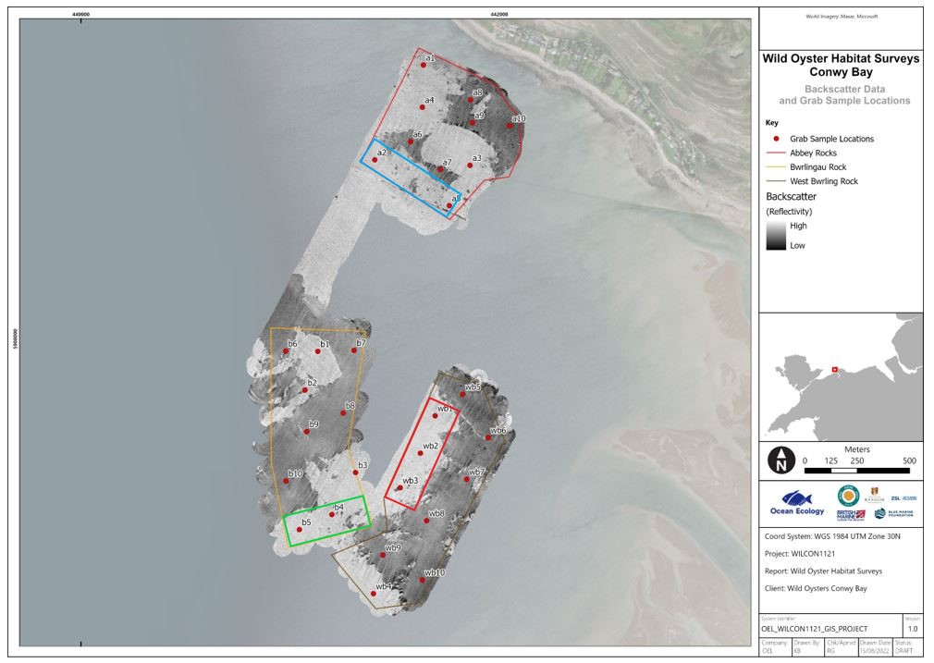
As observed in Figure 3.2, the original project sites encompassed areas comprising medium resemblance reef, low resemblance reef, and ‘not reef’ over a range of sidescan sonar reflectivities and seabed sediments. In order to refine the original project sites, the following criteria were required to be met:
- Seabed substrate comprising sublittoral mixed sediment;
- Reef resemblance not medium or high.
Through ongoing discussion with NRW, and taking the above criteria into consideration, the spatial extent of the project sites was reduced by >80%, from a combined extent of 1.21 km² to 0.20 km². The refined project sites were selected based on the target seabed sediment composition for deployment (mixed sediment), but also strategically placed to avoid areas OEL (2022) identified as medium resemblance reef. As such, the refined (current/proposed) project sites are located on sediments comprising ‘Sublittoral mixed sediments’/’Atlantic and Mediterranean moderate energy infralittoral rock’ (A5.4/A3.2) and ‘Sublittoral mixed sediments’/’Atlantic and Mediterranean moderate energy circalittoral rock’ (A5.4/A4.2); but contain sample stations were reef resemblance was described as ‘low’ (Figure 3.3; Figure 3.4; OEL, 2022).
It is recognised that there are locations between the image sample stations which are not necessarily ground-truthed and were mapped as A5.4/A3.2 or A5.4/A4.2. Without ground-truthing data at these interim positions, it is not certain that the reef resemblance is ‘low’. In order to minimise potential of deployment over areas of unknown or potential ‘medium’ resemblance reef, the initial deployment will take place as close as reasonably practicable to the seabed image locations within the refined (current) project sites, as agreed with NRW Advisory during stakeholder meetings on 20 October 2022 and 16 November 2022:
- Station A2 and/or Station A5 (Abbey);
- Station B5 (Bwrling); and/or
- Station WB1, Station WB2, and/or Station WB3 (West Bwrling).
As such, there is no direct overlap between the proposed project sites and any habitat determined to be representative of Annex I reef within the Y Fenai a Bae Conwy / Menai Strait and Conwy Bay SAC.
Figure 3.4: EUNIS (European Union Nature Information System) Level 3 habitat map based on geophysical and imagery data, and sample locations identified as low and medium resemblance stony reefs based on imagery analysis (From: OEL, 2022)
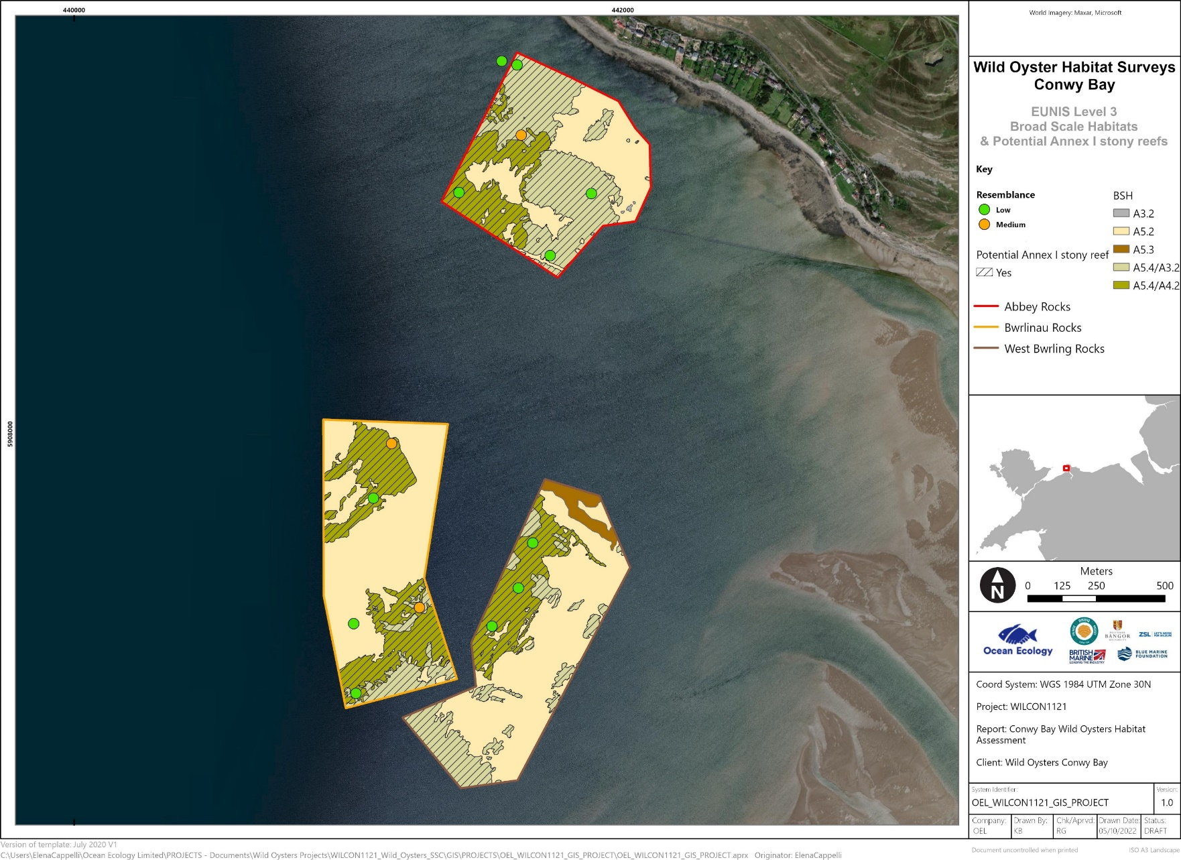

Screening for Likely Significant Effect
Where NRW (2018a) identifies a potential interaction between a pressure associated with the proposed works and a sensitive feature of the SAC, these pressure-receptor interactions have been assessed in Table 3.3. Where No LSE cannot be determined, or where LSE is determined, the pressure-receptor interaction is progressed to Stage 2: Appropriate Assessment.
Table 3.5: Screening for Likely Significant Effect on Y Fenai a Bae Conwy / Menai Strait and Conwy Bay Special Area of Conservation
Pressure(s) | Qualifying Feature(s) or Sub-feature(s) | Conclusion | Justification
Abrasion/disturbance of the substrate on the surface of the seabed  Penetration and/or disturbance of the substratum below the surface of the seabed, including abrasion | Annex I Habitats  - Mud flats and sand flats;  - Reefs;  - Sandbanks;  - Large shallow inlets and bays;  - Sea caves. | No Likely Significant Effect (LSE) | Abrasion/disturbance of the substrate on the surface of the seabed. Any disturbance to the seabed resulting from the introduction of cultch or juvenile oysters is unlikely to cause long-term, permanent, or significant effects. The introduced material will not exceed 50 cm above the surrounding seabed and the project is intended to improve sediment and water quality through biofiltration. Although the project sites are located within the SAC, and directly overlap with the large shallow inlets and bays feature (there is no direct overlap with the Annex I reef feature of the SAC), the total area occupied is 0.20 km². This represents <0.01% of the SAC and a small proportion of the total habitat extents within. As such, No Likely Significant Effect on all features is determined for this pressure.  Penetration and/or disturbance of the substratum below the surface of the seabed, including abrasion. The proposed works do not involve introduction of any manmade structures not naturally found in the marine environment that are likely to cause penetration and/or disturbance below the surface of the seabed. As such, No Likely Significant Effect on all features is determined for this pressure.
Physical change (to another seabed type) | Annex I Habitats  - Mud flats and sand flats;  - Reefs;  - Sandbanks;  - Large shallow inlets and bays;  - Sea caves. | No LSE | Physical change (to another seabed type). Oyster cultch will be placed on the seabed, on subtidal sands and/or gravels, and juvenile oysters will be introduced to the area. Oysters and cultch will not be deployed onto the Annex I reef feature of the SAC; and will deployed at slack tide, meaning that there will be minimal lateral drift (i.e. the deployed material will drop straight down to the seabed and will not be transported over areas of Annex I reef by tidal currents). Oysters will attach to the cultch and, over time, will develop a productive oyster bed. Therefore, the habitat originally present (subtidal sands/gravels) will have changed to habitat which may be more representative of biogenic reef. This constitutes a physical change of habitat and will be unavoidable. However, the spatial extent is very limited, consisting of an area approximately 225 × 225 m within the project sites. The total area of the project sites is 0.20 km², which represents a negligible proportion (<0.01%) of the total area of the SAC.  Additionally, whilst this area of habitat (that currently exists) will be lost, the oyster bed will work to enhance surrounding habitat, potentially offsetting the area of habitat loss. Biofiltration will result in reduction in the concentration of organic and inorganic contaminants from the water column (MMO, 2019; Mara et al., 2021). The presence of the oyster beds will be akin to biogenic reef habitat, providing some level of shelter and food source for other species in the local area, such as juvenile fish (MMO, 2019).  As such, No Likely Significant Effect on all features is determined for this pressure.
Oxygen depletion | Annex I Habitats  - Mud flats and sand flats;  - Reefs;  - Sandbanks;  - Large shallow inlets and bays;  - Sea caves. | No LSE | Oxygen depletion. Deoxygenation is often associated with the artificial introduction of nutrients or organic enrichment of an environment, however, it can also be a result of stagnant water arising from reduced current flow. The project involves the introduction of native oyster and subsequent growth of oyster bed habitat in the shallow subtidal zone. No nutrients will be introduced to the environment, and the introduced material will not exceed 50 cm above the current seabed level; therefore, oxygen depletion will not occur through the aforementioned pathways.  It is possible that the sediment underneath the placed material and oyster bed will experience anoxic conditions, due to being covered by new material. However, the project sites interact with a negligible proportion of total habitat available, and effects are not likely to be significant. The introduction of oyster bed habitat will work to filter and improve water and sediment quality, as well as provide additional habitat to a variety of species.  As such, No Likely Significant Effect on all features is determined for this pressure.
Toxic and non-toxic contamination | Annex I Habitats  - Mud flats and sand flats;  - Reefs;  - Sandbanks;  - Large shallow inlets and bays;  - Sea caves. | No LSE | Toxic and non-toxic contamination. The project site is located within the SAC boundaries and therefore there is potential for interaction.  Shells and any material will be clean and uncontaminated by live biological material and weathered for a suitable period (6 months) prior to introduction to the site. This process will ensure that both invasive non-native species and World Organisation for Animal Health (WOAH)-listed diseases are not introduced. Further to this, a biosecurity plan is in place to ensure that only live native oyster Ostrea edulis, and no other live indigenous species, are translocated as part of the proposed works.  Additionally, best operational practice and health and safety measures (such as spillage kits, ensuring fuels and contaminants are safely stored, etc.) will be followed throughout all operations. This means that vessels will follow biosecurity and pollution protocols. Due to using small, locally sourced vessels, and the infrequent presence of vessels at the project sites, contamination events, such as spillages, are considered highly unlikely to occur.  As such, No Likely Significant Effect on all features is determined for this pressure.
Nutrient and organic enrichment | Annex I Habitats  - Mud flats and sand flats;  - Reefs;  - Sandbanks;  - Large shallow inlets and bays;  - Sea caves. | No LSE | Nutrient and organic enrichment. No nutrients or organic material (other than oysters) will be added to the environment. Oysters naturally cycle nutrients and filter water during feeding. Oyster bed restoration, as proposed under this project, has been shown to reduce organic matter and nitrogen and phosphorous concentrations in the local environment (MMO, 2019; Mara et al., 2021). Therefore, any effect is likely to be positive. As such, No Likely Significant Effect on all features is determined for this pressure.
Addition of pesticides and antifoulants | Annex I Habitats  - Mud flats and sand flats;  - Reefs;  - Sandbanks;  - Large shallow inlets and bays;  - Sea caves. | No LSE | Addition of pesticides and antifoulants. No pesticides or antifoulants are proposed for use in the project. As such, No Likely Significant Effect on all features is determined for this pressure.
Introduction of non-native species | Annex I Habitats  - Mud flats and sand flats;  - Reefs;  - Sandbanks;  - Large shallow inlets and bays;  - Sea caves. | No LSE | Introduction of non-native species. The project sites are located within the SAC boundaries and, therefore, there is potential for introduction of non-native species. The main sources of introduction are considered to be through vessel movement and during placement of cultch at the site. All vessels used throughout the proposed works will operate best practice procedures, to ensure all biosecurity measures and protocols are met. This includes those in relation to vessel cleanliness and ballast water exchanges.  All shells and material will be clean and uncontaminated by live biological material, and weathered for a suitable period (6 months), prior to introduction to the site. This process will ensure that both invasive non-native species and OIE-listed diseases are not introduced. Further to this, a biosecurity plan is in place to ensure that only live native oyster Ostrea edulis, and no other live indigenous species, are translocated as part of the proposed works. Best practice biosecurity protocols will be followed as per the NORA Guidelines on Biosecurity (European Guidelines on Biosecurity in Native Oyster Restoration. 2020. The Zoological Society of London, UK., London, UK).  It is possible that the introduction of cultch to the project sites could result in a steppingstone effect for the spread of non-native species. However, hard substrate is naturally present in the region, and the project will involve introduction over a small spatial scale (up to 0.05 km²), which represents a negligible increase in reef area. Therefore, the spread of non-native species is not considered high risk.  As such, No Likely Significant Effect on all features is determined for this pressure.
Geophysical regime: substrate erosion, local modification of wave regime exposures.  Fundamental environmental parameters: turbidity | Annex I Habitats  - Mud flats and sand flats;  - Reefs;  - Sandbanks;  - Large shallow inlets and bays;  - Sea caves. | No LSE | Substrate erosion, local modification of wave regime exposures, and turbidity. The proposed works are of a very small scale (cultch will be deposited in an area approximately 225 × 225 m (0.05 km²) and will not exceed 50 cm above relative seabed level. The increase in seabed height may result in some waves breaking sooner, however, due to the small spatial scale, this is not expected to result in significant effect. Overall effects on local and regional hydrological conditions, including sediment transport pathways, will be minimal and are not considered significant.  However, it is noted that some sediment may be resuspended during introduction of the cultch, due to direct contact with the seabed. Sediment plume effects, including increases in suspended sediment concentration and turbidity, are expected to be minimal, with some minor resuspension of sediment possible during deposition of cultch or oysters. Nevertheless, this elevation in turbidity will only be for a limited period of time and sediment deposition that does occur will only affect the seabed surface layer. Additionally, suspended sediment concentration is expected to dissipate and return to natural levels within 1-2 tidal cycles. Further to this, the introduction of oysters is likely to result in a decrease in suspended sediment concentration in the long-term through biofiltration (Mara et al., 2021).  As such, No Likely Significant Effect on all receptors is determined for this pressure.
Physical disturbance: collision, noise, and visual. | Annex I Habitats  - Mud flats and sand flats;  - Reefs;  - Sandbanks;  - Large shallow inlets and bays;  - Sea caves. | No LSE | Physical disturbance. There are no species features of the SAC and vessels will not directly interact with the seabed. Therefore, there is no pathway for this pressure. As such, No Likely Significant Effect is determined for this pressure.

No LSE has been determined for all pressures on all qualifying features and sub-features of Y Fenai a Bae Conwy / Menai Strait and Conwy Bay SAC, as such, this site is not taken forward to Stage 2: Appropriate Assessment.
Due to the distance between the project sites and other proposed developments and plans in the wider region, and determination of No LSE for each of the pressures assessed, No LSE can also be determined for in-combination effects with other projects.

Dee Estuary / Aber Dyfrdwy Special Area of Conservation

Site Overview
The Conwy Bay project sites are located approximately 32 km to the west of Dee Estuary / Aber Dyfrdwy SAC. The designated features and conservation objectives of Dee Estuary / Aber Dyfrdwy SAC are presented in Table 3.4.
Table 3.6: Overview of Dee Estuary / Aber Dyfrdwy Special Area of Conservation
Dee Estuary / Aber Dyfrdwy SAC (UK0030131)
https://naturalresources.wales/media/673576/dee-estuary-reg33-volume-1-english-091209_1.pdf
Qualifying Features | Annex I Habitats  - Estuaries;  - Mudflats and sandflats not covered by seawater at low tide;  - Salicornia and other annuals colonising mud and sand;  - Atlantic salt meadows;  - Annual vegetation of drift lines.  Annex II Species  - River lamprey Lampetra fluviatilis;  - Sea lamprey Petromyzon marinus.
Conservation Objectives (NE and CCW, 2010) | 6.1 Interest feature 1: The conservation objective for the estuary  The conservation objective for the “estuaries” feature of the Dee Estuary SAC is to maintain the feature in favourable condition, as defined below:  The “estuaries” feature will be considered to be in favourable condition when, subject to natural processes, each of the following conditions are met:  - the aggregate total extent of all estuarine communities within the site is maintained;  - the spatial distribution of estuarine communities within the site is maintained;  - the extent of individual estuarine habitat features within the site is maintained;  - the variety and relative proportions of sediment and rocky substates within the estuary is maintained;  - the variety and extent of any notable subtidal sediment communities is maintained;  - the variety and extent of notable intertidal hard substrata communities is maintained;  - the spatial and temporal patterns of salinity, suspended sediments and nutrients concentrations are maintained within limits sufficient to satisfy the requirements of statements (i) to (vi) above.  6.2 Interest feature 2: The conservation objective for mudflats and sandflats not covered by seawater at low tide  The conservation objective for the “mudflats and sandflats” feature of the Dee Estuary SAC is to maintain the feature in favourable condition, as defined below:  The “mudflats and sandflats” feature will be considered to be in favourable condition when, subject to natural processes, each of the following conditions are met:  - the total extent of mudflat and sandflat communities within the site is maintained;  - the proportions of individual mudflat and sandflat communities within the site are maintained;  - the topography of the intertidal flats and the dynamic processes of channel migrations and sinuosity across the flats are maintained;  - the abundance of typical species of the mudflat and sandflat feature within the site is maintained.  6.3 Interest feature 3: The conservation objective for Salicornia and other annuals colonising mud and sand  The conservation objective for the “Salicornia and other annuals colonising mud and sand” feature of the Dee Estuary SAC is to maintain the feature in favourable condition, as defined below:  The “Salicornia and other annuals colonising mud and sand” feature will be considered to be in favourable condition when both:  - subject to natural processes, each of the following conditions (i) to (vi) are met:  - the total extent of pioneer saltmarsh vegetation communities within the site is maintained;  - the presence of pioneer saltmarsh vegetation communities as part of transitions from intertidal sediment communities to higher saltmarsh are maintained;  - the abundance of the typical species of the pioneer saltmarsh vegetation communities is maintained;  - the abundance of notable species of the pioneer saltmarsh vegetation communities is maintained.  - and, regardless of natural processes, condition (v) is also met:  - the overall extent of and abundance of common cord grass Spartina anglica is not increasing within the pioneer saltmarsh zone.  6.4 Interest feature 4: The conservation objective for Atlantic salt meadow  The conservation objective for the “Atlantic salt meadow” feature of the Dee Estuary SAC is to maintain the feature in favourable condition, as defined below:  The “Atlantic salt meadow” feature will be considered to be in favourable condition when, subject to natural processes, each of the following conditions are met:  - the total extent of Atlantic salt meadow vegetation communities within the site is maintained;  - the proportions of individual Atlantic salt meadow vegetation communities within the site are maintained;  - the zonation of Atlantic salt meadow vegetation communities and their transitions to fresh water and terrestrial vegetation are maintained;  - the morphology of saltmarsh creeks and pans and the process of their evolution are maintained;  - the extent of ungrazed areas of salt meadow within the estuary is maintained and there is no increase in grazing intensity over the rest of the salt meadow;  - the relative abundance of the typical spices of the Atlantic salt meadow vegetation communities is maintained;  - the abundance of the notable species of the Atlantic salt meadow vegetation communities is maintained.  6.5 Interest feature 5: The conservation objectives for annual vegetation of drift lines  The conservation objective for the “annual vegetation of drift lines” feature of the Dee Estuary SAC is to maintain the feature in a favourable condition, as defined below:  The “annual vegetation of drift lines” feature will be considered to be in favourable condition when, subject to natural processes, each of the following conditions are met:  - the extent of coarse sediment / shingle formations capable of supporting drift line vegetation communities within the site is maintained;  - the presence of annual drift line vegetation communities within the site is maintained;  - the presence of typical species of the annual drift line vegetation communities is maintained.  6.6 Interest feature 6: The conservation objective for Lampetra fluviatilis (river lamprey)  The conservation objective for the “Lampetra fluviatilis (river lamprey)” feature of the Dee Estuary SAC is to maintain the feature in a favourable condition, as defined below:  The “river lamprey” feature will be considered to be in favourable condition when, subject to natural processes, each of the following conditions are met:  - the migratory passage of both adult and juvenile river lamprey through the Dee Estuary between Liverpool Bay and the River Dee is unobstructed by physical barriers and / or poor water quality;  - the five year mean count of river lampreys recorded by the Chester Weir fish trap is no less than 55 under the monitoring regime in use prior to notification [i.e. 100% of the mean annual count during the five years for which data are available prior to notification: 1993, 1997-2000];  - the abundance of prey species forming the river lamprey’s food resource within the estuary, is maintained.  6.7 Interest feature 7: The conservation objective for Petromyzon marinus (sea lamprey)  The conservation objective for the “Petromyzon marinus (sea lamprey)” feature of the Dee Estuary SAC is to maintained the feature in favourable condition, as defined below:  The “sea lamprey” feature will be considered to be in favourable condition when, subject to natural processes, each of the following conditions are met:  - the migratory passage of both adult and juvenile sea lampreys through the Dee Estuary between Liverpool Bay and the River Dee is unobstructed by physical barriers and / or poor water quality;  - the five year mean count of sea lampreys recorded by the Chester Weir fish trap is no less than 18 under the monitoring regime in use prior to notification. [i.e. 100% of the mean annual count during the five years for which data are available prior to notification: 1993, 1997-2000];  - the abundance of prey species forming the sea lamprey’s food resource within the estuary, is maintained.

Screening for Likely Significant Effect
NE and CCW’s advice, given under Regulation 33(2) of the Conservation (Natural Habitats &c.) Regulations 1994 for Dee Estuary / Aber Dyfrdwy SAC, has been used to screen for LSE. Where NE and CCW (2010) determine a feature is vulnerable, or sensitive to a pressure that may be associated with the proposed works, the pressure has been screened for LSE. Where No LSE cannot be determined, or where LSE is determined, the pressure-receptor interaction is progressed to Stage 2: Appropriate Assessment.
Due to the distance between the project sites and Glannau Môn: Cors heli SAC, there is no pressure-receptor pathway for any direct effects. Secondary effects, such as those associated with suspended sediment plumes or introduction/spread of species, are not likely to occur due to the location of the SAC in relation to the proposed works. The SAC is located on the on the north coast of Wales, on the Wales-England border, approximately 32 km east of the project sites, outside the maximum extent of secondary effects by a considerable margin. Therefore, No Likely Significant Effect is determined for all features of Dee Estuary / Aber Dyfrdwy SAC.
No LSE has been determined for all pressures on all qualifying features and sub-features of Dee Estuary / Aber Dyfrdwy SAC, as such, this site is not taken forward to Stage 2: Appropriate Assessment.
Due to its distance from the project sites and determination of No LSE for all pressures assessed, No LSE can also be determined for in-combination effects with other projects.

Bae Cemlyn / Cemlyn Bay Special Area of Conservation

Site Overview
The Conwy Bay project sites are located approximately 43 km to the southeast of Bae Cemlyn / Cemlyn Bay SAC. The designated features and conservation objectives of Bae Cemlyn / Cemlyn Bay SAC are presented in Table 3.7.
Table 3.7: Overview of Bae Cemlyn / Cemlyn Bay Special Area of Conservation
Bae Cemlyn / Cemlyn Bay SAC (UK0030114)
https://naturalresources.wales/media/674074/Cemlyn%20WES32%20plan%20English.pdf
Qualifying Features | Annex I Habitats  - Coastal lagoons;  - Perennial vegetation of stony banks.
Conservation Objectives (CCW, 2008b) | 4.2 Conservation Objective for Feature 5: Coastal Lagoon and Feature 9: Spiral tasselweed Ruppia cirrhosa  Vision for Features 5 and 9: The vision for these features is for them to be in a favourable conservation status, where all the following conditions are satisfied:  - There is no loss of area other than that due to natural processes.  - The specialised plant and animal communities within the lagoon remain.  - All factors affecting the achievement of these conditions are under control.  4.3 Conservation Objective for Feature 6: Perennial vegetation of Stony Banks  Vision for Feature 6: The vision for this feature is for it to be in a favourable conservation status, where all the following conditions are satisfied:  - The extent of the vegetation of shingle banks is maintained unless altered by natural (e.g. storm) events.  - Typical component species of vegetation of shingle banks are maintained.  - Invasive alien species (e.g. Fallopia japonica) are absent.  - The management of activities or operations likely to damage or degrade the population dynamics, natural range and supporting habitat of the feature is appropriate for maintaining favourable conservation status and is secure in the long-term.

Screening for Likely Significant Effect
CCW’s Core Management Plan and, where applicable, NRW’s site level feature condition assessment for Bae Cemlyn / Cemlyn Bay SAC have been used to screen for LSE. The conservation objectives and management requirements for each feature (CCW, 2008b) were reviewed, and where pressures associated with the proposed works may interact with or contravene the conservation objectives or management requirements, the pressure was screened for LSE. Where No LSE cannot be determined, or where LSE is determined, the pressure-receptor interaction is progressed to Stage 2: Appropriate Assessment.
Due to the distance between the project sites and Bae Cemlyn / Cemlyn Bay SAC, and the small scale of the proposed work and sessile nature of the designated features, there is no pressure-receptor pathway for any direct effects. Secondary effects, such as those associated with suspended sediment plumes or introduction/spread of species, are not likely to occur due to the location of the SAC in relation to the proposed works. The SAC is located on the north coast of Anglesey, approximately 43 km northwest of the project sites. Additionally, the designated Annex I habitat features of Bae Cemlyn / Cemlyn Bay SAC are coastal habitat features with limited interaction with the marine environment. Therefore, No Likely Significant Effect is determined for all features of Bae Cemlyn / Cemlyn Bay SAC.
No LSE has been determined for all pressures on all qualifying features and sub-features of Bae Cemlyn / Cemlyn Bay SAC, as such, this site is not taken forward to Stage 2: Appropriate Assessment.
Due to its distance from the project sites and determination of No LSE for all pressures assessed, No LSE can also be determined for in-combination effects with other projects.

North Anglesey Marine / Gogledd Môn Forol Special Area of Conservation

Site Overview
The Conwy Bay project sites are located approximately 23 km to the southeast of North Anglesey Marine / Gogledd Môn Forol SAC. The designated features and conservation objectives of North Anglesey Marine / Gogledd Môn Forol SAC are presented in Table 3.8.
Table 3.8: Overview of Y Fenai a Bae Conwy / Menai Strait and Conwy Bay Special Area of Conservation
North Anglesey Marine / Gogledd Môn Forol SAC (UK0030398)
https://naturalresources.wales/media/691805/north-anglesey-marine-conservation-objectives-and-advice-on-operations.pdf
Qualifying Features | Annex II Species  - Harbour porpoise Phocoena phocoena.
Conservation Objectives (JNCC et al., 2019) | To ensure that the integrity of the site is maintained and that it makes the best possible contribution to maintaining Favourable Conservation Status (FCS) for Harbour Porpoise in UK waters  In the context of natural change, this will be achieved by ensuring that:  - Harbour porpoise is a viable component of the site;  - There is no significant disturbance of the species; and  - The condition of supporting habitats and processes, and the availability of prey is maintained.

Screening for Likely Significant Effect
Joint Nature Conservation Committee (JNCC), NRW, and Department of Agriculture, Environment and Rural Affairs (DAERA)’s advice, provided under Regulation 21 of the Conservation of Offshore Marine Habitats and Species Regulations 2017 and Regulation 37(3) of the Conservation of Habitats and Species Regulations 2017, for North Anglesey Marine / Gogledd Môn Forol SAC has been used to screen for LSE. Where No LSE cannot be determined, or where LSE is determined, the pressure-receptor interaction is progressed to Stage 2: Appropriate Assessment.
North Anglesey Marine / Gogledd Môn Forol SAC was designated in 2019, as it represented part of the top 10% of persistent high-density harbour porpoise areas in the UK for the summer season (NRW and JNCC, 2017). At its closest, the SAC is approximately 23 km from the project sites, however, the majority of the SAC is located north and northwest of Anglesey, away from the inshore waters of Conwy Bay. The most important areas on the west side of the UK for harbour porpoise are Bristol Channel Approaches, encompassing the entrance to the Bristol Channel, and north Devon and south Pembrokeshire; West Wales Marine, including Cardigan Bay and the north and west coasts of Pembrokeshire; North Wales Marine, including the west and north coasts of Anglesey; and North Channel, off the east coast of Northern Ireland (NRW and JNCC, 2017). These 4 SACs are aligned south-north, and the important areas for the species do not extend into the Liverpool Bay region, or along the north coast of mainland Wales. The project sites are located within Conwy Bay, which is not recognised as a particularly important site for harbour porpoise. Vessels transiting to, and from, the project sites will use ports at Conwy or Menai Bridge, and therefore will not interact with the SAC.
Due to the location and small scale and highly localised effects associated with the proposed works, there is no pressure-receptor pathway for any impact on harbour porpoise supporting habitat within North Anglesey Marine / Gogledd Môn Forol SAC. There is potential for foraging harbour porpoise to interact with the proposed works; however, given the extensive foraging range of these highly mobile animals, the proposed works constitute a negligible proportion of their overall foraging grounds, and it is therefore determined that there is no risk in terms of population-level effects on feeding resources. In view of the low likelihood of notable interaction between the harbour porpoise feature, or supporting habitats, of North Anglesey Marine / Gogledd Môn Forol SAC and the proposed works, No Likely Significant Effect is determined.
No LSE has been determined for all pressures on all qualifying features and sub-features of North Anglesey Marine / Gogledd Môn Forol SAC, as such, this site is not taken forward to Stage 2: Appropriate Assessment.
Due to its distance from the project sites, very low usage of the shallow waters at the project sites, and determination of No LSE for all pressures assessed, No LSE can also be determined for in-combination effects with other projects.

Screening for Special Protection Areas
There are 6 SPAs with marine components within 50 km of the project (Figure 1.1):
- Liverpool Bay / Bae Lerpwl SPA (UK9020294);
- Traeth Lafan / Lavan Sands, Conway Bay (UK9013031);
- Anglesey Terns / Morwenoliaid Ynys Môn (UK9013061);
- Ynys Seiriol / Puffin Island (UK9020285);
- The Dee Estuary (UK9013011) and Ramsar Site (UK11082);
- Mersey Narrows and North Wirral Foreshore SPA (UK9020287) and Ramsar Site (UK11042).

Liverpool Bay / Bae Lerpwl Special Protection Area

Site Overview
The Conwy Bay project sites are located entirely within Liverpool Bay / Bae Lerpwl SPA. The designated features and conservation objectives of Liverpool Bay / Bae Lerpwl SPA are presented in Table 3.9.
Table 3.9: Overview of Liverpool Bay / Bae Lerpwl Special Protection Area
Liverpool Bay / Bae Lerpwl SPA (UK9020294)
https://naturalresources.wales/media/678824/liverpool-bay-bae-lerpwl-spa-conservation-advice.pdf
Qualifying Features | Birds  - Red-throated diver Gavia stellata (non-breeding);  - Common scoter Melanitta nigra (non-breeding);  - Waterbird assemblage (non-breeding).
Conservation Objectives (NE and CCW, 2012) | - The conservation objective for Liverpool Bay / Bae Lerpwl SPA Interest feature 1: Internationally important non-breeding population of red-throated diver (Gavia stellata)  Subject to natural change, maintain or enhance the red-throated diver population and its supporting habitats in favourable condition  The interest feature red-throated diver will be considered to be in favourable condition only when both of the following two conditions are met:  - The size of the red-throated diver population is at, or shows only non-significant fluctuation around the mean population at the time of designation of the SPA. To account for natural change;  - The extent of the supporting habitat within the site is maintained.  - The conservation objective for Liverpool Bay / Bae Lerpwl SPA Interest feature 2: Internationally important non-breeding population of common scoter (Melanitta nigra).  Subject to natural change, maintain or enhance the common scoter population and its supporting habitats in favourable condition  The interest feature common scoter will be considered to be in favourable condition only when each of the following two conditions is met:  - The size of the common scoter population is at, or shows only non-significant fluctuation around the mean population at the time of designation of the SPA to account for natural change;  - The extent of the supporting habitat within the site is maintained.  - The conservation objective for Liverpool Bay / Bae Lerpwl SPA Interest feature 3: Non-breeding assemblage of over 20,000 waterbirds  Subject to natural change, maintain or enhance the waterbird assemblage and its supporting habitats in favourable condition  The interest feature waterbird assemblage will be considered to be in favourable condition only when each of the following two conditions is met:  - The size of the waterbird population shows only non-significant fluctuation around the mean at the time of designated to allow for natural change;  - The extent of the waterbird assemblage supporting habitat within the site is maintained.

Screening for Likely Significant Effect
Natural England and CCW’s Advice, under Regulation 35(3) of The Conservation of Habitats and Species Regulations 2010 (as amended) for Liverpool Bay / Bae Lerpwl SPA, has been used to screen for LSE (Table 3.10). Where NE and CCW (2012) identified a pressure associated with the project, that may result in adverse effect on the classified features of the SPA, the vulnerability assessment (Appendix E to NE and CCW, 2012) has been consulted.
Table 3.10: Pressures associated with the project that may cause deterioration or disturbance to the classified features of the Liverpool Bay / Bae Lerpwl Special Protection Area (Source: NE and CCW, 2012)
Key: [_] = not vulnerable, no risk, or no assessment conducted; [_] = low vulnerability; [_] = medium vulnerability; and [_] = high vulnerability.
Pressure | Red-throated Diver | Supporting Habitat | Common Scoter | Supporting Habitat | Waterbird Assemblage | Supporting Habitat
Physical loss of supporting habitat
Smothering (e.g. by artificial structures, disposal of dredge spoil) |  | ✓ |  | ✓ |  | ✓
Physical damage to their habitats
Siltation (e.g. run-off, channel dredging, outfalls) |  | ✓ |  | ✓ |  | ✓
Abrasion (e.g. anchoring, cables) |  | ✓ |  | ✓ |  | ✓
Non-physical disturbance
Noise (e.g. boat activity) | ✓ | ✓ | ✓ |  | ✓ | ✓
Visual (e.g. recreational activity) | ✓ |  | ✓ |  | ✓
Toxic contamination
Introduction of synthetic compounds (e.g. pesticides, tributyltin (TBT), polychlorinated biphenyls (PCBs)) | ✓ | ✓ | ✓ | ✓ | ✓ | ✓
Introduction of non-synthetic compounds (e.g. heavy metals, hydrocarbons) | ✓ | ✓ | ✓ | ✓ | ✓ | ✓
Non-toxic contamination
Changes in nutrient loading (e.g. agricultural run-off, outfalls) |  | ✓ |  | ✓ |  | ✓
Changes in organic loading (e.g. mariculture, outfalls) |  | ✓ |  | ✓ |  | ✓
Changes in turbidity (e.g. run-off, dredging) |  | ✓ |  | ✓ |  | ✓
Biological disturbance
Introduction of microbial pathogens
Introduction of non-native species and translocation |  | ✓ |  | ✓ |  | ✓

Where any receptor is assessed as having a moderate or high vulnerability to a pressure, the pressure has been screened for LSE in Table 3.11. Where No LSE cannot be determined, or where LSE is determined, the pressure-receptor interaction is progressed to Stage 2: Appropriate Assessment.
Table 3.11: Screening for Likely Significant Effect on Liverpool Bay / Bae Lerpwl Special Protection Area
Pressure(s) | Qualifying Feature(s) or Sub-feature(s) | Conclusion | Justification
Smothering (e.g. by artificial structures, disposal of dredge spoil)  Abrasion (e.g. anchoring, cables) | Supporting habitats for:  - Red-throated diver Gavia stellata;  - Common scoter Melanitta nigra;  - Waterbird assemblage. | No Likely Significant Effect (LSE) | Smothering and abrasion. Any disturbance to the seabed resulting from the introduction of cultch or juvenile oysters is unlikely to cause long-term, permanent, or significant effects. The introduced material will not exceed 50 cm above the surrounding seabed and the project is intended to improve sediment and water quality through biofiltration. Some area of supporting habitat in the shallow subtidal zone will be lost; however, once native oyster Ostrea edulis beds are established, these will offer additional supporting habitat and water cycling services. As such, No Likely Significant Effect on all features is determined for this pressure.
Noise (e.g. boat activity)  Visual (e.g. recreational activity) | Birds  - Red-throated diver Gavia stellata;  - Common scoter Melanitta nigra;  - Waterbird assemblage.  Supporting habitats for:  - Common scoter;  - Waterbird assemblage. | No LSE | Red-throated diver are sensitive to vessel disturbance and displacement effects (Furness et al., 2013). The species has been recorded to flush at distances up to 2 km from vessels, with an average disturbance distance of 1,374 ±416 m for individuals and 1,281 ±424 m for flocks (Fleissbach et al., 2019), and has a relatively long resettlement period of 3-7 hours (Schwemmer et al., 2011; Dorsch et al., 2019).  Similar to red-throated diver, common scoter are also highly sensitive to disturbance (Furness et al., 2013) and can be displaced by vessels operating several kilometres away (Fleissbach et al., 2019). The mean flush distance for individuals is 1,600 ±777 m, decreasing to 1,015 ±727 m for flocks, with a maximum recorded distance of 3.2 km (Fleissbach et al., 2019).  Lawson et al. (2016) investigated the distribution of wintering seabirds and waterbirds within the Liverpool Bay / Bae Lerpwl SPA and wider region. Several areas of increased red-throated diver activity were identified, based on survey data from 2004-2011. The areas of highest activity (peak density of 1.15-1.74 birds/km²) were located at Dee Estuary / Aber Dyfrdwy; and in the south section of Conwy Bay / Bae Conwy, at the mouth of the Menai Strait / Y Fenai. Additional hotspots of activity were recorded on the east coast of Anglesey, Colwyn Bay, Formby and Southport, and Barrow in Furness (Lawson et al., 2019).  Lawson et al. (2016) also assessed the distribution of common scoter within the Liverpool Bay / Bae Lerpwl SPA. The study identified 2 main hotspots of common scoter activity, the first located offshore of Blackpool; and the second on the north Wales coast from Colwyn Bay to Dee Estuary / Aber Dyfrdwy. Density peaks at approximately 259-339 birds/km² and 99-138 birds/km² at each location, respectively (Lawson et al., 2016).  Vessel disturbance of red-throated diver and common scoter. The project sites are located on the eastern edge of the Conwy Bay and Menai Strait hotspot of red-throated diver activity (up to 1.74 birds/km²), however, the project sites are in an area of low activity (0.26-0.37 birds/km²). The project sites are also located on the periphery of an area of slightly increased common scoter density (4.5-14 birds/km²).  It should be noted that vessels accessing the project sites are likely to utilise Conwy Harbour or Menai Bridge. Vessels operating from Menai Bridge will pass through, or in close proximity to, the red-throated diver and common scoter hotspots as the vessel exits the Menai Strait.  Red-throated diver and common scoter are present in the Liverpool Bay / Bae Lerpwl SPA over the winter period (October-March), therefore, vessel movements through areas of use during this time may result in temporary disturbance of some individuals.  Vessel transits to, and from, the project sites will be spread over the course of the project (5 years). Introduction of cultch will involve use of a hopper vessel or flat-topped barge and is expected to take up to 2 weeks. Single beam bathymetry surveys will be undertaken shortly after deposition of cultch and take up to 5 days. However, these activities will take place in spring to late summer (April-September) and, as such, would not be expected to interact with red-throated diver or common scoter.  Introduction of juvenile oyster and post-introduction physical and biological surveys may take place year-round. Introduction will largely depend on availability of spat, and all activities will be weather-dependent, reducing likelihood of occurrence during the winter months. Additionally, due to the shallow depth (<3.0 m) and inshore nature of the sites, small vessels will be utilised for these activities, reducing the footprint and area of disturbance.  Due to the use of small vessels (i.e. a small visual profile and footprint), the small scale of the project (225 × 225 m within a 0.20 km² area, representing <0.0001% of the SPA), and limited overlap with areas of high density red-throated diver or common scoter, the spatial extent of disturbance impacts is considered to be low. Further to this, disturbance events will be limited over the course of the project, with longer activities (deposition of cultch) taking place in the spring or summer, when red-throated diver and common scoter usage of the area is lower.  In addition, restoration of native oyster beds is likely to increase water and sediment quality, removing contaminants. This will benefit benthic and fish communities, resulting increased prey abundance and foraging potential for red-throated diver and common scoter. This effect is likely to offset any population-level effect on bird species.  As such, No Likely Significant Effect on all features is determined for this pressure.
Introduction of synthetic compounds (e.g. pesticides, tributyltin (TBT), polychlorinated biphenyls (PCBs))  Introduction of non-synthetic compounds (e.g. heavy metals, hydrocarbons) | Birds  - Red-throated diver Gavia stellata;  - Common scoter Melanitta nigra;  - Waterbird assemblage.  Supporting habitats for:  - Red-throated diver;  - Common scoter;  - Waterbird assemblage. | No LSE | Toxic contamination. No synthetic compounds, such as pesticides; or non-synthetic compounds, such as heavy metals or hydrocarbons, will be introduced to the environment as part of the project.  The only conceivable pathway for introduction of material to the environment is via accidental spillage. Vessel presence at the project sites will be limited throughout the year, and the vessels in use will be small scale. Whilst there is risk of spillage, this risk is considerably small and as such, risk of toxic contamination is negligible.  In addition, embedded mitigation measures to further decrease the already low risk are included for vessel operations. All vessels and crew will follow standard health and safety procedures in order to minimise risk of spillage. This may include, but is not limited to, designated storage points on the vessel for any oils or fuel, appropriate level of training given to all crew, and easily accessible spillage kits.  Further to this, once populations have established, oysters will provide biofiltration services, which will increase the quality of water and sediment, reducing the concentration of contaminants in the environment.  As such, No Likely Significant Effect on all features is determined for this pressure.
Changes in nutrient loading (e.g. agricultural run-off, outfalls)  Changes in organic loading (e.g. mariculture, outfalls) | Supporting habitats for:  - Red-throated diver Gavia stellata;  - Common scoter Melanitta nigra;  - Waterbird assemblage. | No LSE | Non-toxic contamination. No additional nutrients will be added to the environment. Excluding the introduction of project material (cultch and live oyster), no organic content will be added.  Further to this, once populations have established, oysters will provide biofiltration services, which will increase the quality of water and sediment, reducing the concentration of contaminants in the environment.  As such, No Likely Significant Effect on all features is determined for this pressure.
Changes in turbidity (e.g. run-off, dredging)  Siltation (e.g. run-off, channel dredging, outfalls) | Birds  - Red-throated diver Gavia stellata;  - Common scoter Melanitta nigra;  - Waterbird assemblage.  Supporting habitats for:  - Common scoter;  - Waterbird assemblage. | No LSE | Changes in turbidity and siltation. Sediment plume effects, including increases in suspended sediment concentration and turbidity, as well as deposition and smothering, are expected to be minimal, with some minor resuspension of sediment possible during deposition of cultch or oysters. However, this will only be for a limited period of time and any resultant sediment deposition will only affect the seabed surface layer. Additionally, suspended sediment concentration and settled sediment are expected to dissipate and return to natural levels within 1-2 tidal cycles. Further to this, the introduction of oysters is likely to result in a decrease in suspended sediment concentration in the long-term through biofiltration. As such, No Likely Significant Effect on all receptors is determined for this pressure.
Introduction of non-native species and translocation | Birds  Supporting habitats for:  - Red-throated diver Gavia stellata;  - Common scoter Melanitta nigra;  - Waterbird assemblage. | No LSE | Introduction or spread of invasive non-indigenous species (INIS). Shells and any introduced material will be clean and uncontaminated by live biological material and will be weathered for a suitable period (6 months) prior to introduction to the site. This process will ensure that both invasive non-native species and OIE-listed diseases are not introduced. Further to this, a biosecurity plan is in place to ensure that only live native oyster Ostrea edulis and no other indigenous species are translocated as part of the proposed works. The biosecurity measures include visual inspection and manual removal of any flora or fauna other than native oyster, followed by a bleaching process prior to introduction of individuals to the project site.  It is possible that the introduction of cultch to the project sites could result in a steppingstone effect for the spread of non-native species. However, hard substrate is naturally present in the region, and the project will involve introduction over a small spatial scale (0.01 km²), which represents a negligible increase in reef area. Therefore, the spread of non-native species is not considered high risk.  As such, No Likely Significant Effect on all features is determined for this pressure.

No LSE has been determined for all pressures on all qualifying features and sub-features of the Liverpool Bay / Bae Lerpwl SPA, as such, this site is not taken forward to Stage 2: Appropriate Assessment.
Due to the small scale of the project sites and the location of the proposed works outside the hotspots of red-throated diver and common scoter activity, and determination of No LSE for all pressures assessed, No LSE can also be determined for in-combination effects with other projects.

Traeth Lafan / Lavan Sands, Conway Bay Special Protection Area

Site Overview
The Conwy Bay project sites are located approximately 7.8 km to the northeast of Traeth Lafan / Lavan Sands, Conway Bay SPA. The designated features and conservation objectives of Traeth Lafan / Lavan Sands, Conway Bay SPA are presented in Table 3.12.
Table 3.12: Overview of Traeth Lafan / Lavan Sands, Conway Bay Special Protection Area
Traeth Lafan / Lavan Sands, Conway Bay SPA (UK9013031)
https://naturalresources.wales/media/674184/Traeth%20Lafan%20SAC%20Plan%2021[1].4.08%20English.pdf
Qualifying Features | Birds  - Eurasian oystercatcher Heamatopus ostralegus (non-breeding).
Conservation Objectives (CCW, 2008c) | 4.1 Conservation Objective for Feature 1: Oystercatcher (Haematopus ostralegus)  Vision for feature 1  The vision for this feature is for it to be in favourable conservation status, where all of the following conditions are satisfied:  - The 5 year mean peak abundance of wintering oystercatchers is at least 4,000.  - The abundance and distribution of cockles of 15 mm or larger and other suitable food are maintained at levels sufficient to support the population with a 5 year mean peak of 4,000 individuals.  - Oystercatchers are not disturbed in ways that prevent them spending enough time feeding for survival.  - Roost sites, including high tide roost sites, remain suitable for oystercatchers to roost undisturbed.  - The management and control of activities or operations likely to adversely affect the oystercatchers, is appropriate for maintained the feature in favourable conditions and is secure in the long term.

Screening for Likely Significant Effect
CCW’s Core Management Plan including Conservation Objectives for Traeth Lafan / Lavan Sands, Conway Bay SPA, and, where applicable, NRW’s advice provided under Regulation 37 of the Conservation of Habitats and Species Regulations 2017 for the Y Fenai a Bae Conwy / Menai Strait and Conwy Bay SAC⁶, have been used to screen for LSE. The conservation objectives, as well as the most up to date conservation status and management requirements (CCW, 2008c), were used to identify which pressures associated with the proposed works may affect the classified feature of the SPA. Where interaction was identified and may affect the conservation status or management requirements, the pressure was screened for LSE. Where No LSE cannot be determined, or where LSE is determined, the pressure-receptor interaction is progressed to Stage 2: Appropriate Assessment.
Oystercatcher Haematopus ostralegus are waders which utilise the intertidal area and drift line for foraging and roost along the coast and at the shores of coastal and inland lakes and lagoons (RPSB, 2022). The species does not make notable use of the marine environment outside of these areas, and as such there is very limited potential for interaction between the Conwy Bay projects sites and the population at Traeth Lafan / Lavan Sands SPA. Due to the distance between the SPA and the project sites, and the highly coastal/intertidal nature of its qualifying feature, there is no pressure-receptor pathway. As such, No Likely Significant Effect is determined for non-breeding oystercatcher and supporting habitats at Traeth Lafan / Lavan Sands SPA.
No LSE has been determined for all pressures on all qualifying features and sub-features of the Traeth Lafan / Lavan Sands, Conway Bay SPA, as such, this site is not taken forward to Stage 2: Appropriate Assessment.
Due to its distance from the project sites and determination of No LSE for all pressures assessed, No LSE can also be determined for in-combination effects with other projects.

Anglesey Terns / Morwenoliaid Ynys Môn Special Protection Area

Site Overview
The Conwy Bay project sites are located approximately 8.5 km to the east of Anglesey Terns / Morwenoliaid Ynys Môn SPA. The designated features and conservation objectives of Anglesey Terns / Morwenoliaid Ynys Môn SPA are presented in Table 3.13.
Table 3.13: Overview of Anglesey Terns / Morwenoliaid Ynys Môn Special Protection Area
Anglesey Terns / Morwenoliaid Ynys Môn SPA (UK9013061)
https://naturalresources.wales/media/674074/Cemlyn%20WES32%20plan%20English.pdf
https://naturalresources.wales/guidance-and-advice/environmental-topics/consultations/our-own-consultations/our-own-consultations-closed/closed-2016/new-marine-sac/anglesey-terns/?lang=en
Qualifying Features | Birds  - Arctic tern Sterna paradisaea (breeding);  - Common tern Sterna hirundo (breeding);  - Roseate tern Sterna dougallii (breeding);  - Sandwich tern Sterna sandvicensis (breeding).
Conservation Objectives | The original SPA conservation objectives are outlined by CCW (2008b):  4.1 Conservation Objective for Feature 1-4: Breeding population of Terns  Feature 1: Arctic Tern Sterna paradisaea [sic]  Feature 2: Common Tern Stern hirundo  Feature 3: Roseate Tern Sterna dougallii  Feature 4: Sandwich Tern Sterna sandvicensis  Vision for features 1-4  The vision for these features is for them to be in a favourable conservation stations, where all the following conditions are satisfied:  - The number of breeding terns within the SPA is stable or increasing.  - The number of chicks successfully fledged in the SPA and beyond is sufficient to help sustain the population.  - The range and distribution of terns within the SPA and beyond is not considered constrained or hindered.  - The extent of supporting habitats used by terns is stable or increasing.  - Supporting habitats are of sufficient quality to support the requirements of terns.  - There are appropriate and sufficient food sources for terns within access of the SPA.  - Actions or events likely to impinge on the sustainability of the population are under control.  The conservation objectives and SPA boundaries were updated in 2015, and are shared across all 4 features of the SPA (NRW, 2015):  - The size of the population should be stable or increasing, allowing for natural variability, and sustainable in the long term;  - The distribution of the population should be being maintained, or where appropriate increasing;  - There should be sufficient habitat, of sufficient quality, to support the population in the long term;  - Factors affecting the population or its habitat should be under appropriate control.

Screening for Likely Significant Effect
CCW’s Core Management Plan including Conservation Objectives as well as NRW’s Draft Departmental Brief and associated supporting documents for Anglesey Terns / Morwenoliaid Ynys Môn SPA have been used to screen for LSE. The conservation objectives, as well as the most up to date conservation status and management requirements (CCW, 2008b), were used to identify which pressures associated with the proposed works may affect the classified feature of the SPA. Where interaction was identified and may affect the conservation status or management requirements, the pressure was screened for LSE. Where No LSE cannot be determined, or where LSE is determined, the pressure-receptor interaction is progressed to Stage 2: Appropriate Assessment.
The Anglesey Terns / Morwenoliaid Ynys Môn SPA is located 8.5 km from the project sites within Conwy Bay and, therefore, may be within foraging range of Arctic tern Sterna paradisaea (40.5 km), common tern S. hirundo (26.9 km), roseate tern S. dougallii (23.2 km) and Sandwich tern S. sandvicensis (57.5 km); however, it is important to note that these foraging ranges represent the mean maximum (plus 1 SD) values from a range of colonies (Woodward et al., 2019). Therefore, it is deemed more appropriate to use site or colony specific foraging ranges for screening purposes, where the data are available. In 2015, NRW produced a Departmental Brief for the Anglesey Terns / Morwenoliaid Ynys Môn SPA, with proposals to modify the site boundaries to account for tern foraging areas (NRW, 2015). This report includes marine usage areas for each of the tern qualifying features and, therefore, this information has been used to screen for LSE.
The proposed changes for the SPA included extending the marine site boundaries to include foraging areas for: Arctic and common tern colonies at Ynys Feurig, The Skerries, and Cemlyn Bay; and the Sandwich tern colony at Cemlyn Bay (NRW, 2015). Roseate tern were not included in the analyses for this SPA, as the cited population is 3 breeding pairs and the colony is no longer considered present. Site-specific data, collected in 2010 and 2011 by Wilson et al. (2010, 2011; cited by NRW, 2015) show Arctic, common and Sandwich tern abundance around Anglesey, with Arctic and common tern predominantly present around the west and northwest of the island and Sandwich tern utilising areas to the north and east (NRW, 2015).
These data were used to model predicted usage of the marine area by foraging terns in the breeding season (Wilson et al., 2014; cited by NRW, 2015). Arctic and common tern usage areas do not interact with the project sites within Cemlyn Bay (NRW, 2015); therefore, Arctic and common tern are screened out and No Likely Significant Effect is determined.
Although Sandwich tern modelled usage overlaps with the project sites, usage within Conwy Bay is <0.08 individuals/km². The project sites cover a total area of 0.20 km² and, therefore, assuming 0.08 birds/km², the maximum expected Sandwich tern abundance is <0.02 individuals, representing <0.002% of the SPA population (460 pairs) (NRW, 2015). Therefore, Sandwich tern are also screened out, and No Likely Significant Effect is determined.
Roseate tern were not included in the assessment (Wilson et al., 2010, 2011, 2014; cited by NRW, 2015), however the colony was previously present at Ynys Feurig, located on the west side of Anglesey (CCW, 2008b). The project sites are approximately 43 km to the east of Ynys Feurig, outside the foraging range of Roseate tern, therefore, there is very limited potential for interaction as individuals would be required to fly around Anglesey or via the Menai Strait to reach the project sites. Additionally, roseate tern have similar foraging habits to other large tern species (including Arctic, common and Sandwich terns) and therefore, it is reasonable to assume a similar foraging distribution from nesting colonies. As such, roseate tern are also screened out and No Likely Significant Effect is determined.
No LSE has been determined for all pressures on all qualifying features and sub-features of the Anglesey Terns / Morwenoliaid Ynys Môn SPA, as such, this site is not taken forward to Stage 2: Appropriate Assessment.
Due the very low density of birds at the project sites, the distance between the project site and any other proposed plan/development in the area, and determination of No LSE for all pressures assessed, No LSE can also be determined for in-combination effects with other projects.

Ynys Seiriol / Puffin Island Special Protection Area

Site Overview
The Conwy Bay project sites are located approximately 9.3 km to the west of Ynys Seiriol / Puffin Island SPA. The designated features and conservation objectives of Ynys Seiriol / Puffin Island SPA are presented in Table 3.14.
Table 3.14: Overview of Ynys Seiriol / Puffin Island Special Protection Area
Ynys Seiriol / Puffin Island SPA (UK9020285)
https://naturalresources.wales/media/674189/Ynys%20Seiriol%20SPA%20%20management%20Plan%2018%20April%20%20(English).pdf
Qualifying Features | Birds  - Great cormorant Phalacrocorax carbo (breeding).
Conservation Objectives (CCW, 2008d) | 4.1 Conservation Objective for Feature 1: Breeding population of cormorant Phalacrocorax carbo  Vision for feature 1  The conservation objective for the Cormorant is to achieve and maintain favourable conservation status, in which all the following conditions are satisfied:  - The number of breeding cormorants within the SPA are stable or increasing.  - The abundance and distribution of prey species are sufficient to support this number of breeding pairs and for successful breeding.  - The management and control of activities or operations likely to adversely affect the Cormorant, is appropriate for maintaining the feature in favourable conditions and is secure in the long term.

Screening for Likely Significant Effect
CCW’s Core Management Plan for Ynys Seiriol / Puffin Island SPA and, where applicable, the advice package for Y Fenai a Bae Conwy SAC⁶ (also refer to Section 3.1.1 of this report) have been used to screen for LSE. The conservation objectives, as well as the most up to date conservation status and management requirements (CCW, 2008d), were used to identify which pressures associated with the proposed works may affect the classified feature of the SPA. Where interaction was identified and may affect the conservation status or management requirements, the pressure was screened for LSE. Where No LSE cannot be determined, or where LSE is determined, the pressure-receptor interaction is progressed to Stage 2: Appropriate Assessment.
Where available, site-specific foraging range and at-sea usage area data have been used to identify pressure-receptor pathways for Ynys Seiriol / Puffin Island SPA, however, there are no distribution data for great cormorant Phalacrocorax carbo. Puffin Island (Ynys Seiriol) is an important breeding site for the species February-July (CCW, 2008d), and human disturbance is required to be minimised. This includes visits during the breeding season, and disturbance caused by passing vessels, which are advised to maintain a >100 m distance from the island. The project sites are located in excess of 9 km from the SPA, and vessels will operate out of Menai Bridge and/or Conwy Bay ports and, therefore, will not pass by or interact with Puffin Island. Woodward et al. (2019) determined that the mean maximum (plus 1 SD) foraging range of great cormorant is 33.9 km, meaning the project sites within Conwy Bay are within foraging range of Ynys Seiriol / Puffin Island SPA. It is important to recognise that whilst great cormorant forage in coastal waters rather than offshore, they are pursuit divers and dive down to an average of 12.1 m, with a maximum depth of 35 m (NE, 2012), whereas the project sites are in water depth up to 3.0 m. As such, the project sites are unlikely to represent prime foraging habitat for great cormorant due to the shallow water. Additionally, Furness et al. (2013) found that the species is not highly sensitive to vessel disturbance. Therefore, due to the small scale and localised effects associated with the proposed works, No Likely Significant Effect is determined for Ynys Seiriol / Puffin Island SAC.
No LSE has been determined for all pressures on all qualifying features and sub-features of Ynys Seiriol / Puffin Island SAC, as such, this site is not taken forward to Stage 2: Appropriate Assessment.
Due to the expect limited use of the site project sites by great cormorant, and determination of No LSE for all pressures assessed, No LSE can also be determined for in-combination effects with other projects.

The Dee Estuary Special Protection Area and Ramsar Site

Site Overview
The Conwy Bay project sites are located approximately 32 km to the west of The Dee Estuary SPA and Ramsar Site. The designated features and conservation objectives of The Dee Estuary SPA are presented in Table 3.15.
Table 3.15: Overview of The Dee Estuary Special Protection Area
The Dee Estuary SPA (UK9013011) and Ramsar Site (UK11082)
https://naturalresources.wales/media/673576/dee-estuary-reg33-volume-1-english-091209_1.pdf
Qualifying Features | Birds  - Common shelduck Tadorna tadorna (non-breeding);  - Eurasian teal Anas crecca (non-breeding);  - Northern pintail Ana acuta (non-breeding);  - Eurasian oystercatcher Haematopus ostralegus (non-breeding);  - Grey plover Pluvialis squatarola (non-breeding);  - Red knot Calidris canutus (non-breeding);  - Dunlin Calidris alpina alpina (non-breeding);  - Black-tailed godwit Limosa limosa islandica (non-breeding);  - Bar-tailed godwit Limosa lapponica (non-breeding);  - Eurasian curlew Numenius arquata (non-breeding);  - Common redshank Tringa totanus (non-breeding);  - Sandwich tern Sterna sandvicensis (non-breeding);  - Common tern Sterna hirundo (breeding);  - Little tern Sternula albifrons (breeding);  - Waterbird assemblage (non-breeding).
Conservation Objectives (NE, 2019a) | Ensure that the integrity of the site is maintained or restored as appropriate, and ensure that the site contributes to achieving the aims of the Wild Birds Directive, by maintaining or restoring;  - The extent and distribution of the habitats of the qualifying features  - The structure and function of the habitats of the qualifying features  - The supporting processes on which the habitats of the qualifying features rely  - The population of each of the qualifying features, and,  - The distribution of the qualifying features within the site.

Screening for Likely Significant Effect
Natural England and CCW’s advice given under Regulation 33(2) of the Conservation (Natural Habitats &c.) Regulations 1994 for The Dee Estuary SPA has been used to screen for LSE. Where NE and CCW (2010) determine a feature is vulnerable or sensitive, to a pressure that may be associated with the proposed works, the pressure has been screened for LSE (Table 3.16). Where No LSE cannot be determined, or where LSE is determined, the pressure-receptor interaction is progressed to Stage 2: Appropriate Assessment.
The Dee Estuary SPA is located >30 km (in a direct line) from the project sites. The majority (11 out of 14 species, plus the waterbird assemblage) of the qualifying features of the SPA are overwintering waders or waterbirds. These species utilise the nearshore and intertidal areas of the SPA for food resources and roosting sites, predominantly within and around the Dee Estuary (NE and CCW, 2010). NE and CCW identify the supporting habitats for these features within the SPA as rocky shores, shingle banks, saltmarsh, intertidal mudflats and sand flats, and estuary channels. Vessels will operate out Menai Bridge and/or Colwyn Bay ports. Due to the distance between the project sites and the SPA, and the coastal and intertidal habitat usage of these species, there is no pressure-receptor pathway for any impact.
Where available, site-specific foraging range and usage data have been used to identify potential exposure pathways for seabird receptors. Where site-specific data are not available, Woodward et al. (2019) seabird foraging ranges have been used. There are 3 seabird features of The Dee Estuary SPA: common, little, and Sandwich tern. NE and CCW (2010) identified the supporting habitats for the tern species as estuary channels and shingle banks. Tern species use the estuary channels for feeding, diving into the water to catch benthic and pelagic prey, primarily consisting of small fish and crustaceans (Green, 2017). Common and little tern utilise areas of vegetated shingle for nesting during the summer season (April-September), creating small, shallow nests in the sand. Both of these habitats are located in excess of 35 km from the project sites. NE and CCW (2010) provide limited information on at-sea usage areas of tern species, and as such, foraging ranges provided by Woodward et al. (2019) have been used. Little and common tern have foraging ranges (mean maximum, plus 1 SD) of 5.0 km and 26.9 km, respectively, resulting in no pressure-receptor pathway. Sandwich tern have a foraging range of 57.5 km and, as such, may interact with the project sites.
Table 3.16: Screening for Likely Significant Effect on The Dee Estuary Special Protection Area and Ramsar Site
Pressure(s) | Qualifying Feature(s) or Sub-feature(s) | Conclusion | Justification
Abrasion/disturbance of the substrate on the surface of the seabed  Penetration and/or disturbance of the substratum below the surface of the seabed, including abrasion  (Termed “Physical damage by abrasion” (NE and CCW, 2010)) | Supporting habitats:  - Intertidal mudflats and sandflats;  - Saltmarsh;  - Rocky shore;  - Shingle ridges. | No Likely Significant Effect (LSE) | Abrasion/disturbance of the substrate on the surface of the seabed. The project sites are located in excess of 30 km from the SPA. As previously noted, the project site is outside the foraging range for all features other than Sandwich tern. As such there is no pressure pathway for these species. Given the extensive foraging range of Sandwich tern, the project footprint (0.20 km²) constitutes a negligible proportion of overall foraging grounds available. As such, any effects on feeding resources would have a negligible effect on this classified population. As such, No Likely Significant Effect on all features is determined for this pressure.  Penetration and/or disturbance of the substratum below the surface of the seabed, including abrasion. The project sites are located in excess of 30 km from the SPA. As previously noted, the project site is outside the foraging range for all features other than Sandwich tern. As such there is no pressure pathway for these species. Given the extensive foraging range of Sandwich tern, the project footprint (0.20 km²) constitutes a negligible proportion of overall foraging grounds available. As such, any effects on feeding resources would have a negligible effect on this classified population. As such, No Likely Significant Effect on all features is determined for this pressure.
Changes in suspended solids (water clarity)  (Termed “Non-toxic contamination by changes in turbidity” (NE and CCW, 2010)) | Birds  - Little tern Sternula albifrons, breeding;  - Common tern Sterna hirundo, breeding;  - Sandwich tern Sterna sandvicensis, non-breeding.  Supporting habitats:  - Estuary channels. | No LSE | Changes in suspended solids (water clarity). The project sites are located in excess of 30 km from the SPA and are therefore outside the foraging range and the at-use areas of little tern and common tern. Whilst Sandwich tern foraging range (57.5 km) overlaps with the project sites, the species is predominantly coastal and utilises the nearshore and estuary channels of the SPA, foraging for small-medium fish. It is possible that a small number of individuals may interact with the project site. However, Sandwich tern have a wide spatial extent of available foraging habitat and the project sites cover a combined total of just 0.20 km² (although it is important to note that cultch will be deposited over a much smaller area: 225 × 225 m, or 0.05 km²), a negligible proportion of foraging habitat. Therefore, No Likely Significant Effect on all features is determined for this pressure.
Introduction of microbial pathogens  (Termed “Biological disturbance by introduction of microbial pathogens” (NE and CCW, 2010)) | Birds  - Common shelduck Tadorna tadorna, non-breeding;  - Eurasian teal Anas crecca, non-breeding;  - Northern pintail Ana acuta, non-breeding;  - Eurasian oystercatcher Haematopus ostralegus, non-breeding;  - Grey plover Pluvialis squatarola, non-breeding;  - Red knot Calidris canutus, non-breeding;  - Dunlin Calidris alpina alpina, non-breeding;  - Black-tailed godwit Limosa limosa islandica, non-breeding;  - Bar-tailed godwit Limosa lapponica, non-breeding;  - Eurasian curlew Numenius arquata, non-breeding;  - Common redshank Tringa totanus, non-breeding;  - Sandwich tern Sterna sandvicensis, non-breeding;  - Common tern Sterna hirundo, breeding;  - Little tern Sternula albifrons, breeding;  - Waterbird assemblage, non-breeding.  Supporting habitats:  - Rocky shores;  - Shingle banks;  - Saltmarsh;  - Intertidal mudflats and sand flats;  - Estuary channels. | No LSE | Introduction of microbial pathogens. The project sites are located in excess of 30 km from the SPA. Further to this NE and CCW (2010) assessed all features, and all supporting habitats, as having a low sensitivity and vulnerability to the introduction of microbial pathogens.  Additionally, shells will be clean and uncontaminated by live biological material and will be weathered for a suitable period (6 months) prior to introduction to the site. This process will ensure that both invasive non-native species and OIE-listed diseases are not introduced. Further to this, a biosecurity plan is in place to ensure that only live native oyster Ostrea edulis and no other indigenous species are translocated as part of the proposed works.  As such, No Likely Significant Effect on all features is determined for this pressure.
Introduction or spread of invasive non-indigenous species (INIS)  (Termed “Biological disturbance by introduction of non-native species” (NE and CCW, 2010)) | Birds  - Common shelduck Tadorna tadorna, non-breeding;  - Eurasian teal Anas crecca, non-breeding;  - Northern pintail Ana acuta, non-breeding;  - Eurasian oystercatcher Haematopus ostralegus, non-breeding;  - Grey plover Pluvialis squatarola, non-breeding;  - Red knot Calidris canutus, non-breeding;  - Dunlin Calidris alpina alpina, non-breeding;  - Black-tailed godwit Limosa limosa islandica, non-breeding;  - Bar-tailed godwit Limosa lapponica, non-breeding;  - Eurasian curlew Numenius arquata, non-breeding;  - Common redshank Tringa totanus, non-breeding;  - Sandwich tern Sterna sandvicensis, non-breeding;  - Common tern Sterna hirundo, breeding;  - Little tern Sternula albifrons, breeding;  - Waterbird assemblage, non-breeding.  Supporting habitats:  - Rocky shores;  - Shingle banks;  - Saltmarsh;  - Intertidal mudflats and sand flats;  - Estuary channels. | No LSE | Introduction or spread of invasive non-indigenous species (INIS). NE and CCW (2010) assess qualifying features and supporting habitats as moderately sensitive to the pressure, however, it is highlighted that the primary concern is introduction of common cordgrass Spartina anglica to the saltmarsh habitat, or introduction of marine INIS through ship ballast water. The project sites are located in excess of 30 km from the SPA. Further to this, NE and CCW (2010) assessed all features, and all supporting habitats, as having a low sensitivity and vulnerability to the introduction of microbial pathogens.  Additionally, shells will be clean and uncontaminated by live biological material and will be weathered for a suitable period (6 months), prior to introduction to the site. This process will ensure that both INIS and OIE-listed diseases are not introduced. Further to this, a biosecurity plan is in place to ensure that only live native oyster Ostrea edulis and no other indigenous species are translocated as part of the proposed works.  As such, No Likely Significant Effect on all features is determined for this pressure.
Removal of non-target species  Removal of target species  (Termed “Biological disturbance by selective extraction of species” NE and CCW (2010)) | Birds  - Common shelduck Tadorna tadorna, non-breeding;  - Eurasian teal Anas crecca, non-breeding;  - Northern pintail Ana acuta, non-breeding;  - Eurasian oystercatcher Haematopus ostralegus, non-breeding;  - Grey plover Pluvialis squatarola, non-breeding;  - Red knot Calidris canutus, non-breeding;  - Dunlin Calidris alpina alpina, non-breeding;  - Black-tailed godwit Limosa limosa islandica, non-breeding;  - Bar-tailed godwit Limosa lapponica, non-breeding;  - Eurasian curlew Numenius arquata, non-breeding;  - Common redshank Tringa totanus, non-breeding;  - Sandwich tern Sterna sandvicensis, non-breeding;  - Common tern Sterna hirundo, breeding;  - Little tern Sternula albifrons, breeding;  - Waterbird assemblage, non-breeding.  Supporting habitats:  - Rocky shores;  - Shingle banks;  - Saltmarsh;  - Intertidal mudflats and sand flats;  - Estuary channels. | No LSE | Removal of non-target species. The proposed works do not involve removal of any, including non-target, species, rather it concerns the deposition of cultch and juvenile oysters. As such, No Likely Significant Effect on all features is determined for this pressure.  Removal of target species. The proposed works do not involve removal of any species, rather it concerns the deposition of cultch and juvenile oysters. As such, No Likely Significant Effect on all features is determined for this pressure.
Smothering and siltation rate changes (Light)  (Termed “Physical loss by smothering” and “Physical damage by siltation” (NE and CCW, 2010)) | Supporting habitats:  - Rocky shores;  - Shingle banks;  - Saltmarsh;  - Intertidal mudflats and sand flats;  - Estuary channels. | No LSE | Smothering and siltation rate changes (Light). The project sites are located in excess of 30 km from the SPA and, as such, No Likely Significant Effect on all features is determined for this pressure.
Visual disturbance  (Termed “Non-physical disturbance caused by visual cues” (NE and CCW, 2010)) | Birds  - Common shelduck Tadorna tadorna, non-breeding;  - Eurasian teal Anas crecca, non-breeding;  - Northern pintail Ana acuta, non-breeding;  - Eurasian oystercatcher Haematopus ostralegus, non-breeding;  - Grey plover Pluvialis squatarola, non-breeding;  - Red knot Calidris canutus, non-breeding;  - Dunlin Calidris alpina alpina, non-breeding;  - Black-tailed godwit Limosa limosa islandica, non-breeding;  - Bar-tailed godwit Limosa lapponica, non-breeding;  - Eurasian curlew Numenius arquata, non-breeding;  - Common redshank Tringa totanus, non-breeding;  - Sandwich tern Sterna sandvicensis, non-breeding;  - Common tern Sterna hirundo, breeding;  - Little tern Sternula albifrons, breeding;  - Waterbird assemblage, non-breeding. | No LSE | Visual disturbance. Vessels accessing the project sites will do so from harbours and ports within Conwy Bay/Bae Conwy or Menai Bridge/Porthaethwy, and as such will not interact with The Dee Estuary SPA during transit. The project sites are located in excess of 30 km from the SPA, placing them outside the foraging range of all features except Sandwich tern. Sandwich tern usage areas are typically the nearshore and estuary channels, as well as the beach and intertidal area of the SPA. It is possible that a limited number of individuals may use Conwy Bay for foraging, however, the species has a wide spatial extent within its foraging range and the project sites occupy just 0.20 km² (noting that cultch will be deposited over just 0.05 km²), a negligible proportion. As such, No Likely Significant Effect on all features is determined for this pressure.

No LSE has been determined for all pressures on all qualifying features and sub-features of The Dee Estuary SPA, as such, this site is not taken forward to Stage 2: Appropriate Assessment.
Due to its distance from the project sites, only Sandwich tern is within foraging range, which has very limited usage of the project sites within Conwy Bay. This, in addition to the determination of No LSE for all pressures assessed, means that No LSE can also be determined for in-combination effects with other projects.

Mersey Narrows and North Wirral Foreshore Special Protection Area and Ramsar Site

Site Overview
The Conwy Bay project sites are located approximately 44 km to the west of the Mersey Narrows and North Wirral Foreshore SPA and Ramsar Site. The designated features and conservation objectives of the Mersey Narrows and North Wirral Foreshore SPA are presented in Table 3.17.
Table 3.17: Overview of the Mersey Narrows and North Wirral Foreshore Special Protection Area
Mersey Narrows and North Wirral Foreshore SPA (UK9020287) and Ramsar Site (UK11042)
https://designatedsites.naturalengland.org.uk/Marine/SupAdvice.aspx?SiteCode=UK9020287
Qualifying Features | Birds  - Knot Calidris canutus (non-breeding);  - Bar-tailed godwit Limosa lapponica (non-breeding);  - Common tern Sterna hirundo (breeding and non-breeding);  - Little gull Hydrocoloeus minutus (non-breeding);  - Waterbird assemblage (non-breeding).
Conservation Objectives (NE, 2019b) | Ensure that the integrity of the site is maintained or restored as appropriate, and ensure that the site contributes to achieving the aims of the Wild Bird Directive, by maintaining or restoring;  - The extent and distribution of the habitats of the qualifying features  - The structure and function of the habitats of the qualifying features  - The supporting processes on which the habitats of the qualifying features rely  - The population of each of the qualifying features, and,  - The distribution of the qualifying features within the site.

Screening for Likely Significant Effect
Natural England’s ‘Advice on Operations’ package for the Mersey Narrows and North Wirral Foreshore SPA has been used to screen for LSE. Where a pressure is considered medium-high risk, and qualifying features or sub-features of the SAC are assessed as ‘Sensitive’, there is ‘Insufficient Evidence’, or the sensitivity was ‘Not Assessed’, these pressure-receptor interactions have been considered. Where No LSE cannot be determined, or where LSE is determined, the pressure-receptor interaction is progressed to Stage 2: Appropriate Assessment.
Mersey Narrows and North Wirral Foreshore SPA is located >40 km (in a direct line) from the project sites. Of the qualifying features of the SPA, 3 are waders or waterbird (or an assemblage thereof) and thus are coastal/intertidal species which are not likely to use the Conwy Bay area, over 40 km away where the project sites are located. These species utilise the nearshore and intertidal areas of the SPA for food resources and roosting sites, and as such there is no pressure-receptor pathway for any impact to waders or waterbirds, or their supporting habitats, of the Mersey Narrows and North Wirral Foreshore SPA. Therefore, No Likely Significant Effect is determined for these features.
Where available, site-specific foraging range and usage data have been used to identify potential exposure pathways for seabird receptors. Where site-specific data are not available, Woodward et al. (2019) seabird foraging ranges have been used. There are 3 seabird features of Mersey Narrows and North Wirral Foreshore SPA: non-breeding little gull Hydrocoloeus minutus, breeding little tern, and non-breeding little tern. There are no site-specific data for at-sea usage areas or foraging ranges for either of these species, and therefore Woodward et al. (2019) data have been used. Little tern are a coastal-foraging species (NE and CCW, 2010), utilising intertidal and estuary channels to target prey of small fishes. During the breeding season, little tern forage up to 5.0 km from their colony and, as such, the Conwy Bay project sites are outside the foraging range of this species. Woodward et al. (2019) did not include little gull in the study, however, data from the adjacent Liverpool Bay / Bae Lerpwl SPA can be used. NE et al. (2016) identified little gull usage areas within the Liverpool Bay / Bae Lerpwl SPA, these areas are located north of the Dee estuary and along the Cumbrian coast. The Conwy Bay project sites are located in an area of extremely low little gull density (>0.01 individuals/km²). Due to the distance between the project site and the at-use areas of the qualifying features of the Mersey Narrows and North Wirral Foreshore SPA, there is no pressure-receptor pathway. Therefore, No Likely Significant Effect is determined for these features
No Likely Significant Effect is determined or all qualifying features and supporting habitats, of the Mersey Narrows and North Wirral Foreshore SPA.
No LSE has been determined for all pressures on all qualifying features and sub-features of the Mersey Narrows and North Wirral Foreshore SPA, as such, this site is not taken forward to Stage 2: Appropriate Assessment.
Due to its distance from the project sites and determination of No LSE for all pressures assessed, No LSE can also be determined for in-combination effects with other projects.

Habitats Regulations Assessment Stage 2: Appropriate Assessment
With consideration for refinement of the original project sites in order to select areas for deployment which avoid areas of medium resemblance Annex I reef, No Likely Significant Effect (LSE) could be determined for all features and designated sites screened in Section 3, as such no sites have been screened in and taken forward for Appropriate Assessment. It is, therefore, concluded that the project will result in no adverse effect on site integrity on any SAC, SPA, or Ramsar Site, or any of their qualifying features.

References
CCW (Countryside Council for Wales), 2008a. Core Management Plan including Conservation Objectives for Y Twyni o Abermenai I Aberfrawa/Abermenai to Aberffraw Dunes SAC, Glannau Môn: Cors heli/ Anglesey Coast: Saltmarsh SAC, Newborough Warren – Ynys Llanddwyn SSSI, Tywyn Aberffraw SSSI, Morfa Dinlle SSSI. Available online at: https://naturalresources.wales/media/670652/Abermenai%20to%20Aberffraw%20Dunes%20WES32%20plan.pdf [Accessed February 2022].
CCW (Countryside Council for Wales), 2008b. Core Management Plan including Conservation Objectives for Ynys Feurig, Cemlyn Bay and The Skerries SPA, Cemlyn Bay SAC, Ynys Feurig SSSI, The Skerries SSSI, Cemlyn Bay SSSI. Available online at: https://naturalresources.wales/media/674074/Cemlyn%20WES32%20plan%20English.pdf [Accessed February 2022].
CCW (Countryside Council for Wales), 2008c. Core Management Plan including Conservation Objectives for Traeth Lafan / Lavan Sands, Conway Bay SPA (incorporating a section of Y Fenai a Bae Conwy/Menai Strait and Conwy Bay SAC; refer also to the Regulation 33 Advice documents). Available online at: https://naturalresources.wales/media/674184/Traeth%20Lafan%20SAC%20Plan%2021[1].4.08%20English.pdf [Accessed February 2022].
CCW (Countryside Council for Wales), 2008d. Core Management Plan including Conservation Objectives for Ynys Seiriol/Puffin Island SPA. Available online at: https://naturalresources.wales/media/674189/Ynys%20Seiriol%20SPA%20%20management%20Plan%2018%20April%20%20(English).pdf [Accessed February 2022].
CCW (Countryside Council for Wales), 2009. Pen Llŷn a’r Sarnau /Lleyn Peninsula and the Sarnau European Marine Site comprising: Pen Llŷn a’r Sarnau /Lleyn Peninsula and the Sarnau Special Area of Conservation Advice provided by the Countryside Council for Wales in fulfilment of Regulation 33 of the Conservation (Natural Habitats &c.) Regulations 1994. Available online at: https://naturalresources.wales/media/673816/Pen%20Llyn%20ar%20Sarnau%20%20R33%20Feb%202009.pdf [Accessed February 2022].
Dorsch M, Burger C, Schubert A, Nehls G, Quillfeldt P, Heinänen S, Zydelis R, and Morkūnas J, 2019. DIVER – German tracking study of seabirds in areas of planned Offshore Wind Farms at the example of divers. Final report on the joint project DIVER, FKZ 0325747A/B, funded by the Federal Ministry of Economics and Energy (BMWi) on the basis of a decision by the German Bundestag.
Fliessbach KL, Borkenagen K, Guse N, Markones N, Schwemmer P, and Garthe S, 2019. A Ship Traffic Disturbance Vulnerability Index for Northwest European Seabirds as a Tool for Marine Spatial Planning. Frontiers in Marine Science, 6.
Furness RW, Wade HM, and Madsen EA, 2013. Assessing vulnerability of marine bird populations to offshore wind farms. Journal of Marine Environmental Management, 119: pp.56-66.
Green E, 2017. Tern diet in the UK and Ireland: a review of key prey species and potential impacts of climate change. RSPB Report produced under the EU LIFE project ‘Improving the conservation prospects of the priority species roseate tern throughout its range in the UK and Ireland’ (LIFE14 NAT/UK/394 ROSEATE TERN).
JNCC (Joint Nature Conservation Committee), NRW (Natural Resources Wales), and DAERA (Department of Agriculture, Environment and Rural Affairs), 2019. Harbour Porpoise (Phocoena phocoena) Special Area of Conservation: North Anglesey Marine/Gogledd Môn Forol Conservation Objectives and Advice on Operations. Available online at: https://naturalresources.wales/media/691805/north-anglesey-marine-conservation-objectives-and-advice-on-operations.pdf [Accessed February 2022].
Mara P, Edgcomb VP, Sehein TR, Beaudoin D, Martinsen C, Lovely C, Belcher B, Cox R, Curran M, Farnan C, Giannini P, Lott S, Paquette K, Pinckney A, Schafer N, Surgeon-Rogers T-M, and Rogers DR, 2021. Comparison of Oyster Aquaculture Methods and Their Potential to Enhance Microbial Nitrogen Removal From Coastal Ecosystems. Frontiers in Marine Science, 8: p.174.
MMO (Marine Management Organisation), 2014. Mapping UK Shipping Density and Routes from AIS. A report produced for the Marine Management Organisation. MMO Project No. 1066.
MMO (Marine Management Organisation), 2019. Identifying sites suitable for marine habitat restoration or creation. A report produced for the Marine Management Organisation by ABPmer and AER. MMO Project No. 1135, 93pp.
NE (Natural England), 2012. Great cormorant: species information for marine Special Protection Are consultations. Natural England Technical Information Note TIN140.
NE (Natural England), 2019a. European Site Conservation Objectives for The Dee Estuary Special Protection Area Site Code: UK9013011. Available online at: http://publications.naturalengland.org.uk/publication/6557770283220992 [Accessed February 2022].
NE (Natural England), 2019b. European Site Conservation Objectives for Mersey Narrows and North Wirral Foreshore Special Protection Area Site Code: UK9020287. Available online at: http://publications.naturalengland.org.uk/publication/6521906232557568 [Accessed February 2022].
NE (Natural England), and CCW (Countryside Council for Wales), 2010. The Dee Estuary European Marine Site comprising: Dee Estuary / Aber Dyfrdwy Special Area of Conservation, The Dee Estuary Special Protection Area, The Dee Estuary Ramsar Site; Natural England & the Contryside Council for Wales’ advice given under Regulation 33(2) of the Conservation (Natural Habitats &c.) Regulations 1994. Available online at: https://naturalresources.wales/media/673576/dee-estuary-reg33-volume-1-english-091209_1.pdf [Accessed February 2022].
NE (Natural England), and CCW (Countryside Council for Wales), 2012. Liverpool Bay / Bae Lerpwl Special Protection Area Advice under Regulation 35(3) of The Conservation of Habitats and Species Regulations 2010 (as amended) Version 6.5 (October 2012). Available online at: https://naturalresources.wales/media/678824/liverpool-bay-bae-lerpwl-spa-conservation-advice.pdf [Accessed February 2022].
NE (Natural England), NRW (Natural Resources Wales), and JNCC (Joint Nature Conservation Committee), 2016. Departmental Brief: Liverpool Bay / Bae Lerpwl potential Special Protection Area (pSPA) Proposal for extension to existing site and adding new features: Advice to the Welsh Government and UK Government. Available online at: https://assets.publishing.service.gov.uk/government/uploads/system/uploads/attachment_data/file/566835/liverpool-bay-bae-lerpwl-spa-departmental-brief.pdf [Accessed February 2022].
NRW (Natural Resource Wales), 2018b. Pen Llŷn a’r Sarnau / Lleyn Peninsula and the Sarnau Special Area of Conservation: Indicative site level feature condition assessments 2018. NRW Evidence Report 234. Available online at: https://cdn.naturalresources.wales/media/686276/cym-report-234-pen-llyn-ar-sarnau-sac-indicative-site-level.pdf [Accessed February 2022].
NRW (Natural Resources Wales), 2015. Proposal to extend and reclassify Ynys Feurig, Cemlyn Bay and The Skerries Special Protection Area and rename it as Anglesey Terns / Morwenoliaid Ynys Môn Special Protection Area. Available online at: https://naturalresources.wales/guidance-and-advice/environmental-topics/consultations/our-own-consultations/our-own-consultations-closed/closed-2016/new-marine-sac/anglesey-terns/?lang=en [Accessed February 2022].
NRW (Natural Resources Wales), 2016. Menai Strait and Conwy Bay non-interactive A3 map. Available online at: https://naturalresources.wales/media/681446/menai-strait-conwy-bay-non-interactive-a3-map.pdf [Accessed February 2022].
NRW (Natural Resources Wales), 2018a. Menai Strait & Conwy Bay / Y Fenai a Bae Conwy Special Area of Conservation Advice provided by Natural Resources Wales in fulfilment of Regulation 37 of the Conservation of Habitats and Species Regulations 2017. Natural Resources Wales, Cardiff: 107pp. Available online at: https://naturalresources.wales/media/688114/sac_uk0030202_enreg_37.pdf [Accessed February 2022].
ODPM (Office of the Deputy Prime Minister), 2005. Government Circular: Biodiversity and Geological Conservation – Statutory Obligations and the Impact within the Planning System. ODM Circular and Defra Circular, London. 88pp.
OEL (Ocean Ecology Ltd), 2022. Conwy Bay Wild Oysters Habitat Assessment. Document Ref.: OEL_WILCON1121_TCR_HA. Draft Report by OEL, prepared for The Wild Oysters Project
RSPB (Royal Society for the Protection of Birds), 2022. Oystercatcher. Available online at: https://www.rspb.org.uk/birds-and-wildlife/wildlife-guides/bird-a-z/oystercatcher/ [Accessed February 2022].
Schwemmer P, Mendel B, Sonntag N, Dierschke V, and Garthe S, 2011. Effects of ship traffic on seabirds in offshore waters: Implications for marine conservation and spatial planning. Ecological Applications, 21: pp.1851-1860.
Wilson LJ, Bingham CJ, Black J, Kober K, Mavor RA, O’Brien SH, Parsons M, Win I, Allen S, and Reid JB, 2011. Identifying important marine areas for terns: JNCC 3rd interim report. Unpublished JNCC Report.
Wilson LJ, Bingham CJ, Black J, Kober K, Mavor RA, O’Brien SH, Win I, Webb A, and Reid JB, 2010. Identifying important marine areas for terns: JNCC 2nd interim report. Unpublished JNCC Report.
Wilson LJ, Black J, Brewer MJ, Potts JM, Keupfer A, Win I, Kober K, Bingham C, Mavor R, and Webb A, 2014. Quantifying usage of the marine environment by terns Sterna sp. around their breeding colony SPAs. JNCC Report No. 500.
Woodward I, Thaxter CB, Owen E, and Cook ASCP, 2019. Desk-based revision of seabird foraging ranges used for HRA screening. BTO Research Report No. 724.

End page left blank

https://www.legislation.gov.uk/uksi/2017/1012/contents/made
https://www.legislation.gov.uk/uksi/2017/1013/contents/made
Council Directive 92/43/EEC of 21 May 1992 on the conservation of natural habitats and of wild fauna and flora: https://eur-lex.europa.eu/legal-content/EN/TXT/?uri=celex%3A31992L0043
Directive 2009/147/EC of the European Parliament and of the Council of 30 November 2009 on the conservation of wild birds: https://eur-lex.europa.eu/legal-content/EN/TXT/?uri=CELEX%3A32009L0147
As defined by Regulation 3 of the Conservation of Habitats and Species Regulations 2017.
https://naturalresources.wales/media/688114/sac_uk0030202_enreg_37.pdf
https://naturalresources.wales/media/673576/Dee%20Estuary-Reg33-Volume%201-English-091209_1.pdf
https://naturalresources.wales/media/674074/Cemlyn%20WES32%20plan%20English.pdf
https://cdn.cyfoethnaturiol.cymru/media/686265/eng-report-228-cemlyn-bay-sac-indicative-site-level-feature-condition-2018.pdf
https://naturalresources.wales/media/691805/north-anglesey-marine-conservation-objectives-and-advice-on-operations.pdf
https://naturalresources.wales/media/678824/liverpool-bay-bae-lerpwl-spa-conservation-advice.pdf
https://naturalresources.wales/media/674184/Traeth%20Lafan%20SAC%20Plan%2021[1].4.08%20English.pdf
https://naturalresources.wales/media/674074/Cemlyn%20WES32%20plan%20English.pdf
https://naturalresources.wales/guidance-and-advice/environmental-topics/consultations/our-own-consultations/our-own-consultations-closed/closed-2016/new-marine-sac/anglesey-terns/?lang=en
https://naturalresources.wales/media/674189/Ynys%20Seiriol%20SPA%20%20management%20Plan%2018%20April%20%20(English).pdf
https://naturalresources.wales/media/673576/dee-estuary-reg33-volume-1-english-091209_1.pdf
https://designatedsites.naturalengland.org.uk/Marine/SupAdvice.aspx?SiteCode=UK9020287

