PAN-019723 MyMap Report
Watercourses, wells and boreholes, springs and issues.
Trefwtial 1457, 1645
Spring to N, Issue to S.
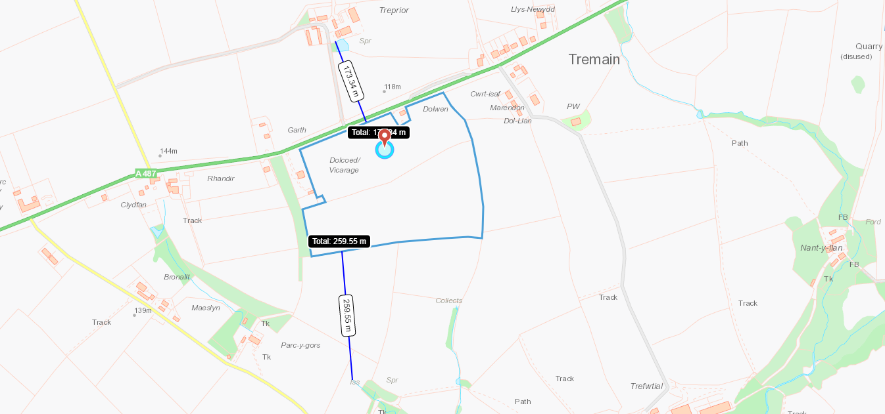

Trefwtial 6661
Watercourse adjacent to NE, buffers identified on application maps.
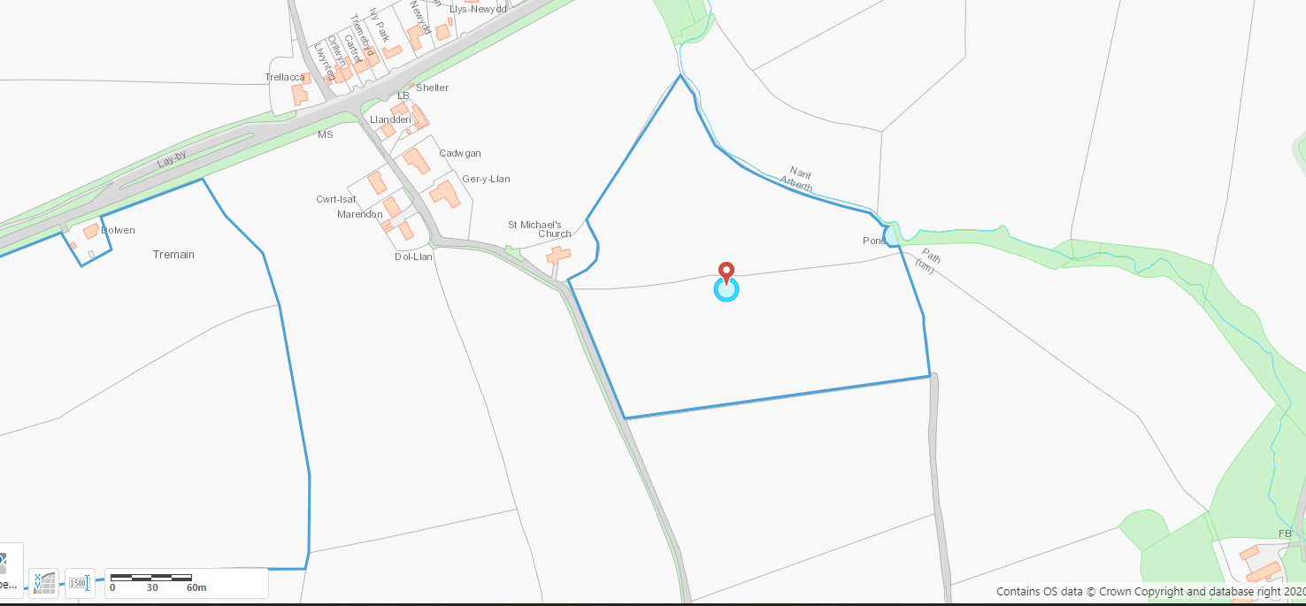

Trefwtial 3393
Spring to N, Issue to N
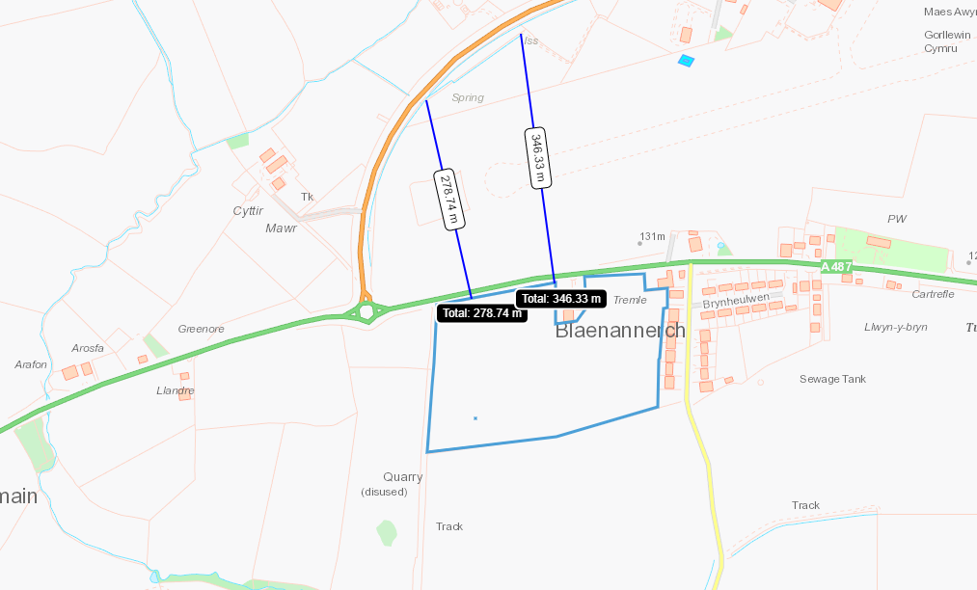

Land at Rhosygadair 3, 4, 5, 6, 7
Spring to W, Issue to S, Issue to E, Issue to NE
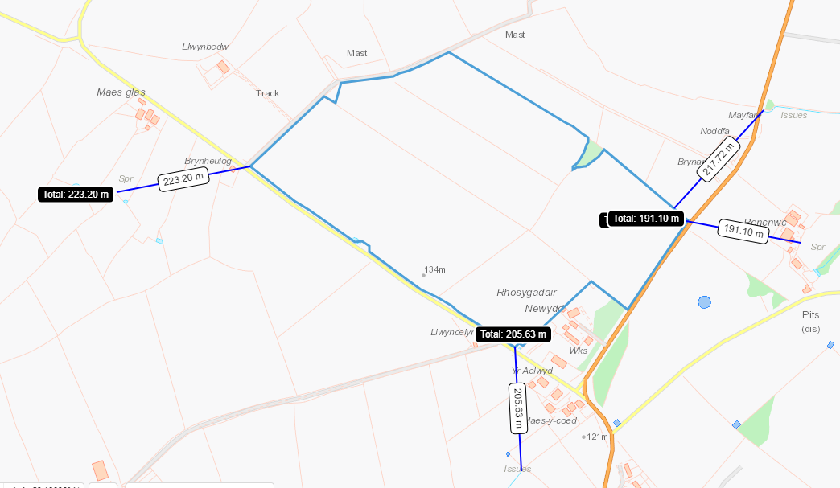

Bigni 8, 9
Issues to E, SW, W
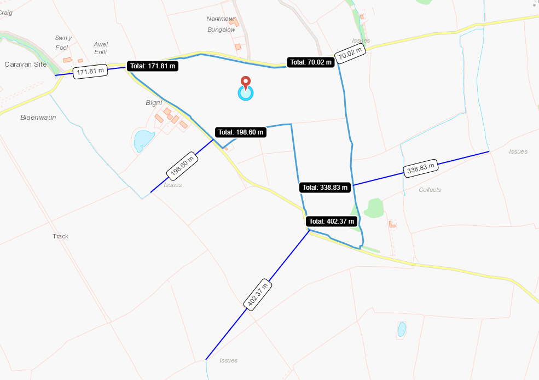

European designated sites- Natura 2000 (SPA, pSPA, SAC or cSAC) or Ramsar- or SSSI within 500m
Trefwtial 1457, 1645, 6661, 3393. No markers.
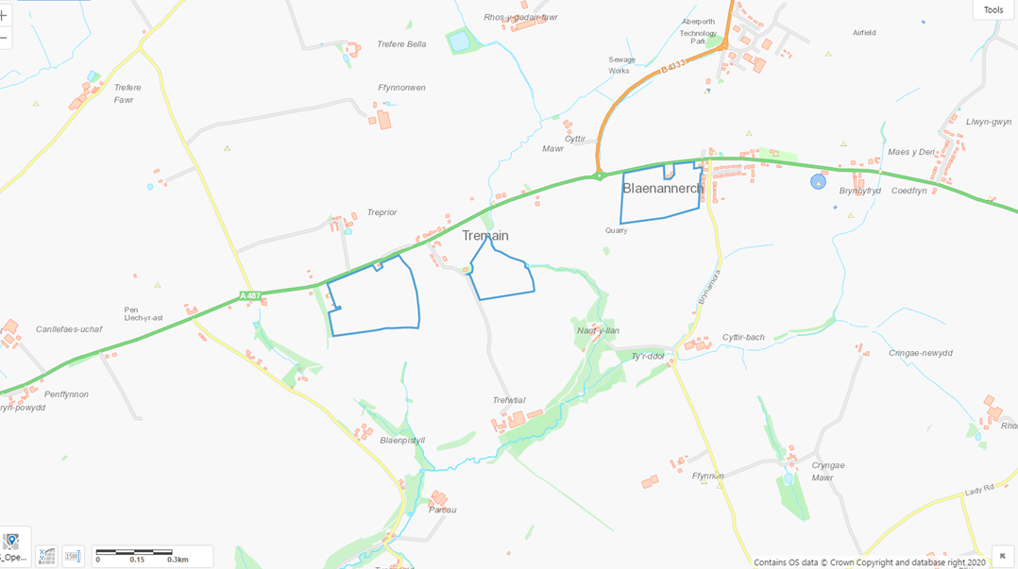
Land at Rhosygadair 3, 4, 5, 6, 7. No Markers
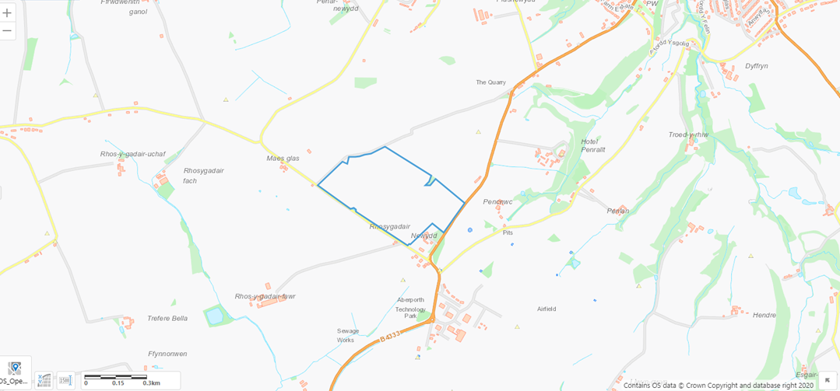
Bigni 9, 10
SSSI - Caeau Crug Bychan, Ty Gwyn a Llwyn Ysgaw. To NE of Bigni 9 at 485.73m. Buffer of 30m has been identified on application map which places SSSI beyond 500m.
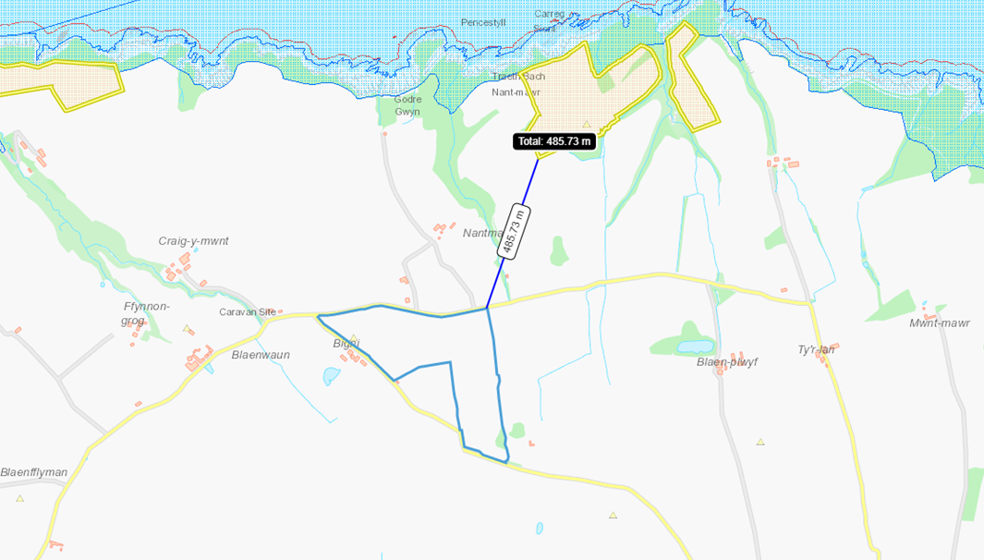

Species and habitats
Trfwtial 6661 - Lowland dry acid grassland immediately adjacent to W, buffer in place. Purple moor grass and rush pastures to NW and SE. Lowland dry acid grassland and Lowland calcareous grassland to SE.
Trefwtial 1645 - Lowland dry acid grassland to E. Purple moor grass and rush pastures to NE, W, S. Lowland dry acid grassland and Lowland calcareous grassland to S
Trefwtial 1457 - Lowland dry acid grassland to E. Purple moor grass and rush pastures to NE, W.
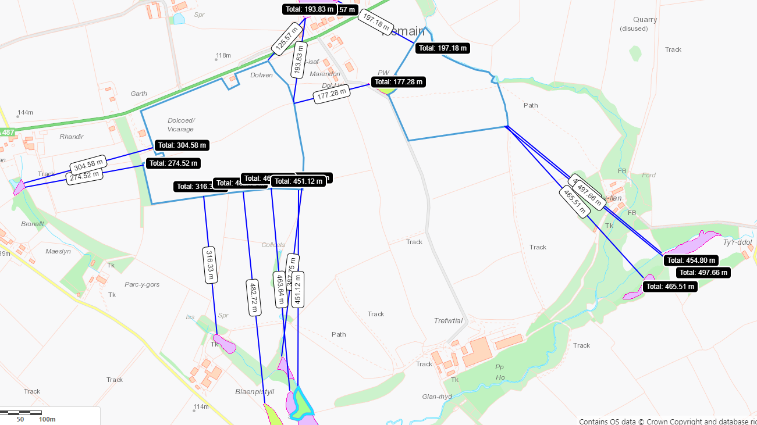
Trefwtial 3393 - Threatened Lichen to NE, Lowland dry acid grassland and Lowland calcareous grassland to E
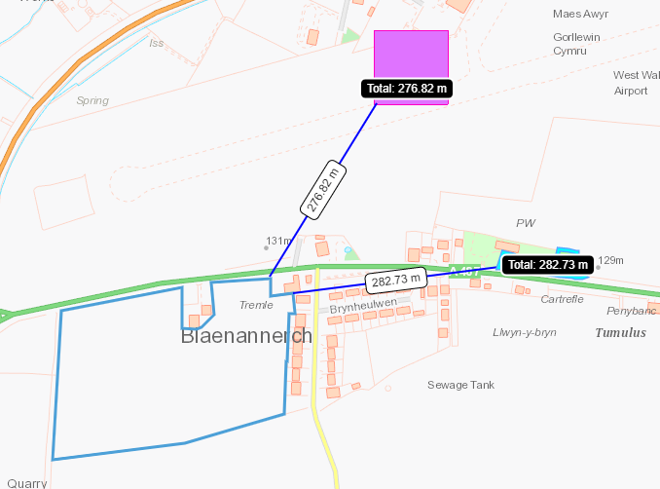
Land at Rhosygadair 3-7 – Reedbeds to W, S. Lowland dry acid grassland and Lowland calcareous grassland to SE, Purple moor grass and rush pastures to SE.
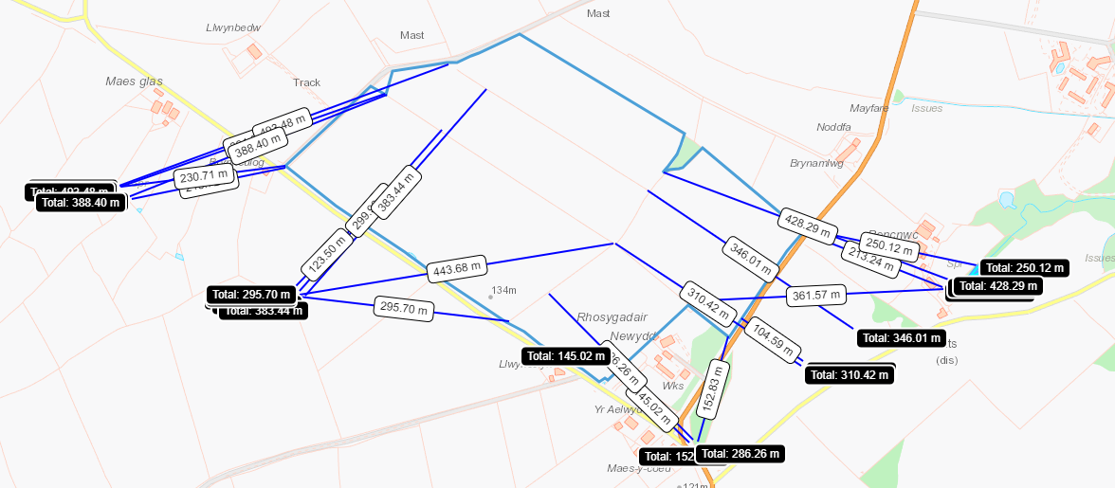
Bigni 8&9 - Purple moor grass and rush pastures to W, N, E, S. Lowland dry acid grassland and Lowland calcareous grassland to N, NE, E. Reedbeds to S.
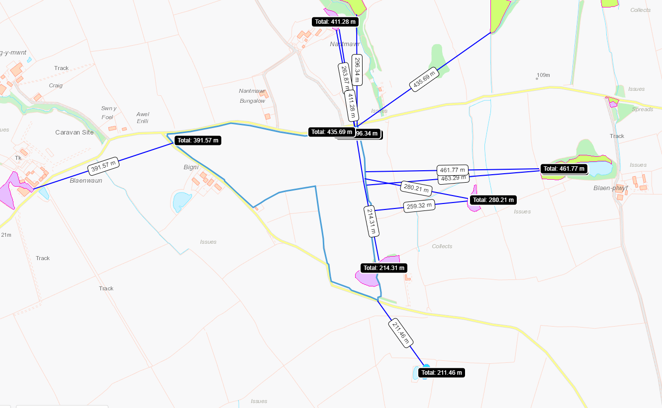
Ancient woodland
Trefwtial 1547/1645 – Ancient woodland to SW, S and adjacent to W
Trefwtial 6661 Ancient woodland to S
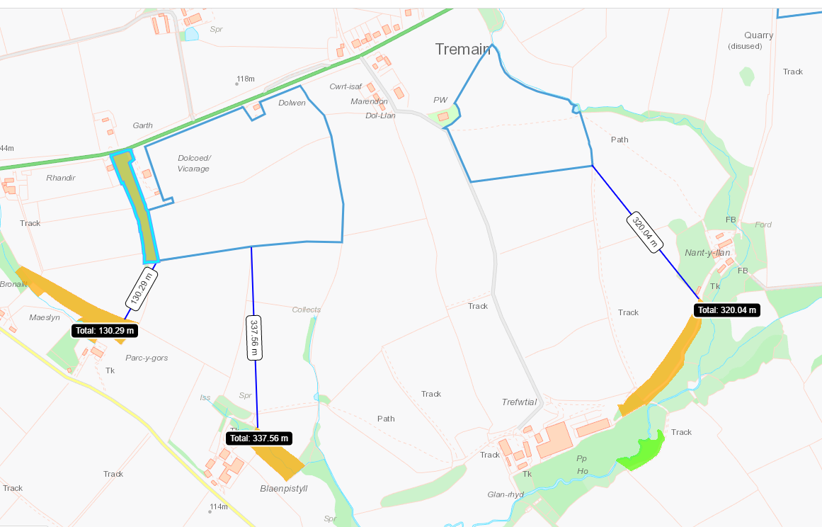

Slopes
All fields 0-7%
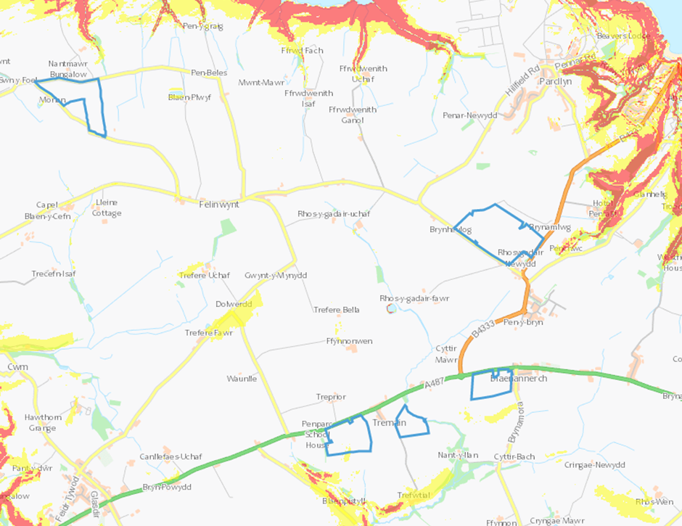

Scheduled Monuments
PAN-019723 Distance to Scheduled Monuments
Blaenannerch Round Burrow to East at 448.49m
Pillbox to north at 292.44m
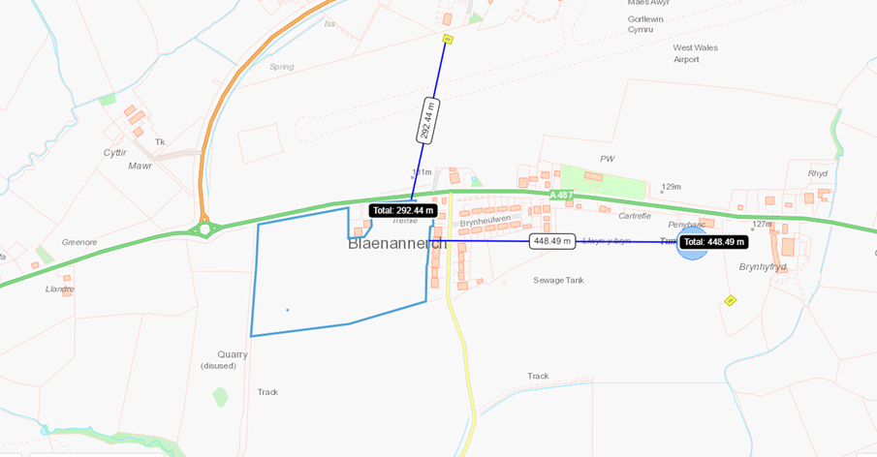
Land at Rhosygadair 3, 7
Proximity to Airfield Perimeter Defences at Blaenannerch, South – 174.4m, 186.14m, South East – 91.04m, 254.51m, 306.95m
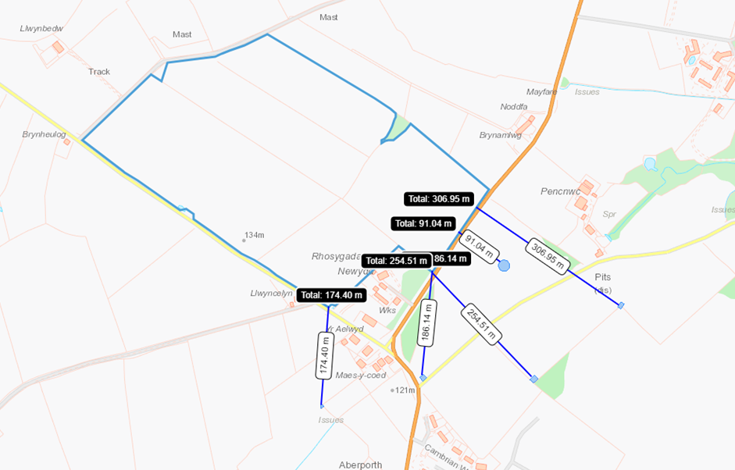
All other fields in application are free of markers

