Watercourse, wells, boreholes, springs
Gotrel 1-5, watercourse to N and W, spring to E flows towards site feeding watercourse to N, issue to SW feeding watercourse to W. buffer indicated on application map.
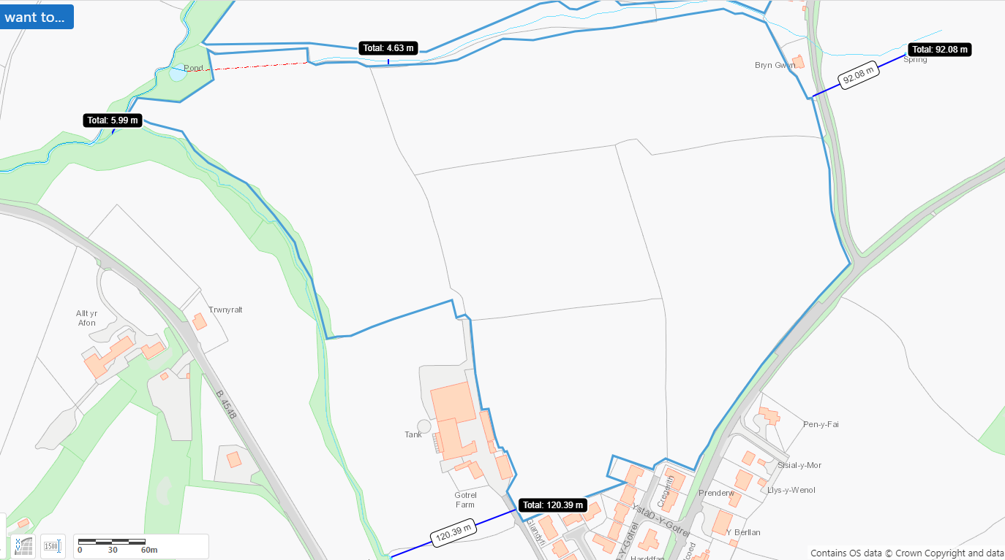
Gotrel 6, 7 watercourses to N, NW and S. buffer indicated on application map.
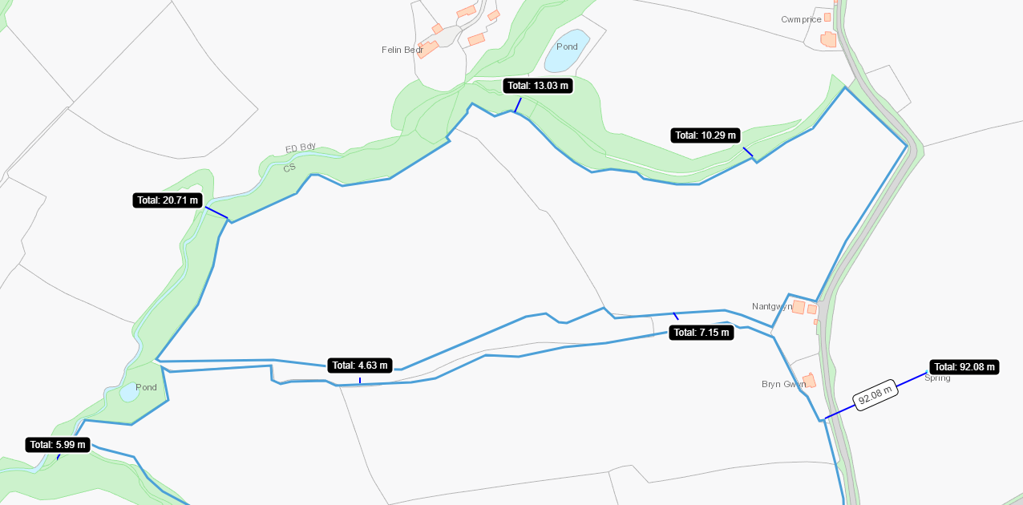

Ty Gwyn 18, 19. Watercourse to S. buffer indicated on application map.
Ty Gwyn 15, 16, 17 and 20/21 Watercourse to N, Issue to E. Collects to S. buffer indicated on application map.
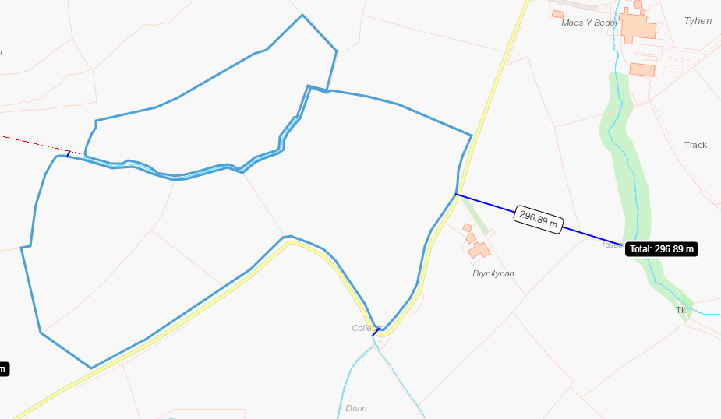

Hafod 2675, Issue to NW and S, Collects to N.
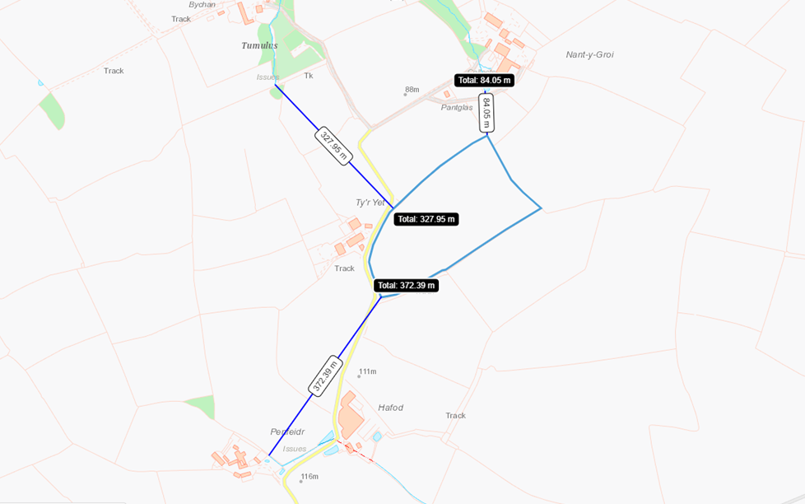

Ramsar, SSSI, European Designated Sites
Gotrel 5, SSSI to W. buffer in place on application map
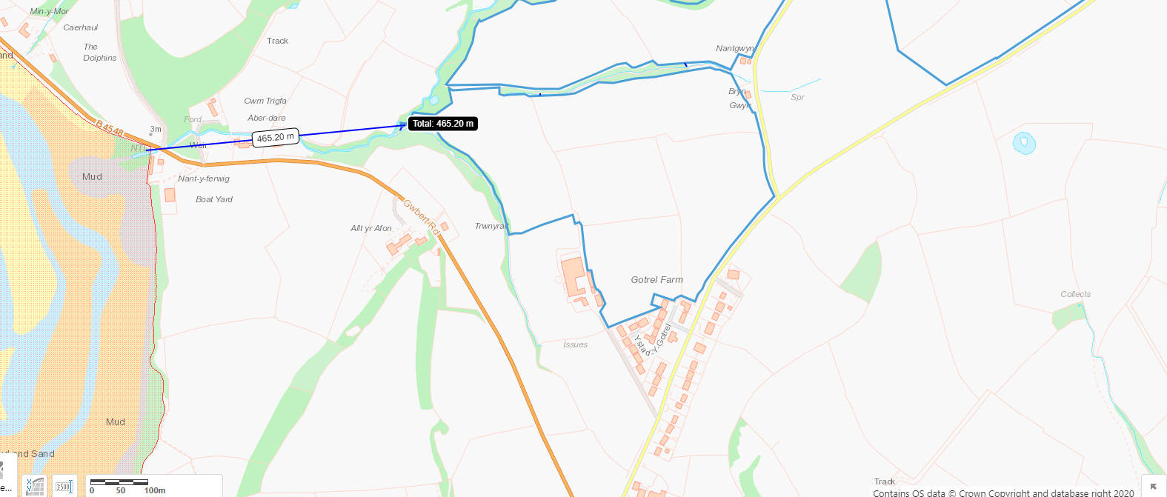

Scheduled Ancient Monuments
Hafod 2675
Crug-Bychan Round Barrow to NW
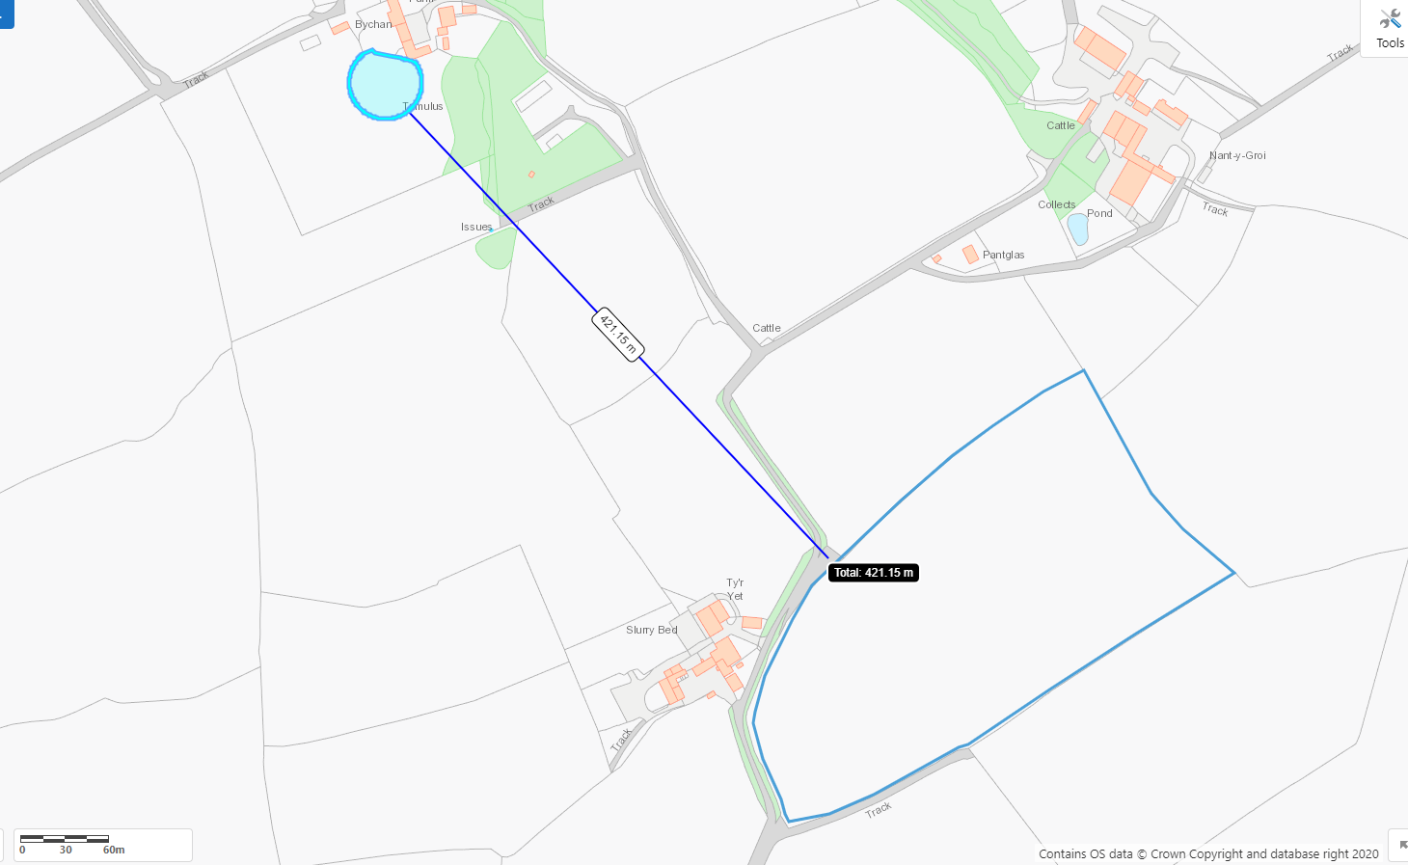
No other markers

Protected Habitats and Species
Gotrel 1, 2, 3, 4, 7 Lowland dry acid grassland and Lowland calcareous grassland to SE
Gotrel 5 coastal saltmarsh to W. Lowland dry acid grassland and Lowland calcareous grassland and Purple moor grass and rush pastures to W.
Gotrel 3, 4, 5, 6 Lowland dry acid grassland and Lowland calcareous grassland and Purple moor grass and rush pastures to W.
Gotrel 6, 7 Lowland dry acid grassland and Lowland calcareous grassland to N and W
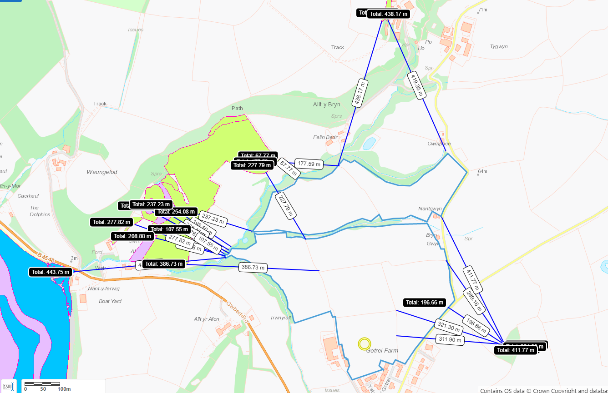
Ty Gwyn 17-21, BANC Y MWLDAN wetland catchment to E
Ty Gwyn 18-21, Lowland dry acid grassland and Lowland calcareous grassland and Purple moor grass and rush pastures to N
Ty Gwyn 15, 17, Lowland dry acid grassland and Lowland calcareous grassland to SW
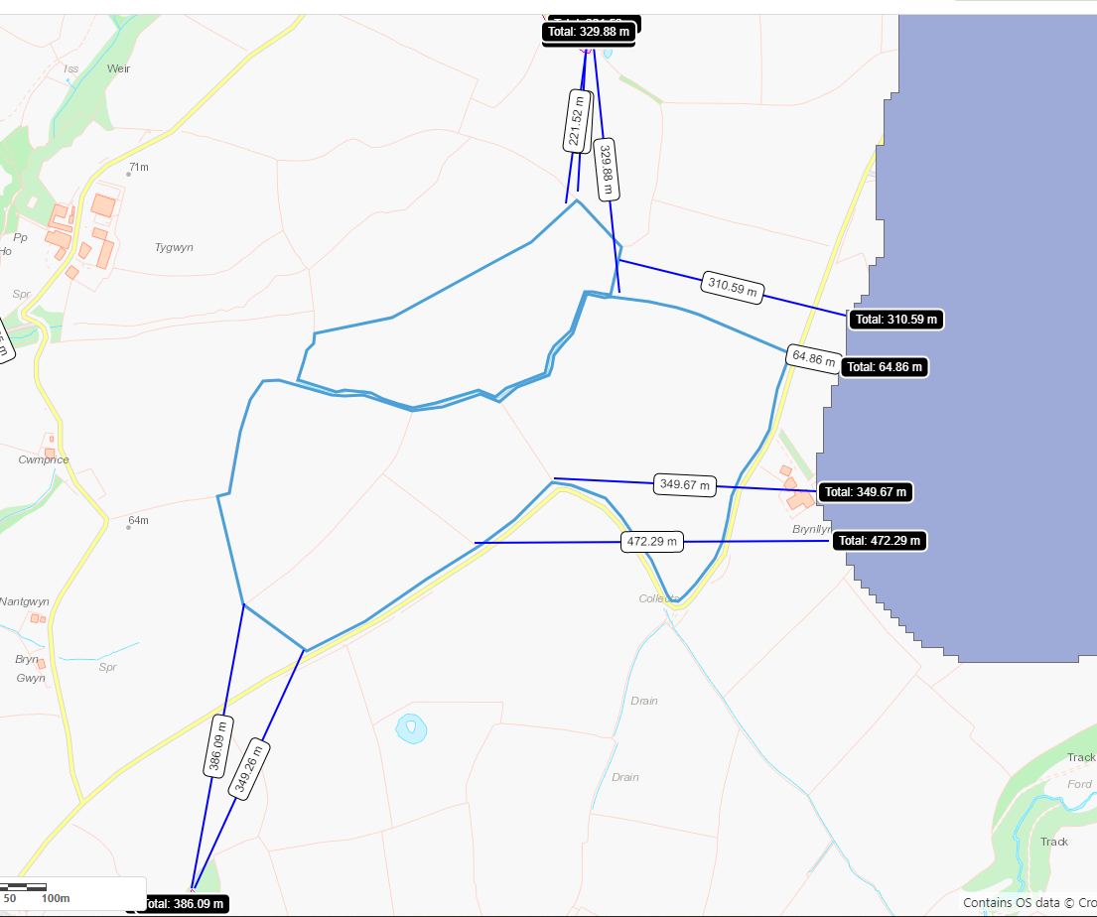

Hafod 2675 - Lowland dry acid grassland and Lowland calcareous grassland to NW and adjacent to NE. Purple moor grass and rush pastures to N
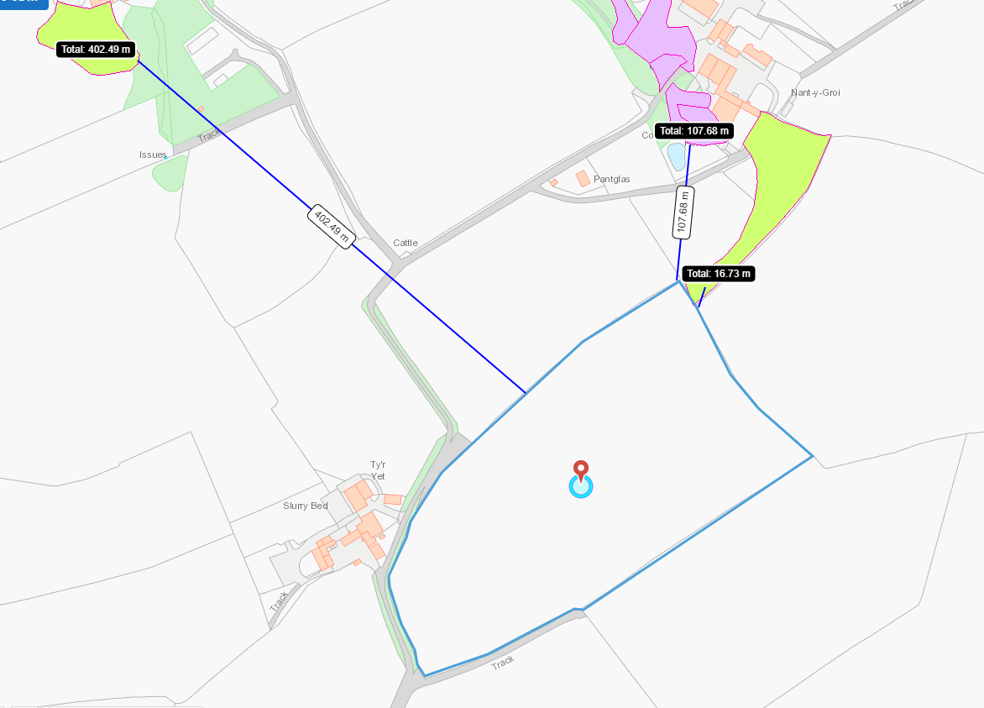

Slopes
Hafod 2675, 0-7 and partial 7-12
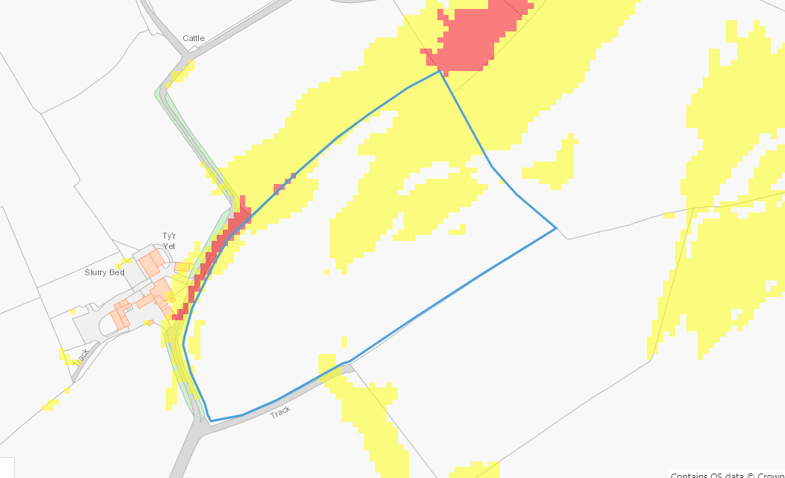
Ty Gwyn, generally 0-7 with some 7-12. One section of 12 in TY Gwyn 18/19 – area is within no spread buffer on application map.
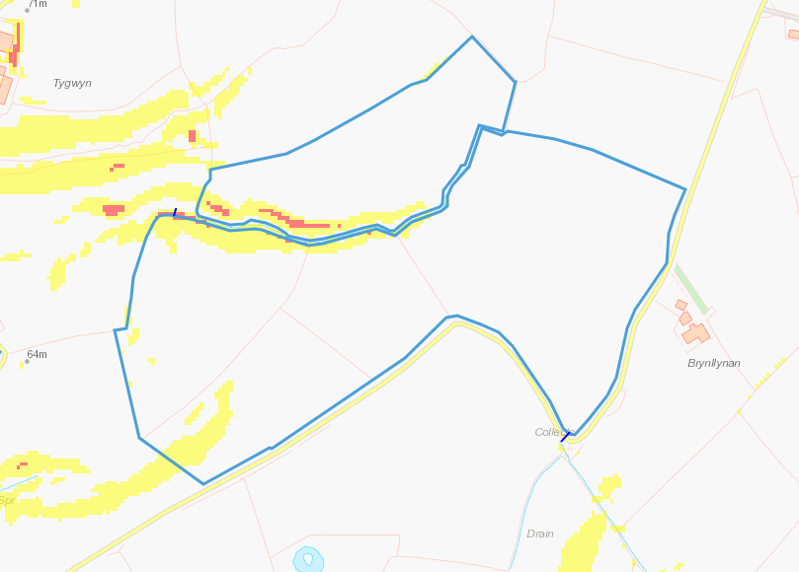
Gotrel 1, 0-7. Gotrel 2, 0-7. Gotrel 3, 0-7. Gotrel 4, 7-12 with some 12 plus to N this being within the no spread buffer on application map. Gotrel 5, 0-7 with 12 plus to W this being within the no spread buffer on application map
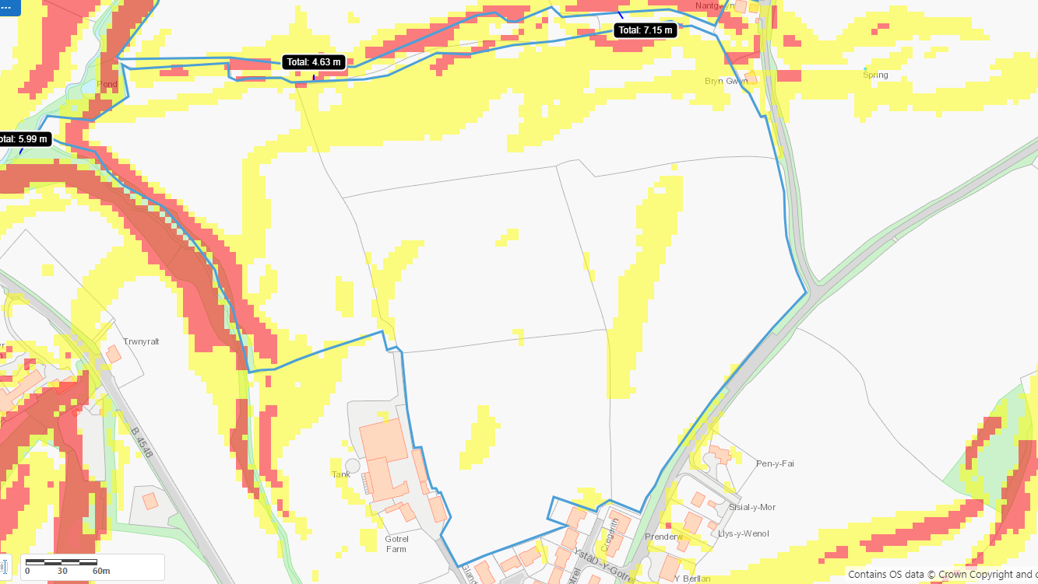
Gotrel 6, 0-7 with some 7-12 and 12 plus to NW (external to site) and S, no spread buffers in place as indicated on application maps.


