Bespoke Permit for Water Discharge

 | Water Management Plan
Date | 18/10/2021
Revision B 13/12/2021
Revision C 10/03/2022
Revision D 13/04/2022
Revision E 27/07/2022

 | Prepared
Author | Elliot Hutchings – Environmental Advisor
Signature | 
Checker Approver
Signature

REVISION TABLE

General update – all pages have been revised.

TABLE OF CONTENTS
1 Preliminaries 5
1.1 Purpose 5
1.2 Scope 5
1.3 Definitions & abbreviations 5
1.4 Responsibilities 6
2 Compliance obligations 7
2.1 Environmental Permitting Regulations 2016 7
3 background and controls 7
3.1 Background 7
3.2 Procedural Control Measures (Surface water runoff) 7
4 Pollution mitigation 10
4.1 oil use, storage and Refuelling 10
4.2 Chemical use / Storage (CoSHH) 10
4.3 Permit to Pump 11
5 Monitoring 11
5.1 Siltbuster Check sheet 12
6 B6 Bespoke permit for discharge Prince Charles (Water Discharge Activity) 12
6.1 overview 12
6.2 Siltbuster 2-Stage Chemical Pre-Treatment System 13
7 Gurnos Cut (Water Discharge Activity) 15
7.1 overview 15
7.2 Siltbuster 2-stage chemical Pre-Treatment System 16
8 Mostyn (Water Discharge Activity) 17
8.1 Overview 17
8.2 Siltbuster 2-stage chemical Pre-Treatment System 18
9 Water Catchment on Average Rainfall 20
10 operational Arrangements 21
11 appendix 1 21
11.1 Aquatreat 21
11.2 Brenntag PAC 24
11.3 Caustic Soda Liquor 31
12 Appendix 2 – Siltbuster check sheet 39
13 Appendix 3 40
13.1 Rutpen A9 40
13.2 Water Lynx 360 42
13.3 Water Lynx 395 44
14 Appendix 14 – Floc mat Release Rate 47

Preliminaries

Purpose
The purpose of this Water Management Plan (WMP) is to identify the FVC / FCC works that may require a water discharge activity permit and control measures required to prevent such contamination of water courses by, interaction with water infrastructure or generated water effluent (Trade Effluent), and detail the management and monitoring in compliance with regulatory guidelines and advice.
- Dewatering of Excavation(s)
- Surface Water Runoff

Scope
FVC / FCC are constructing a 17.7km / 11 mile road known as the A465 Heads of the Valleys section 5 and 6. The project will extend between Hirwaun and Dowlais Top. It will leave the current A465 between the Hirwaun and Trewaun junctions for about a mile (1.4km) and between the Taf Fechan Viaduct and the Gurnos Farm underpass for about half a mile (0.8km).

Definitions & abbreviations
FVC | Future Valleys Construction
FCC | FCC Construction
NRW | Natural Resources Wales
TSS | Total Suspended Solids
AGC | Alun Griffiths Contractors
RB | Road Bridge
RPS | Regulatory Position Statement
NTU | Nephelometric Turbidity Units

Responsibilities
Responsibilities to prepare and maintain this document:

FVC / FCC
FVC / FCC as the principle contractor are responsible for driving Good Industry Practice to minimise the impacts of works on the water environment, by ensuring contractors undertake all measures to protect identified receptors of water courses by pathway means.
- Ensuring resources are available to contractors for mitigation measures;
- Updating and approving amendments to all relevant contractor documentation;
- Protecting water management infrastructure in their areas of work scope;
- Undertaking inspections, assessments and audits;
- Evaluating compliance on an ongoing basis, ensuring contractors are compliant;
- Monitoring;
- Supporting incident investigations in a timely manner;

FVC / FCC Environmental Manager/Advisor
- They will be responsible for updating this management plan and carrying out duties such as monitoring to ensure compliance and control measures are in place
- All the above 1.4.1 shall be within this scope of works

Construction Managers and Supervisors
- They will be responsible for ensuring a request has been submitted for a permit to pump before entering a new area and that adequate water management arrangements have been made.
- They will be responsible for ensuring any accidents that may have an impact on water quality have been reported to the FVC / FCC Environmental Team immediately to prevent further pollution from occurring.
- They (or a nominated deputy) will be responsible for the implementation of the control measures as detailed in this Water Management Plan. They will be responsible for the day to day checking and operation of equipment associated with water management.

Compliance obligations

Environmental Permitting Regulations 2016
These Regulations set out an environmental permitting and compliance regime that applies to various activities and industries. Permits set controls and emission standards to minimise pollution and allow operators of certain installations to operate. Any operational ‘regulated facility’ requires an environmental permit; a regulated facility means a water discharge, groundwater and radioactive substances activities.

background and controls

Background
There are a total of 58 water features: three main rivers, five significant tributaries and a further 50 channels that are crossed or which lie within a 500 m buffer zone around the extent of the scheme, the majority of which are already crossed by the existing road. These include two large tributaries of the Afon Taf (the Cwm Taf Fechan and Afon Taf Fawr) and the Afon Cynon.

Procedural Control Measures (Surface water runoff)
There shall be a Tier approach system to control and minimise potential silt laden surface water runoff. It is key to ensure that surface water is kept clear and away from excavations and earth works as best as reasonably practicable. Each Tier system shall be deployed to ensure the natural flow of water is not affect by works and diverted away, failure to carry out these requirements each tier approach shall be upped in measure. Where all systems are overwhelmed Tier 4 / 5 shall be implemented for active treatment and recognition with requirements of NRW / Local Authorities.

Tier 1
Mechanisms for reducing the volume of water and silt available for transfer to surface waters. Primary mechanism of control will be segregation. Surface water/runoff will be segregated and/or minimised from contact with the surface to reduce, as far as is practical, the volume of sediment contaminated water (Silt).
- Excavated drainage channels or stoned and lined V-drains (French Drainage).
- Weathering off of exposed areas, tracked in, sealed or covered
- Silt fencing, fibre rolls, geo-textiles and can be used to manage areas to prevent that of surface water runoff (Fig Below jute matting)
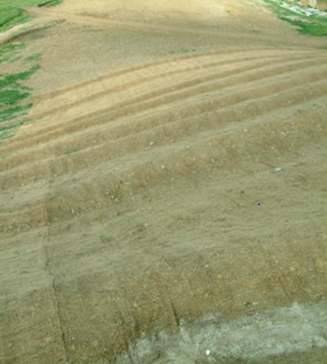

Tier 2
Mechanisms for slowing the flow of sediment rich water to help sediment dropout and treatment. This primarily involves increasing the retention of water as it passes through the Schemes drainage channels, allowing sediment to settle out naturally. Examples of potential mitigation methods include:
- Discharge to Vegetation
- Straw Bales
- Weirs
- Pea Shingle Beds
- Filter Fabrics
- Erosion Berms (Fig below)
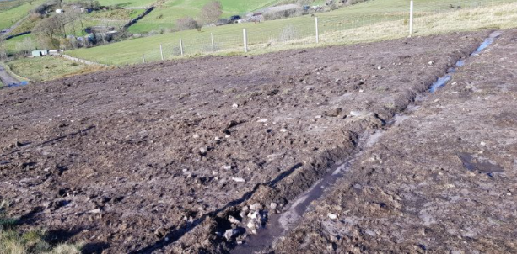

Tier 3
Mechanisms offer solutions for retaining sediment rich water, to allow further settlement prior to discharge or further treatment. This requires the inclusion of systems that allow sediment to settle out naturally, examples of potential mitigation methods include settlement lagoons or settlement systems.
- Attenuation / Settlement Lagoons
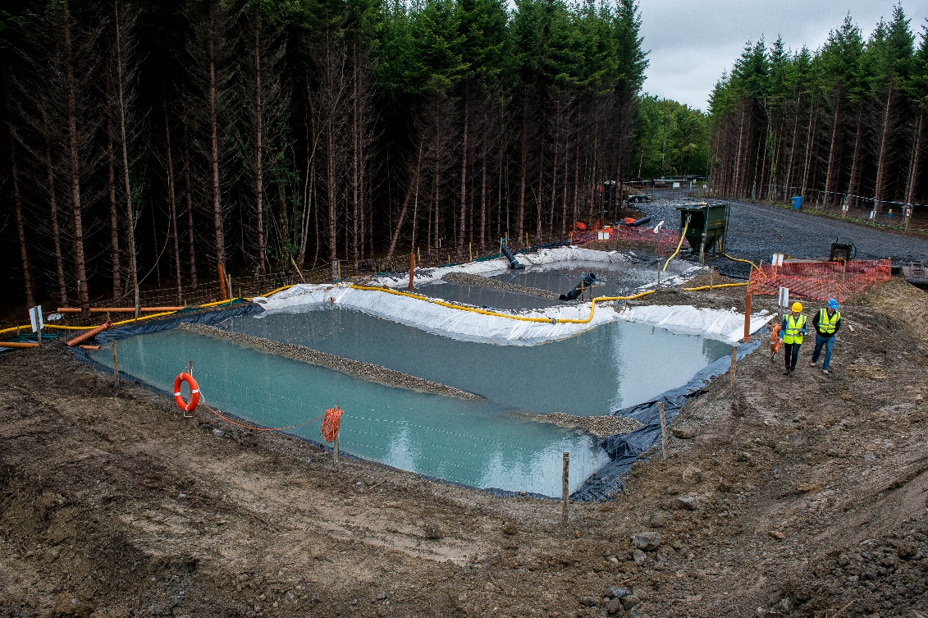

Tier 4
Active settlement and polishing of waters from site run off and excavations with use of flocculant-based materials. Where settlement can be achieved within lagoons added measure shall be used to help with NTU / TSS to reach a more acceptable discharge. Products shall be used at inlets of ponds and outlet drainage channels to ensure discharges remain silt free. See appendix for safety data sheets

Floc Mat
The floc mat is designed to treat and capture fine silts and suspended particles. Its main function is to flocculate fine sediments enabling settling and separation from water. Sediment is trapped within the matrix of the matting; a single matting can hold up to 50kg of sediment.
- Material – Coir (fibres, netting, rope),
- Dimensions – 2x1 x 0.1m
- WaterLynx Gel Flocculant 360
- WaterLynx Gel Flocculant 395
See appendix 14 for release rate based on 5, 10, 15 and 20 mat deployment

Rutpen Flocculant Block A9
The A9 shall be used in aid with settlement lagoons should the settlement not be sufficient. Visual checks will be carried out to confirm clarity of water to confirm requirement for use of A9. A9 block shall be suspended at inlet of ponds to allow water to flow over block which will actively promote settlement. The product is a synthetic anionic flocculant in the form of a solid block, designed to slowly dissolve and flocculate suspended solids. The A9 block comes in 3kgs. It is estimated on average 1 A9 block of 3kg shall last approximately 3 months.
Representative Example 1 Matt
Flow rate at inlet | 40m3 (Pump)
Dosage | 1 x A9 flocculant 3kg
Rinse of Polish | - Pump 40m3/h – 36,000m6/90days (3 months)  - A9 Block 3kg – 3,000,000mg  - 3,000,000 / 3,600,000ltrs  - A9 – 0.8mg/ltrs over 90 days if run at full ratio

Note – here active siltbuster treatment is ongoing, the above shall not be used in conjunction

Tier 5
Active Treatment Subject to site constraints, flow rates, elevated levels of sediment load, effectiveness of passive measures, etc. it may be necessary to implement active treatment techniques to mitigate sediment release.
Treatment options can include:
- Conditioning through use of coagulants i.e. ‘floc-blocks’
- Lamella clarifiers
- Hydro-cyclones
- Silt-buster settlement tanks, etc.

Pollution mitigation
All temporary and permanent site compounds shall be at least 15 m away from the top of the bank of main rivers or 8 m away from ordinary watercourses. No single skin storage containers containing hydrocarbons, only double skin mobile bowsers will be allowed. All storage of any hazardous substance will be within impervious or internal, bunded, secure areas.

oil use, storage and Refuelling
All oil storage above ground containing more than 200ltrs shall follow the guidelines of the Oil Storage Regulations (OSR) Wales 2016 and GPP2.
- Tanks shall be of sufficient strength and structural integrity to ensure that it won’t burst or leak in ordinary use
- There shall be no single skinned tanks present on site, where there are these shall be placed into a secondary containment system
- Double skinned tanks must be of the design that allows for 110% capacity of the volume of the tank
- All secondary containment must hold 110% of the volume
- All singular items of oils shall be store on secondary containment either of 110% capacity or 25% of the total capacity whichever is greater
- Secondary containment shall be covered from excess dependent rainfall
- Mobile bowsers with pipe shall be locked by padlock when not in use, parked away from any watercourse on impermeable grounds
- All refuelling of plant on site shall be carried out at platform designated refuelling point. Plant working near watercourse shall track back to point for refuelling.
- Regular daily maintenance of containers / tanks / delivery hoses shall be carried out to ensure integrity

Chemical use / Storage (CoSHH)
- All secondary containment must hold 110% of the volume
- All singular items of oils shall be store on secondary containment either of 110% capacity or 25% of the total capacity whichever is greater
- All chemicals must be accompanied with a valid Safety Data Sheet, and reference to section 6
- All chemicals shall be store in a designated area, away from access / egress ports utilised by plant and vehicles
- Only chemicals required for days work shall be out for use on platforms, all other chemicals shall be placed in storage as above
- All products brought onto site shall be of water based quality / WRAS certification
- Storage of chemical within containment tor secondary bunding shall be placed on impermeable ground or compacted hard stand ground at site

Permit to Pump
Before any works for dewatering commences all Contractors must submit a ‘Permit to Pump’ or similar works authorisation will be sought from the Environmental Team.
Therefore, AGC / RB shall:
- Submit a Permit to Pump request to the FVC / FCC Environmental Team.
The following details will be included as a minimum:
- The location that the permit to pump will cover;
- The purpose of the permit to pump (i.e. draining of surface water, dewatering of excavations);
- A sketch plan showing the planned area for the permit to pump to cover including drainage arrangements.
- Proposal on mitigation measures in place to prevent pollution.
All permit requests will be completed by those preparing for the work e.g. section engineers or project managers, with the support of the FVC / FCC Environment Team.

Monitoring
Daily / Weekly physical checks will be completed in line with the requirements of each permit. For monitoring purposes and consistency, these checks will be completed at the location of the upstream (Lagoon[s]) and downstream (outlet[s]) as identified in the plans submitted. The checks will include the following:
- pH test
- TSS / NTU
- Turbidity
- Dissolved Oxygen
- Check for visible oil or grease (i.e. ‘rainbow’ sheen);
- Check that the pumping set up appears to be functioning as designed.
- Check for the build-up of solids; and
- Check the pollution prevention controls are in place.
Monitoring shall be carried out with the use of a calibrated Aquaread AP 800.
- pH4.01 Buffer
- ORP Cal Solution
- Zero Oxygen Solution
- 1000NTU Calibration Solution

Siltbuster Check sheet
Preoperational daily check sheets shall be used to ensure the unit(s) full system is operational before any water discharge activities begin. Such checks shall cover the following processes…
- General (Unusual sounds, pipework and connections, alarms and fault errors, cables)
- Mechanical (Motors running correctly, Vents, flowmeters, dosing pumps, sludge pumps)
- Consumables (Level of chemicals, damage occurred, storage containment of chemicals)
- Clarifier (Visual checks clear water outlet, solid build up, hoppers i.e. de-sludge)
- Reaction Tank (pH level of water 6-9, lines for blockages, visual check solids aggregating, cleaning of pH prob)
- All silt busters have contingency pumping arrangements in the event of mechanical failure or primary pump.
Note – see appendix for template

B6 Bespoke permit for discharge Prince Charles (Water Discharge Activity)

overview
Project | A465 Section 5 and 6 Hirwaun to Dowlais Top
Site Office | Baverstock Compound, Dynevor Arms, Llwydcoed, Aberdare CF44 0ND
Discharge Location | National Grid Ref – N51°46.0844 W003°23.1754
Monitoring Point | Upstream – SO 05066 08683  Downstream – SO 04457 08620
Effluent Discharge | Prince Charles Discharge
Nature | Dewatering of excavation, capture of surface water run off of works to settlement ponds, treatment of water via chemical treatment before discharge to existing drainage ditch, entry point Taff Fechan.
Volume Calculation | Siltbuster HB50 treatable of 50m3/h  3600sec (60secs to 1 min) – 13.8ltrs/s  10 hour working day, subject to operation over 10 hours this would conclude 450m3/Day  The nominal 10 hour working day can be extended in response to server storms by running unit at 24 hours a day, with concomitant staffing provided even during nights, providing a treatment volume of up to 1,080m3 per day.
Process of Treatment | Lagoon settlement, Primary Settlement, Chemical Settlement
Waste Arisings | Siltbuster units shall require an element of “desludging”. Secondary to the dewatering ponds shall be in place “slurry ponds”. Slurry ponds shall be for TSS that have been captured within the lamella system, they shall be processed by means of drying out to allow moisture content to demise. There shall be no off-site removal of material from this process as the slurry or silt shall be tested as per client materials management plan criteria to ascertain if material is good for landscape fill process.
Outline Drawing | 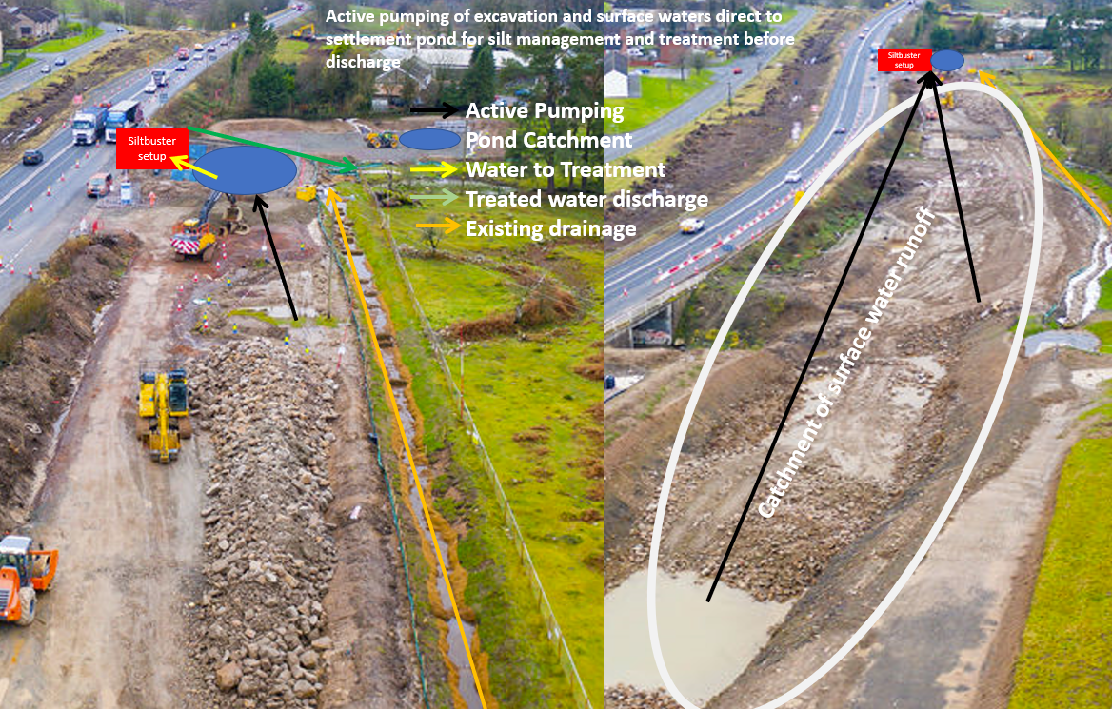

Siltbuster 2-Stage Chemical Pre-Treatment System
The 2-stage chemical pre-treatment system will comprise of the Silt-buster HB50. This unit is subject to treatment quantities of 5-50m3/h – slow settling solids. Set up system shall include the following process…
- Inlet electromagnetic flow meter to record the volume of water treated and allow flow proportional dosing of coagulant and polymer.
- Mix Tank to allow the controlled mixing of the treatment chemicals ensuring flocculation of the solids (size dependant on flow).
- Flow proportional control system for coagulant and flocculant polymer dosing. The use of flow proportional dosing system minimises the risk associated with the overdosing of the treatment chemicals.
- Coagulant dosing pump and associated pipework to allow the automatic flow proportional addition of the coagulant.
- Flocculant make-up system complete with 1000 litre make up tank, mixer bridge 110 V (32 Amp) mixer complete with paddle (potable water will be required on site for polymer dilution) and flow proportional dosing pump (peristaltic or similar).
- 1 No IBC spill stand/containment bunds for the temporary storage of chemicals.
Siltbuster HB50 Gravity Operated Settlement Units (Recovery of Suspended Solids)
- 2 No. Siltbuster HB50 Lamella Clarifiers (dependent on flow rate) to separate the suspended solids from the treated water.

Site Setup as provided by Silt-buster | 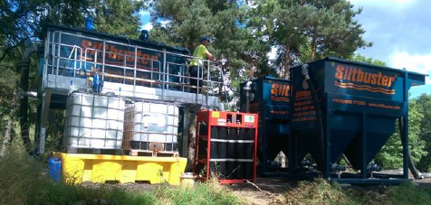

Treatment and dosing
Improved settling characteristics shall be achieved using two stage chemical pre-treatment in which…
- A coagulant (PAC) is added to the water to cause the fine particulates to aggregate together into larger particles.
- A flocculant (anionic polymer) is added to bind the particles together and increase the particle size, enhancing the settlement rate. The addition of the polymer shall enable near complete removal of the suspended solids.

Estimated Coagulant Consumption (PAC Brenntag)
At a dose rate of 25mg/l of PAC at a flow rate of 50m3/hr, it is estimated that 17.09 litres of coagulant will be consumed per hour. If consistently operated over a 24-hour period, expect 410.2 litres of coagulant be consumed per day.

Estimated Flocculant Consumption (AquaTreat)
At a dose rate of 2.25mg/l of EM533 at a flow rate of 50m³/hr, at a working strength of 0.2% it is estimated that 56.25 litres of flocculant as a working strength solution (water + flocculant) will be consumed per hour. This would equate to 55.9 litres of water only per hour, and 0.375 litres of flocculant only per hour. If consistently operated over a 24-hour period, we would expect 9 litres of neat flocculant to be consumed per day, and 237.6 litres of water only to be consumed per day

Water Quality for Discharge
Lab Result | Feed Water (From Lagoon) | Treated Outlet from Silt-buster
pH | 7.82 | 7.05
Total Suspended Solids (TTS) | 4294mg/l | 11mg/l
Evidence | 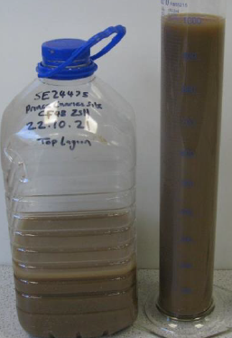 | 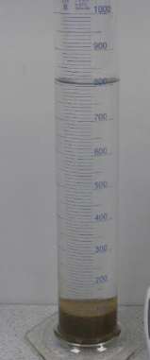

Gurnos Cut (Water Discharge Activity)

overview
Project | A465 Section 5 and 6 Hirwaun to Dowlais Top
Site Office | Baverstock Compound, Dynevor Arms, Llwydcoed, Aberdare CF44 0ND
Discharge Location | National Grid Ref – SO 03697 08322
Monitoring Point | Discharge as above  Upstream – SO 03939 08699  Downstream – SO 03374 08148
Effluent Discharge | Gurnos Cut Discharge
Nature | Dewatering of excavation, capture of surface water run off of works to settlement ponds, treatment of water via chemical treatment before discharge to existing ditch to Taff Fechan
Volume Calculation | Siltbuster HB50 treatable of 25m3/h  3600sec (60secs to 1 min) – 13.8ltrs/s  10 hour working day, subject to operation over 10 hours this would conclude 250m3/Day  The nominal 10 hour working day can be extended in response to server storms by running unit at 24 hours a day, with concomitant staffing provided even during nights, providing a treatment volume of up to 600m3 per day.
Process of Treatment | Lagoon settlement, Primary Settlement, Chemical Settlement
Waste Arisings | Siltbuster units shall require an element of “desludging”. Secondary to the dewatering ponds shall be in place “slurry ponds”. Slurry ponds shall be for TSS that have been captured within the lamella system, they shall be processed by means of drying out to allow moisture content to demise. There shall be no off-site removal of material from this process as the slurry or silt shall be tested as per client materials management plan criteria to ascertain if material is good for landscape fill process.
Outline Drawing | 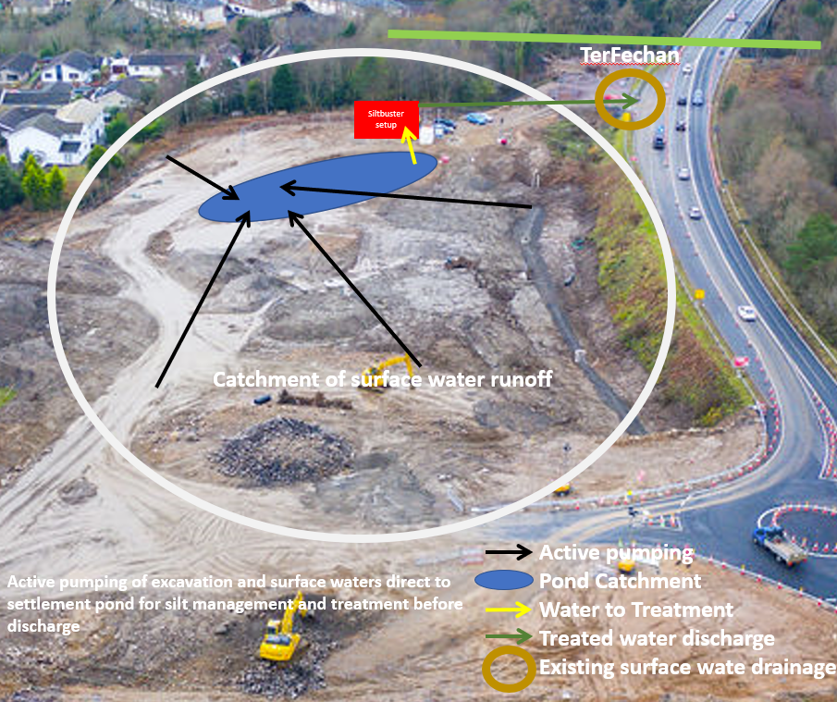

Siltbuster 2-stage chemical Pre-Treatment System
The 2-stage chemical pre-treatment system will comprise of the Silt-buster HB50. This unit is subject to treatment quantities of 3-30m3/h – slow settling solids. Set up system shall include the following process…
- Inlet electromagnetic flow meter to record the volume of water treated and allow flow proportional dosing of coagulant and polymer.
- Mix Tank to allow the controlled mixing of the treatment chemicals ensuring flocculation of the solids (size dependant on flow).
- Flow proportional control system for coagulant and flocculant polymer dosing. The use of flow proportional dosing system minimises the risk associated with the overdosing of the treatment chemicals.
- Coagulant dosing pump and associated pipework to allow the automatic flow proportional addition of the coagulant.
- Flocculant make-up system complete with 1000 litre make up tank, mixer bridge 110 V (32 Amp) mixer complete with paddle (potable water will be required on site for polymer dilution) and flow proportional dosing pump (peristaltic or similar).
- 1 No IBC spill stand/containment bunds for the temporary storage of chemicals.
Siltbuster HB50 Gravity Operated Settlement Units (Recovery of Suspended Solids)
- 1 No. Siltbuster HB50 Lamella Clarifiers (dependent on flow rate) to separate the suspended solids from the treated water.
Site Setup as provided by Silt-buster | 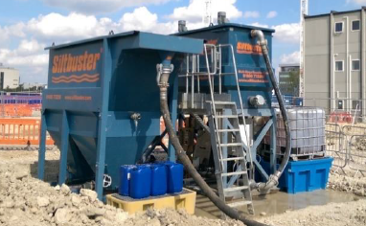

Treatment and dosing
Improved settling characteristics shall be achieved using two stage chemical pre-treatment in which…
- A coagulant (PAC) is added to the water to cause the fine particulates to aggregate together into larger particles.
- A flocculant (anionic polymer) is added to bind the particles together and increase the particle size, enhancing the settlement rate. The addition of the polymer shall enable near complete removal of the suspended solids.

Estimated Coagulant Consumption (PAC Brenntag)
At a dose rate of 15mg/l of PAC at a flow rate of 30m³/hr, it is estimated that 6.15 litres of coagulant will be consumed per hour. If consistently operated over a 24-hour period, we would expect 147.7 litres of coagulant be consumed per day.

Estimated Flocculant Consumption (AquaTreat)
At a dose rate of 1.7mg/l of EM533 at a flow rate of 30m³/hr, at a working strength of 0.2% it is estimated that 26.25 litres of flocculant as a working strength solution (water + flocculant) will be consumed per hour. This would equate to 26.04 litres of water only per hour, and 0.175 litres of flocculant only per hour. If consistently operated over a 24-hour period, expect 4.2 litres of neat flocculant to be consumed per day, and 625.8 litres of water only to be consumed per day.

Water Quality for Discharge
Lab Result | Feed Water (From Lagoon) | Treated Outlet from Silt-buster
pH | 7.76 | 6.76
Total Suspended Solids (TTS) | 1926mg/l | 7mg/l

Mostyn (Water Discharge Activity)

Overview
Project | A465 Section 5 and 6 Hirwaun to Dowlais Top
Site Office | Future Valleys Construction Site Compound Aberdare CF44 0LX
Discharge Location | National Grid Ref – SO 02486 07531
Monitoring Location | Discharge as above  Upstream – 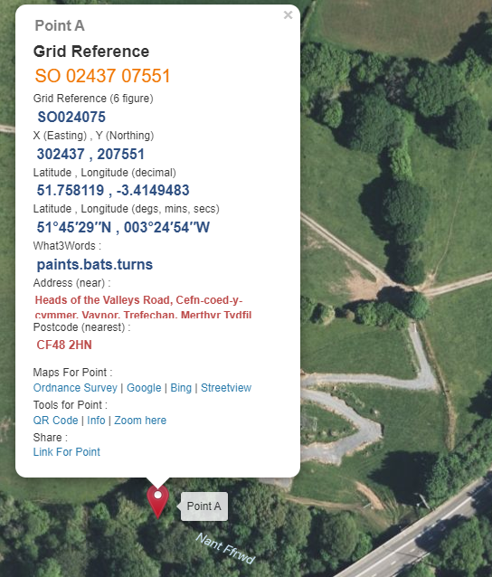  Downstream – 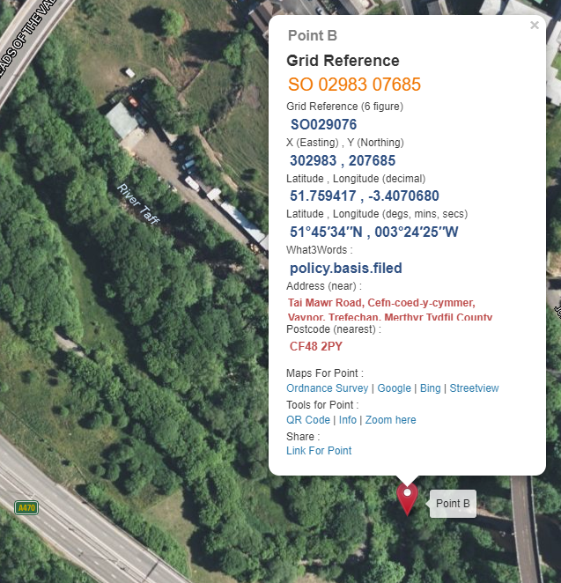
Effluent Discharge | Mostyn Discharge
Nature | Capture of surface water run off of works to settlement ponds, treatment of water via chemical treatment before discharge to existing culvert. Flow outlet direct Nant Ffrwd
Volume Calculation | Siltbuster HB50 treatable of 60m3/h  3600sec (60secs to 1 min) – 13.8ltrs/s  10 hour working day, subject to operation over 10 hours this would conclude 550m3/Day  The nominal 10 hour working day can be extended in response to server storms by running unit at 24 hours a day, with concomitant staffing provided even during nights, providing a treatment volume of up to 1,440m3 per day.
Process of Treatment | Lagoon settlement, Primary Settlement, Chemical Settlement
Waste Arisings | Siltbuster units shall require an element of “desludging”. Secondary to the dewatering ponds shall be in place “slurry ponds”. Slurry ponds shall be for TSS that have been captured within the lamella system, they shall be processed by means of drying out to allow moisture content to demise. There shall be no off-site removal of material from this process as the slurry or silt shall be tested as per client materials management plan criteria to ascertain if material is good for landscape fill process.
Outline Drawing | 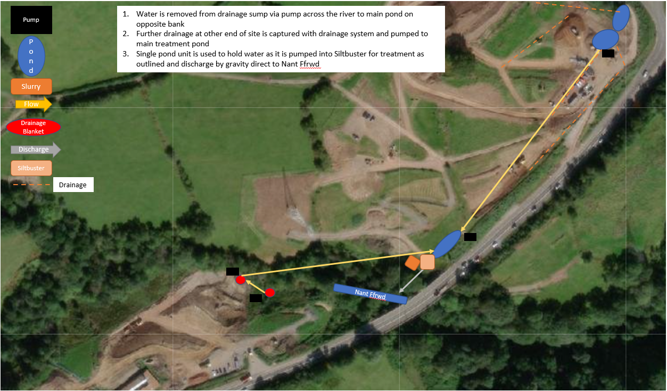  Distance of change from orginal application.  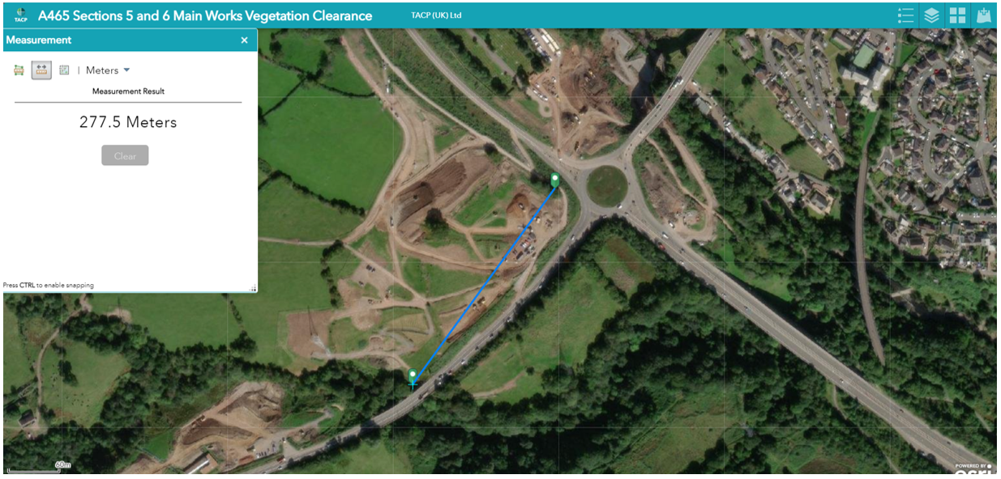

Siltbuster 2-stage chemical Pre-Treatment System
The 2-stage chemical pre-treatment system will comprise of the Silt-buster HB50. This unit is subject to treatment quantities of 6-60m3/h – slow settling solids. Set up system shall include the following process…
- Inlet electromagnetic flow meter to record the volume of water treated and allow flow proportional dosing of coagulant and polymer.
- Mix Tank to allow the controlled mixing of the treatment chemicals ensuring flocculation of the solids (size dependant on flow).
- Flow proportional control system for coagulant and flocculant polymer dosing. The use of flow proportional dosing system minimises the risk associated with the overdosing of the treatment chemicals.
- Coagulant dosing pump and associated pipework to allow the automatic flow proportional addition of the coagulant.
- Flocculant make-up system complete with 1000 litre make up tank, mixer bridge 110 V (32 Amp) mixer complete with paddle (potable water will be required on site for polymer dilution – to be provided by others) and flow proportional dosing pump (peristaltic or similar).
- 1 No IBC spill stand/containment bunds for the temporary storage of chemicals.
Siltbuster HB50 Gravity Operated Settlement Units (Recovery of Suspended Solids)
- 2 No. Siltbuster HB50 Lamella Clarifiers (dependent on flow rate) to separate the suspended solids from the treated water.

Treatment and dosing
Improved settling characteristics shall be achieved using two stage chemical pre-treatment in which…
- A coagulant (PAC) is added to the water to cause the fine particulates to aggregate together into larger particles.
- A flocculant (anionic polymer) is added to bind the particles together and increase the particle size, enhancing the settlement rate. The addition of the polymer shall enable near complete removal of the suspended solids.

Estimated Coagulant Consumption (PAC Brenntag)
At a dose rate of 12.5mg/l of PAC at a flow rate of 60m³/hr, it is estimated that 10.25 litres of coagulant will be consumed per hour. If consistently operated over a 24-hour period, we would expect 246.1 litres of coagulant be consumed per day.

Estimated Flocculant Consumption (AquaTreat)
At a dose rate of 2mg/l of EM533 at a flow rate of 60m³/hr, at a working strength of 0.2% it is estimated that 60 litres of flocculant as a working strength solution (water + flocculant) will be consumed per hour. This would equate to 59.6 litres of water only per hour, and 0.4 litres of flocculant only per hour. If consistently operated over a 24-hour period, expect 4.8 litres of neat flocculant to be consumed per day, and 1430.4 litres of water only to be consumed per day.

Water Quality for Discharge
Lab Result | Feed Water (From Lagoon) | Treated Outlet from Silt-buster
pH | 7.64 | 7.25
Total Suspended Solids (TTS) | 3758 | 23

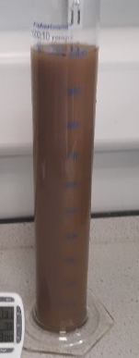 | 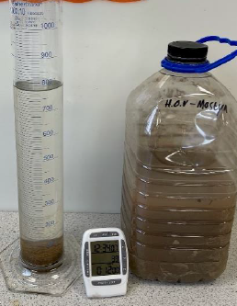

Water Catchment on Average Rainfall
The below table is an estimated summary of each site inclusive of its catchment area along with the average rainfall prediction as per Natural Resource Wales measuring station situated at Hirwain 2022. The information below is a guideline for a month period, as this cannot be assessed as each monthly rainfall event can change.
The calculation used to determine such runoff is concluded (Cumulative actual 301mm recorded February 2022) …
Average Rainfall (m) x Catchment Area (m2) x Surface Coefficient 0.1
Untreated Ground Catchments
Soil on slopes less 10% | 0.0 – 0.3
Rocky Natural Catchments | 0.2 – 0.5
Reference: Pacey, Arnold and Cullis, Adrian 1989, Rainwater Harvesting: The collection of rainfall and runoff in rural areas, Intermediate Technology Publications, London
Site Name | Catchment Area m2 | Surface run off estimate on average highest rainfall per 1 month (m3) | Attenuation Pond (m3)
Prince Charles Discharge | 7,500 | 225 | 5190
Gurnos | 9,800 | 294 | 1500
Mostyn | 4,100 | 123 | 1,131
Based on the above calculations there is an expectance of…
6,750m3 over a monthly high rainfall event as per NRW raw data 301mm – Prince Charles
8,820m3 over a monthly high rainfall event as per NRW raw data 301mm – Gurnos
3,690m3 over a monthly high rainfall event as per NRW raw data 301mm - Mostyn

operational Arrangements
FVC / FCC / AGC / RB shall operate the Silt-buster unit at location on a daily basis. The operational outfit shall follow the daily pattern of works, Monday to Friday 0700hrs to 1700hrs. Only at which there is consistent heavy down pour causing sub sequential flooding of excavations shall the unit be operated at night. This shall be monitored with weather patterns on daily basis and notice given for dedicated night / weekend shift team if ever required.
Note - The nominal 10 hour working day can be extended in response to severe storms by running unit at 24 hours a day, with concomitant staffing provided even during nights.

appendix 1

Aquatreat
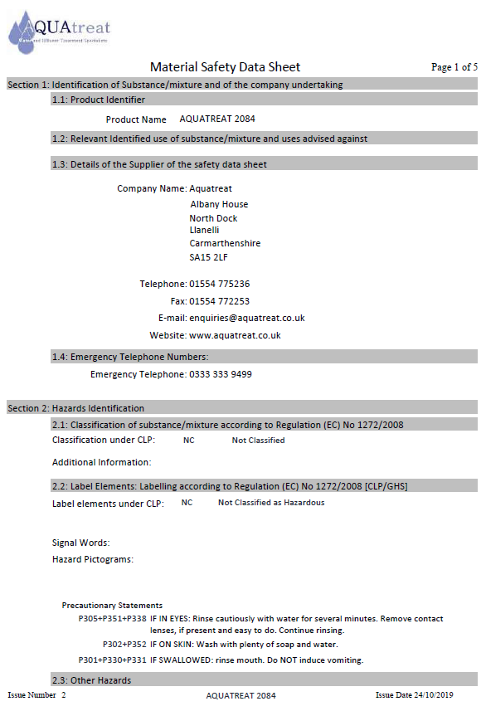
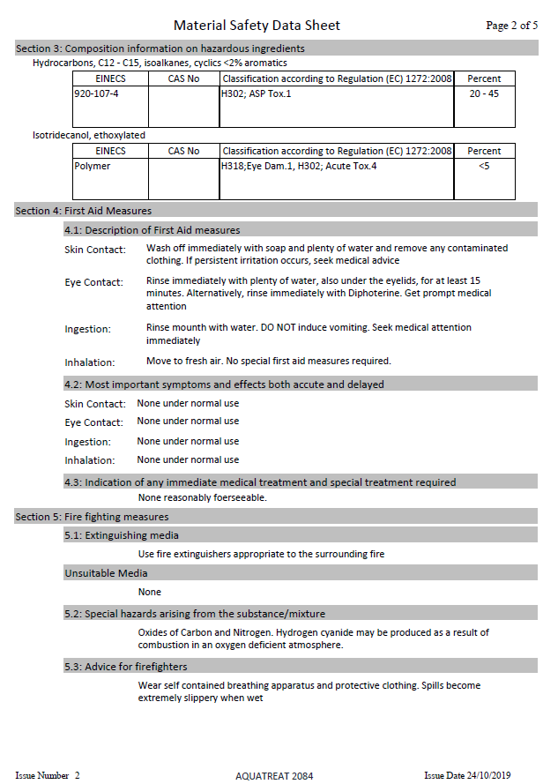
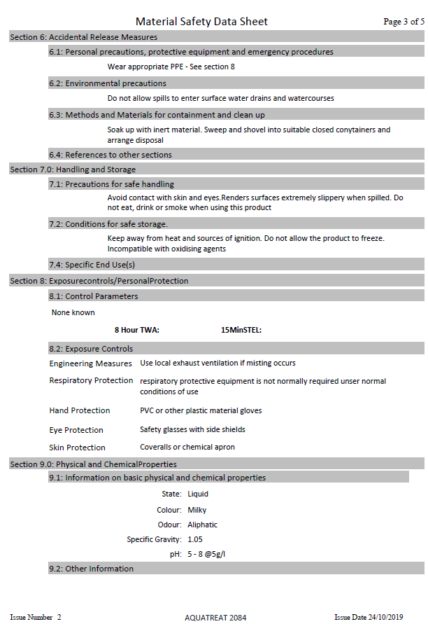
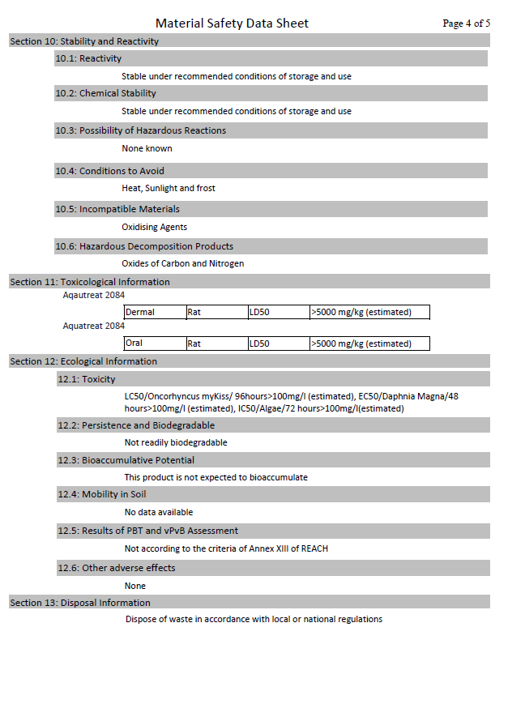
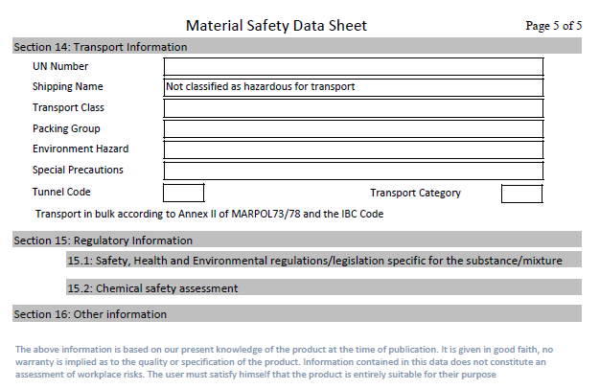

Brenntag PAC
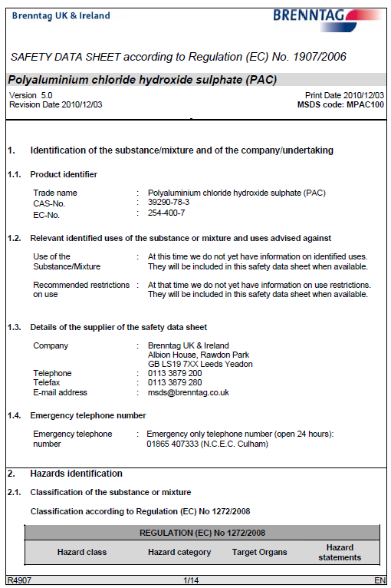
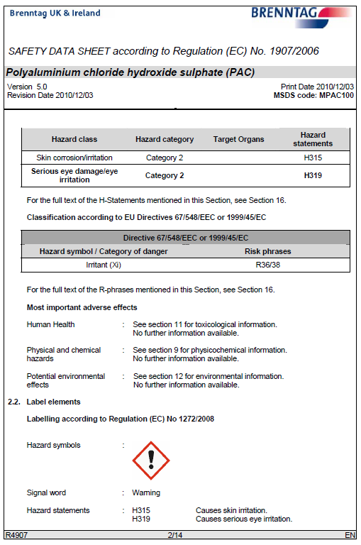
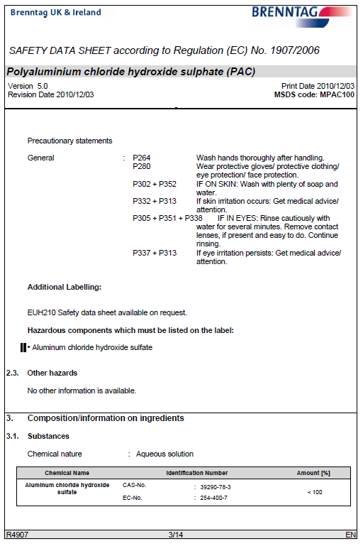
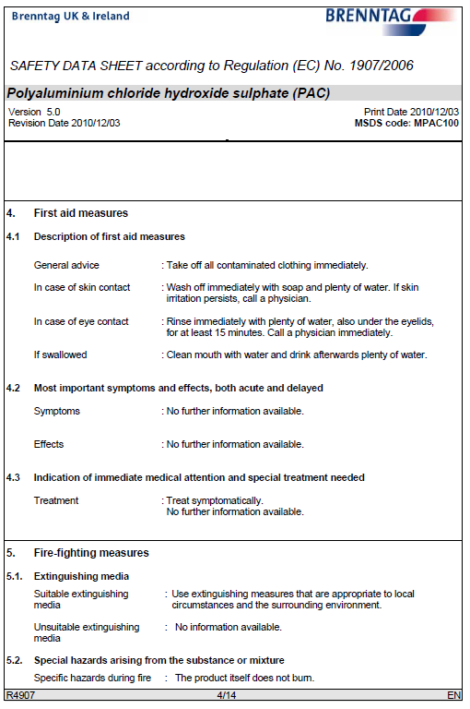
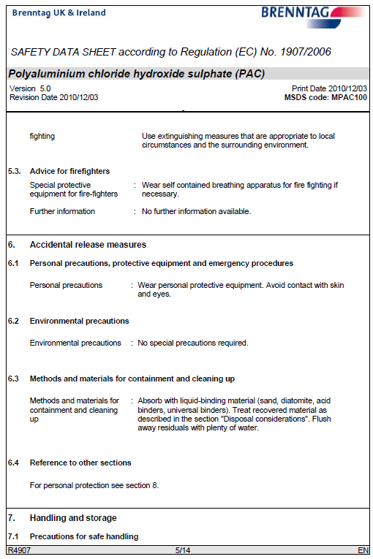
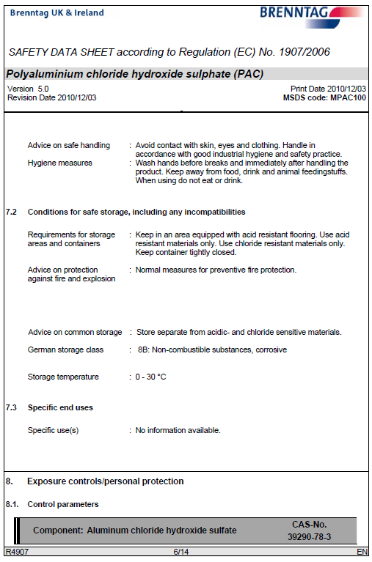
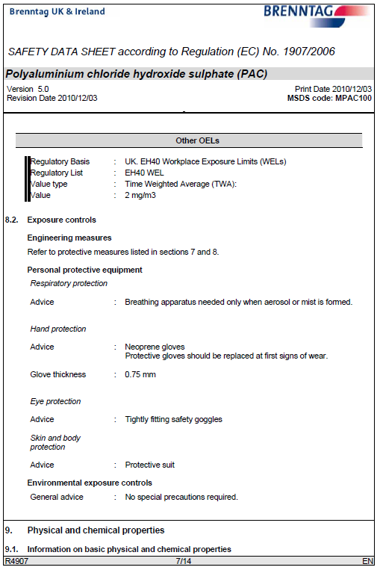
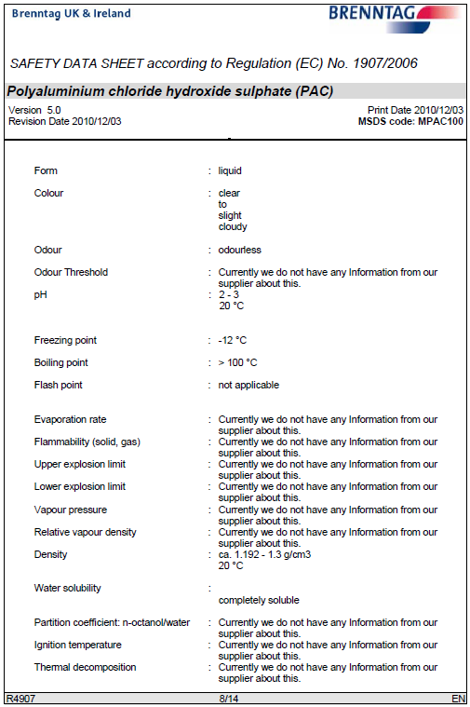
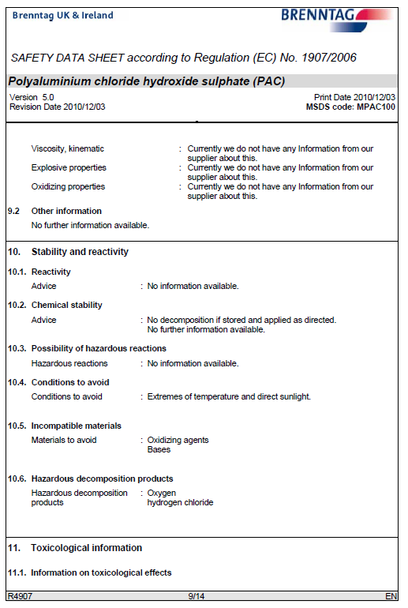
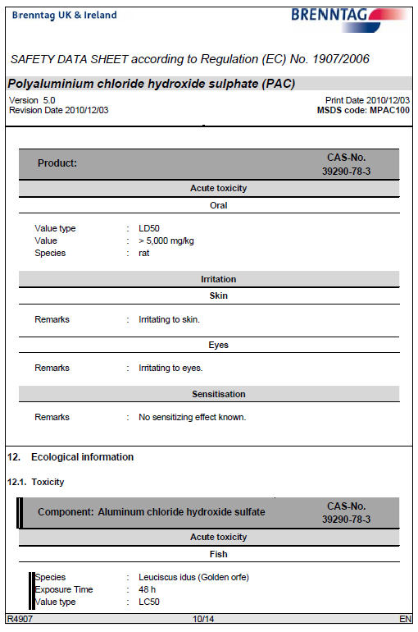
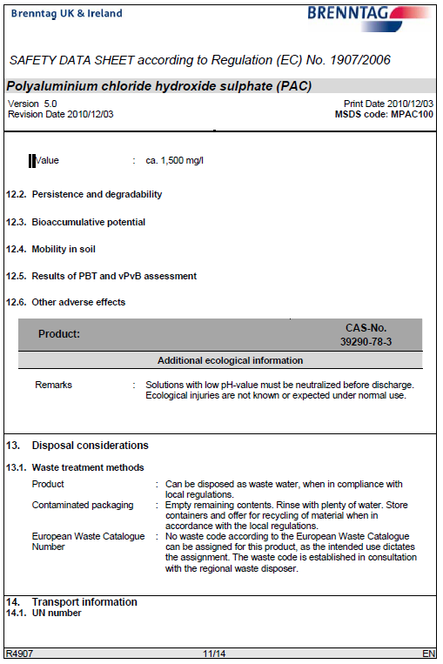
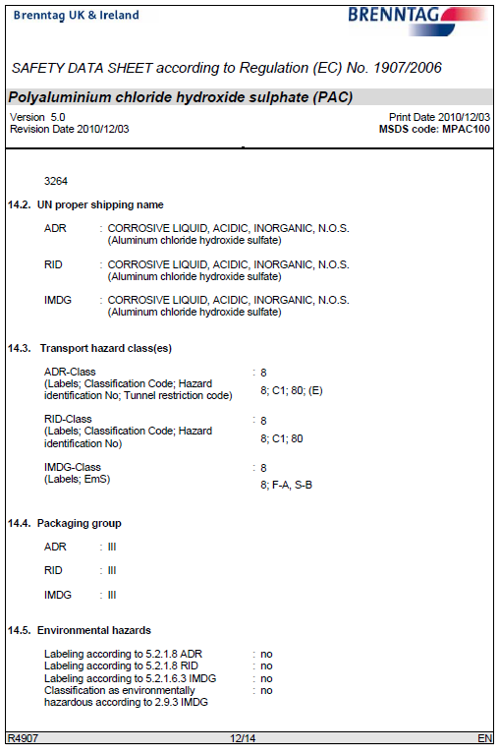
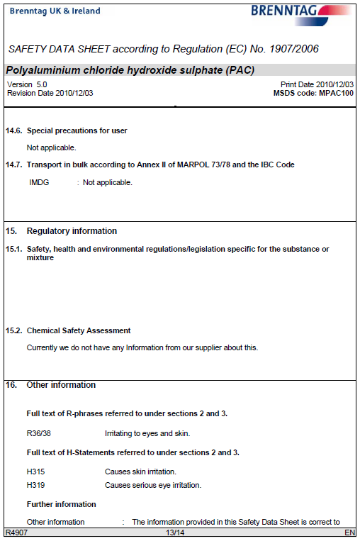

Caustic Soda Liquor
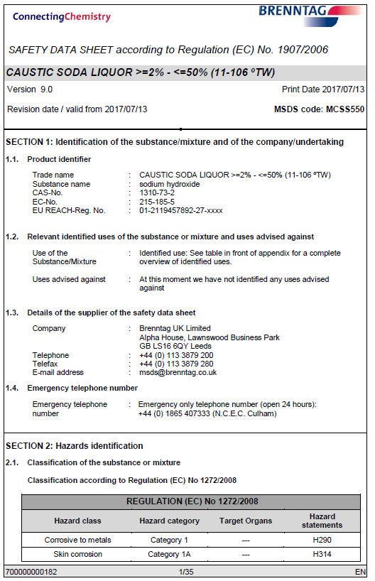
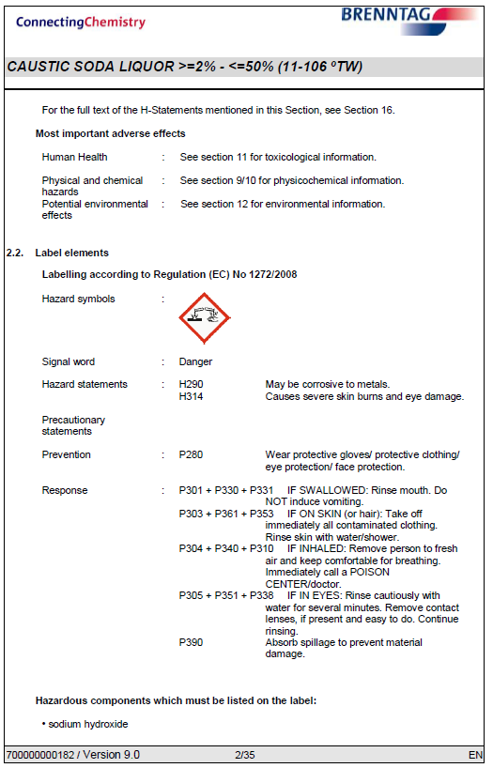
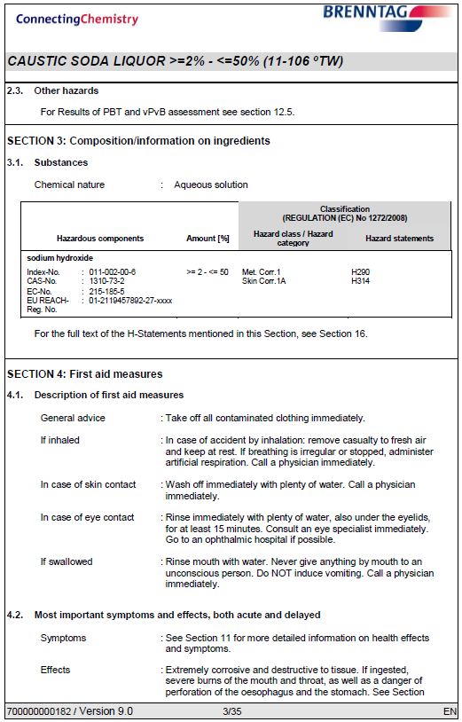
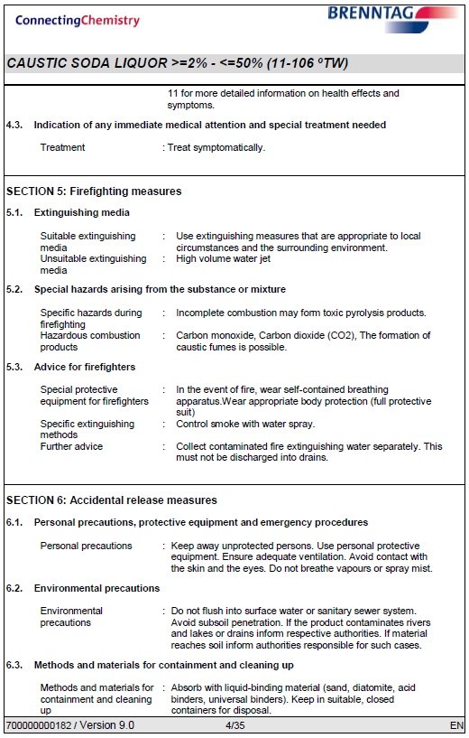
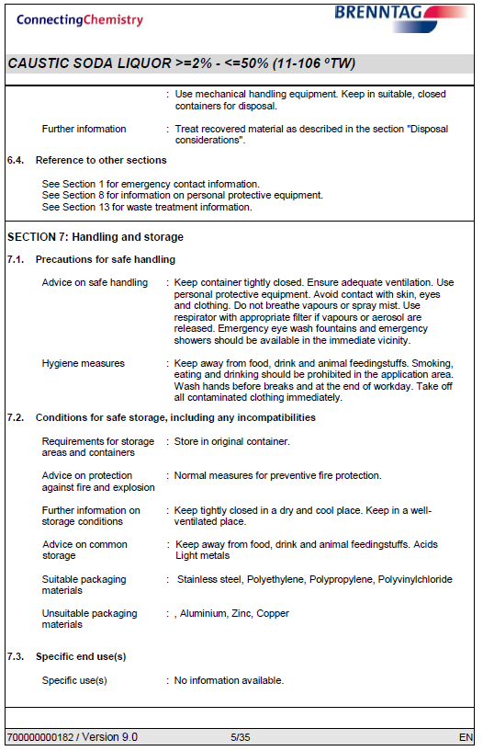
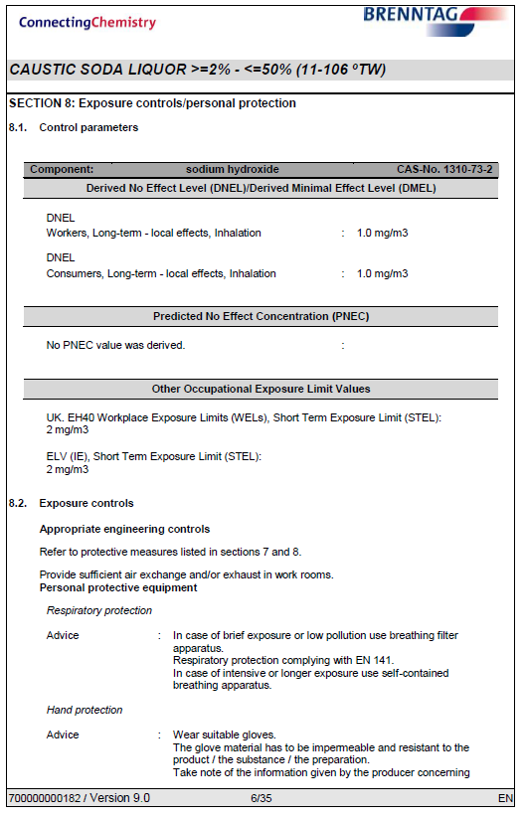
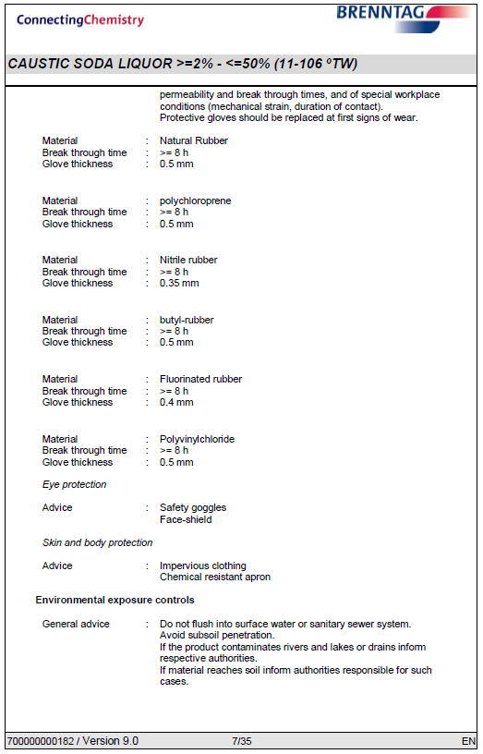
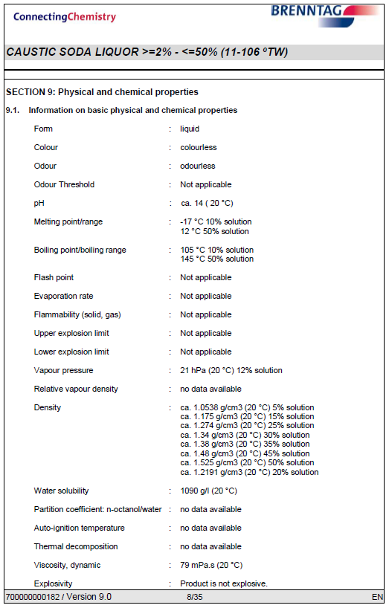
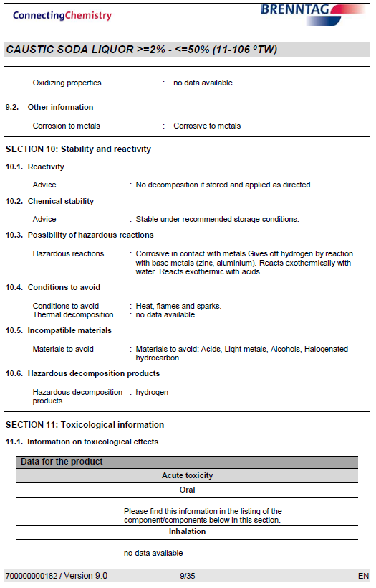
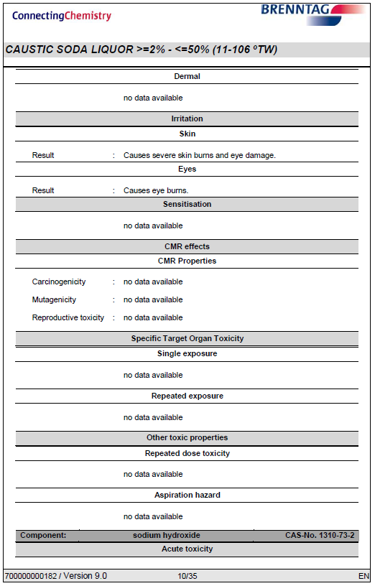
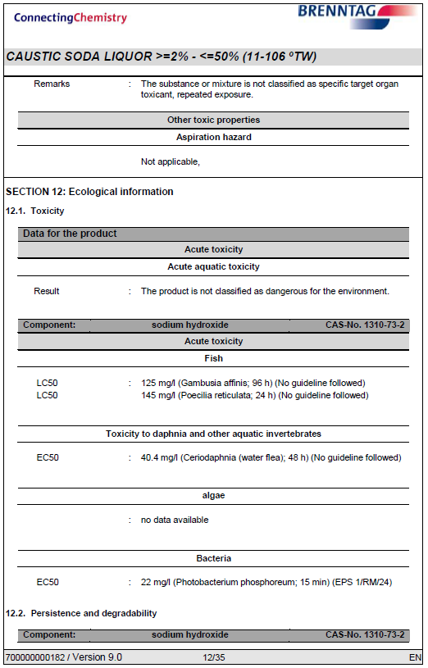
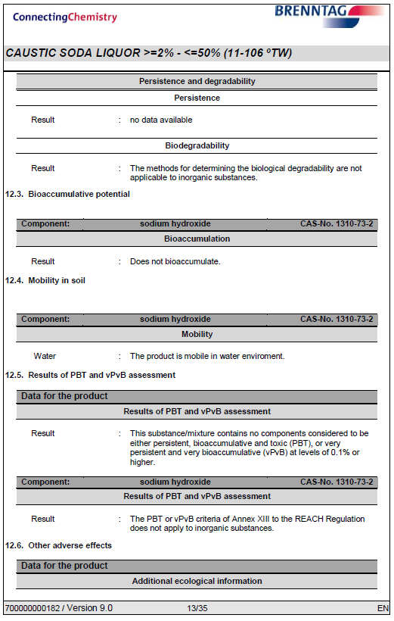
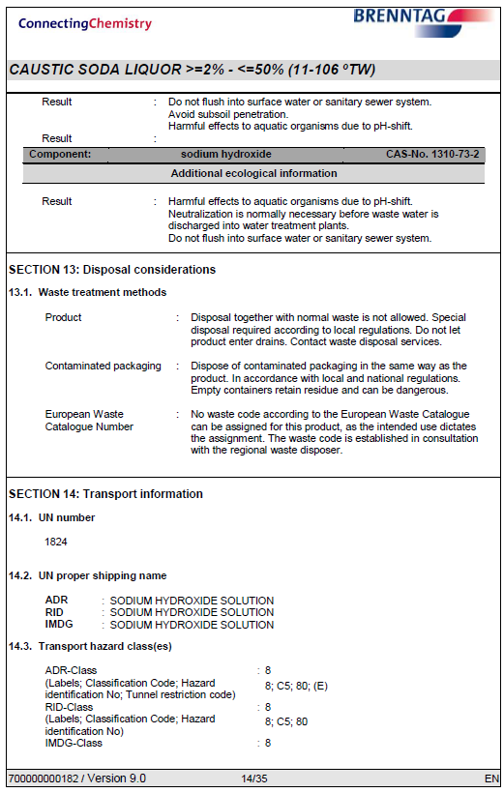

Appendix 2 – Siltbuster check sheet
Silt Buster Daily Check Sheet
Description | Check | Outcome (tick all good) | Issues / Action
General | Any unusual sounds, vibrations or smells
General | Pipework checks, leaks, frozen, wear and tear
General | Control panel check no faults or alarms
General | Power cables in working order, Visual
Mechanical | Motors running, no signs of sticking, bearing noise
Mechanical | Motor vents clear and free from debris
Mechanical | Flowmeter registering presence of water
Mechanical | Chemical dosing pump head in auto mode
Mechanical | Sludge pump activities in auto / manual mode
Consumables | Check level of Coagulant
Consumables | Check level of Flocculant
Consumables | Bunding of chemicals not compromised
Clarifier | Visual check of clear water at outlet of clarifier
Clarifier | Lamella plates free from solid build up
Clarifier | Hoppers de-sludge
Reaction Tank | Check pH level on controls 6-9
Reaction Tank | Check chemical dosing line blockage, solution entering
Reaction Tank | Wipe clean pH probe
Check by |  | Company
pH Level |  | Further Comment
Coagulant pump rate | l/hr | Further Comment
Flocculant pump rate | l/hr | Further Comment

Appendix 3

Rutpen A9
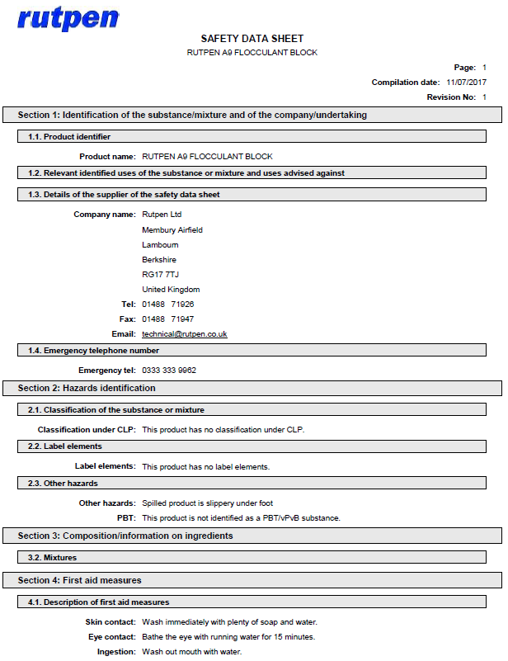
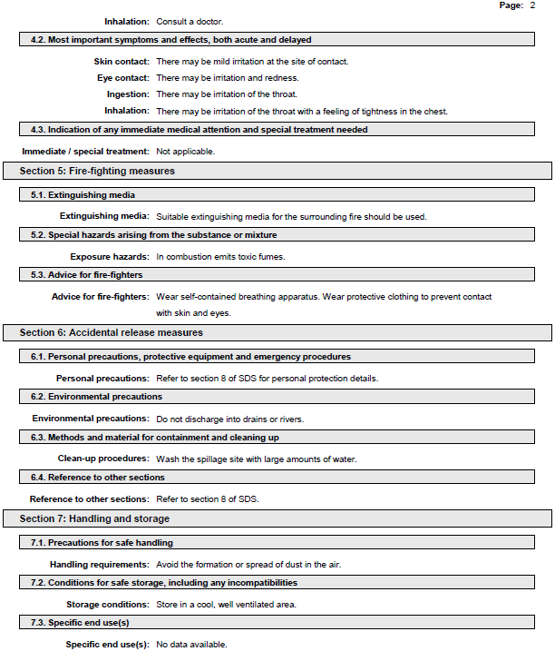
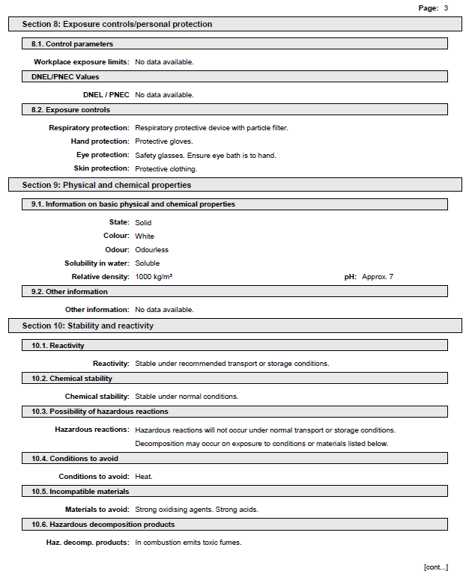
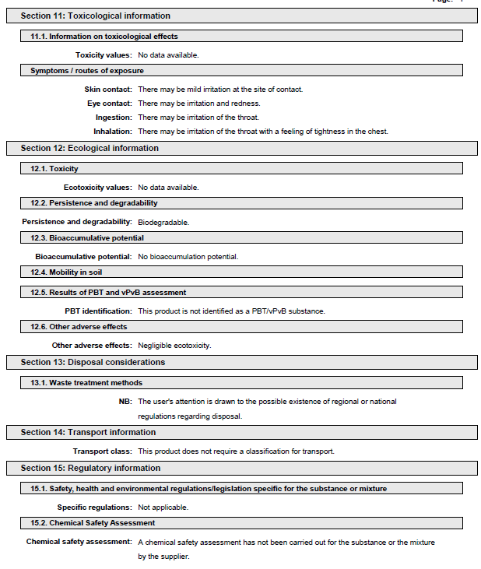
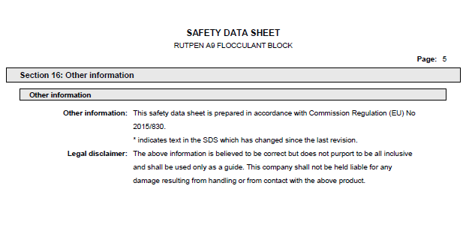

Water Lynx 360
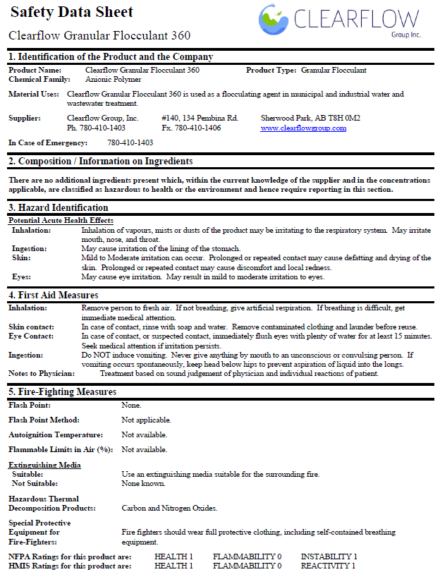
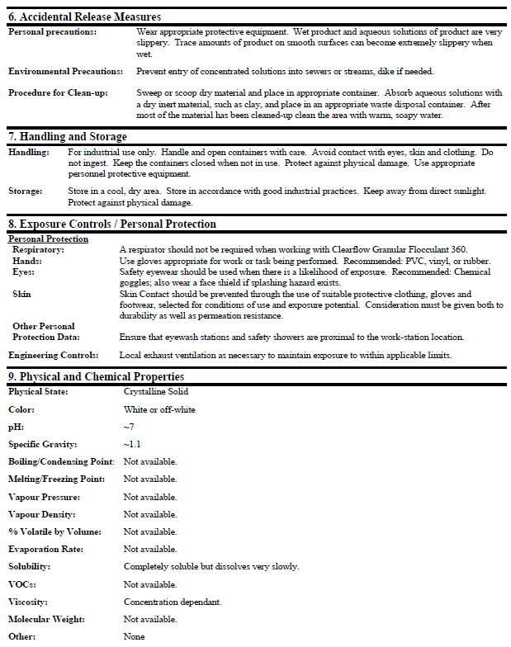
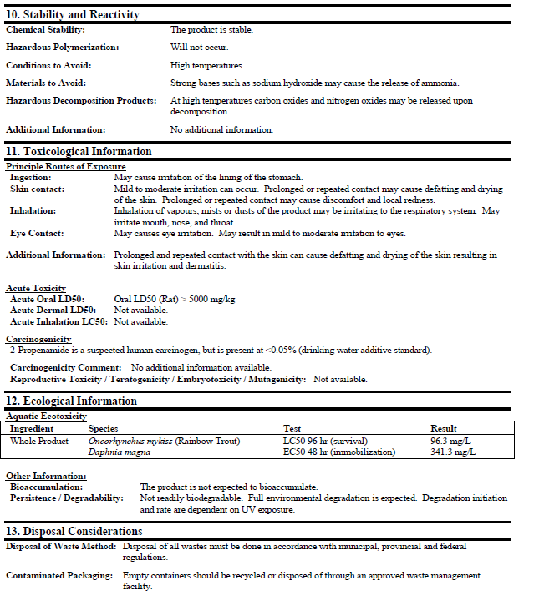
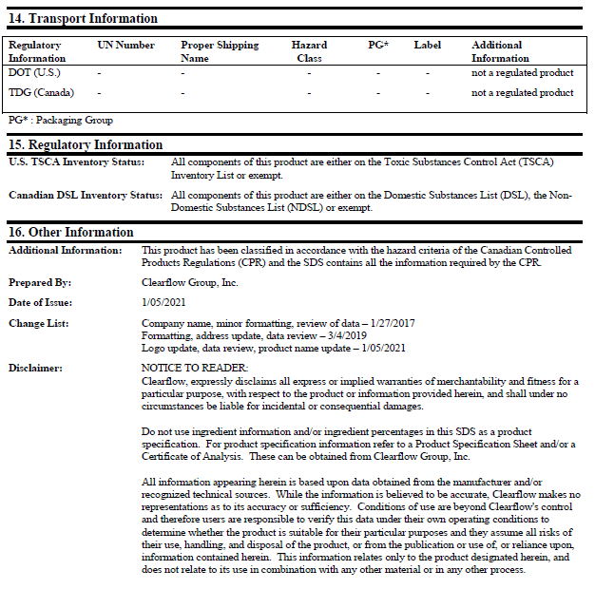

Water Lynx 395

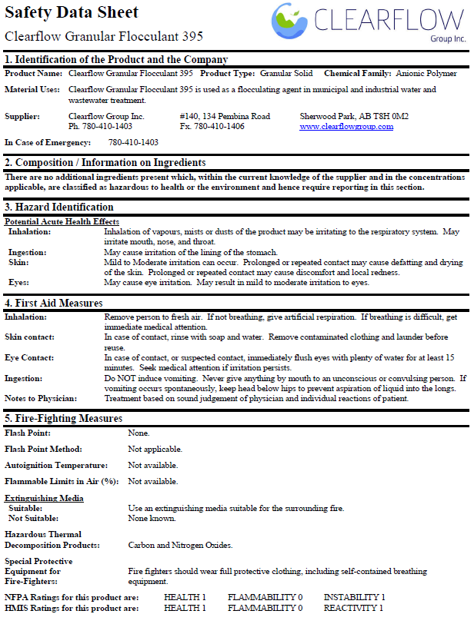

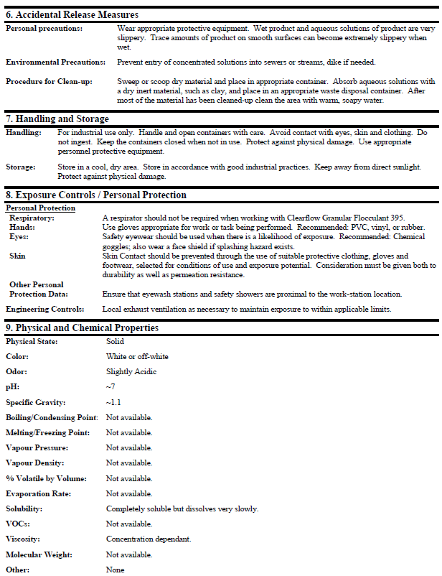

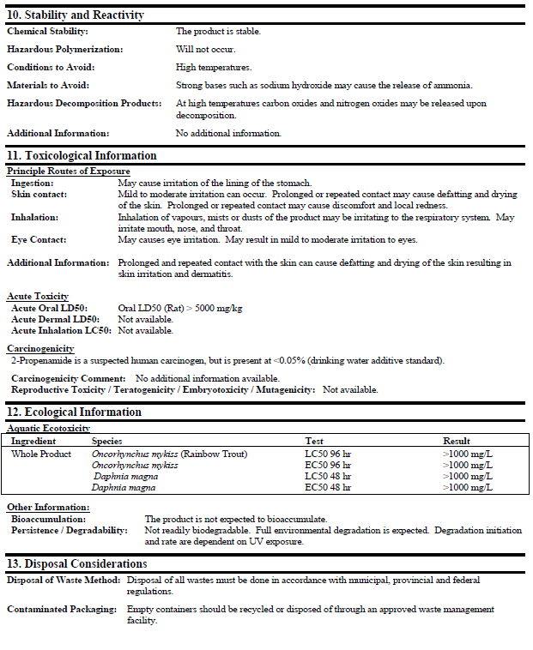

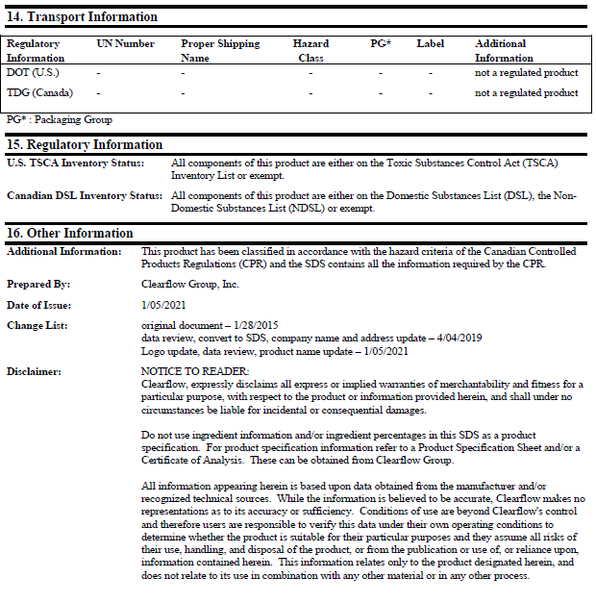

Appendix 14 – Floc mat Release Rate


